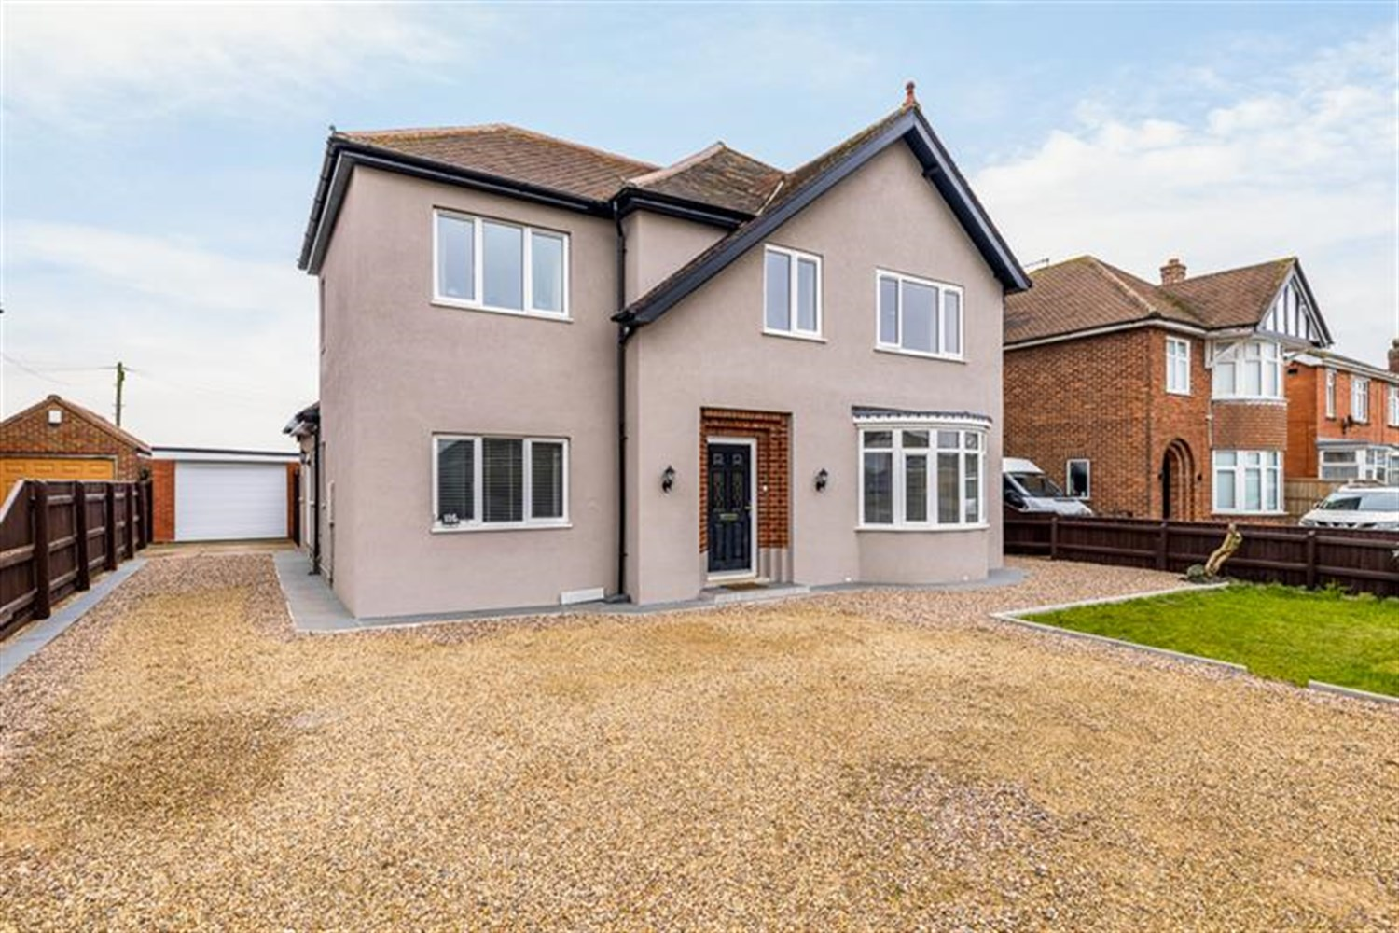




5 Bedroom(s)
3 Reception(s)
3 Bathroom(s)
£425,000.00
Eastwood Road, PE21
EPC Rating ‘67 D’

- Beautiful Four/Five Bedroom Detached Family Home
- Superb Open-Plan 'Living Kitchen'
- Garage, Field View Garden and Ample Off-Road Parking

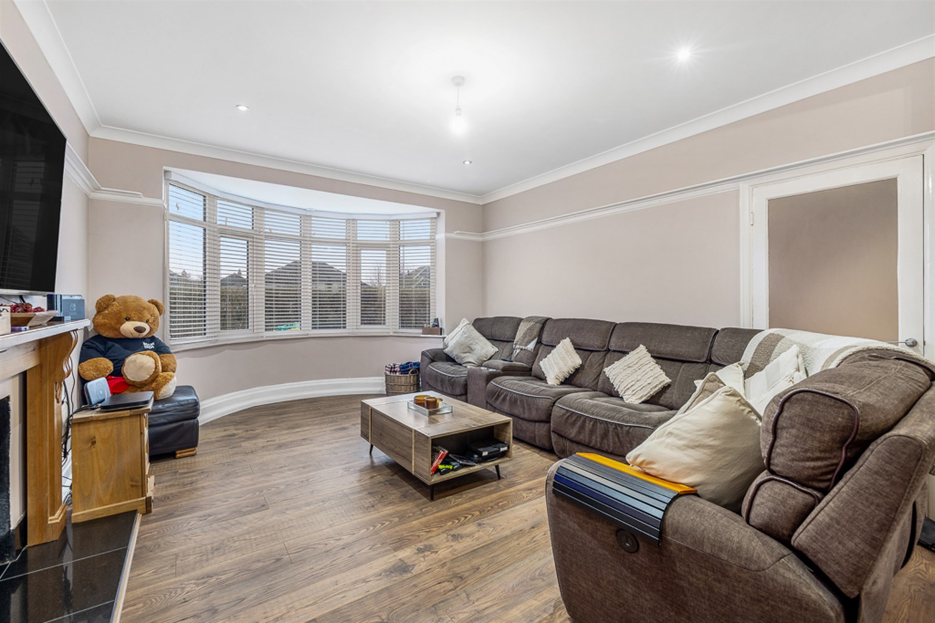
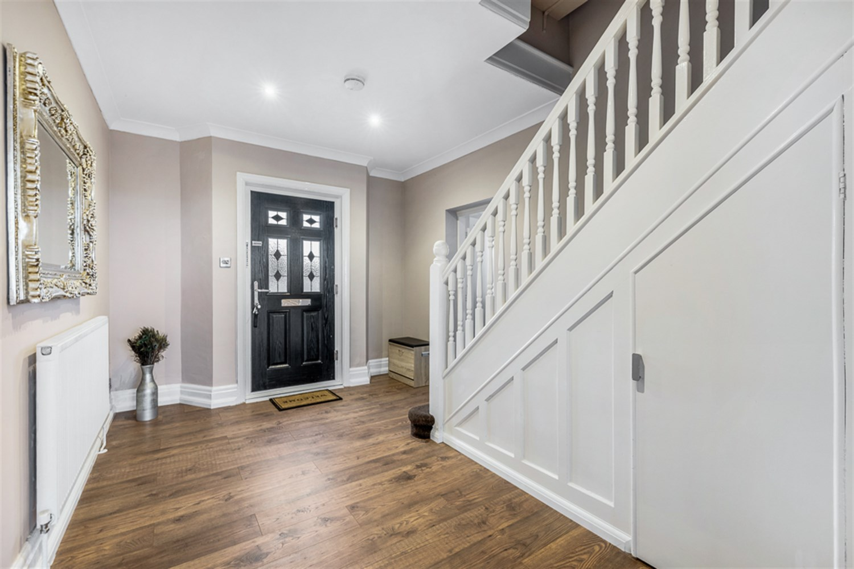
00
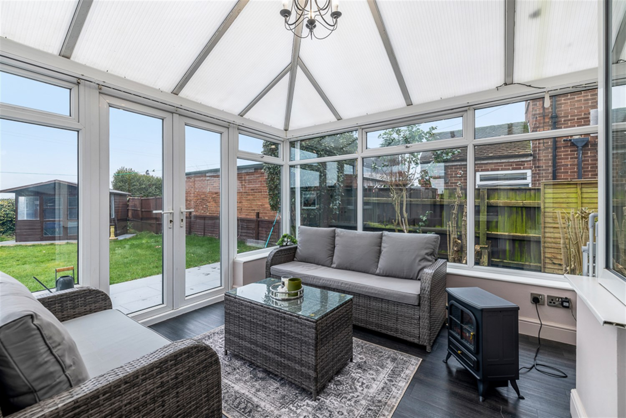
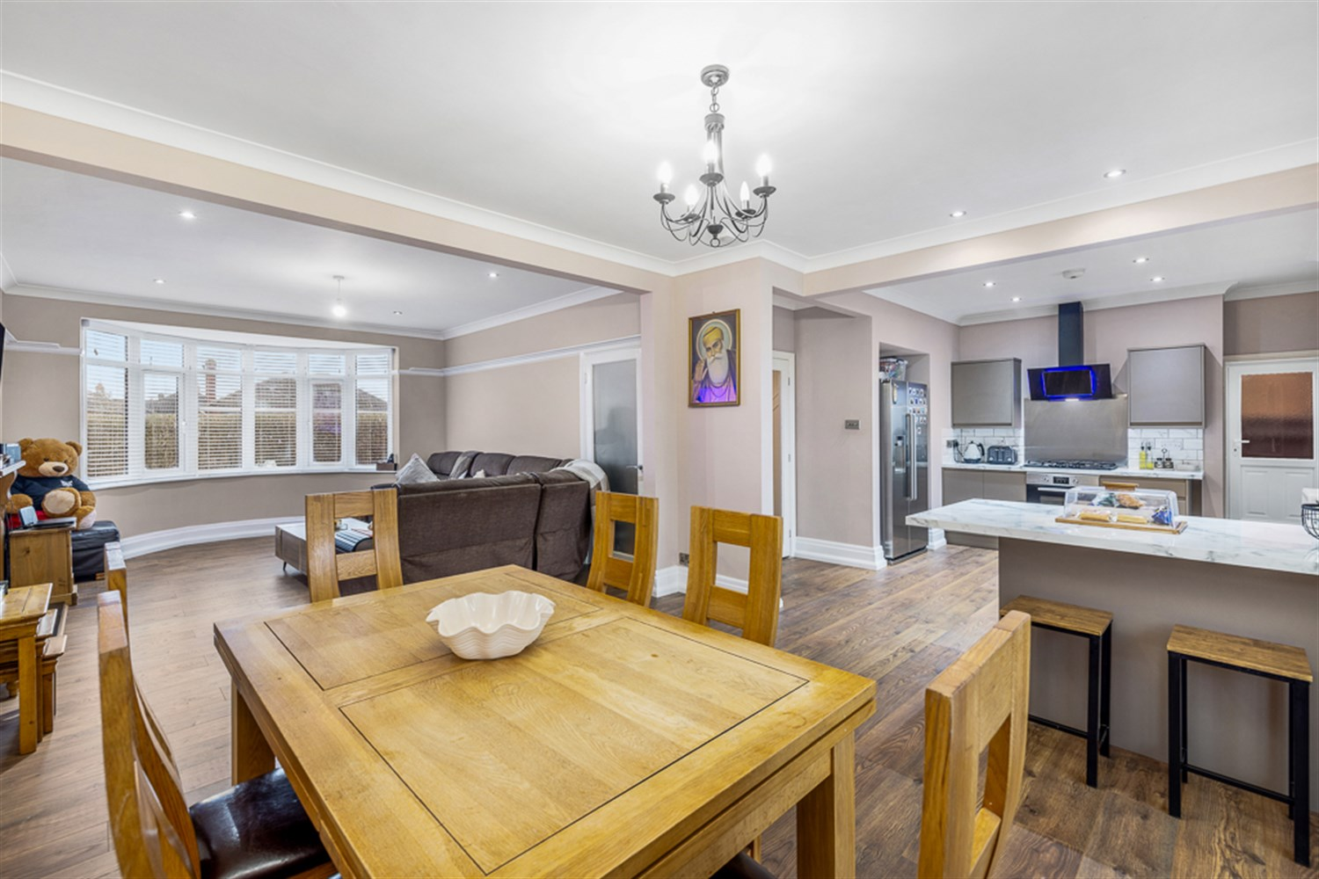
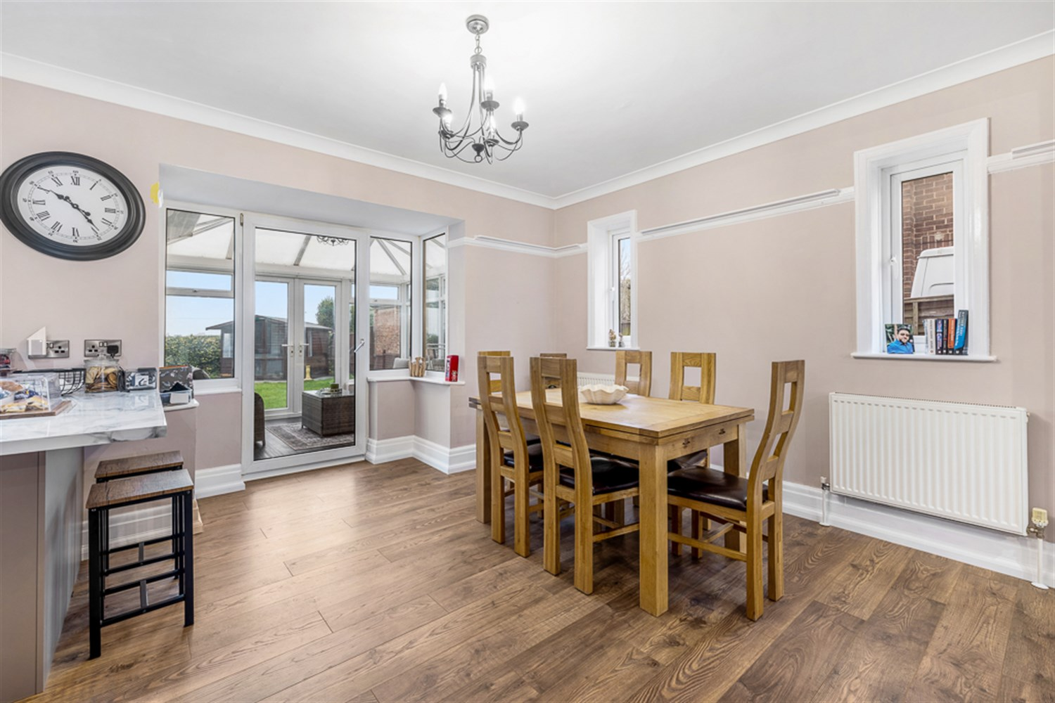
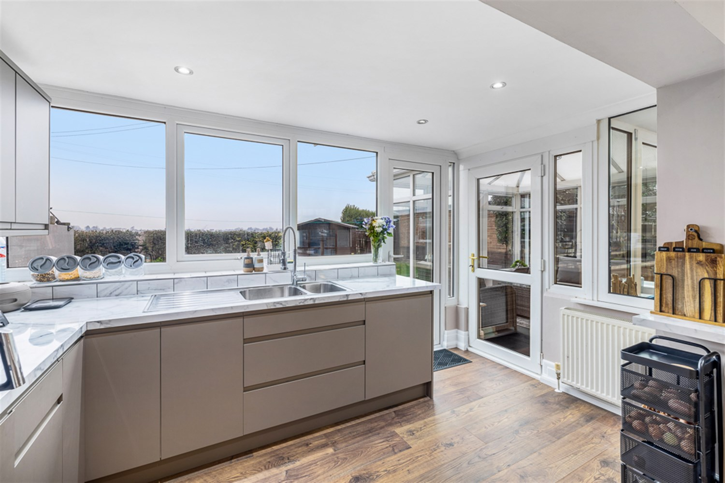
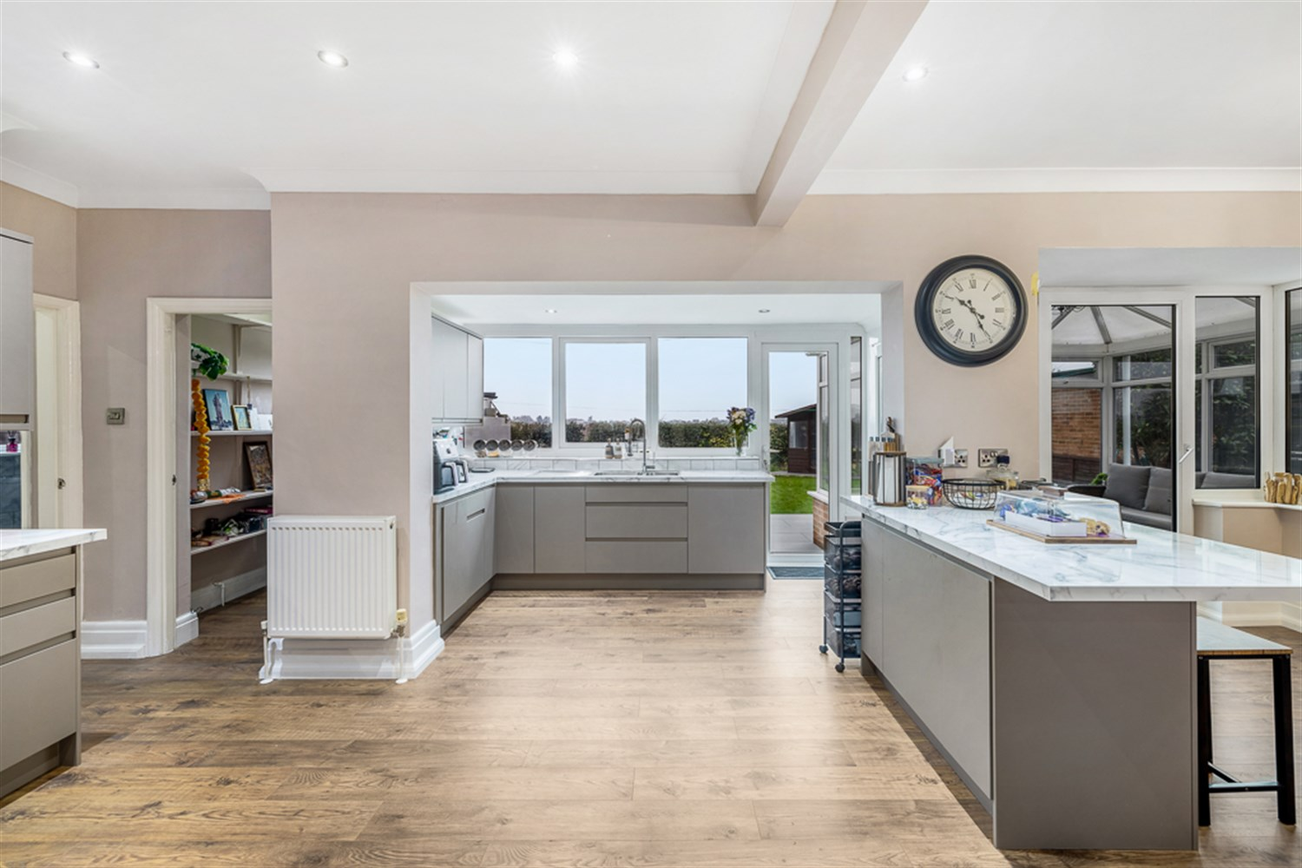
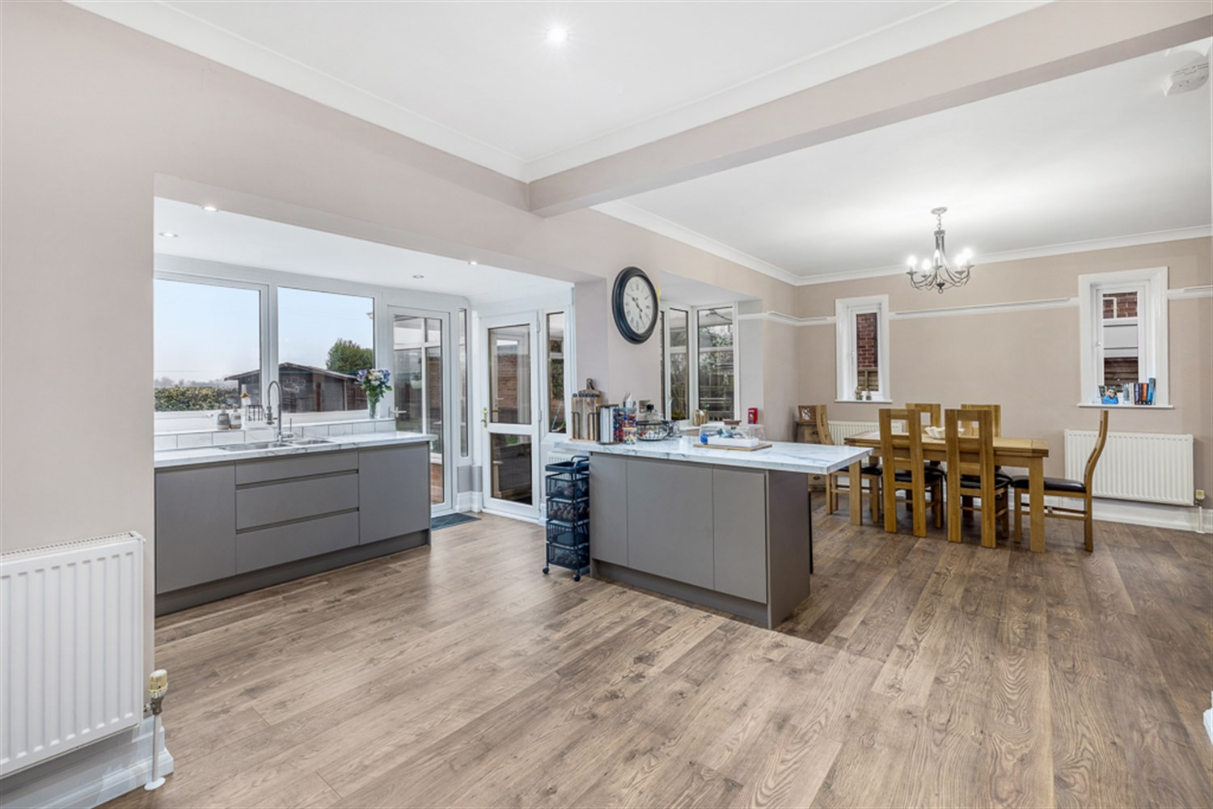
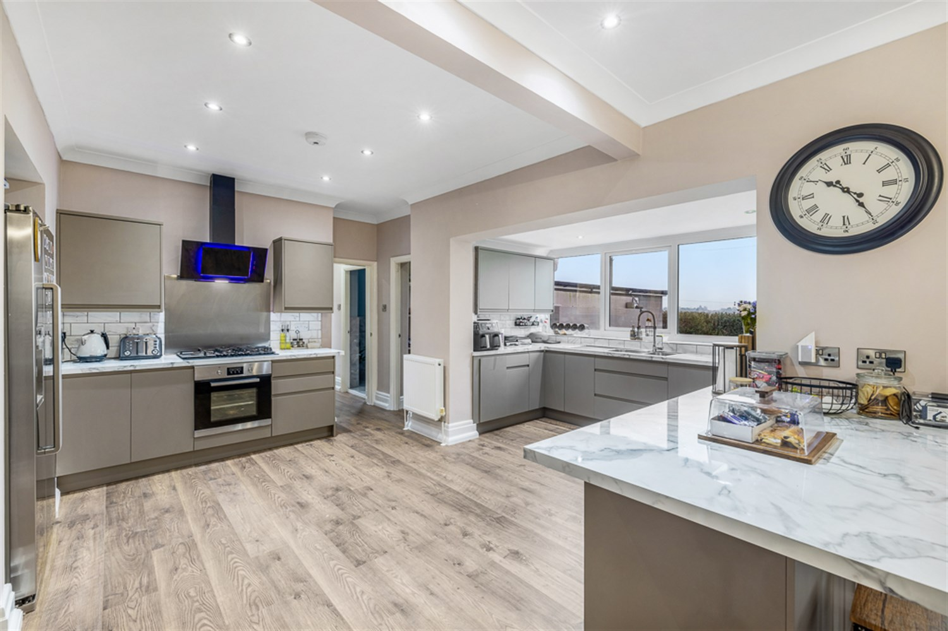
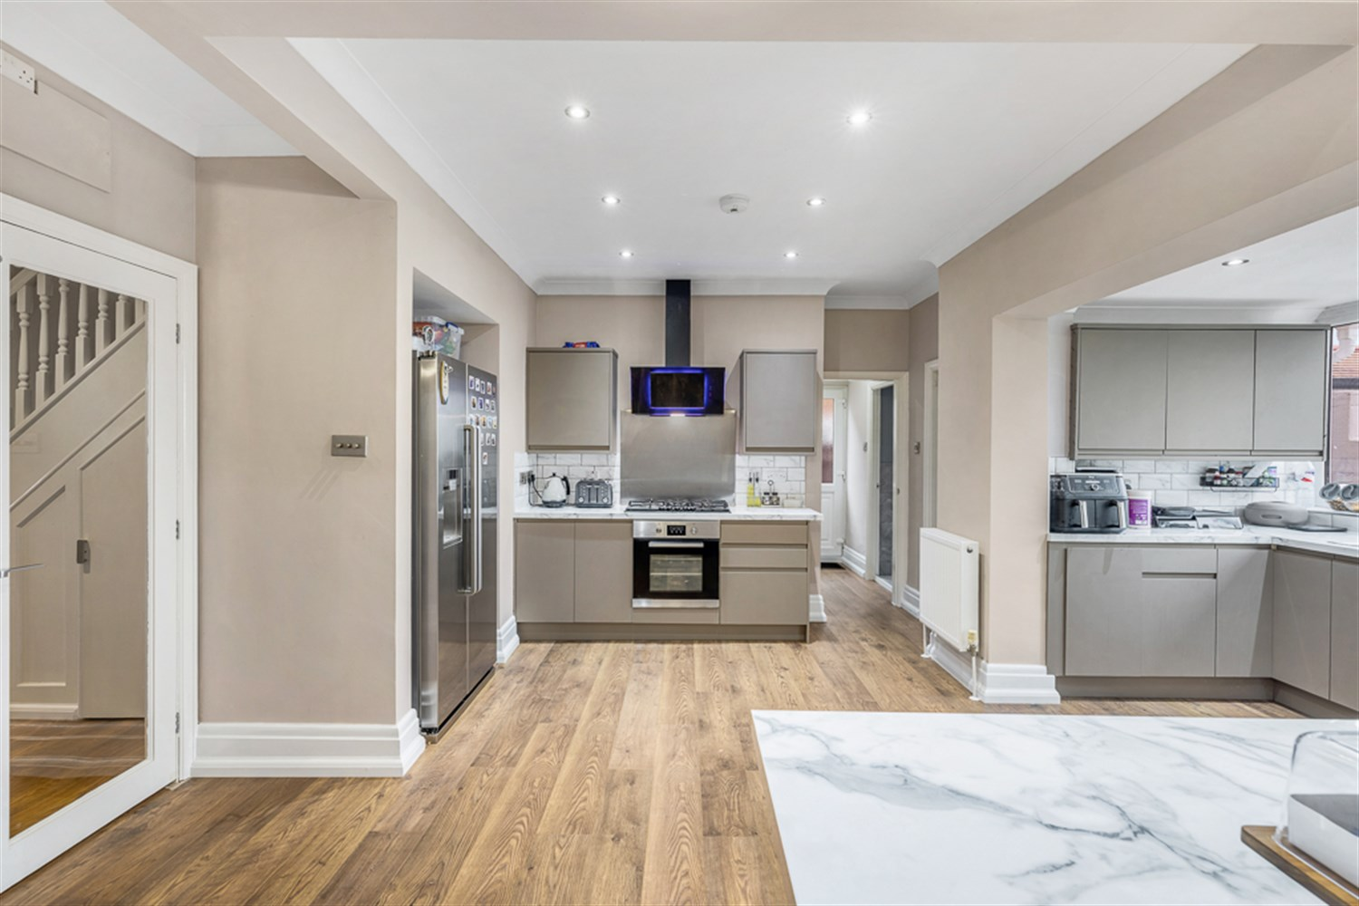

Property Description
Totally renovated by the current owners to an exceptional standard, this beautiful property sits proudly on Eastwood Road.
The family home features an inviting hallway, an open-plan kitchen, lounge and dining room, conservatory, laundry room and WC. There is also a second sitting room, which could alternatively be used as a fifth bedroom.
Most viewers will inevitably be drawn to the open plan living kitchen which is one of the most immediately striking elements of the property and a superb social space for a large family or for entertaining
On the first floor are four well-proportioned bedrooms, including an ensuite, along with a modern family bathroom.
Externally, the property benefits from a larger-than-average garage, a generous driveway providing parking for several vehicles, and a garden with open field views to the rear.

Entrance Hallway 4.26m (14') x 3.04m (10')
LVT style dark wood effect flooring, stairs to the first floor and double panelled radiator. This room is really cozy and gives access to all the downstairs rooms.

Lounge 4.26m (14') x 3.95m (13')
14' 3" x 9' 9" (4.367m x 2.987m) Lounge :- Having a double panelled radiator, windows to the front and side elevations, TV point, spot-lights to ceiling, LVT Wood effect flooring that has continued throughout the ground floor. This open plan room gives a warm feel for relaxing, family time or entering. Having a wood burner with fireplace and hearth too, creating such a beautiful warm and light space.

Open Plan Kitchen/Dining/Lounge Area 5.07m (16'8) x 8.89m (29'2)
The newly fitted modern kitchen features grey based units with pan drawers, a marble effect worktop, and a matching marble-effect splashback. Appliances include an electric oven, a six burner gas hob with an extractor as well as an integrated dishwasher, and also holds a space for an American style fridge freezer. There is a breakfast bar, spot lighting, and soft close drawers .A pantry with a sliding door is included, fitted with shelves and a window to the rear, along with double panelled radiators. The real hub of the house, perfect for avid cooks, family gatherings and much more. This room gives access to the dining area, lounge, conservatory, downstairs WC and laundry room.

Dining Area 3.66m (12'0) x 3.95m (13')
Open plan to the Kitchen and Lounge, this room is perfectly sized for a dining table and the Conservatory leads on from here. There is also a continuation of the LVT flooring.

Conservatory 4.01m (13'2) x 3.45m (11'4)
Having windows to side elevations, further windows to rear elevation, patio door to rear elevation leading into the garden, LVT Style flooring in black, TV point.

Pantry 1.7m (5'7) x 1.17m (3'10)
Having a door taken from kitchen, window to rear elevation, Karndean flooring, shelving.

Downstairs WC
Having window to side elevation, fully tiled floor, spot-lights to ceiling, low level WC, modern sink, drawers and cupboards underneath, half tiled.

Laundry Room/Utility 2.14m (7'0) x 1.85m (6'1)
Having window to side elevation, LVT flooring, wall mounted central heating boiler, water cylinder, water softener, stainless steel sink and drainer, space and plumbing for automatic washing machine, space for tumble dryer, spot-lights to ceiling.

Bedroom 5/Family room/Second Sitting Room 4.37m (14'4) x 3m (9'10)
This room is extremely versatile with a window to the front and side, LVT Style flooring, double panelled radiator. Ideal downstairs bedroom, family room or second sitting room.

Staircase taken from entrance hallway leading to first floor landing
The hallway features spot lights to the ceiling, with Dark wood-effect LVT flooring with a double panel radiator.

Bedroom 1 3.66m (12'0) x 3.95m (13')
LVT flooring, double room with a window to the front elevation and a double panel radiator.

En-Suite 1.71m (5'7) x 2.21m (7'3)
Having a marble effect tiled floor with electric underfloor heating, with a sink unit and drawer storage, tiled splashbacks, vanity mirror, shaver point, double shower cubicle with sliding glass door and mixer shower, oval shaped bath with mixer taps to the middle, low level WC, heated towel rail, spot-lights to ceiling, window to rear elevation.

Bedroom 2 4.25m (13'11) x 3.95m (13')
The bedroom features LVT flooring with spot lighting and bay windows to the front and side elevation.

Bedroom 3 4.37m (14'4) x 2.98m (9'9)
LVT flooring with spot lighting, with a bay window to the rear elevation, has double panelled radiators.

Bedroom 4 3.04m (10') x 2.75m (9'0)
LVT flooring, good-sized single room with a window to the front elevation.

Family Bathroom 3.12m (10'3) x 2.36m (7'9)
The family bathroom consists of spot lighting with a bath and mixer tap with handheld shower, separate shower cubicle with mixer tap, frosted window to the side elevation. Also consists of a vanity sink unit with drawers, low-level WC, tiled splashbacks,LVT5 flooring, and a double panelled radiator.
Large Storage cupboard/loft space 3.13m x 1.72m.

Outside
The property is approached via an extensive gravelled driveaway providing ample off road parking for several vehicles. There is a section of lawn to the front and mature hedging and borders. The driveaway extends to the side of the property.

Tandem Garage 8.3m (27'3) x 3.16m (10'4)
Electric car charging electric point.

Rear Garden
The rear garden includes a shed, summer house, air-raid shelter, and is enclosed with fencing and hedging. Additional features include exterior lighting, electric points to the side elevation, an electric garage door with remote control, a side gate, a long larger than average garage. This also benefits from open field views to the rear.

Air Raid Shelter
Being of concrete construction and providing additional outside storage.

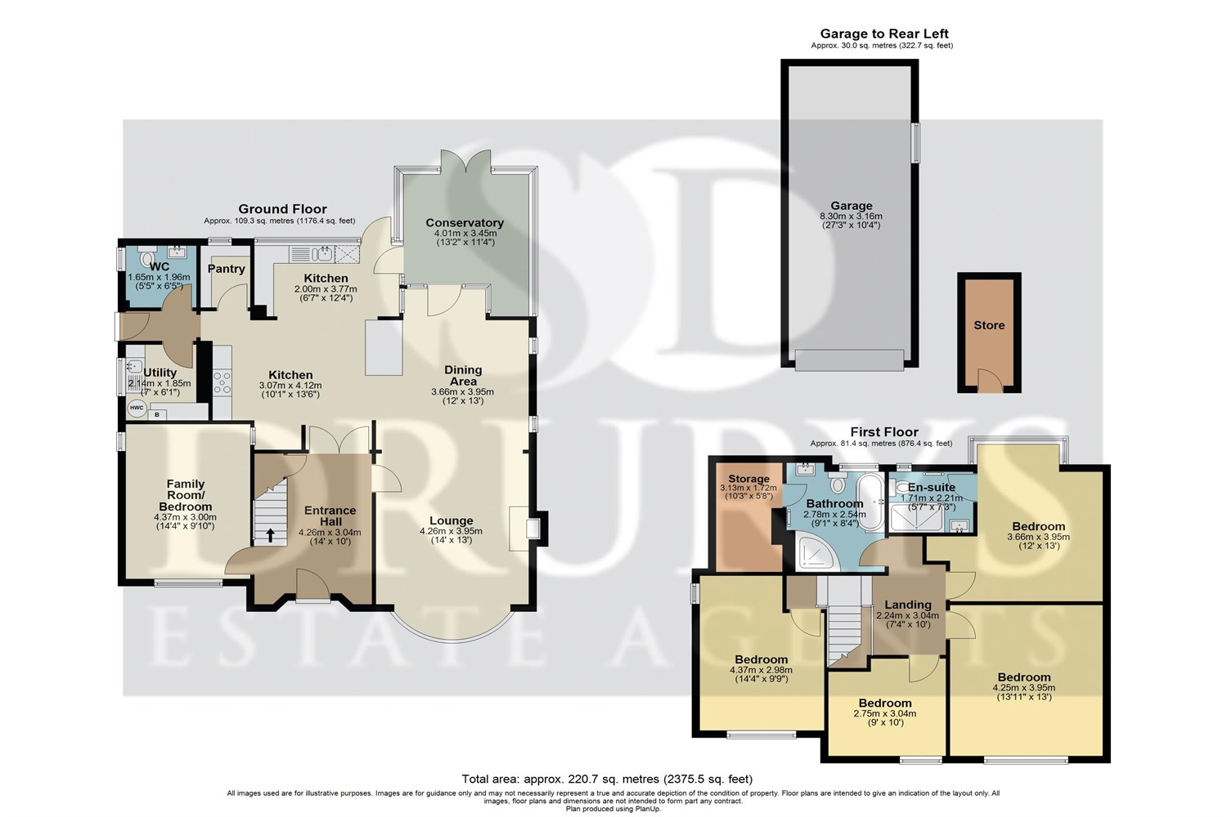

These particulars are intended to give a fair description of the property, but their accuracy cannot be guaranteed, and they do not constitute an offer of contract. Intending purchasers must rely on their own inspection of the property. None of the above appliances/services have been tested by ourselves. We recommend purchasers arrange for a qualified person to check all appliances/services before legal commitment.

Property Ref: 3208

www.drurysestateagents.co.uk
amber@drurysestateagents.co.uk
01205 350889

45 Willoughby Road
Boston
Lincolnshire
PE21 9HN
Agents Note: Whilst every care has been taken to prepare these sales particulars, they are for guidance purposes only. All measurements are approximate are for general guidance purposes only and whilst every care has been taken to ensure their accuracy, they should not be relied upon and potential buyers are advised to recheck the measurements

