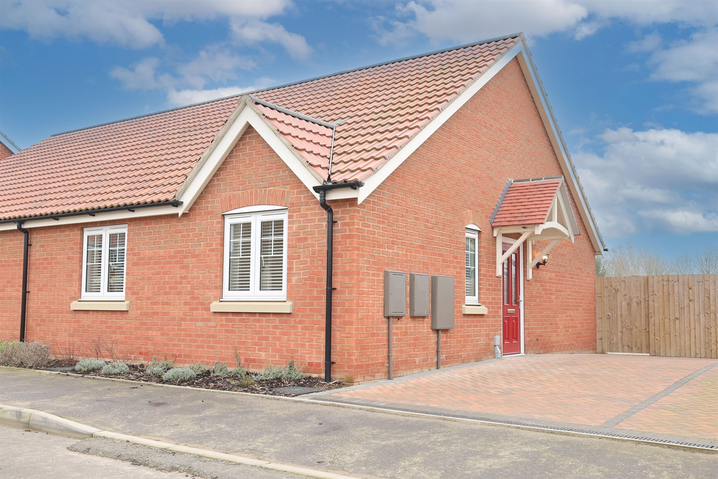




2 Bedroom(s)
2 Reception(s)
1 Bathroom(s)
£178,950.00
136, PE21
EPC Rating ‘’

- Chain Free
- Close to Local Amenities
- Close to Local Schools

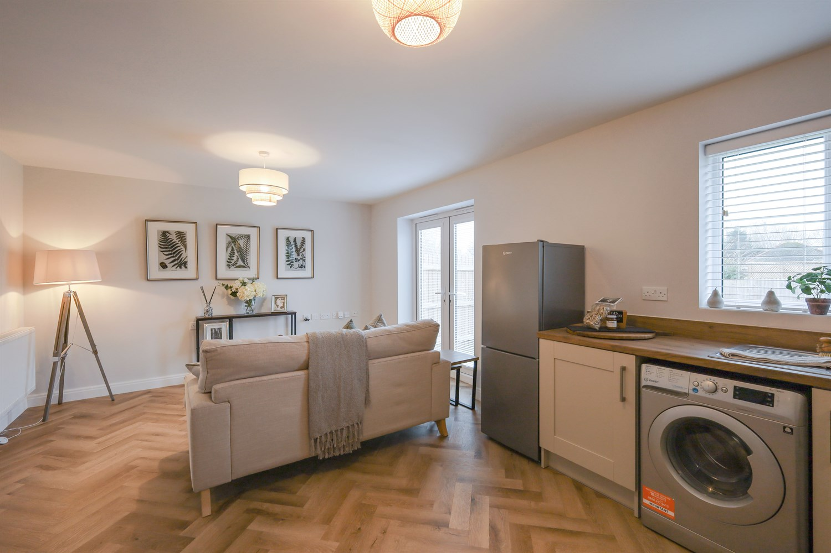
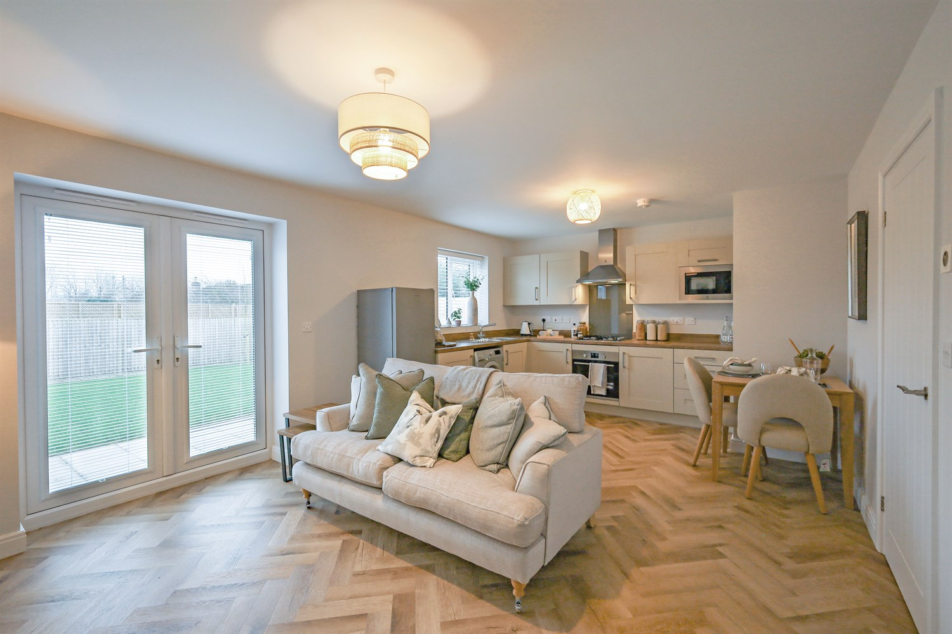
00

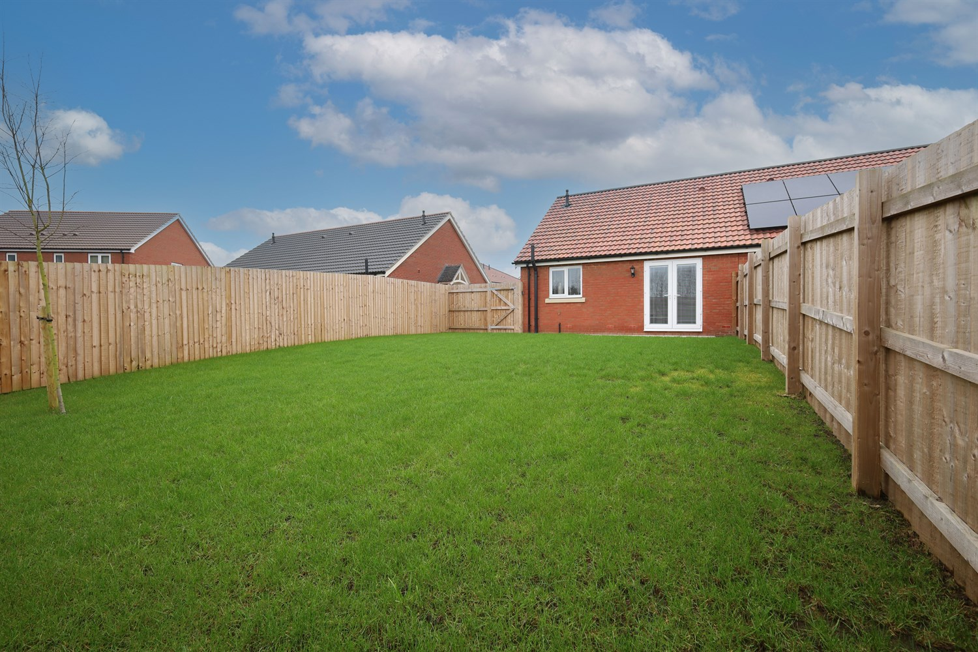
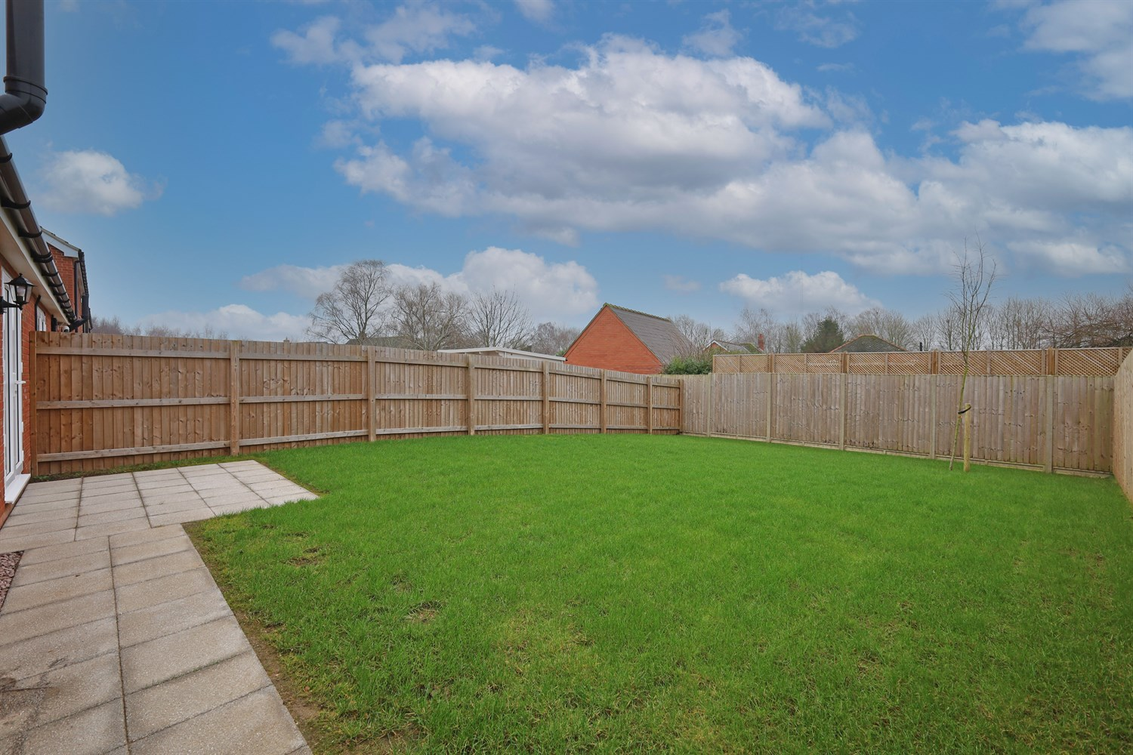
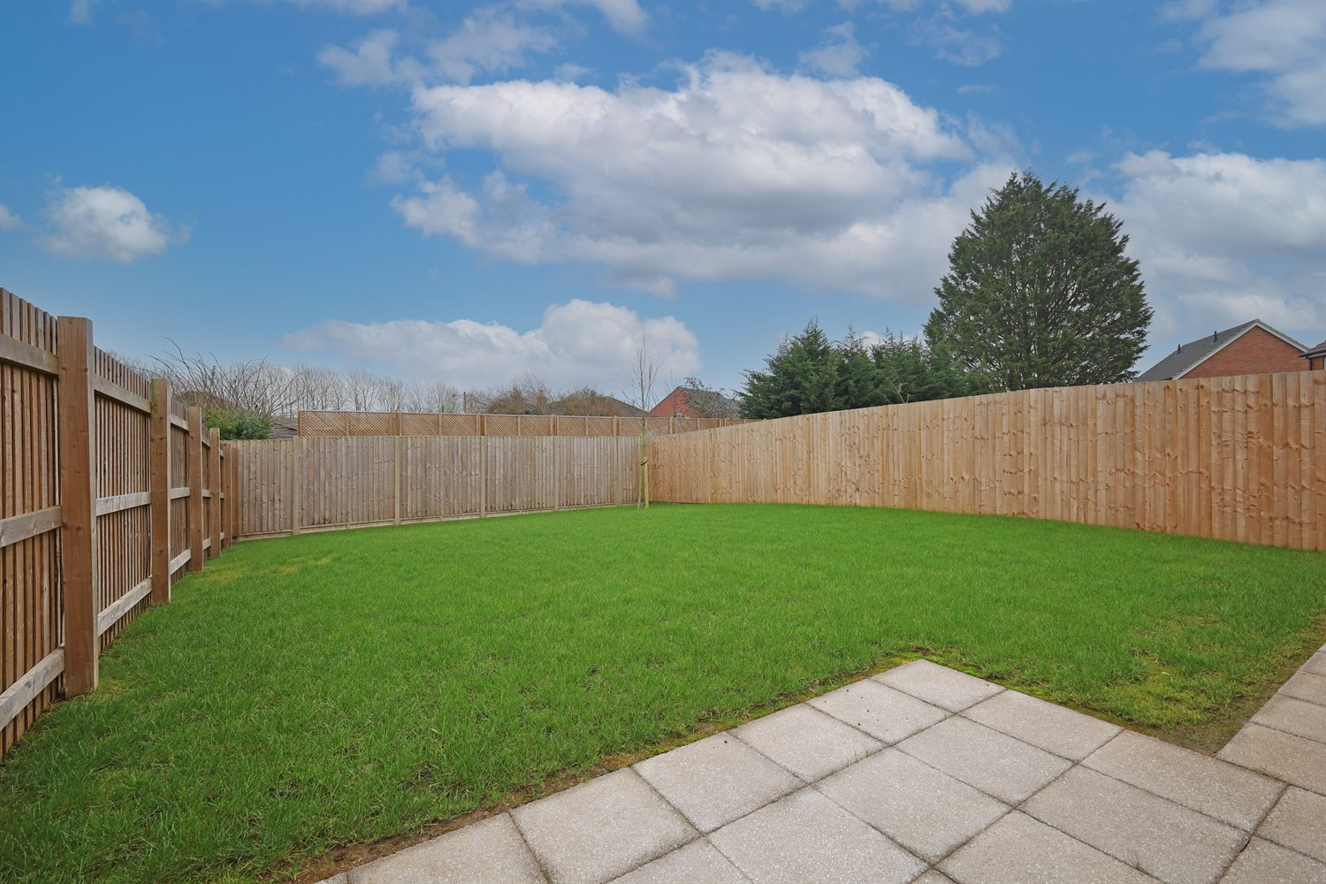
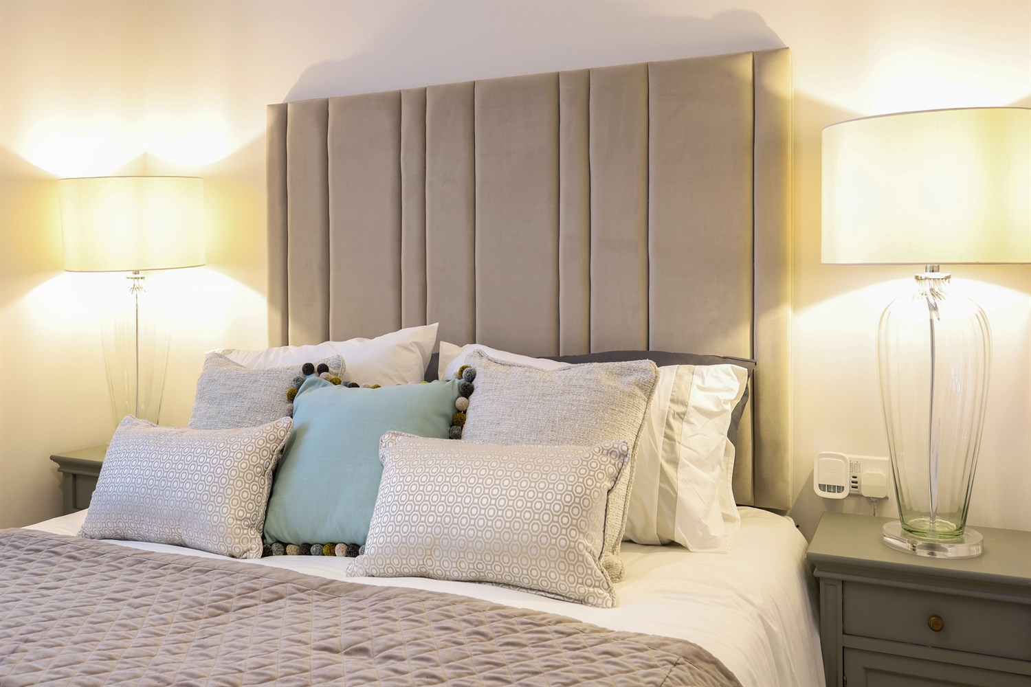
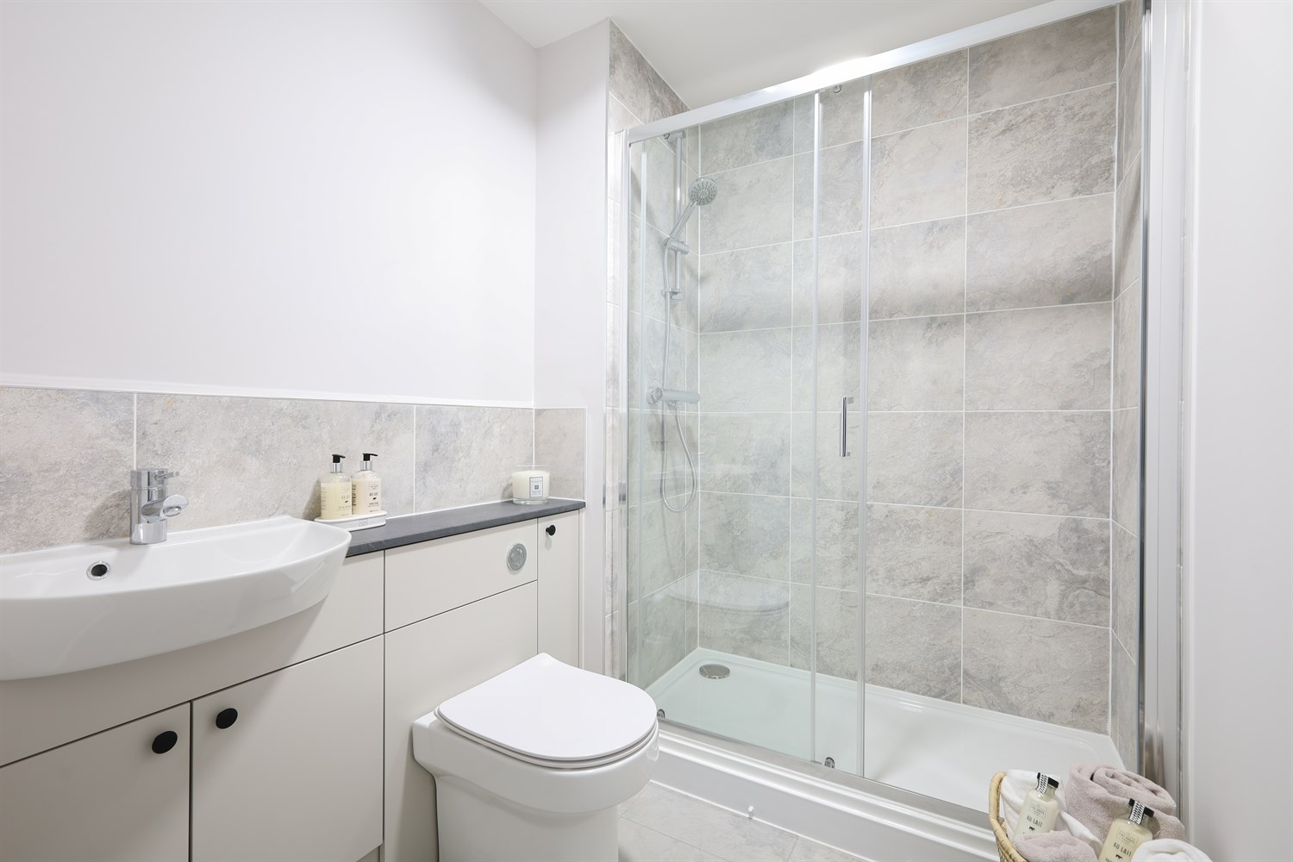
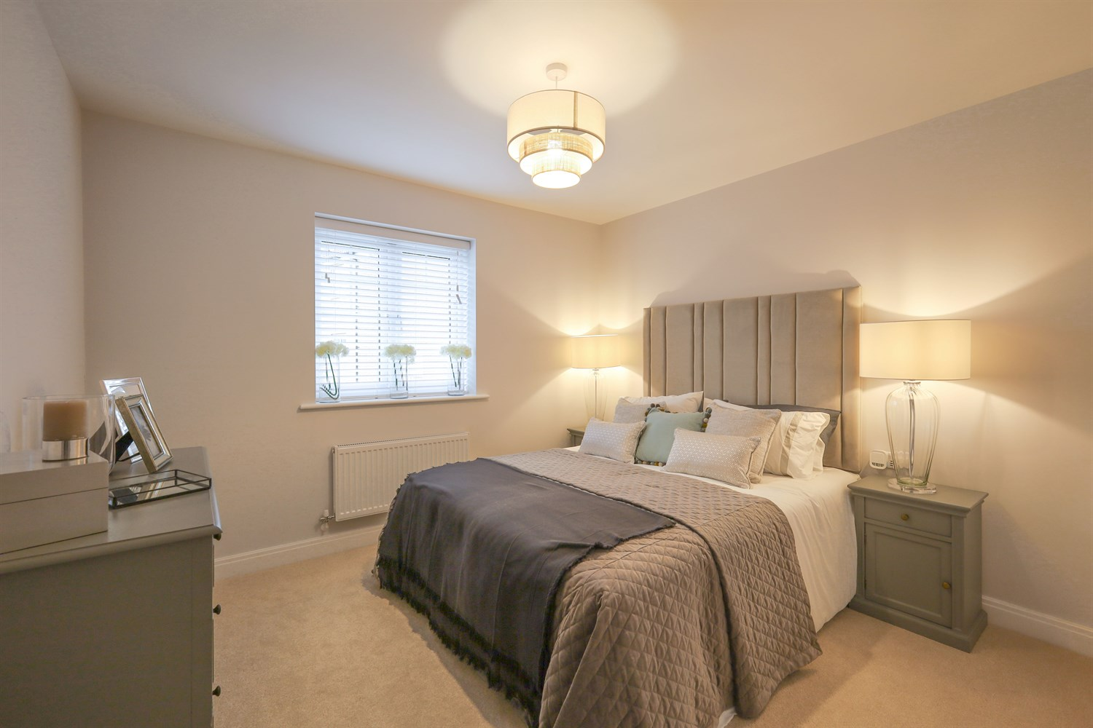
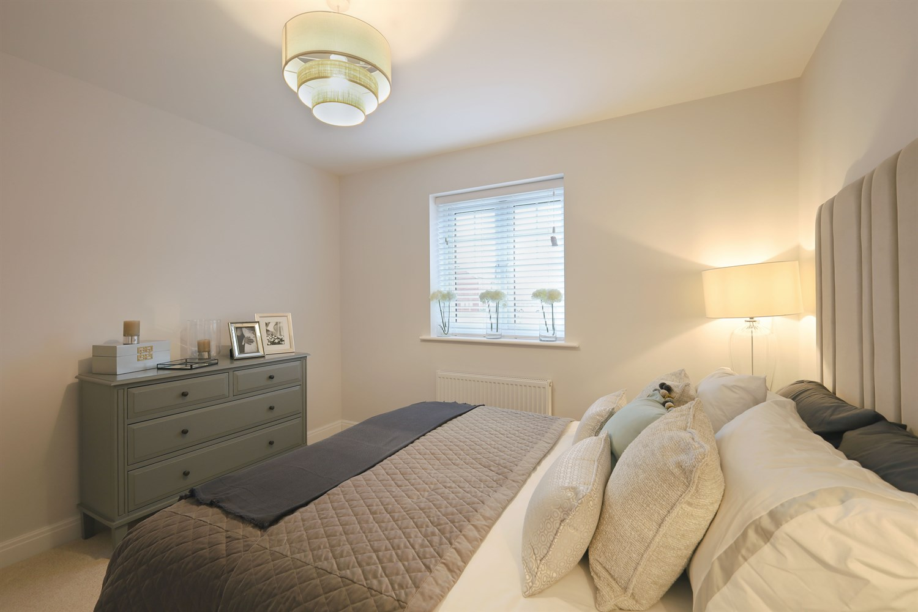

Property Description
Built by Chestnut Homes, the property benefits from a 2-year developer warranty and a 10-year NHBC structural guarantee for complete peace of mind. Designed with energy efficiency in mind, the home combines style and practicality throughout.
The contemporary kitchen features units with square-edge worktops and integrated appliances including an oven, hob, extractor and microwave. The bathroom is finished to a high standard with porcelain tiling. Double-glazed uPVC windows, French doors opening onto the garden, and a private driveway complete the specification.
Ideally positioned close to everyday amenities, residents are within easy reach of coffee shops, a post office, local supermarkets, a gym and the Boston United Football Stadium.
Chain Free

Front Aspect
The property presents an attractive red brick façade beneath a pitched tiled roof, complemented by decorative front gables and a covered entrance porch. UPVC double-glazed windows with contrasting surrounds add character, while a block-paved driveway provides off-road parking. The frontage is enhanced by neatly planted borders and a well-maintained setting within a quiet residential position.

Lounge
A bright and stylish living space. French doors to the rear elevation provide excellent natural light and direct access to the garden. The room offers ample space for both seating and occasional furniture, finished with neutral flooring and complemented by a pleasant outlook, creating a comfortable and inviting setting.

Kitchen
A modern fitted kitchen comprising a range of wall and base units with complementary work surfaces incorporating a stainless steel sink and drainer. Integrated appliances include an oven with hob and extractor over. UPVC double-glazed window to the side elevation providing natural light, with space for additional appliances and dining. Finished with contemporary flooring and ample storage throughout.

Bedroom 1
A well-proportioned double bedroom with uPVC double-glazed window to the side elevation providing natural light. Offering ample space for a double bed and additional bedroom furniture, the room is finished with neutral décor and carpeting, creating a comfortable and versatile space to suit a variety of styles.

Bathroom
A modern shower room fitted with a contemporary white suite comprising a fully tiled shower enclosure with glazed screen and mixer shower, close-coupled WC and wall-mounted wash hand basin set within a vanity unit. Finished with stylish wall tiling and complementary flooring, providing a clean, modern and practical space.

Bedroom 2
A further well-proportioned bedroom with uPVC double-glazed window to the side elevation providing natural light. Offering space for a double bed and freestanding furniture, the room is finished with neutral décor and carpeting, creating a versatile space suitable for a range of uses including guest accommodation.

Small Garden
The property enjoys an enclosed rear garden predominantly laid to lawn with a paved patio area directly adjoining the property, ideal for outdoor seating and entertaining. The garden is bordered by timber fencing, providing privacy, and offers a pleasant, low-maintenance outdoor space suitable for a variety of uses.

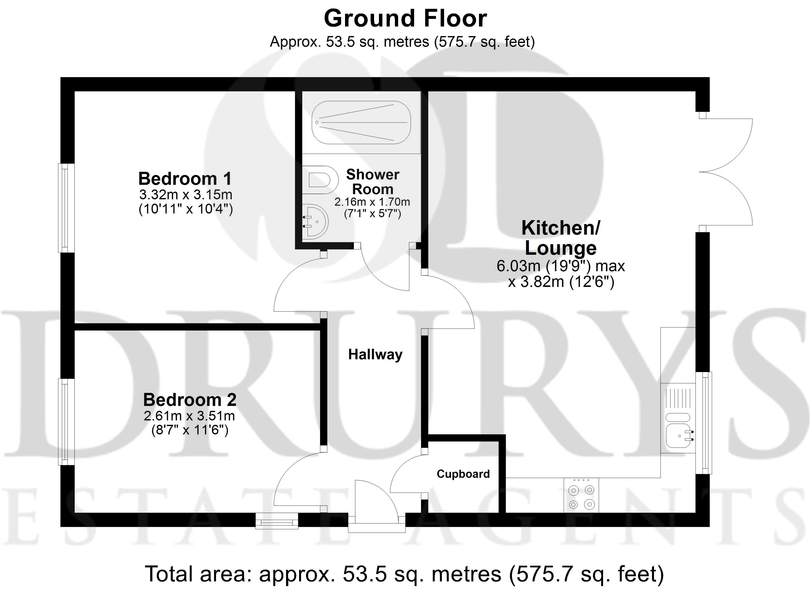

These particulars are intended to give a fair description of the property, but their accuracy cannot be guaranteed, and they do not constitute an offer of contract. Intending purchasers must rely on their own inspection of the property. None of the above appliances/services have been tested by ourselves. We recommend purchasers arrange for a qualified person to check all appliances/services before legal commitment.

Property Ref: 3291

www.drurysestateagents.co.uk
amber@drurysestateagents.co.uk
01205 350889

45 Willoughby Road
Boston
Lincolnshire
PE21 9HN
Agents Note: Whilst every care has been taken to prepare these sales particulars, they are for guidance purposes only. All measurements are approximate are for general guidance purposes only and whilst every care has been taken to ensure their accuracy, they should not be relied upon and potential buyers are advised to recheck the measurements

