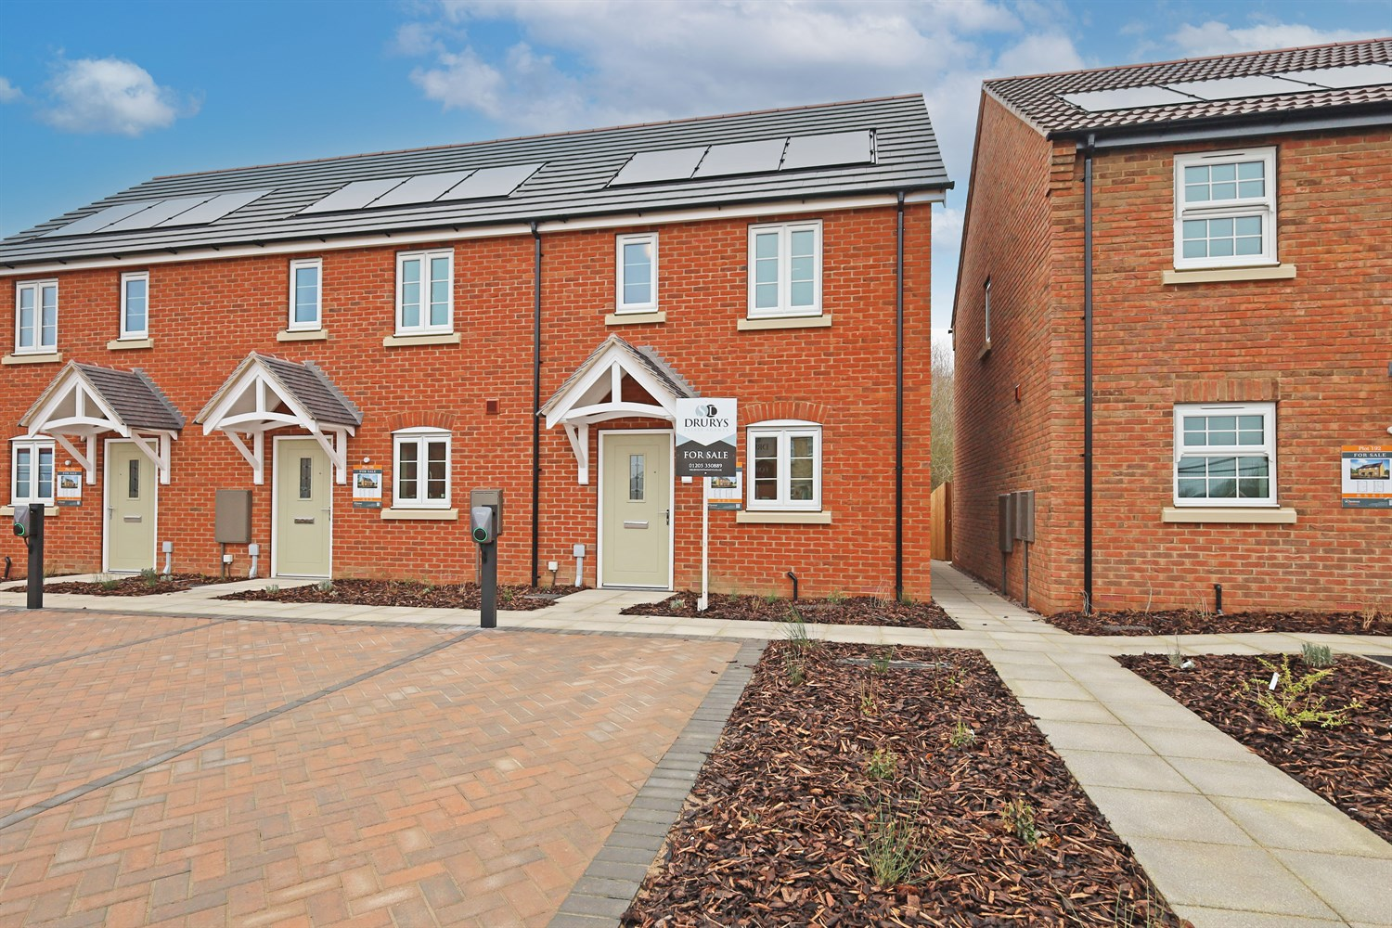




2 Bedroom(s)
3 Reception(s)
1 Bathroom(s)
£
, PE21
EPC Rating ‘’

00

Property Description
A well-proportioned and thoughtfully arranged two-bedroom home, offering practical living space across two floors and perfectly suited to first-time buyers, downsizers or investors.
The ground floor welcomes you into a fitted kitchen positioned to the front elevation, offering a functional layout with ample preparation space. To the rear, a spacious lounge seamlessly incorporates a defined dining area, creating a sociable and versatile living environment. French doors open directly onto the rear garden, allowing natural light to flood the space and providing an ideal setting for entertaining or relaxing.
A convenient ground floor cloakroom/WC adds further practicality.
To the first floor, the property offers two well-balanced bedrooms. The principal bedroom is a generous double and benefits from built-in wardrobe space. Bedroom two is ideal as a single bedroom, nursery or home office. The landing also provides additional cupboard storage.
Completing the accommodation is a family bathroom fitted with a panelled bath, WC and wash hand basin.
Overall, this home offers an excellent layout with a strong sense of flow, making it both comfortable and highly functional for modern living.

Front Aspect
To the front, the property presents a neat and well-maintained façade, offering attractive kerb appeal. The entrance is clearly defined and welcoming, with a tidy frontage that complements the overall design of the home.
The property enjoys a pleasant position within the development, making it an appealing option for buyers seeking a well-situated and low-maintenance home.

Lounge/Dining Area 4.54m (14'11) x 3.95m (13')
Positioned to the rear of the property, the lounge is a well-proportioned and inviting space, thoughtfully arranged to accommodate both comfortable seating and a defined dining area. The layout allows for flexible furniture placement, making it ideal for everyday living as well as entertaining guests.
French doors open directly onto the rear garden, allowing natural light to flood the room and creating a bright, airy feel throughout. This space forms the heart of the home.

Kitchen 2.63m (8'8) x 4.51m (14'10)
The kitchen is thoughtfully arranged to maximise both storage and preparation space, offering a clean and practical environment for modern living. Positioned to the front of the property, it enjoys natural light and provides a well-balanced layout with ample cabinetry and workspace, making it as functional as it is inviting.

Downstairs Toilet/Cloakroom .95m (3'1) x 1.78m (5'10)
The property further benefits from a well-appointed ground floor cloakroom, thoughtfully positioned for convenience. Comprising a WC and wash hand basin, this practical addition enhances the flow of the home and is particularly useful when entertaining.

Bedroom 1 3.8m (12'6) x 3.19m (10'6)
A well-proportioned principal bedroom positioned to the front elevation, offering ample space for a double bed and accompanying furniture. The room benefits from built-in wardrobe storage, providing a practical solution while maintaining a clean and uncluttered layout.
Natural light enhances the bright and comfortable feel of the space.

Bedroom 2 3.4m (11'2) x 2.49m (8'2)
Bedroom two is a versatile and functional space, perfectly suited as a child¿s bedroom, guest room or home office. The well-balanced proportions allow for flexible furniture placement, making it an ideal addition for growing families or those working from home.

Bathroom 1.96m (6'5) x 1.7m (5'7)
The first-floor bathroom is fitted with a three-piece suite comprising a panelled bath, low level WC and pedestal wash hand basin. The layout is both practical and well-proportioned, offering comfortable space for everyday use.
Positioned off the landing for easy access, the bathroom completes the first-floor accommodation and serves both bedrooms conveniently.

Small Garden
The first-floor landing provides access to both bedrooms and the family bathroom, creating a practical and well-connected layout. The space also benefits from a useful storage cupboard, ideal for linens and household essentials, helping to keep the home organised and clutter-free.

Parking
The property benefits from a private driveway, offering convenient off-road parking directly adjacent to the home. A highly desirable feature, providing both practicality and everyday ease.

These particulars are intended to give a fair description of the property, but their accuracy cannot be guaranteed, and they do not constitute an offer of contract. Intending purchasers must rely on their own inspection of the property. None of the above appliances/services have been tested by ourselves. We recommend purchasers arrange for a qualified person to check all appliances/services before legal commitment.

Property Ref: 3299

www.drurysestateagents.co.uk
amber@drurysestateagents.co.uk
01205 350889

45 Willoughby Road
Boston
Lincolnshire
PE21 9HN
Agents Note: Whilst every care has been taken to prepare these sales particulars, they are for guidance purposes only. All measurements are approximate are for general guidance purposes only and whilst every care has been taken to ensure their accuracy, they should not be relied upon and potential buyers are advised to recheck the measurements

