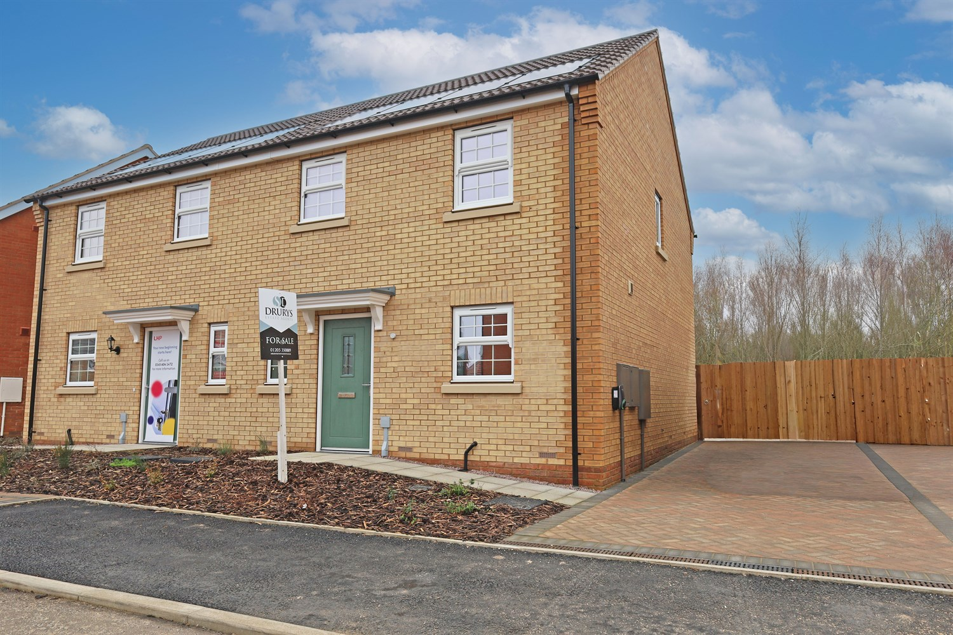




3 Bedroom(s)
2 Reception(s)
1 Bathroom(s)
£219,950.00
, PE21
EPC Rating ‘’

00

Property Description
An attractive and energy-efficient three-bedroom semi-detached home, thoughtfully designed to offer spacious and modern living across two floors.
The ground floor welcomes you into a well-appointed kitchen positioned to the front elevation, offering ample worktop space and storage, ideal for everyday family life. To the rear, a generous lounge seamlessly connects to the dining area, creating a bright and sociable living space perfect for both relaxing and entertaining. French doors open directly onto the rear garden, allowing natural light to flood the room and enhancing the sense of space. A convenient ground floor cloakroom adds further practicality.
To the first floor, the property offers three well-proportioned bedrooms. The principal bedroom benefits from a private en-suite shower room, providing comfort and privacy. Bedrooms two and three offer flexible accommodation suitable for family members, guests or home working. A modern family bathroom serves the remaining bedrooms.
Externally, the property enjoys an attractive frontage with landscaped planting and off-road parking. Solar panels further enhance the home¿s energy efficiency, helping to reduce running costs and appeal to environmentally conscious buyers.
Well positioned within a modern development, this home offers a superb balance of style, functionality and efficiency ¿ making it an ideal purchase for growing families, first-time buyers looking to upsize, or professional couples.

Front Aspect
The property presents a striking and well-balanced frontage, finished in quality brickwork beneath a pitched tiled roof with integrated solar panels, offering both visual appeal and energy efficiency. The clean lines and symmetrical design create an elegant first impression, complemented by landscaped planting to the front and convenient off-road parking to the side.

Living / Dining Area 4.04m (13'3) x 5.17m (17')
The lounge is a generous and thoughtfully arranged living space, designed to offer both comfort and versatility. Positioned to the rear with French doors leading out to the garden, the room enjoys an abundance of natural light, creating a bright and welcoming atmosphere. Seamlessly connecting to the dining area, this is a superb space for entertaining or unwinding at the end of the day.

Kitchen 3.3m (10'10) x 4.13m (13'7)
Positioned to the front of the property, the kitchen is thoughtfully designed to offer both practicality and style. The well-planned layout provides ample worktop space and storage, making it ideal for everyday cooking and meal preparation.
With room for essential appliances and a clean, modern arrangement, the space is perfectly suited to contemporary living. Its front-facing aspect allows for natural light, creating a bright and functional environment that works effortlessly alongside the open-plan lounge and dining area.

Downstairs Toilet/Cloakroom .95m (3'1) x 1.49m (4'11)
The property further benefits from a well-appointed ground floor cloakroom, thoughtfully located for convenience. Comprising a WC and wash hand basin, this practical addition enhances the flow of the home and is particularly useful when entertaining.

Landing
The first-floor landing provides access to all three bedrooms and the family bathroom, creating a well-connected and practical layout. A built-in storage cupboard offers useful additional space for linens and household essentials, helping to keep the home organised.

Bedroom 1 with En-Suite 3.09m (10'2) x 3.17m (10'5)
A generous bedroom positioned to the front of the property, offering ample space for a double bed and accompanying furniture. The room benefits from direct access to a private en-suite, creating a comfortable and functional retreat. The en-suite is fitted with a modern three-piece suite comprising a shower enclosure, WC and wash hand basin. Designed for convenience and privacy, this space enhances the practicality of the principal bedroom.

Bedroom 2 3.09m (10'2) x 3.17m (10'5)
A well-proportioned double bedroom enjoying a pleasant rear aspect. Offering comfortable space for furnishings, this room is ideal for family members or guests and provides flexibility for a variety of needs.

Bedroom 3 1.98m (6'6) x 2.11m (6'11)
A versatile third bedroom, perfectly suited as a child¿s bedroom, nursery or home office. The layout allows for practical furniture placement, making it an adaptable space to suit modern lifestyles.

Bathroom 1.98m (6'6) x 2.16m (7'1)
The family bathroom is fitted with a three-piece suite including a panelled bath, WC and wash hand basin. Positioned conveniently off the landing, it comfortably serves bedrooms two and three, completing the first-floor accommodation.

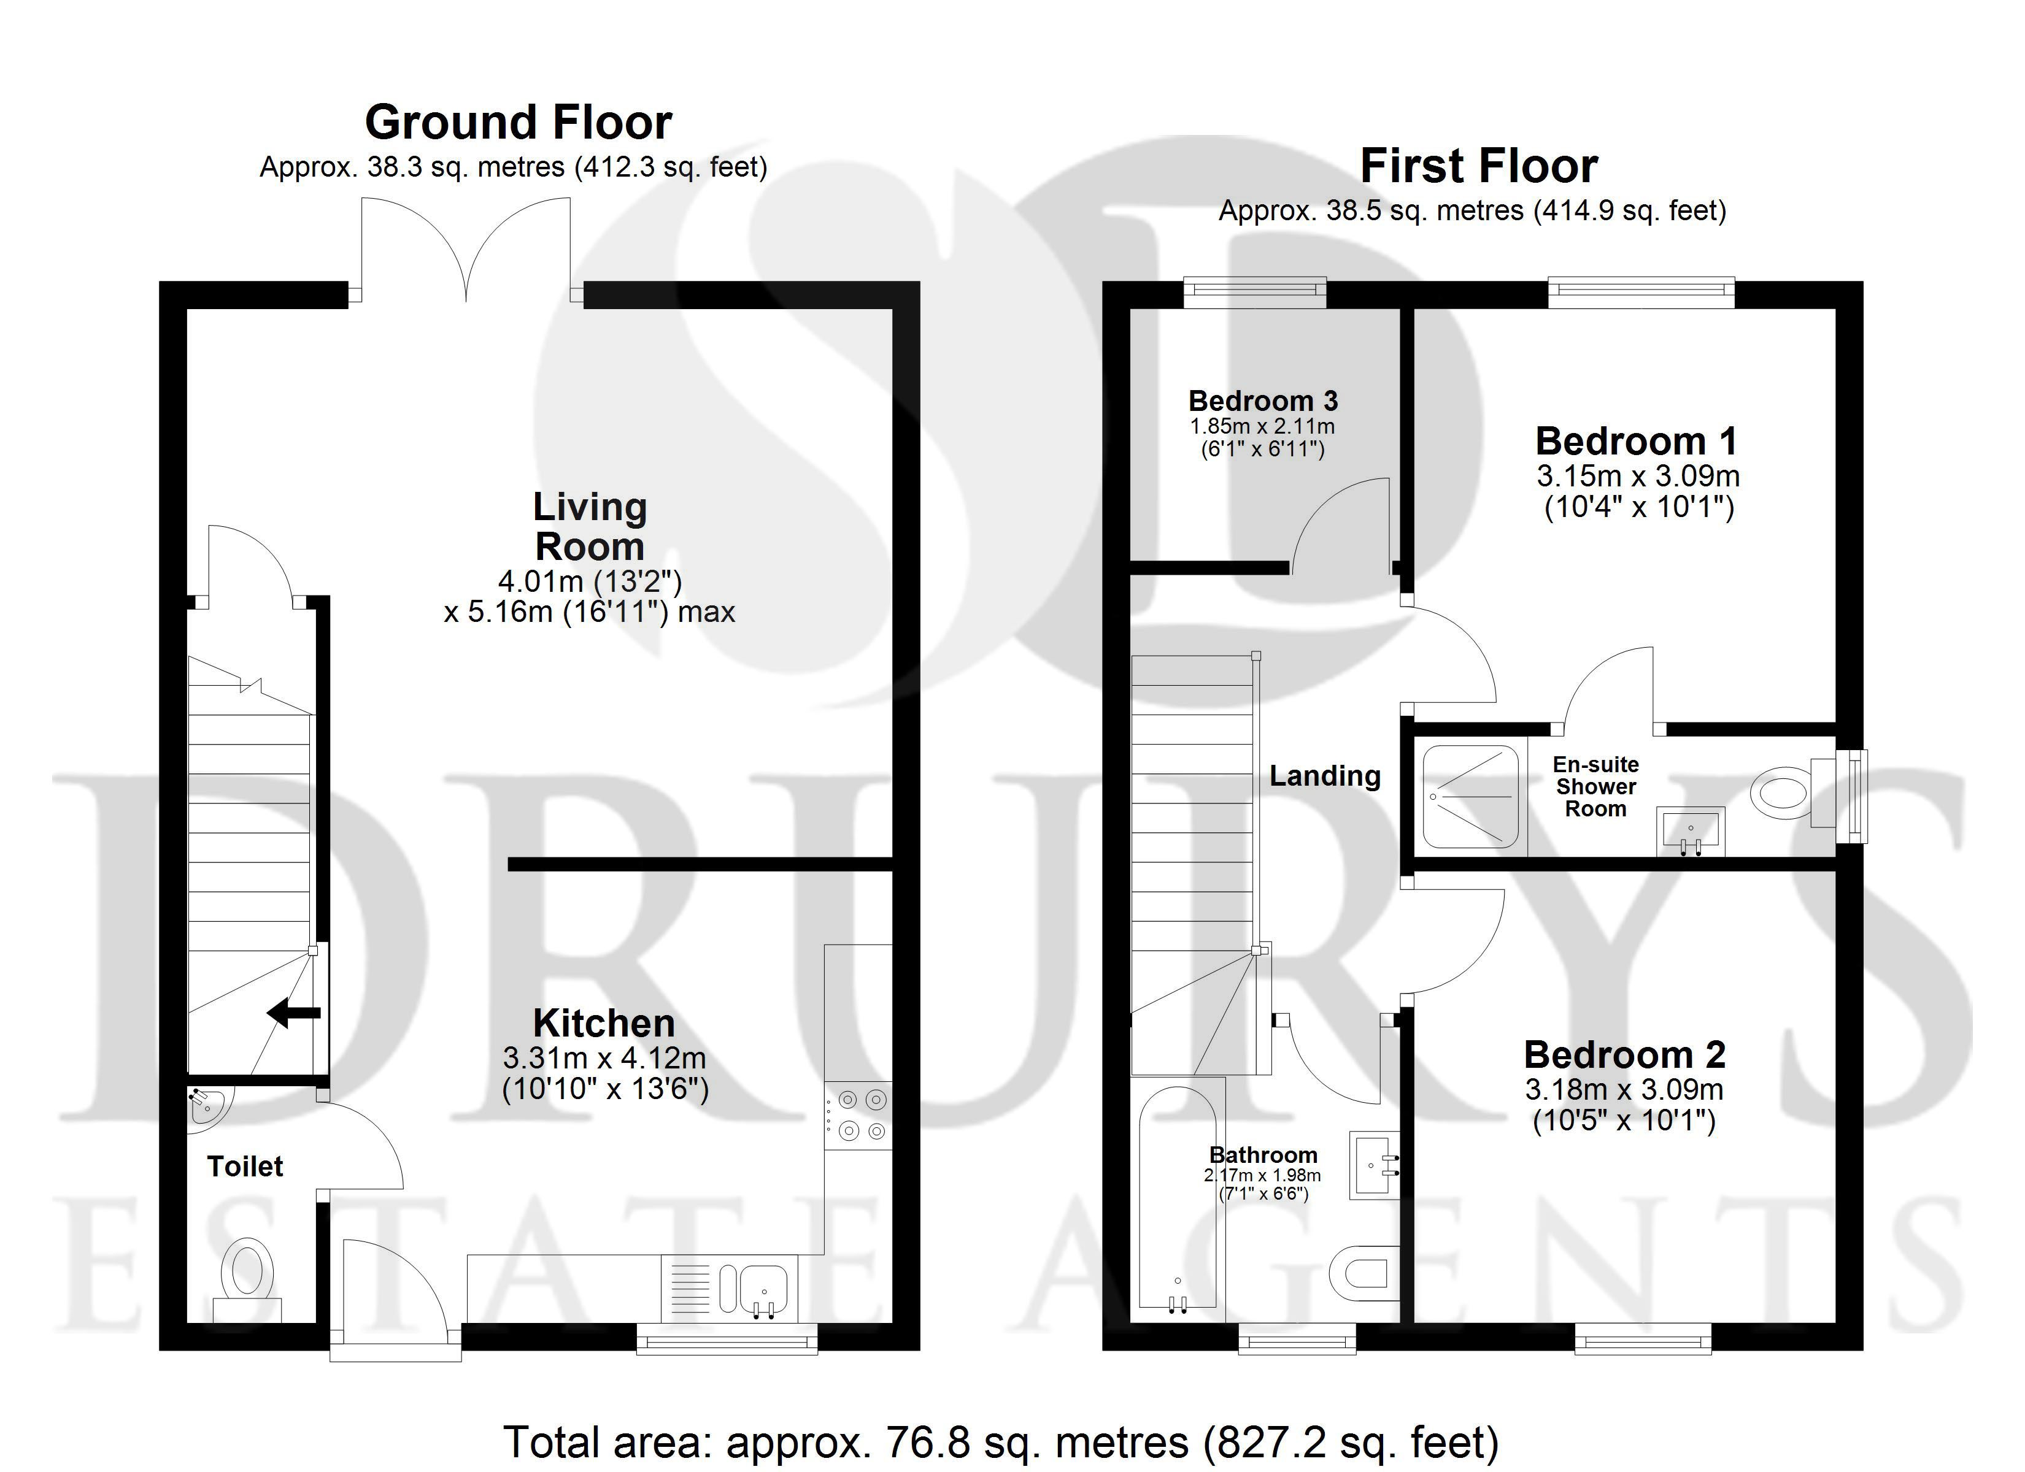

These particulars are intended to give a fair description of the property, but their accuracy cannot be guaranteed, and they do not constitute an offer of contract. Intending purchasers must rely on their own inspection of the property. None of the above appliances/services have been tested by ourselves. We recommend purchasers arrange for a qualified person to check all appliances/services before legal commitment.

Property Ref: 3298

www.drurysestateagents.co.uk
amber@drurysestateagents.co.uk
01205 350889

45 Willoughby Road
Boston
Lincolnshire
PE21 9HN
Agents Note: Whilst every care has been taken to prepare these sales particulars, they are for guidance purposes only. All measurements are approximate are for general guidance purposes only and whilst every care has been taken to ensure their accuracy, they should not be relied upon and potential buyers are advised to recheck the measurements

