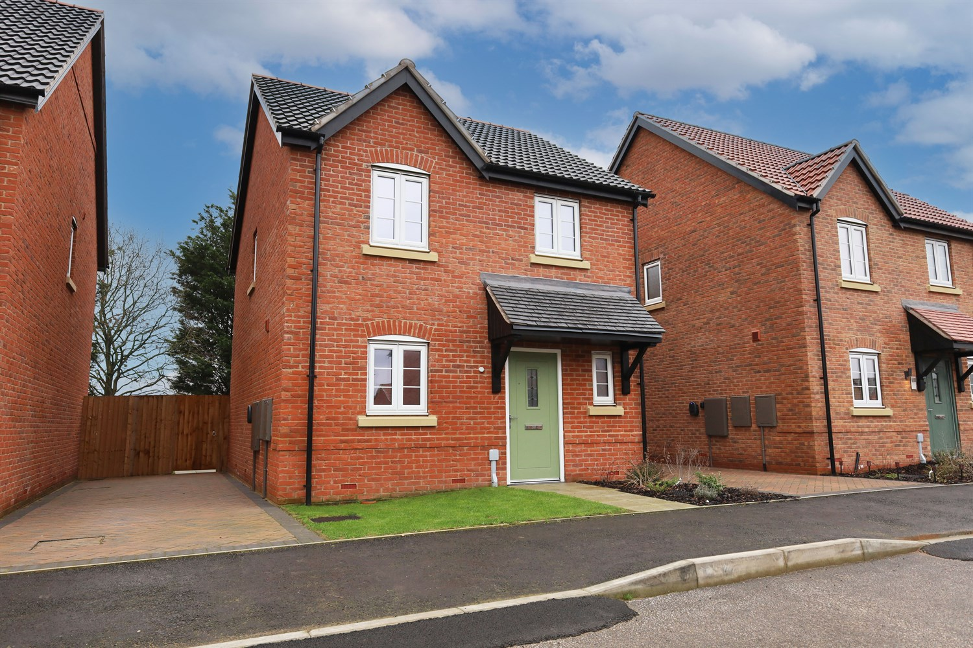




3 Bedroom(s)
2 Reception(s)
1 Bathroom(s)
£239,950.00
231 Kings Manor, LN4
EPC Rating ‘’

- Allocated Driveway
- Move-In Ready Condition
- Generous Enclosed Rear Garden

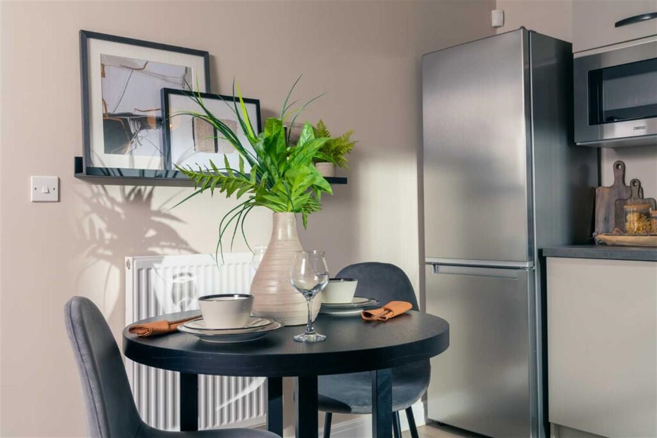
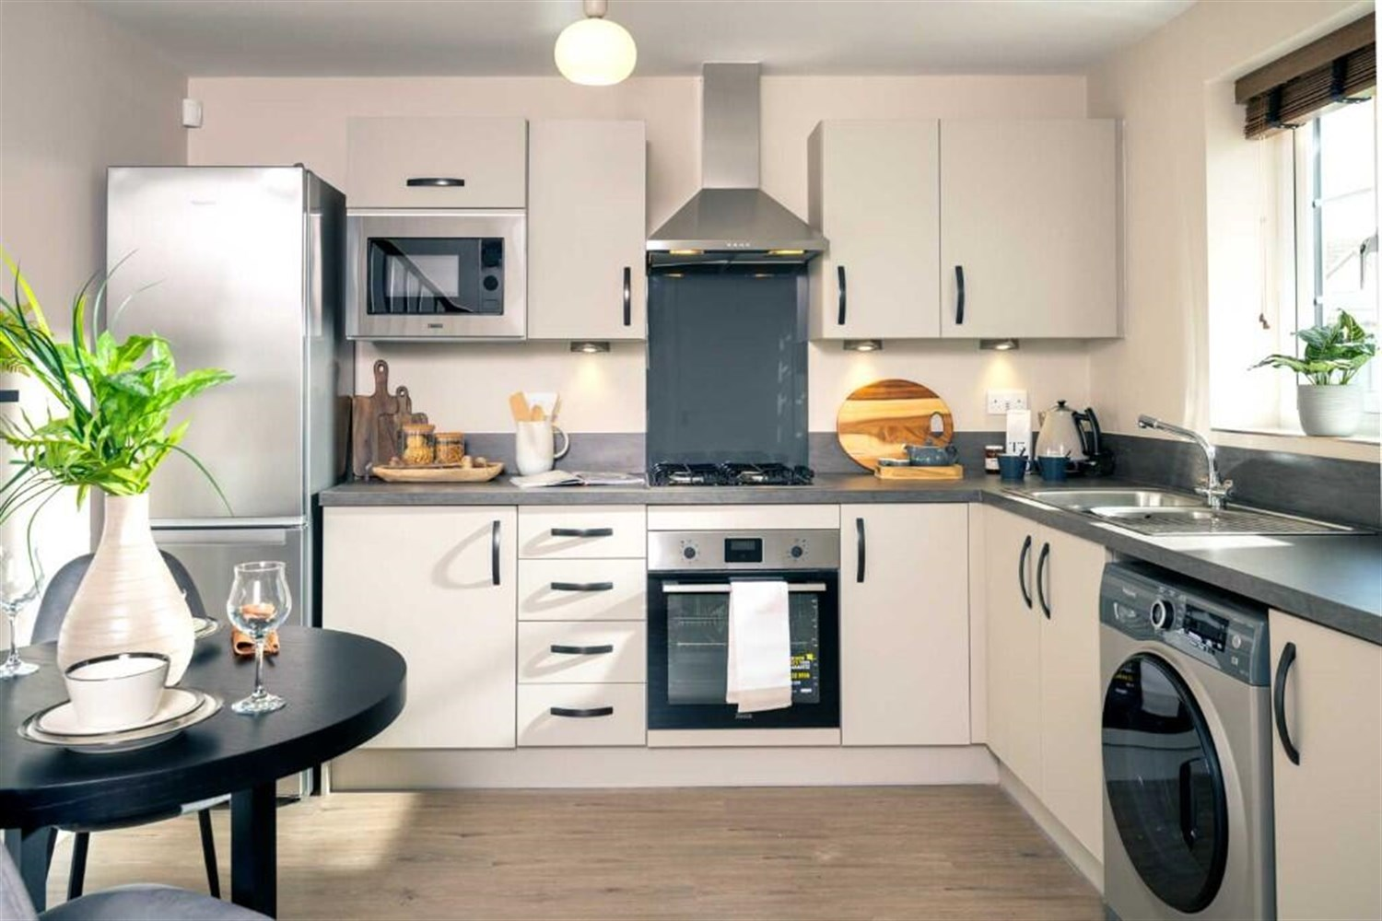
00

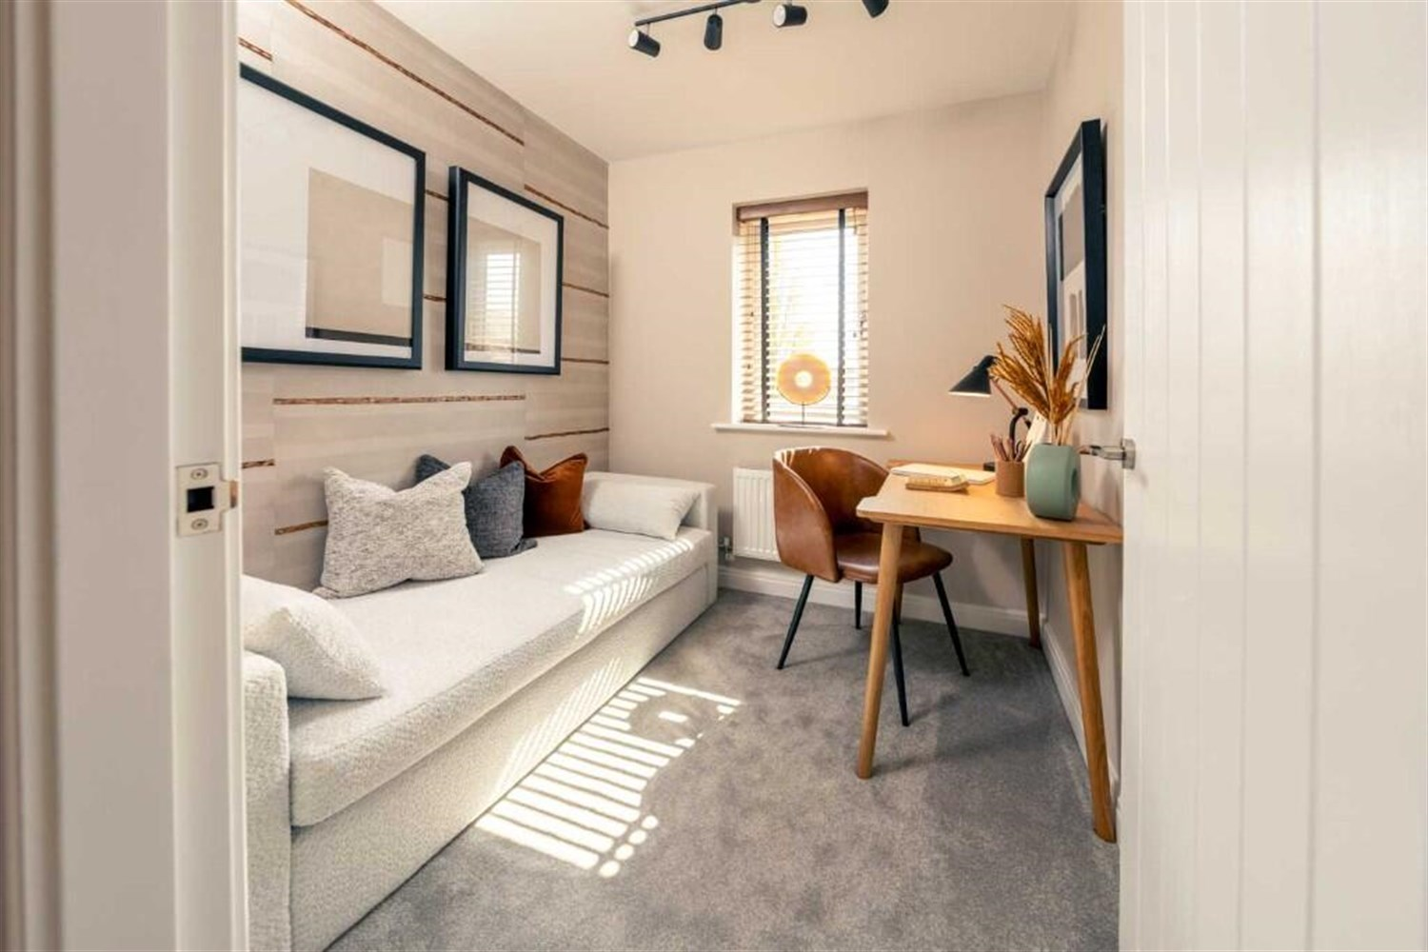

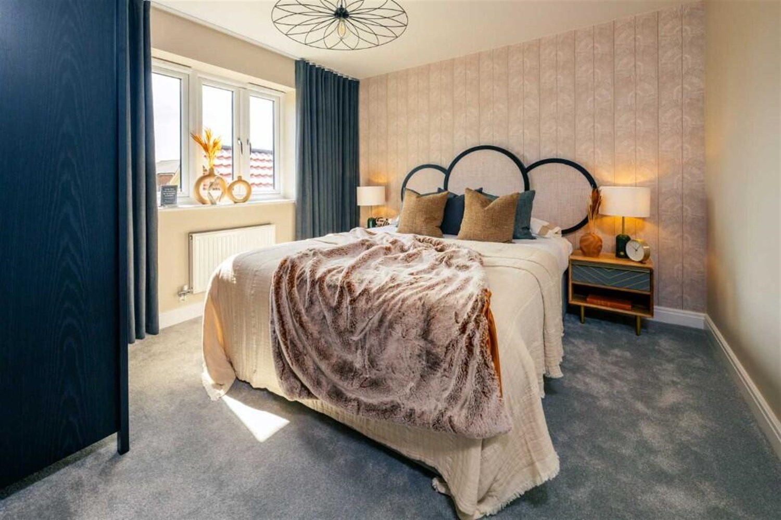
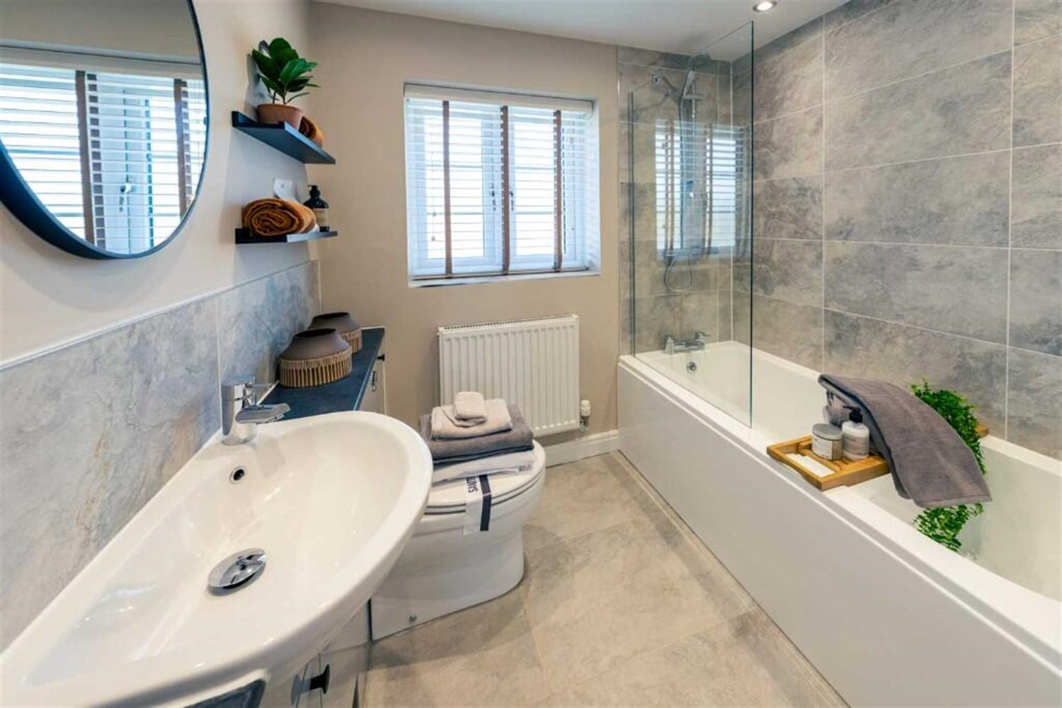

Property Description
An attractive and beautifully presented three-bedroom detached home, situated within a popular modern residential development and enjoying a pleasant open outlook towards water and mature trees to the rear.
This contemporary property offers well-balanced accommodation throughout and is ideal for first-time buyers, young families or those looking for a move-in ready home with nothing to do.
To the ground floor, the accommodation comprises a welcoming entrance hall, a modern fitted kitchen/dining area complete with integrated appliances and ample storage, a spacious and light-filled lounge with French doors opening directly onto the rear garden, and a convenient downstairs cloakroom.
To the first floor are three well-proportioned bedrooms, including a generous principal bedroom and a second double bedroom, together with a stylish and modern family bathroom fitted with a white suite and shower over bath.
Externally, the property benefits from a private driveway providing off-road parking and gated side access to the rear. The enclosed rear garden is predominantly laid to lawn with a paved patio area, ideal for outdoor dining and entertaining. To the rear boundary, the property enjoys an attractive outlook towards mature trees and water, creating a pleasant and tranquil setting rarely found with modern homes.
Early viewing is highly recommended to fully appreciate the space, presentation and setting this home has to offer.

Front Aspect
An attractive and well-presented modern detached home, constructed in traditional red brick with contrasting stone detailing and a pitched tiled roof. The property enjoys a pleasant position within a sought-after residential development and benefits from a private driveway providing off-road parking to the side, with gated access leading to the rear garden.
The frontage is neatly landscaped with a lawned garden and pathway leading to a contemporary composite entrance door, complete with a covered storm porch canopy. uPVC double glazed windows feature throughout, and the property offers a smart, low-maintenance exterior ideal for modern family living.

Lounge
A beautifully presented and generously proportioned living space, enjoying an abundance of natural light via full-height uPVC double glazed French doors opening directly onto the rear garden. The room offers a superb indoor-outdoor feel, ideal for entertaining or relaxed family living.
The space comfortably accommodates multiple seating arrangements and benefits from modern flooring and a bright, airy atmosphere throughout. The French doors not only enhance the sense of space but provide seamless access to the patio and lawn beyond.

Kitchen/Dining Area
A modern and well-appointed fitted kitchen comprising a range of contemporary wall and base units with complementary work surfaces and matching upstands. The kitchen is equipped with an integrated oven, four-ring gas hob with stainless steel extractor canopy over, integrated microwave and space/plumbing for additional appliances including washing machine and fridge freezer.
A stainless steel sink and drainer unit is positioned beneath a uPVC double glazed window overlooking the side elevation, allowing for plenty of natural light. The room benefits from ample storage and practical worktop space, ideal for everyday family living.
There is space for a dining table, creating a sociable kitchen/dining environment perfect for both casual meals and entertaining.

Downstairs Toilet/Cloakroom
Fitted with a modern white two-piece suite comprising a low-level WC and wall-mounted wash hand basin with chrome mixer tap and tiled splashback. A uPVC double glazed window to the side elevation provides natural light and ventilation.
The room benefits from a radiator, making it both practical and stylish ¿ ideal for guests and everyday convenience.

Bedroom 1
A spacious and beautifully presented principal bedroom, offering ample space for a double or king-size bed along with additional freestanding furniture. A uPVC double glazed window to the rear elevation provides a pleasant outlook and allows for excellent natural light. Also benefits from a En - Suite.
The room benefits from fitted carpet and a radiator, creating a calm and inviting retreat at the end of the day. A well-proportioned layout makes this a comfortable and practical main bedroom.

Bedroom 2
A well-proportioned double bedroom, tastefully presented and enjoying a pleasant outlook via a uPVC double glazed window to the front elevation. The room offers ample space for a double bed and additional bedroom furniture, making it ideal as a guest room.
This benefits from fitted carpet and a radiator, this is a bright and comfortable space ready to move straight into.

Bedroom 3
A versatile third bedroom enjoying natural light via a uPVC double glazed window to the front elevation. The room offers flexibility of use and would make an ideal single bedroom, nursery, dressing room or home office.
Finished in neutral tones with fitted carpet and radiator, this is a bright and adaptable space suited to a range of modern living requirements.

Bathroom
Fitted with a contemporary white three-piece suite comprising panelled bath with mixer tap and shower over, glazed shower screen, pedestal wash hand basin with chrome mixer tap and low-level WC.
The room is attractively finished with modern tiling to splashback areas, complemented by neutral décor and flooring. A uPVC double glazed window to the rear elevation provides natural light and ventilation, and the bathroom also benefits from a radiator.
A stylish and well-presented space, ideal for modern family living.

Rear Garden
A generously sized and fully enclosed rear garden, predominantly laid to lawn with a paved patio area immediately adjoining the property, ideal for outdoor seating and entertaining.
The garden is enclosed by timber fencing to all boundaries and benefits from gated side access to the driveway. Offering a good degree of privacy and a safe space for children or pets, the garden provides excellent scope for landscaping or further enhancement.
To the rear boundary, the property enjoys an attractive open outlook towards mature trees and water beyond, creating a pleasant and tranquil setting rarely found on modern developments.

These particulars are intended to give a fair description of the property, but their accuracy cannot be guaranteed, and they do not constitute an offer of contract. Intending purchasers must rely on their own inspection of the property. None of the above appliances/services have been tested by ourselves. We recommend purchasers arrange for a qualified person to check all appliances/services before legal commitment.

Property Ref: 3354

www.drurysestateagents.co.uk
amber@drurysestateagents.co.uk
01205 350889

45 Willoughby Road
Boston
Lincolnshire
PE21 9HN
Agents Note: Whilst every care has been taken to prepare these sales particulars, they are for guidance purposes only. All measurements are approximate are for general guidance purposes only and whilst every care has been taken to ensure their accuracy, they should not be relied upon and potential buyers are advised to recheck the measurements

