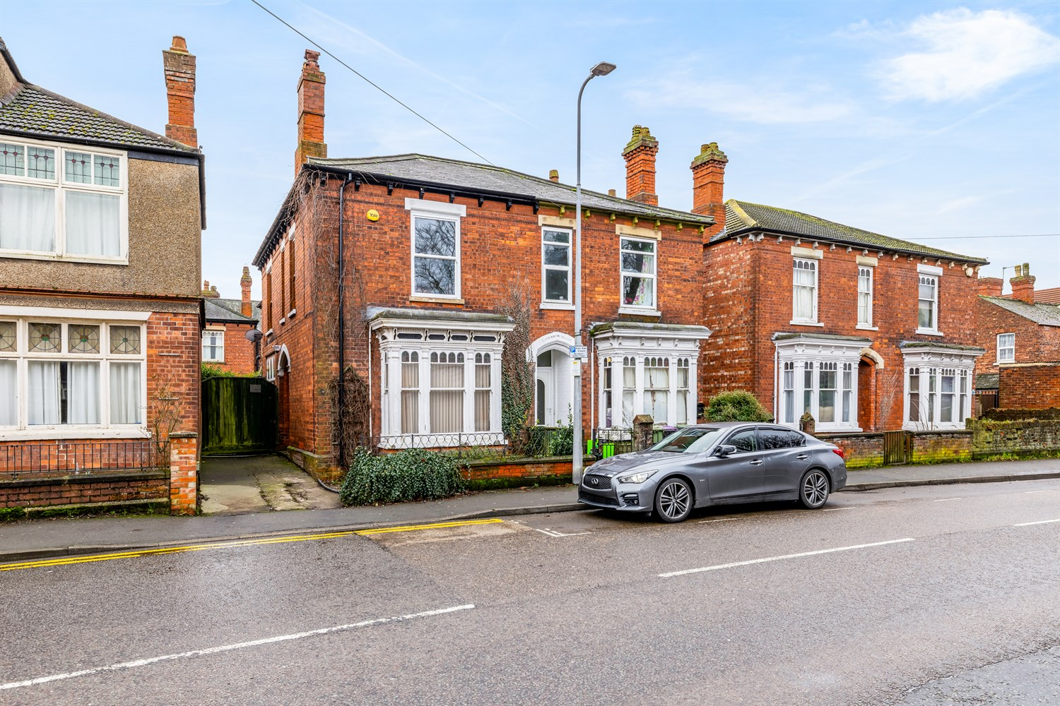




3 Bedroom(s)
4 Reception(s)
1 Bathroom(s)
£199,950.00
Norfolk Street, PE21
EPC Rating ‘’

- 3 Double Bedroom Town House
- 3 Reception Rooms
- Driveway
- Close to the Town Centre

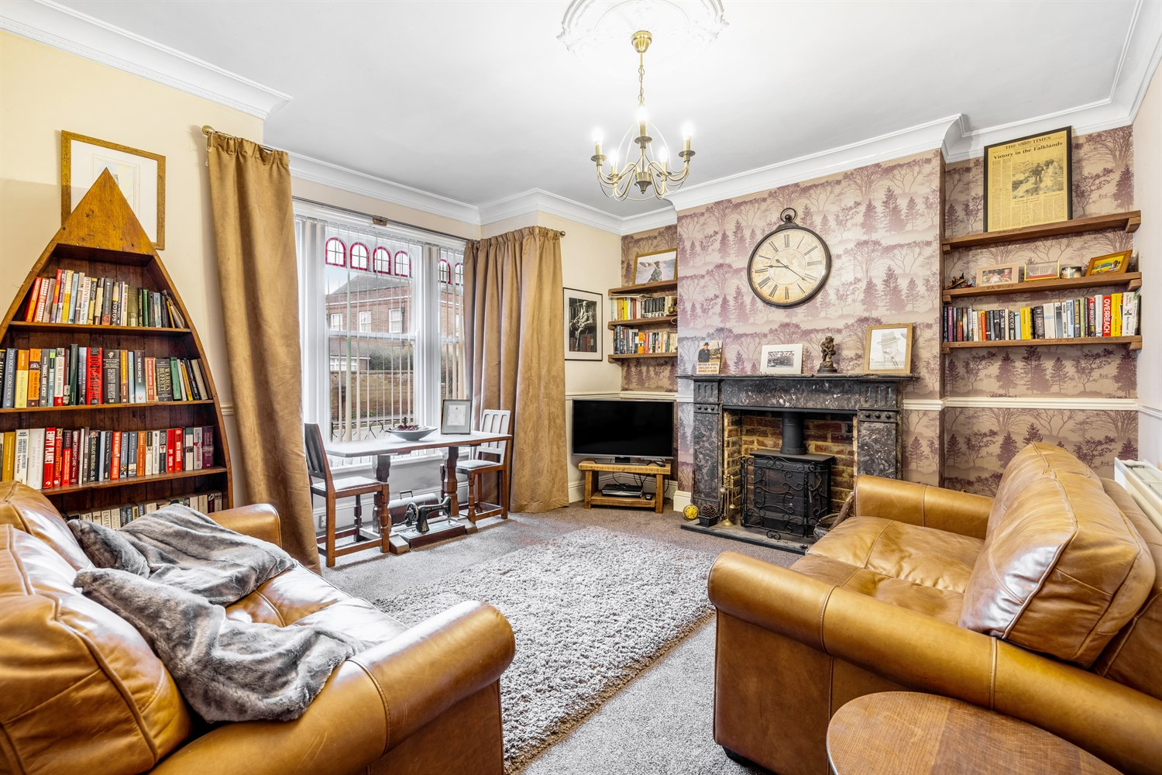
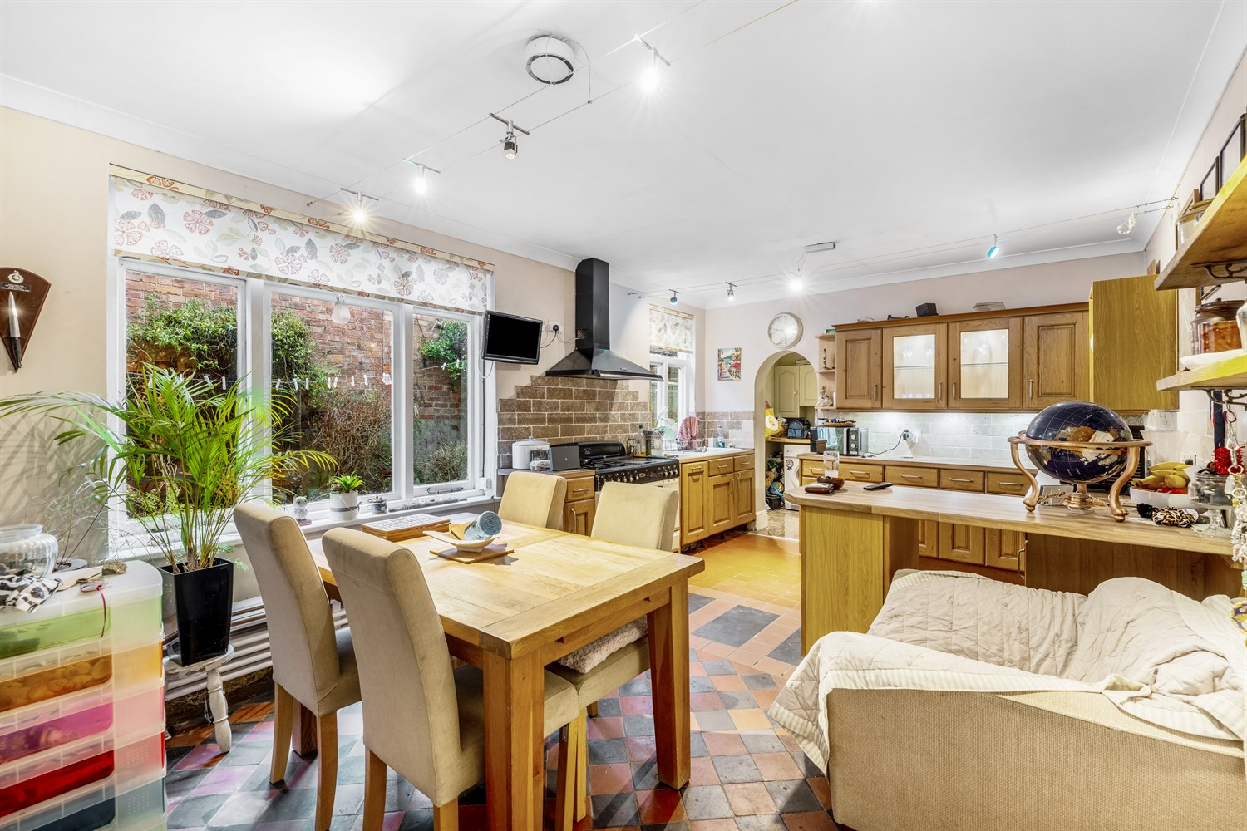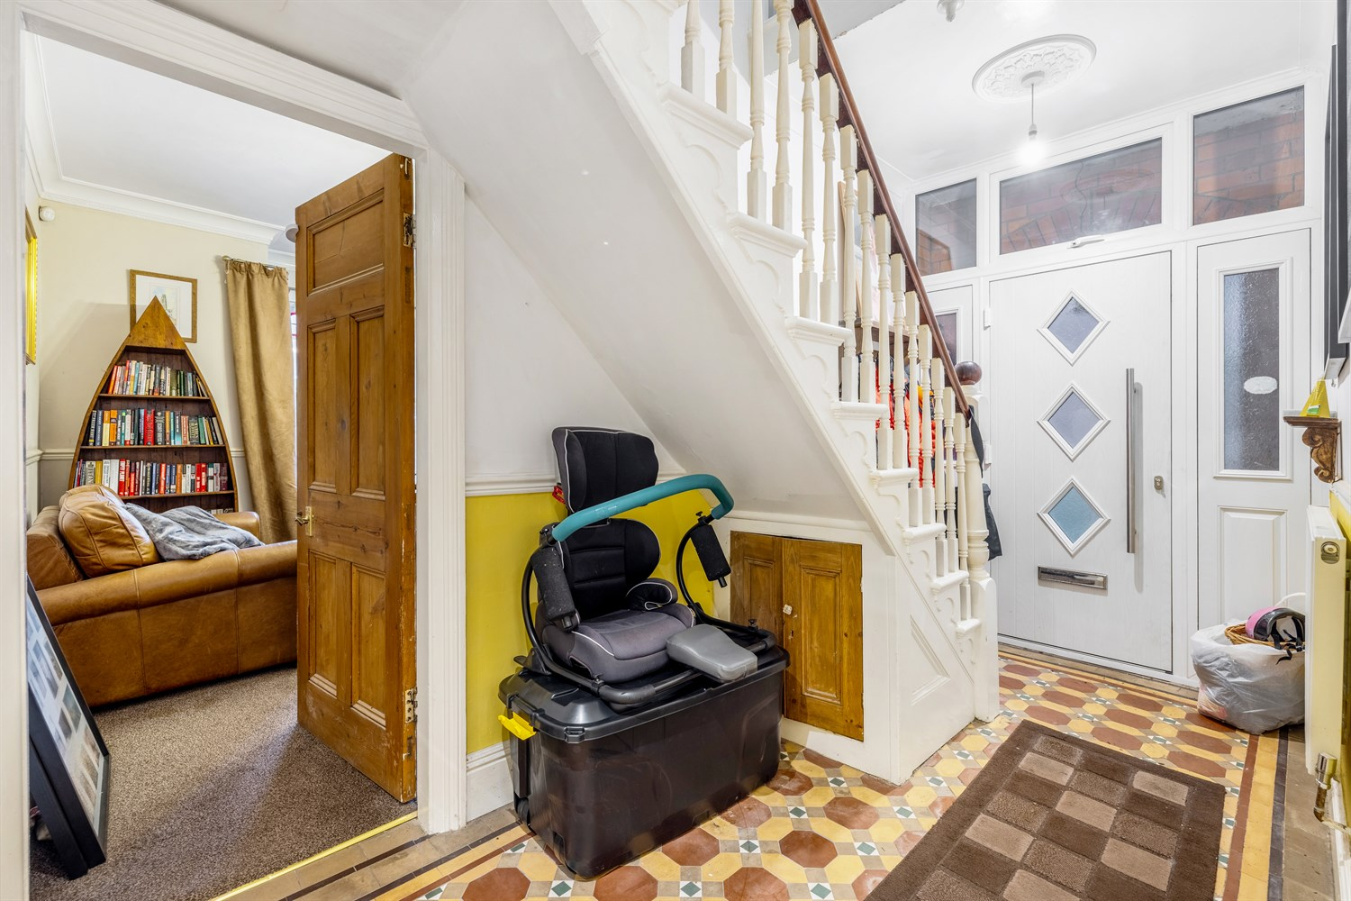
00
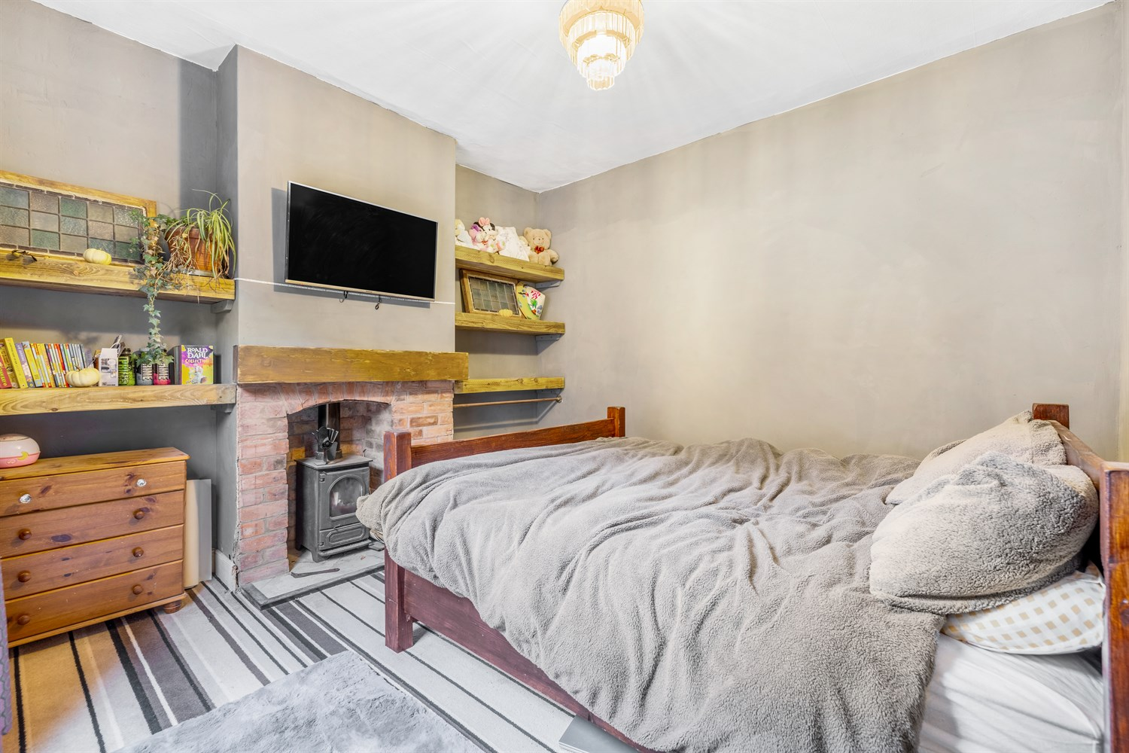
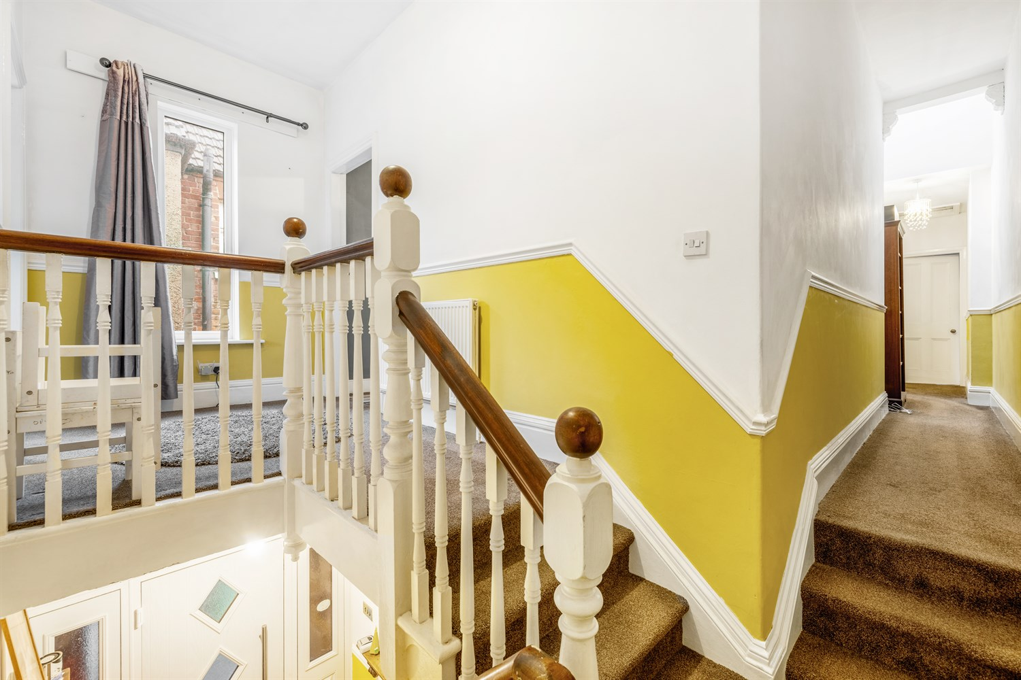
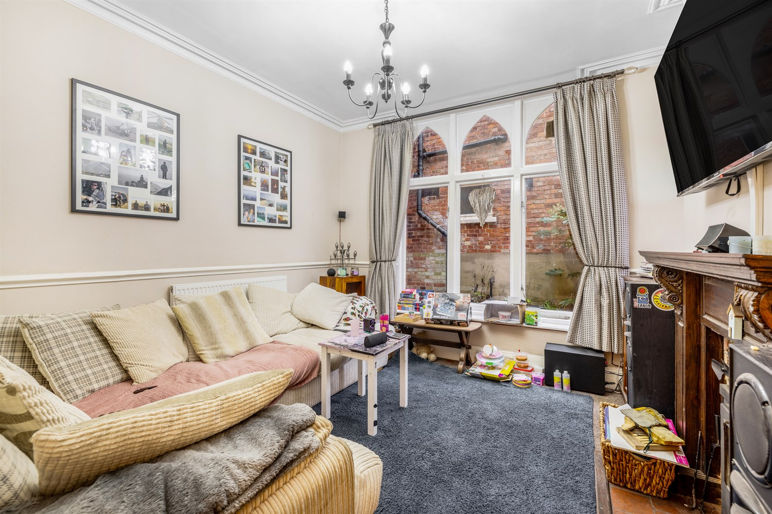
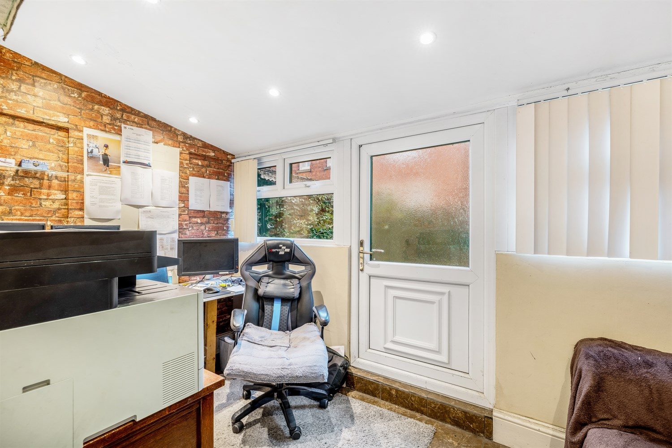
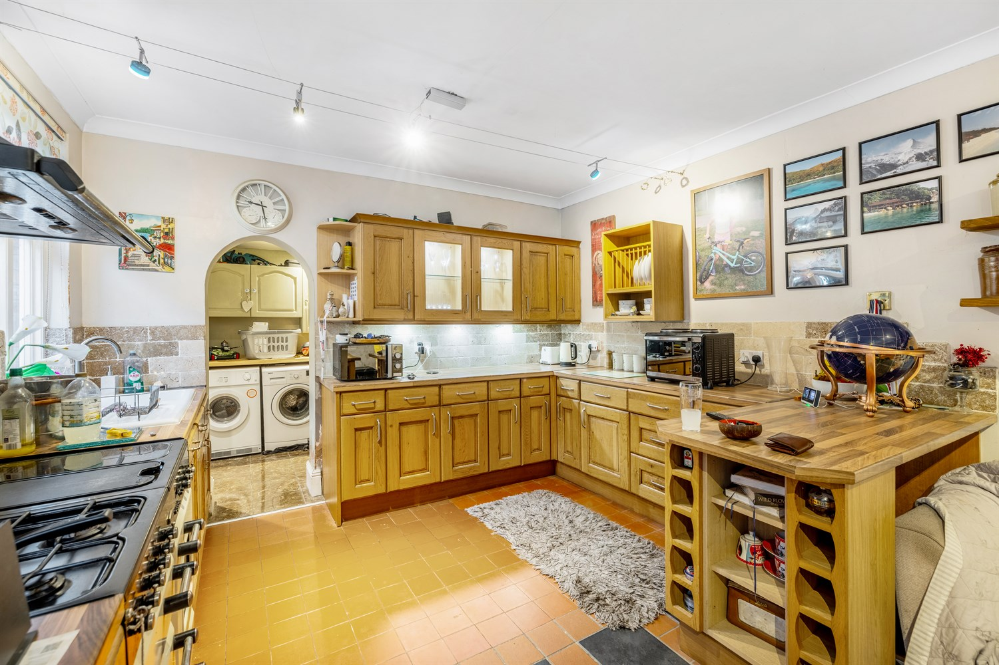
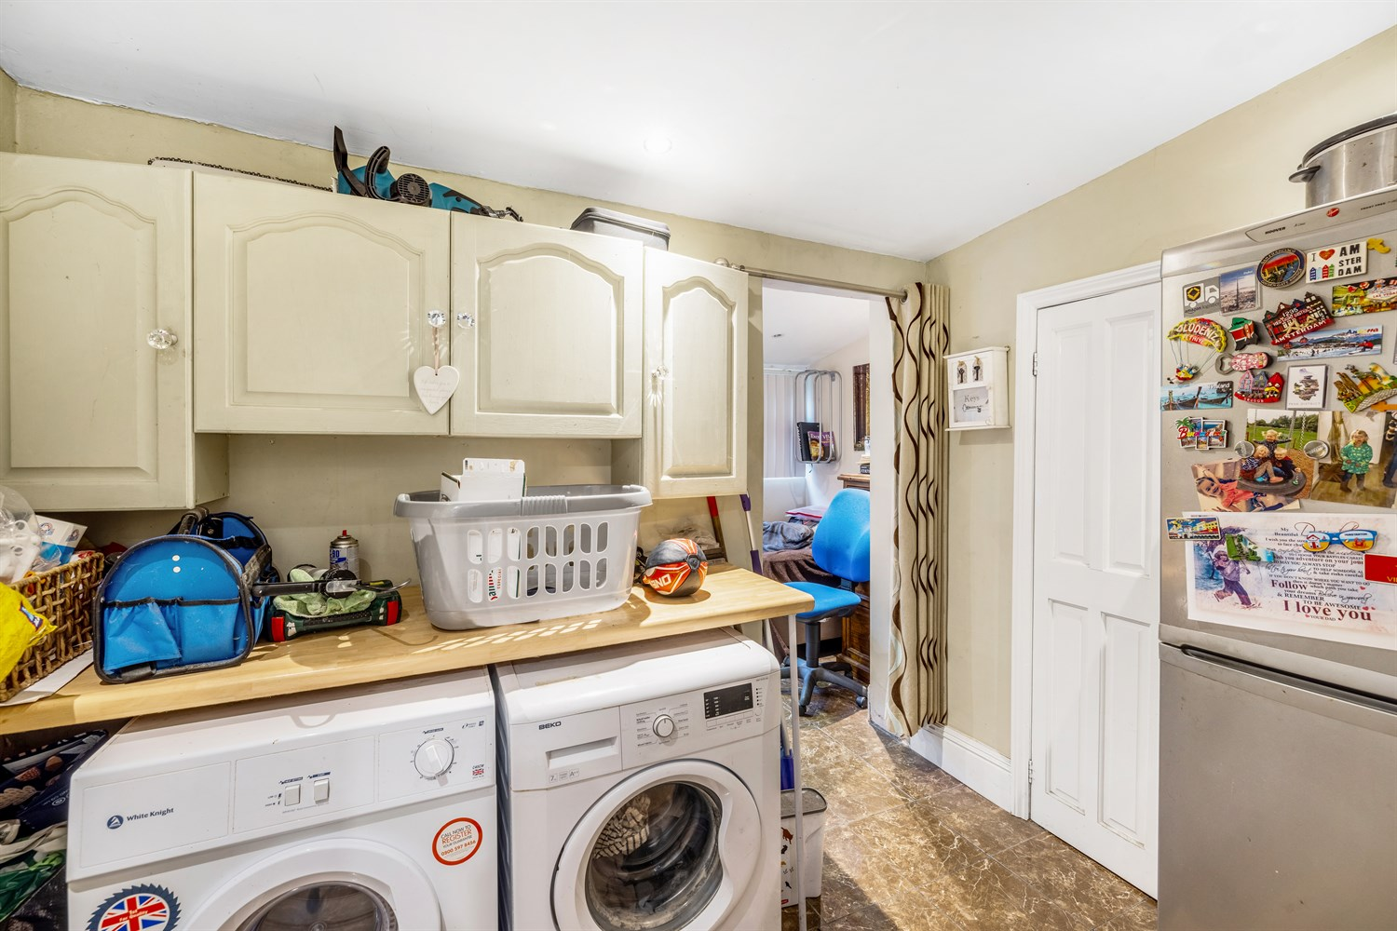
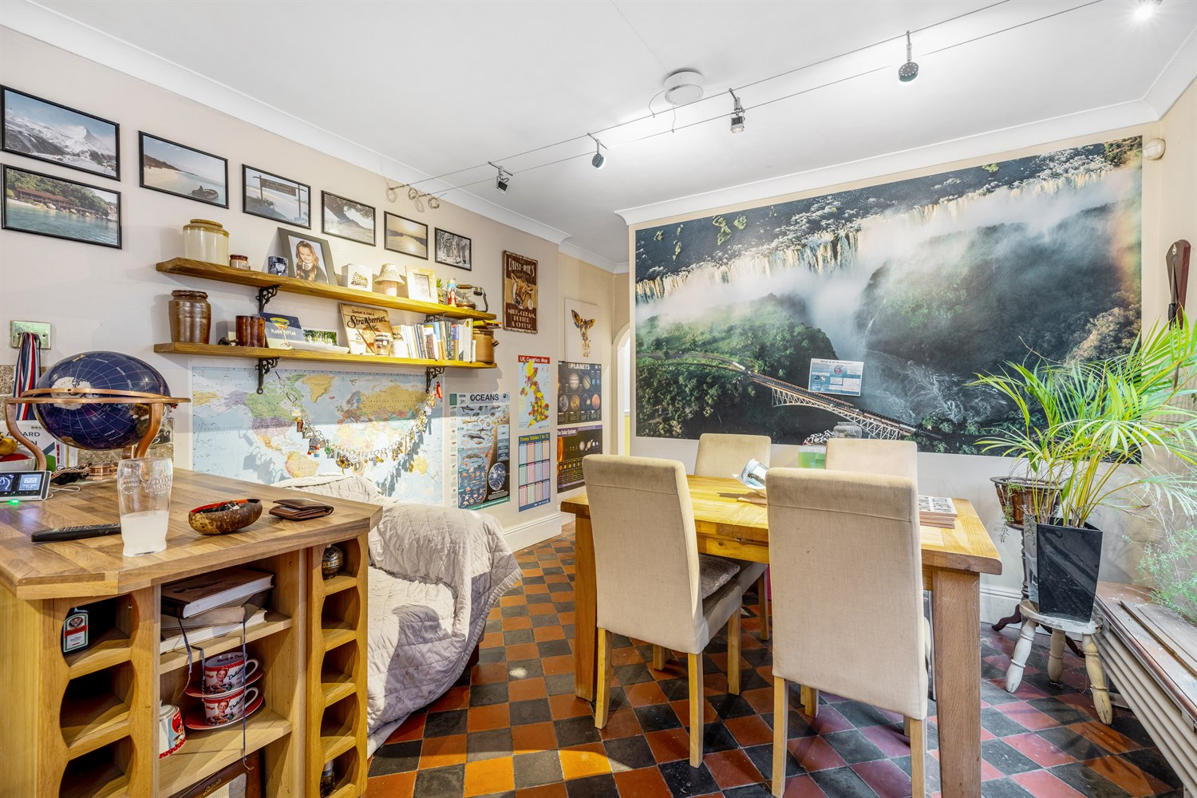

Property Description
A spacious and characterful three bedroom home offering versatile accommodation, period features and a generous rear garden with parking potential.
The property opens into an impressive entrance hallway showcasing striking original style tiled flooring and a traditional staircase. These are two well proportioned reception rooms, providing flexible living space, alongside spacious diner to the rear.
Additional ground floor benefits include a separate utility room, walk in pantry, ground floor WC and a versatile home office with direct access to the garden. Ideal for working from home or running a small business.
To the first floor, a bright split level from both uPVC window and skylight, leading to three bedrooms and a generous family bathroom featuring both a bath shower enclosure.
Externally, the property enjoys a good sized rear garden comprising lawn and gravelled sections, a substantial timber outbuilding for storage and double rear gates offering potential off road parking. Gated side access adds further practicality.
A fantastic opportunity for families or buyers seeking space, character and flexibility.

Entrance Hallway
A characterful and welcoming entrance hallway featuring a striking original style tiled flooring, creating an immediate impression upon entering the property.
Period detailing continues throughout with decorative panelling, dado rail and traditional staircase with a balustrade rising to the first floor. A radiator provides heating, and the hallway offers access to the principles ground floor accommodation.

Living Room
A beautifully presented principal reception room, combining character features with a warm and inviting atmosphere.
The room is centred around an attractive feature fireplace with exposed brick inset and decorative surround, housing a multi fuel style stove. Creating a striking focal point point and cosy ambience during the winter.
A large front facing window allows excellent natural light, with ample space for seating and additional furnishings. Period style detailing including coving and dado rail add further charm and character to the space.
Finished in tasteful neutral tones with feature wall décor, this is an elegant yet comfortable living area ideal for both relaxing and entertaining.

Kitchen/Dining Area
A spacious and characterful kitchen diner forming the heart of the home, featuring a comprehensive rang of solid wood wall and base units with contrasting work surfaces and tiled splashbacks.
The kitchen is fitted with a range-style cooker with extractor hood over, inset sink unit beneath the rear facing window and ample preparation space. A attractive archway leads through to a additional utility space, enhancing the practical layout.
The dining area benefits from a large front facing windows allowing excellent natural light, with ample space for a family dining table and seating.
Finished with distinctive tiled flooring, inset and track lighting and a neutral décor throughout, this is a warm and inviting space with both charm and functionality.

Walk in Pantry / Storage Cupboard
A highly practical walk in pantry/storage cupboard accessed from the kitchen, offering excellent additional storage space.
Fitted with shelving to both sides, the room provides ample room for dry goods, household appliances and general storage. A rear facing obscured window allows for natural light and ventilation, enhancing the usability of the space.
An ideal addition for family living, keeping the main kitchen area clutter free and organised.

Utility Room
A useful and practical utility area located off the kitchen, providing additional space for laundry and household appliances.
The room offers plumbing and space for white goods, worktop preparation space and access to the rear of the property. An attractive arched opening connects the utility to the kitchen, maintaining a sense of flow while keeping the main kitchen area free from everyday clutter.
With tiled flooring and inset ceiling lights, this is a functional addition for the modern family living.

Home Office / Study
Located to the rear of the property and accessed via the utility room, this versatile space is currently utilised as a home office.
The room benefits from natural light via uPVC double glazed windows and a rear access door leading out to the garden, making it ideal for those working from home or running a small business.
Offering flexibility of use, the space could equally serve as a hobby room, playroom or additional storage area, depending on requirements.

Ground Floor Cloakroom
A convenient ground floor cloakroom comprising a low level WC and handwash basin.
The room benefits from an obscured window providing natural light and ventilation, making it a practical addition for guests and everyday family use.
An essential feature for modern living, particularly in a property offering multiple receptions.

Rear Lounge/Reception Room
A charming and inviting rear reception room, beautifully positioned to the back of the property and enjoying excellent natural light via a striking arched feature window overlooking the garden.
The room offers a warm and comfortable atmosphere, centred around an attractive fireplace with a decorative surround and hearth, creating a natural focal point for the space. Original style coving adds further character to the room.
There is ample room for sofas and additional furnishings, making this an ideal snug, second lounge or relaxing family sitting room.
Neutral décor and soft carpeting complete the space, offering a cosy yet versatile room suited to a variety of uses.

First Floor Landing
A split level first floor landing providing access to all bedrooms and the family bathroom.
The space benefits from natural light via a uPVC double glazed window, along with fitted carpet, radiator and traditional balustrade staircase. Period style detailing including dado rail and decorative panelling continues from the ground floor, enhancing the overall character of the property.
The layout offers practical separation between rooms while maintaining a light and airy feel.

Bedroom 1
A well proportioned double bedroom positioned to the first floor, benefiting from a large uPVC double glazed window allowing for excellent natural light.
The room offers ample space for a double bed and additional freestanding furniture, with neutral décor creating calm and comfortable atmosphere.
A practical and spacious principle bedroom ideal for a range of buyers.

Bedroom 2
A further well sized double bedroom situated on the first floor, enjoying natural light via a uPVC double glazed window.
The room offers ample space for a double bed along with freestanding wardrobes and additional furniture. Neutral décor and fitted flooring create comfortable and practical space.
An ideal guest room, children's bedroom or additional principle bedroom, offering flexibility for a variety of buyers.

Bedroom 3
A well proportioned third bedroom situated on the first floor, benefiting from a uPVC double glazed window providing natural light.
The room offers flexibility of use and would make an ideal single bedroom, nursery, home office or dressing room. There is space for essential furnishings, making it a practical addition to the accommodation.
An ideal space for modern working from home requirements or growing families.

Family Bathroom
A spacious family bathroom fitted with a white suite comprising of a panelled bath with mixer tap and shower attachment, separate shower enclosure, low level WC and hand wash basin.
The room benefits from two uPVC double glazed windows providing natural light and ventilation, along with complementary tiled splashbacks and wood effect flooring.
A well proportioned bathroom offering both bath and separate shower facilities, ideal for family living.

Rear Garden & Outside Space
The property benefits from a generous rear garden comprising a lawned area with a feature pathway leading to a further gravelled section, creating a low maintenance and versatile outdoor space.
To the rear of the garden is a substantial timber outbuilding providing useful storage. Beyond sits a further gravelled area with double timber gates, offering potential for off road parking.
The garden is enclosed by fencing and mature planting, providing privacy and clearly defined boundaries, while gated access enhances practicality.

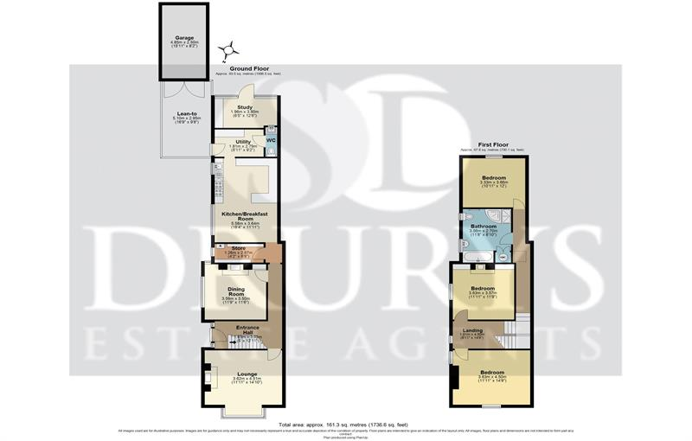

These particulars are intended to give a fair description of the property, but their accuracy cannot be guaranteed, and they do not constitute an offer of contract. Intending purchasers must rely on their own inspection of the property. None of the above appliances/services have been tested by ourselves. We recommend purchasers arrange for a qualified person to check all appliances/services before legal commitment.

Property Ref: 2346

www.drurysestateagents.co.uk
amber@drurysestateagents.co.uk
01205 350889

45 Willoughby Road
Boston
Lincolnshire
PE21 9HN
Agents Note: Whilst every care has been taken to prepare these sales particulars, they are for guidance purposes only. All measurements are approximate are for general guidance purposes only and whilst every care has been taken to ensure their accuracy, they should not be relied upon and potential buyers are advised to recheck the measurements

