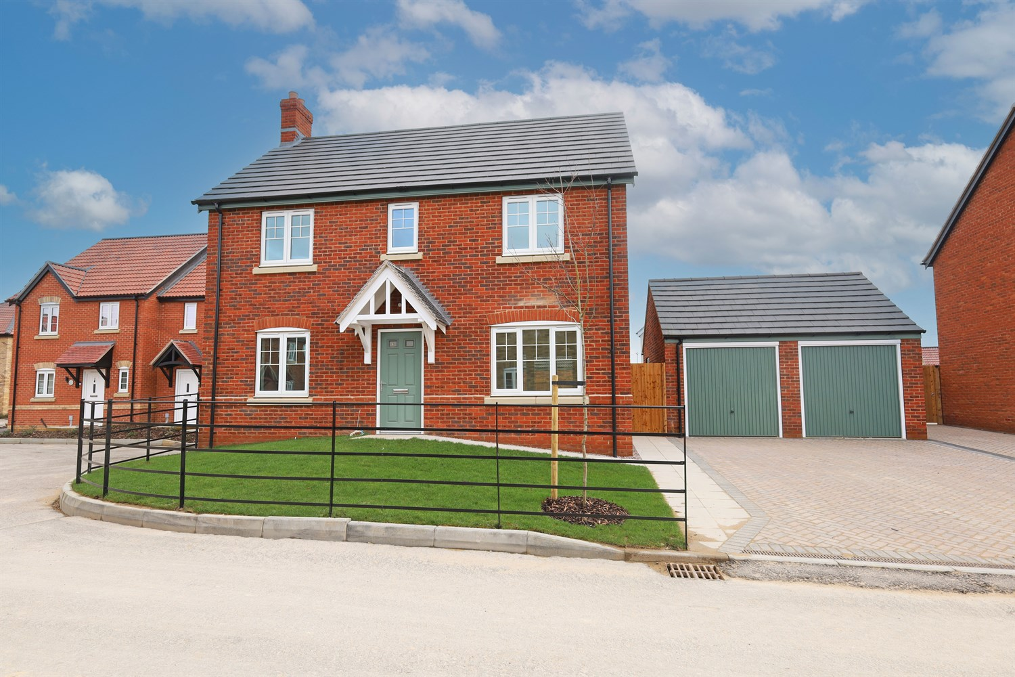




4 Bedroom(s)
4 Reception(s)
1 Bathroom(s)
£359,950.00
Plot 293, The Quadrant PE21 7UF
EPC Rating ‘’

- Ideal Executive Family Home
- Detached Double Garage
- Move-In Ready Condition

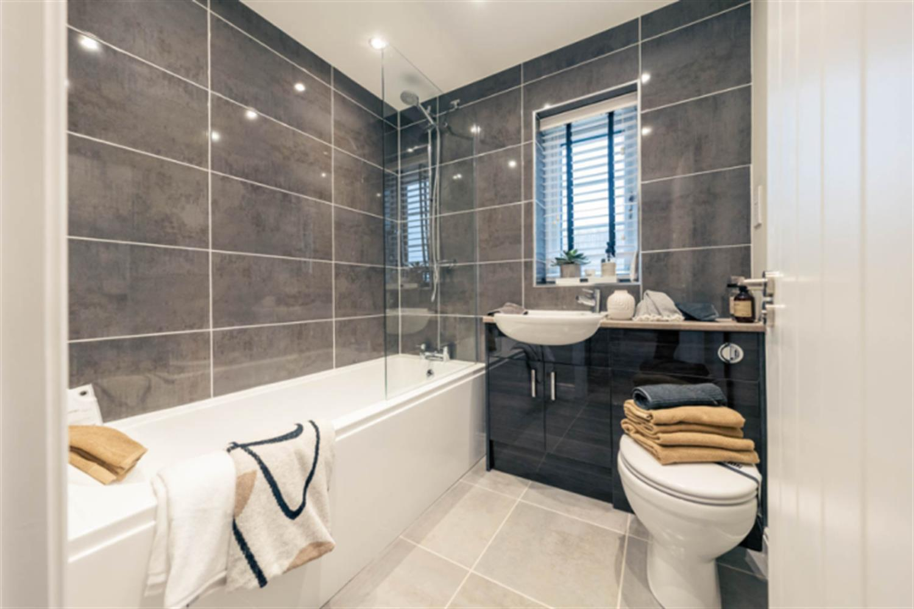
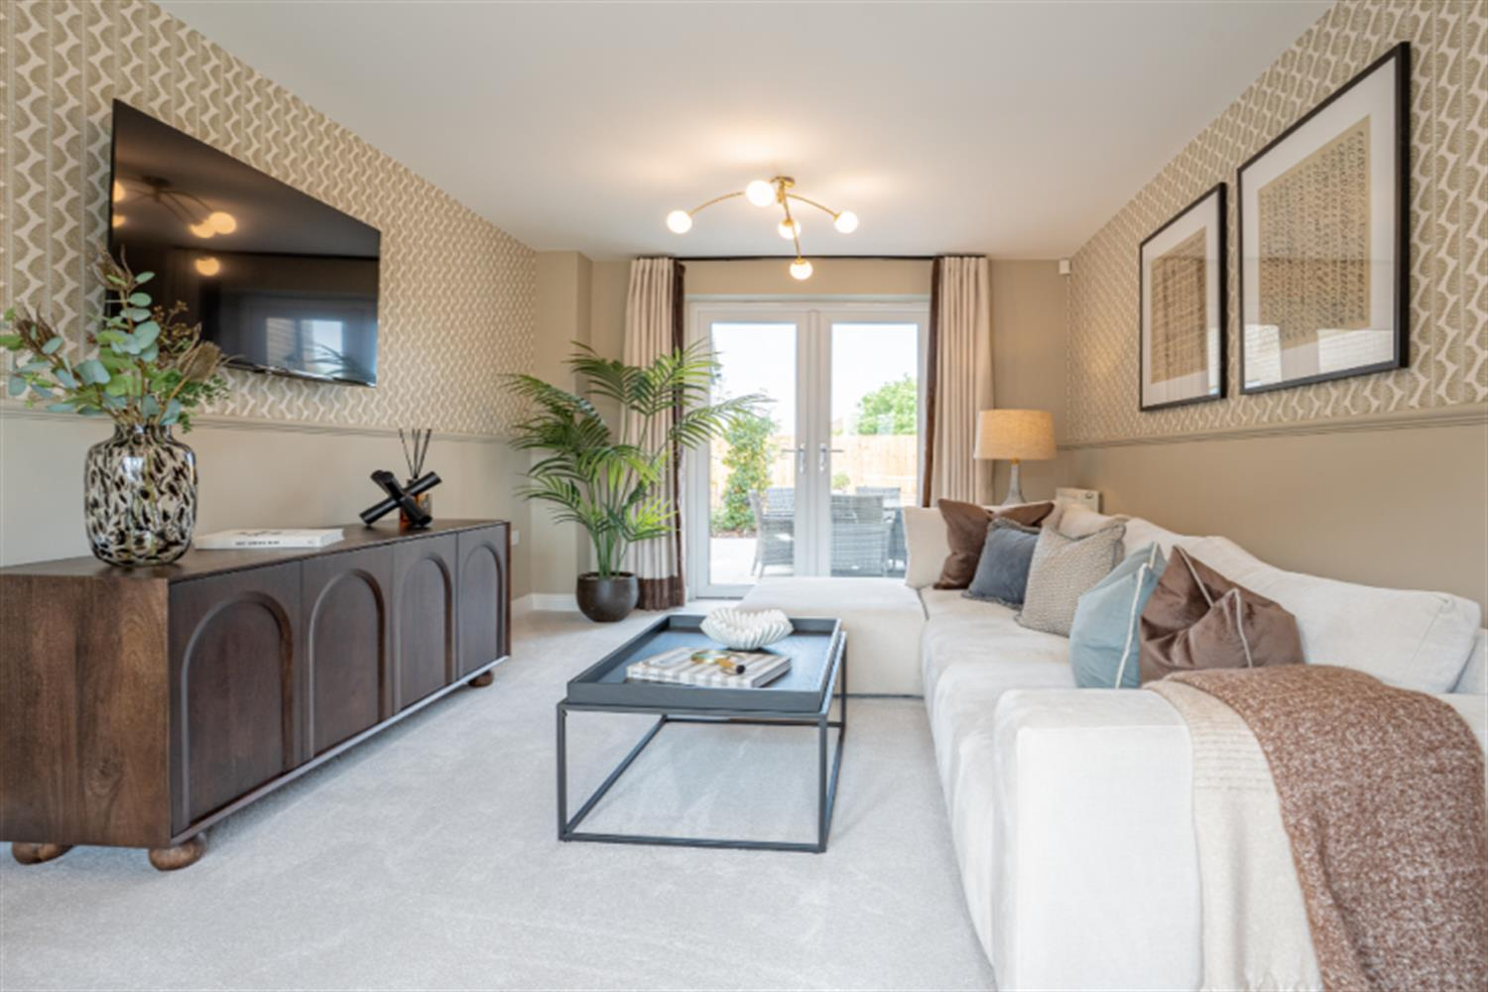
00

Property Description
An attractive and well-appointed four-bedroom detached home, offering spacious and thoughtfully designed accommodation ideal for modern family living.
The property is accessed via a welcoming entrance hall, leading through to a generous front-facing lounge with a bright and comfortable space perfectly suited for relaxation and everyday living. To the rear, the open-plan kitchen with island and dining room forms the heart of the home, providing ample worktop space and storage alongside a dedicated dining area ideal for family meals and entertaining. French doors open directly onto the rear garden, creating a light-filled and sociable environment with seamless indoor-outdoor flow. Office or play room, utility room and down stairs toilet.
The utility room adds valuable practicality, helping to keep the main kitchen area organised, while a ground floor cloakroom enhances convenience. The property also benefits from a double garage, offering secure parking or additional storage.
To the first floor, the home offers four well-proportioned bedrooms. The principal bedroom enjoys built-in wardrobe space and a private en-suite shower room, creating a comfortable retreat. Bedrooms two also has an en-suite bedroom and three and four provide flexible accommodation suitable for family members, guests or home working. A modern family bathroom completes the upstairs layout.
Externally, the property boasts an attractive frontage with driveway parking and access to the double garage, complemented by landscaped surroundings. Combining space, functionality and traditional styling, this home is perfectly suited to growing families or professional buyers seeking a stylish and practical long-term residence.

Front Aspect
An impressive and attractive double-fronted detached home, constructed in traditional red brick beneath a pitched tiled roof and occupying a generous corner-style position within the development.
The property benefits from a substantial block-paved driveway providing ample off-road parking and leading to a detached double garage with twin up-and-over doors. A neatly laid lawned frontage with pathway leads to the composite entrance door, framed by an attractive pitched canopy porch.
The property enjoys excellent kerb appeal and a spacious feel to the frontage, enhancing its executive family home credentials.

Entrance Hallway
A welcoming central entrance hall providing access to the principal ground floor accommodation, with staircase rising to the first floor and useful under-stairs storage cupboard. Offers a practical and spacious first impression.

Downstairs Toilet/Cloakroom
Conveniently positioned ground floor cloakroom fitted with a low-level WC and wash hand basin, ideal for guests and everyday family use.

Study/Lounge
A versatile front-facing room, perfectly suited for use as a home office, playroom or snug. An increasingly essential feature for modern working arrangements.

Lounge
A well-proportioned and comfortable main reception room, offering ample space for a range of seating furniture. Positioned to provide a cosy yet spacious environment, ideal for relaxing or entertaining.

Kitchen
A generous fitted kitchen providing an excellent range of wall and base units with complementary work surfaces. Designed with functionality in mind, the layout offers ample preparation space and flows seamlessly into the dining area, creating a sociable family hub.

Dining Room
Open-plan to the kitchen and positioned to the rear of the property, with French doors opening onto the garden. A superb space for family meals and entertaining, with natural light enhancing the sense of space.

Landing
Spacious landing area providing access to all four bedrooms and the family bathroom.

Bedroom 1
A generous principal bedroom offering space for a double or king-size bed and additional furniture. Benefiting from fitted wardrobe space and access to a private ensuite shower room.

En Suite
Fitted with a shower enclosure, wash hand basin and WC, providing convenience and privacy for the main bedroom.

Bedroom 2
A well-proportioned double bedroom, ideal for family members or guests.

Bedroom 3
Another comfortable bedroom offering flexibility for family living.

Bedroom 4
A versatile fourth bedroom which could also function as a nursery, dressing room or additional home office depending on requirements.

Family Bathroom
Fitted with a suite comprising bath, wash hand basin and WC. Well positioned to serve the remaining bedrooms.

These particulars are intended to give a fair description of the property, but their accuracy cannot be guaranteed, and they do not constitute an offer of contract. Intending purchasers must rely on their own inspection of the property. None of the above appliances/services have been tested by ourselves. We recommend purchasers arrange for a qualified person to check all appliances/services before legal commitment.

Property Ref: 3350

www.drurysestateagents.co.uk
amber@drurysestateagents.co.uk
01205 350889

45 Willoughby Road
Boston
Lincolnshire
PE21 9HN
Agents Note: Whilst every care has been taken to prepare these sales particulars, they are for guidance purposes only. All measurements are approximate are for general guidance purposes only and whilst every care has been taken to ensure their accuracy, they should not be relied upon and potential buyers are advised to recheck the measurements

