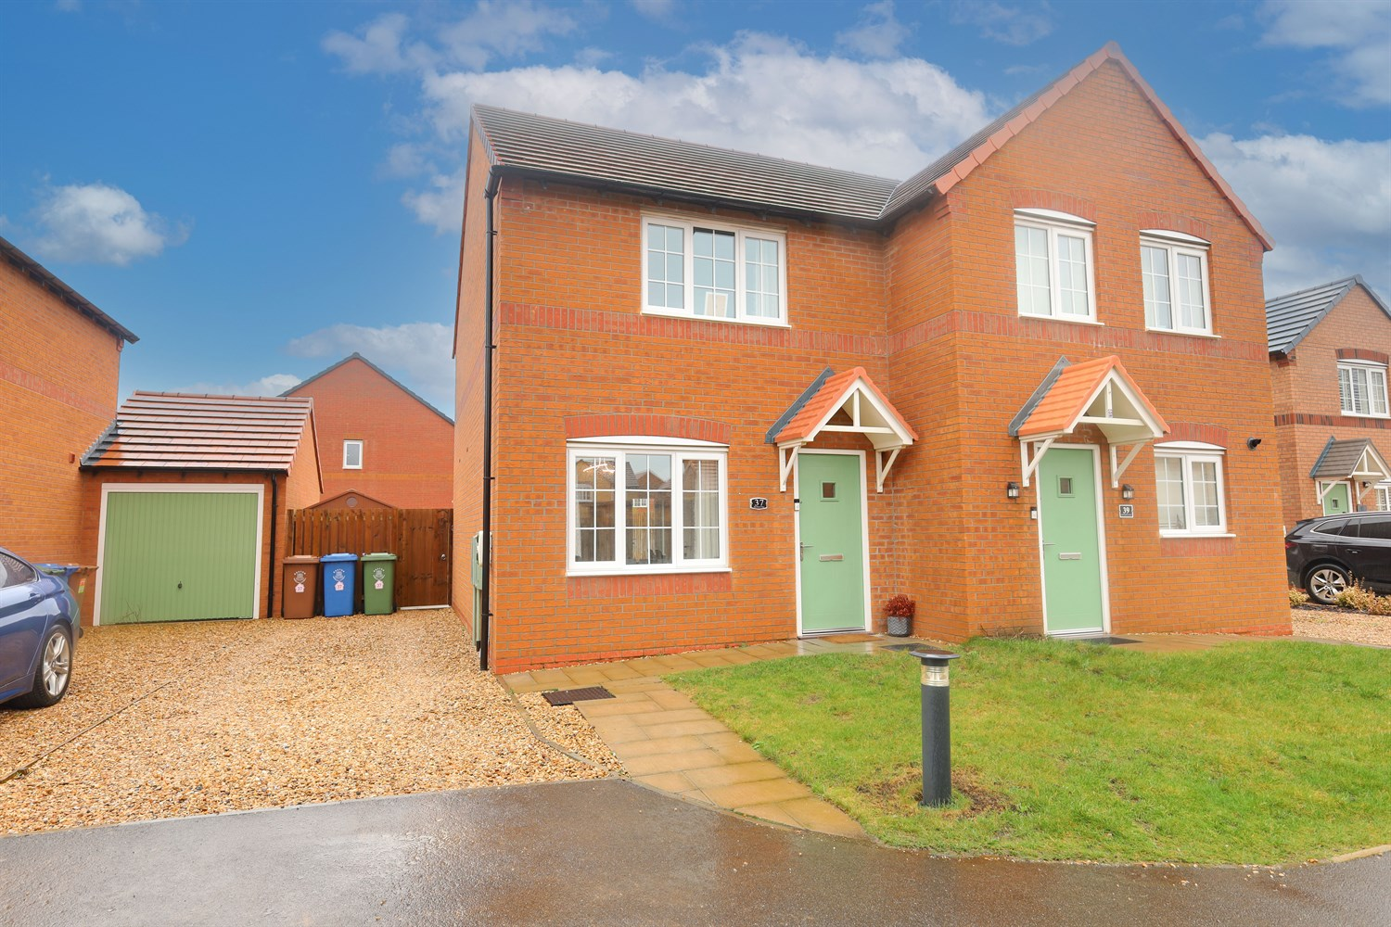




2 Bedroom(s)
1 Reception(s)
1 Bathroom(s)
£155,000.00
Hawthorn Close, PE21
EPC Rating ‘’

- Extremely well presented throughout
- 2 Bed-Semi Detached Property
- Close to popular schools and amenities
- Cul-de -sac location

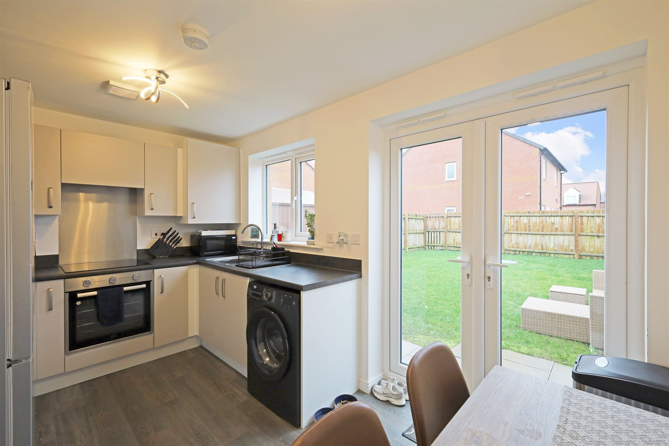
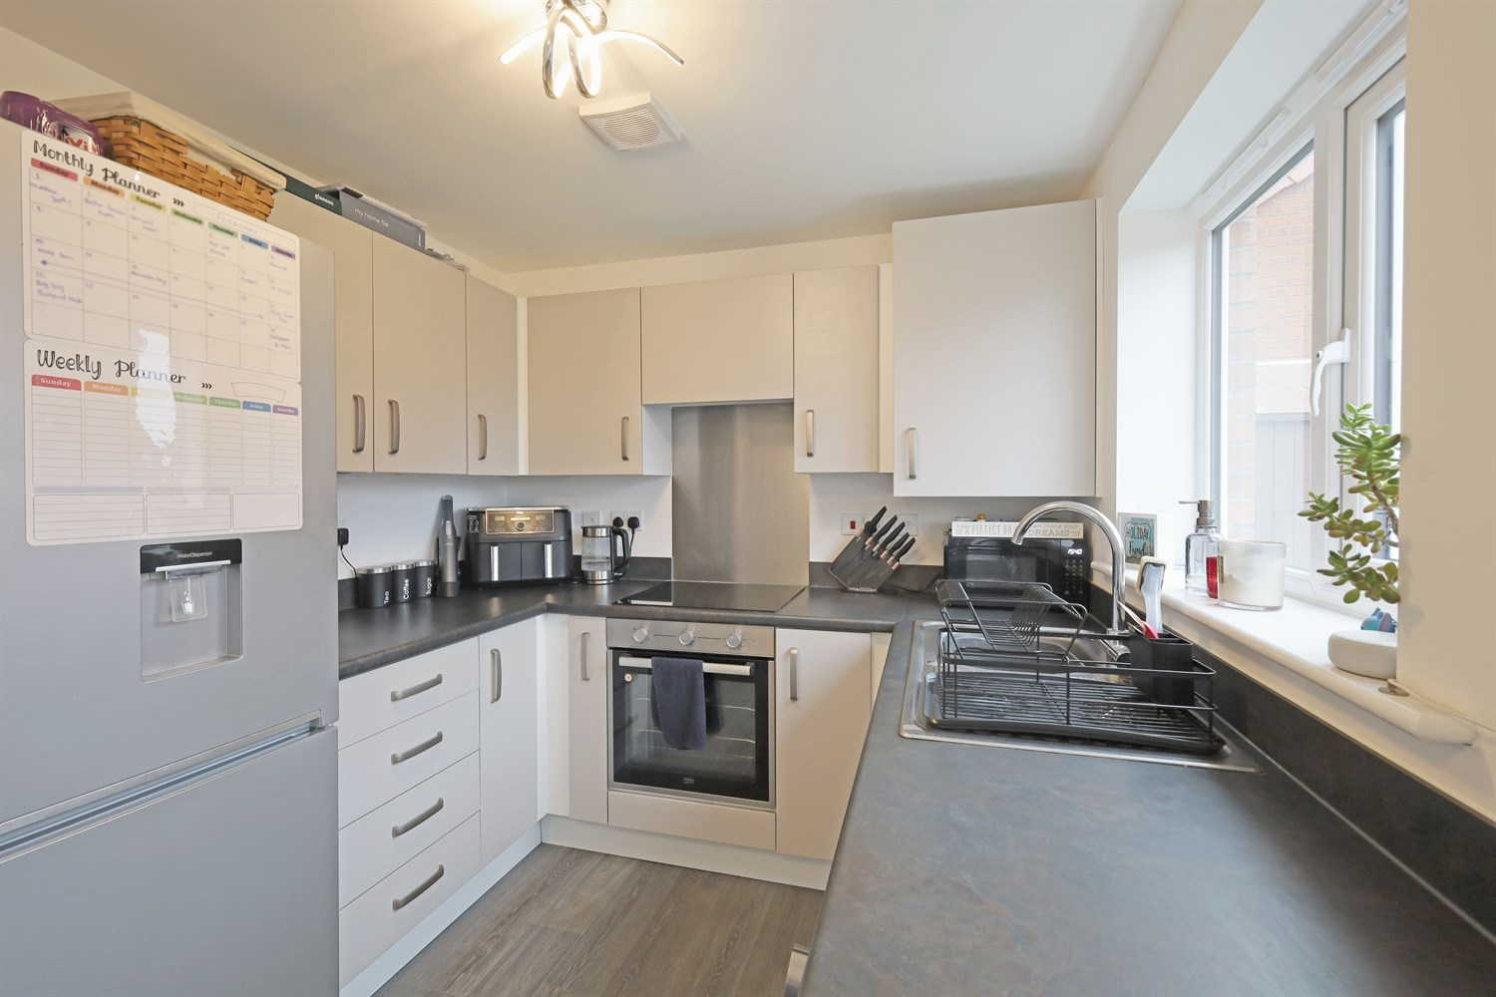
00
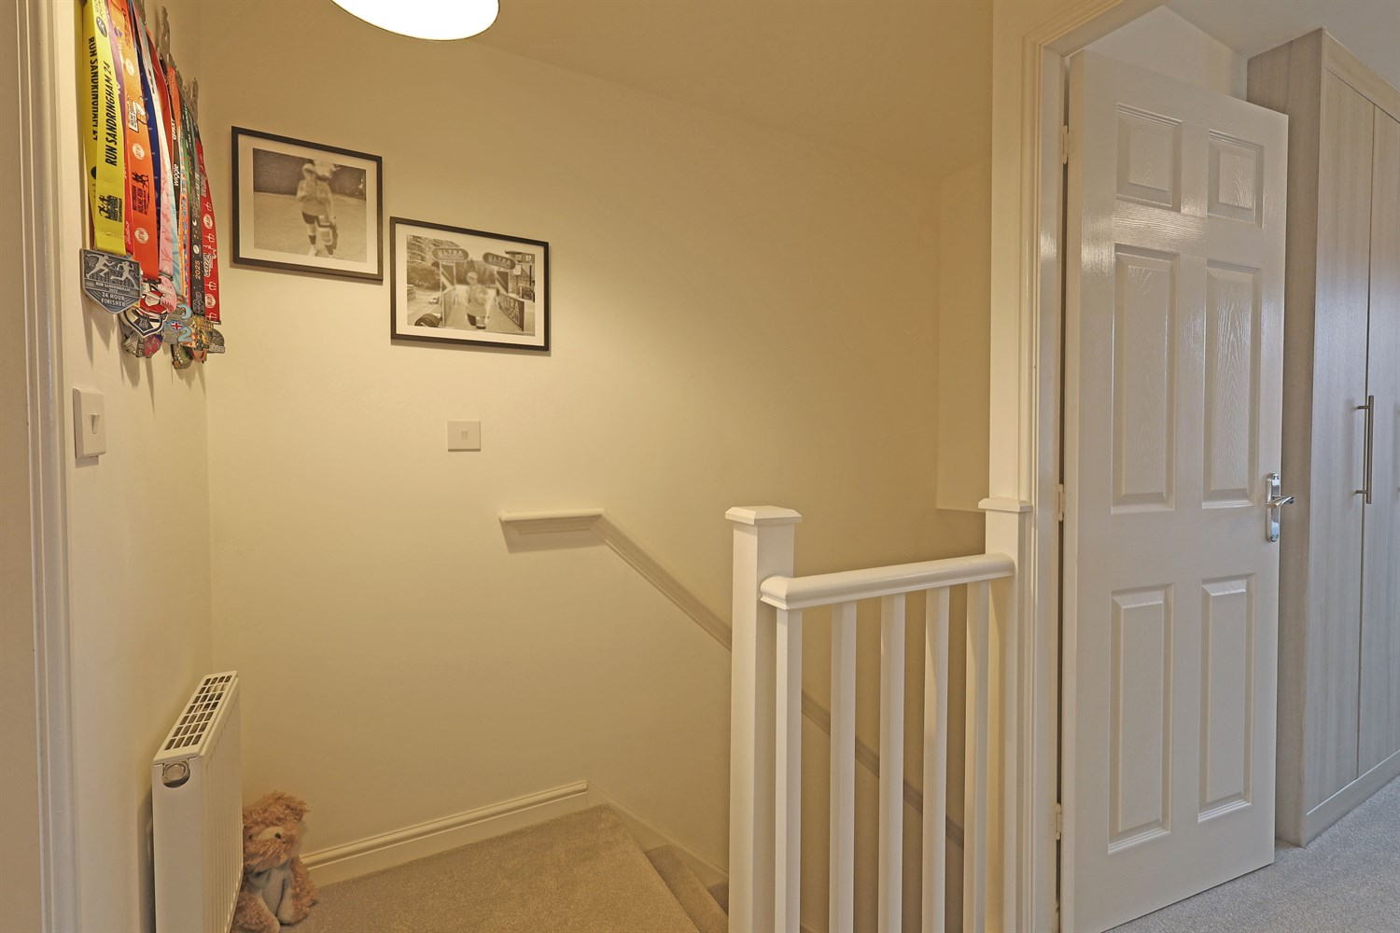
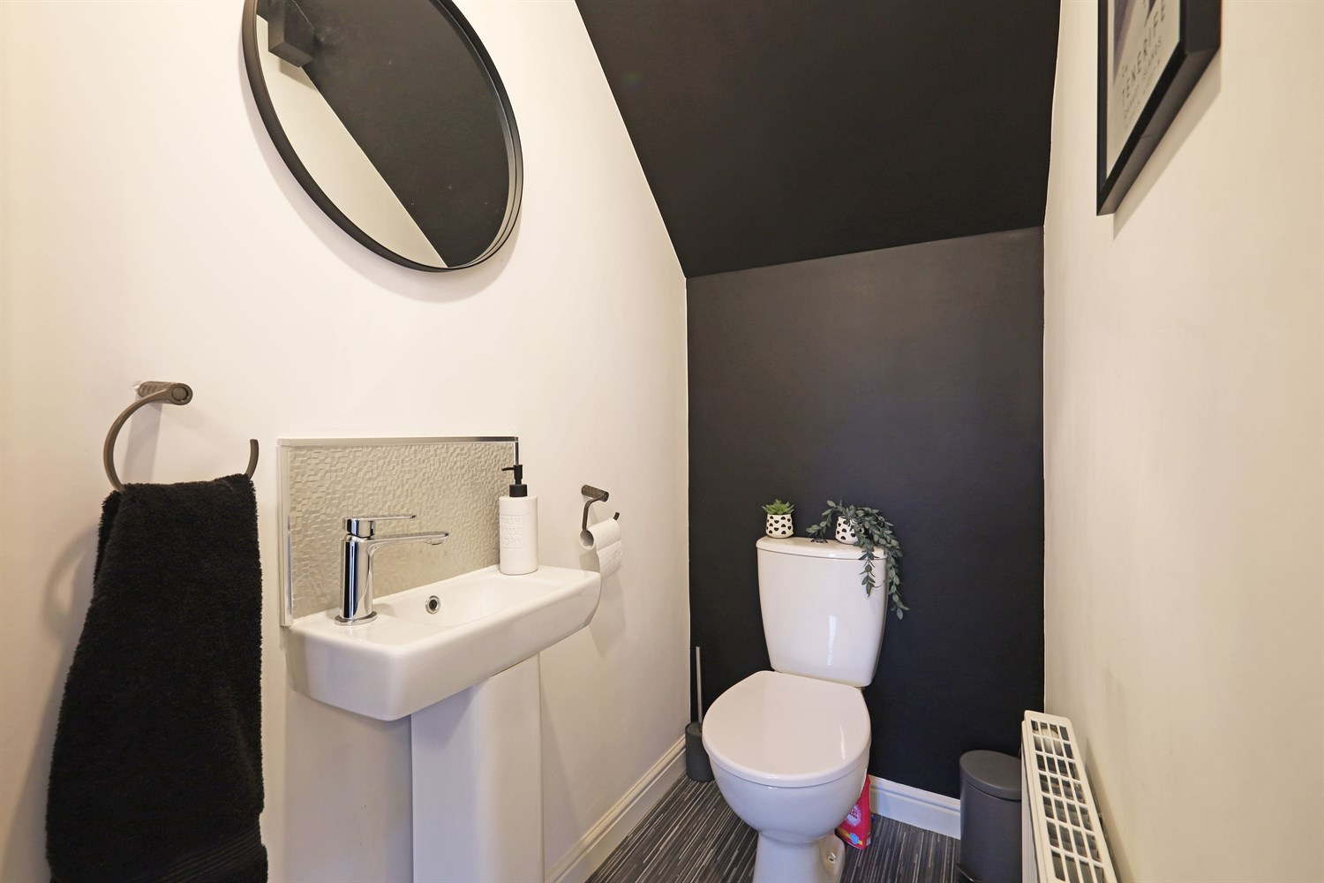
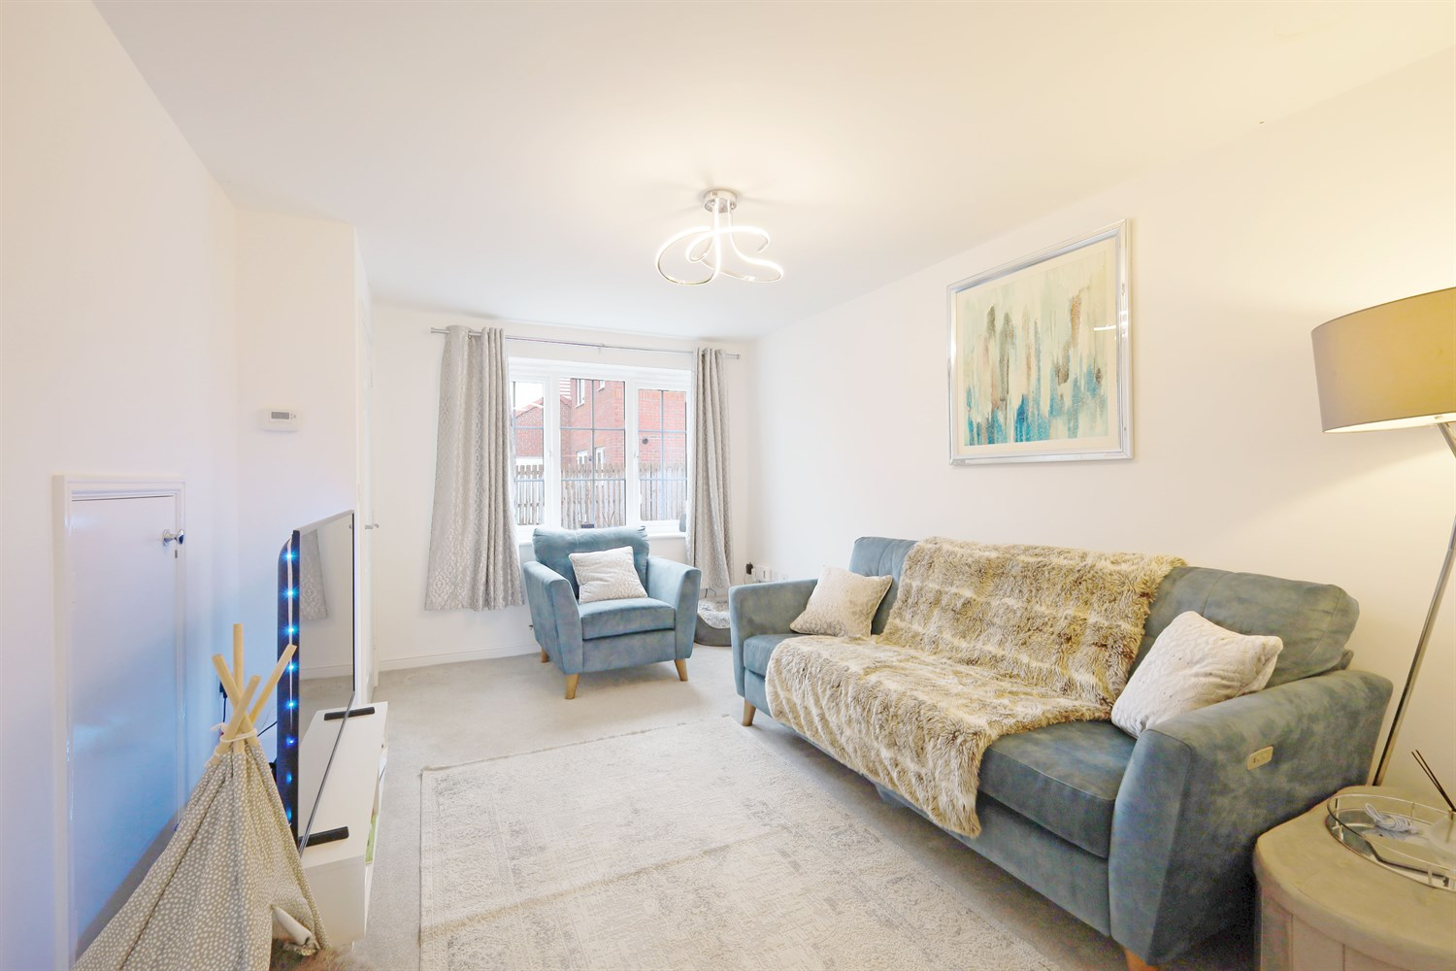
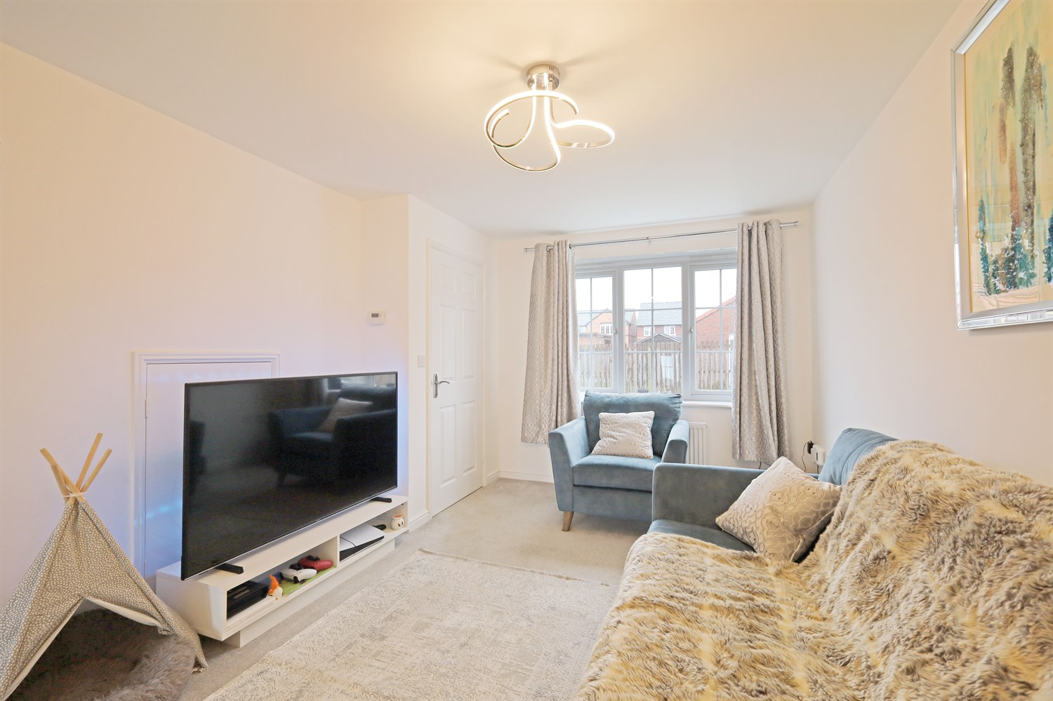
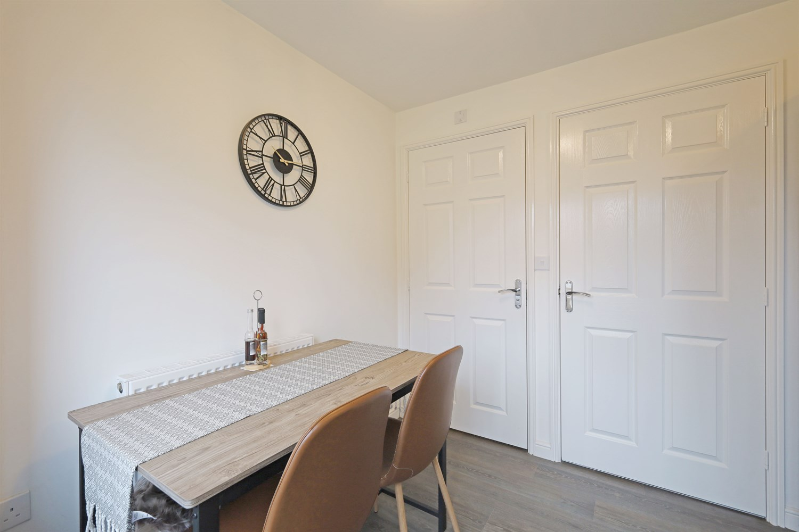
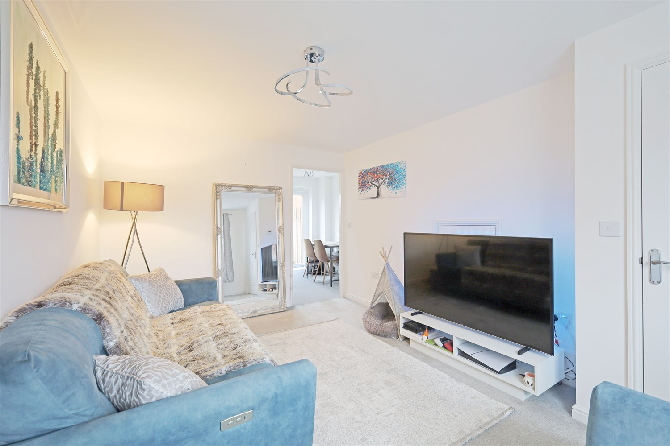
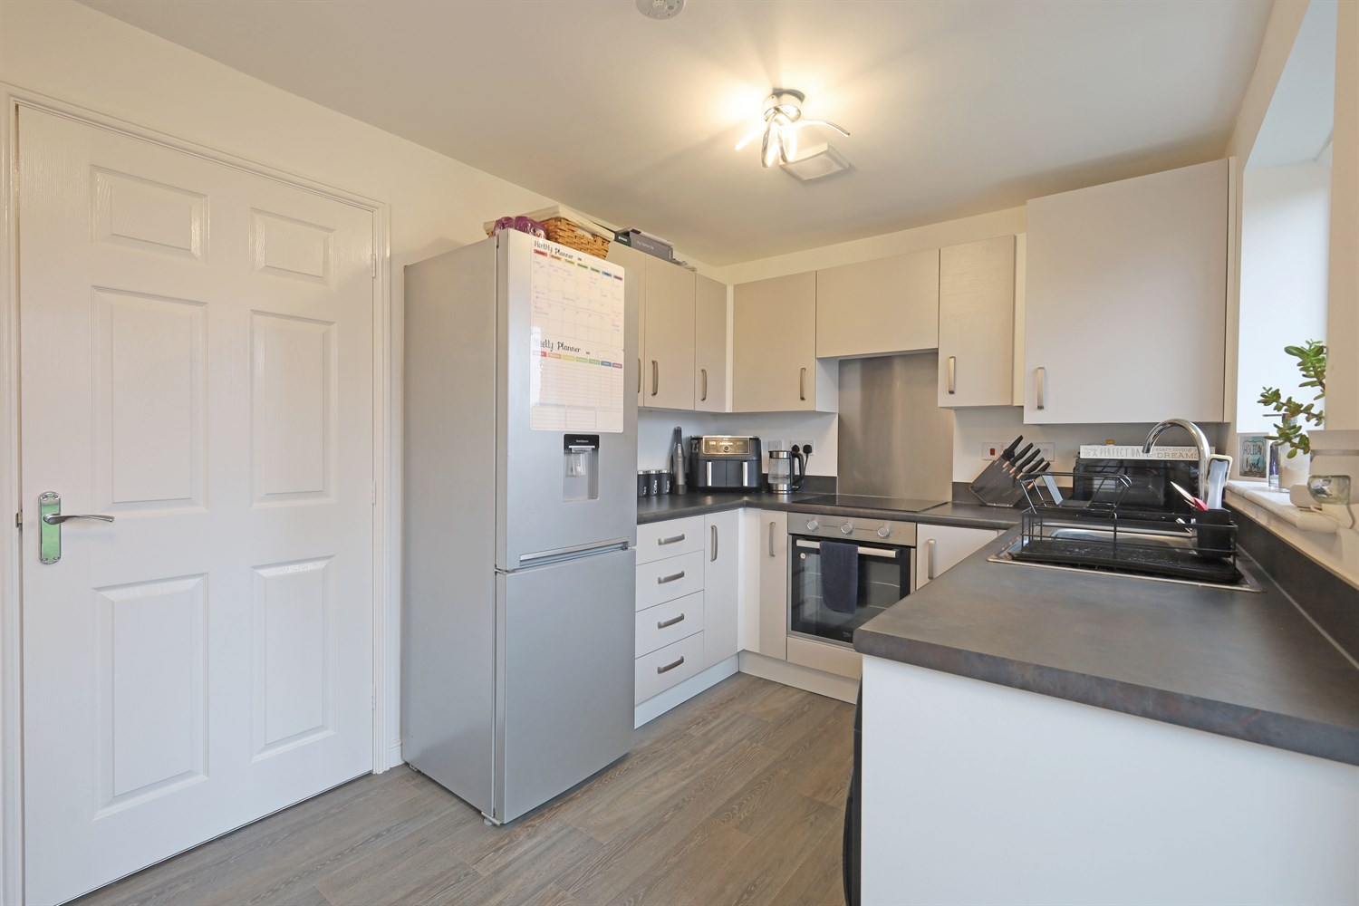
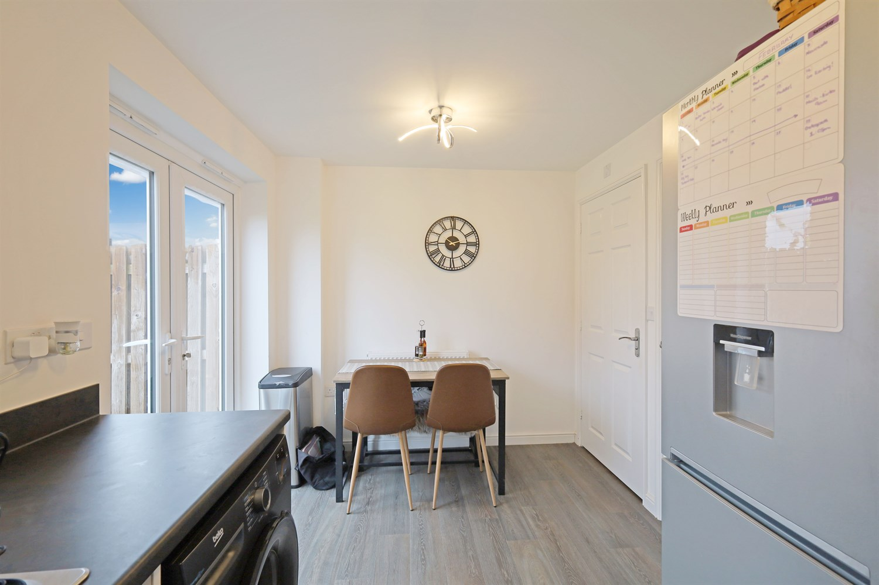

Property Description
Drury's are delighted to present this modern 'CHAIN FREE' semi-detached property benefitting from a semi- south facing garden to the rear. Accommodation comprises of an entrance hall, lounge, kitchen diner, ground floor cloakroom, two bedrooms to the first floor and a family bathroom. Further benefits include gas central heating, uPVC double glazing, driveway and good size rear garden.

Entrance Hallway
Having a modern front entrance door, staircase leading off, double panelled radiator, wall mounted electric fuse box, ceiling light.

Kitchen
Having units to the eye and base level with work top over, matching drawers, and tiled splashbacks, inset stainless steel sink and drainer with mixer tap, space for American fridge freezer, plumbing for automatic washing machine, integrated electric oven and grill, four ring gas hob with extractor above, concealed Ideal gas central heating boiler, window to rear elevation, French doors leading to the rear garden, tiled floor, double panelled radiator, and spot lights.

Lounge
Having window to the front elevation, double panelled radiator, under stairs storage cupboard, thermostat and spot light.

Toilet
Having a WC and hand wash basin, ideal for the modern home.

Landing
Landing giving access to all the first floor rooms.

Bedroom 1
Having window to front elevation, double panelled radiator, built-in wardrobes fitted to one wall with hanging rails and shelving within.

Bedroom 2
Having window to rear elevation and double panelled radiator.

Bathroom
Featuring a three piece white bathroom suite with a panelled bath, pedestal sink and low level WC. Partly tiled and frosted window to the side elevation.

Small Garden
Having a partly lawned area, with patio area and fencing around.

Parking
Gravelled driveway and pathway to the house.

Central Heating
Gas boiler.

Double Glazing
Throughout the property.

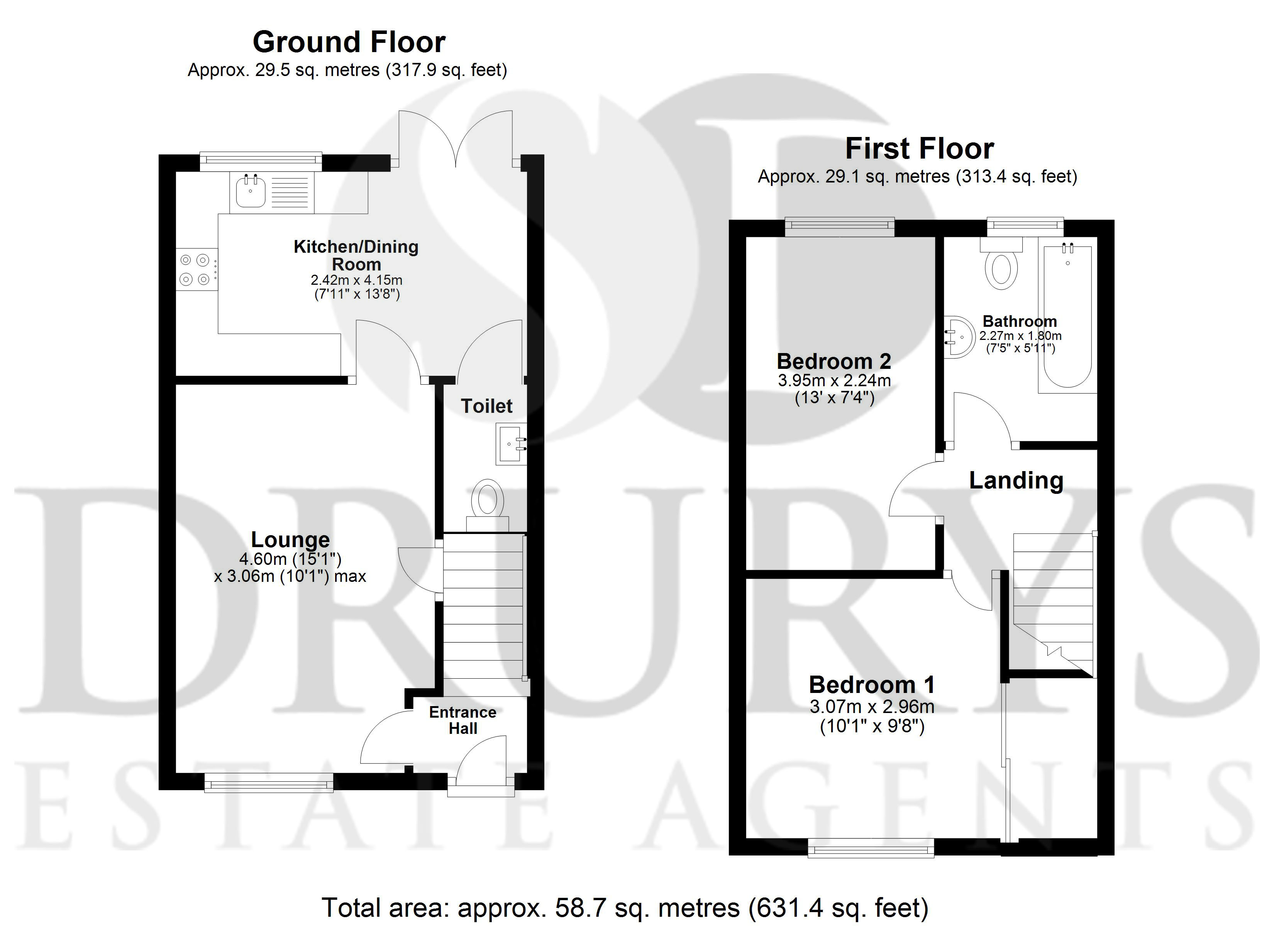

These particulars are intended to give a fair description of the property, but their accuracy cannot be guaranteed, and they do not constitute an offer of contract. Intending purchasers must rely on their own inspection of the property. None of the above appliances/services have been tested by ourselves. We recommend purchasers arrange for a qualified person to check all appliances/services before legal commitment.

Property Ref: 3309

www.drurysestateagents.co.uk
amber@drurysestateagents.co.uk
01205 350889

45 Willoughby Road
Boston
Lincolnshire
PE21 9HN
Agents Note: Whilst every care has been taken to prepare these sales particulars, they are for guidance purposes only. All measurements are approximate are for general guidance purposes only and whilst every care has been taken to ensure their accuracy, they should not be relied upon and potential buyers are advised to recheck the measurements

