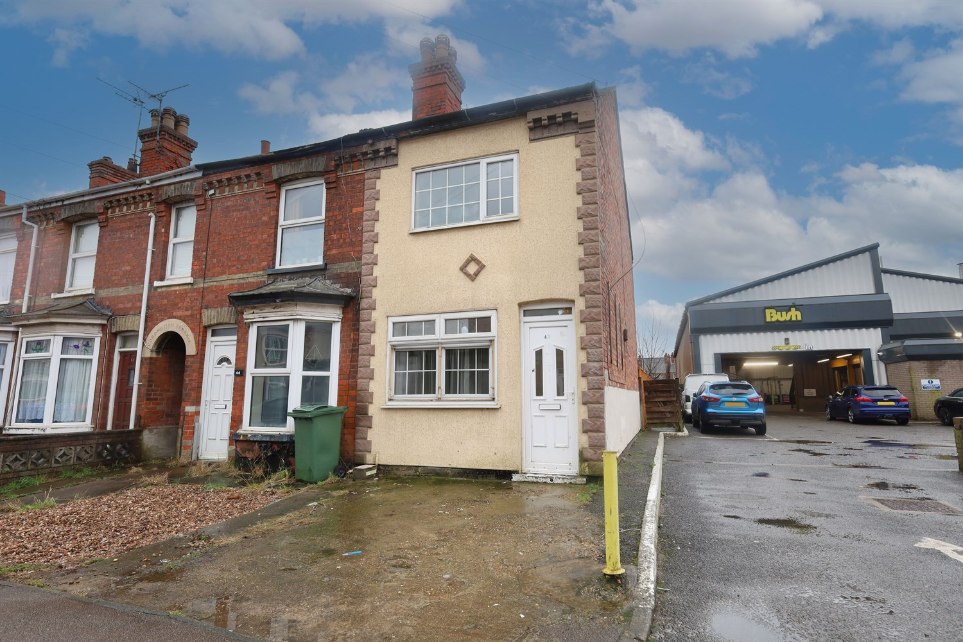




3 Bedroom(s)
3 Reception(s)
1 Bathroom(s)
£125,000.00
Norfolk Street, PE21
EPC Rating ‘’

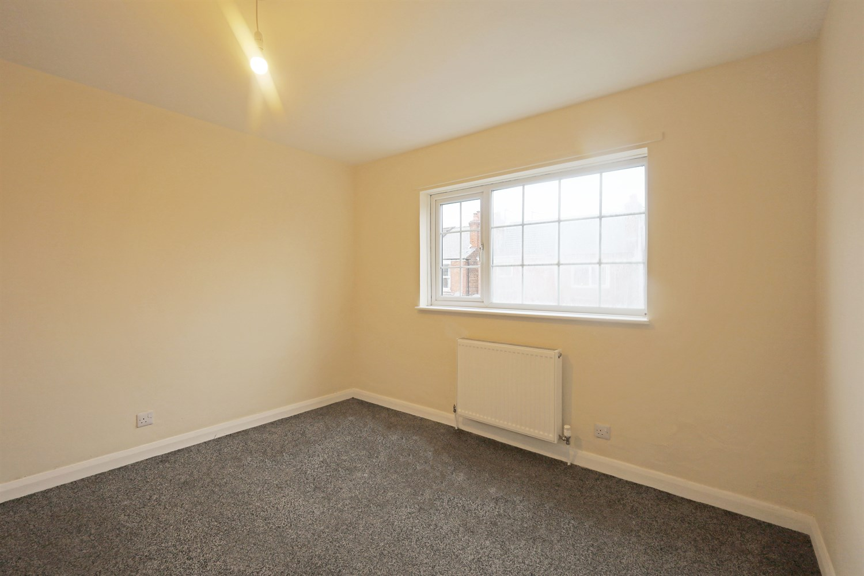
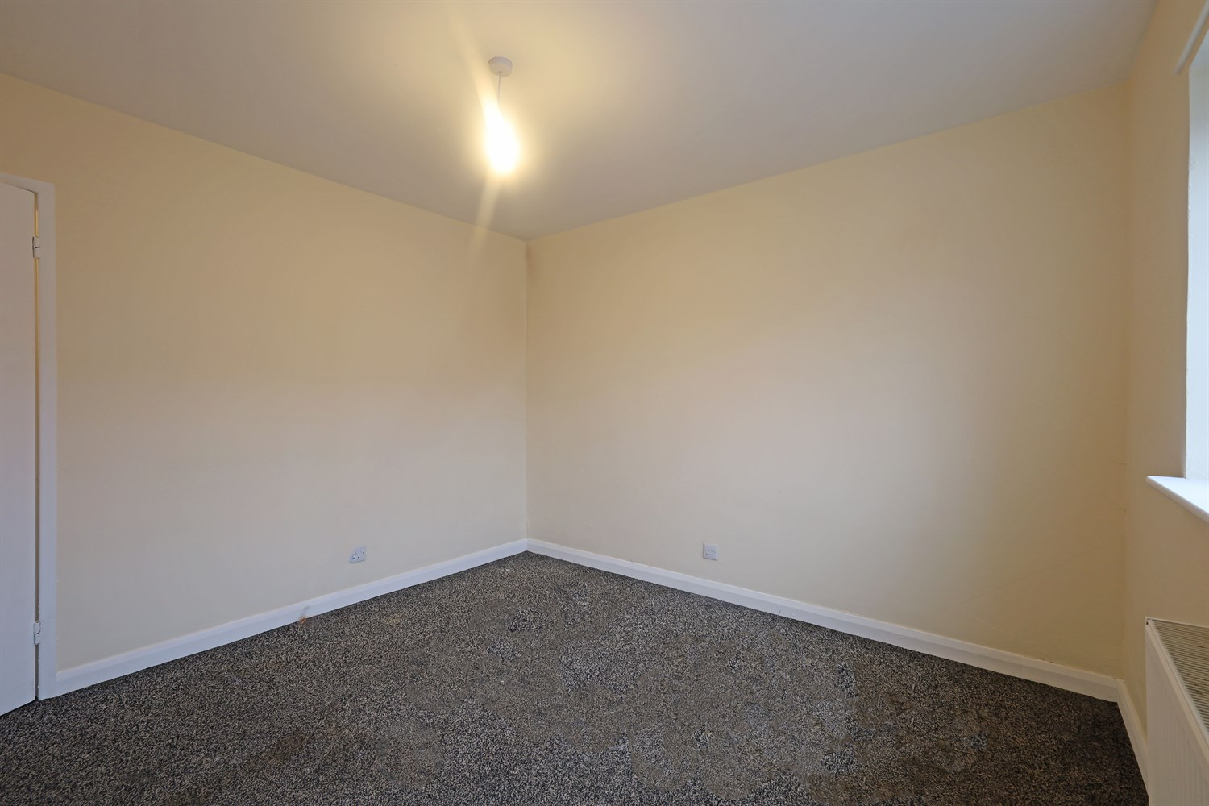
00
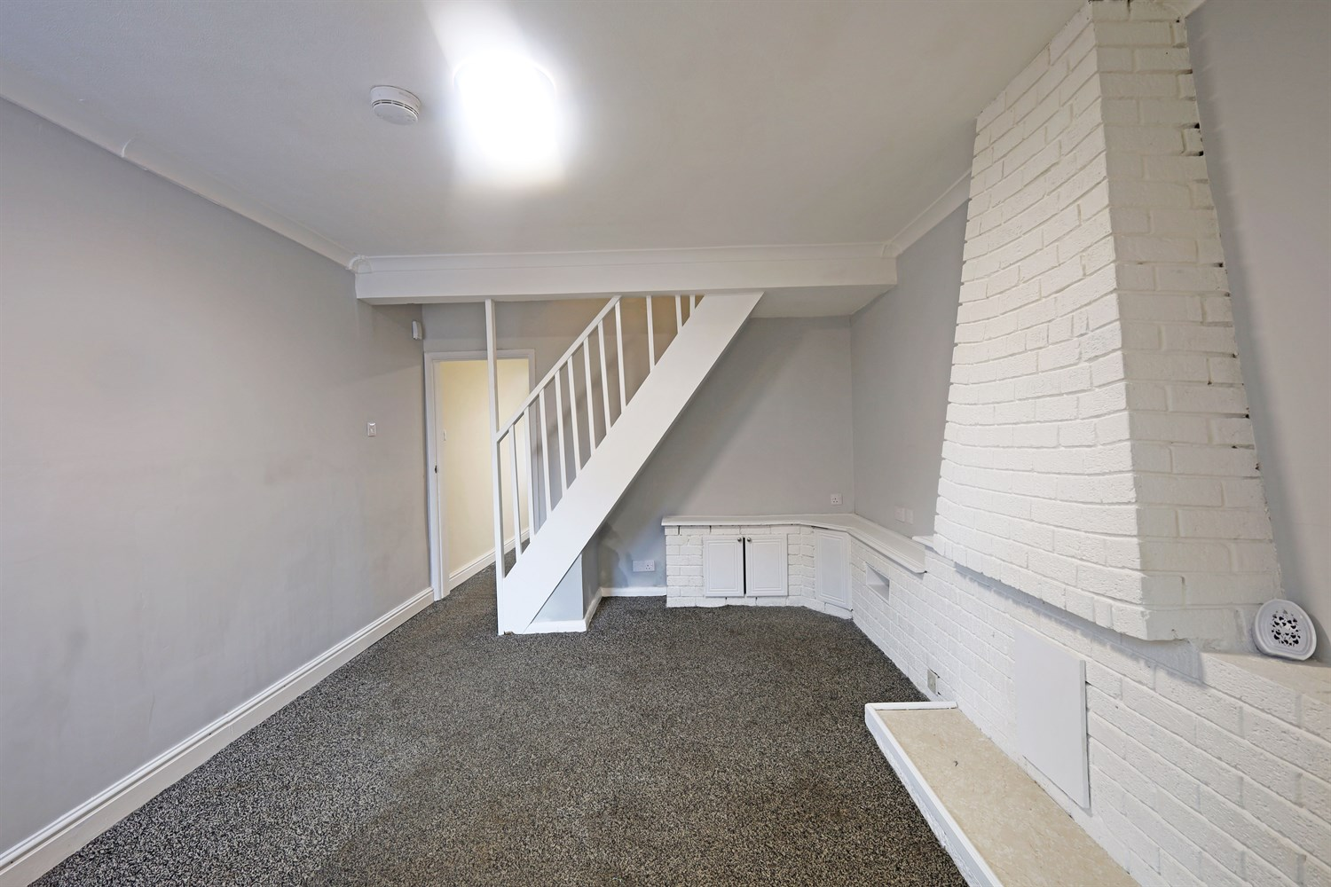
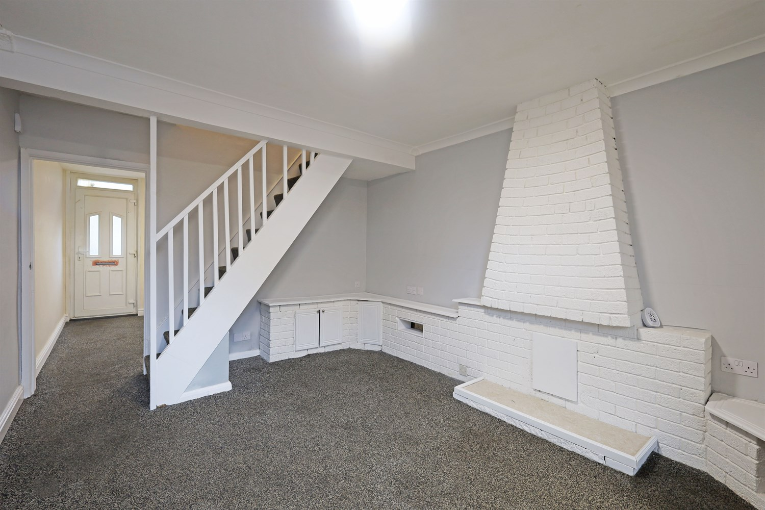
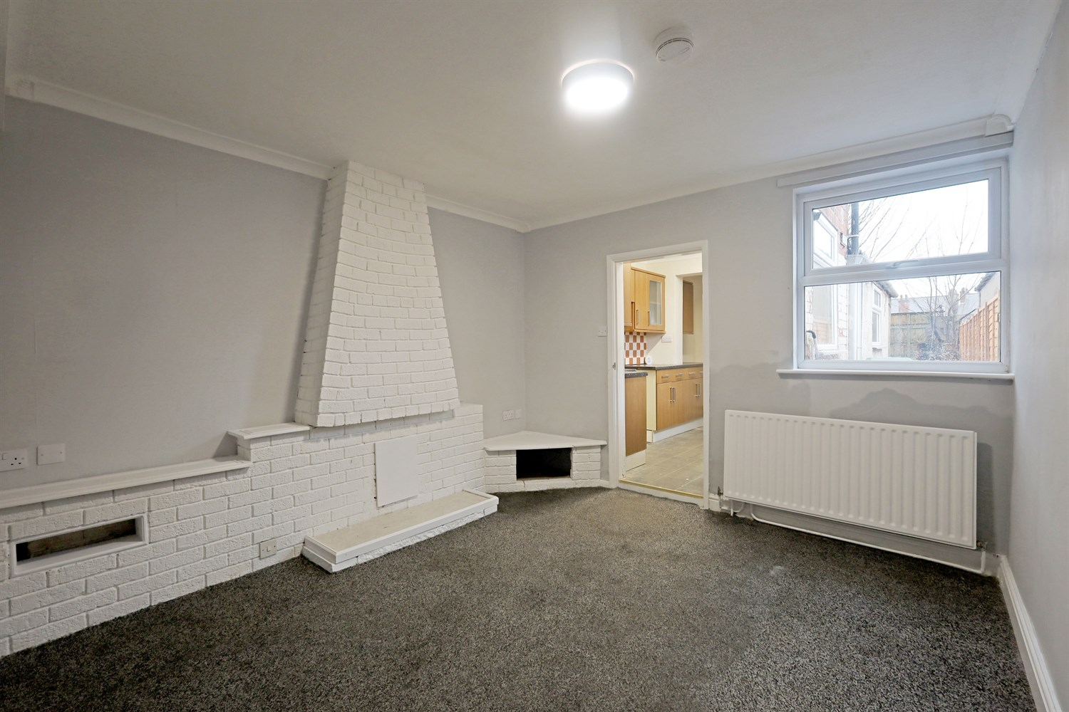
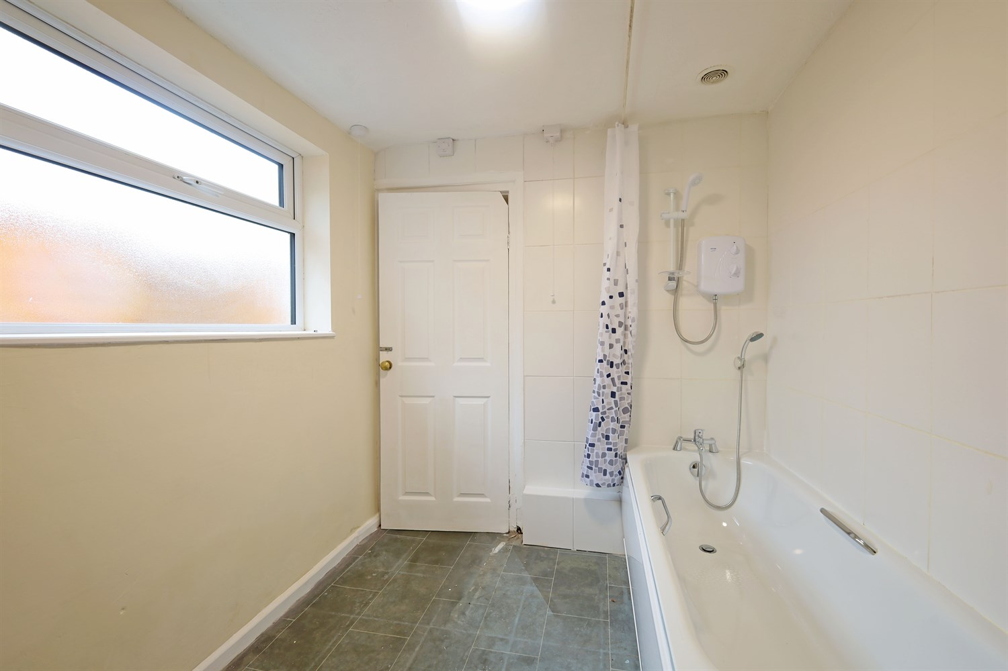
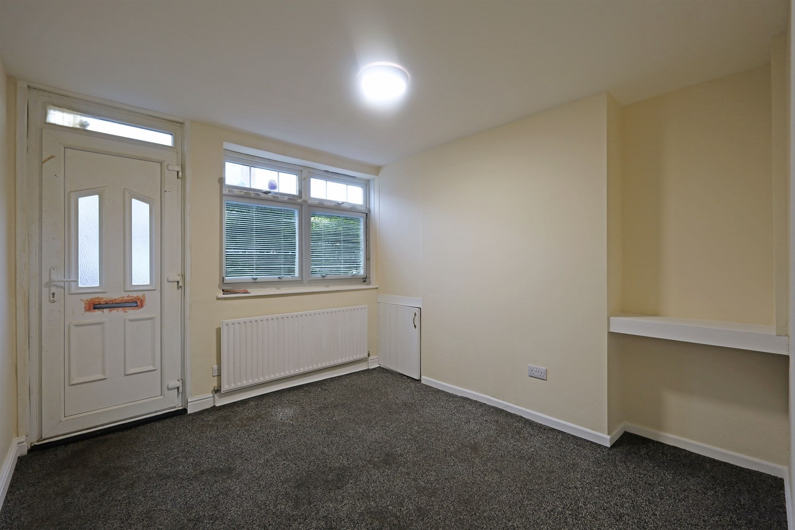
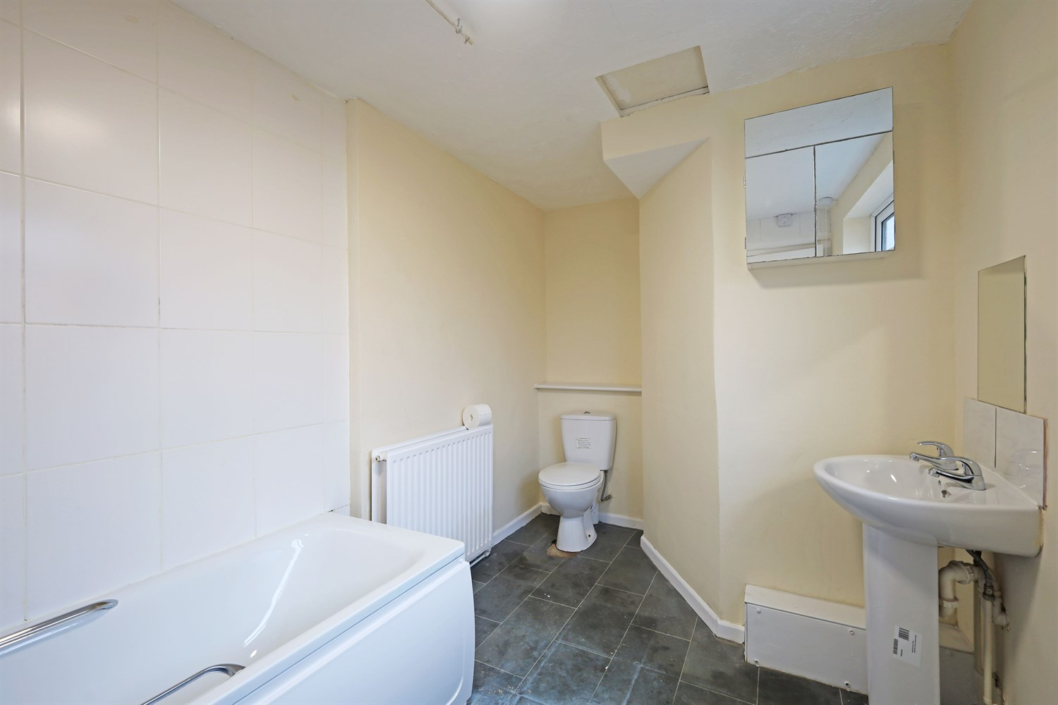
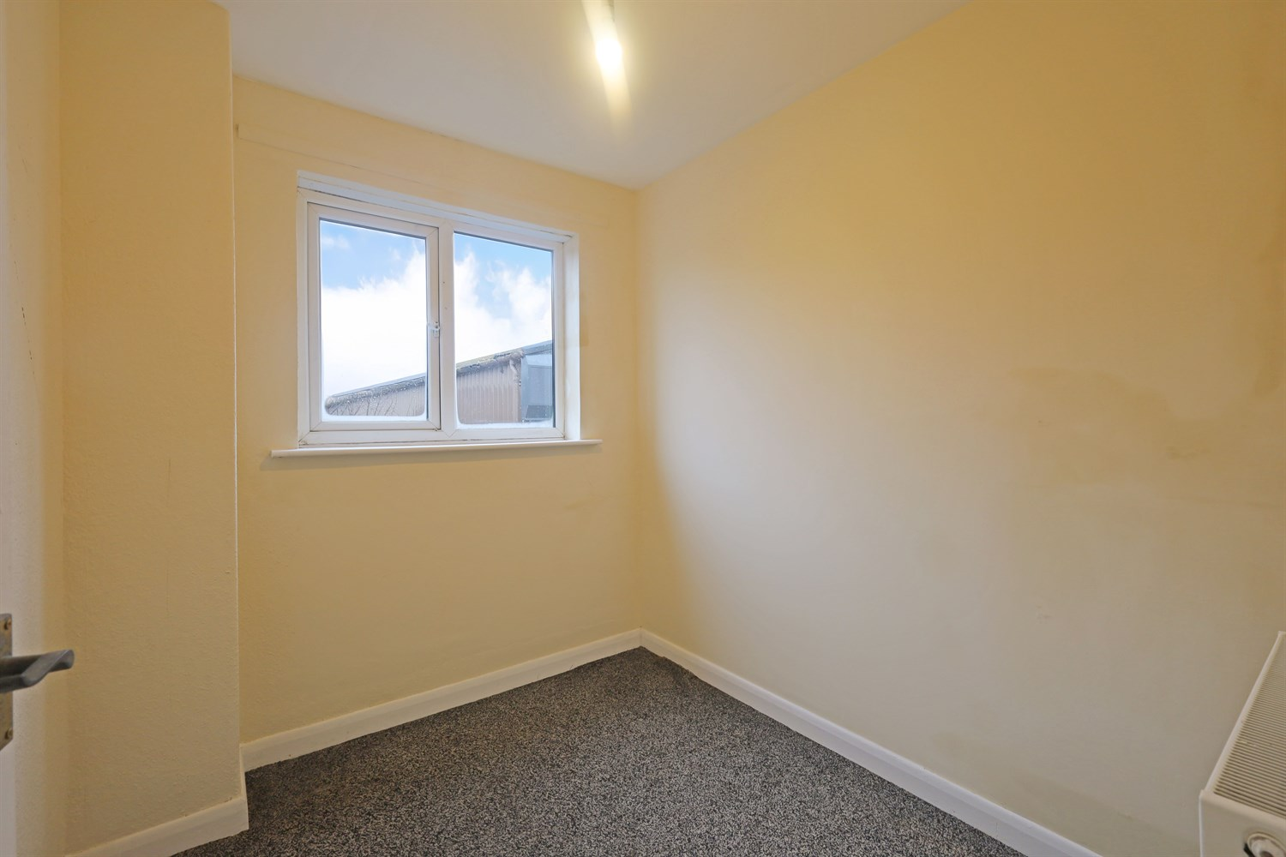
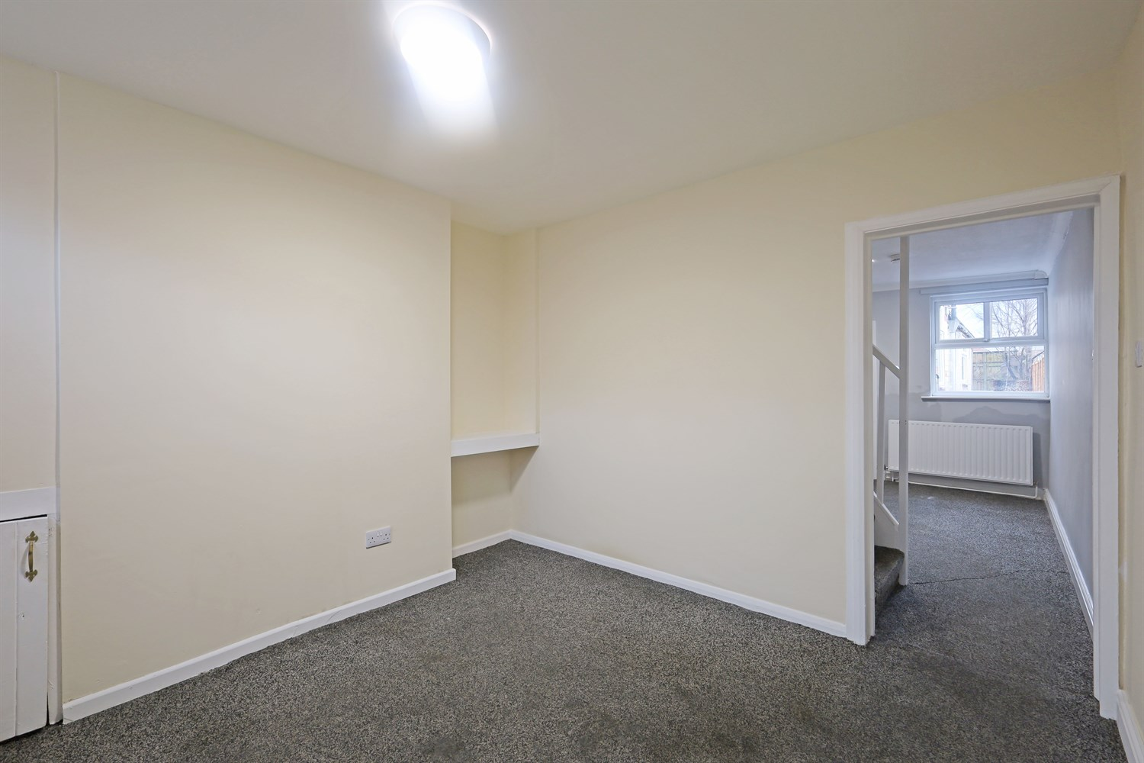

Property Description
Situated in a convenient town location, this end-terraced property offers spacious accommodation arranged over two floors and presents an excellent opportunity for first-time buyers or investors alike.
The ground floor comprises an entrance hallway leading through to a well-proportioned living room, providing a bright and comfortable reception space. To the rear is a separate dining room featuring character brick detailing and built-in storage, with direct access through to the kitchen. The galley-style kitchen is fitted with a range of wall and base units and offers access to the rear lobby and ground floor bathroom, which is fitted with a three-piece white suite including bath with shower over.
To the first floor, the property offers three bedrooms, including two well-sized doubles and a further single bedroom, all benefiting from uPVC double glazing and radiators throughout.
Externally, the property benefits from a low-maintenance rear garden, enclosed by timber fencing and mainly laid to gravel with a paved pathway. There is also a concrete base area suitable for a shed or outbuilding (subject to any necessary consents).
The property further benefits from uPVC double glazing and gas central heating (not tested).
Offering generous internal space and scope for cosmetic updating, this is a fantastic opportunity to add value and create a home tailored to individual taste.

Front Aspect
An end-terraced property positioned in a convenient town location, offering a distinctive rendered façade with contrasting brick detailing. The home benefits from uPVC double glazed windows and a uPVC entrance door to the front elevation.
Set back from the road, the property has a low-maintenance frontage providing off-road parking potential, with side access leading through to the rear.
Being end-terraced, the property enjoys additional natural light via the side elevation and a slightly wider plot than neighboring homes, making it an attractive option for first-time buyers or investors alike.

Lounge
A bright and well-proportioned reception room positioned to the front of the property, having a uPVC double glazed window to the front elevation allowing for plenty of natural light.
The room benefits from a radiator, fitted carpet and neutral décor throughout, making it ready for immediate occupation while still offering scope for personalisation. A useful built-in storage cupboard is also in there, providing practical additional storage space.
There is also direct access through to the inner hallway and staircase leading to the first floor, creating a practical and well-connected ground floor layout.

Dining Room
A spacious and well-proportioned dining room positioned to the rear of the property, featuring a uPVC double glazed window to the rear elevation allowing for good natural light.
The room benefits from fitted carpet, radiator and neutral décor throughout. A distinctive painted brick chimney breast with built-in display shelving and storage cupboards creates a focal point and adds character to the space.
Open access to the staircase provides a flowing layout, while a doorway leads directly into the kitchen, making it ideal for both everyday dining and entertaining.

Kitchen
A galley-style kitchen fitted with a range of wall and base units with contrasting work surfaces and tiled splash backs. The room benefits from a stainless steel sink and drainer unit, space for freestanding appliances and ample worktop preparation space.
There is a uPVC double glazed window allowing for natural light, along with tiled flooring and ceiling lighting. The layout offers practical storage throughout and provides direct access through to the rear lobby and ground floor shower room.
A functional space with plenty of potential for modernisation to suit a buyer's own taste and style.

Downstairs Bathroom
A ground floor bathroom fitted with a three-piece white suite comprising panelled bath with shower over, low level WC and pedestal wash hand basin.
The room benefits from tiled splash backs, tiled flooring, radiator and a uPVC double glazed window to the side elevation allowing for natural light and ventilation.
A functional space offering scope for cosmetic updating, ideal for buyers looking to add their own style and value.

Bedroom 1
A well-proportioned double bedroom positioned to the front of the property, having a uPVC double glazed window to the front elevation allowing for excellent natural light.
The room benefits from fitted carpet, radiator and neutral décor throughout, providing a blank canvas for personalisation. There is ample space for a double bed and additional bedroom furniture.
An ideal principal bedroom offering comfortable accommodation with scope to add your own style.

Bedroom 2
A good-sized second bedroom having a uPVC double glazed window to the rear elevation, providing natural light and outlook.
The room benefits from fitted carpet, radiator and neutral décor throughout, making it ready for immediate use as a bedroom, nursery or home office. There is ample space for a bed and freestanding furniture.
A versatile room ideal for growing families, guests or those working from home.

Bedroom 3
A single bedroom having a uPVC double glazed window to the rear elevation, allowing for natural light.
The room benefits from fitted carpet, radiator and neutral décor throughout. Ideal for use as a child's bedroom, nursery, dressing room or home office.
A practical third bedroom offering flexibility to suit a buyer's individual needs.

Rear Garden
An enclosed rear garden, being predominantly low maintenance and enclosed by timber fencing to both sides.
The garden is mainly laid to gravel with a paved pathway leading from the property to the rear boundary. There is a concrete base area, previously used for a shed or outbuilding, offering potential for replacement storage.
A practical outdoor space with scope for landscaping and improvement, ideal for buyers looking to create their own garden design or add further value to the property.

These particulars are intended to give a fair description of the property, but their accuracy cannot be guaranteed, and they do not constitute an offer of contract. Intending purchasers must rely on their own inspection of the property. None of the above appliances/services have been tested by ourselves. We recommend purchasers arrange for a qualified person to check all appliances/services before legal commitment.

Property Ref: 3308

www.drurysestateagents.co.uk
amber@drurysestateagents.co.uk
01205 350889

45 Willoughby Road
Boston
Lincolnshire
PE21 9HN
Agents Note: Whilst every care has been taken to prepare these sales particulars, they are for guidance purposes only. All measurements are approximate are for general guidance purposes only and whilst every care has been taken to ensure their accuracy, they should not be relied upon and potential buyers are advised to recheck the measurements

