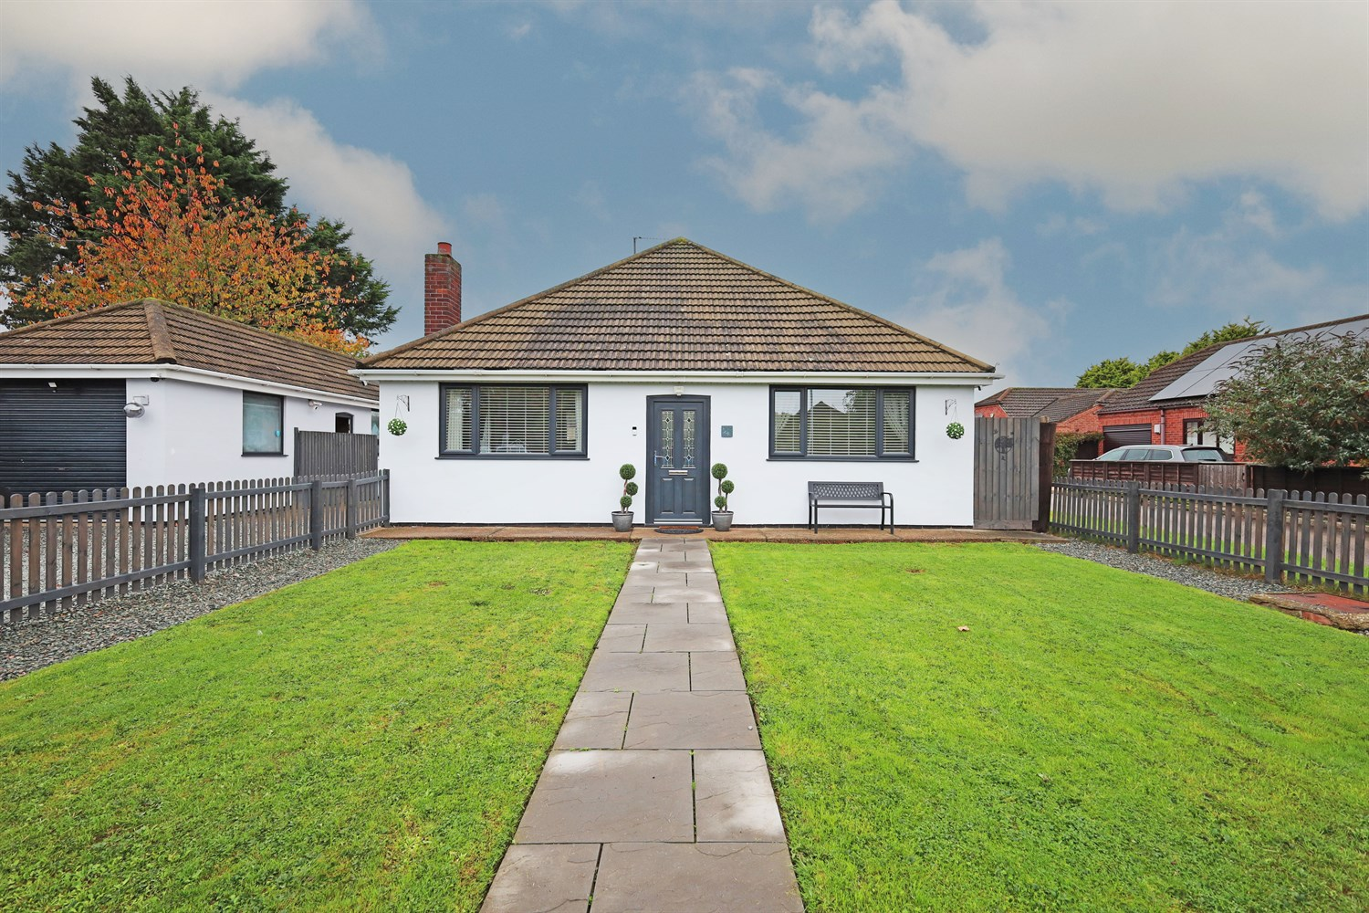




3 Bedroom(s)
1 Reception(s)
1 Bathroom(s)
£269,000.00
Robin Hoods Walk, PE21
EPC Rating ‘’

- Spacious Three Bedroom Detached Bungalow
- Three Bedrooms, Fully Updated Breakfast Kitchen and Bathroom
- Double-Width Driveway, Garage With Attached Office
- Generous Enclosed Garden & Patio
- New uPVC Double Glazing & Gas-Fired Central Heating

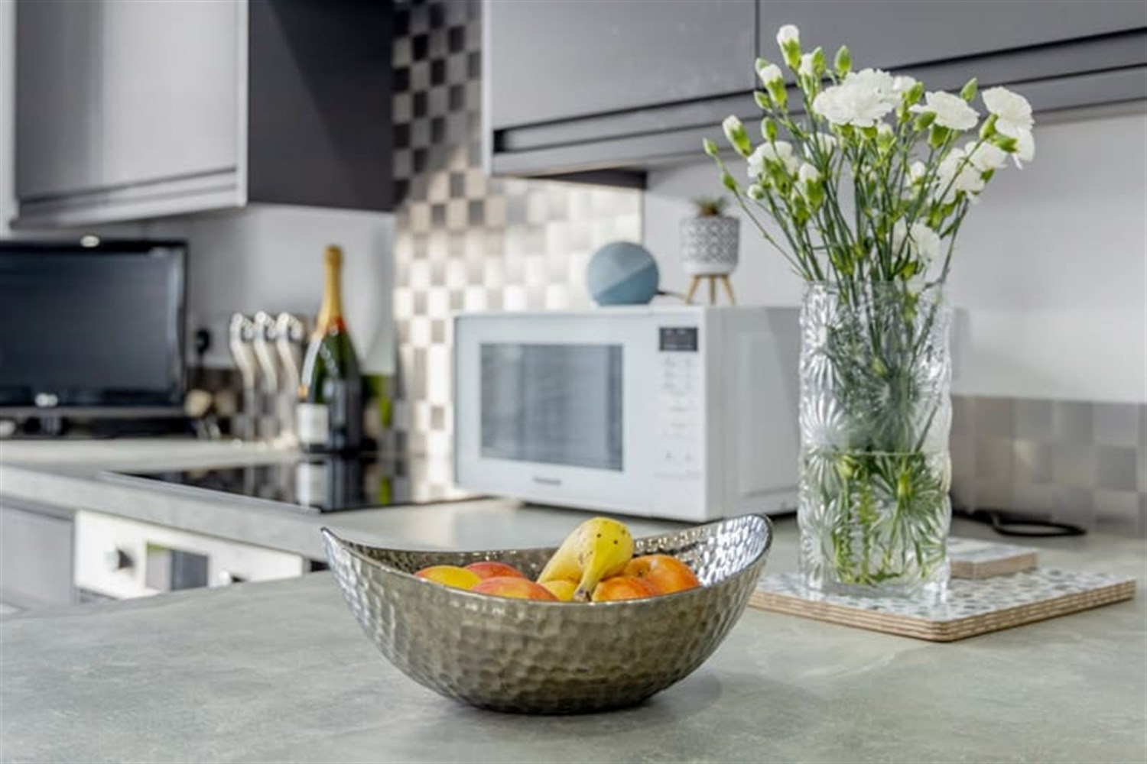
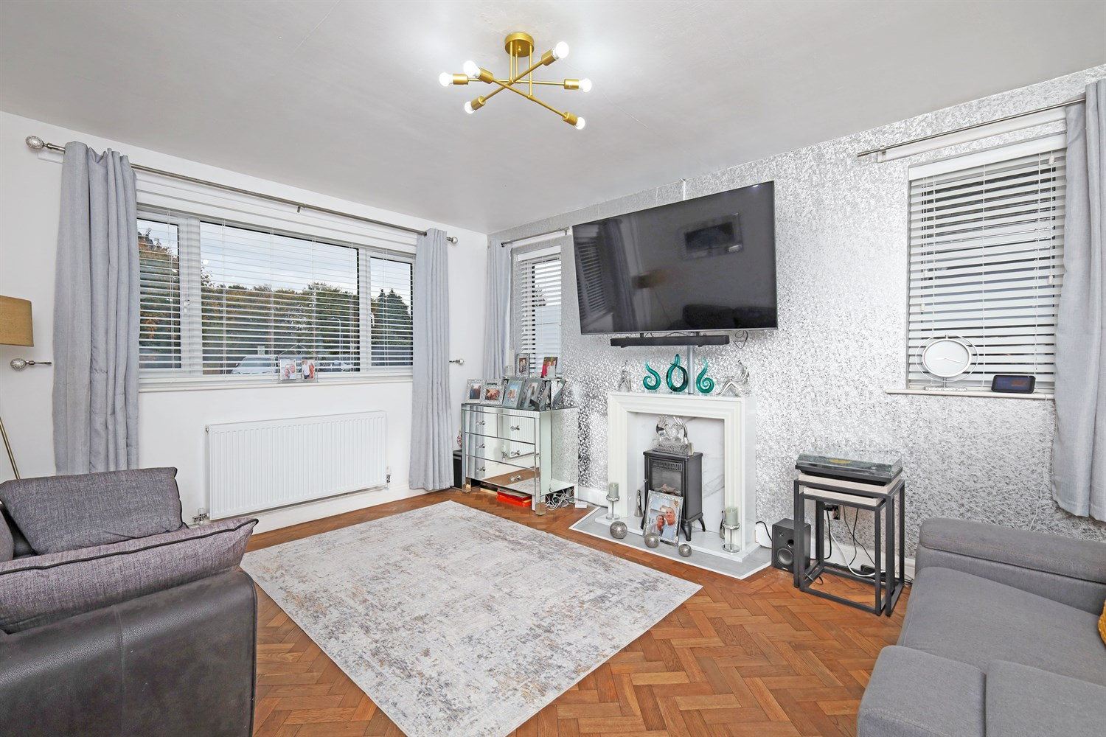
00
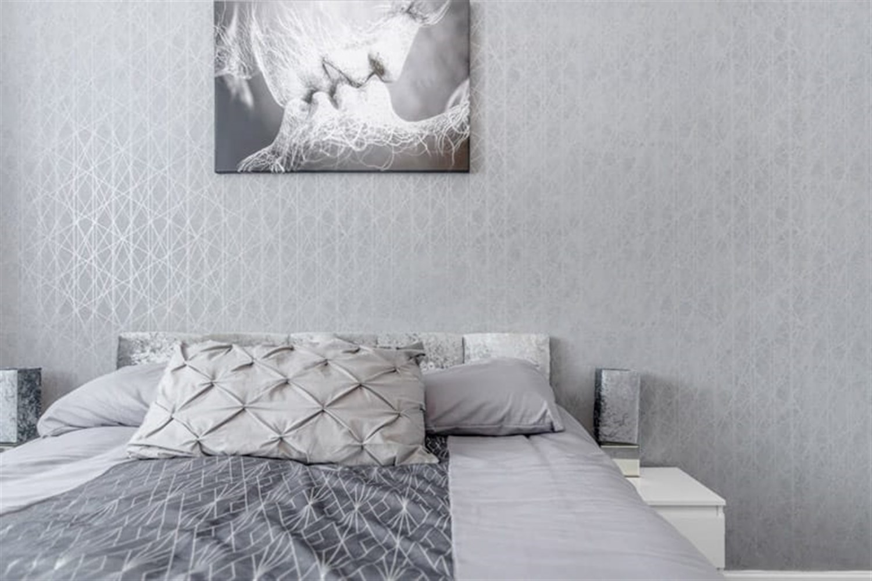
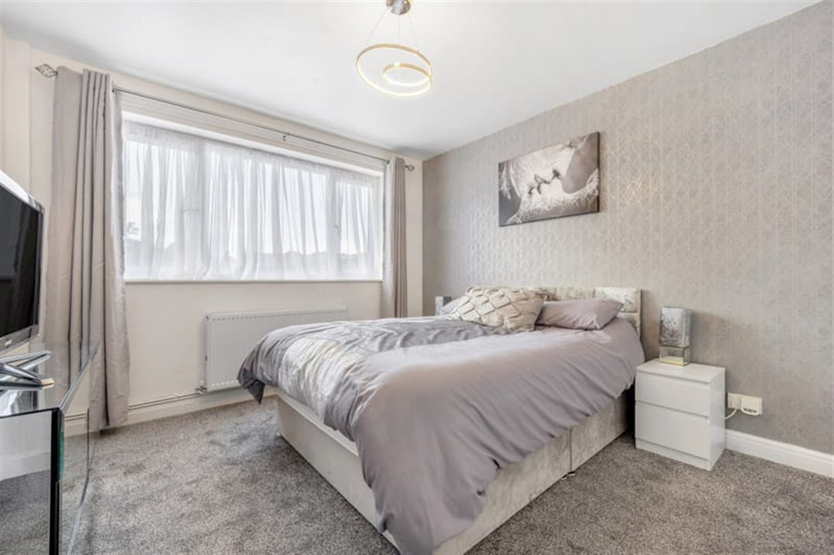
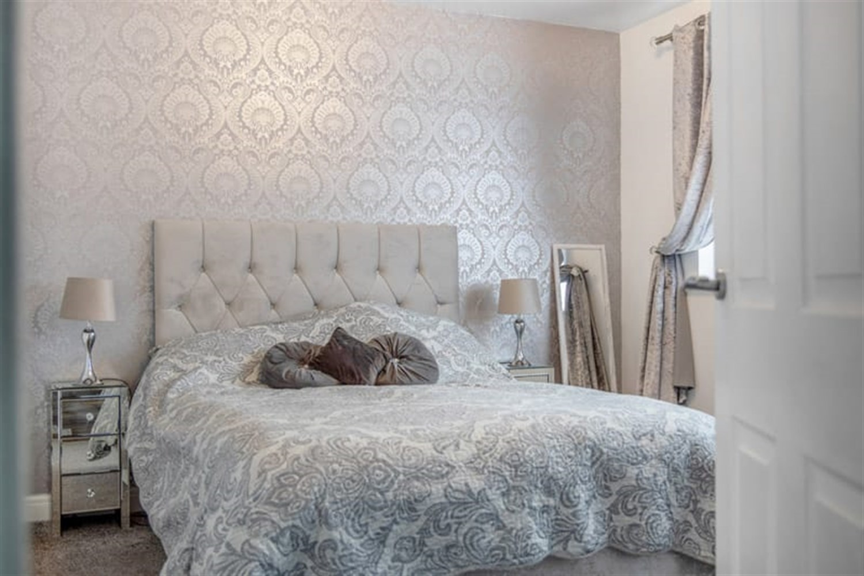
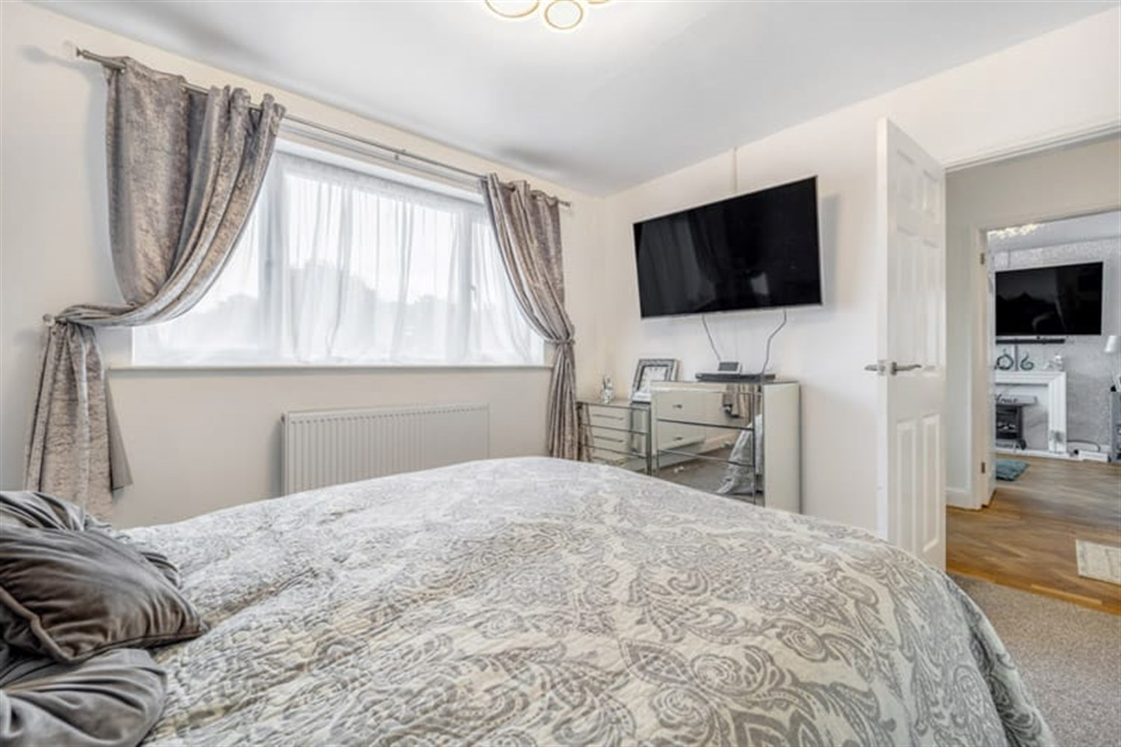
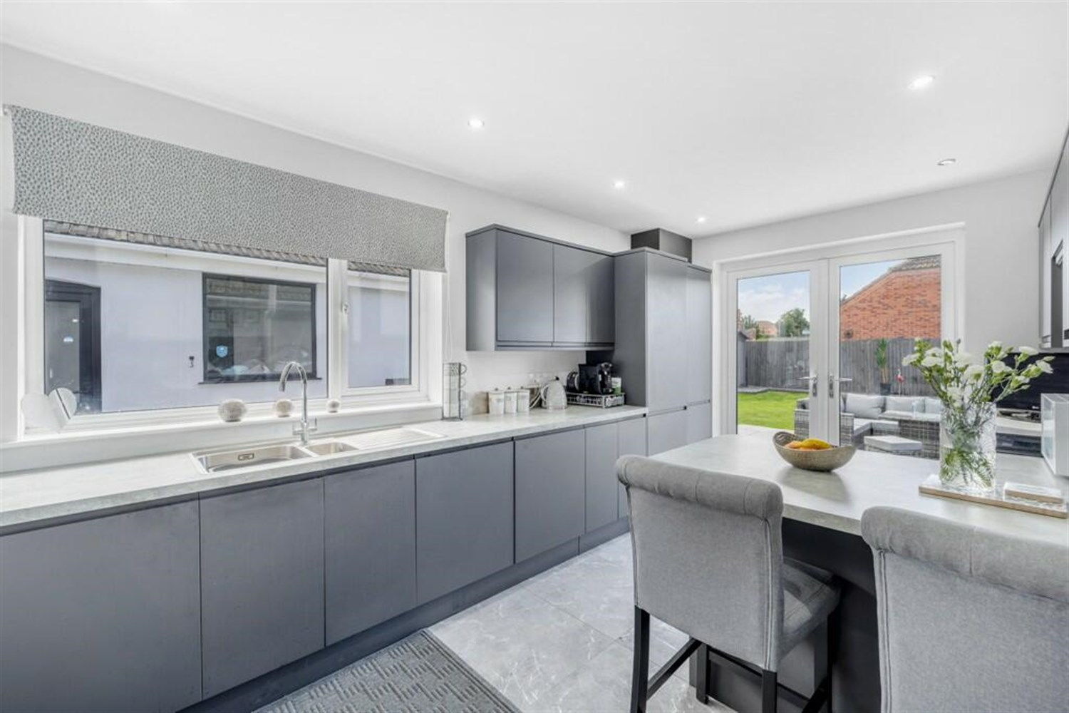
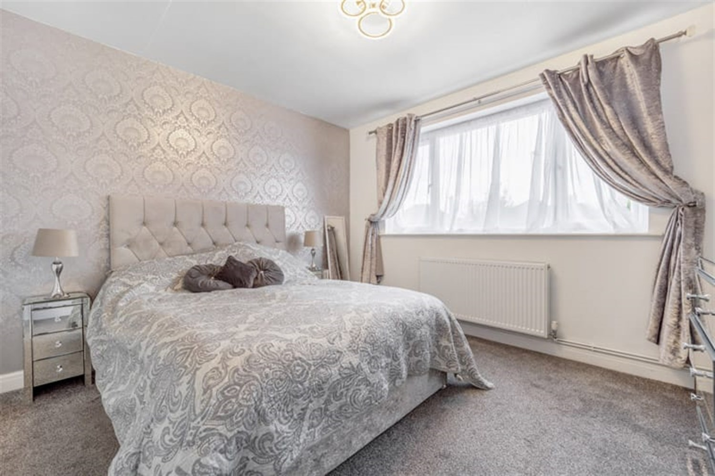
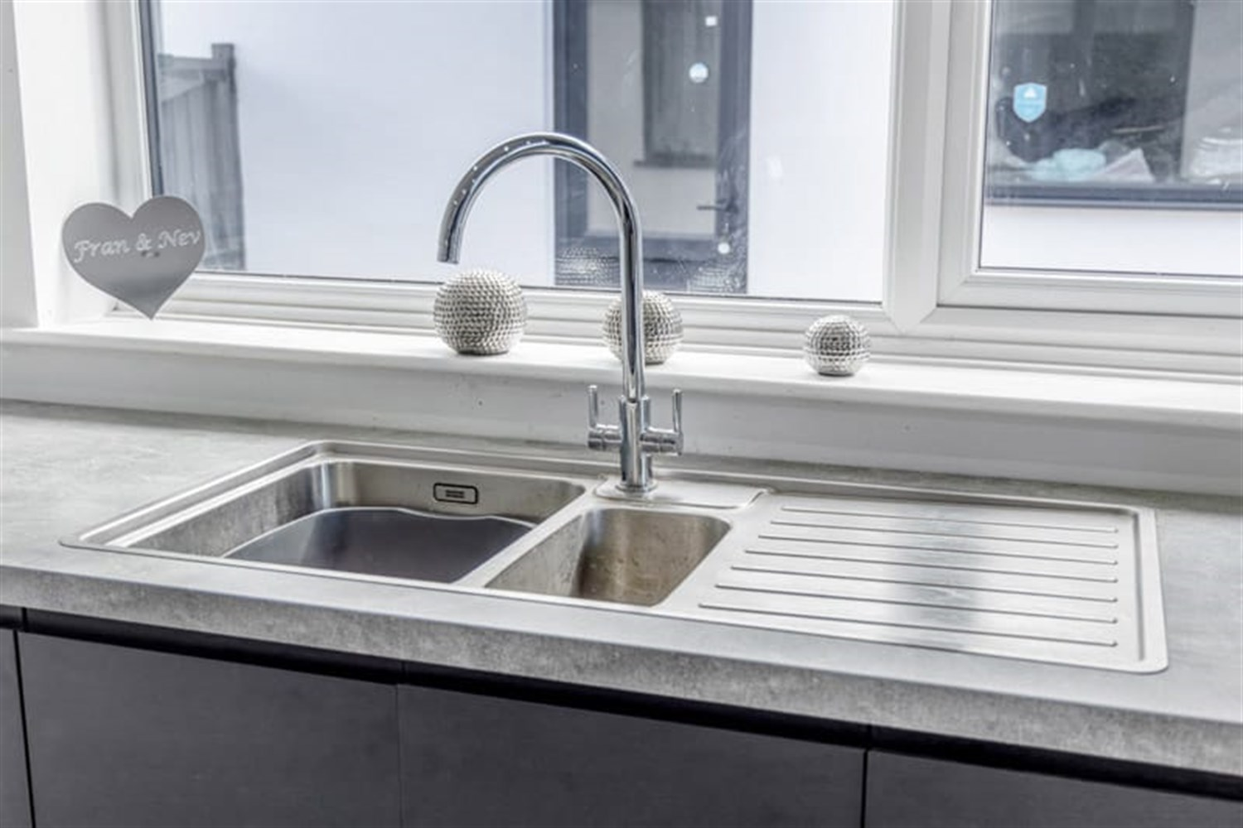
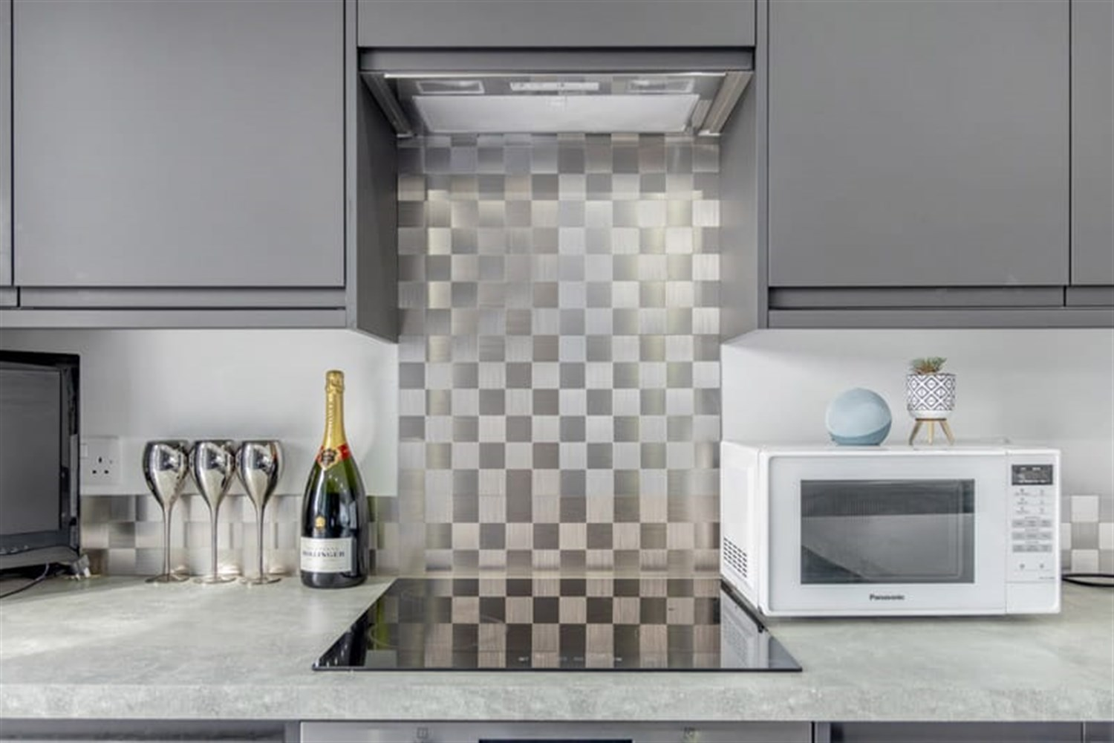

Property Description
This beautifully presented detached bungalow is conveniently located close to town and local schools. Having great kerb appeal, 3 double bedrooms, modern breakfast kitchen and bathroom, lounge, office, garage and gardens. This property is beautifully decorated throughout and has been maintained to a high level.

Hallway
Inside this lovely bungalow is an entrance porch leading to a welcoming entrance hallway with all the rooms leading on from here, a double panelled radiator and modern herringbone wooden flooring.

Lounge
With a continuation of the herringbone designed flooring, this room is flooded with light from the window to the front and side aspects. Fitted with a modern fire surround and electric fire, double panelled radiator, this room is ideal for relaxing in.

Kitchen
Beautifully modern Breakfast Kitchen with stunning modern features along with an array of light. This room feels a perfect space for testing your culinary skills, family time together and entertaining. Along with various grey modern units to the eye and base level with worktop over, various integral appliances, electric oven and ceramic hob. The stainless sink and drainer is situated next to the window to the side aspect, in addition the light floods in through modern French Doors which lead out into the garden. An additional bonus to this space is a breakfast bar, ideal for eating, chatting while cooking or working from.

Bedroom 1
The master bedroom is a great sized double with a window to the front aspect and double panelled radiator.

Bedroom 2
Another double room with a window to the rear aspect and double panelled radiator.

Bedroom 3
Another great double room, with window to the side aspect and double panelled radiator.

Bathroom
The modern bathroom comprises a lovely white luxury suite with soft close sink and drawers, panel bath with central mixer tap and shower, over shower enclosure with both a hand-held shower and rain head and a low-profile WC. Featuring a window to the rear aspect and heated towel rail.

Garage
Benefitting from a electrically operated roller door, uPVC window to the side, power, and lighting.

Garden
There are lawned gardens to the front and rear, with the rear garden featuring an extensive paved patio, which enjoys the sun, perfect for entertaining or relaxing in.

Driveway
Gravelled driveway providing ample off road parking and access to the garage. There is also an electric charging point.

Office
This perfect space for the modern professional, the benefit of having an office/gym space separate to the bungalow. This allows you the flexibility of escaping but not having to travel. Fitted with wood effect flooring, window, lights, electricity and heating. This is accessed from the rear garden.

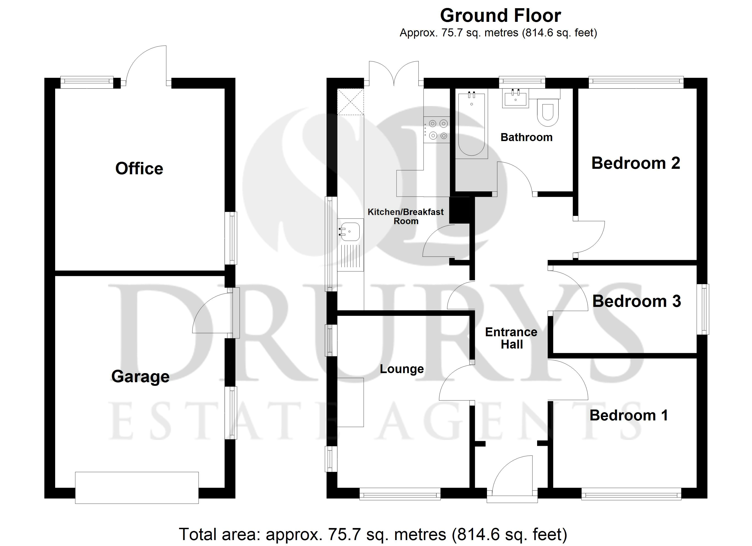

These particulars are intended to give a fair description of the property, but their accuracy cannot be guaranteed, and they do not constitute an offer of contract. Intending purchasers must rely on their own inspection of the property. None of the above appliances/services have been tested by ourselves. We recommend purchasers arrange for a qualified person to check all appliances/services before legal commitment.

Property Ref: 3050

www.drurysestateagents.co.uk
amber@drurysestateagents.co.uk
01205 350889

45 Willoughby Road
Boston
Lincolnshire
PE21 9HN
Agents Note: Whilst every care has been taken to prepare these sales particulars, they are for guidance purposes only. All measurements are approximate are for general guidance purposes only and whilst every care has been taken to ensure their accuracy, they should not be relied upon and potential buyers are advised to recheck the measurements

