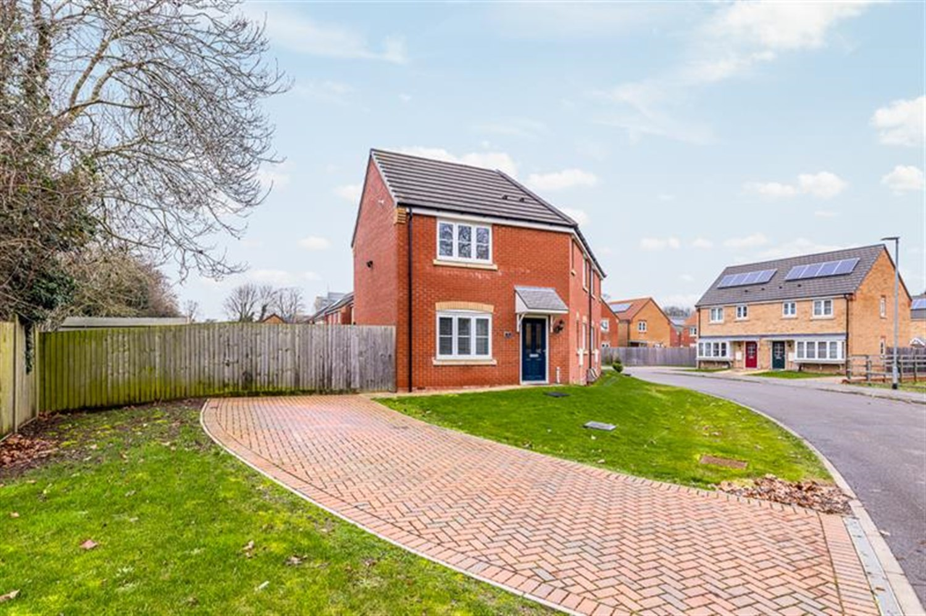




3 Bedroom(s)
1 Reception(s)
2 Bathroom(s)
£245,000
Blue Cedar Drive, PE21
EPC Rating ‘87 B’

- Modern 3 Bedroom House
- Corner Plot
- Close to the Pilgrim Hospital & Schools
- Kitchen/Diner & Lounge

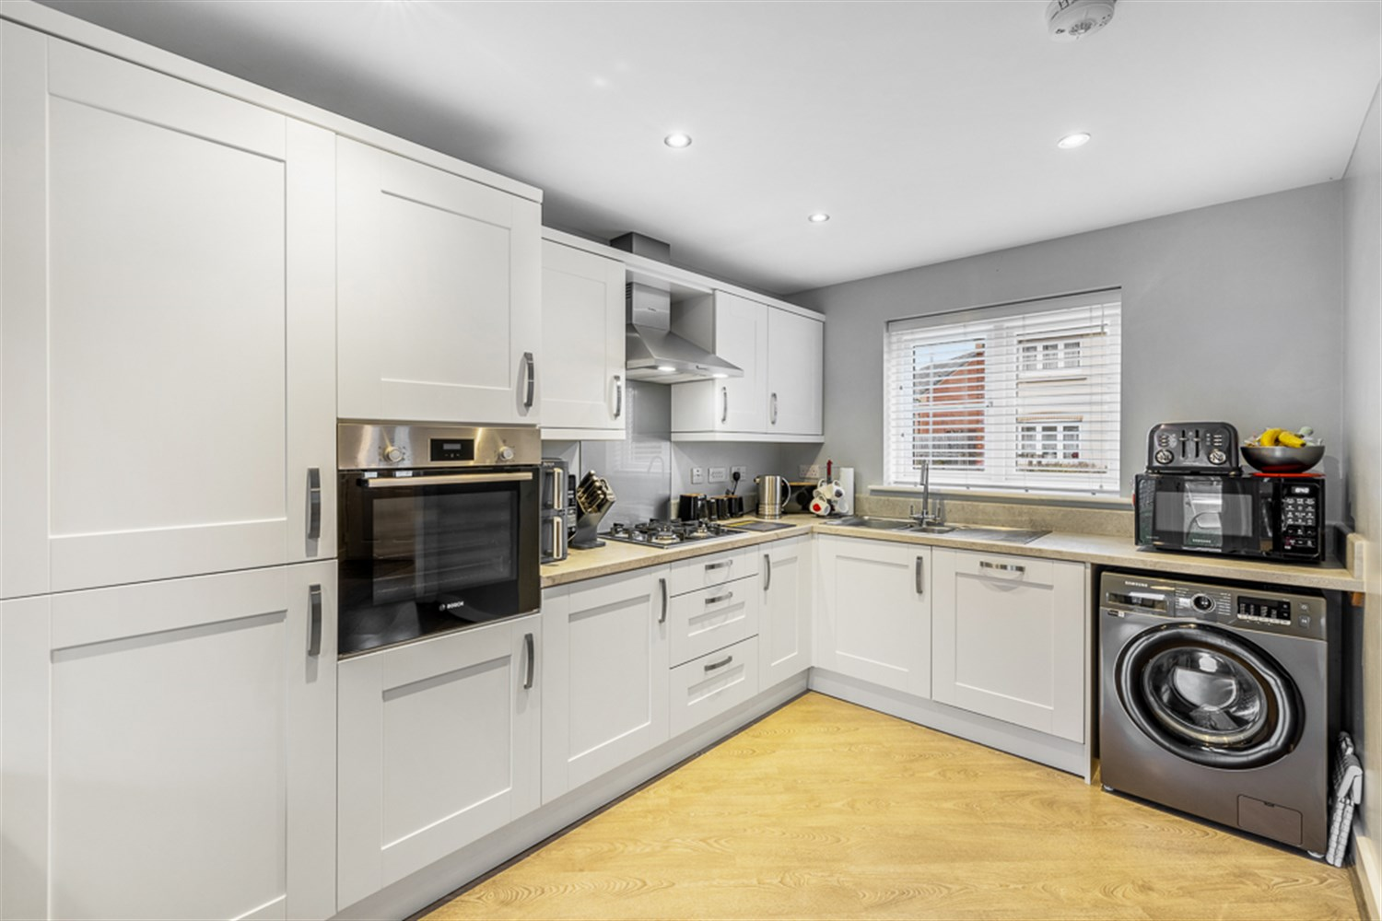
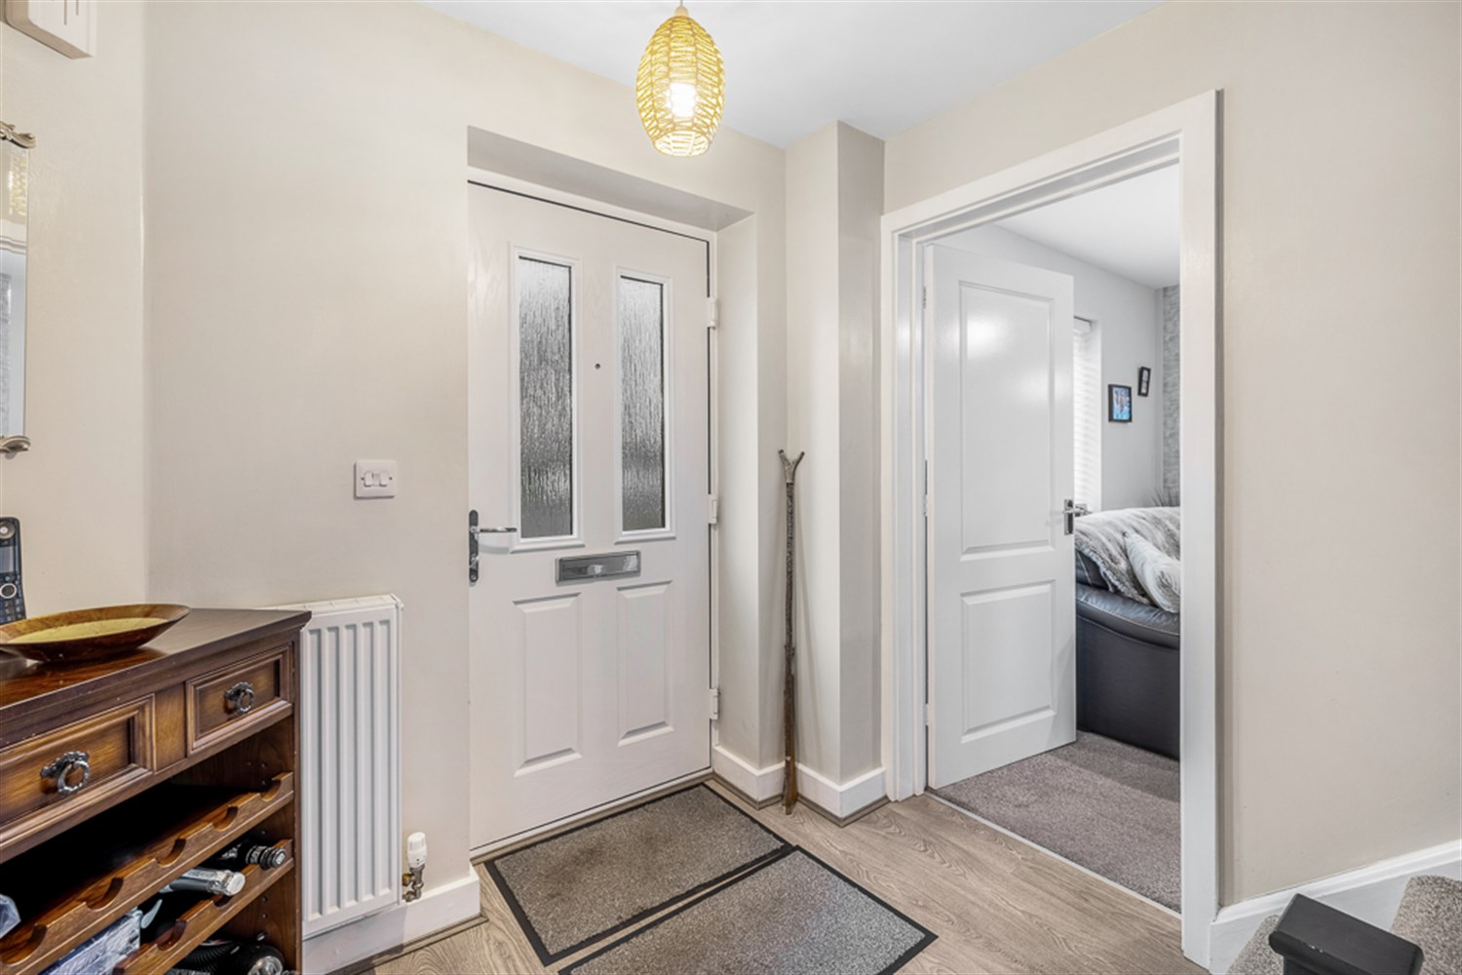
00
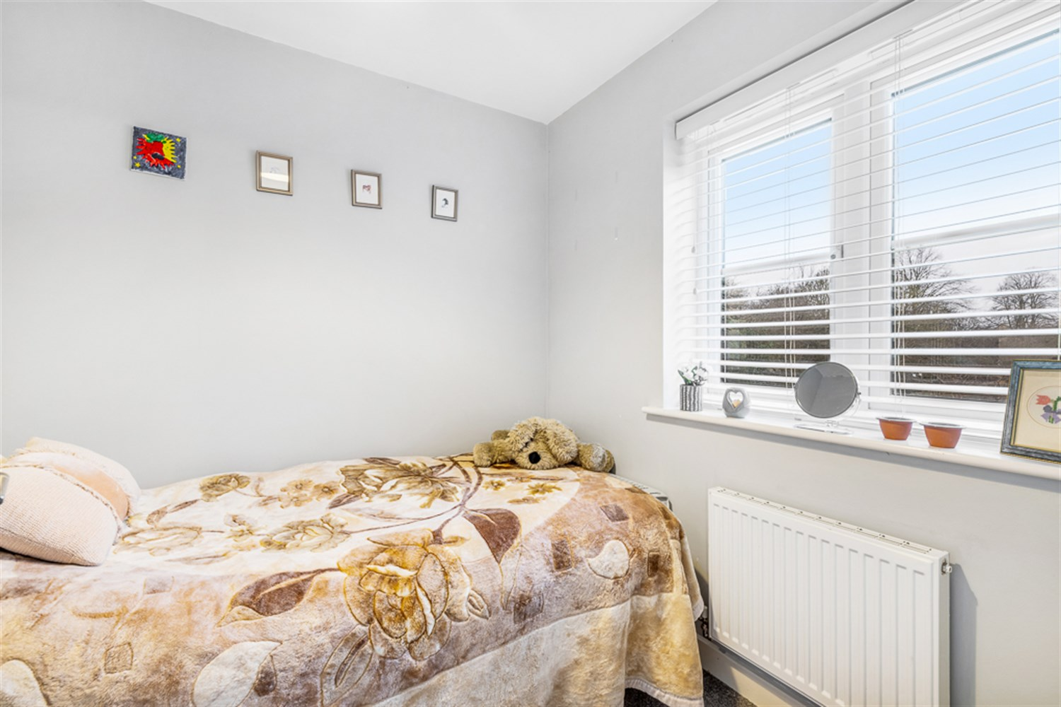
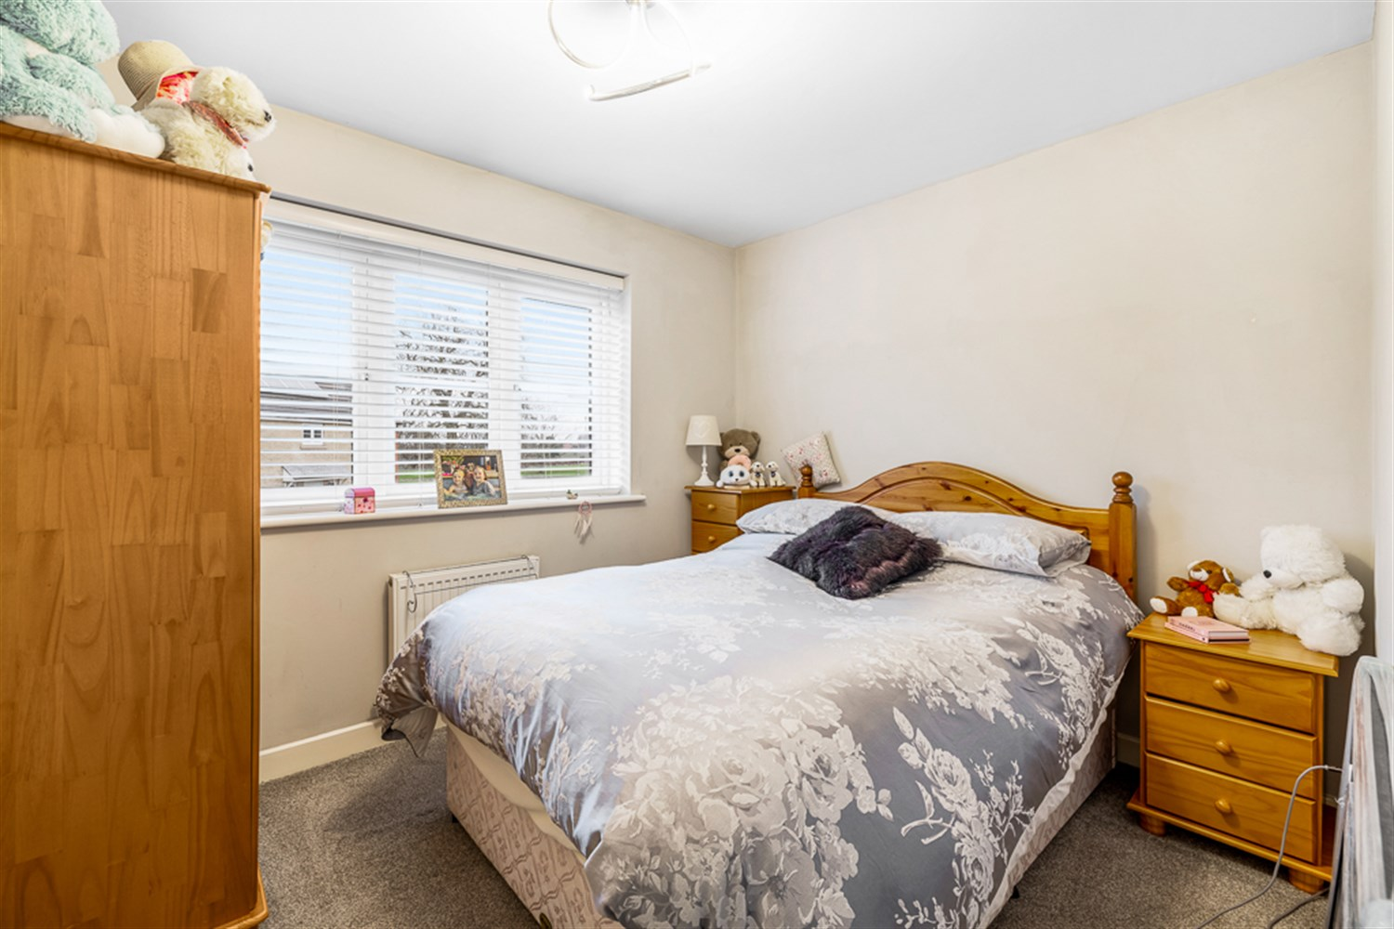
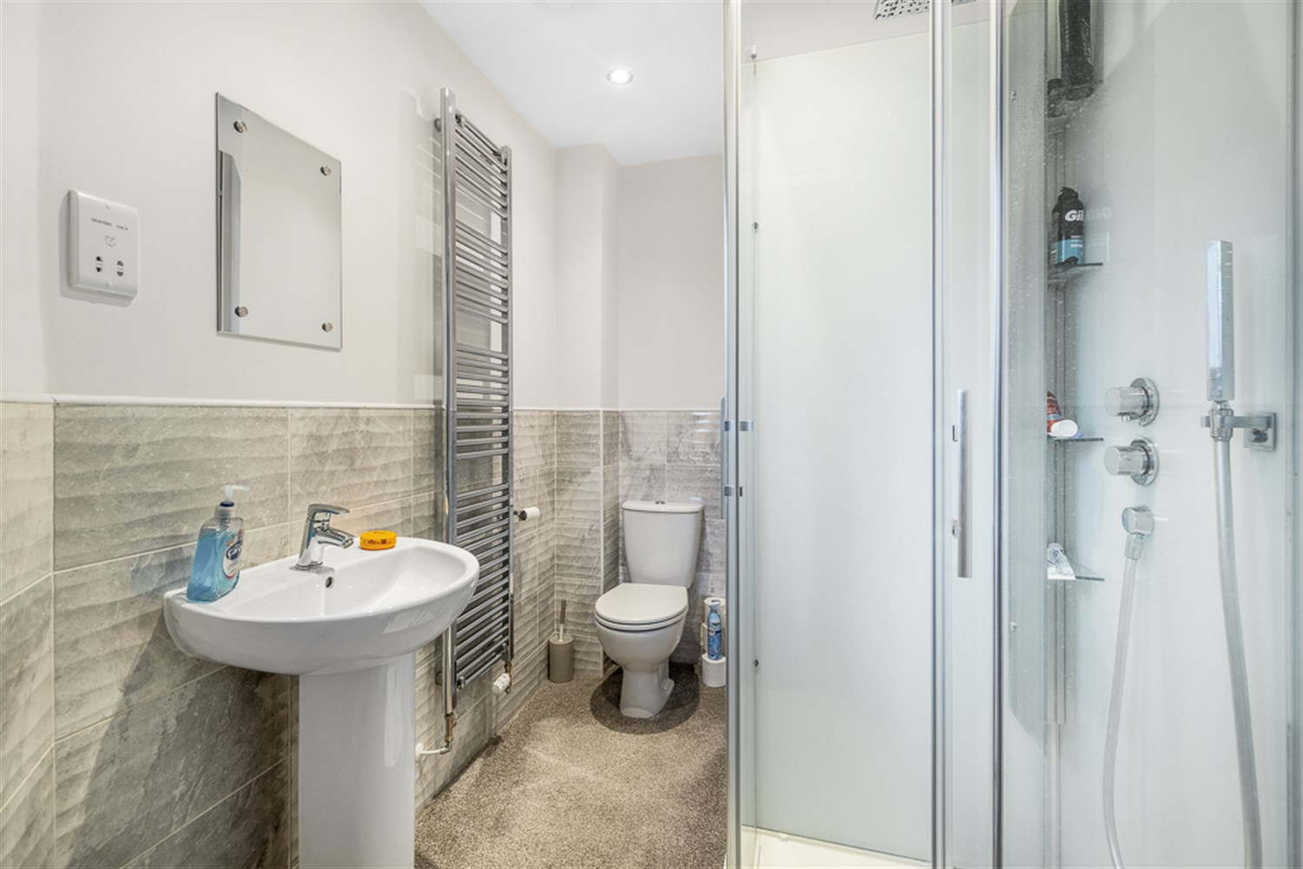
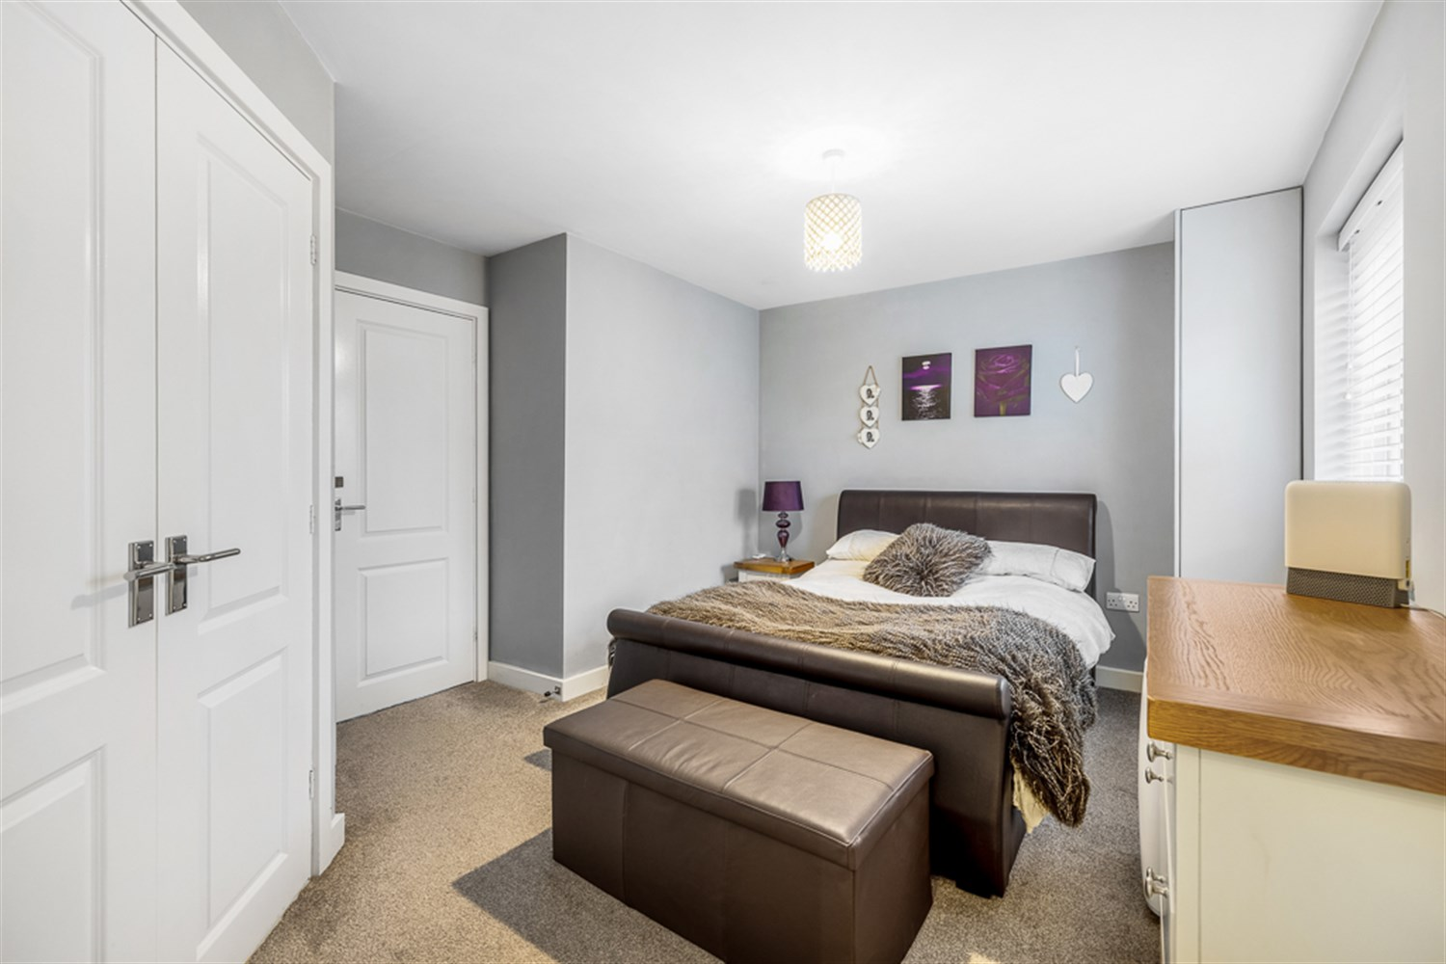
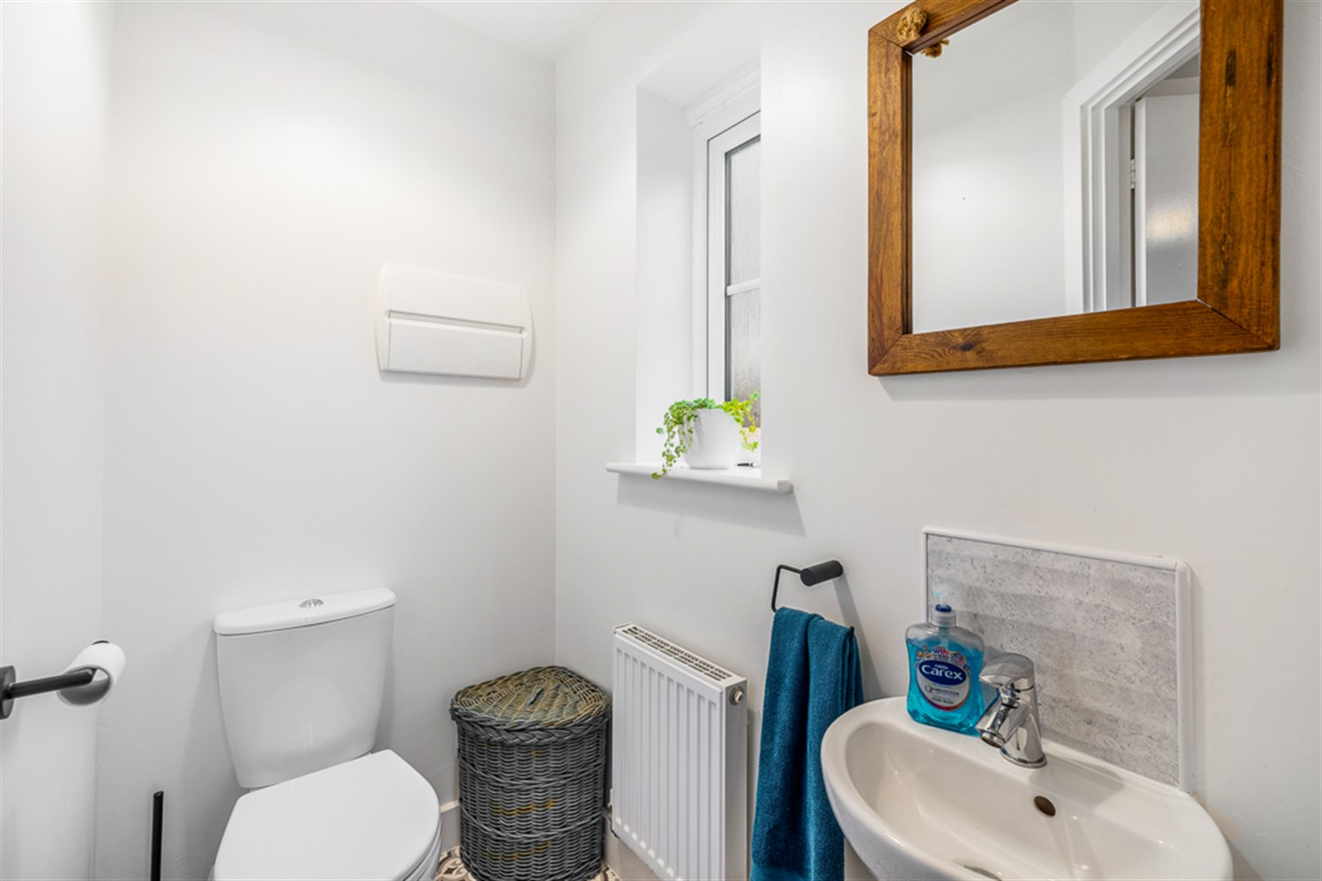
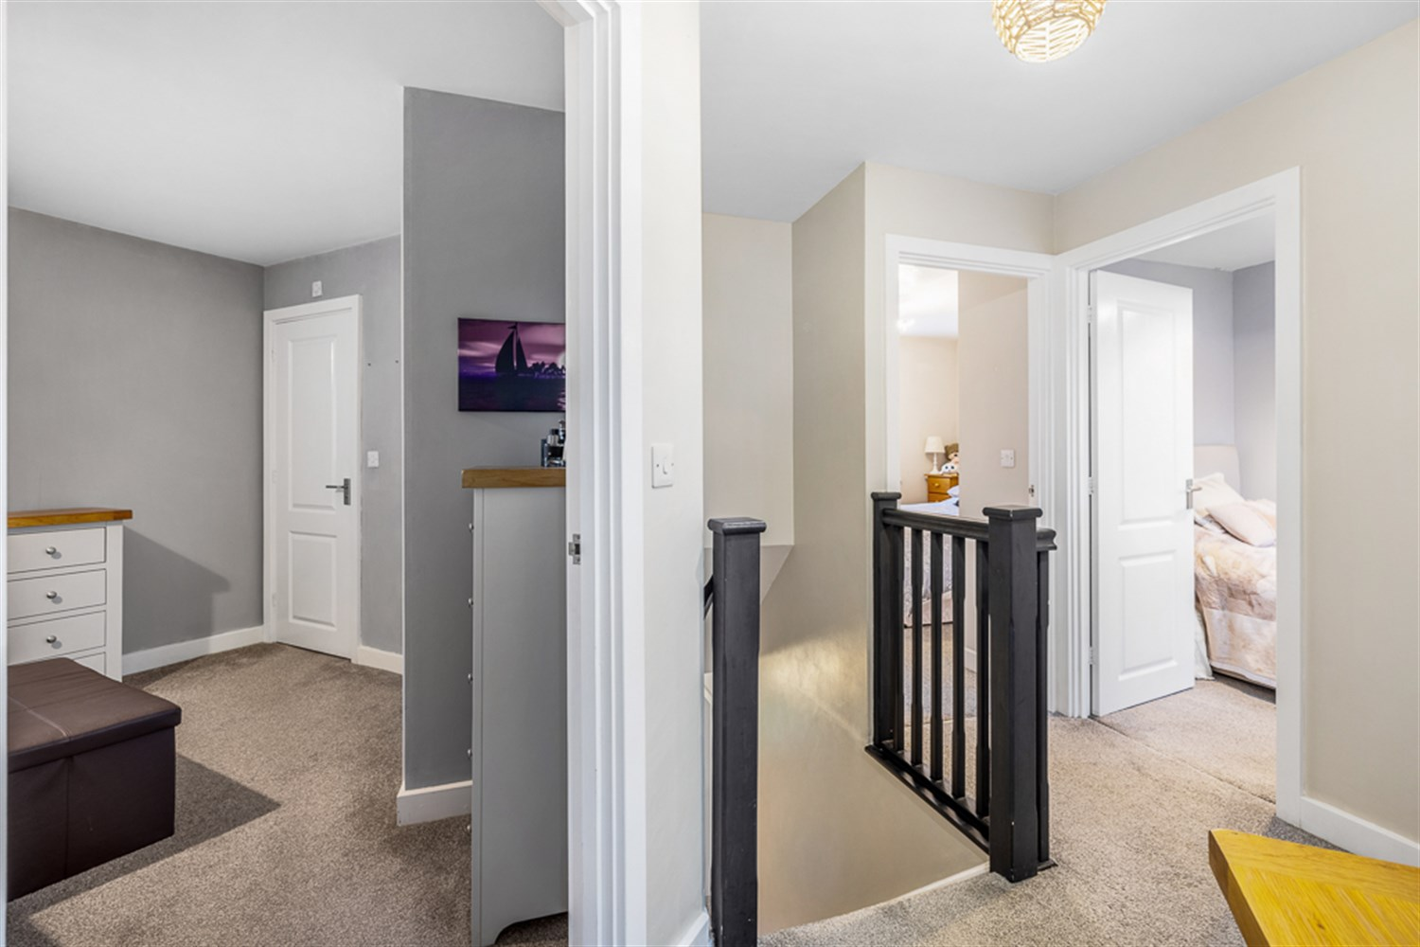
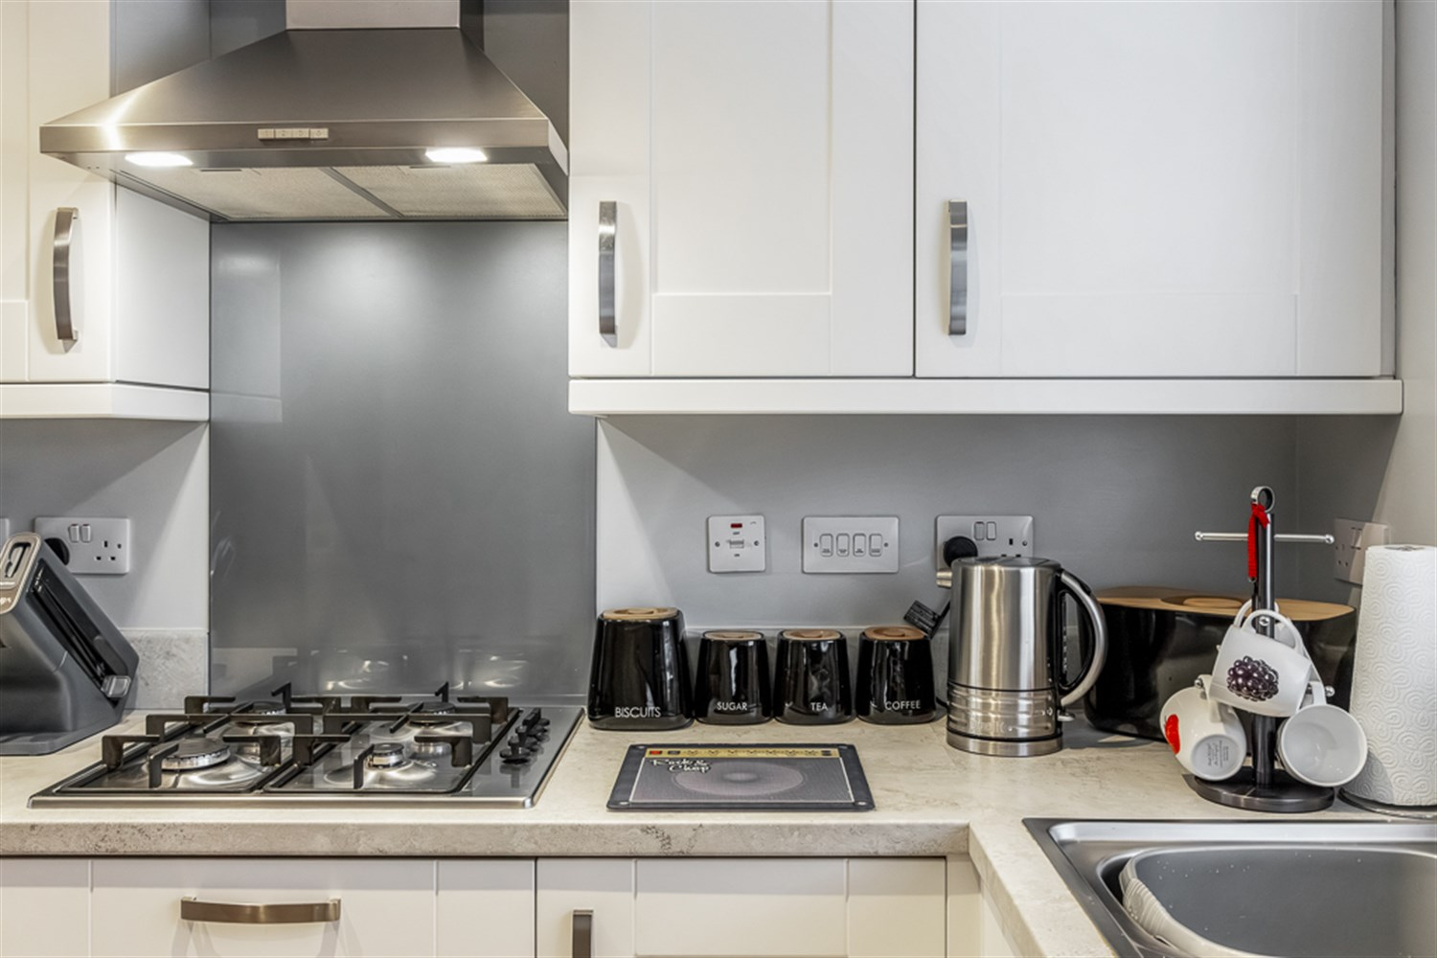
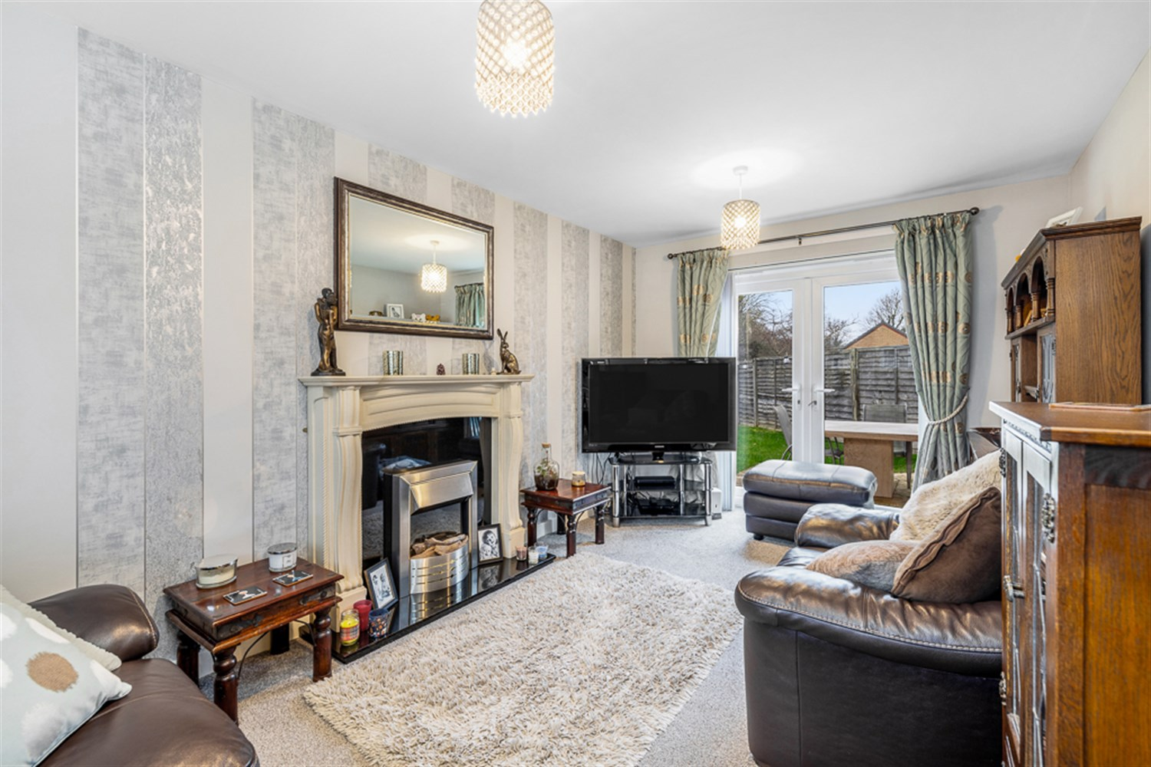

Property Description
This beautiful three bedroom property situated on a lovely corner plot, comprises of entrance hall, downstairs WC, lounge, and a dining kitchen with integrated appliances on the ground floor. Upstairs there is a master bedroom with en-suite, two further bedrooms, landing and a family bathroom. Outside, the property features a block-paved driveway offering off-road parking and an enclosed private rear garden, along with gas central heating and double glazing throughout. The property is situated close to Pilgrim Hospital, local schools and amenities. This property needs to be viewed to appreciate the perfect location with no close neighbour’s to the rear, gated access and green space.
EPC Rating: B

Entrance Hallway
This house feels very welcoming and has space for coats and shoes a staircase leading to the first floor with LVT Flooring and carpet to the stairs. Giving access to all the ground floor rooms.

Lounge 2.97m (9'9) x 4.95m (16'3)
With a sealed unit double-glazed uPVC window to the front elevation, sealed unit double-glazed uPVC French doors opening to the rear garden, double panelled radiator, television aerial connection point, and a fireplace with inset electric fire.

Dining Kitchen 2.54m (8'4) x 4.95m (16'3)
The kitchen and dining space is bright and well-proportioned, enjoying a uPVC double-glazed window to the front and double-glazed French doors opening directly onto the rear garden. The room is finished with laminate flooring, inset ceiling spotlights, and a radiator, creating a modern and practical living area.
The kitchen is fully fitted with a comprehensive range of contemporary base and wall units topped with coordinating work surfaces and upstands. Integrated appliances include a dishwasher, electric oven, fridge, freezer, and a gas hob with stainless steel extractor hood above. A 1¼ bowl stainless steel sink with mixer tap is set into the work surface, while additional space and plumbing are provided for an automatic washing machine. Storage is further enhanced by tall units offering cupboards above and below.
In addition there is ample room for a dining table, ideal for First time buyers or a family.
The doors open out onto the patio area and is perfect sun spot for entertaining.

Cloakroom
Featuring a sealed unit double-glazed uPVC window to the front elevation, together with a close-coupled WC and hand basin.

First Floor Landing
Having sealed unit double glazed uPVC window to rear elevation, access to all bedroom, bathroom and loft space.

Master Bedroom 2.95m (9'8) x 3.96m (13')
A great sized double room with natural light is provided via a front-facing uPVC double-glazed window, with fitted wardrobe storage and a radiator completing the space. This room also leads onto the ensuite shower room.

En - Suite 1.75m (5'9) x 2.06m (6'9)
This contemporary bathroom is stylishly appointed and benefits from a front-aspect uPVC double-glazed window, recessed ceiling spotlights, a sleek chrome heated towel rail, and coordinated tiled finishes. The space is completed by a crisp white suite comprising a fully tiled shower enclosure with modern mixer shower, pedestal wash hand basin, and close-coupled WC.

Bedroom 2 2.59m (8'6) x 3.02m (9'11)
This room enjoys natural light from a front-facing uPVC double-glazed window and is finished with a radiator. A built-in storage cupboard discreetly houses the gas-fired boiler, which serves both the domestic hot water system and central heating. This is another good sized double room, Ideal for families or as a guest room.

Bedroom 3 2.03m (6'8) x 2.26m (7'5)
The room benefits from a rear-facing uPVC double-glazed window providing natural light, together with a radiator for comfort.

Family Bathroom 1.75m (5'9) x 1.88m (6'2)
This well-appointed bathroom enjoys a rear-aspect uPVC double-glazed window, recessed ceiling spotlights, a convenient shaver point, and coordinated tiled finishes. The white bathroom suite comprises a panelled bath with mixer tap and shower attachment, pedestal wash hand basin, and close-coupled WC.

Rear Garden
The rear garden is fully enclosed with timber fencing and is primarily laid to lawn, complemented by a paved patio area, a decked seating space, and a garden shed. There are trees behind the fence making this very private at the bottom with no close neighbours at the rear.

Greenspace
There is a lovely green space on the development suitable for walking and a children's play area. This is also a gated community.

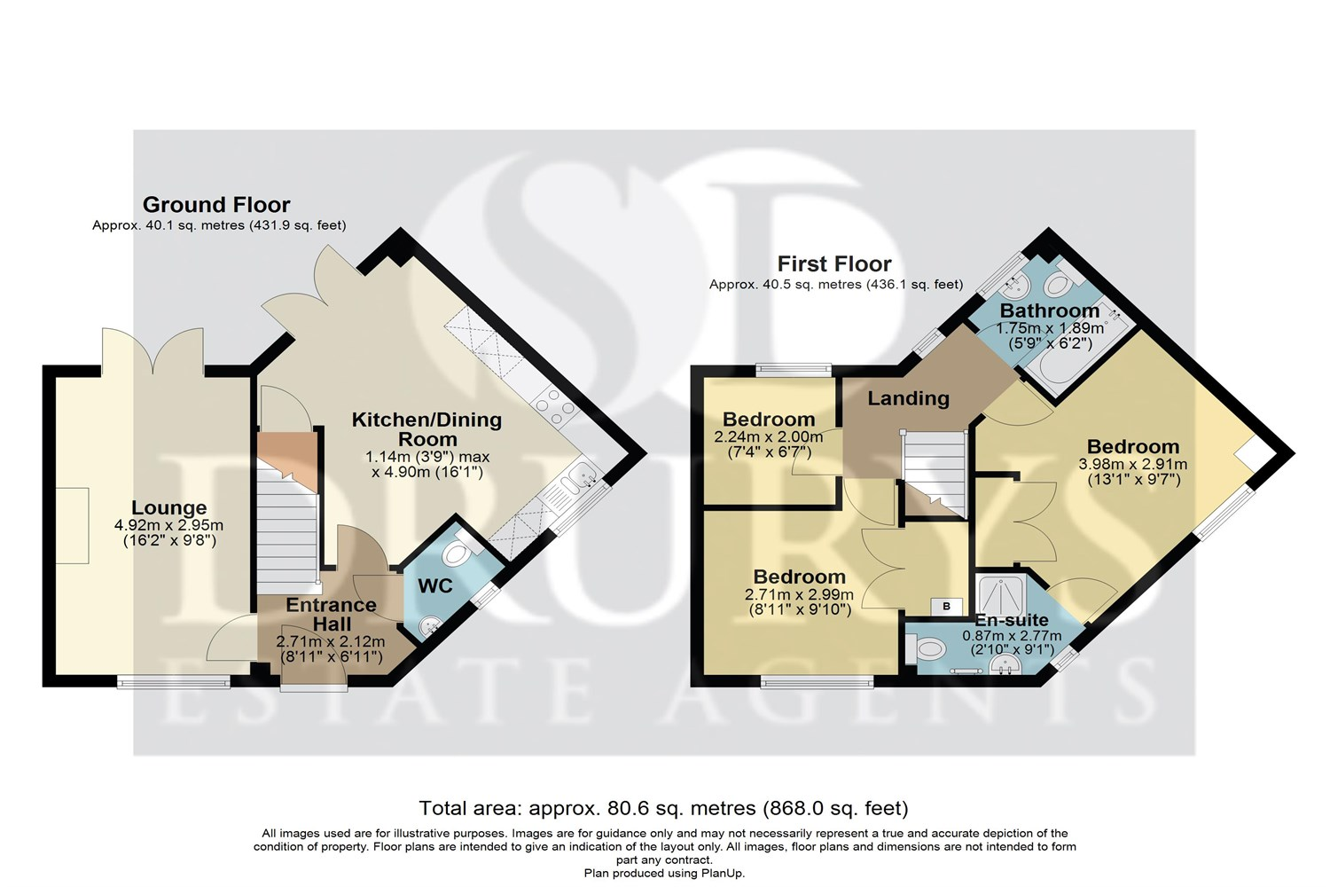

These particulars are intended to give a fair description of the property, but their accuracy cannot be guaranteed, and they do not constitute an offer of contract. Intending purchasers must rely on their own inspection of the property. None of the above appliances/services have been tested by ourselves. We recommend purchasers arrange for a qualified person to check all appliances/services before legal commitment.

Property Ref: 3199

www.drurysestateagents.co.uk
amber@drurysestateagents.co.uk
01205 350889

45 Willoughby Road
Boston
Lincolnshire
PE21 9HN
Agents Note: Whilst every care has been taken to prepare these sales particulars, they are for guidance purposes only. All measurements are approximate are for general guidance purposes only and whilst every care has been taken to ensure their accuracy, they should not be relied upon and potential buyers are advised to recheck the measurements

