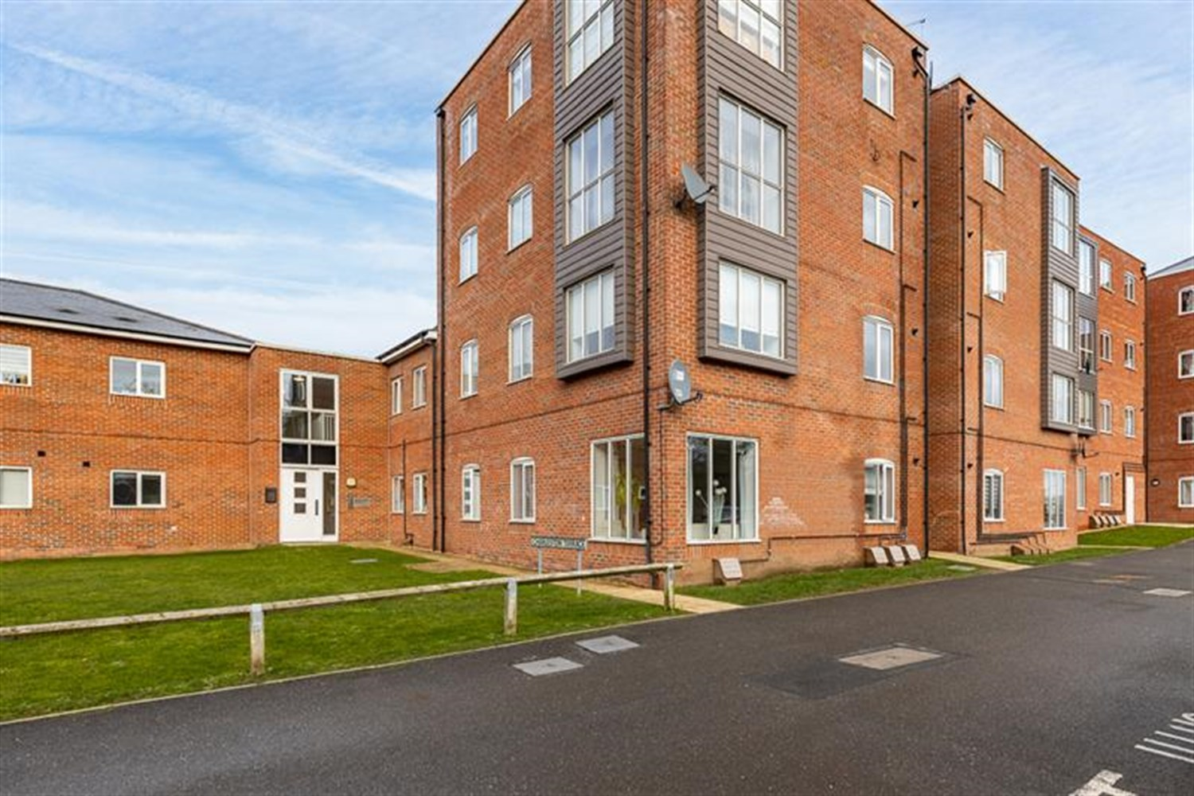




2 Bedroom(s)
1 Reception(s)
1 Bathroom(s)
£114,950.00
Haven Village, PE21
EPC Rating ‘’

- GROUND FLOOR FLAT
- OPEN PLAN KITCHEN/DINING/LIVING AREA
- TWO DOUBLE BEDROOMS
- ALLOCATED PARKING SPACE

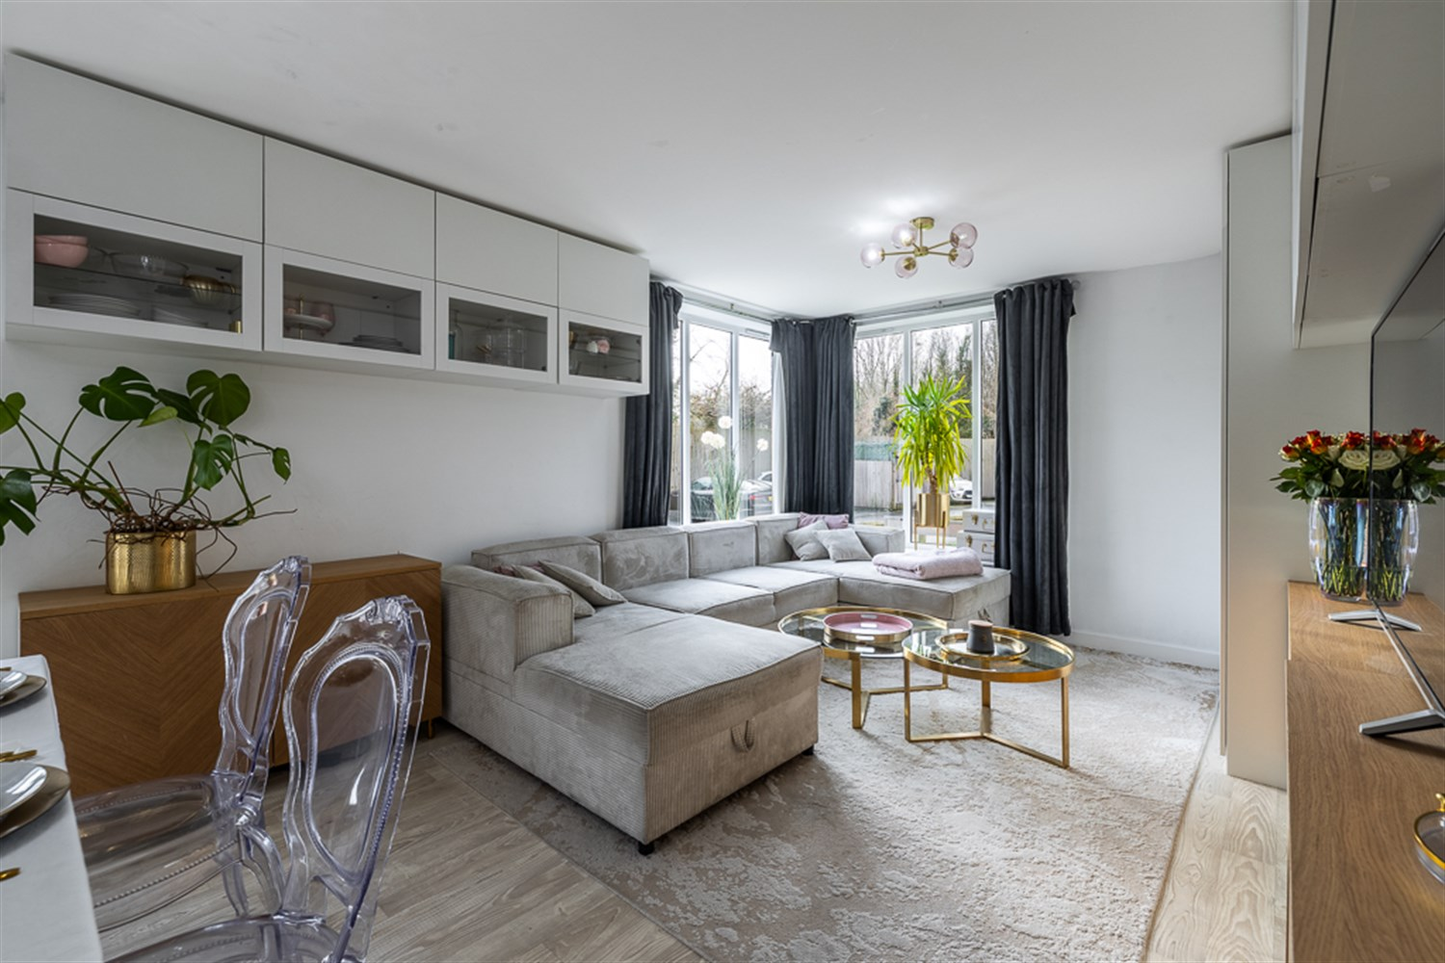
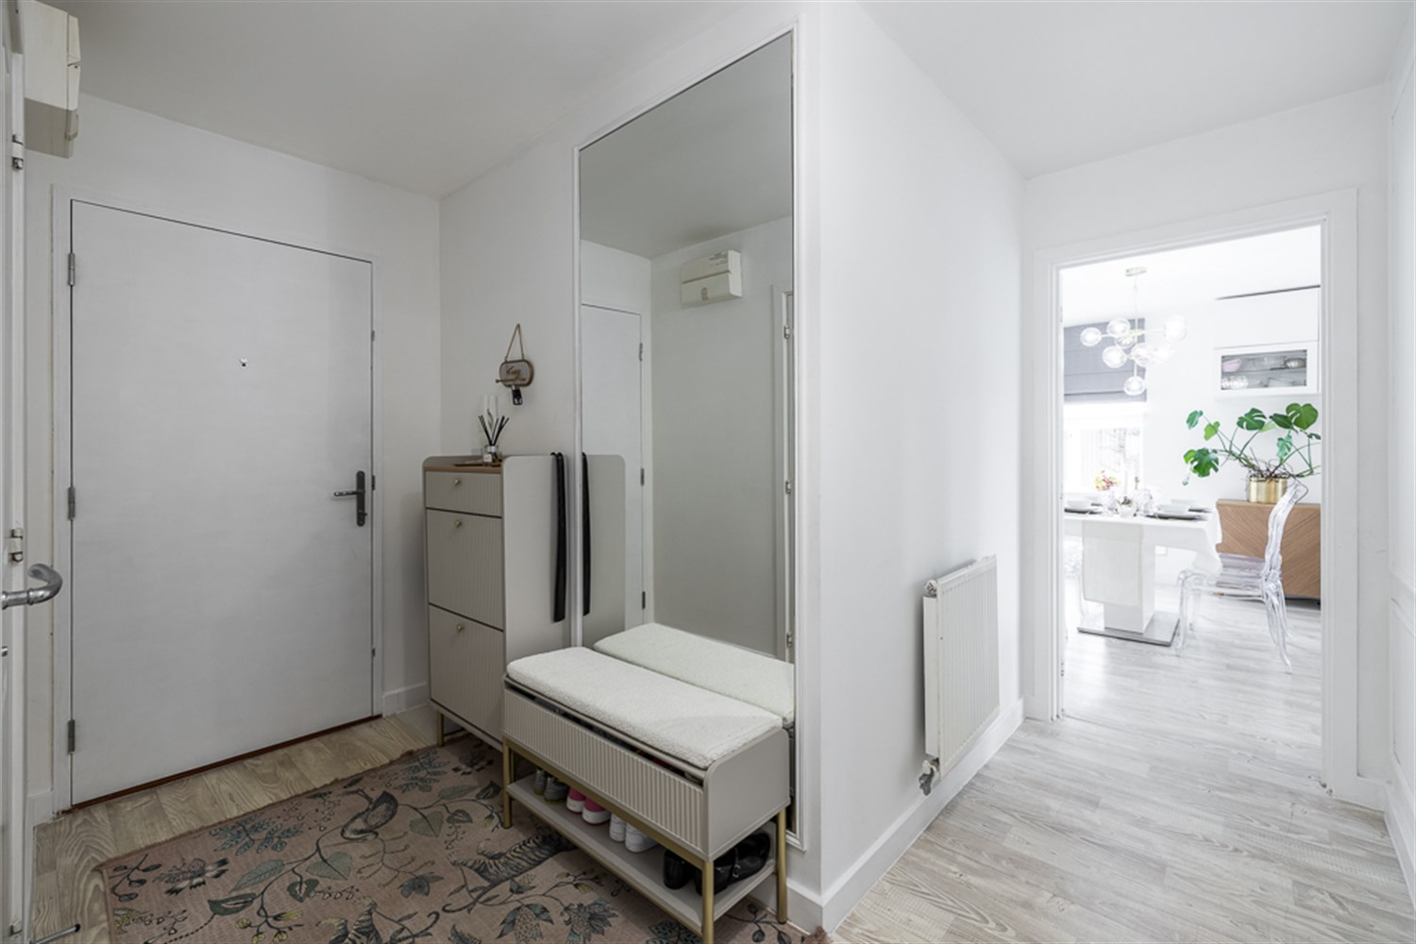
00
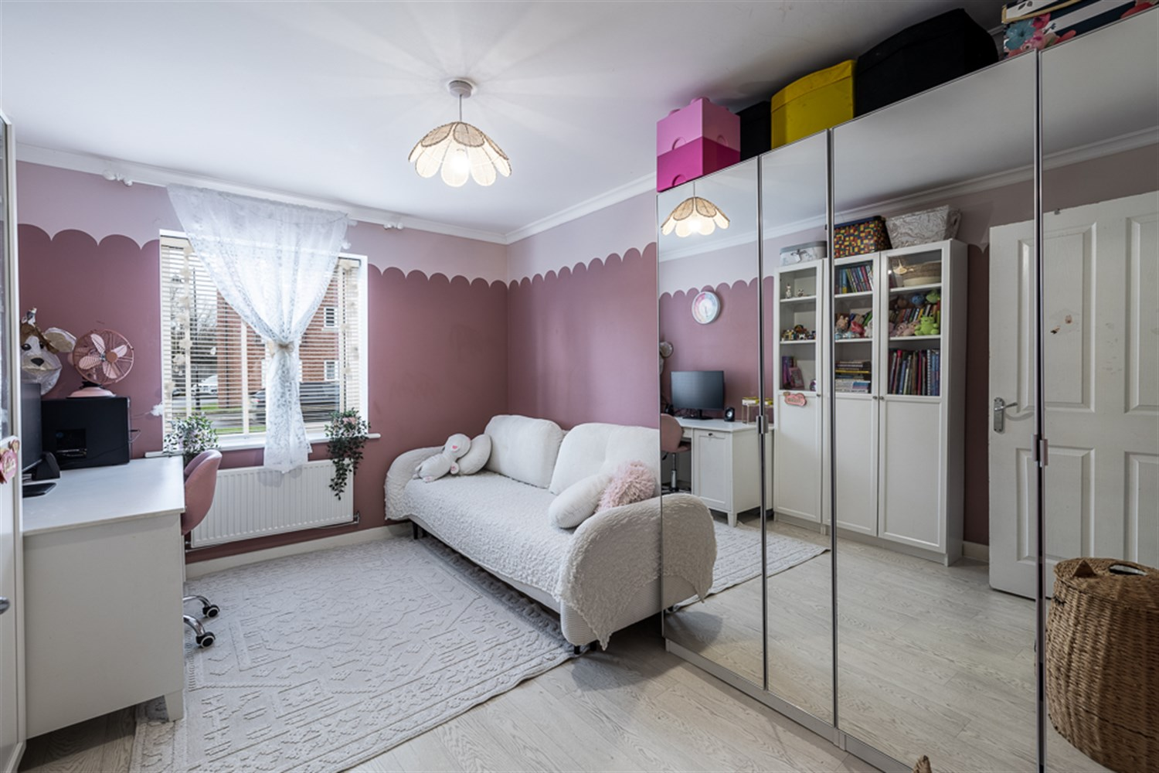
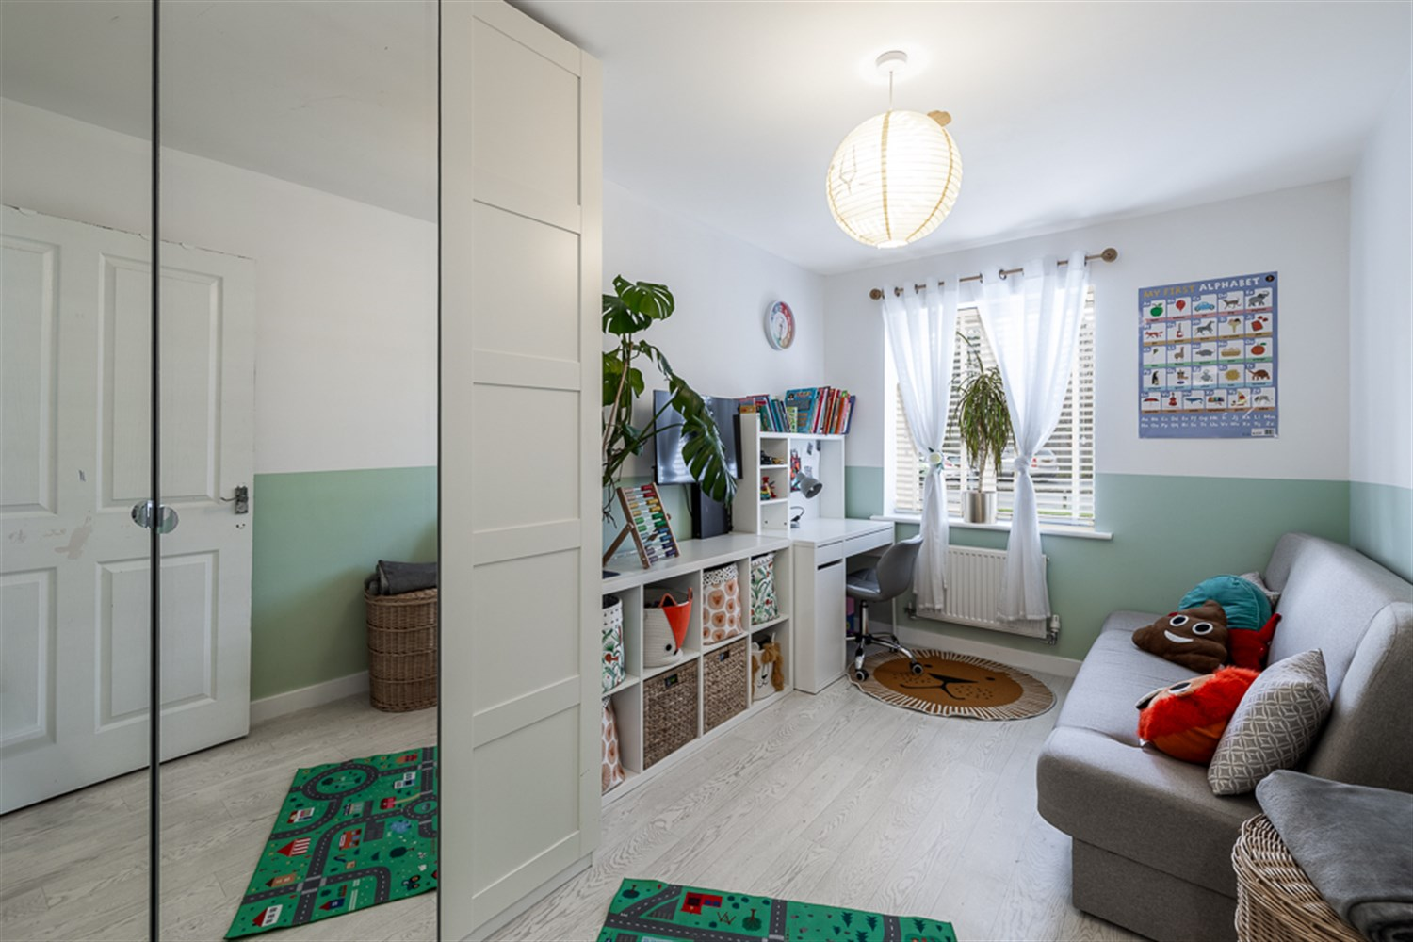
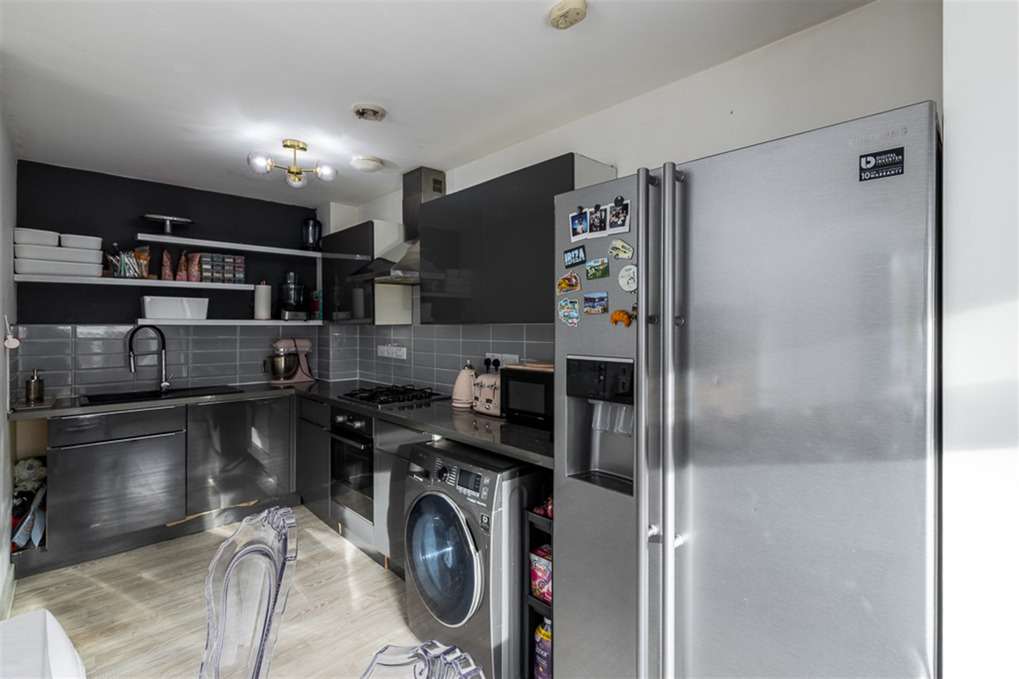
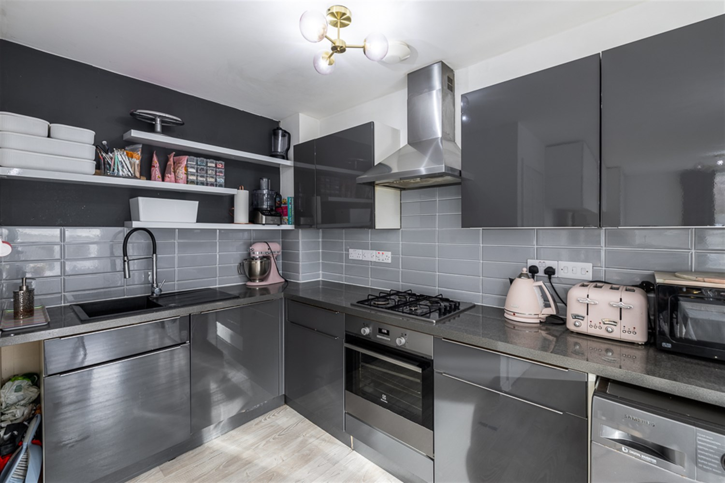

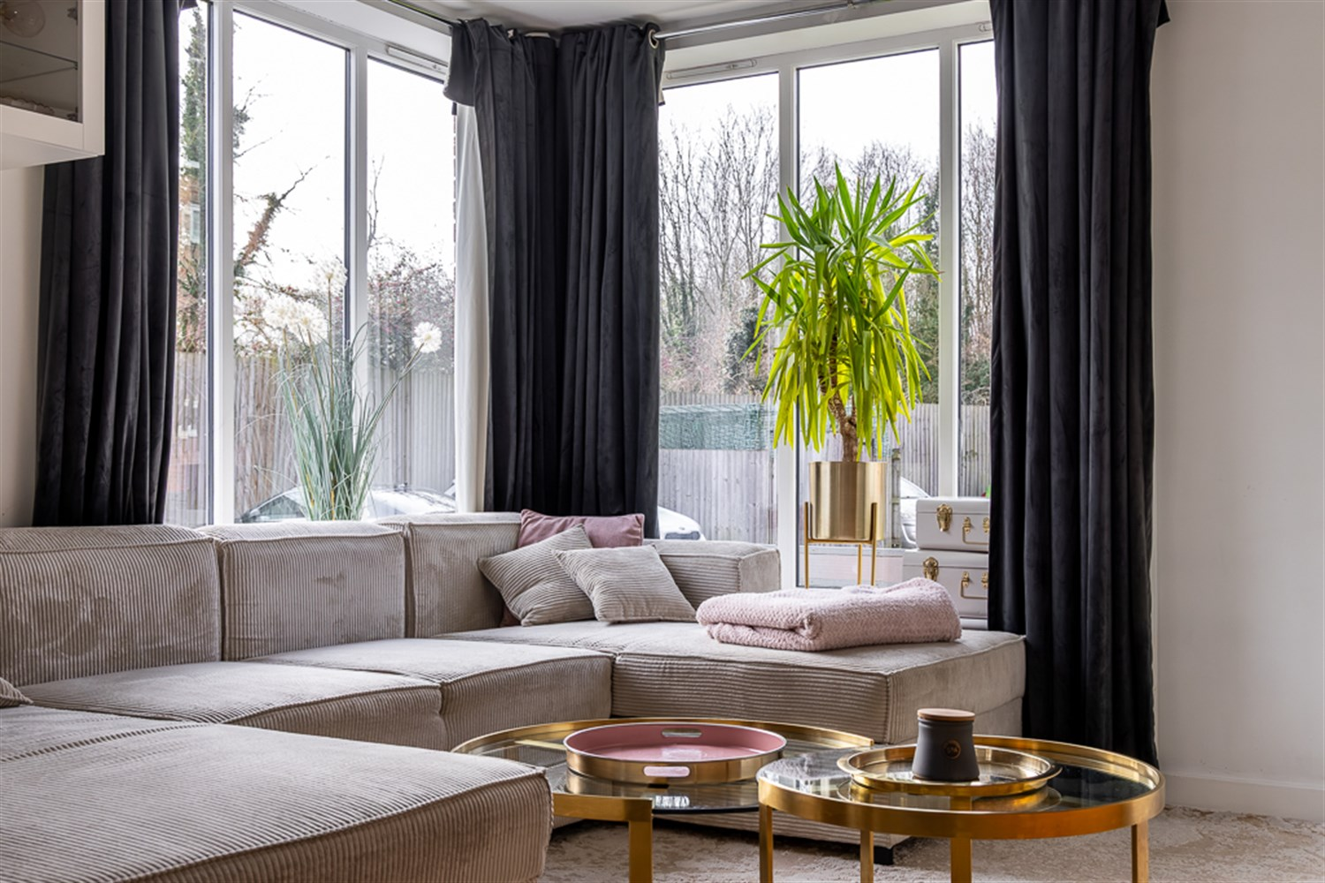
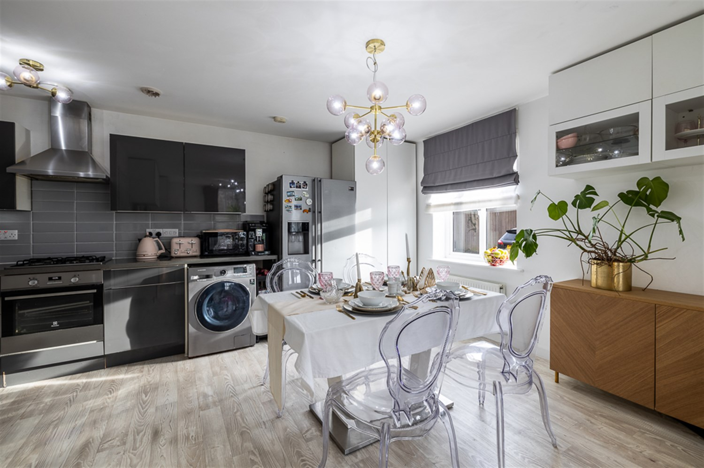
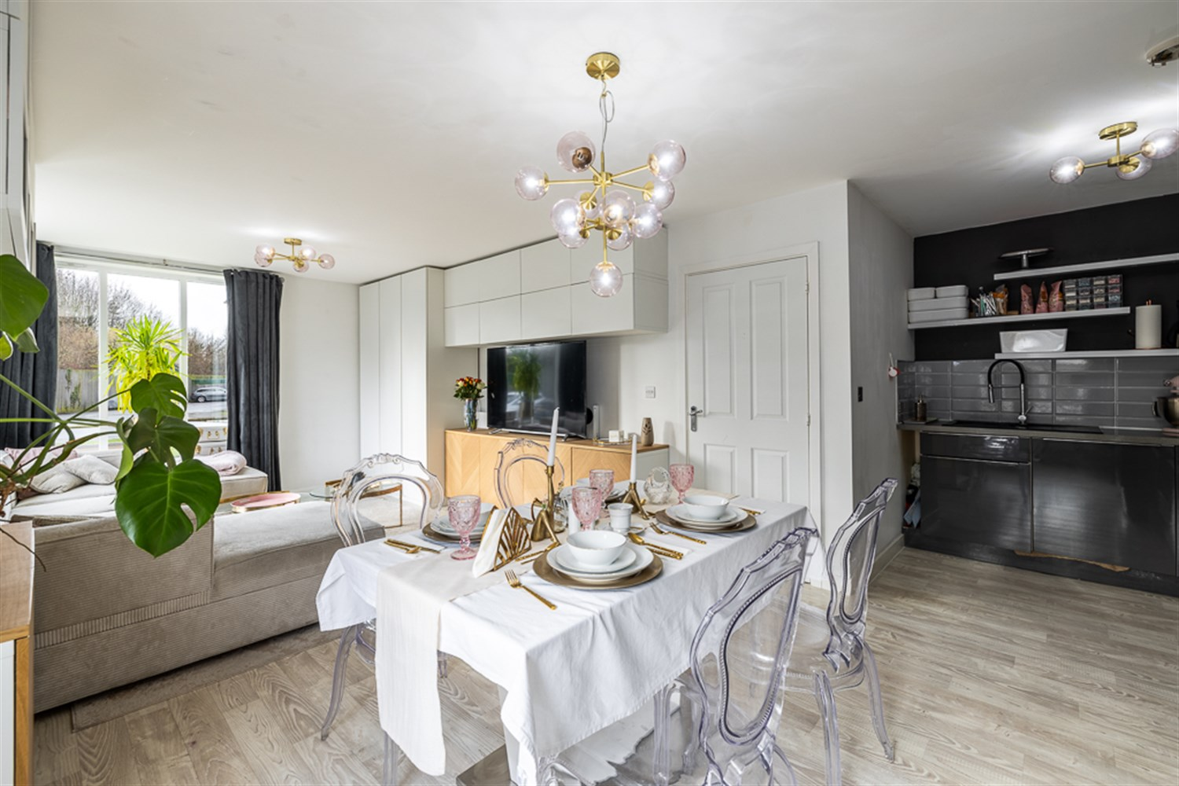

Property Description
Drury's are proud to present this neutrally decorated modern ground floor flat available for sale, ideal for first-time buyers and investors alike. The property features a pair of double bedrooms, providing ample storage space, bathroom, open plan kitchen/diner and lounge.
In terms of energy efficiency, the flat boasts an impressive EPC rating of B, indicating that it is economical to run. It falls within council tax band A, making it an affordable choice for those looking to keep their living costs low. Furnishings can be available under separate negotiation.
The flat is conveniently located with excellent public transport links close by, making commuting or travelling to town in a few minutes.
In conclusion, this two-bedroom flat offers a neutral and modern living space in a convenient location. It's perfect for those looking to step onto the property ladder or investors seeking a property with good potential returns.

Entrance Hallway
Telecom secure entrance system, allocated parking for one car and visitor parking.

Hallway
Recessed spotlights, radiator, bright white/grey wood effect vinyl flooring and doors leading to both double bedrooms, living/dining/kitchen area, bathroom and storage cupboard.

Lounge/Dining Area
Recessed spotlights, double glazed double aspect uPVC windows to the front and side, creating an abundance of light, radiators and a continuation of the wood effect vinyl flooring. The furniture

Kitchen
Recessed spotlights, eye and base level units with worktop over, integrated electric oven with gas hob and extractor hood over, integrated dishwasher and space for an American fridge freezer, washing machine, inset sink unit with dual mixer tap and spray, space for a dining table and vinyl wood effect flooring. This room is the hub of the property and is full of light and has a really modern feel with plenty of storage.

Bedroom 1
Double room with centre light point, uPVC window to the side aspect, plenty of space for wardrobes, radiator and a continuation of the flooring.

Bedroom 2
Another double room with centre light point, uPVC window to the side aspect, plenty of space for wardrobes, radiator and a continuation of the flooring.

Bathroom
Recessed spotlights, matching three piece suite comprising of white panelled bath, pedestal hand wash basin and low level wc, radiator, extractor fan, storage cupboard and vinyl flooring.

Storage Cupboard
Having an abundance of space and shelving.

Communal Garden
There is a communal green space in Haven Village. The ground rent is £100 per annum and the current service charge is £194.56 per month.

Parking
Allocated parking space and Visitor space.

Central Heating
Gas boiler is situated in the kitchen area.

Double Glazing
Throughout the property

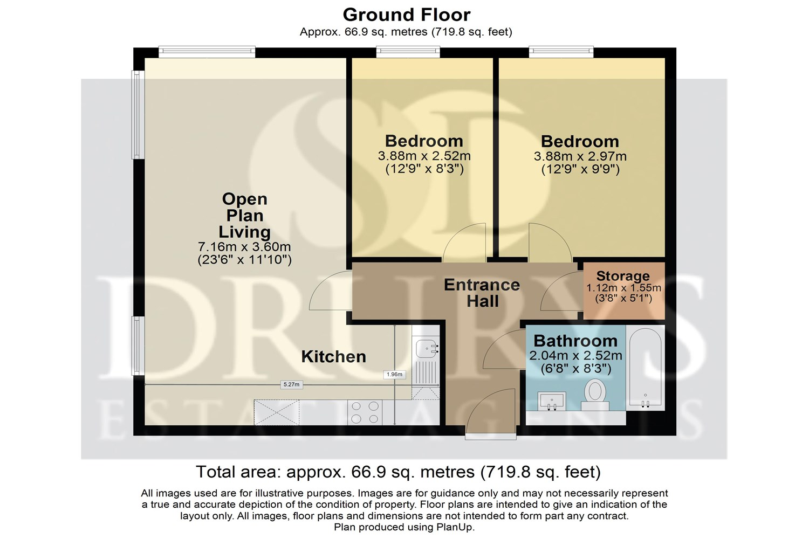

These particulars are intended to give a fair description of the property, but their accuracy cannot be guaranteed, and they do not constitute an offer of contract. Intending purchasers must rely on their own inspection of the property. None of the above appliances/services have been tested by ourselves. We recommend purchasers arrange for a qualified person to check all appliances/services before legal commitment.

Property Ref: 3184

www.drurysestateagents.co.uk
amber@drurysestateagents.co.uk
01205 350889

45 Willoughby Road
Boston
Lincolnshire
PE21 9HN
Agents Note: Whilst every care has been taken to prepare these sales particulars, they are for guidance purposes only. All measurements are approximate are for general guidance purposes only and whilst every care has been taken to ensure their accuracy, they should not be relied upon and potential buyers are advised to recheck the measurements

