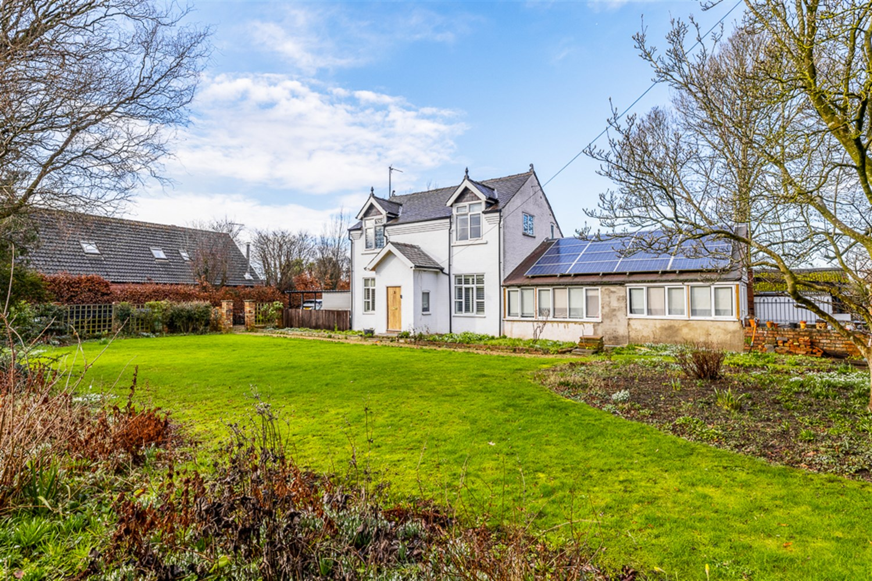




3 Bedroom(s)
2 Reception(s)
1 Bathroom(s)
£365,000.00
Garfits Lane, PE21
EPC Rating ‘’

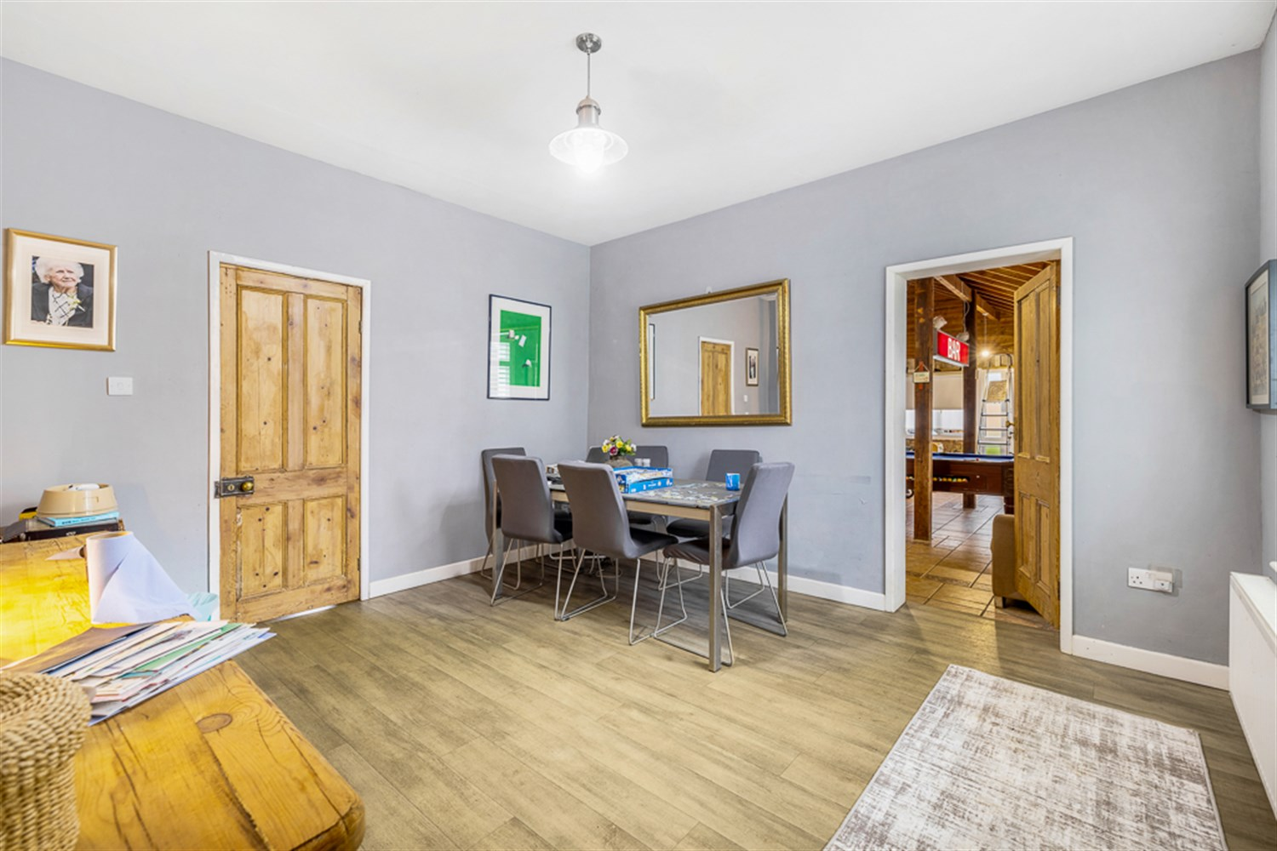
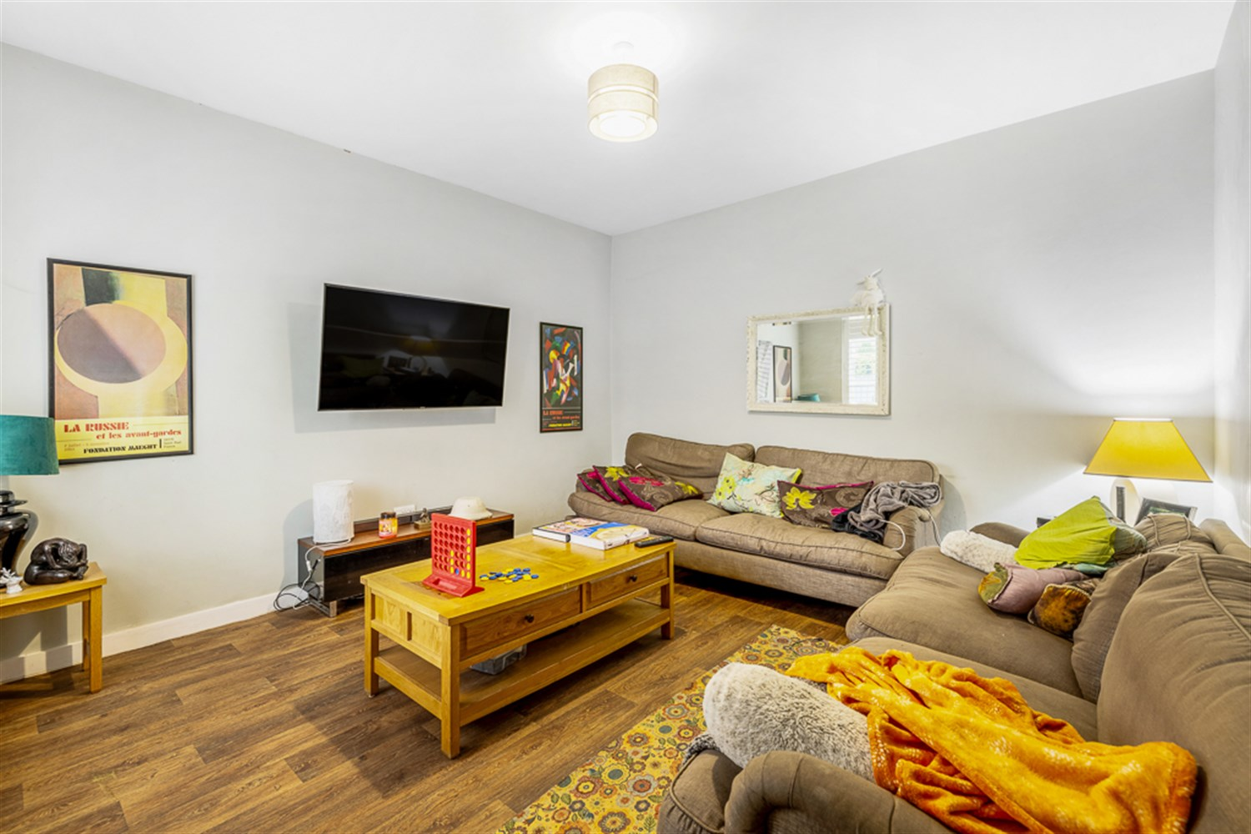
00
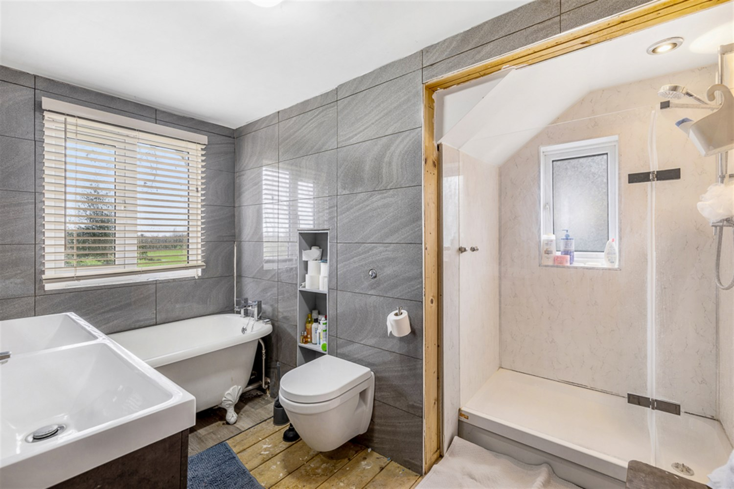
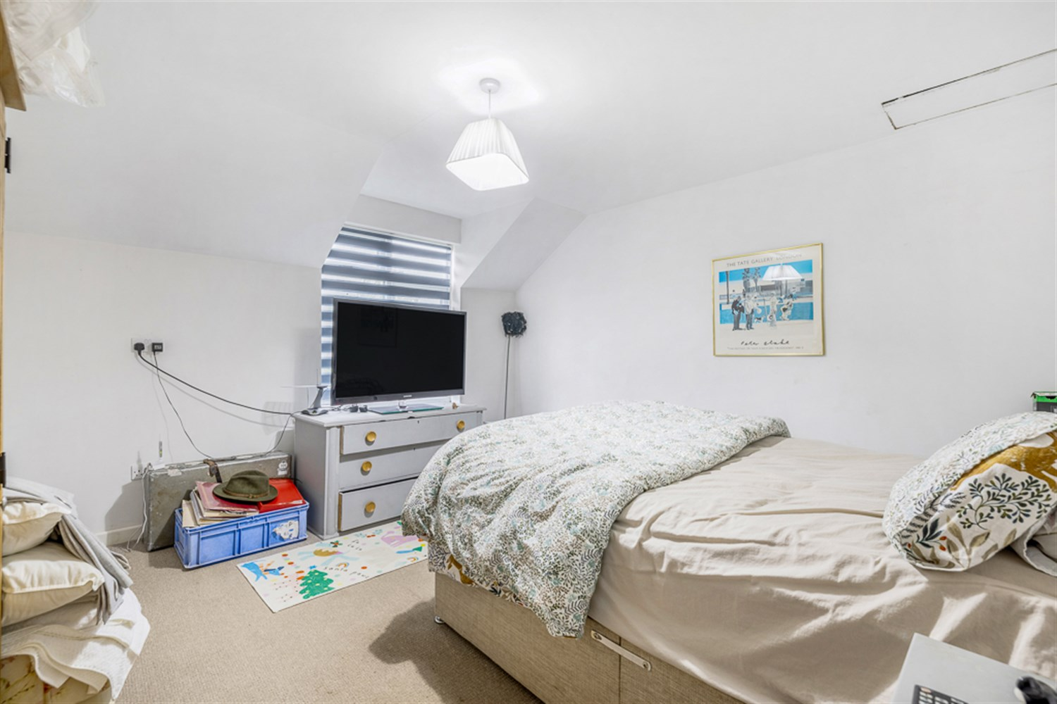
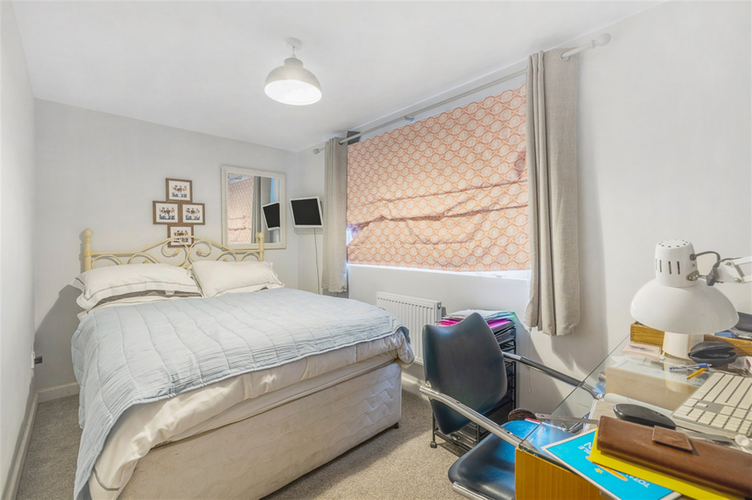
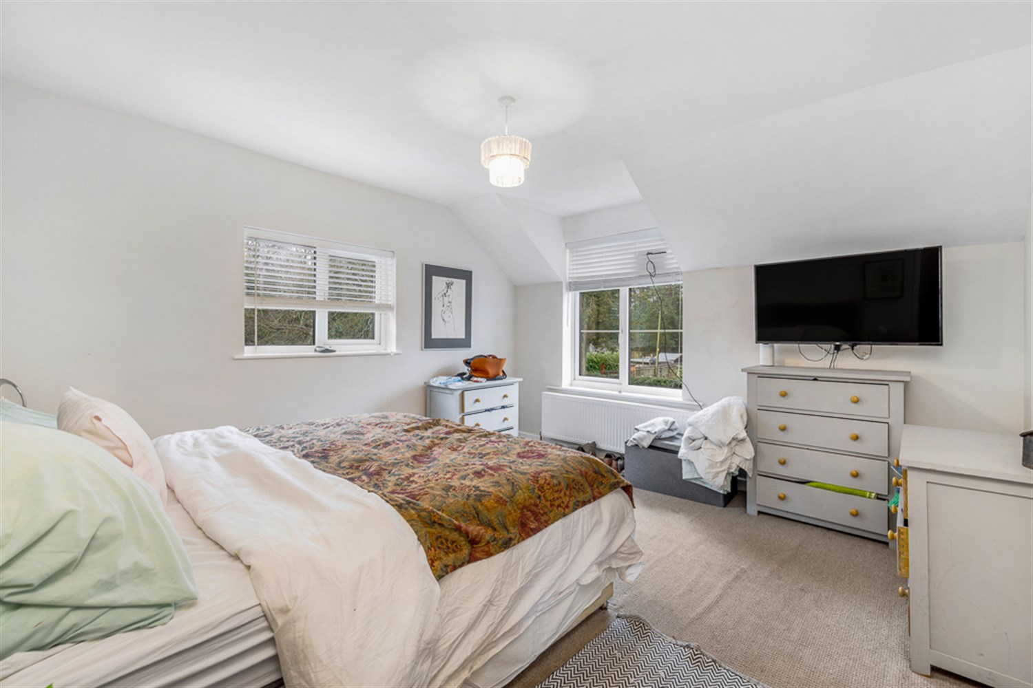
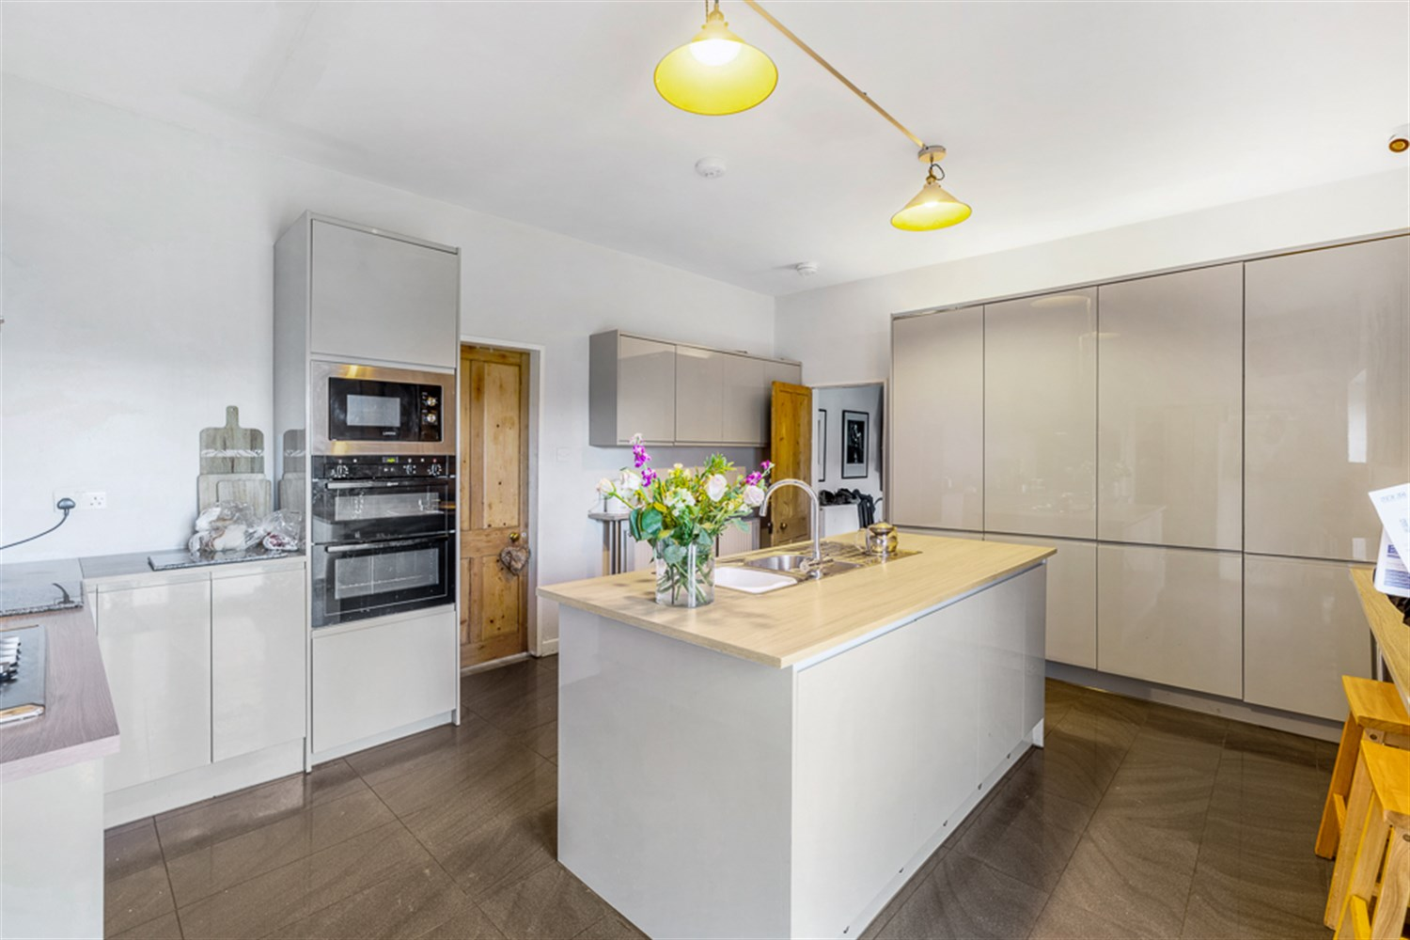
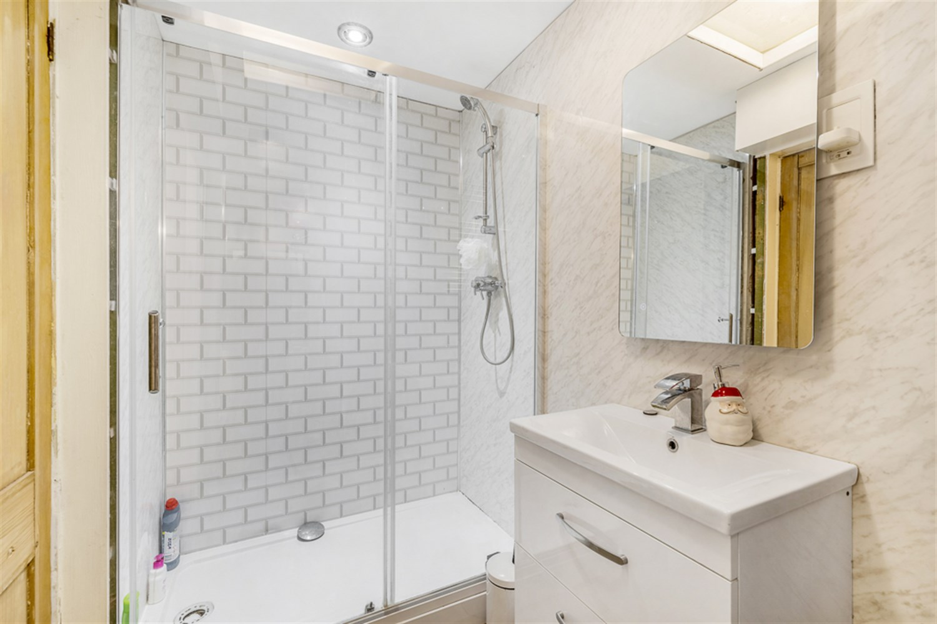
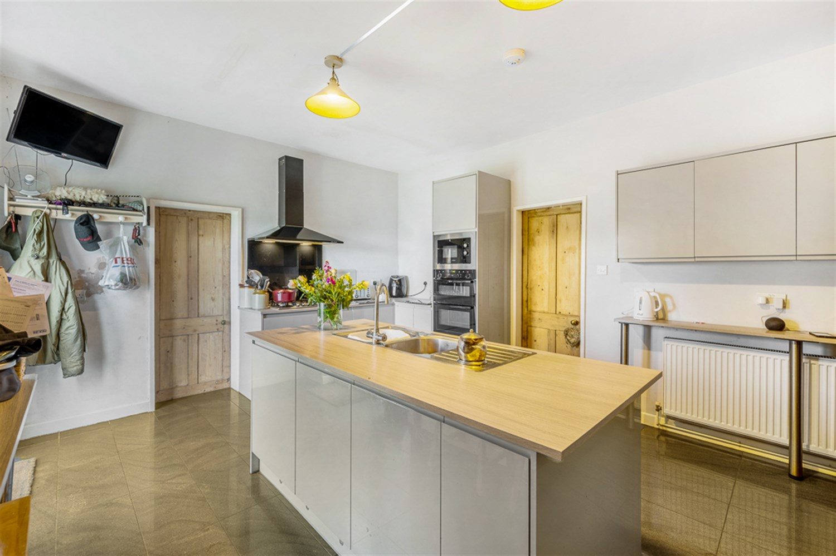
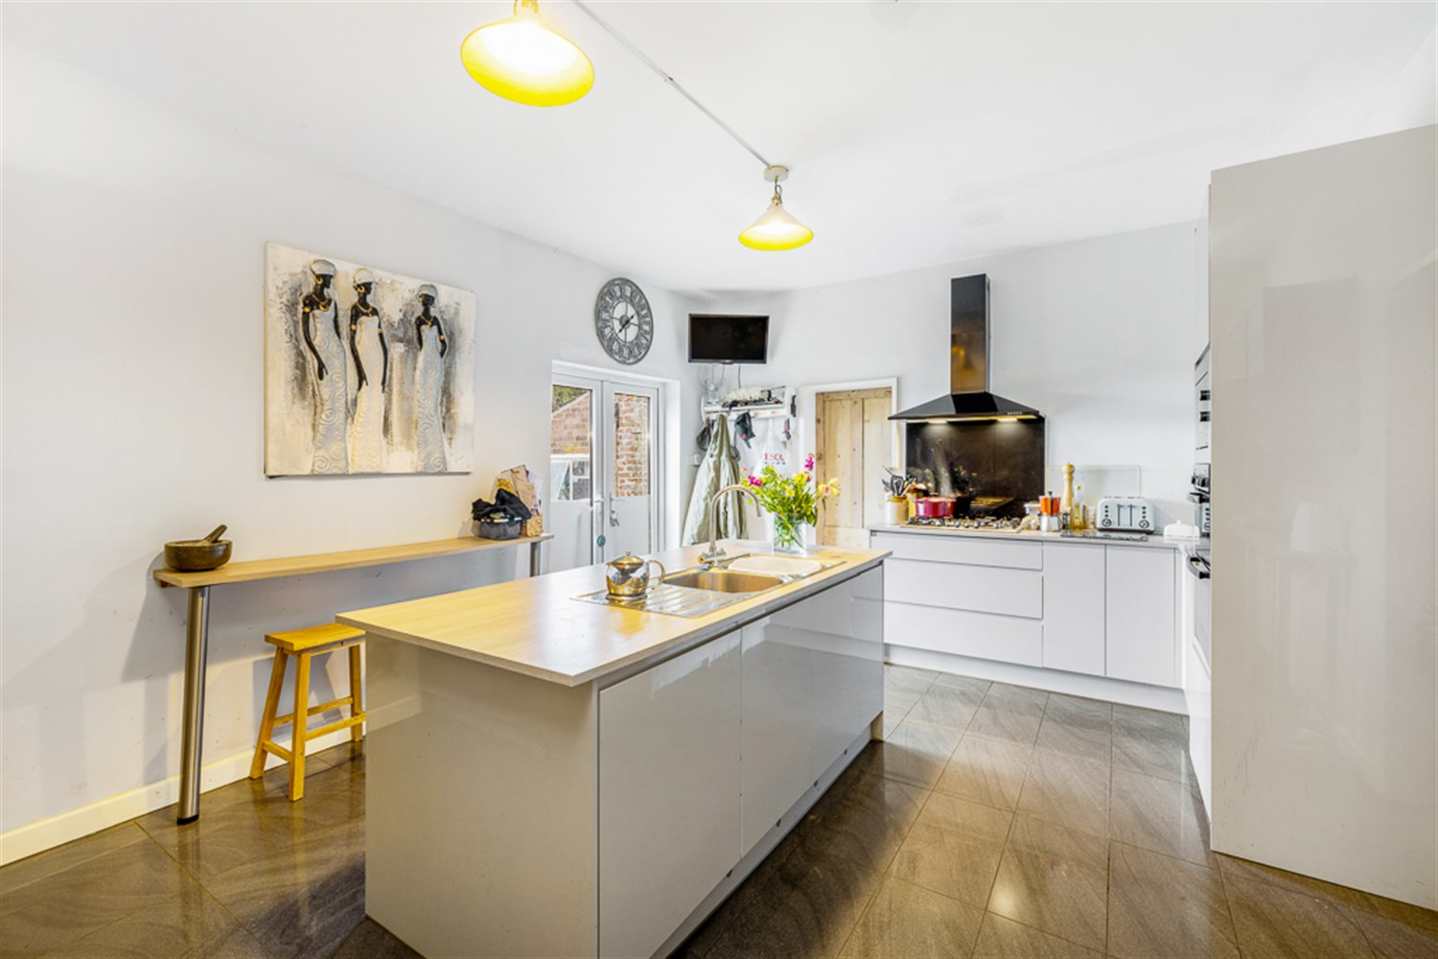

Property Description
Set within a mature and private position, this substantial detached residence offers a rare combination of character, space and flexibility. Sitting on an exceptional plot with expansive gardens, private driveway parking and useful outbuildings.
This is a home that immediately stands out for its setting. The sweeping lawned frontage and established boundaries create a strong sense of arrival, while the long driveway provides ample off road parking and access to the rear.
Inside, the property delivers well balanced and versatile accommodation ideal for family living. Multiple reception areas offer flexibility for both formal and informal use, while the modern kitchen with a central island provides a sociable heart to the home, perfectly suited to every day life and entertaining alike. A ground floor shower room adds practicality, and the additional garden room/conservatory offers further adaptable space that could serve as a games room, home office or relaxation area.
Upstairs, the bedrooms are well proportioned and complimented by a modern family bathroom, creating comfortable accommodation throughout.
The real highlight, however, is the outside space. The rear garden is substantial, mainly laid to lawn with mature trees, established borders and patio seating areas which offers privacy, scale and excellent potential for further landscaping or extension. Brick built outbuildings provide additional storage or workshop space, enhancing the property's versatility.

Front Aspect
An attractive and characterful detached property set within a generous plot, approached via a lawned frontage with mature boundaries and established trees. The home features a striking white brick façade complimented by a pitched porch entrance, uPVC double glazed windows with plantation shutters, and a slate style roofline creating charming yet substantial first impression. The property benefits from a wide frontage and mature surroundings, offering privacy and kerb appeal to equal measure.

Lounge
A well proportioned and inviting lounge featuring a uPVC double glazed window to the front elevation, fitted with plantation style shutters allowing for privacy while maintaining excellent natural light.
The room benefits from laminate flooring, neutral décor and a double panel radiator positioned beneath the window. Generous in size, the space comfortably accommodates multiple sofas and additional furniture, creating an ideal setting for both relaxing and entertaining.

Dining Room
A well proportioned and bright dining room featuring a uPVC double glazed window to the front elevation, fitted with plantation style shutters allowing for both privacy and excellent natural light.
The room benefits from laminate flooring, neutral décor and a double panel radiator positioned beneath the window. Generous in size, the space comfortably accommodates a family dining table and chairs, making it ideal for everyday dining and entertaining.
Internal doors provide access to the adjoining rooms, creating a practical and well connected ground floor layout.

Conservatory / Garden Room
A spacious and characterful conservatory accessed directly from the dining room, offering a versatile additional reception space.
Featuring tiled flooring and a vaulted ceiling with exposed timber beams, the room enjoys an abundance of natural light from surrounding glazing and uPVC door providing access to the garden. A radiator is fitted, allowing for year round use.
Generous in size, the space is currently utilised as a games and seating area but would equally suit use as a second lounge, home office, entertaining space or playroom.

Kitchen
The kitchen is modern and well laid out, fitted with sleek contemporary units and a central island incorporating stainless steel sink and drainer. Integrated appliances include double oven, hob and extractor. There is ample storage via full height fitted units, tiled flooring, and space for informal dining via breakfast bar seating. A door provides external access.

Ground Floor Shower Room
A useful and well appointed ground floor shower room accessed from the kitchen, fitted with a modern white suite comprising a low level WC, wash hand basin set within a vanity unit, and a walk in shower enclosure with glazed sliding doors and wall mounted shower.
The room benefits from contemporary wall tiling, wood effect flooring and fitted storage. Ideal for guests or for busy family living, this additional shower room adds excellent practicality to the ground floor accommodation.

Inner Hallway/Staircase
An inner hallway accessed from the kitchen, featuring stairs rising to the first floor accommodation. The space benefits from a uPVC double glazed window allowing natural light, along with laminate flooring and under stairs storage providing practical additional space.

Landing
A bright and neutrally presented first floor landing providing access to all bedrooms and the family bathroom. The space benefits from a uPVC double glazed window positioned at the top of the stairs, allowing for excellent natural light and creating an airy feel throughout.
Finished with fitted carpet and light décor, with ceiling light point and internal doors leading to adjoining rooms. A well connected and practical central space to the first floor accommodation.

Bedroom 1
A spacious and well appointed principal bedroom enjoying dual aspect uPVC double glazed windows to the front and side elevations, allowing for an abundance of natural light throughout the day.
The room benefits from fitted carpet, neutral décor and a double panel radiator positioned beneath the main window. The layout comfortable accommodates a double or king size bed along with additional freestanding furniture, creating a bright and airy main bedroom.

Bedroom 2
A well presented double bedroom featuring uPVC double glazed window to the rear elevation, allowing for good natural light.
The room benefits from fitted carpet, neutral décor and a single panel radiator positioned beneath the window. The space comfortably accommodates a double bed and additional furniture, making it an ideal guest room, second bedroom or home office if required.

Bedroom 3
A well presented double bedroom featuring uPVC double glazed window to the rear elevation, allowing for good natural light.
The room benefits from fitted carpet, neutral décor and a single panel radiator positioned beneath the window. The space comfortably accommodates a double bed and additional furniture, making it an ideal guest room, second bedroom or home office if required.

Family Bathroom
A stylish and contemporary family bathroom fitted with a modern white suite comprising a freestanding bath with mixer tap and shower attachment, dual hand wash basins set within a vanity unit and a wall mounted WC.
The room also benefits from a walk in shower enclosure with a glazed screen and wall mounted shower, recessed shelving for storage and a chrome wall heated towel radiator.
Finished with full height contemporary tiling, wooden flooring and a uPVC double glazed window to the rear elevation providing natural light and ventilation. A well designed and spacious bathroom offering both practicality and modern appeal.

Rear Garden
A generous and mature rear garden offering an excellent outdoor space ideal for families and entertaining. Primarily laid to lawn, the garden features a patio seating area directly accessed from the property, along with established trees, shrubs and planted borders providing character and privacy.
The plot extends to include a useful range of outbuildings and storage areas, offering potential for workshop use, hobbies or further development. Enjoying open aspects to the rear and a substantial overall footprint, this garden represents a fantastic extension of the living space and is a real highlight of the property.

These particulars are intended to give a fair description of the property, but their accuracy cannot be guaranteed, and they do not constitute an offer of contract. Intending purchasers must rely on their own inspection of the property. None of the above appliances/services have been tested by ourselves. We recommend purchasers arrange for a qualified person to check all appliances/services before legal commitment.

Property Ref: 3328

www.drurysestateagents.co.uk
amber@drurysestateagents.co.uk
01205 350889

45 Willoughby Road
Boston
Lincolnshire
PE21 9HN
Agents Note: Whilst every care has been taken to prepare these sales particulars, they are for guidance purposes only. All measurements are approximate are for general guidance purposes only and whilst every care has been taken to ensure their accuracy, they should not be relied upon and potential buyers are advised to recheck the measurements

