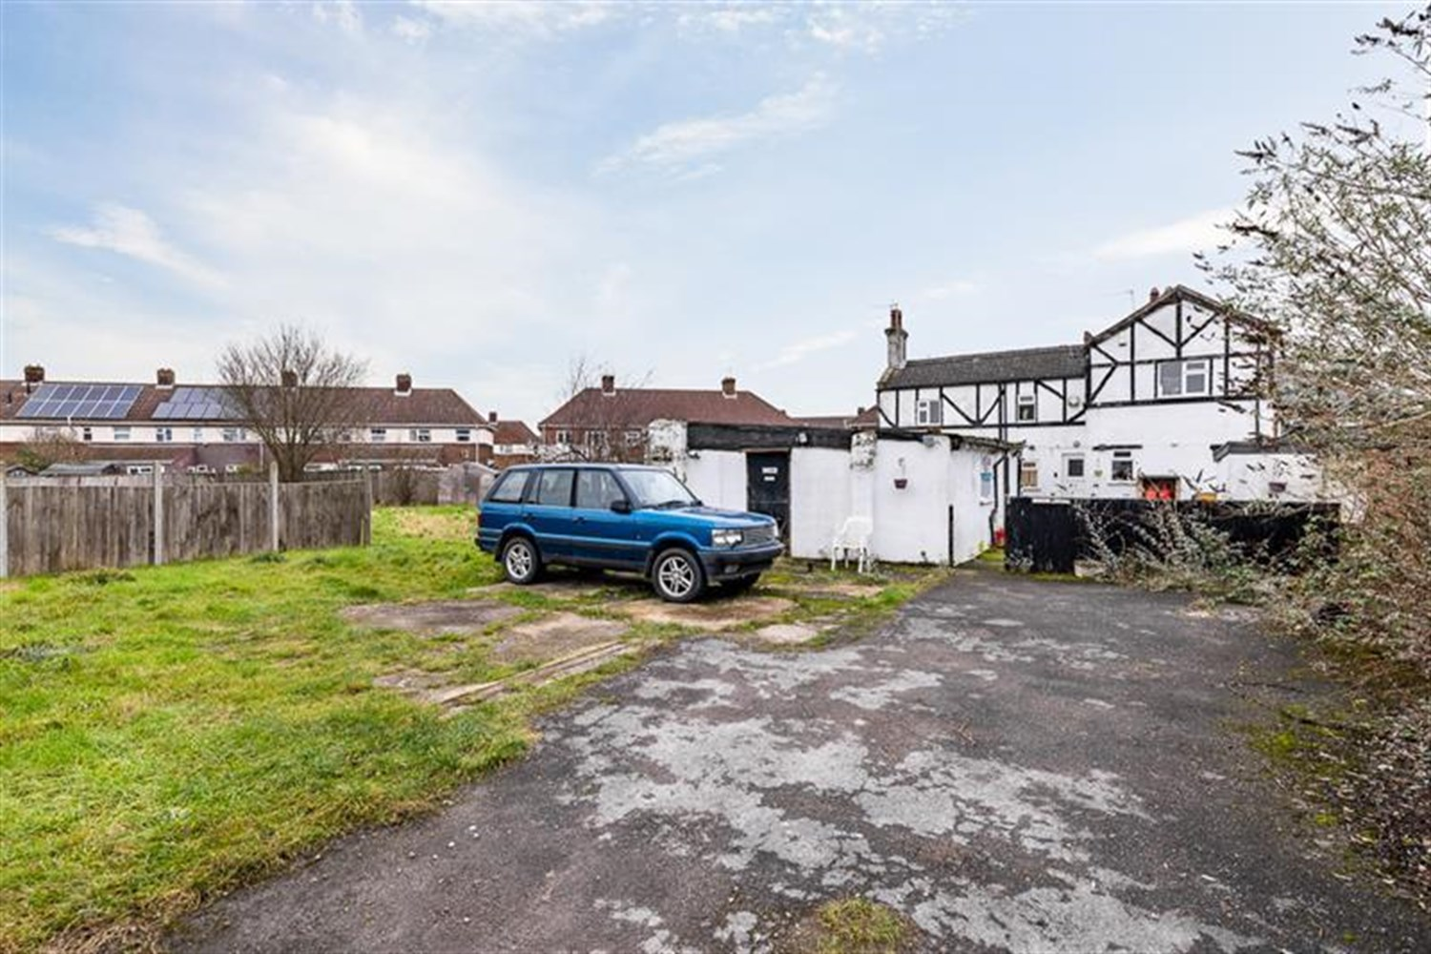




5/6 Bedroom(s)
3 Reception(s)
2 Bathroom(s)
£225,000
Hessle Gardens, PE21
EPC Rating ‘’

- 5/6 Bedroom Detached Property in need of renovation
- Building Plot/Large Garden
- Cul-de-sac location
- 3 Reception Rooms

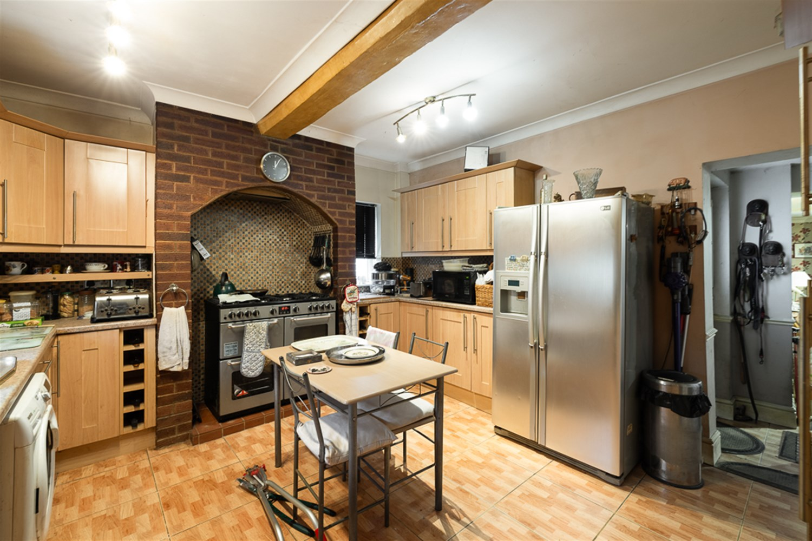
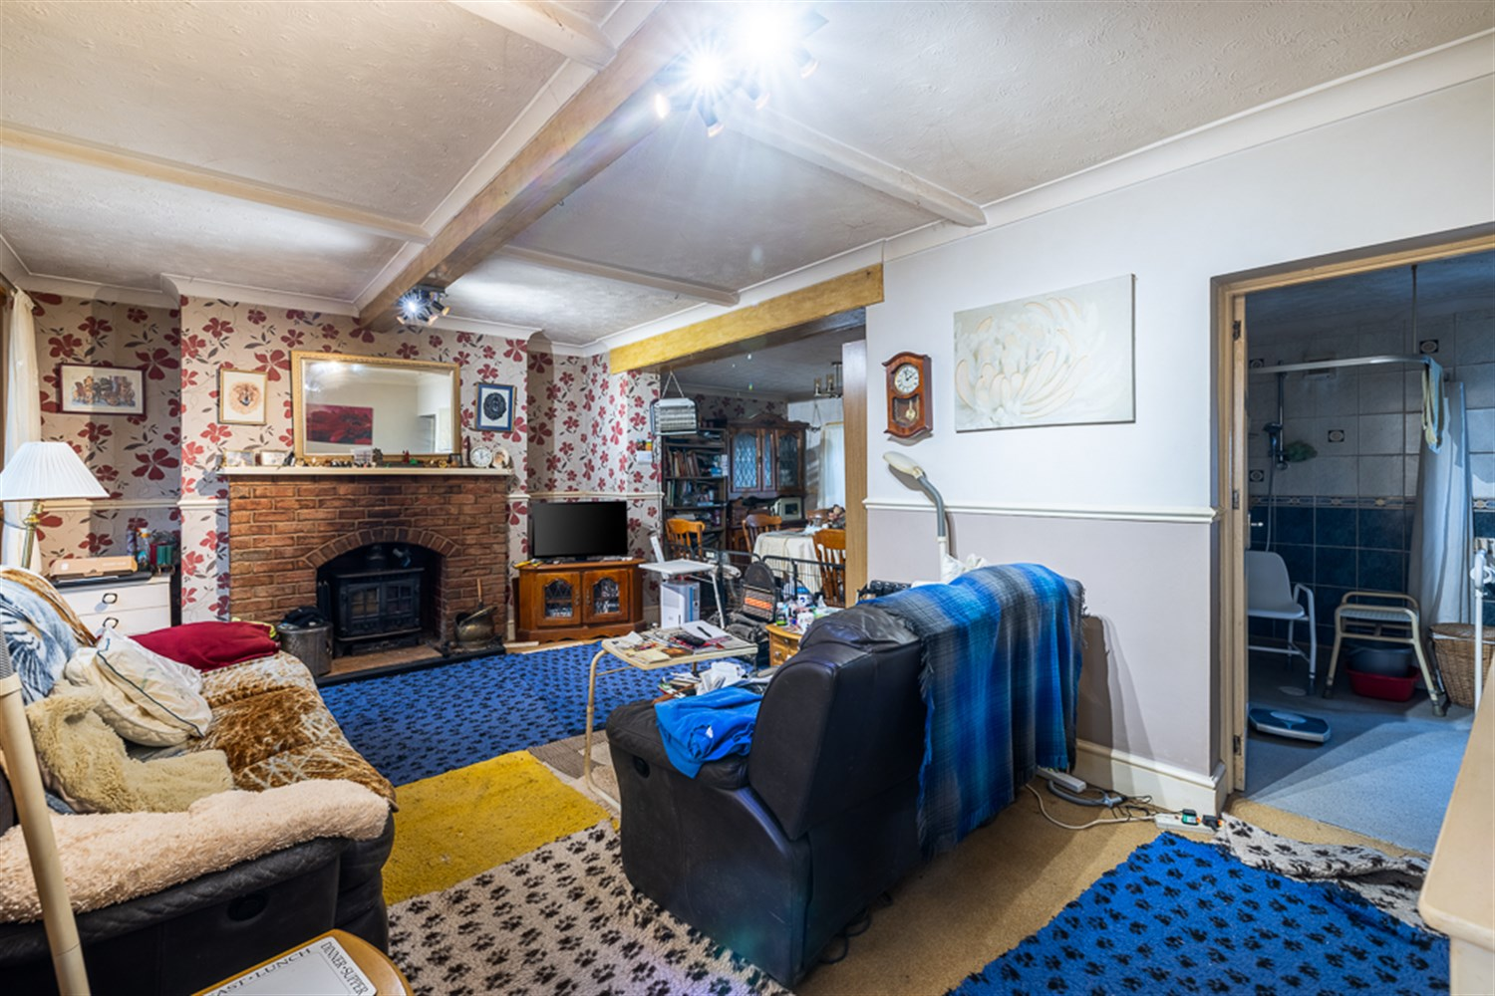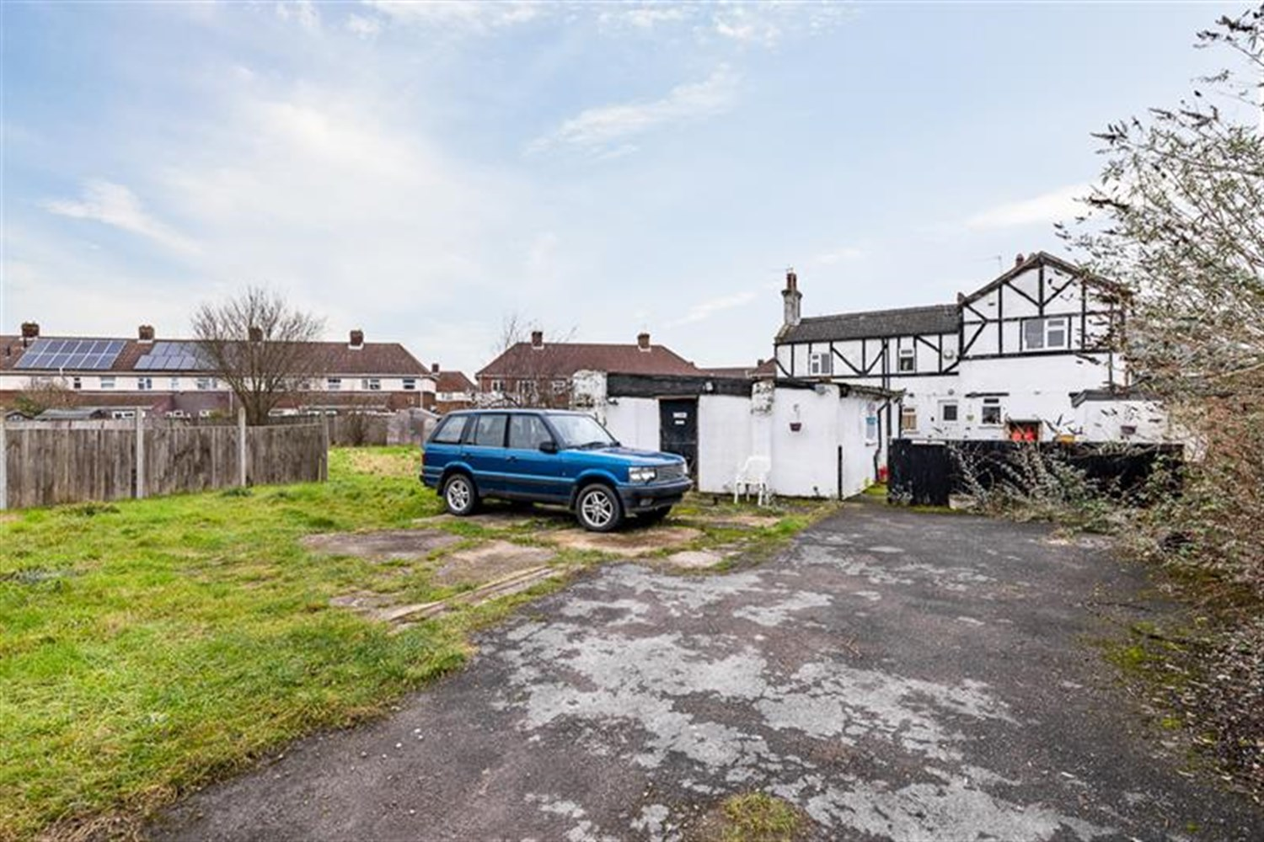
00
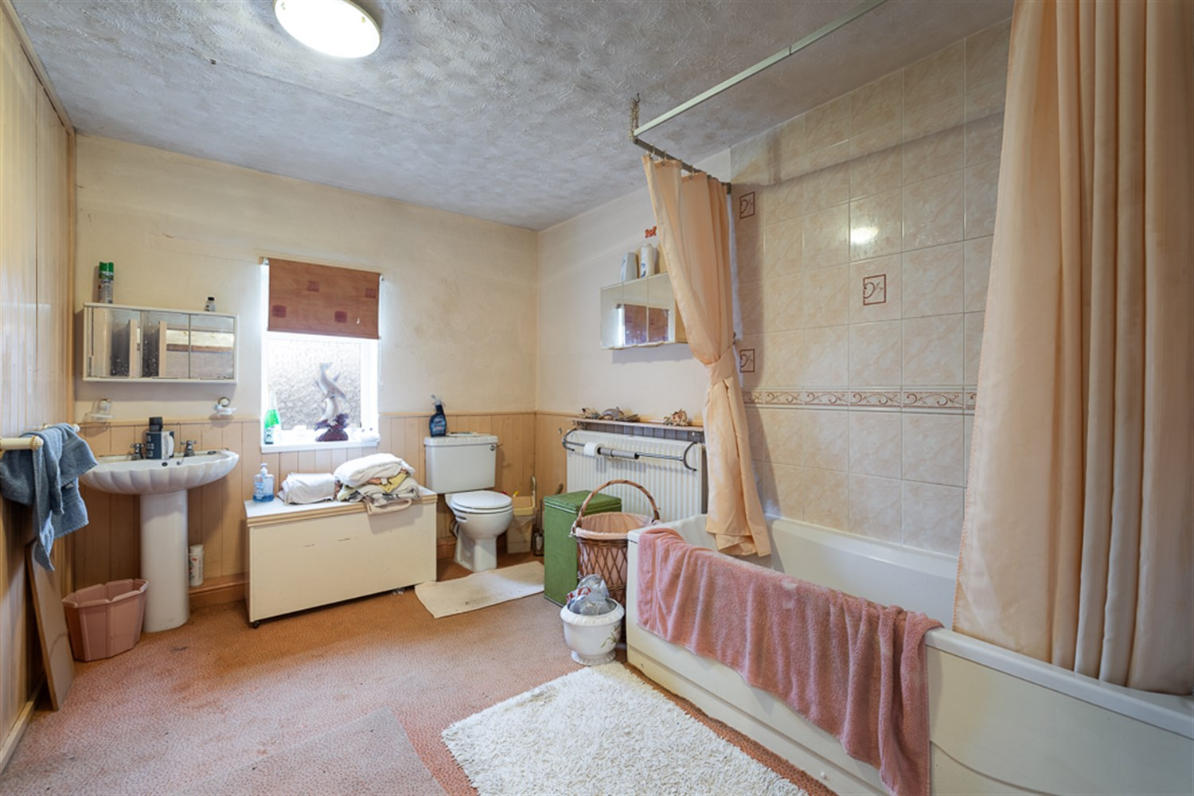
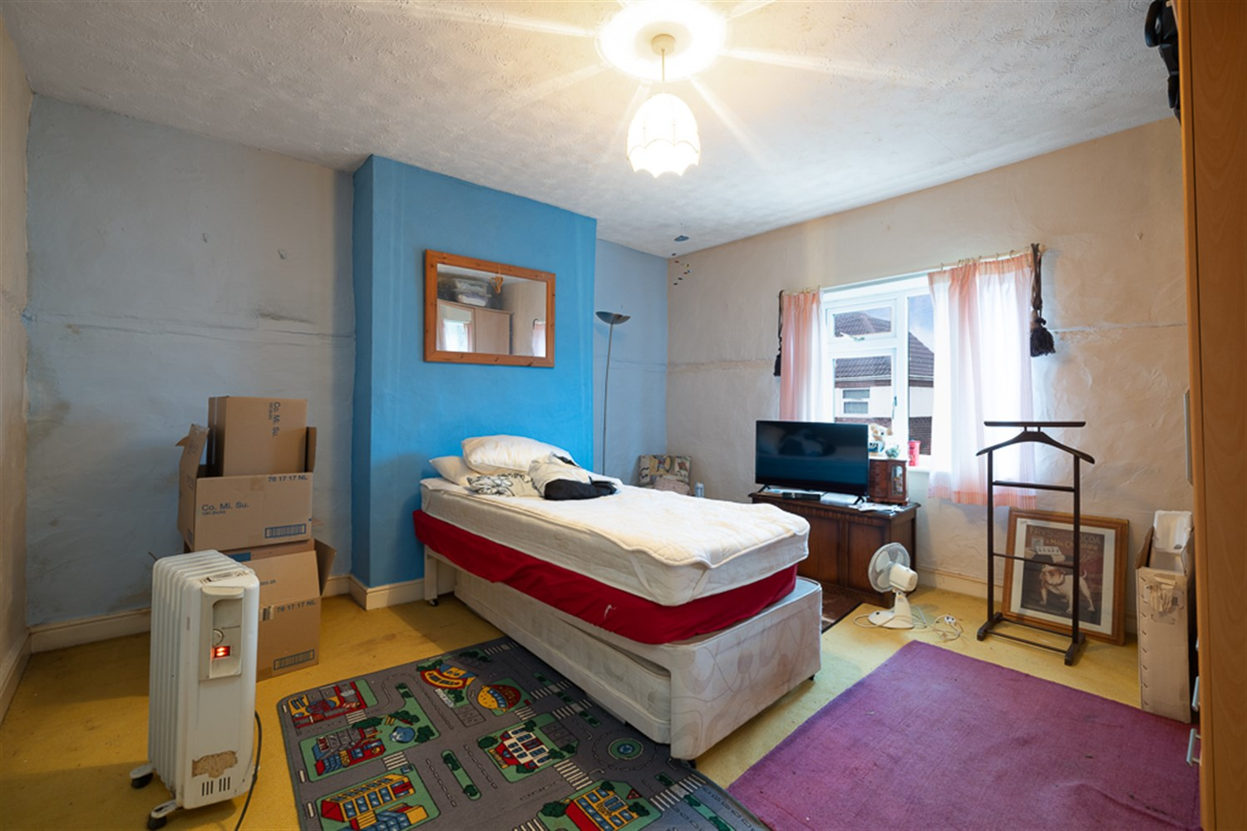
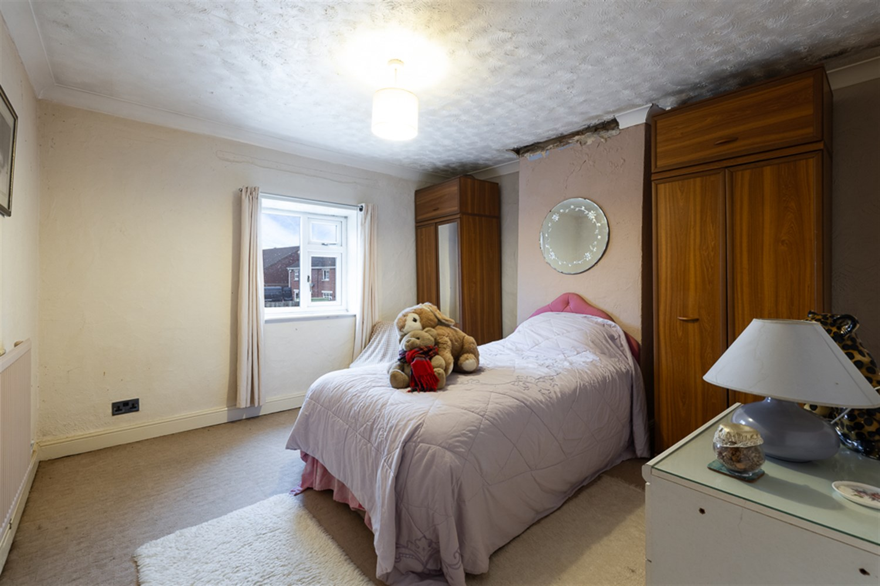
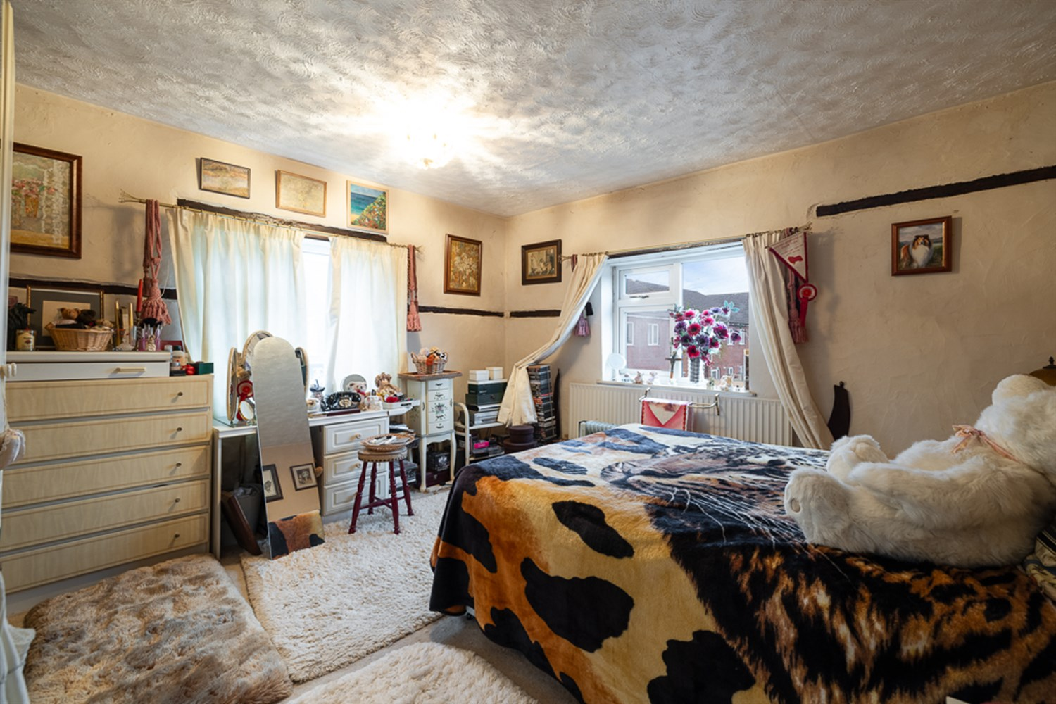
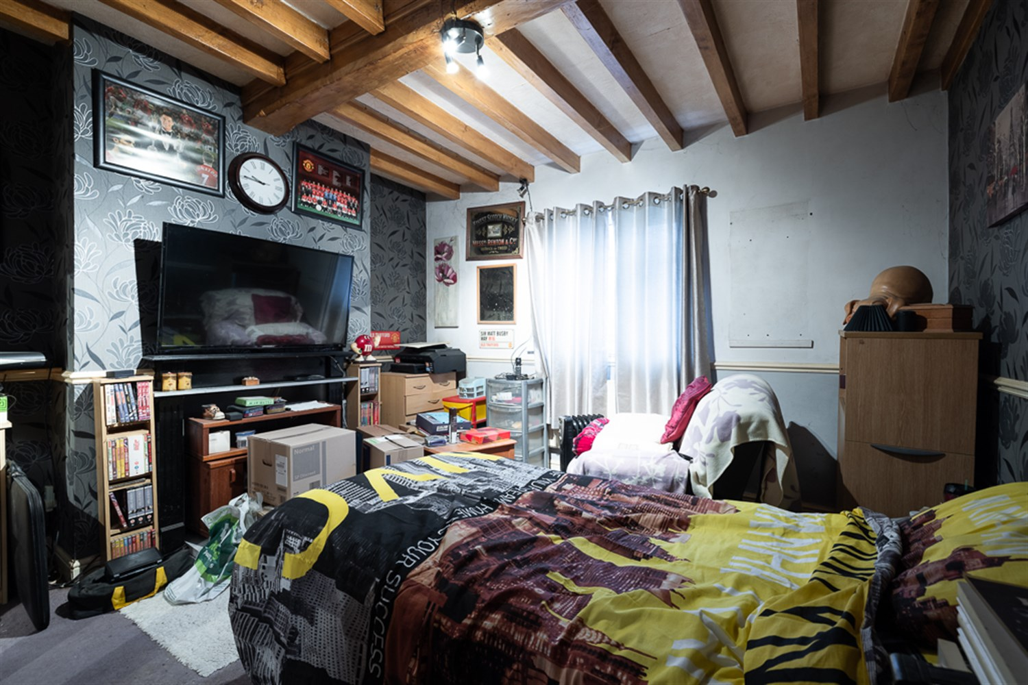
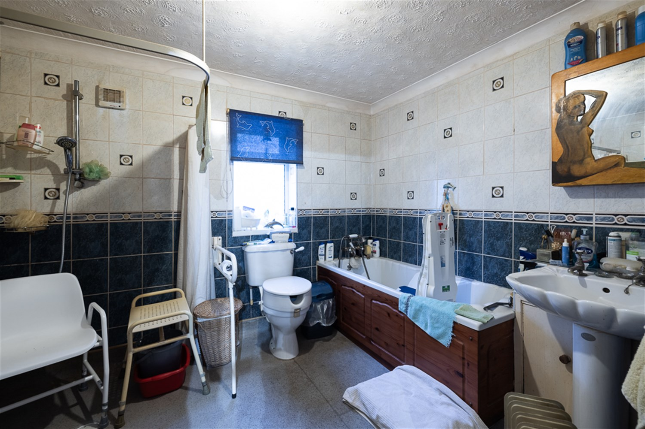
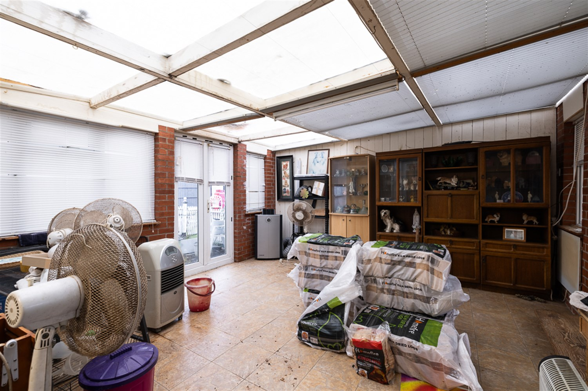

Property Description
5/6 Bedroom detached property in need of renovation, offering spacious accommodation with 3 receptions and a building plot with full planning permission for 3 bedroom detached bungalow and garage. In brief accommodation comprises entrance hall, lounge/diner, conservatory, downstairs wet room, family room, breakfast kitchen, side hall, landing leading to 2 double rooms and bathroom, study, further landing to bedroom 3 & 4, large workshop/utility with fitted kitchen area surrounding gardens.

Hallway
Upvc half glazed front door, radiator, ceramic tiled flooring, dado rail, thermostat, exposed beams, open plan to the kitchen/Breakfast Room, open plan to lounge/diner, door leading to:

Kitchen/Breakfast Room
Fitted with a matching base and eye level units with worktop space and under lighting, stainless steel sink with mixer tap, tiled splashbacks, integrated dishwasher, plumbing for washing machine, space for fridge/freezer, cooker and range, extractor hood, window to side aspect, walk in cupboard, radiator, ceramic tiled flooring, coving to ceiling with exposed beams, door to:

Lounge
Window to rear aspect, two windows to front aspect, fireplace with brick surround and tiled hearth, cast-iron solid fuel burner, two radiators, telephone point, TV point, dado rail, coving to textured ceiling with exposed beams, door to staircase. Patio door to CONSERVATORY, door to:

Conservatory
Brick and PVCu construction, four windows to side aspect, radiator, ceramic tiled flooring, TV point, two double doors.

Dining Room
Window to rear aspect and staircase up to the first floor.

Family Room/ Bedroom 6
Window to side aspect, open fireplace, radiator, telephone point, dado rail, exposed beams. This downstairs room is an ideal bedroom or additional family room.

Downstairs Wet Room
Panelled bath with hand shower attachment, pedestal wash hand basin, shower area with curtain rail and low level WC, fully tiled walls, extractor fan, window to rear aspect, coving to textured ceiling.

Hall
Radiator, stairs to the first floor, PVCu half glazed door to side.

Landing
Step up to: Bedrooms 1 & 2

Bedroom 1
Window to side aspect, window to front aspect, radiator, TV point, fitted corner wardrobes

Bedroom 2
Window to side aspect, radiator, TV point.

Bathroom
Leading from hall, Panelled bath with shower over, pedestal wash hand basin and low-level WC, tiled surround, window to front aspect, storage cupboard, radiator, part panelling, access to loft, door to:

Study
Window to rear aspect, radiator, telephone point, TV point, sloping ceiling with exposed beams, open plan to:

Landing
Exposed beams, stairs, doors to bedrooms 3 & 4

Bedroom 3
11' 9" x 11' 10" (3.58m x 3.61m) Window to front aspect, radiator, coving to textured ceiling.

Bedroom 4
9' 6" x 8' (2.90m x 2.44m) Window to side aspect, radiator, sloping ceiling with exposed beams.

Work Shop/Utility
30' x 19' (9.14m x 5.79m) (approximate measurements). Can be easily converted back to a garage. It has working power, light and water connected with fitted kitchen area having base and eye level units with worktop surfaces, plumbing for washing machine and stainless steel sink/drainer.

Driveway
The property is approached via wrought iron double gates providing vehicular access to off road parking area. Gated access leads to a courtyard area with rubber safety flooring, outside toilet with power water connected, gazebo and built in storage shed with power connected.

Garden
The rear garden is fully enclosed with gated access having sheltered seating area which is laid with rubber safety flooring. There is also a gravel and patio area with ample security lighting and metal storage shed.

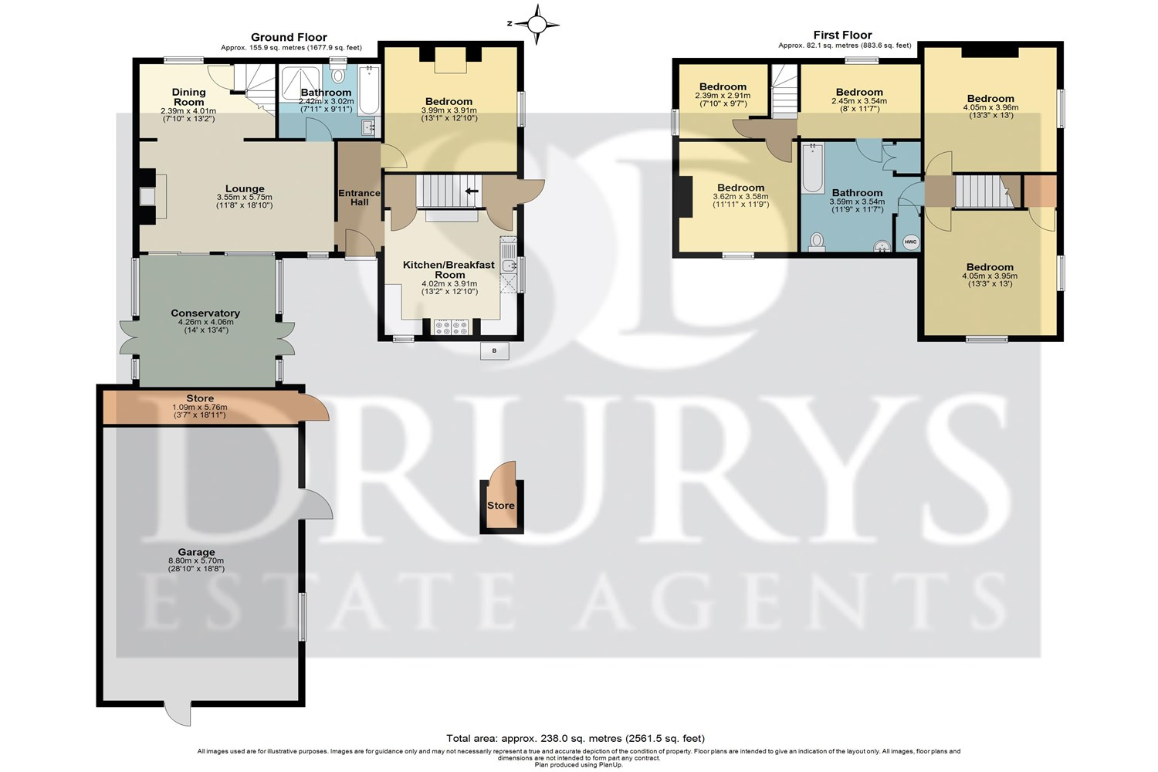

These particulars are intended to give a fair description of the property, but their accuracy cannot be guaranteed, and they do not constitute an offer of contract. Intending purchasers must rely on their own inspection of the property. None of the above appliances/services have been tested by ourselves. We recommend purchasers arrange for a qualified person to check all appliances/services before legal commitment.

Property Ref: 3190

www.drurysestateagents.co.uk
amber@drurysestateagents.co.uk
01205 350889

45 Willoughby Road
Boston
Lincolnshire
PE21 9HN
Agents Note: Whilst every care has been taken to prepare these sales particulars, they are for guidance purposes only. All measurements are approximate are for general guidance purposes only and whilst every care has been taken to ensure their accuracy, they should not be relied upon and potential buyers are advised to recheck the measurements

