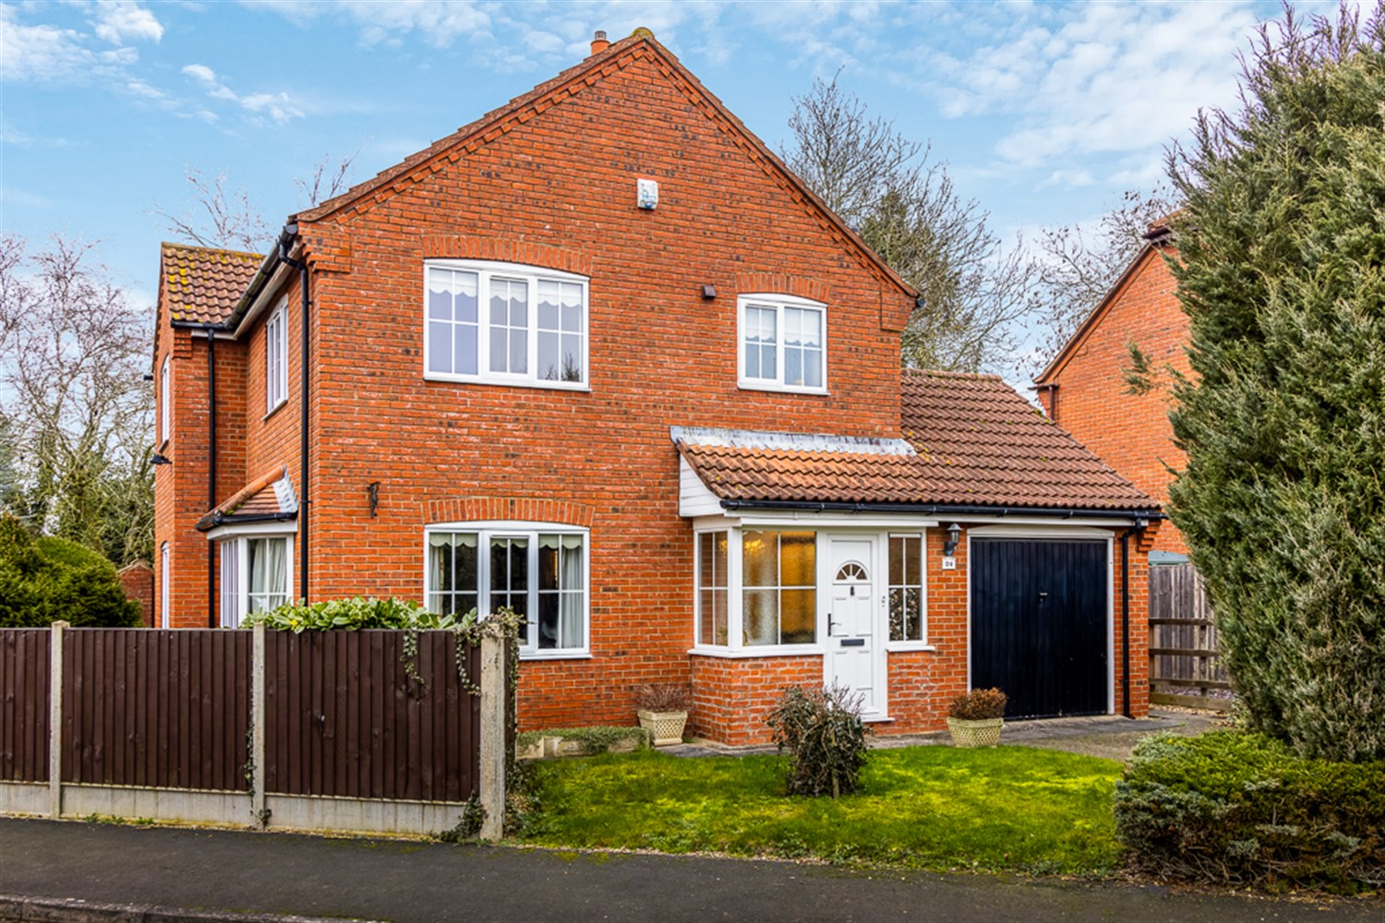




3 Bedroom(s)
2 Reception(s)
2 Bathroom(s)
£250,000.00
Millers Gate, PE22
EPC Rating ‘’

- 3 Bedroom Detached House
- Cul-De-Sac Location
- Field views to the rear
- Village location

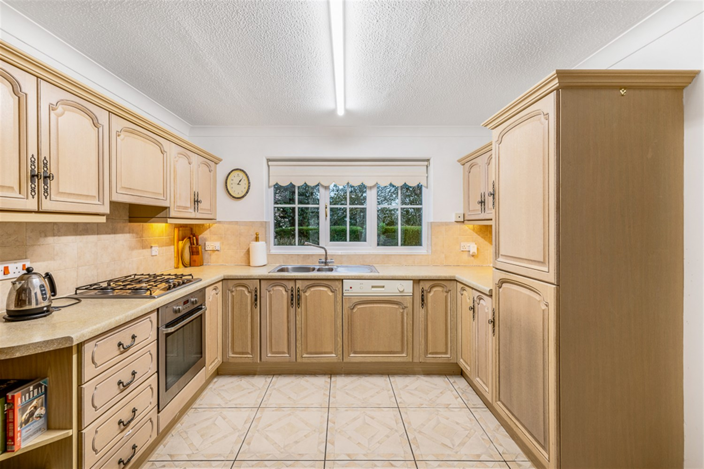
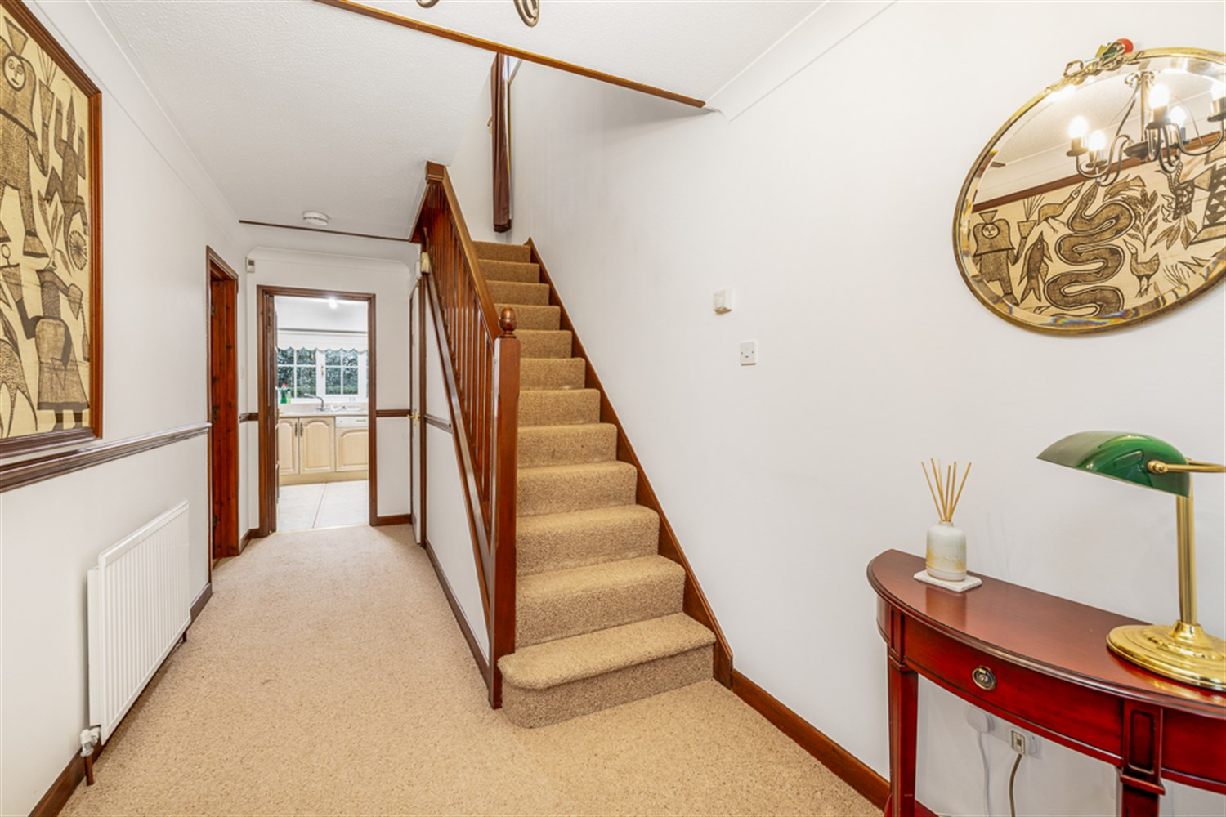
00
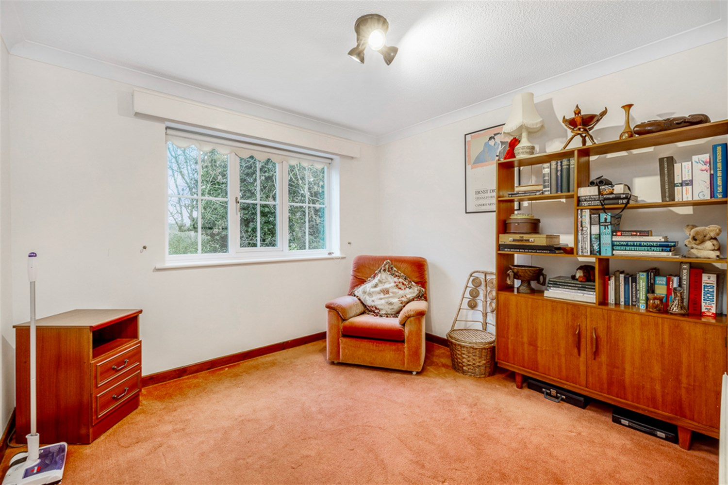
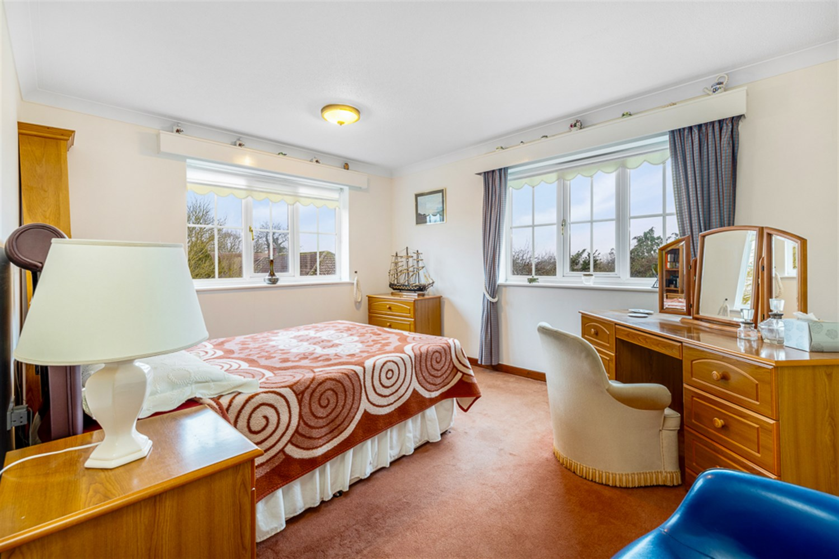
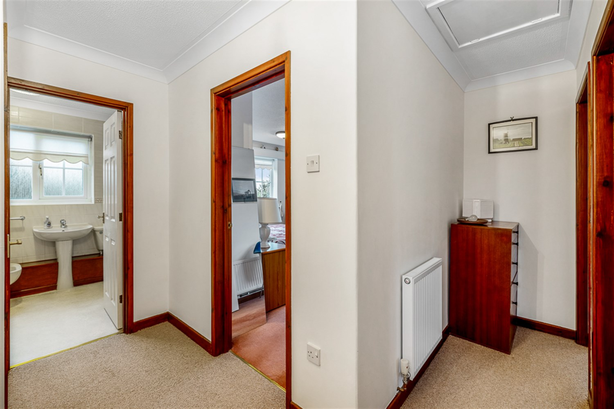
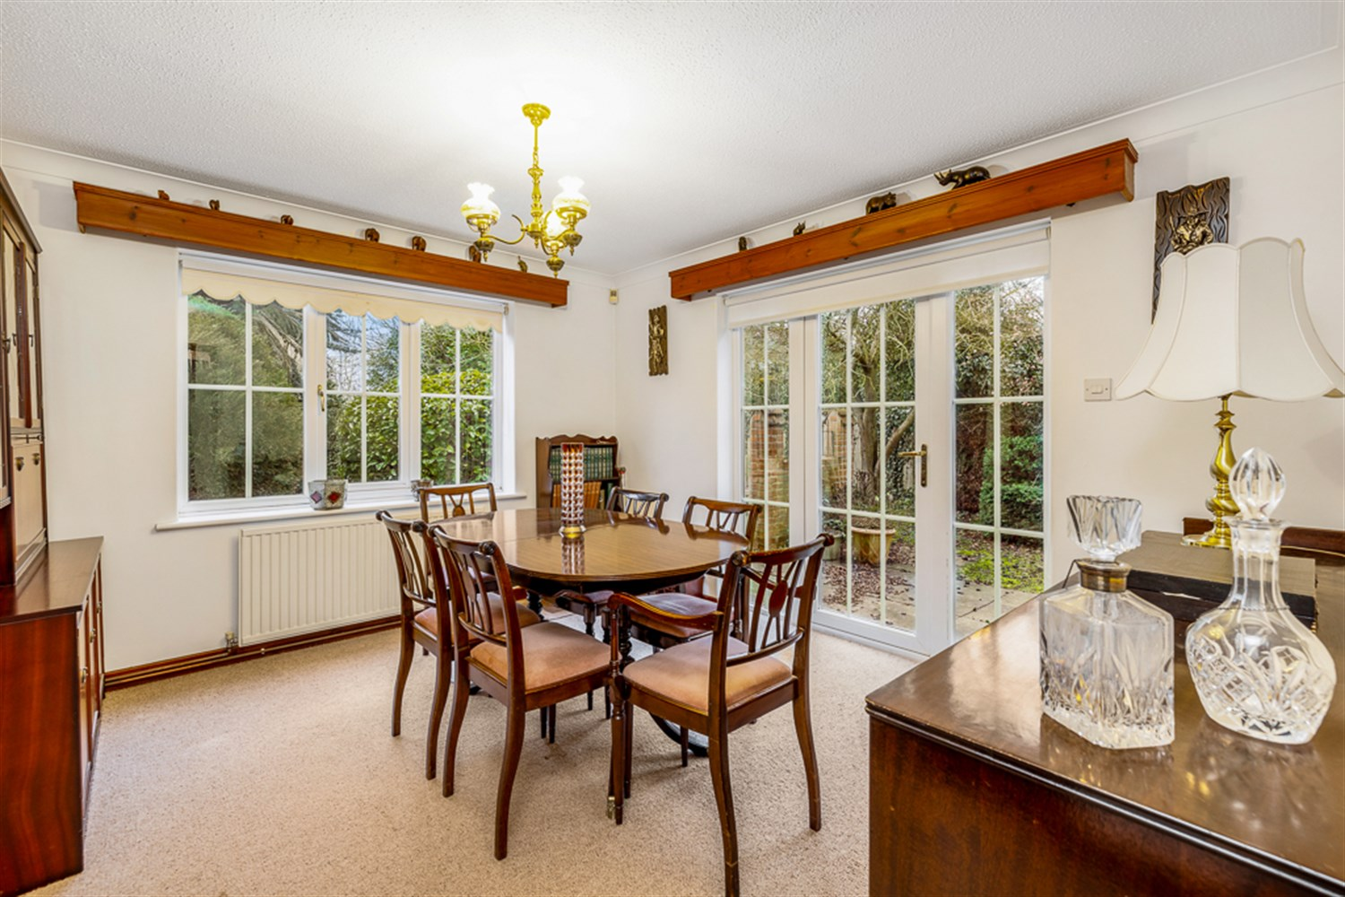
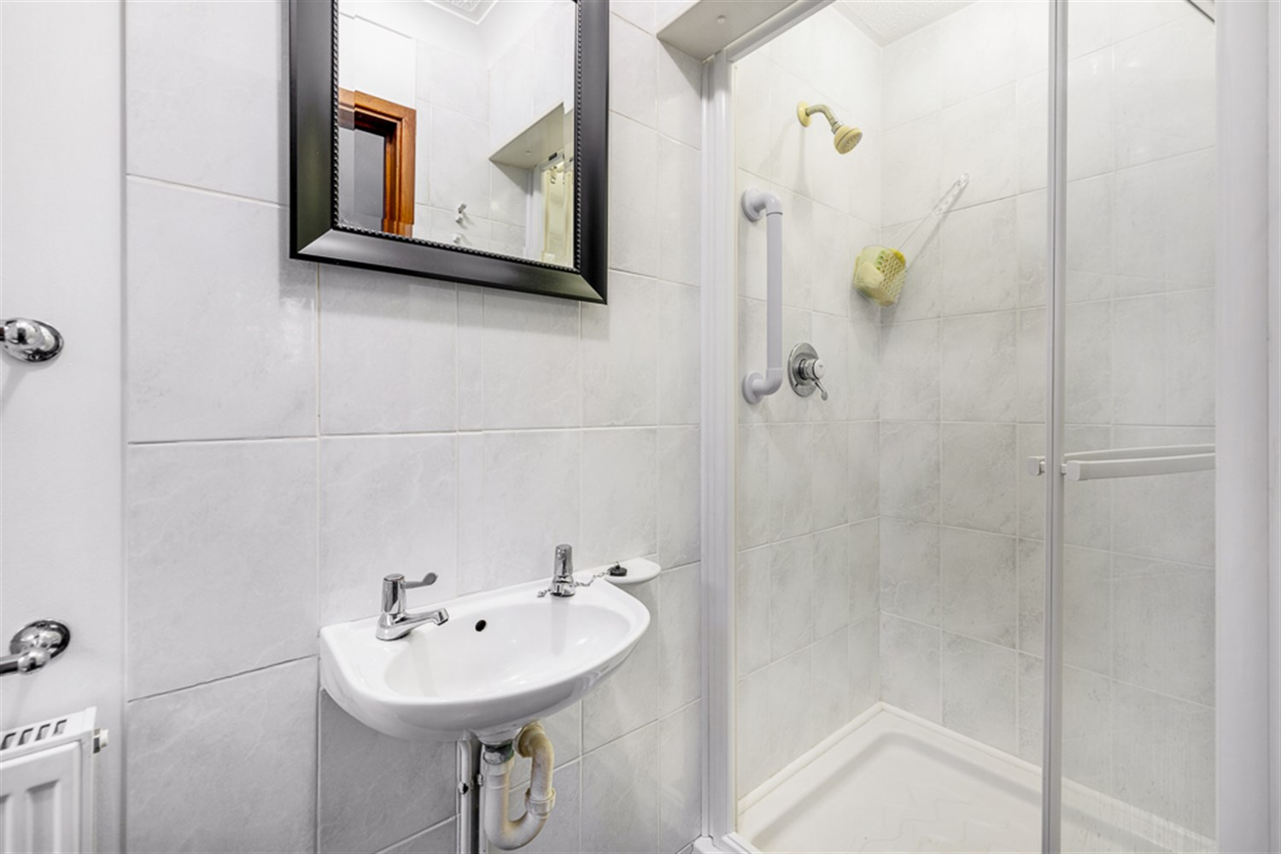
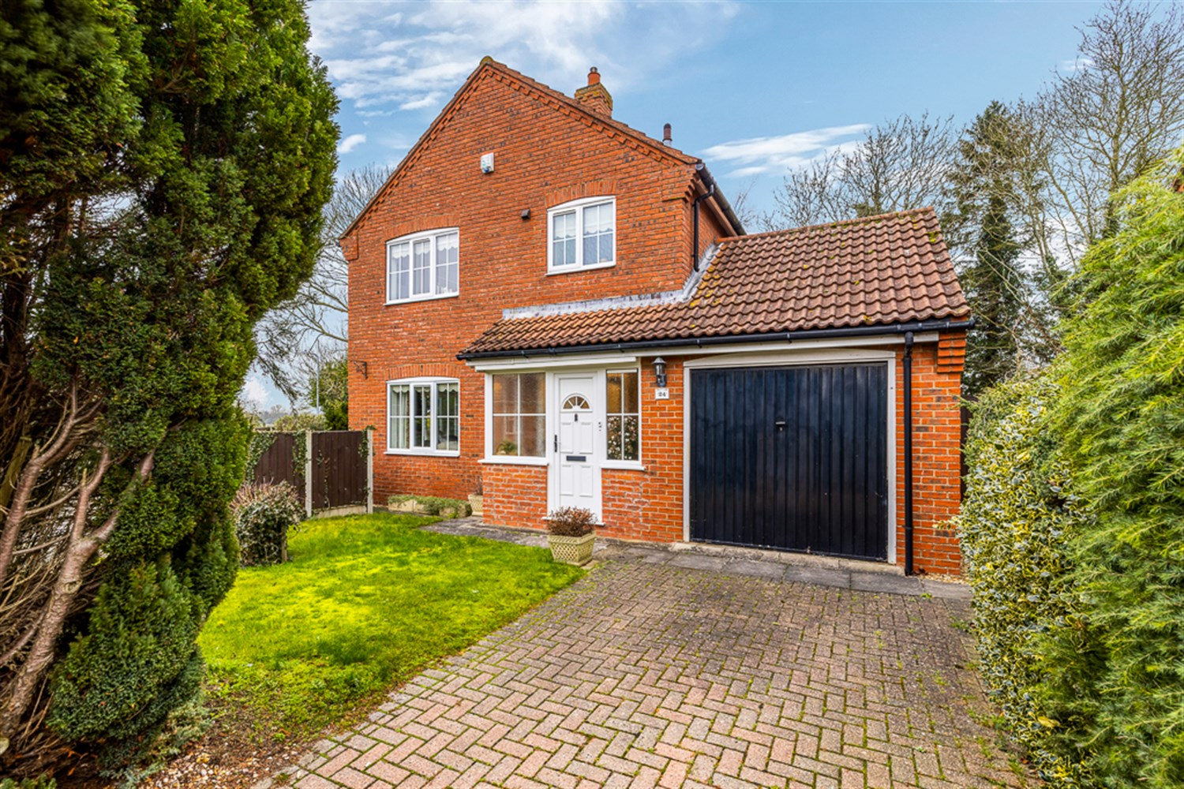
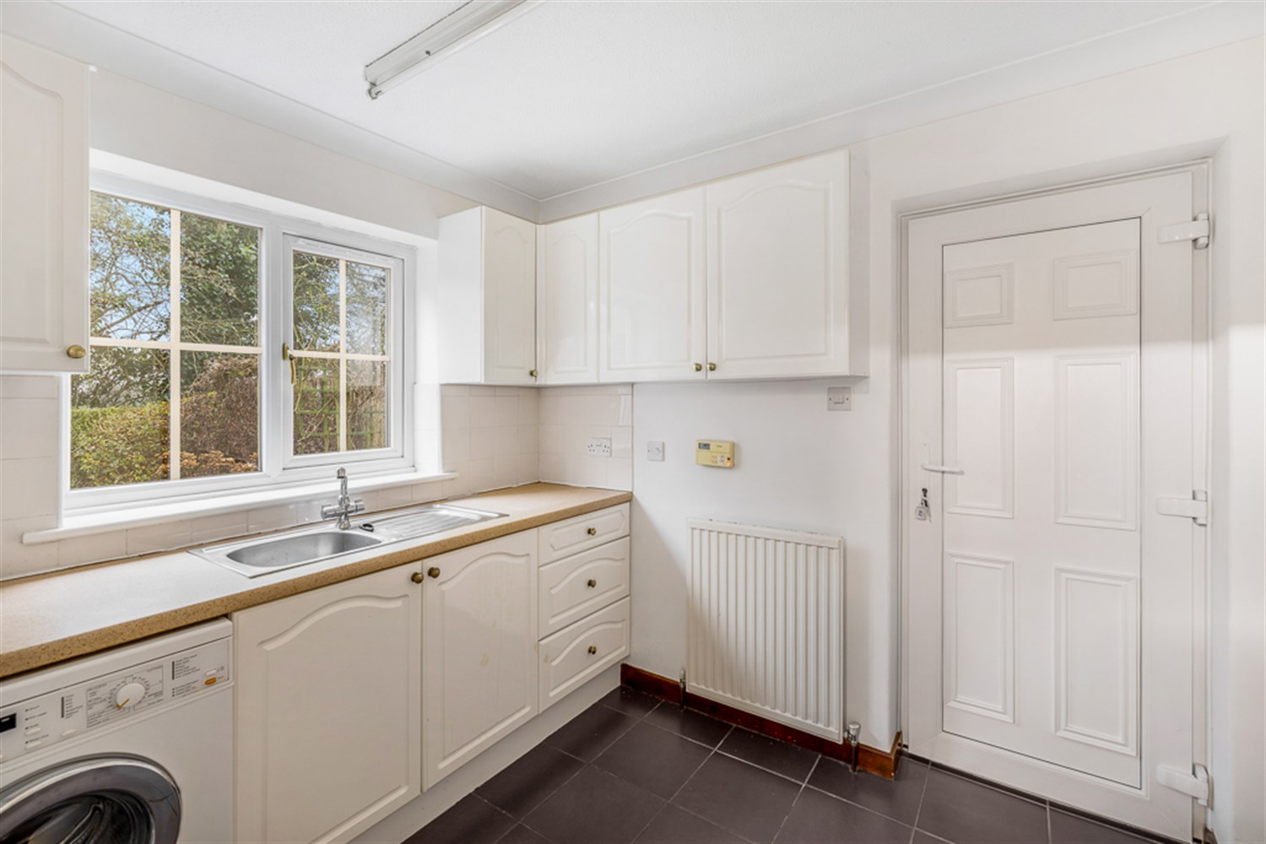
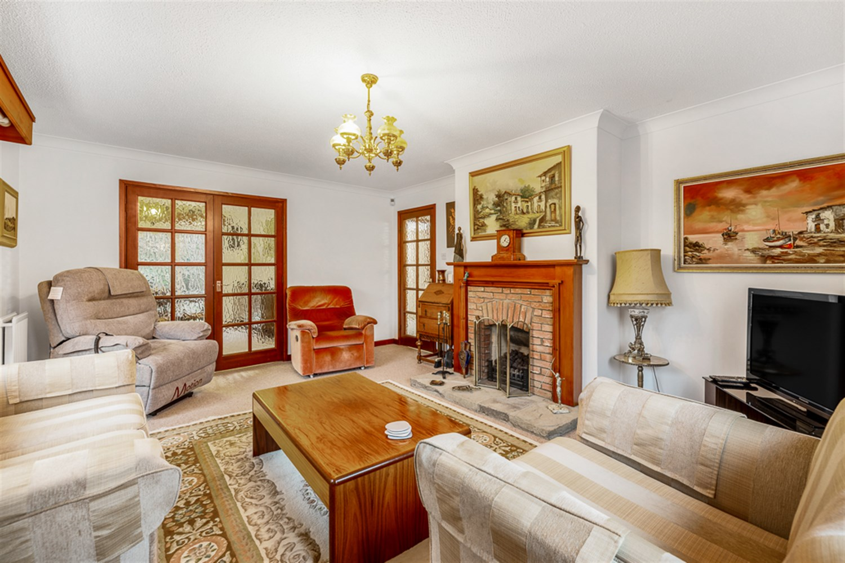

Property Description
A spacious and well-appointed three-bedroom detached home offering versatile living accommodation and attractive open views to the rear.
The property benefits from a welcoming entrance, generous lounge with feature fireplace, separate dining room with direct access to the garden, a well-equipped kitchen, utility room and ground floor shower room, providing excellent flexibility for modern family living.
Upstairs, three well-proportioned bedrooms are served by a four-piece family bathroom, while the landing balcony and rear bedroom outlook take full advantage of the surrounding green space.
Externally, the home enjoys a generous L-shaped garden with field views, patio area, greenhouse and established planting, along with a driveway and garage complete with EV charging point.
Combining practical living space with a pleasant semi-rural aspect, this property represents an excellent opportunity for families or those seeking additional space in a peaceful setting.

Front Aspect
The property is approached via a block paved driveway providing off-road parking, complemented by a neatly maintained lawned frontage which enhances the overall kerb appeal.

Entrance Porch and Hallway
The property is accessed via a uPVC entrance door leading into a welcoming porch area, featuring part brick construction with uPVC side windows allowing for natural light.
This in turn opens into the main entrance hallway, providing access to the ground floor accommodation and creating a practical transition into the home.

Entrance Hallway
The entrance hallway provides a welcoming introduction to the home, featuring a decorative dado rail which adds character and definition to the space.
A staircase rises to the first floor, while a useful understairs cupboard offers practical storage. The hallway is completed by a single panelled radiator and provides access to the ground floor accommodation.

Kitchen
Accessed via a glazed internal door, the kitchen is fitted with a range of eye and base level units complemented by tall storage cupboards, providing ample storage and preparation space.
A work surface runs over the units with tiled splashbacks, incorporating a stainless steel sink and drainer with mixer tap. Integrated appliances include a dishwasher, electric oven and gas hob, creating a practical and well-equipped cooking space.
A rear elevation window allows for natural light, enhancing the bright and functional feel of the room.

Utility Room
A well-appointed utility room featuring a tiled floor and a range of white gloss eye and base level units, offering excellent additional storage and workspace.
A stainless steel sink and drainer with mixer tap is set into the work surface, with plumbing in place for a washing machine and space for a tumble dryer. There is also room for a freestanding fridge freezer.
A rear elevation window allows for natural light, while a uPVC door provides direct access to the rear garden ¿ ideal for busy households. The room is completed by a single panelled radiator, making it a practical and versatile addition to the home.

Downstairs Shower Room
Accessed via the utility room, the property benefits from a convenient ground floor shower room fitted with a shower cubicle, low-level WC and wash hand basin.
A side elevation window provides natural light and ventilation, while a double panelled radiator ensures comfort. This additional facility offers excellent practicality for busy households or visiting guests.

Lounge
A spacious and characterful lounge enjoying a window to the front elevation as well as a side-facing bay window, allowing for excellent natural light and creating an attractive feature within the room.
The focal point is a charming brick and timber fireplace set upon a tiled hearth, housing a gas fire and providing a cosy atmosphere. The space is further enhanced by two double panelled radiators.

Dining Room
A well-proportioned dining room featuring a side elevation window allowing for natural light, and a single panelled radiator.
Glazed uPVC doors with side panels open directly onto the rear garden, creating a bright and inviting space that is ideal for entertaining or family meals, with a seamless connection to the outdoors.

Landing
The landing is a bright and spacious area, benefitting from a side elevation window allowing natural light to flow through the space. A double panelled radiator ensures comfort, while a useful airing cupboard houses the hot water tank and provides practical linen storage.
A particular feature of this level is the balcony access, offering an additional outdoor aspect and adding character to the home.

Master Bedroom
A bright and well-proportioned principal bedroom benefiting from dual aspect windows to the front and side elevations, allowing for excellent natural light throughout the day.
The room features a built-in wardrobe providing convenient storage, and is completed by a single panelled radiator, creating a comfortable and practical main bedroom.

Bedroom 2
A comfortable second bedroom featuring a side elevation window allowing for natural light, and a single panelled radiator.

Bedroom 3
A pleasant third bedroom enjoying a rear elevation window with attractive views over open fields and green space, creating a peaceful and private outlook.
The room is fitted with a single panelled radiator.

Bathroom
The family bathroom is fitted with a four-piece suite comprising a panelled bath, separate shower cubicle, pedestal wash hand basin, low-level WC and bidet.
A front elevation window provides natural light and ventilation, complemented by an extractor fan. The layout offers practicality and flexibility for busy households, with both bath and shower facilities available.

Garage
The garage is fitted with an up-and-over door and benefits from power and lighting, making it suitable for both vehicle storage and workshop use.
The space houses the boiler and electrical consumer unit, and also provides access to loft storage, offering additional practicality. An EV car charging point is installed, adding a modern and energy-conscious feature to the home.

Rear Garden
The property enjoys a generous L-shaped rear garden, offering a wonderful sense of space and attractive open views across fields and green surroundings.
The garden is enclosed by mature hedging to the rear, enhancing privacy while maintaining the pleasant outlook. A variety of established shrubs and trees add depth and character, complemented by a feature brick wall which provides additional charm.
There is a patio area ideal for outdoor dining and entertaining, alongside areas of gravel and planted shrubbery creating low-maintenance sections. The garden further benefits from a greenhouse, garden shed and access to both sides of the property for added convenience.

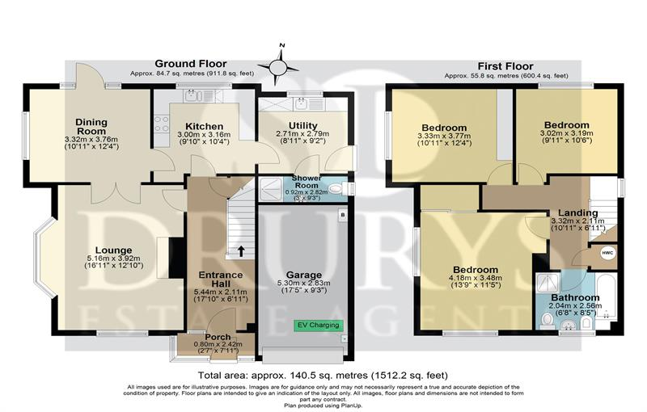

These particulars are intended to give a fair description of the property, but their accuracy cannot be guaranteed, and they do not constitute an offer of contract. Intending purchasers must rely on their own inspection of the property. None of the above appliances/services have been tested by ourselves. We recommend purchasers arrange for a qualified person to check all appliances/services before legal commitment.

Property Ref: 3180

www.drurysestateagents.co.uk
amber@drurysestateagents.co.uk
01205 350889

45 Willoughby Road
Boston
Lincolnshire
PE21 9HN
Agents Note: Whilst every care has been taken to prepare these sales particulars, they are for guidance purposes only. All measurements are approximate are for general guidance purposes only and whilst every care has been taken to ensure their accuracy, they should not be relied upon and potential buyers are advised to recheck the measurements

