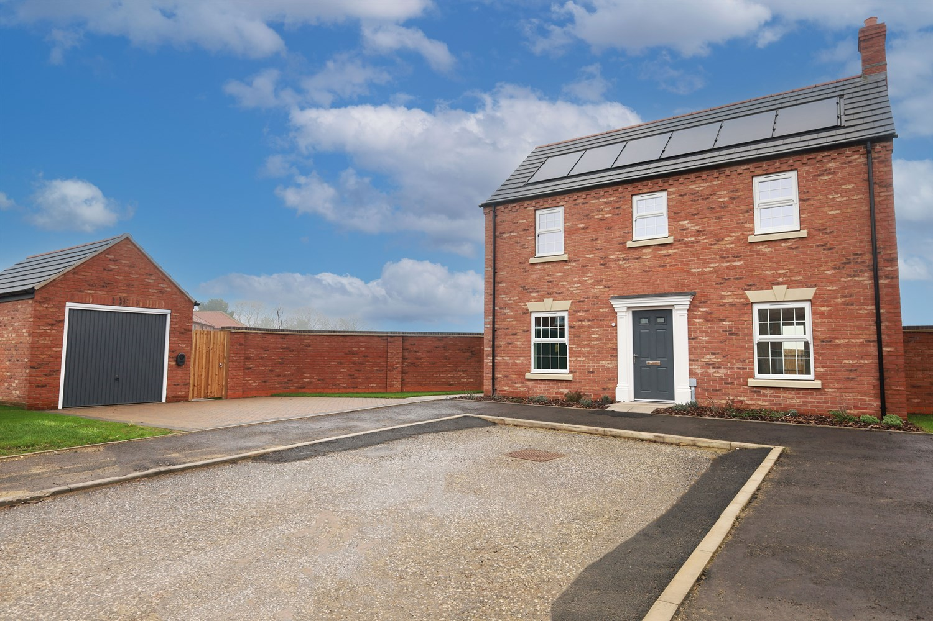




3 Bedroom(s)
2 Reception(s)
1 Bathroom(s)
£304,950.00
The Lumbley, Main Road, Sibsey, PE22
EPC Rating ‘’

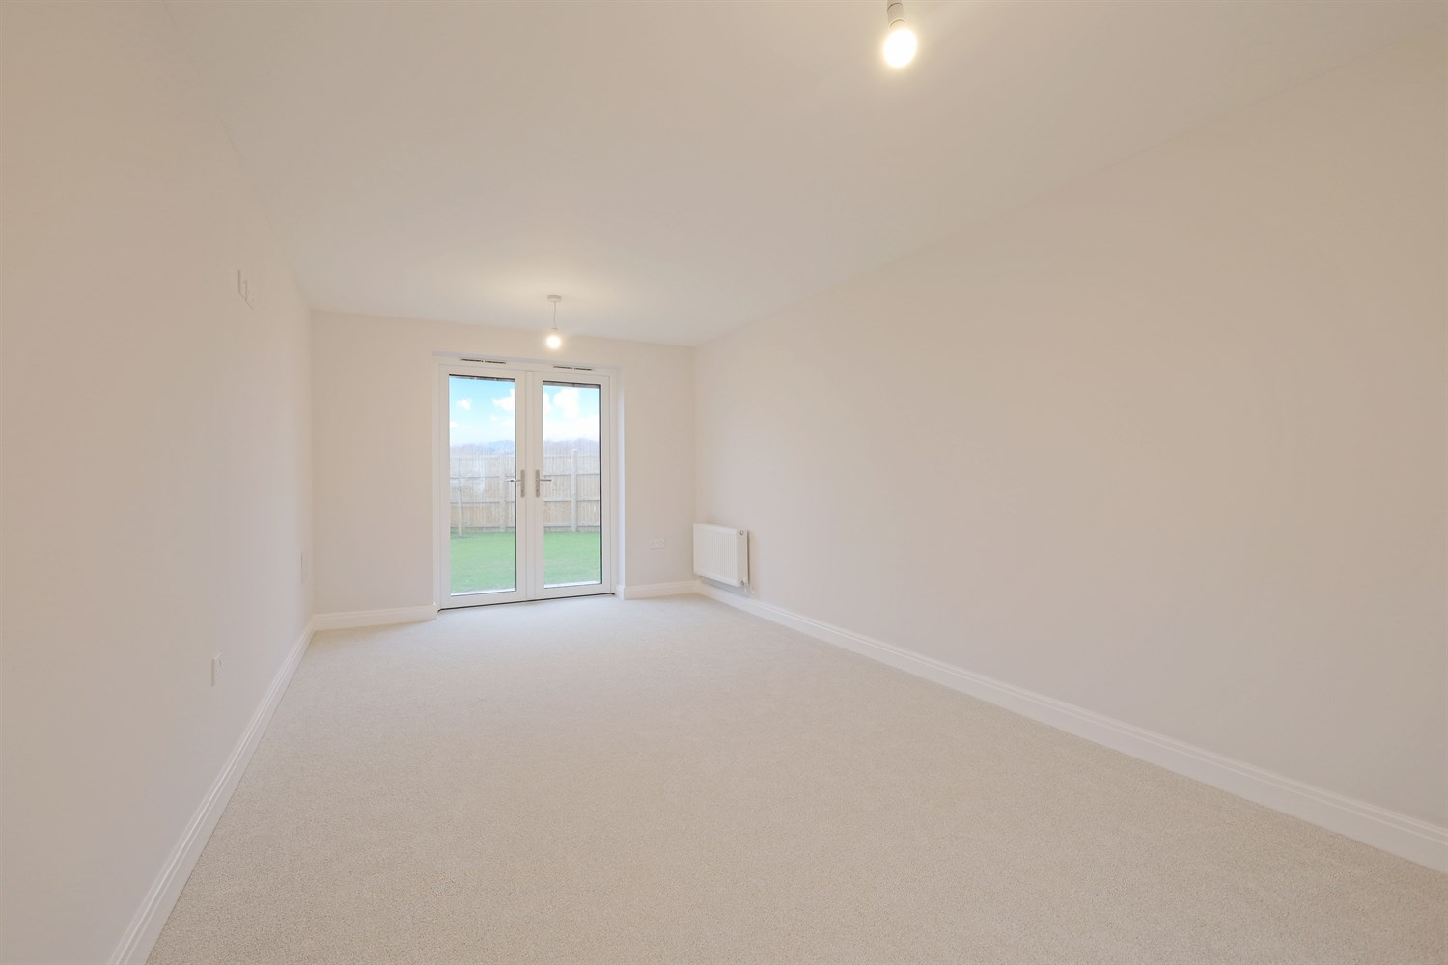
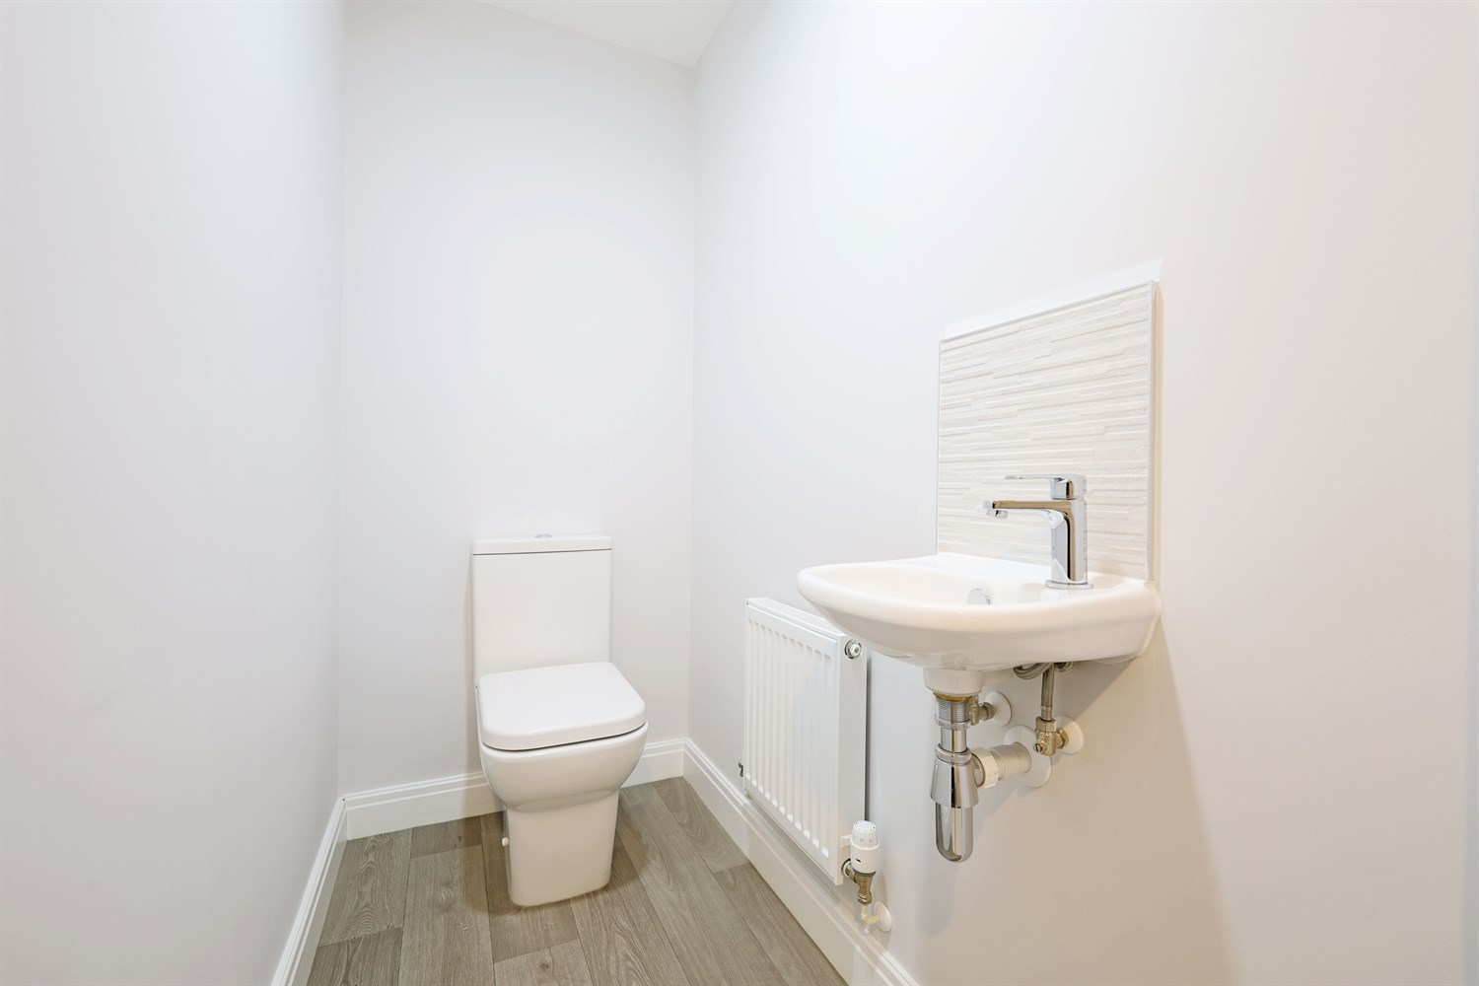
00
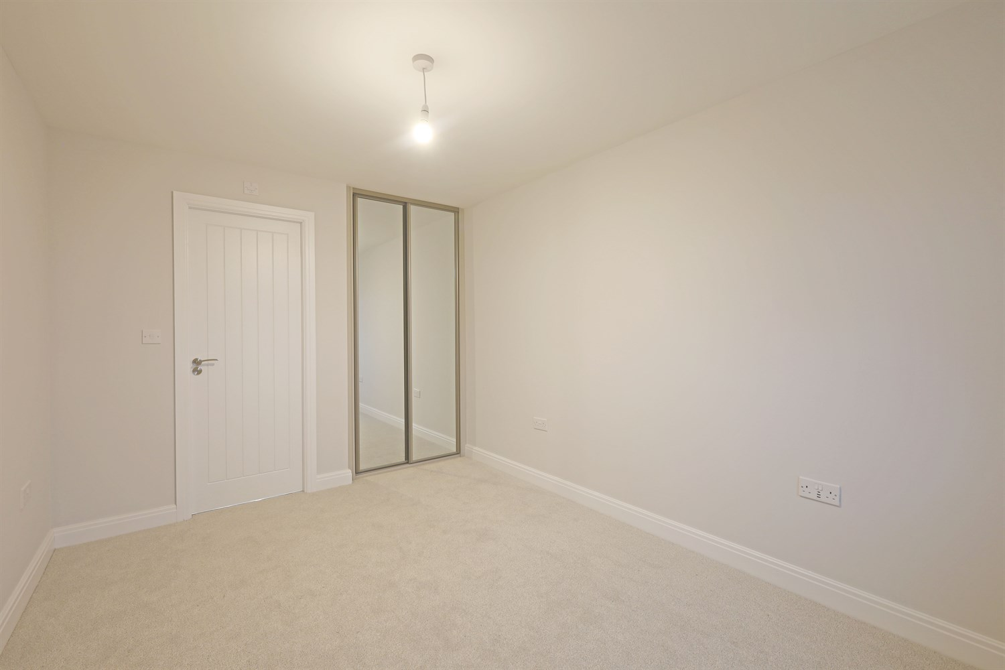
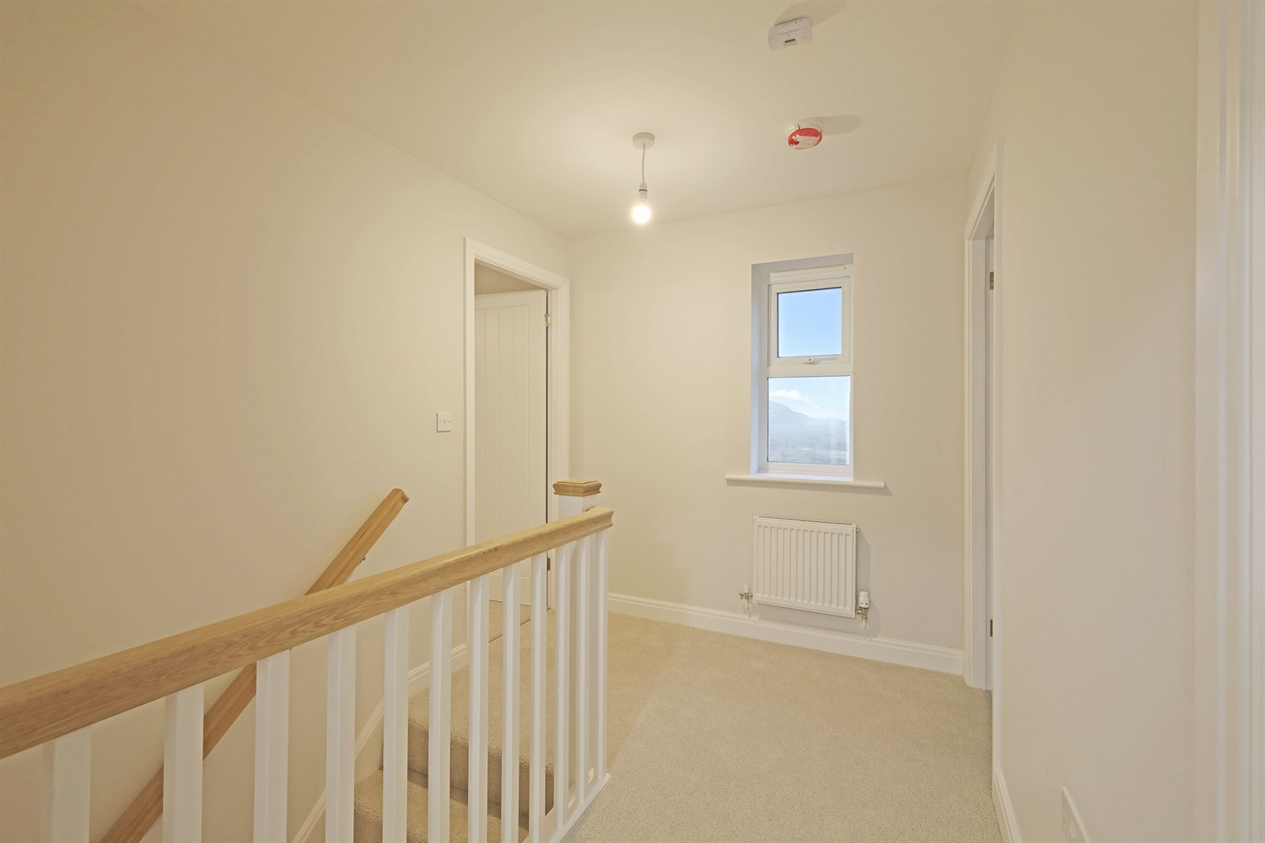
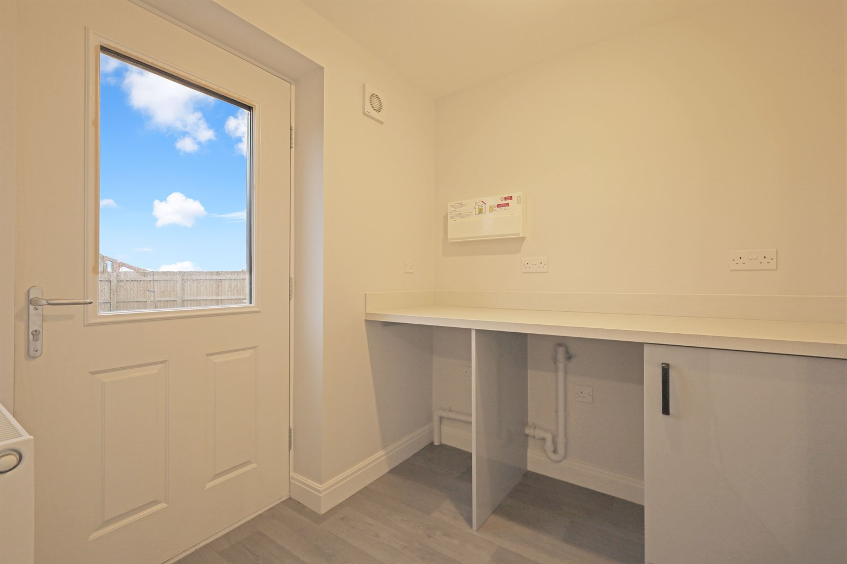
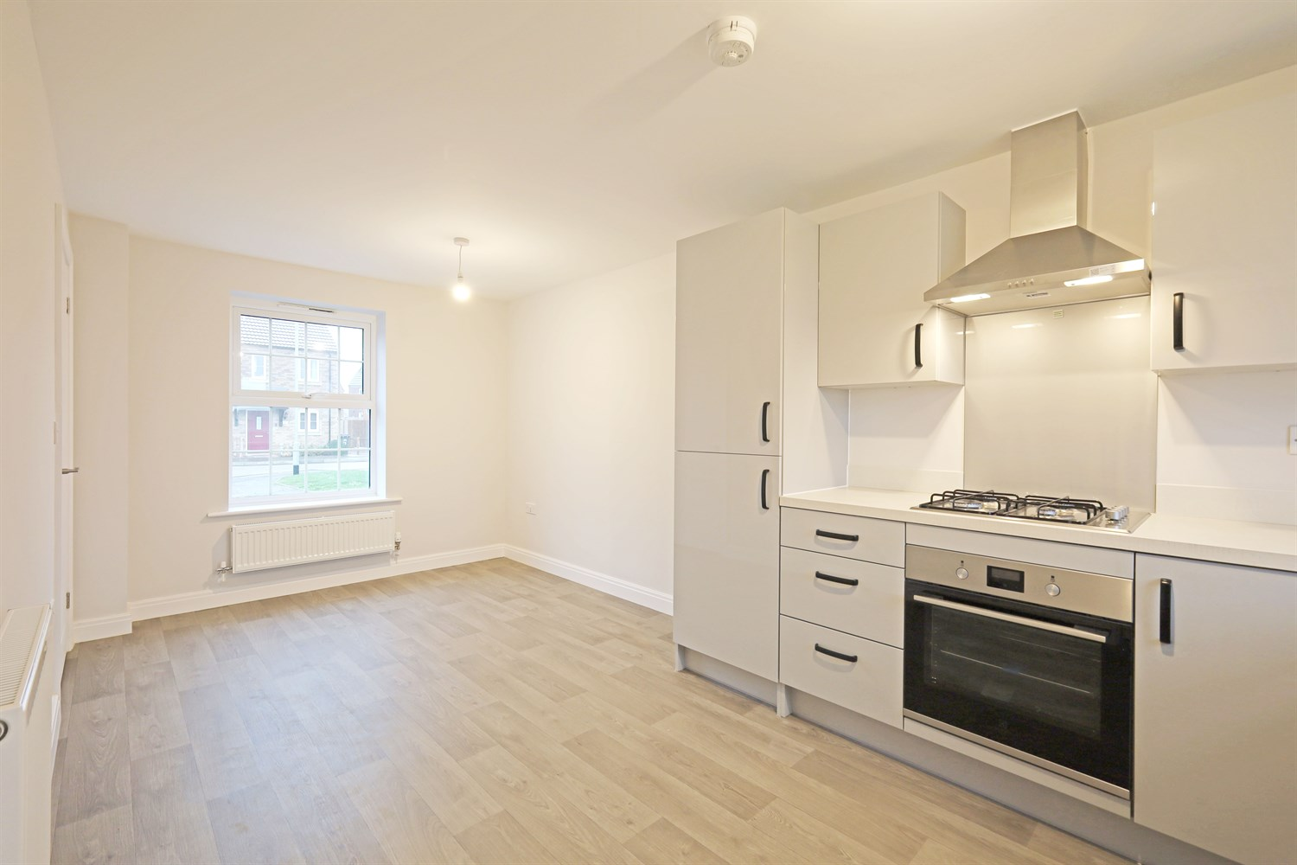
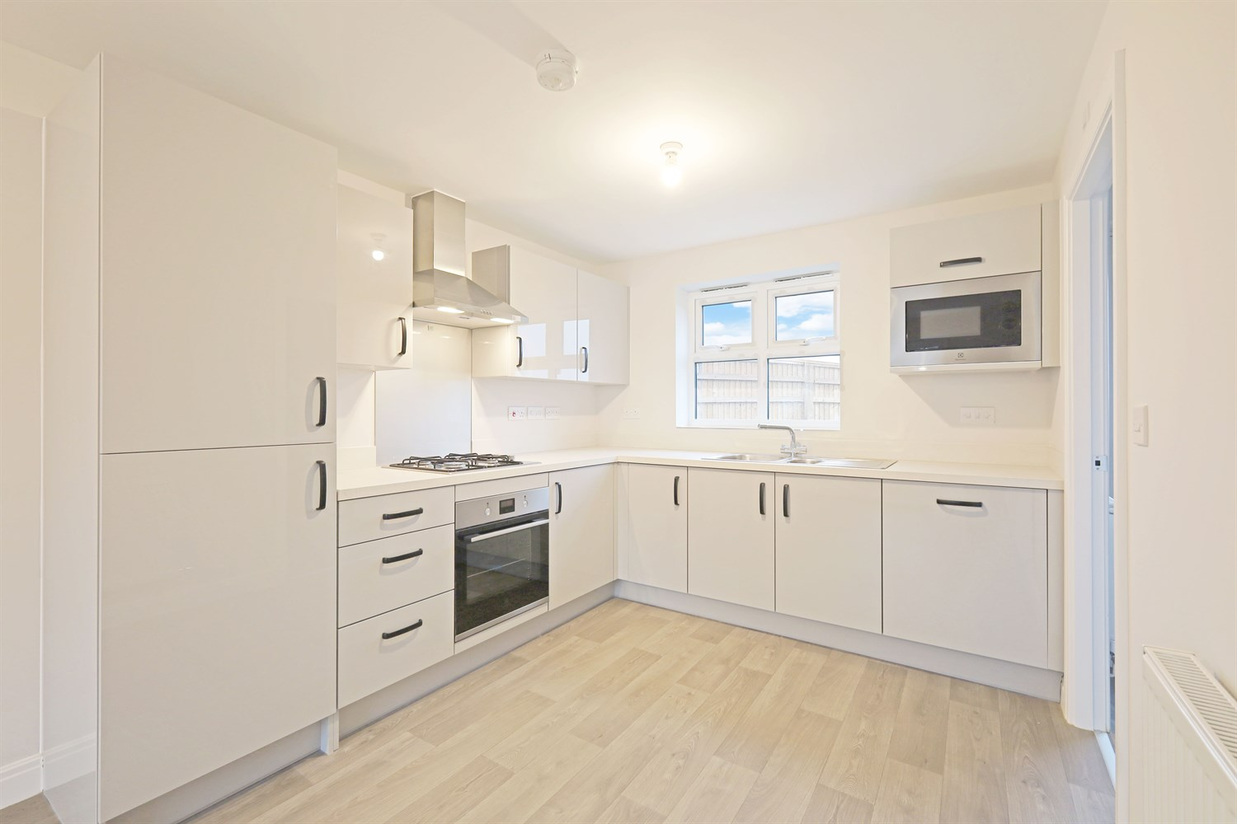
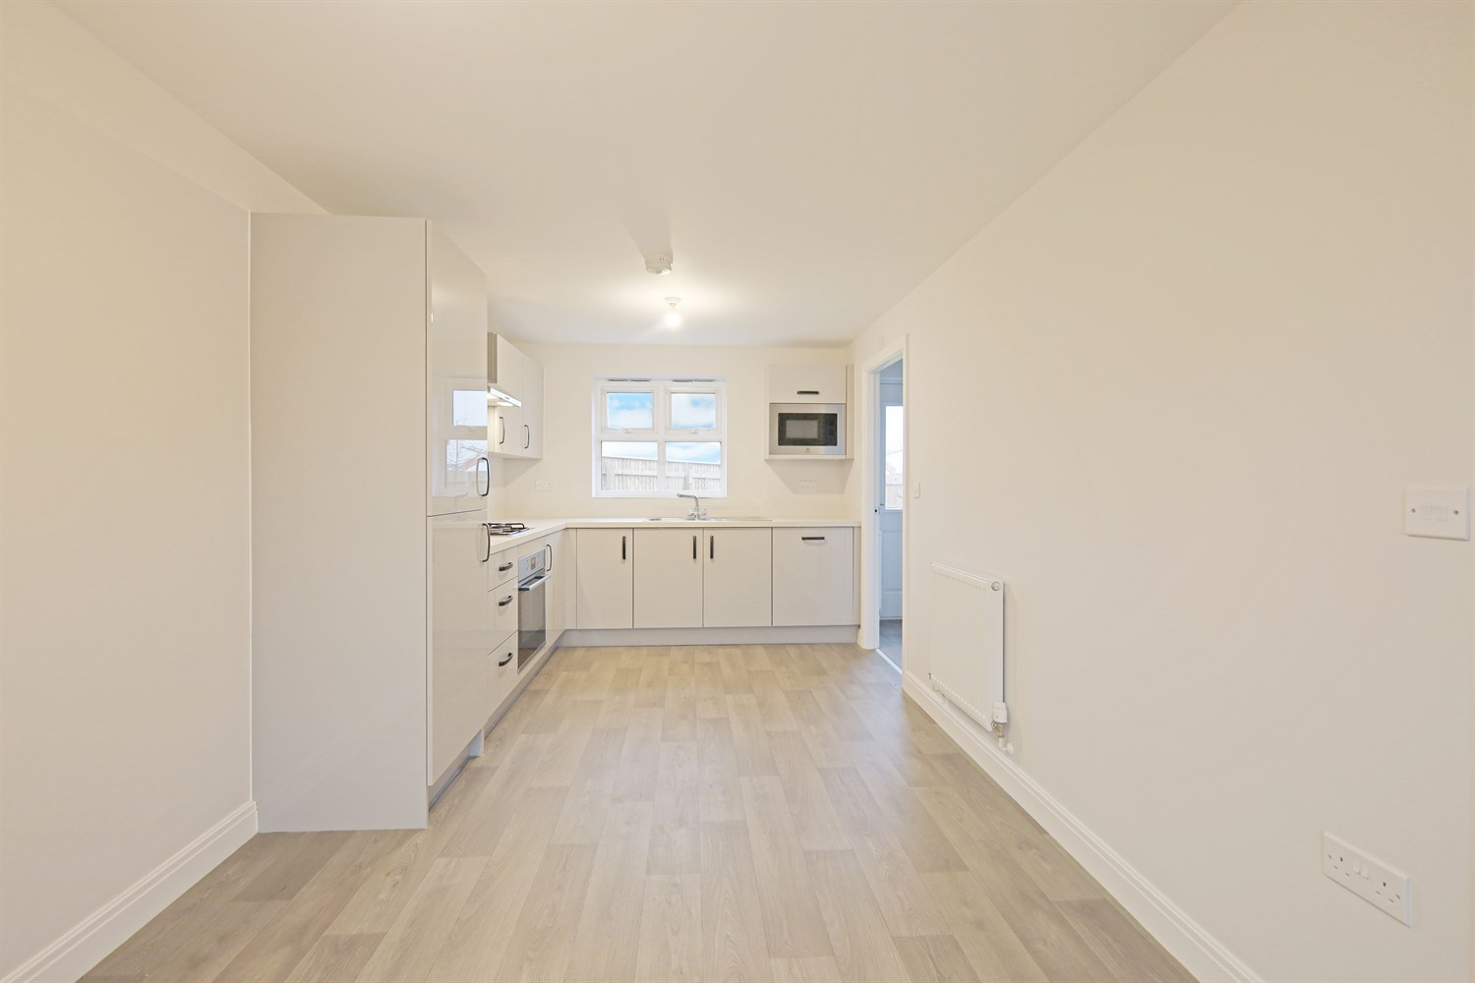
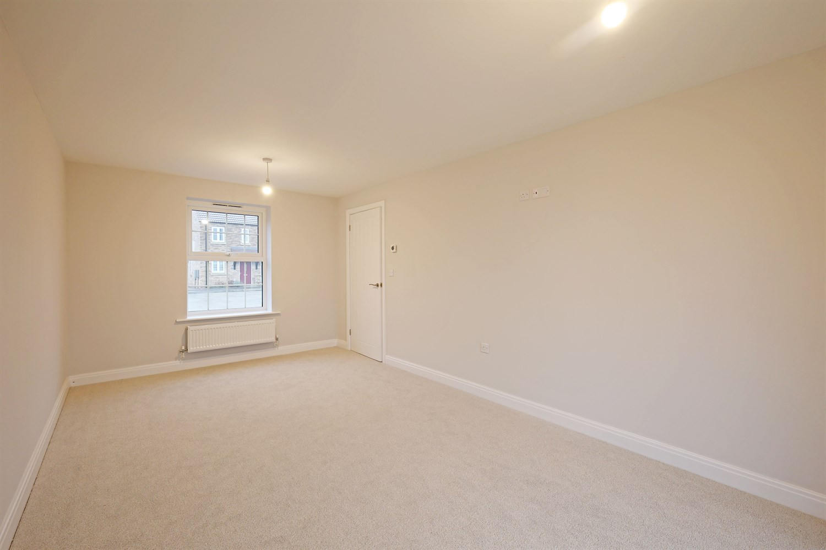
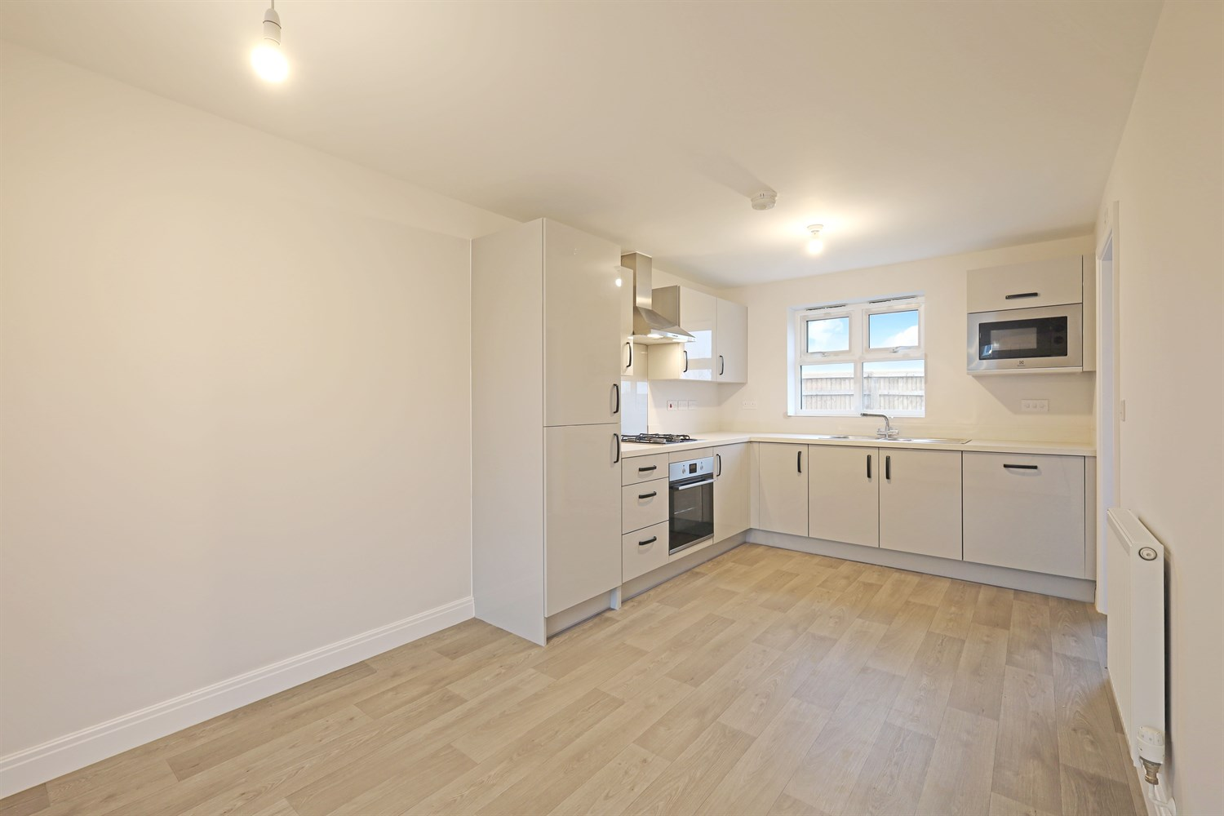

Property Description
An attractive and energy-efficient three-bedroom detached home, offering well-proportioned and thoughtfully designed accommodation ideal for modern family living.
The property is accessed via a welcoming entrance hall, providing access to the principal ground floor rooms. Positioned to the front, the spacious lounge offers a bright and comfortable setting for relaxation, with ample space for family seating arrangements.
To the rear, the open-plan kitchen and dining room forms the heart of the home. Thoughtfully arranged with generous worktop space and storage, this sociable area comfortably accommodates family dining and entertaining. French doors open directly onto the rear garden, allowing natural light to flood the space and creating seamless indoor-outdoor flow. A separate utility room enhances practicality, while a ground floor cloakroom adds further convenience.
To the first floor, the property offers three well-proportioned bedrooms. The principal bedroom benefits from built-in wardrobe space and a private en-suite shower room, creating a comfortable and private retreat. Bedrooms two and three provide flexible accommodation suitable for family members, guests or home working. A modern family bathroom completes the upstairs layout.
Externally, the property enjoys an attractive detached frontage with driveway parking and access to a garage, complemented by landscaped surroundings. Integrated solar panels further enhance the home¿s energy efficiency, helping to reduce running costs.
Combining space, functionality and modern efficiency, this home is perfectly suited to growing families or professional buyers seeking a stylish and practical long-term residence.

Front Aspect
The property enjoys an attractive and well-proportioned detached frontage, constructed in quality red brick beneath a pitched tiled roof with integrated solar panels, combining traditional styling with modern energy efficiency.
The symmetrical design creates a balanced and appealing appearance, enhanced by well-proportioned windows that allow for excellent natural light. A welcoming covered entrance frames the front door, adding character and definition to the façade.
A private driveway provides ample off-road parking and leads to a detached garage, offering both practicality and convenience. The front garden is neatly laid out with landscaped planting and enclosed by decorative fencing, contributing to the home¿s strong kerb appeal.

Entrance Hallway
A welcoming entrance hall providing access to the principal ground floor rooms, with staircase rising to the first floor. The layout creates a practical and well-balanced flow throughout the home, with a useful storage cupboard for coats and household essentials.

Downstairs Toilet/Cloakroom 1.81m (5'11) x .97m (3'2)
Conveniently positioned off the hallway, the ground floor cloakroom is fitted with a WC and wash hand basin. A valuable addition for modern family living and ideal for guests.

Lounge 5.63m (18'6) x 3m (9'10)
A generously proportioned lounge positioned to the front of the property, offering a bright and comfortable setting for relaxation. The well-balanced layout allows for flexible seating arrangements, creating an inviting space ideal for everyday family life or entertaining.

Kitchen/Dining Area 5.63m (18'6) x 2.73m (8'11)
Forming the heart of the home, the open-plan kitchen and dining area is thoughtfully arranged to provide ample worktop space and storage, alongside a dedicated dining area ideal for family meals. French doors open directly onto the rear garden, allowing natural light to flood the space and creating seamless indoor-outdoor flow.

Utility Room 2.01m (6'7) x 1.88m (6'2)
Accessed from the kitchen, the separate utility room provides additional workspace and storage, with space for laundry appliances. This practical addition helps keep the main kitchen area organised and clutter-free, with convenient external access.

Landing
The first-floor landing provides access to all three bedrooms and the family bathroom, creating a practical and well-connected layout. A built-in storage cupboard offers useful additional space for linens and household essentials.

Bedroom 1 3.75m (12'4) x 2.37m (7'9)
A generous principal bedroom positioned to the front of the property, offering ample space for a double bed and accompanying furniture. The room benefits from built-in wardrobe space and direct access to a private en-suite shower room, creating a comfortable and well-appointed retreat.

En-Suite 2.73m (8'11) x 1.78m (5'10)
The en-suite is fitted with a modern suite comprising a shower enclosure, WC and wash hand basin. Designed for both comfort and convenience, this well-appointed space enhances the practicality of the principal bedroom.

Bedroom 2 3.41m (11'2) x 2.9m (9'6)
A well-proportioned double bedroom enjoying a pleasant rear aspect. Offering comfortable space for furnishings, this versatile room is ideal for family members, guests or even home working.

Bedroom 3 2.9m (9'6) x 2.15m (7'1)
A further well-balanced bedroom, perfectly suited as a child¿s bedroom, nursery or study. The layout allows for practical furniture placement while maintaining a bright and airy feel.

Family Bathroom 2.18m (7'2) x 1.7m (5'7)
The family bathroom is fitted with a three-piece suite comprising a panelled bath, WC and wash hand basin. Positioned conveniently off the landing, it comfortably serves bedrooms two and three, completing the first-floor accommodation.

These particulars are intended to give a fair description of the property, but their accuracy cannot be guaranteed, and they do not constitute an offer of contract. Intending purchasers must rely on their own inspection of the property. None of the above appliances/services have been tested by ourselves. We recommend purchasers arrange for a qualified person to check all appliances/services before legal commitment.

Property Ref: 3305

www.drurysestateagents.co.uk
amber@drurysestateagents.co.uk
01205 350889

45 Willoughby Road
Boston
Lincolnshire
PE21 9HN
Agents Note: Whilst every care has been taken to prepare these sales particulars, they are for guidance purposes only. All measurements are approximate are for general guidance purposes only and whilst every care has been taken to ensure their accuracy, they should not be relied upon and potential buyers are advised to recheck the measurements

