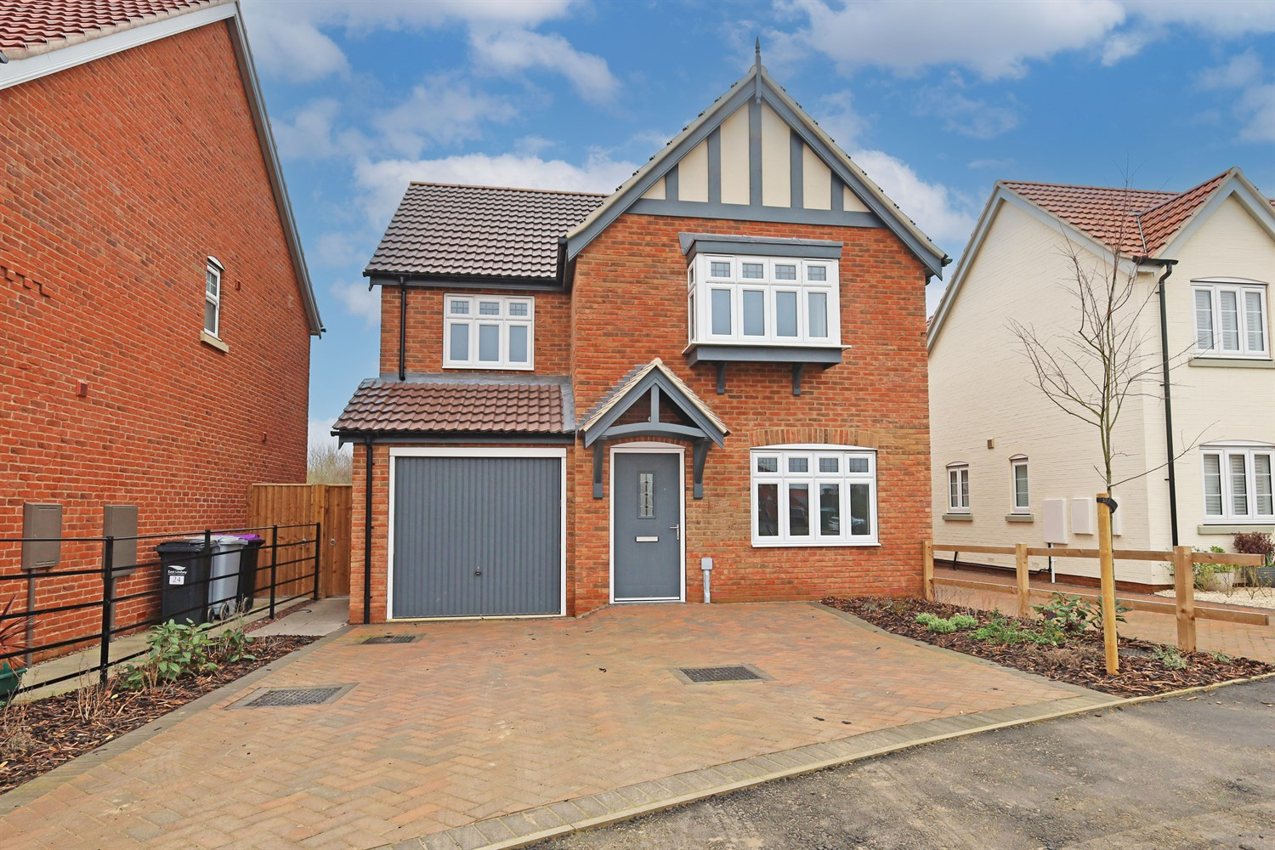




3 Bedroom(s)
3 Reception(s)
1 Bathroom(s)
£289,950.00
The Mulberry, Main Road, Sibsey, PE22
EPC Rating ‘’

00

Property Description
An attractive and well-appointed three-bedroom detached home, offering spacious and thoughtfully designed accommodation ideal for modern family living.
The property is accessed via a welcoming entrance hall, leading through to a generous front-facing lounge with a bright and comfortable space perfectly suited for relaxation and everyday living. To the rear, the open-plan kitchen and dining room forms the heart of the home, providing ample worktop space and storage alongside a dedicated dining area ideal for family meals and entertaining. French doors open directly onto the rear garden, creating a light-filled and sociable environment with seamless indoor-outdoor flow.
A separate utility room adds valuable practicality, helping to keep the main kitchen area organised, while a ground floor cloakroom enhances convenience. The property also benefits from an integral garage, offering secure parking or additional storage.
To the first floor, the home offers three well-proportioned bedrooms. The principal bedroom enjoys built-in wardrobe space and a private en-suite shower room, creating a comfortable retreat. Bedrooms two and three provide flexible accommodation suitable for family members, guests or home working. A modern family bathroom completes the upstairs layout.
Externally, the property boasts an attractive frontage with driveway parking and access to the garage, complemented by landscaped surroundings. Combining space, functionality and traditional styling, this home is perfectly suited to growing families or professional buyers seeking a stylish and practical long-term residence.

Front Aspect
The property presents a striking and characterful frontage, constructed in quality red brick beneath a pitched tiled roof with attractive gable detailing. Decorative timber-style features to the upper elevation enhance the traditional design, creating a home with real kerb appeal.
A welcoming storm porch frames the entrance, adding charm and architectural interest, while a feature bay window allows for excellent natural light and further enhances the balanced façade. A private driveway provides off-road parking and leads to the integral garage, offering both practicality and convenience.
Neatly landscaped planting and a well-maintained frontage complete the picture, ensuring an impressive first impression from the moment you arrive.

Entrance Hallway
A welcoming entrance hall providing access to the principal ground floor rooms, with staircase rising to the first floor. The layout creates a practical and well-connected flow throughout the home, setting the tone for the spacious accommodation beyond.

Downstairs Toilet and Cloakroom 1.79m (5'10) x .9m (2'11)
Conveniently positioned off the hallway, the ground floor cloakroom is fitted with a WC and wash hand basin. An essential addition for modern family living and particularly useful when entertaining guests.

Lounge 3.2m (10'6) x 5.18m (17')
A generously proportioned lounge positioned to the front of the property, offering a bright and comfortable space for relaxation. The well-balanced layout allows for ample seating arrangements, creating an inviting setting ideal for everyday family life or entertaining.

Kitchen/Dining Area 5.42m (17'9) x 2.54m (8'4)
The heart of the home, the open-plan kitchen/dining area is thoughtfully arranged to provide ample worktop space and storage, alongside a dedicated dining area perfect for family meals. French doors open directly onto the rear garden, allowing natural light to flood the space and creating seamless indoor-outdoor flow ¿ ideal for both entertaining and modern living.

Utility Room 1.58m (5'2) x 2.39m (7'10)
Accessed from the kitchen, the separate utility room provides additional workspace and storage, with space for laundry appliances. A highly practical addition that helps keep the main kitchen area organised and clutter-free, which includes an entrance to the garage.

Garage
The property further benefits from an integral garage, offering secure parking or valuable additional storage space. This versatile area also provides potential for conversion (subject to the necessary consents), enhancing the flexibility of the home.

Landing
The first-floor landing provides access to all three bedrooms and the family bathroom, creating a practical and well-connected layout. A built-in storage cupboard offers valuable additional space for linens and household essentials.

Bedroom 1 4.28m (14'1) x 3.49m (11'5)
A generous principal bedroom positioned to the front of the property, offering ample space for a double bed and accompanying furnishings. The room benefits from built-in wardrobe space, creating a clean and organised feel, and enjoys direct access to a private en-suite shower room.

En-Suite 2.26m (7'5) x 1.75m (5'9)
The en-suite is fitted with a modern suite comprising a shower enclosure, WC and wash hand basin. Designed for both comfort and convenience, this well-appointed space enhances the practicality of the principal bedroom.

Bedroom 2 3.92m (12'10) x 2.72m (8'11)
A well-proportioned double bedroom enjoying a pleasant rear aspect. Offering comfortable space for furnishings, this versatile room is ideal for family members, guests or even a home office if required.

Bedroom 3 4.28m (14'1) x 2.15m (7'1)
A further well-balanced bedroom, perfectly suited as a child¿s bedroom, nursery or study. The layout allows for practical furniture placement while maintaining a bright and airy feel.

Bathroom 2.72m (8'11) x 1.95m (6'5)
The family bathroom is fitted with a three-piece suite comprising a panelled bath, WC and wash hand basin. Positioned conveniently off the landing, it comfortably serves bedrooms two and three, completing the first-floor accommodation.

These particulars are intended to give a fair description of the property, but their accuracy cannot be guaranteed, and they do not constitute an offer of contract. Intending purchasers must rely on their own inspection of the property. None of the above appliances/services have been tested by ourselves. We recommend purchasers arrange for a qualified person to check all appliances/services before legal commitment.

Property Ref: 3303

www.drurysestateagents.co.uk
amber@drurysestateagents.co.uk
01205 350889

45 Willoughby Road
Boston
Lincolnshire
PE21 9HN
Agents Note: Whilst every care has been taken to prepare these sales particulars, they are for guidance purposes only. All measurements are approximate are for general guidance purposes only and whilst every care has been taken to ensure their accuracy, they should not be relied upon and potential buyers are advised to recheck the measurements

