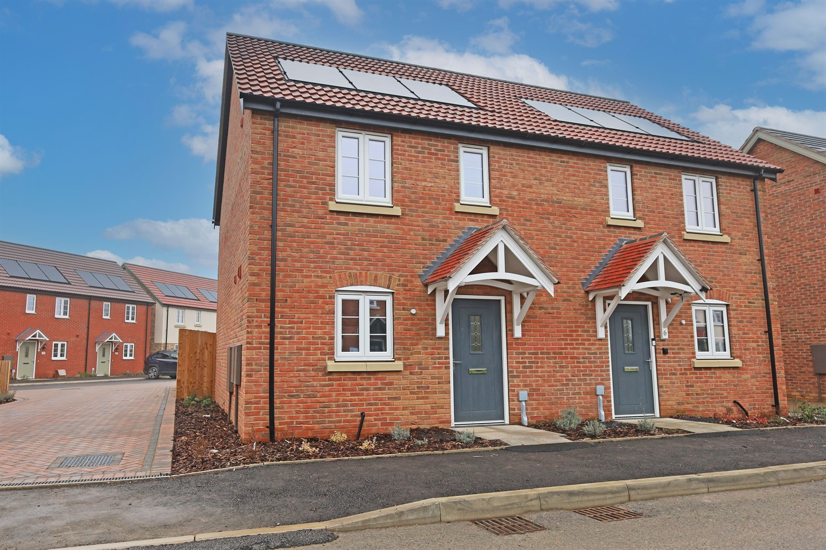




2 Bedroom(s)
2 Reception(s)
1 Bathroom(s)
£169,950.00
The Nook, Main Road, Sibsey, PE22
EPC Rating ‘’

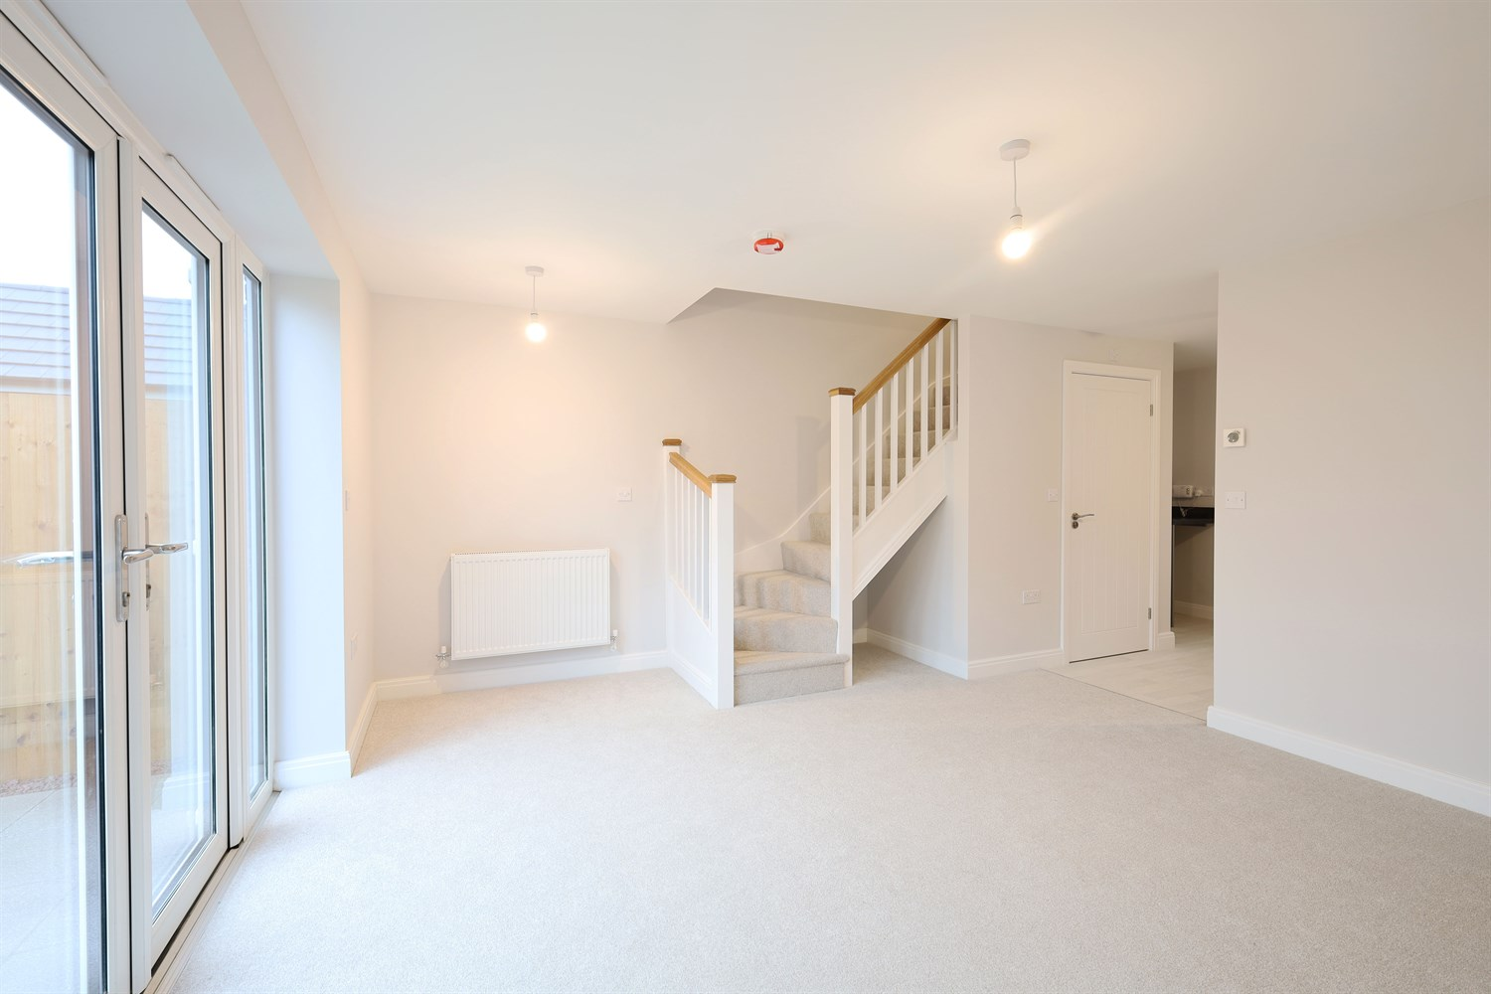
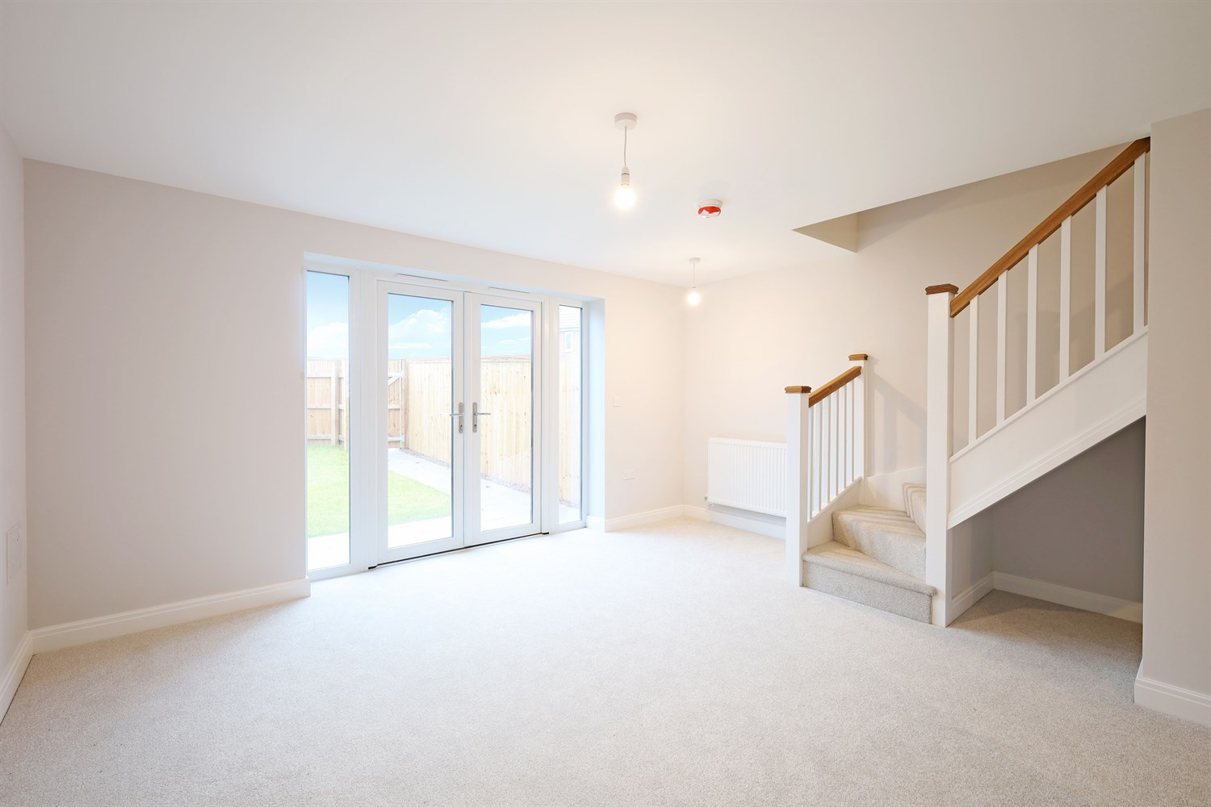
00
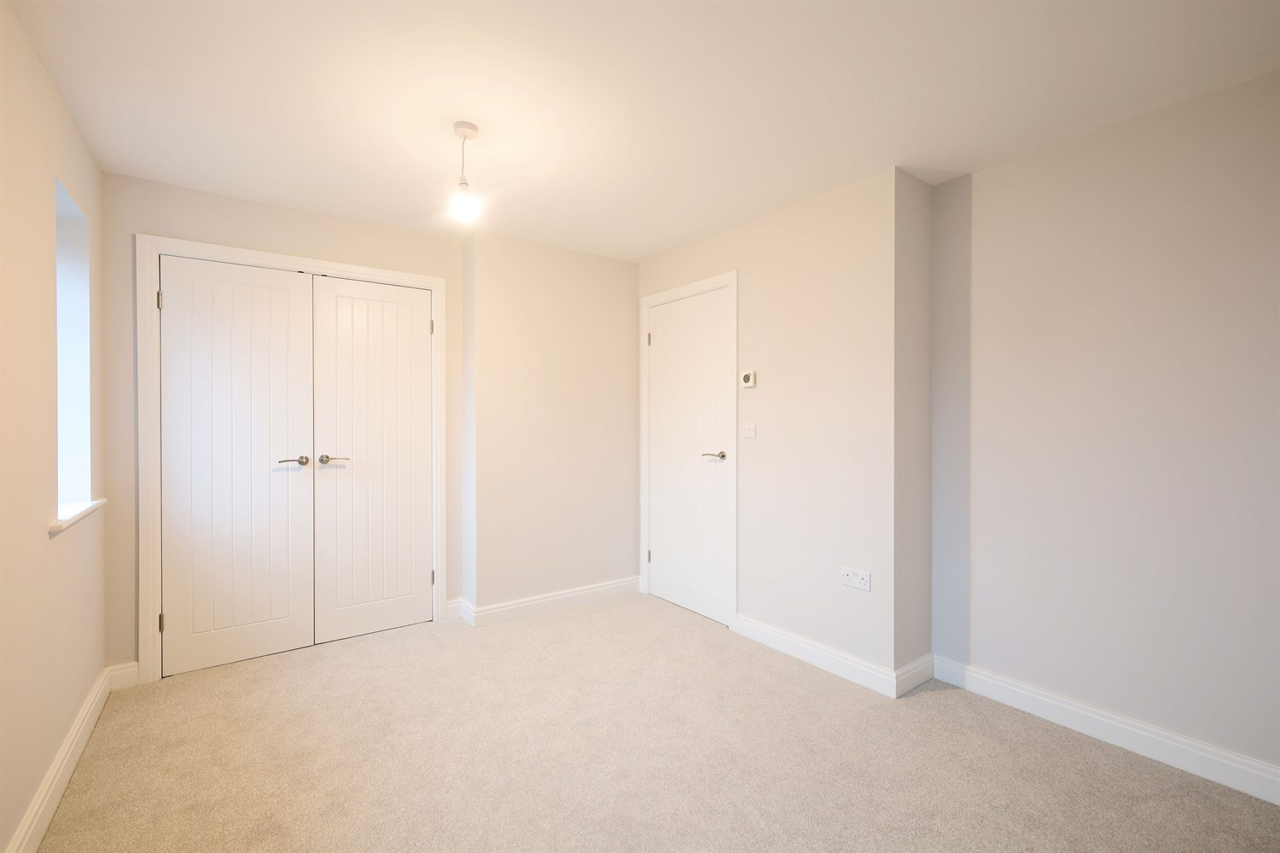
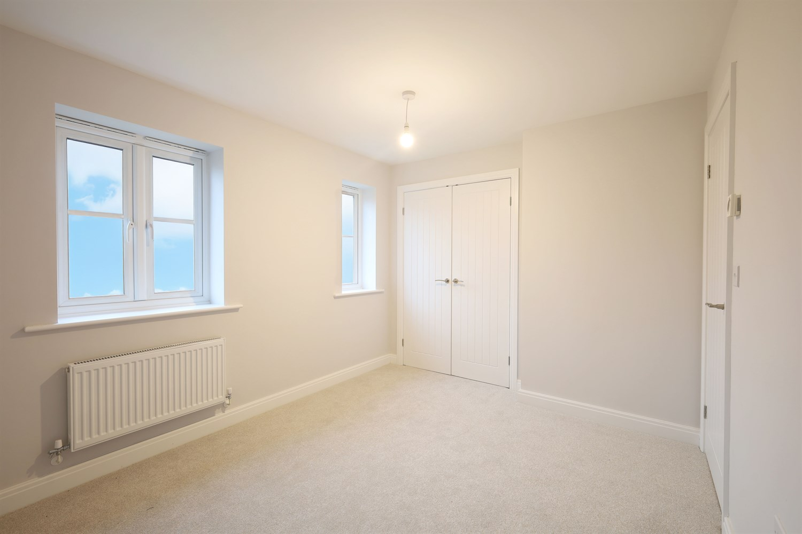
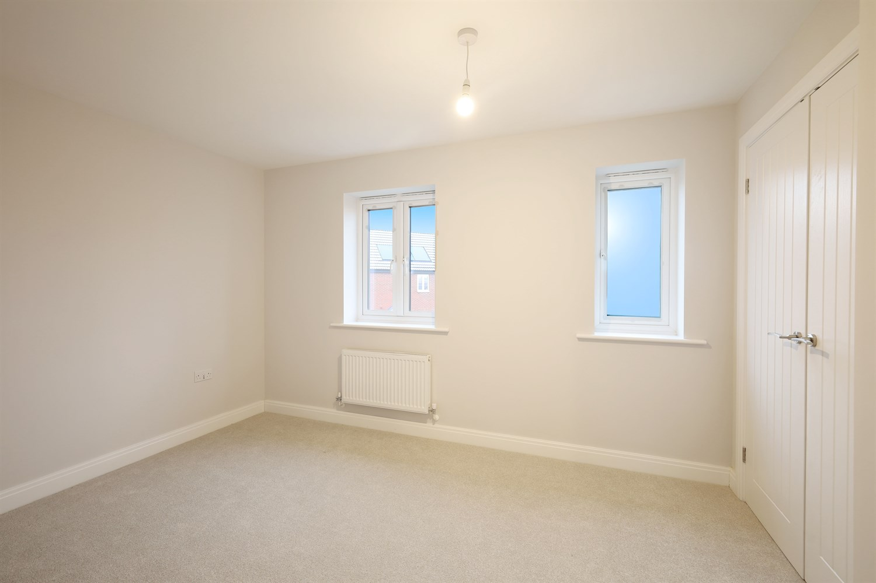
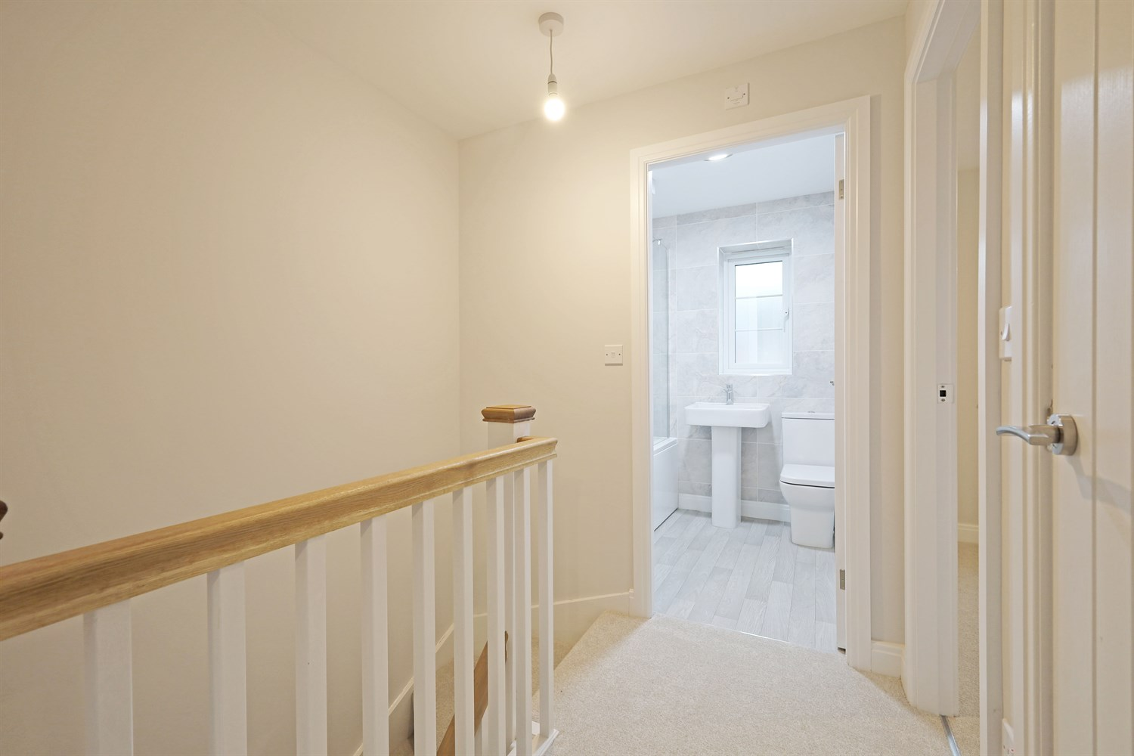
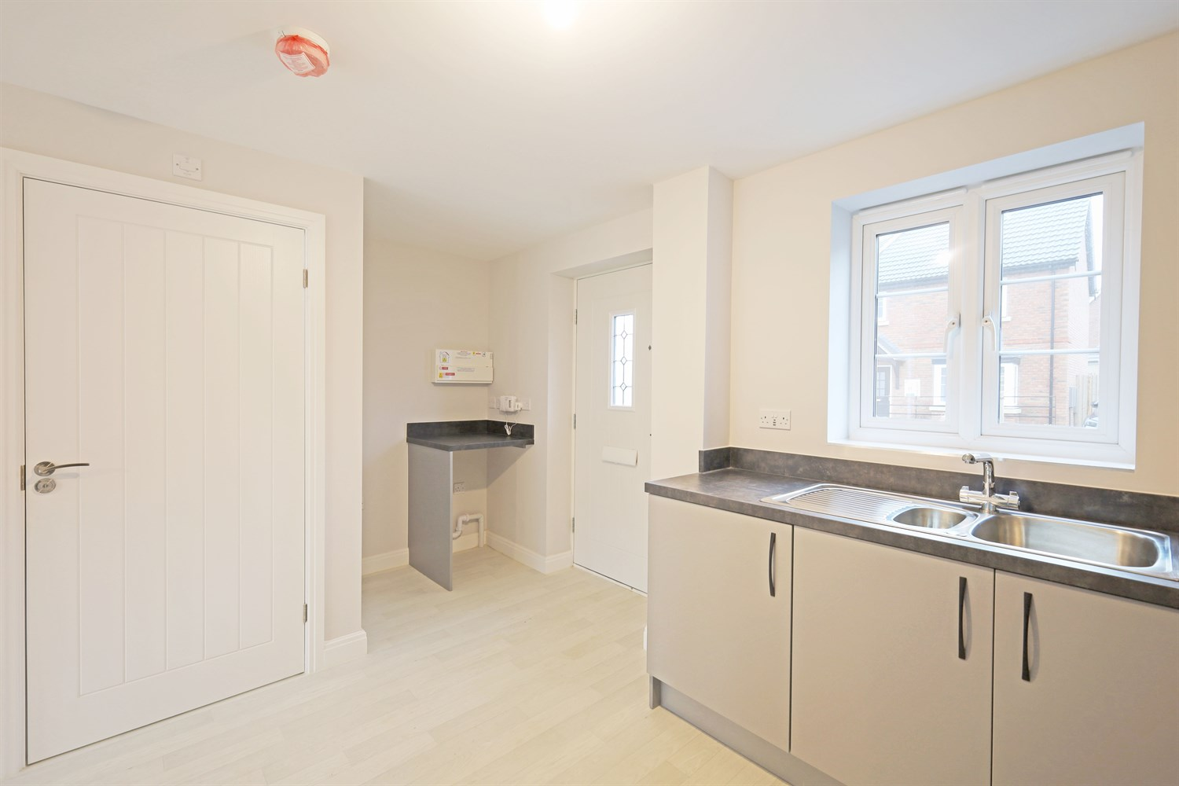
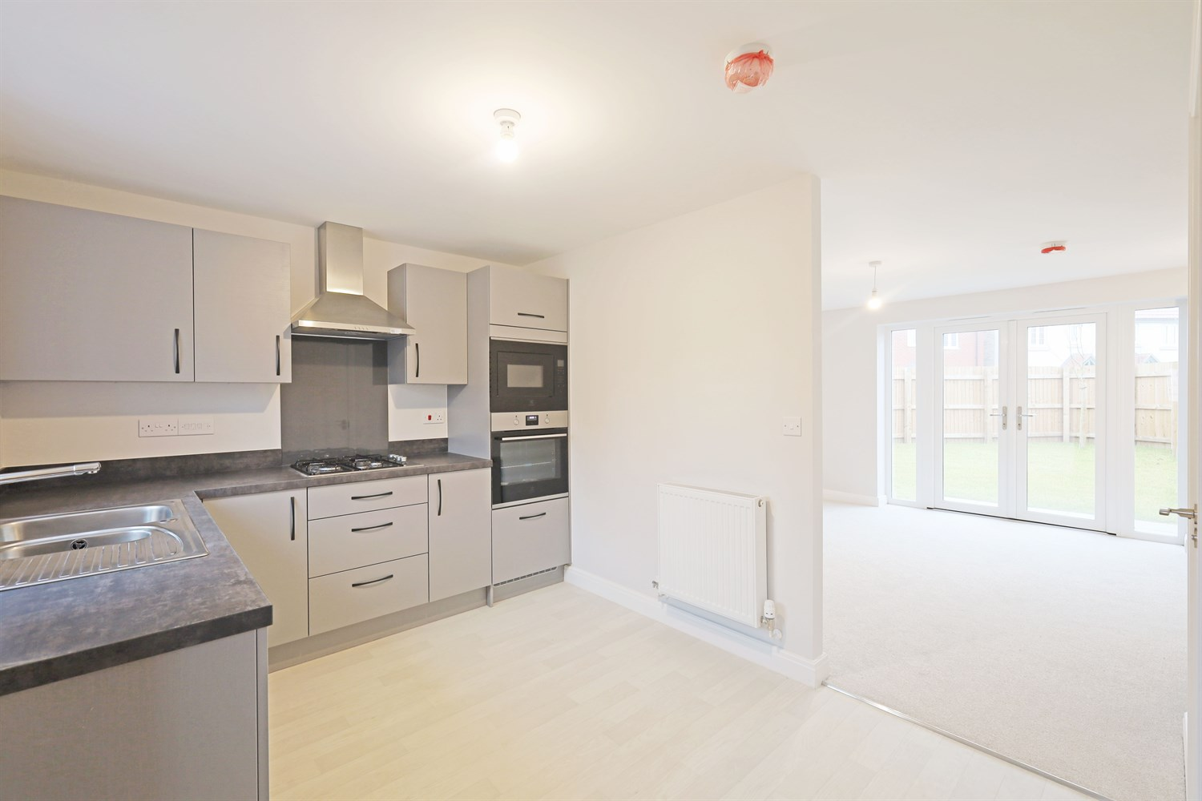
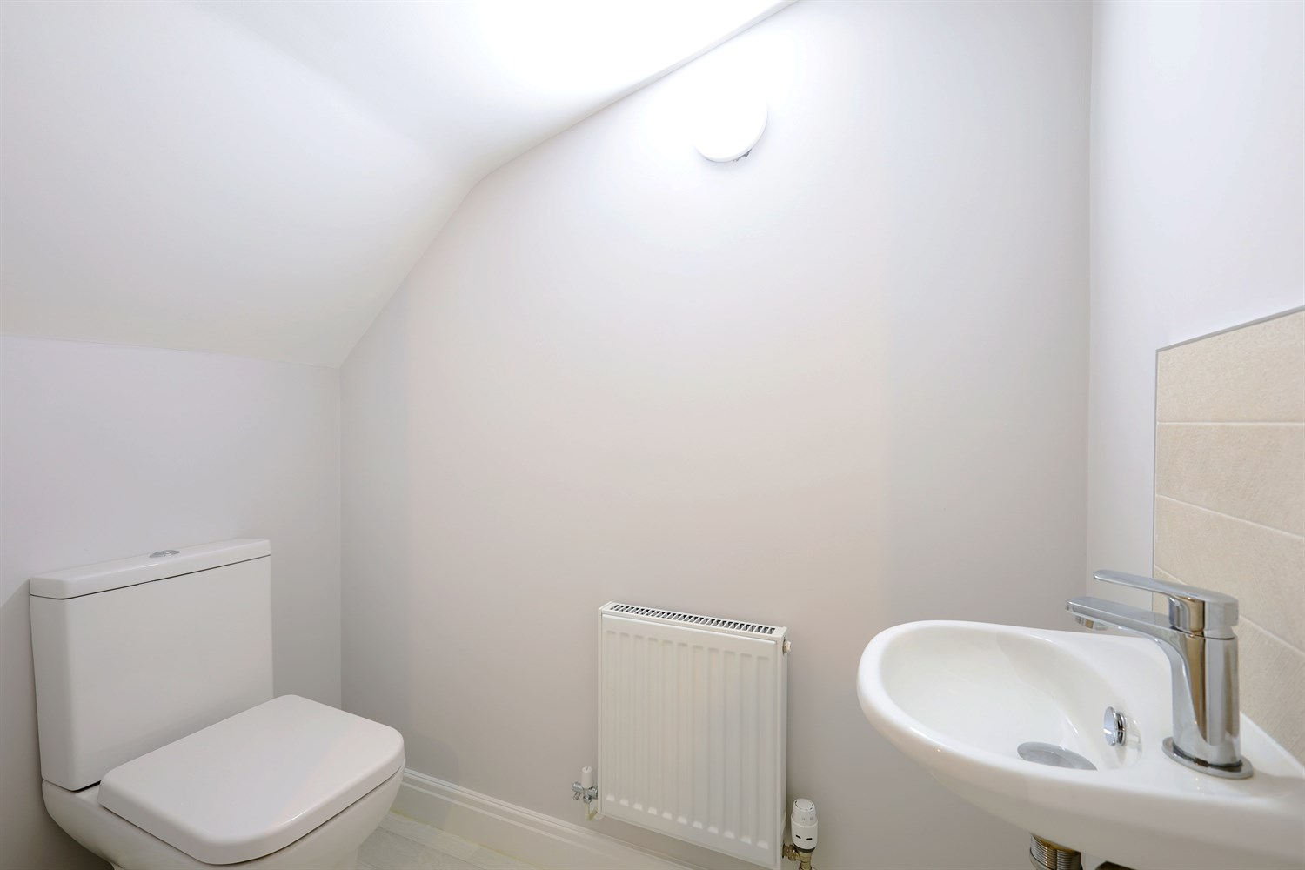
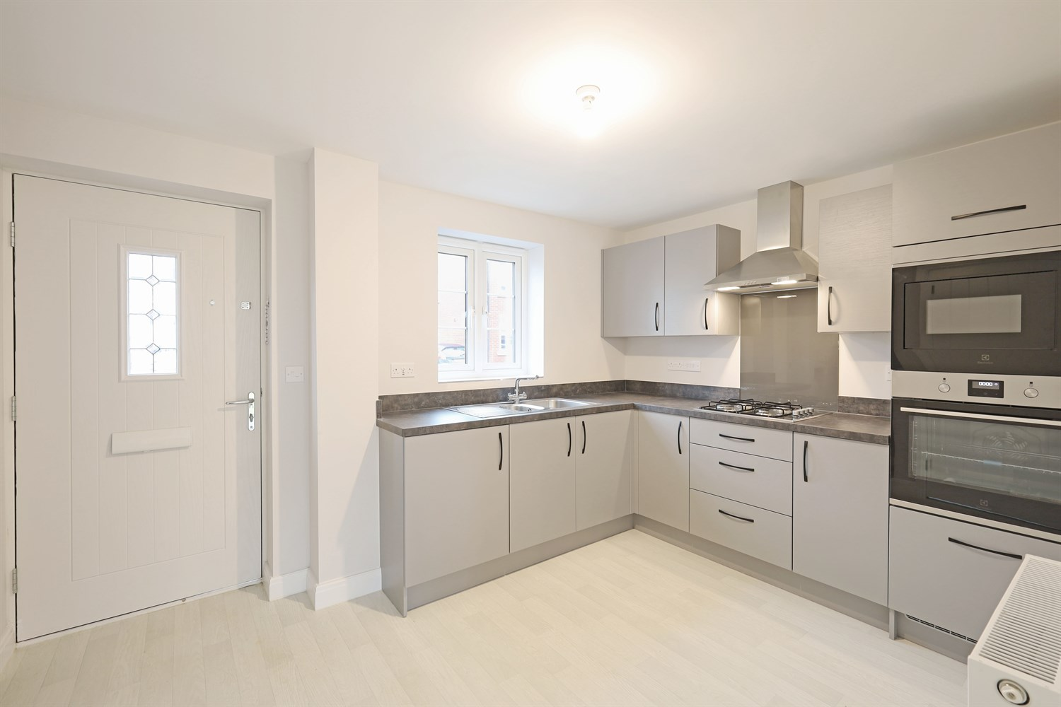

Property Description
An attractive and well-presented two-bedroom semi-detached home, offering thoughtfully arranged accommodation ideal for first-time buyers, downsizers or investors.
The ground floor is accessed via a welcoming entrance hall, leading to a well-appointed kitchen positioned to the front of the property, offering ample worktop space and storage for everyday living. To the rear, the lounge provides a comfortable and inviting setting, seamlessly incorporating a defined dining area ideal for family meals and entertaining. French doors open directly onto the rear garden, allowing natural light to flood the space and creating a bright and airy atmosphere. A convenient ground floor cloakroom adds further practicality.
To the first floor, the property offers two well-proportioned bedrooms. The principal bedroom benefits from built-in wardrobe space, while bedroom two provides flexible accommodation suitable as a nursery, guest room or home office. A family bathroom completes the upstairs layout.
Externally, the property enjoys an attractive frontage with driveway parking and a low-maintenance exterior, making it a superb opportunity for buyers seeking modern, manageable living.
Combining functionality, comfort and excellent starter-home appeal, this property presents an ideal first step onto the property ladder.

Front Aspect
The property boasts a striking and characterful façade, combining traditional brickwork with elegant storm porch detailing and a classic pitched roof. The balanced design offers excellent kerb appeal, complemented by private driveway parking and neatly landscaped surroundings, creating a welcoming and refined first impression.

Entrance Hallway
A welcoming entrance hall providing access to the kitchen and ground floor cloakroom, with staircase rising to the first floor. The layout creates a practical flow through the home while maintaining separation between living areas.

Downstairs Toilet and Cloakroom 1.8m (5'11) x .95m (3'1)
Conveniently positioned off the hallway, the ground floor cloakroom is fitted with a WC and wash hand basin. A highly desirable feature in modern homes, adding practicality for everyday living and guests.

Kitchen 4.49m (14'9) x 2.65m (8'8)
Located to the front of the property, the kitchen is thoughtfully arranged to maximise both worktop space and storage. The layout offers practicality for everyday cooking, with space for essential appliances and a pleasant outlook enhancing the bright and functional feel of the room.

Lounge/Dining Area 3.9m (12'10) x 4.49m (14'9)
Positioned to the rear, the lounge provides a comfortable and well-proportioned living space ideal for relaxation. The layout allows for flexible seating arrangements, creating an inviting setting for everyday family life. Situated within the main living space, the defined dining area offers ample room for a dining table and chairs, making it ideal for family meals and entertaining. French doors open directly onto the rear garden, allowing natural light to flood the room and creating seamless indoor-outdoor flow.

Landing
The first-floor landing provides access to both bedrooms and the family bathroom, creating a practical and well-balanced layout. A built-in storage cupboard offers valuable additional space for linens and household essentials.

Bedroom 1 3.15m (10'4) x 3.75m (12'4)
A well-proportioned principal bedroom positioned to the front of the property, offering ample space for a double bed and accompanying furnishings. The room benefits from built-in wardrobe space, providing excellent storage while maintaining a clean and uncluttered feel.

Bedroom 2 2.49m (8'2) x 3.4m (11'2)
A versatile second bedroom enjoying a pleasant rear aspect. Ideal as a single bedroom, nursery or home office, the layout allows for practical furniture placement and flexible use to suit modern lifestyles.

Bathroom 1.96m (6'5) x 1.7m (5'7)
The family bathroom is fitted with a three-piece suite comprising a panelled bath, WC and wash hand basin. Positioned conveniently off the landing, it comfortably serves both bedrooms and completes the first-floor accommodation.

These particulars are intended to give a fair description of the property, but their accuracy cannot be guaranteed, and they do not constitute an offer of contract. Intending purchasers must rely on their own inspection of the property. None of the above appliances/services have been tested by ourselves. We recommend purchasers arrange for a qualified person to check all appliances/services before legal commitment.

Property Ref: 3304

www.drurysestateagents.co.uk
amber@drurysestateagents.co.uk
01205 350889

45 Willoughby Road
Boston
Lincolnshire
PE21 9HN
Agents Note: Whilst every care has been taken to prepare these sales particulars, they are for guidance purposes only. All measurements are approximate are for general guidance purposes only and whilst every care has been taken to ensure their accuracy, they should not be relied upon and potential buyers are advised to recheck the measurements

