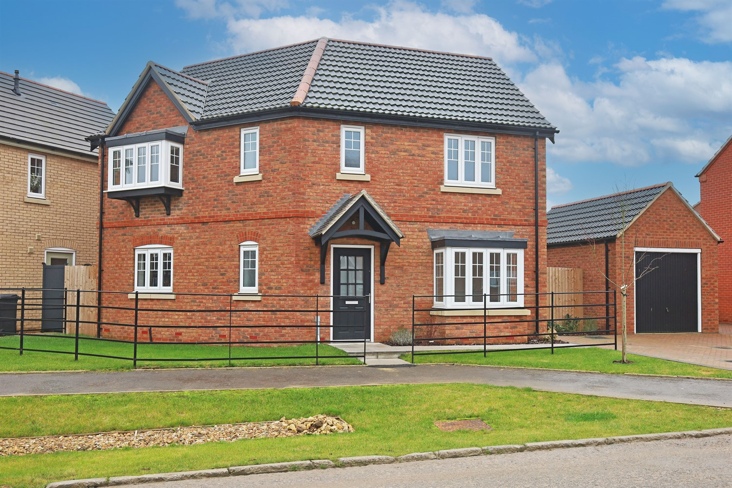




3 Bedroom(s)
3 Reception(s)
1 Bathroom(s)
£279,950.00
The Rest, Main Road, Sibsey, PE22
EPC Rating ‘’

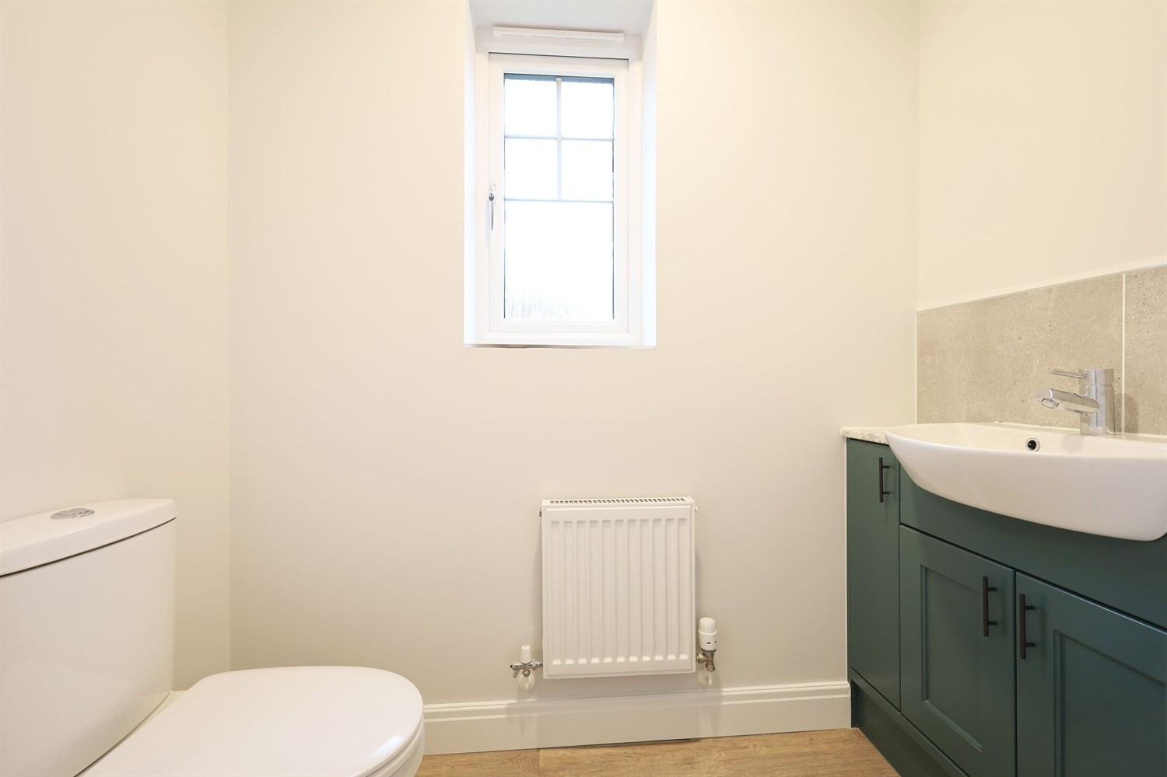
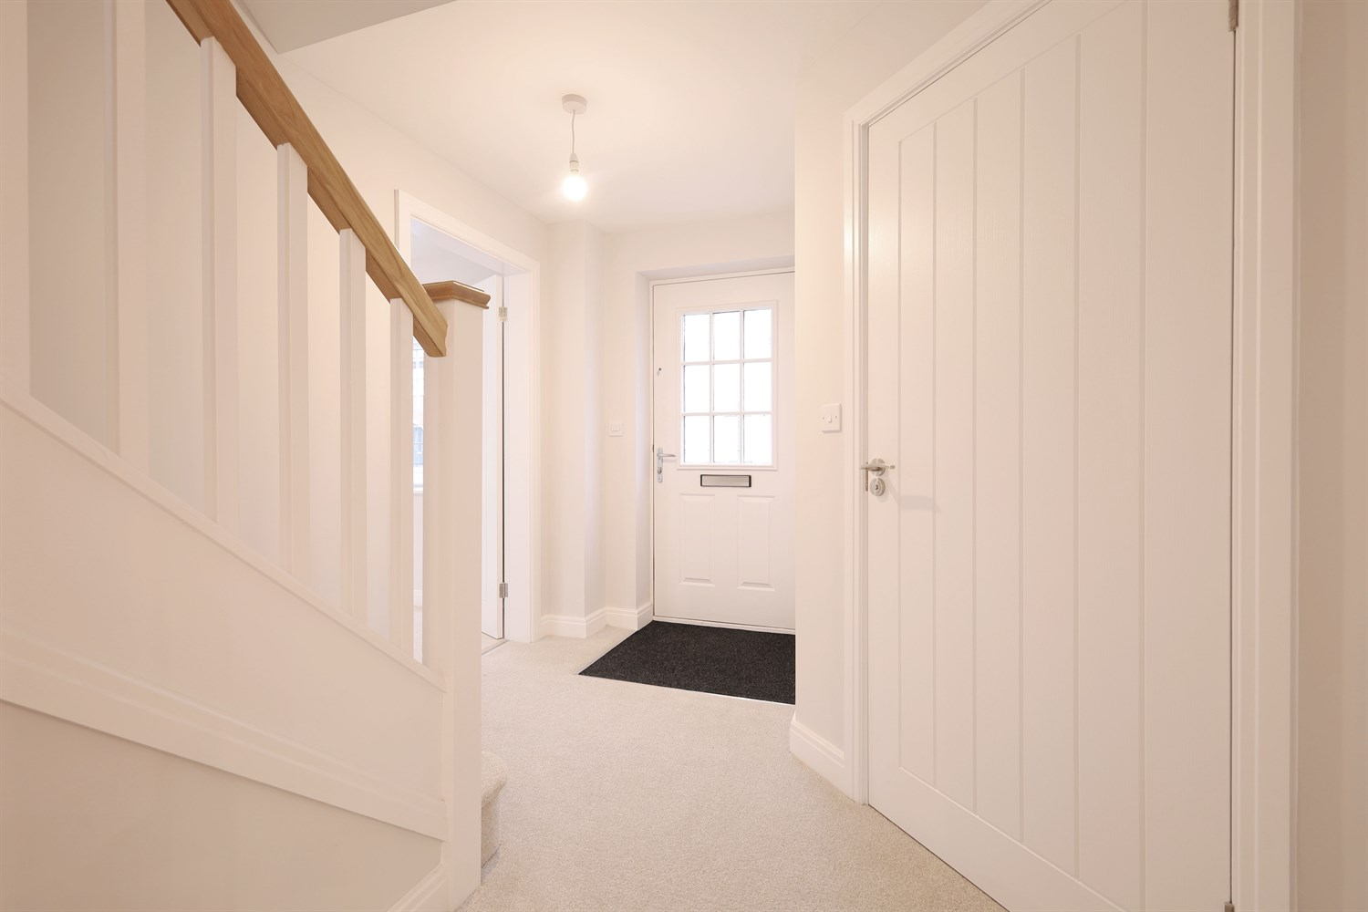
00
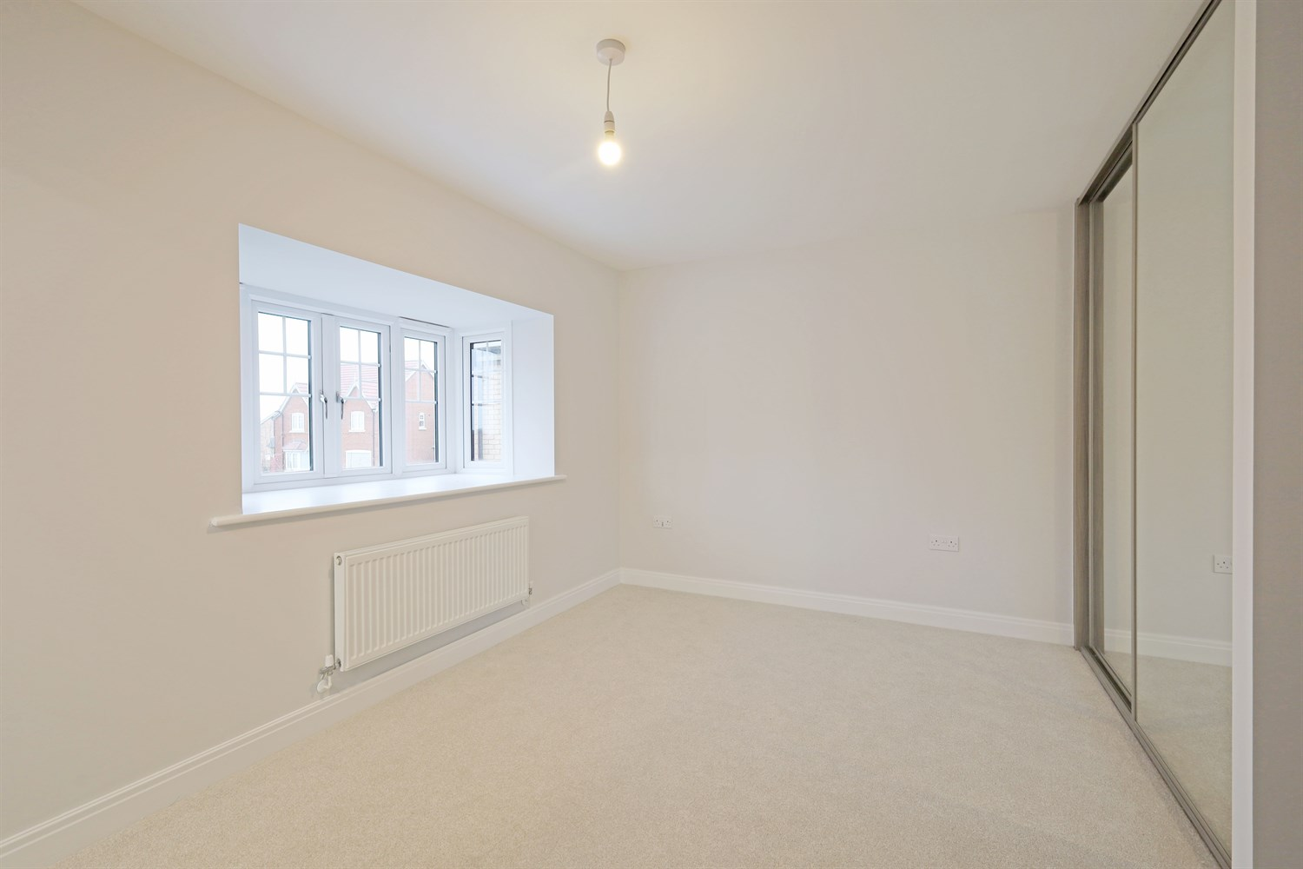
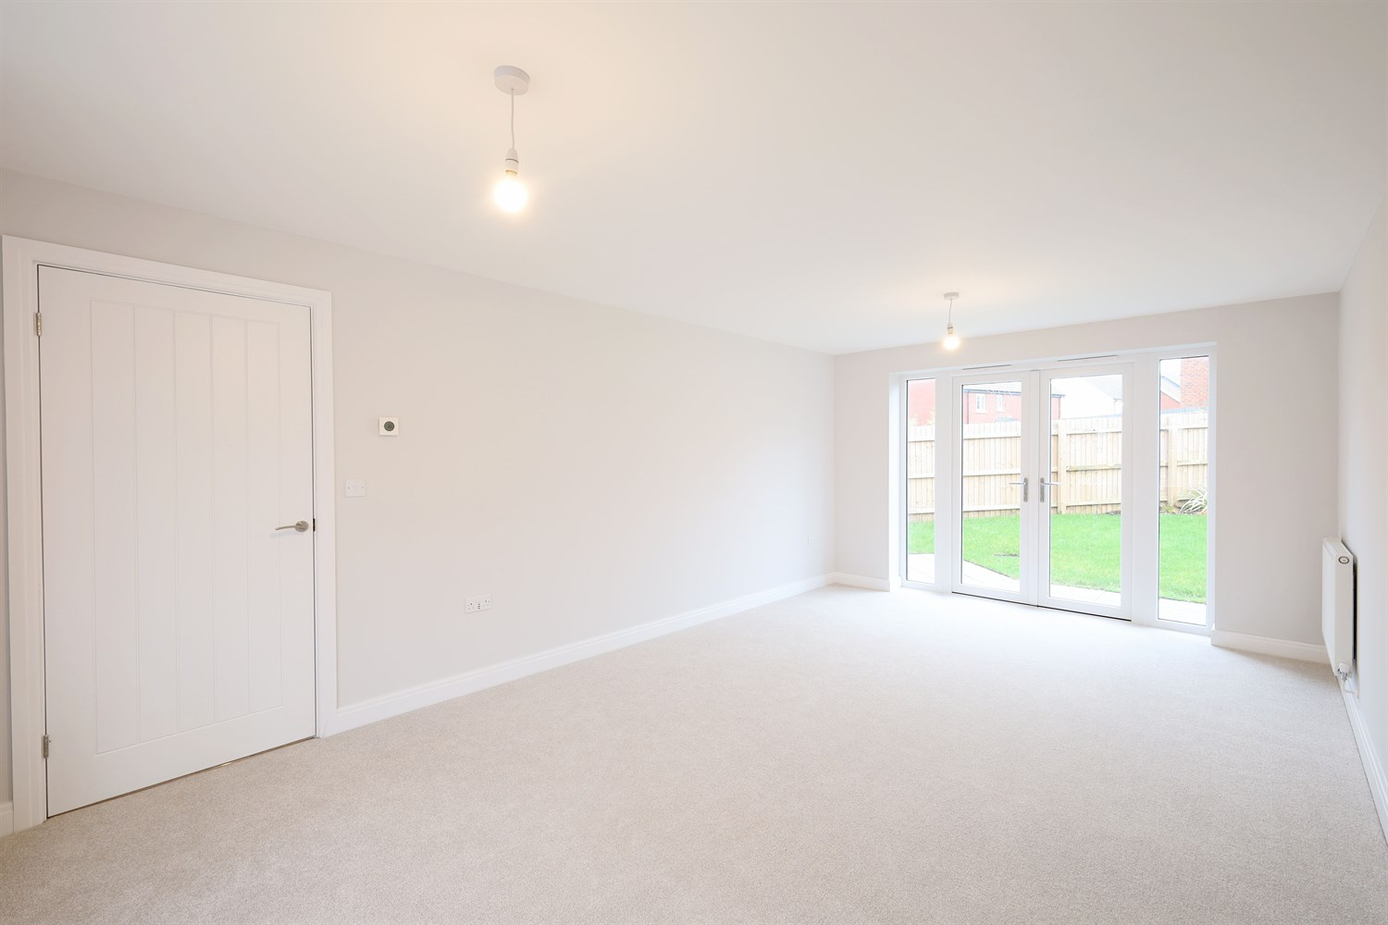
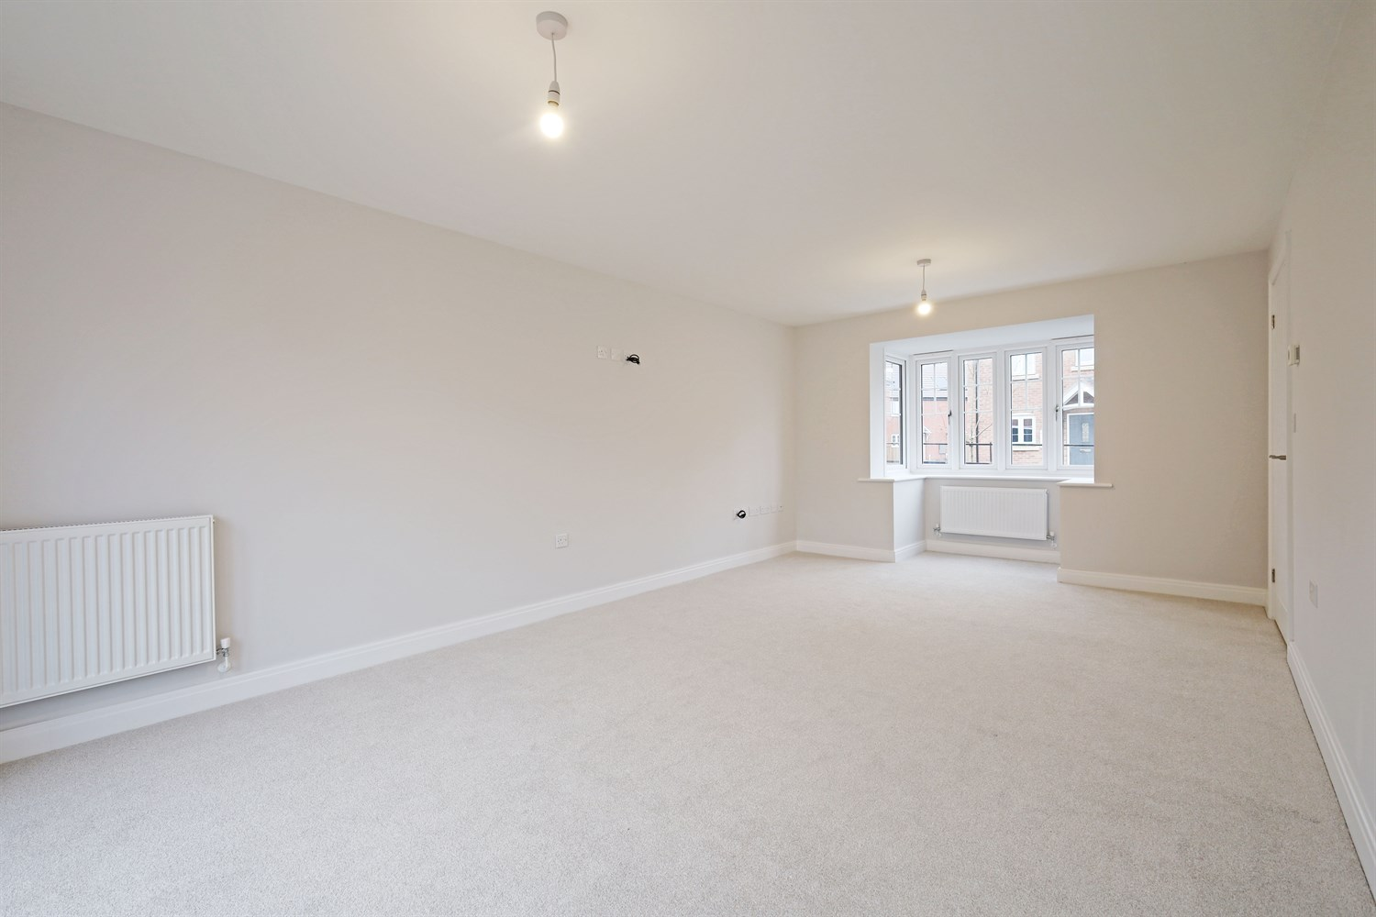
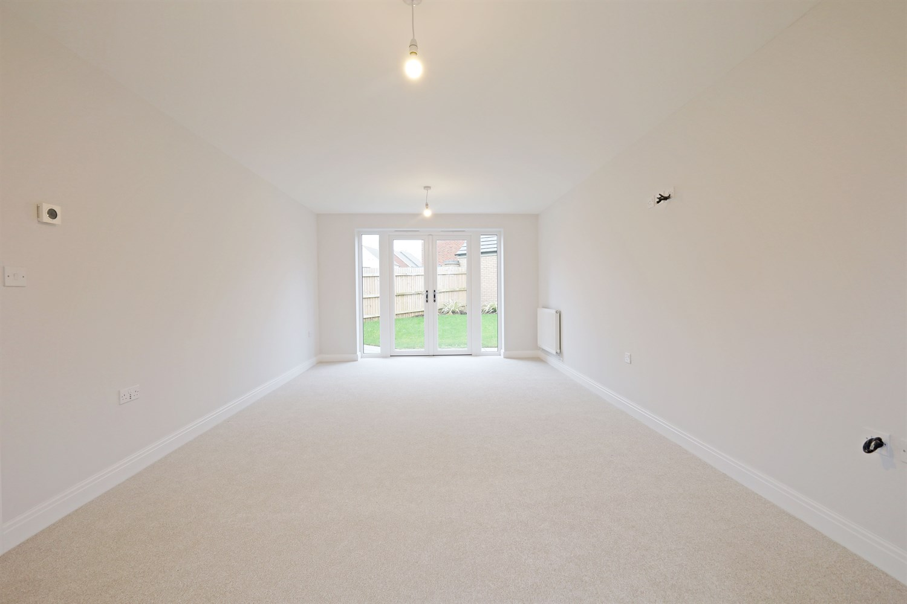
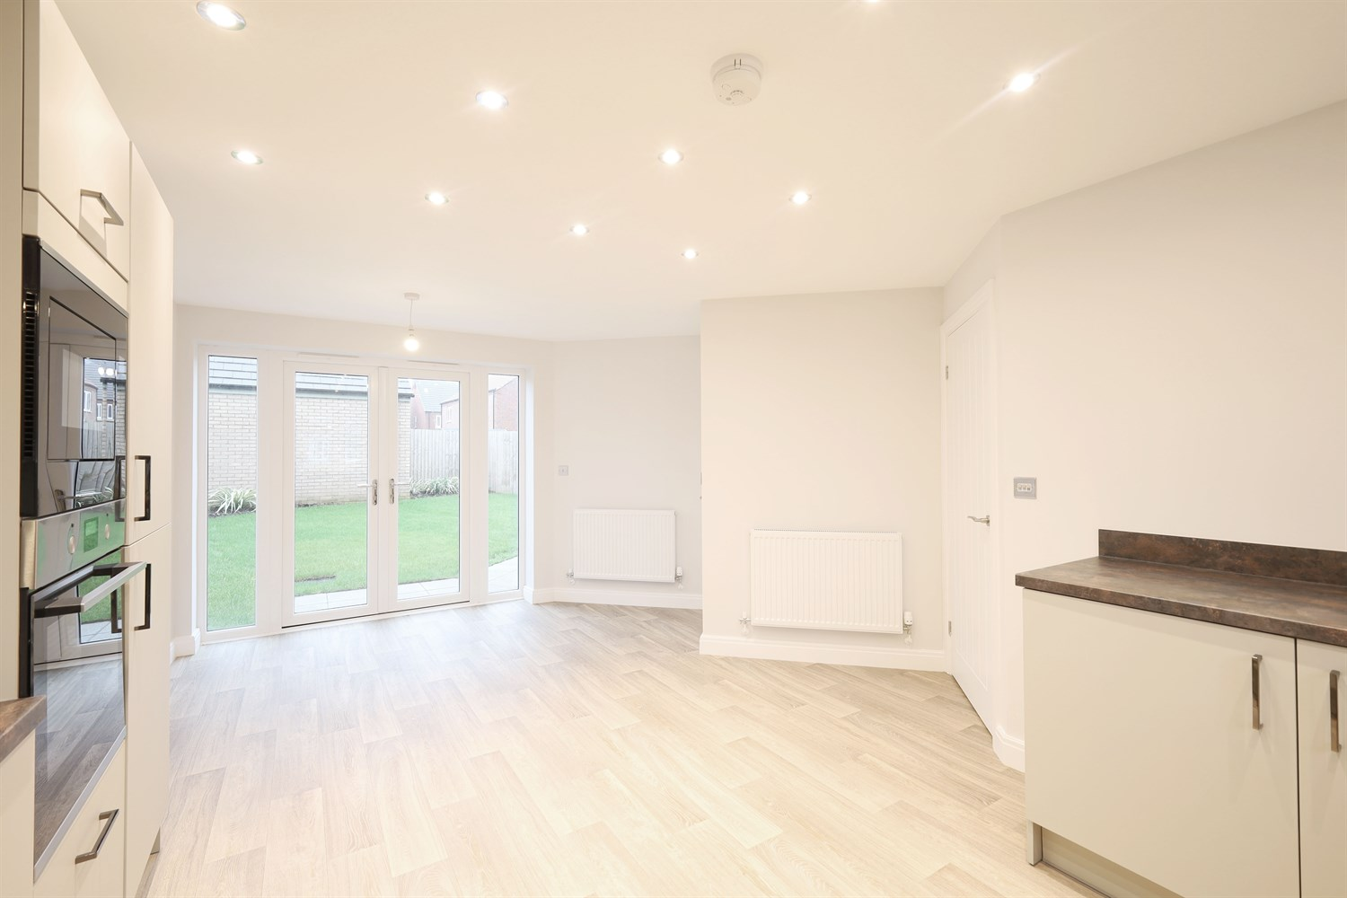
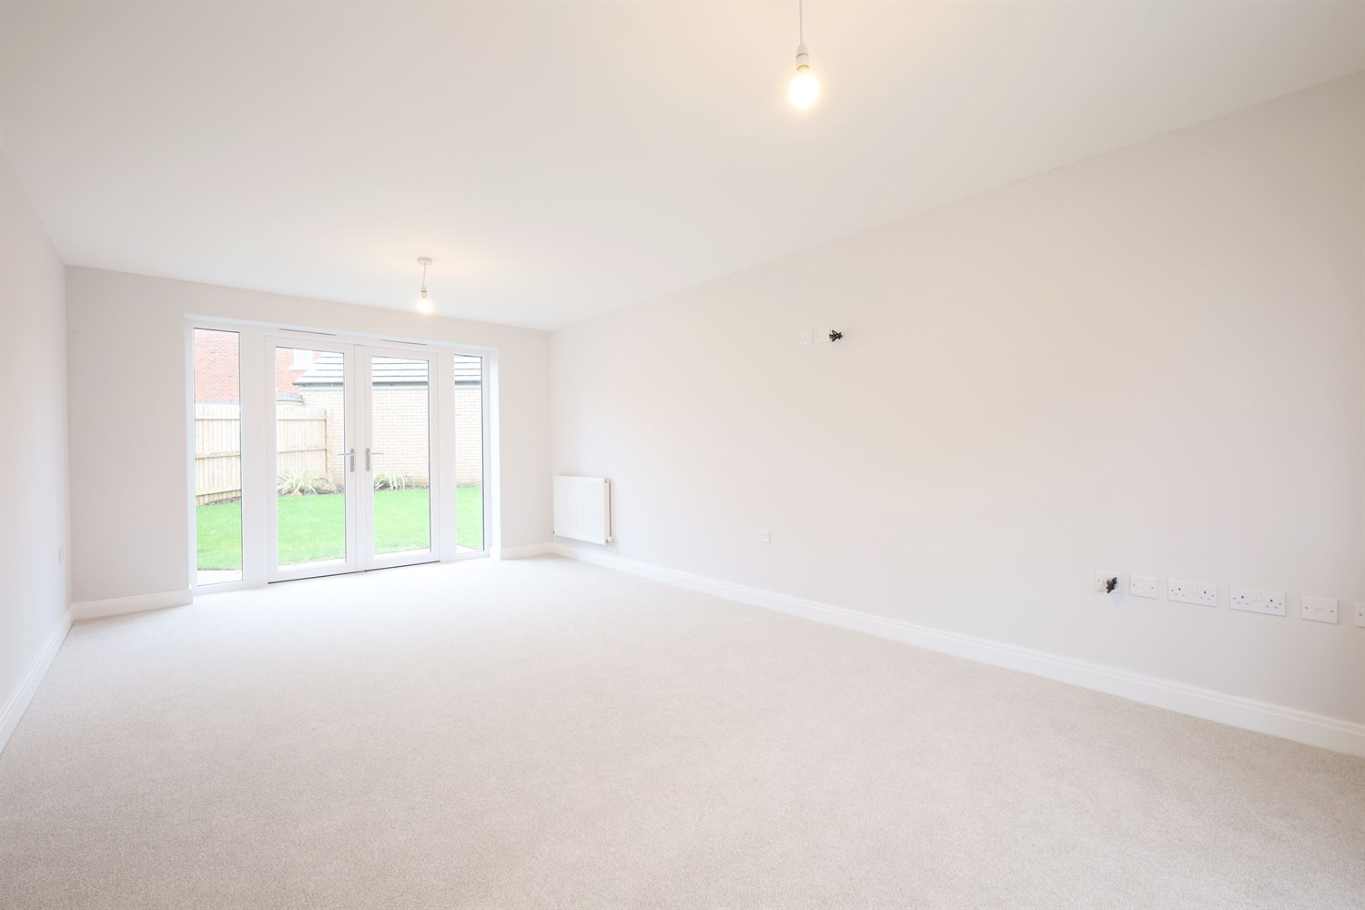
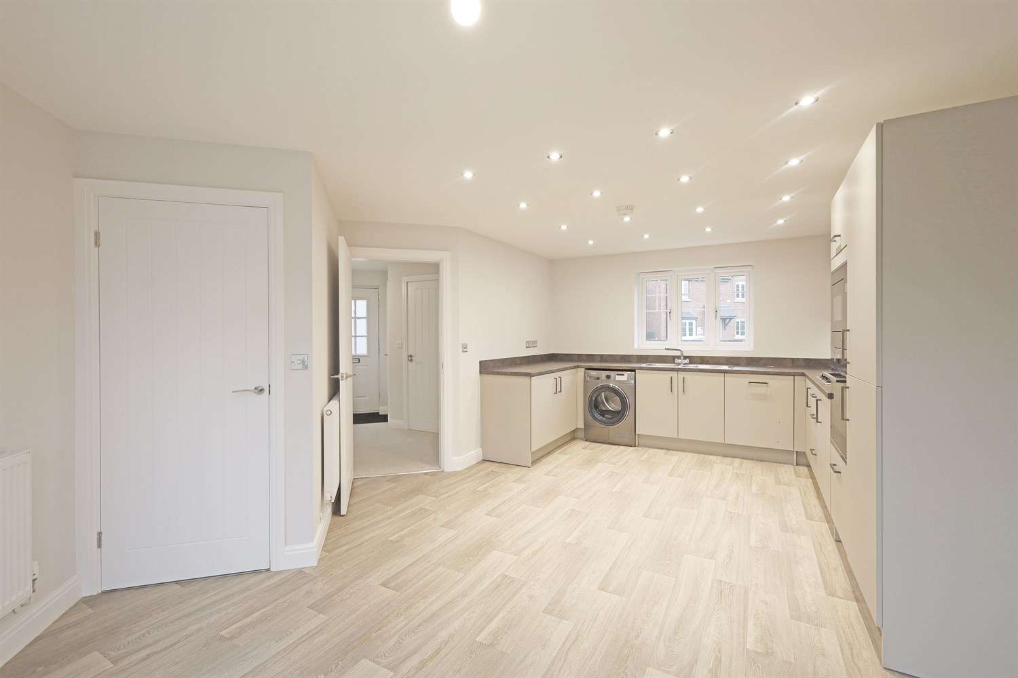
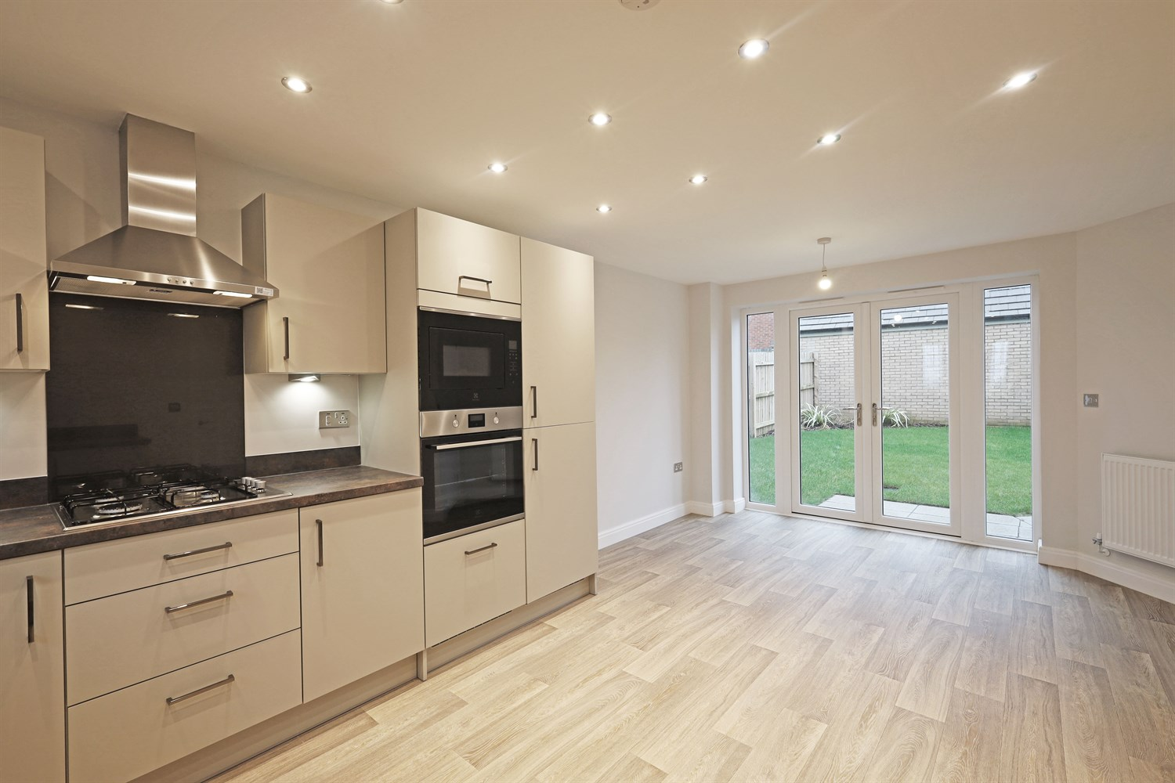

Property Description
An attractive and well-designed three-bedroom detached home, offering spacious and thoughtfully arranged accommodation with distinctive architectural features that set it apart from standard layouts.
The ground floor is accessed via a welcoming entrance hall, providing access to the principal living areas. Positioned to the front, the kitchen is practically arranged with ample worktop space and storage, ideal for everyday family life. Adjacent to this, a dedicated dining room offers a sociable setting for family meals and entertaining, with French doors opening directly onto the rear garden, creating a bright and airy environment with seamless indoor-outdoor flow.
A standout feature of the home is the generously proportioned lounge, boasting an eye-catching angled design that adds character and visual interest. This impressive reception space provides a comfortable and versatile setting for relaxation. A ground floor cloakroom and useful storage complete the downstairs accommodation.
To the first floor, the property offers three well-proportioned bedrooms. The principal bedroom benefits from built-in wardrobe space and a private en-suite shower room, creating a comfortable and practical retreat. Bedrooms two and three provide flexible accommodation suitable for family members, guests or home working. A modern family bathroom serves the remaining bedrooms.
Externally, the property enjoys an attractive frontage with driveway parking, complemented by landscaped surroundings. Combining space, individuality and functionality, this home is perfectly suited to growing families or professional couples seeking a stylish and well-balanced residence.

Front Aspect
The property presents a striking and beautifully designed façade, featuring quality brickwork and a classic pitched roof. The double-fronted appearance creates an impressive first impression, enhanced by a charming storm porch and elegant window detailing. A private driveway to the side provides practical off-road parking, while landscaped planting completes the home¿s strong kerb appeal.

Entrance Hallway
A welcoming entrance hall providing access to the principal ground floor rooms, with staircase rising to the first floor. The layout creates a natural flow through the home, with a useful storage cupboard ideal for coats and household essentials.

Downstairs Toilet/Cloakroom 1.9m (6'3) x 1.05m (3'5)
Conveniently positioned off the hallway, the ground floor cloakroom is fitted with a WC and wash hand basin. A practical addition for modern living and particularly useful when entertaining guests.

Kitchen 5.86m (19'3) x 3.19m (10'6)
Positioned to the front of the property, the kitchen is thoughtfully arranged to provide ample worktop space and storage. The layout offers practicality for everyday cooking, with space for essential appliances and a pleasant outlook enhancing the bright and functional feel of the room.

Dining Room
Located adjacent to the kitchen, the dining room provides a dedicated space for family meals and entertaining. The layout comfortably accommodates a dining table and chairs, while French doors open onto the rear garden, allowing natural light to flood the space and creating seamless indoor-outdoor flow.

Lounge 6.64m (21'9) x 3.5m (11'6)
A standout feature of the home, the generously proportioned lounge enjoys a distinctive angled design that adds character and visual interest. This spacious reception room offers ample space for comfortable seating arrangements, creating a relaxing and inviting environment ideal for family living. Large windows enhance the light and airy atmosphere, making this an impressive and versatile living space.

Landing
The first-floor landing provides access to all three bedrooms and the family bathroom, creating a well-balanced and practical layout. A built-in storage cupboard offers valuable additional space for linens and household essentials, enhancing the functionality of the home.

Bedroom 1 3.75m (12'4) x 3.41m (11'2)
A generous principal bedroom positioned to the front of the property, offering ample space for a double bed and accompanying furniture. The room benefits from built-in wardrobe space, creating a clean and uncluttered feel, and enjoys direct access to a private en-suite shower room.

En-Suite 2.91m (9'7) x 2.62m (8'7)
The en-suite is fitted with a modern suite comprising a shower enclosure, WC and wash hand basin. Designed with both convenience and privacy in mind, this well-appointed space enhances the comfort of the principal bedroom.

Bedroom 2 4.11m (13'6) x 3.36m (11'0)
A spacious and versatile double bedroom featuring an angled layout that adds character and visual interest. With ample space for furnishings, this room is ideal for family members or guests and offers flexibility to suit a variety of needs.

Bedroom 3 2.5m (8'2) x 2.4m (7'10)
A well-proportioned third bedroom, perfectly suited as a child¿s bedroom, nursery or home office. The distinctive shape of the room provides a unique layout while maintaining practical furniture placement options.

Bathroom 2.35m (7'9) x 1.95m (6'5)
The family bathroom is fitted with a three-piece suite comprising a panelled bath, WC and wash hand basin. Positioned conveniently off the landing, it comfortably serves bedrooms two and three, completing the first-floor accommodation.

Garage
Garage

These particulars are intended to give a fair description of the property, but their accuracy cannot be guaranteed, and they do not constitute an offer of contract. Intending purchasers must rely on their own inspection of the property. None of the above appliances/services have been tested by ourselves. We recommend purchasers arrange for a qualified person to check all appliances/services before legal commitment.

Property Ref: 3302

www.drurysestateagents.co.uk
amber@drurysestateagents.co.uk
01205 350889

45 Willoughby Road
Boston
Lincolnshire
PE21 9HN
Agents Note: Whilst every care has been taken to prepare these sales particulars, they are for guidance purposes only. All measurements are approximate are for general guidance purposes only and whilst every care has been taken to ensure their accuracy, they should not be relied upon and potential buyers are advised to recheck the measurements

