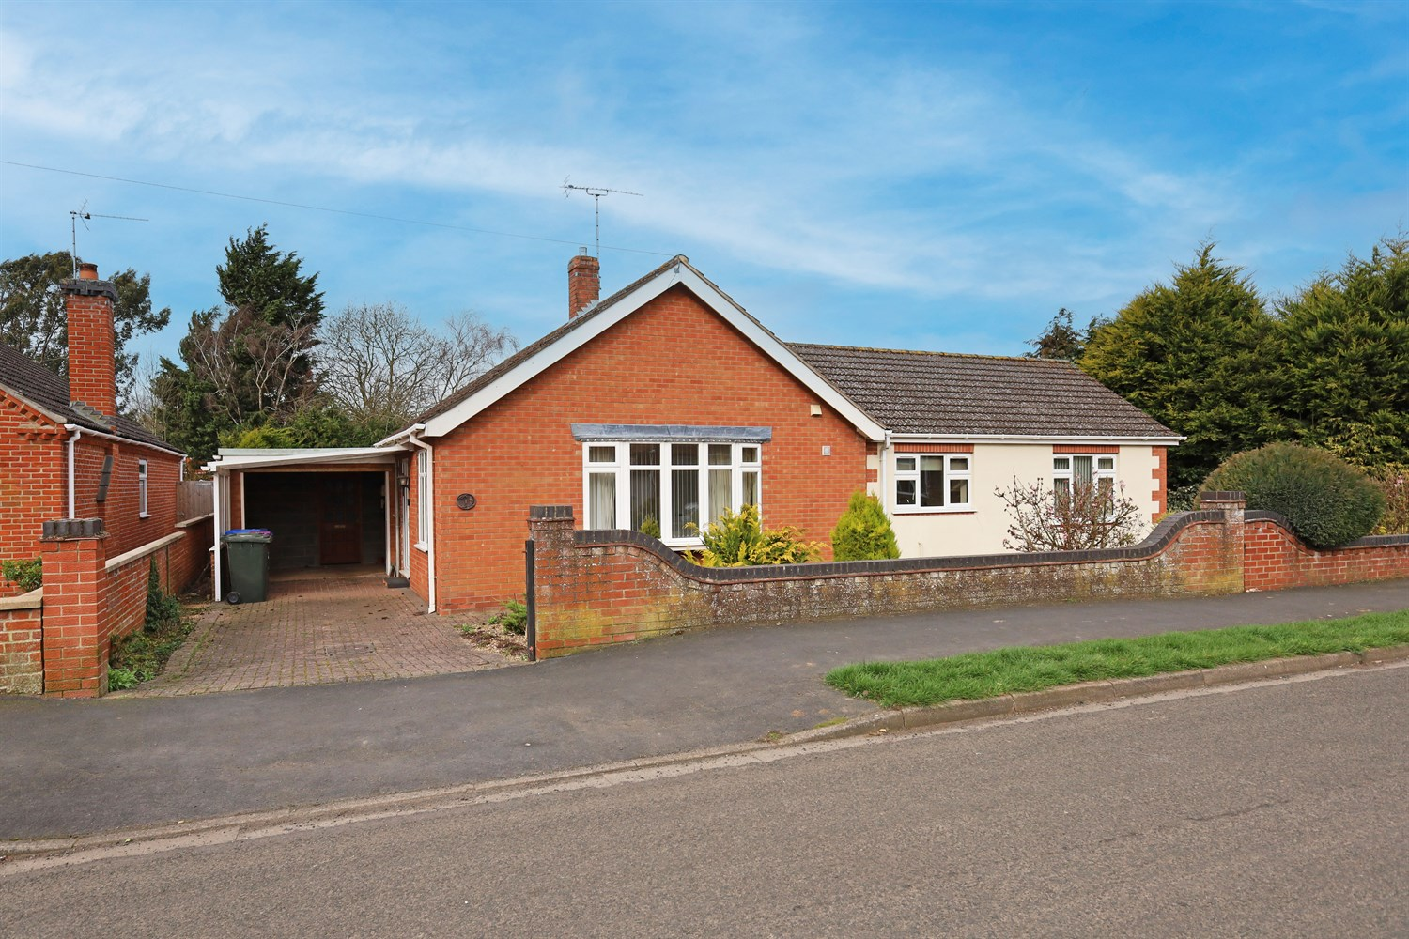




- Three Bedrooms/Two Bathrooms CHAIN FREE
- Walk in Wardrobe/Dressing Room
- Close to Local Amenities

3 Bedroom(s)
2 Reception(s)
2 Bathroom(s)
£279,950.00
South Parade, PE21
EPC Rating ‘’

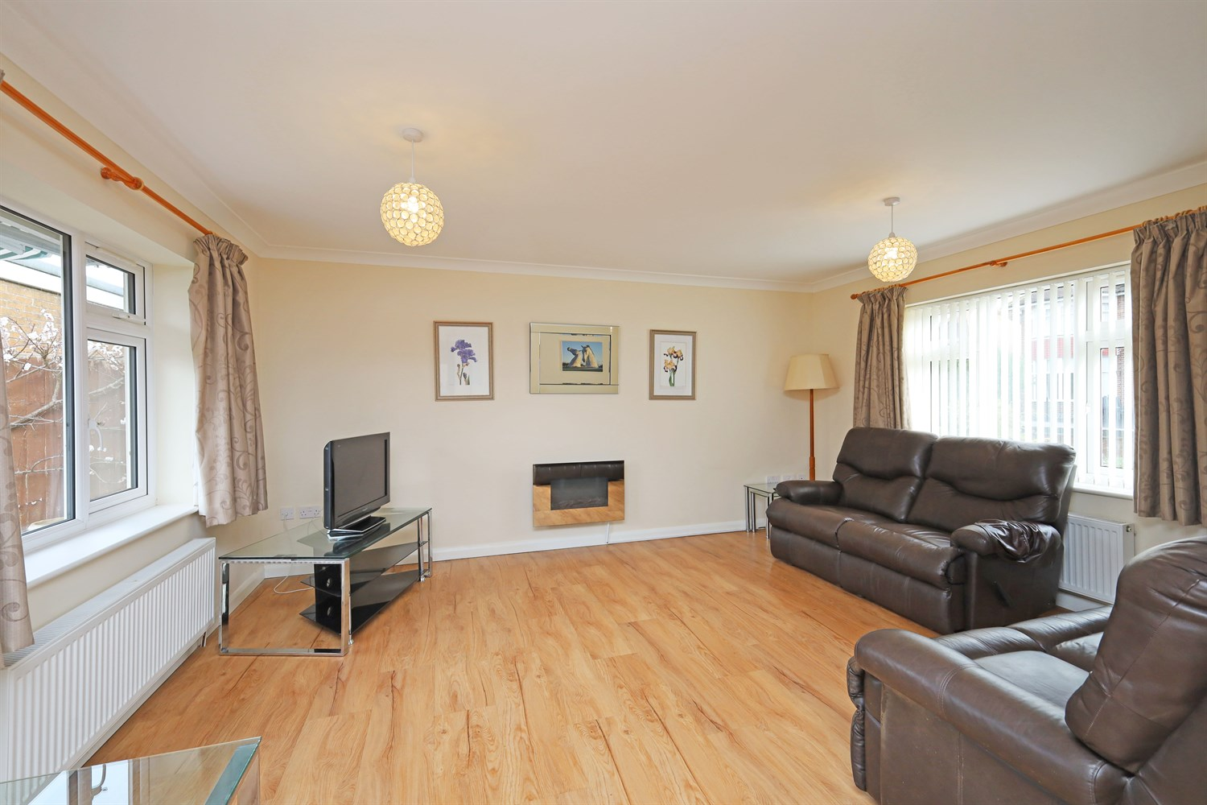
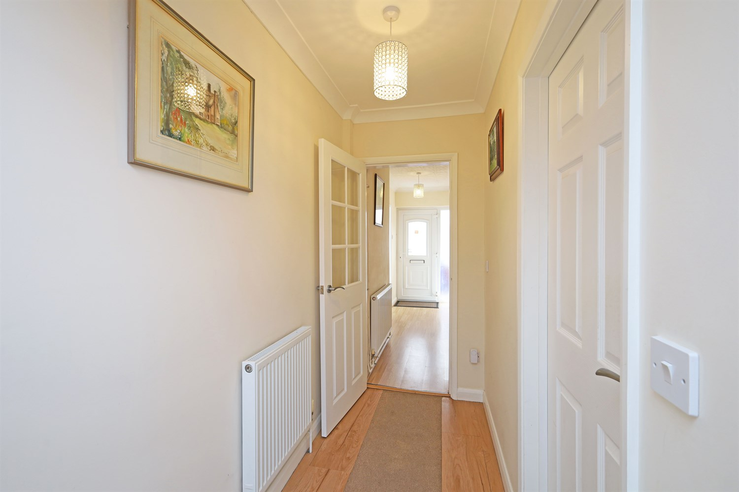
00
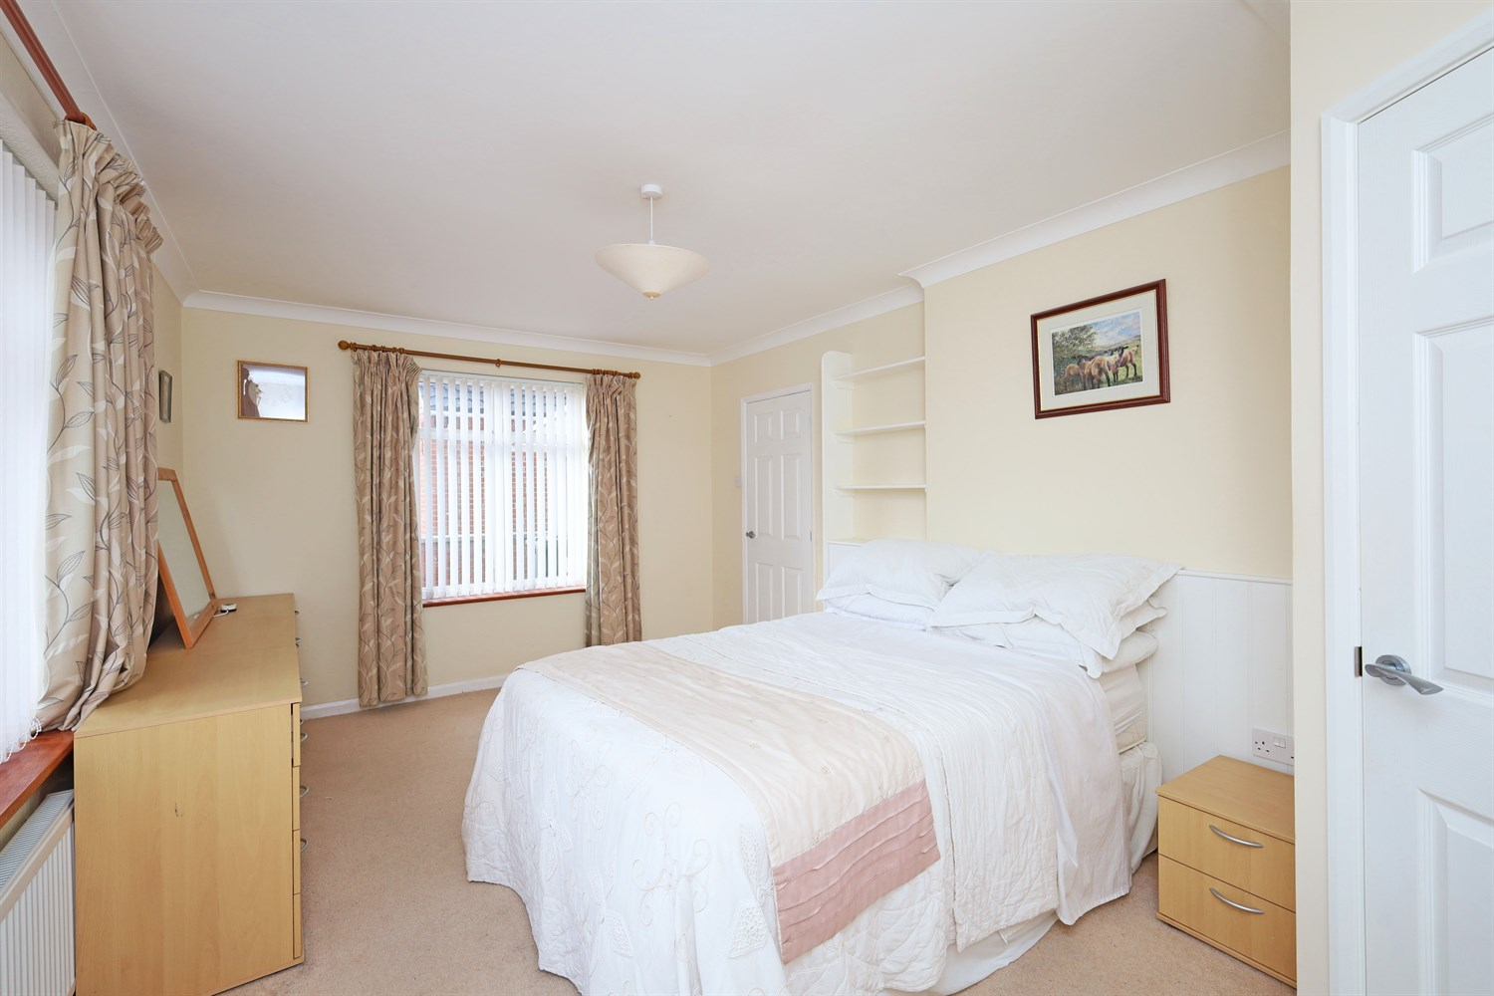
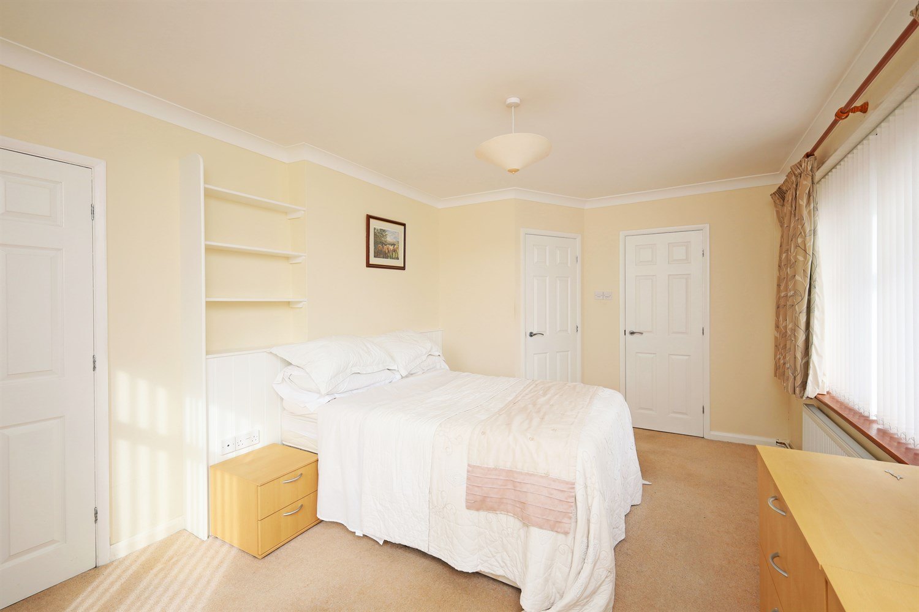
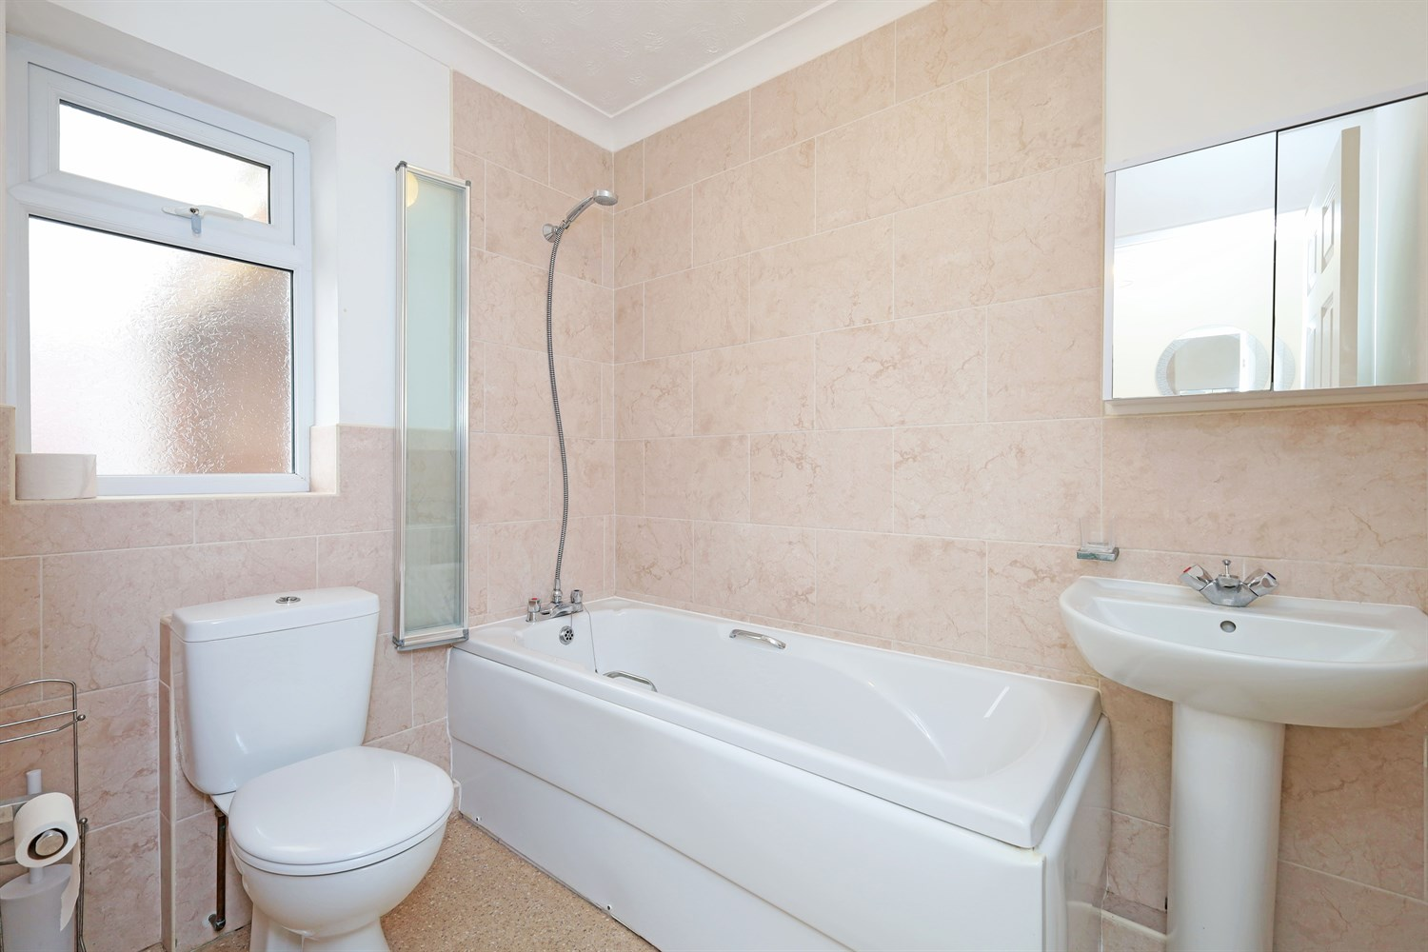
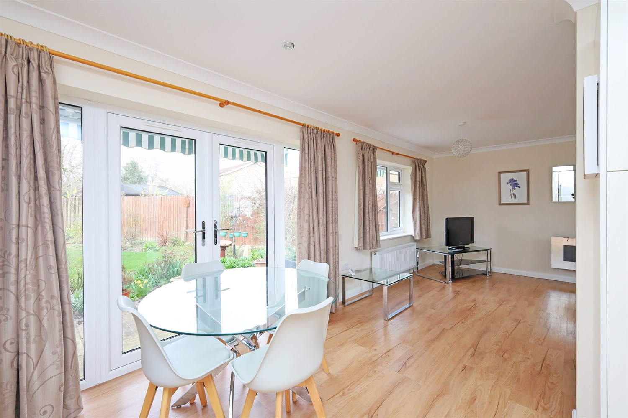
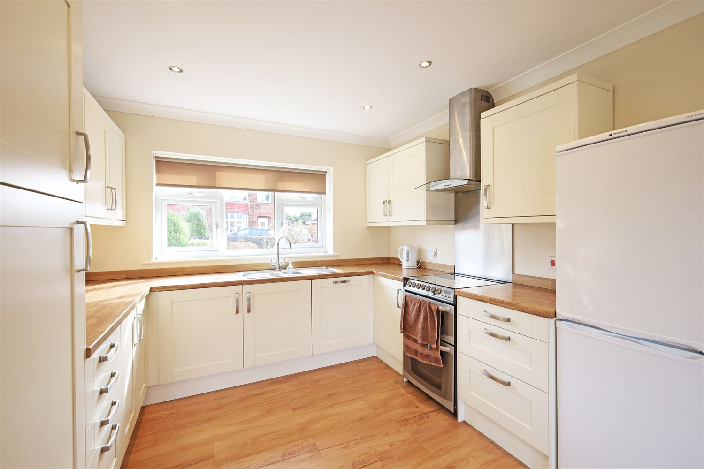
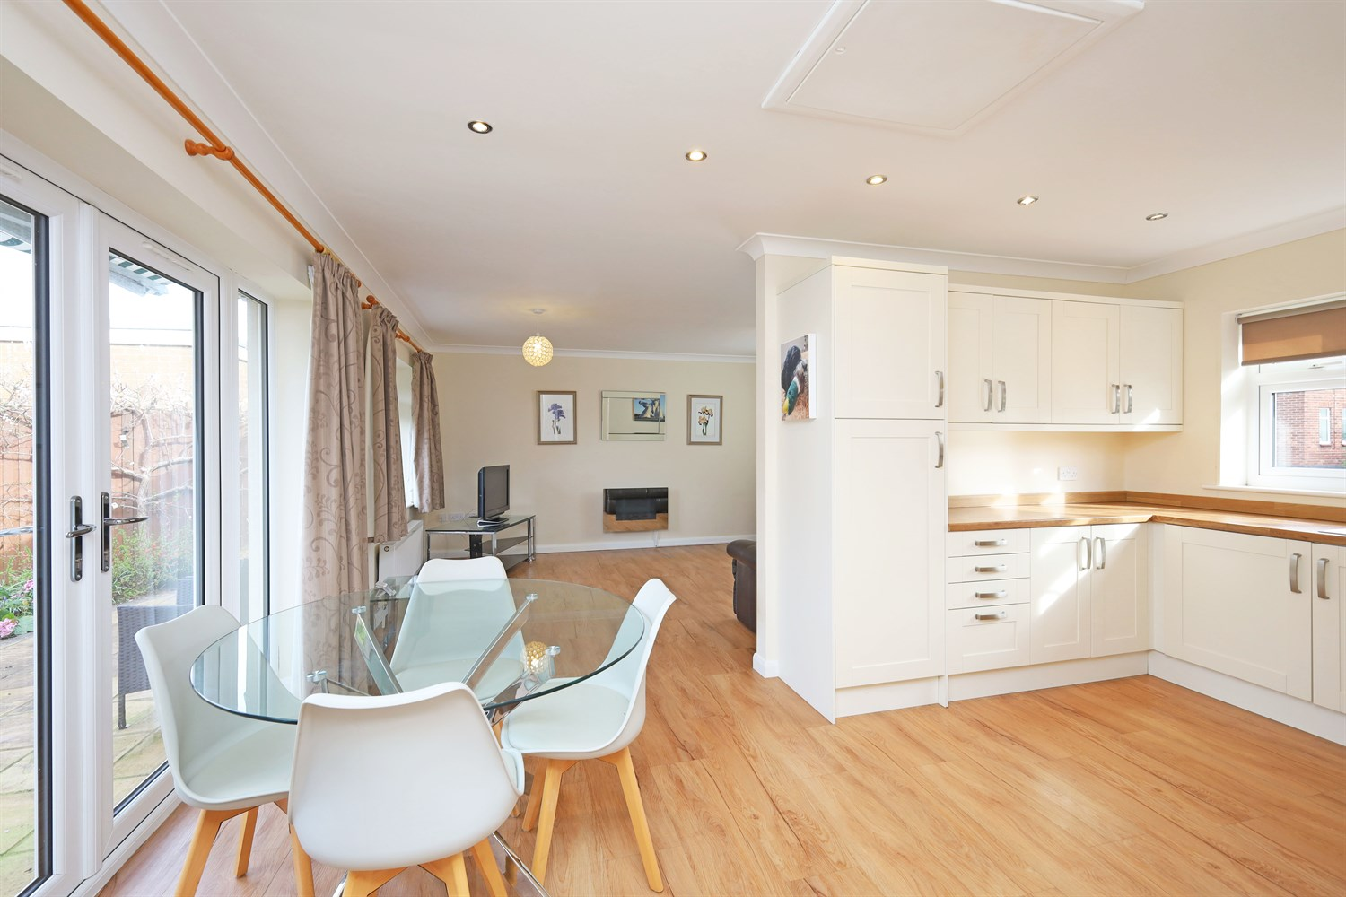
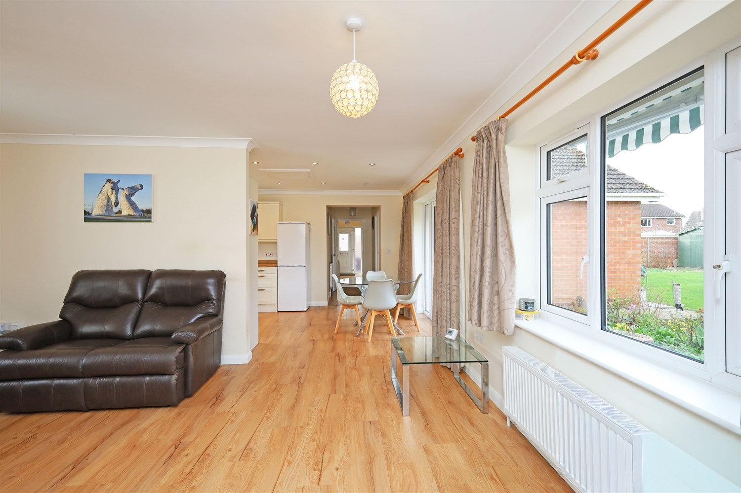
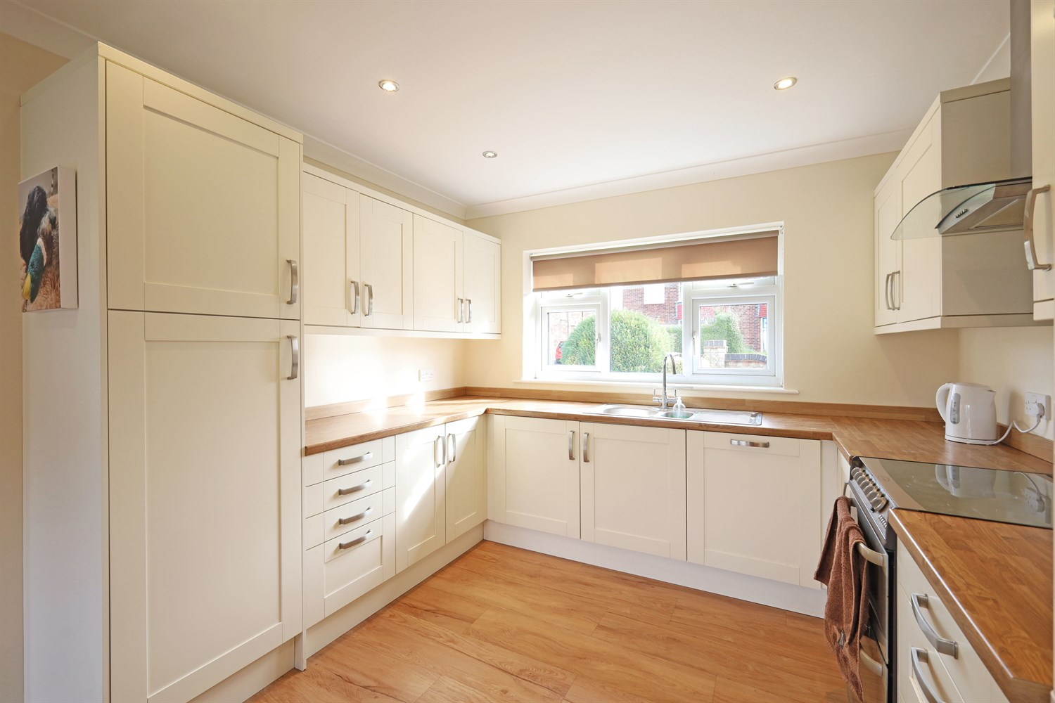

Property Description
Drury's Estate Agents are pleased to offer for sale Chain free, this well presented three bedroom detached bungalow, situated within a pleasant residential location and offering spacious and versatile accommodation throughout.
The property briefly comprises an entrance hallway leading through to a bright and spacious open plan kitchen, dining and living area, creating the heart of the home and an ideal space for both everyday living and entertaining. The modern fitted kitchen offers a range of wall and base units with work surfaces over and space for appliances, while the generous living areas benefits from large windows allowing plenty of natural light and features a contemporary wall mounted electric fireplace.
There are three well proportioned bedrooms, including a generous principle bedroom which benefits from its own en suite shower room and walk in wardrobe/dressing area. A family bathroom serves the remaining bedrooms.
Further accommodation includes a useful utility room, providing additional storage, space for laundry appliances and access to the rear garden.
Externally, the property boasts a substantial rear garden predominantly laid to lawn, offering an excellent outdoor space for families, entertaining or keen gardeners, with added benefit of garden sheds and a greenhouse.
To the front of the property is a driveway providing off road parking, leading to a covered car port, along with an attractively arranged front garden.
This property would make an ideal home for families, downsizers or buyers seeking spacious single storey living.
Early viewing is highly recommended.

Front Aspect
To the front of the property is a driveway providing off road parking, leading to a covered car port. The front garden is attractively arranged with decorative gravel and established shrubs, creating a neat and welcoming approach to the home.

Entrance Hallway
A welcoming entrance hallway providing access to the main accommodation within the property. The hallway offers practical layout connecting the bedrooms, bathroom and living areas, and benefits from fitted flooring and a wall mounted intercom system.

Lounge
A spacious and inviting living area forming part of the open plan kitchen, dining and living space, creating a fantastic area for modern family living. The room offers plenty of space for lounge furniture and benefits from large windows allowing natural light to fill the space. A contemporary wall mounted electric fireplace provides an attractive focal point, enhancing the warm and comfortable feel of the room.

Kitchen/Dining Area
A modern fitted kitchen comprising a range of wall and base units with work surfaces over, incorporating a stainless steel sink and drainer positioned beneath a window overlooking the rear. The kitchen also provides space for freestanding appliances including a cooker and fridge freezer.
The room opens into a generous dining area, offering ample space for a family dining table and chairs, with large windows and patio doors allowing plenty of natural light to fill the space. This creates an ideal area for everyday family living and entertaining.

Bathroom
A well presented family bathroom fitted with a three piece suite co prising a panelled bath with shower attachment, pedestal hand wash basin and low level WC. The room is finished with tiled walls surrounding the bath area, creating a clean and practical space.
A frosted window provides natural light and ventilation, completing this functional family bathroom.

Bedroom 1
A spacious double bedroom positioned to the front of the property, offering a bright and comfortable space with a window allowing plenty of natural light. The room benefits from fitted shelving and ample space for freestanding furniture.
This impressive principal bedroom also features a walk in wardrobe/dressing area, providing excellent storage and hanging space.
The room is further enhanced by a private en-suite shower room, fitted with a shower cubicle, pedestal hand wash basin and low level WC.

Master Bedroom Ensuite
Having a pedestal sink, shower cubicle, heated towel rail and WC.

Bedroom 2
A well proportioned second double bedroom positioned to the rear of the property. The room features a large window allowing plenty of natural light, along with space for a double bed and additional bedroom furniture.
This versatile room would make an ideal guest bedroom, children's room or home office, depending on a buyers needs.

Bedroom 3
A comfortable third bedroom with rear facing window allowing natural light to fill the room. The space offers flexibility for a variety of uses including a single bedroom, nursery, dressing room or home office.
The room also provides space for bedroom furniture and additional storage.

Utility Room
A useful utility room providing additional storage and work surface space, fitted with a range of wall and base units. The room offers space and plumbing for laundry appliances and houses the boiler.
A rear door provides convenient access to the garden, making this a practical space for everyday household tasks.

Rear Garden
The property benefits from a generous rear garden, predominantly laid to lawn, providing an excellent outdoor space for families, gardening enthusiasts or those who enjoy entertaining.
The garden is bordered by mature plants, trees and fencing, offering a pleasant and private setting. Additional features include garden sheds and a greenhouse, providing useful outdoor storage and space for gardening.

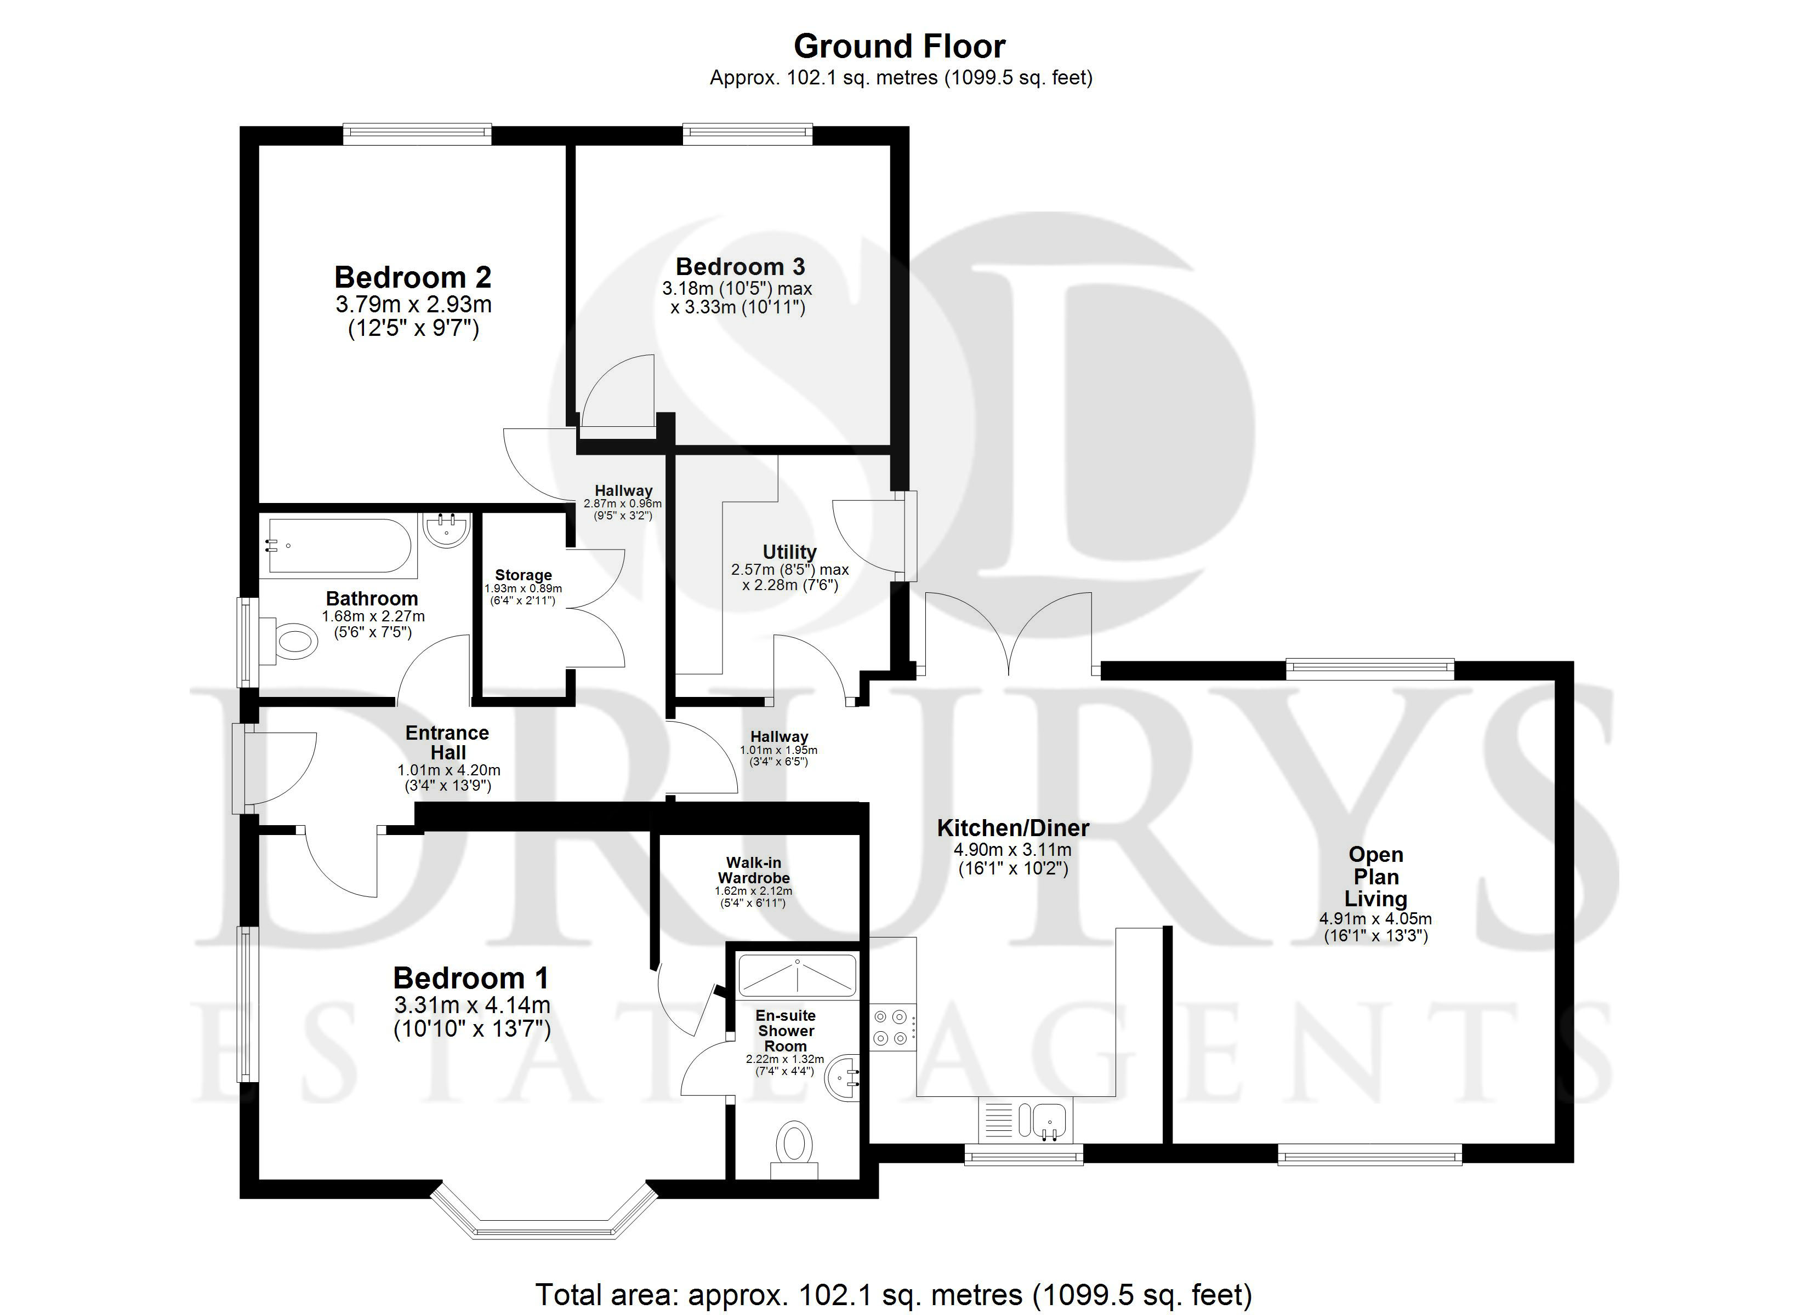

These particulars are intended to give a fair description of the property, but their accuracy cannot be guaranteed, and they do not constitute an offer of contract. Intending purchasers must rely on their own inspection of the property. None of the above appliances/services have been tested by ourselves. We recommend purchasers arrange for a qualified person to check all appliances/services before legal commitment.

Property Ref: 3364

www.drurysestateagents.co.uk
amber@drurysestateagents.co.uk
01205 350889

45 Willoughby Road
Boston
Lincolnshire
PE21 9HN
Agents Note: Whilst every care has been taken to prepare these sales particulars, they are for guidance purposes only. All measurements are approximate are for general guidance purposes only and whilst every care has been taken to ensure their accuracy, they should not be relied upon and potential buyers are advised to recheck the measurements

