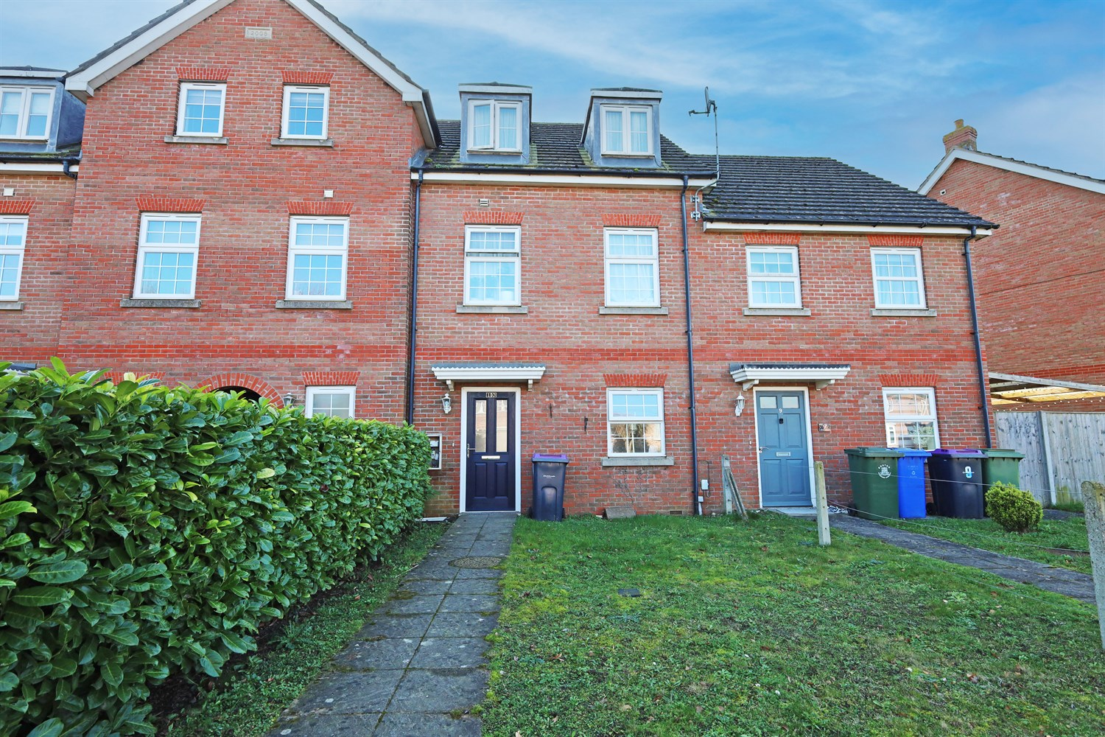




4 Bedroom(s)
1 Reception(s)
1 Bathroom(s)
£179,950.00
Kime Mews, PE20
EPC Rating ‘’

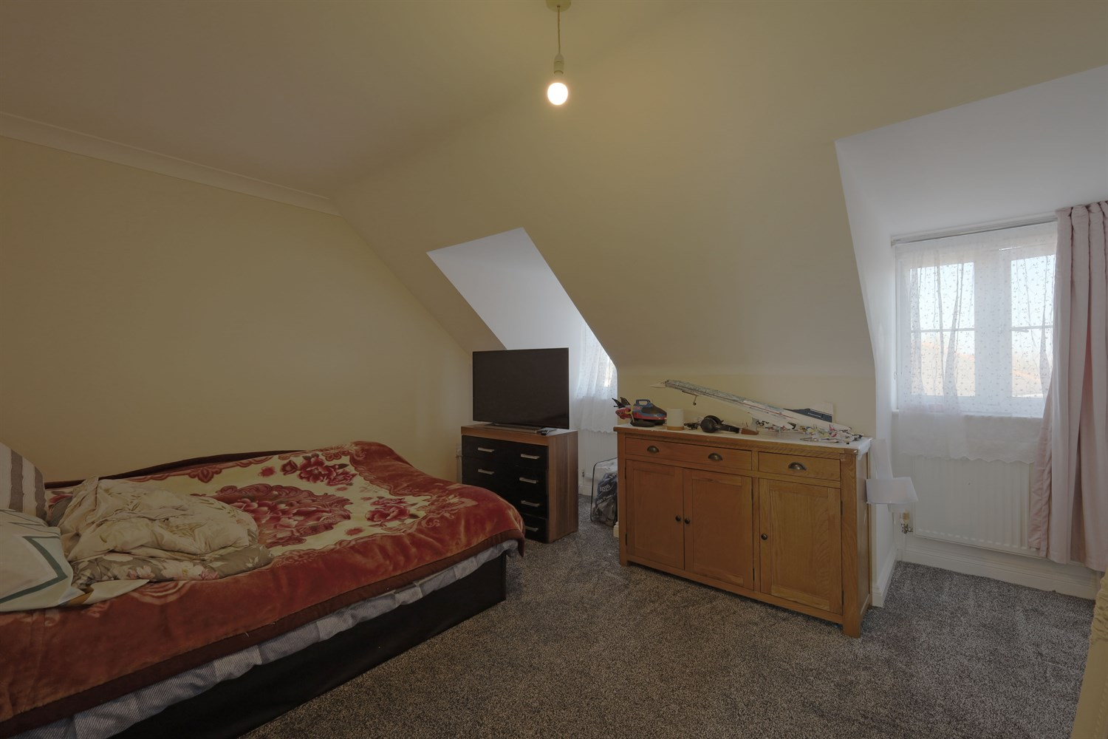
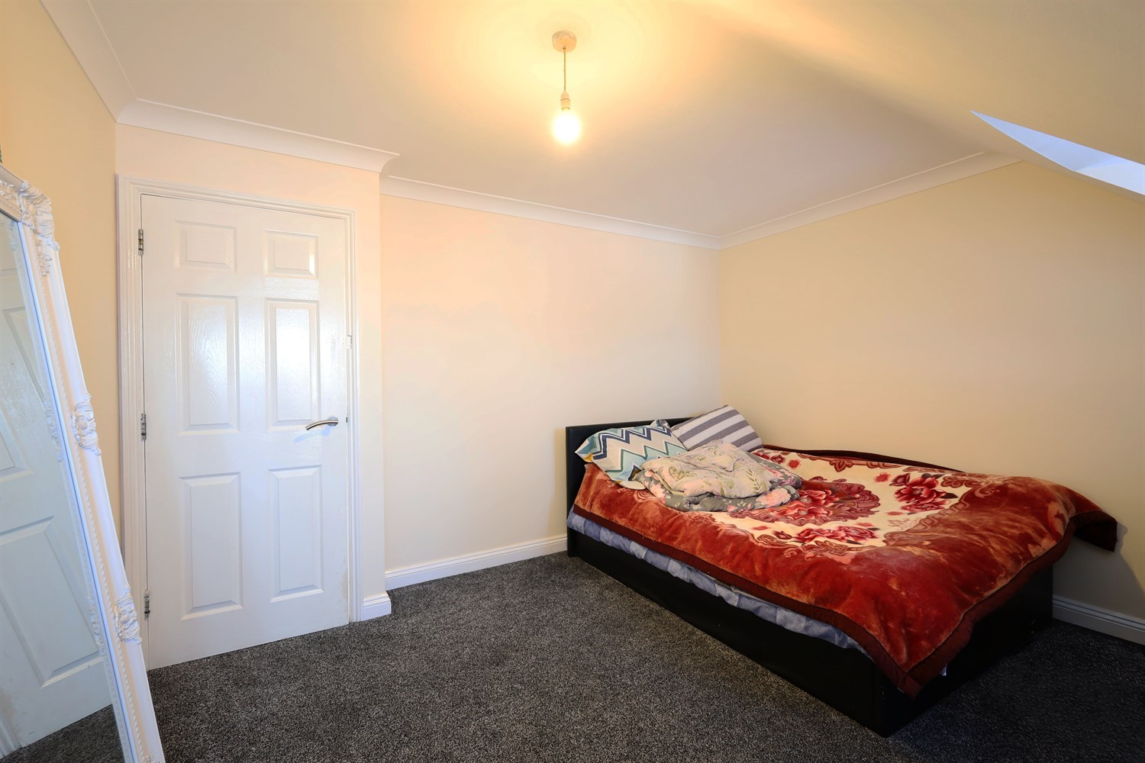
00
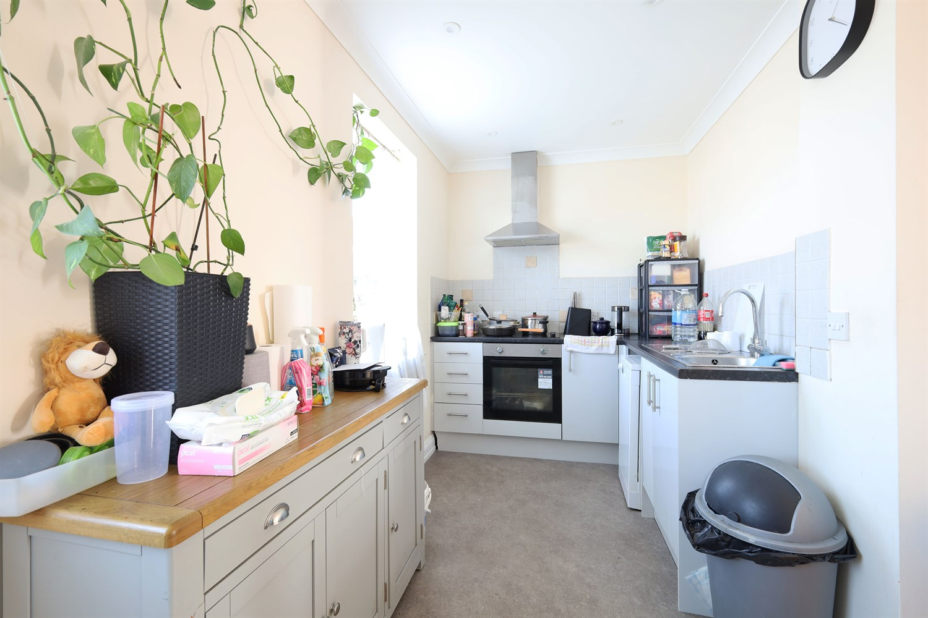
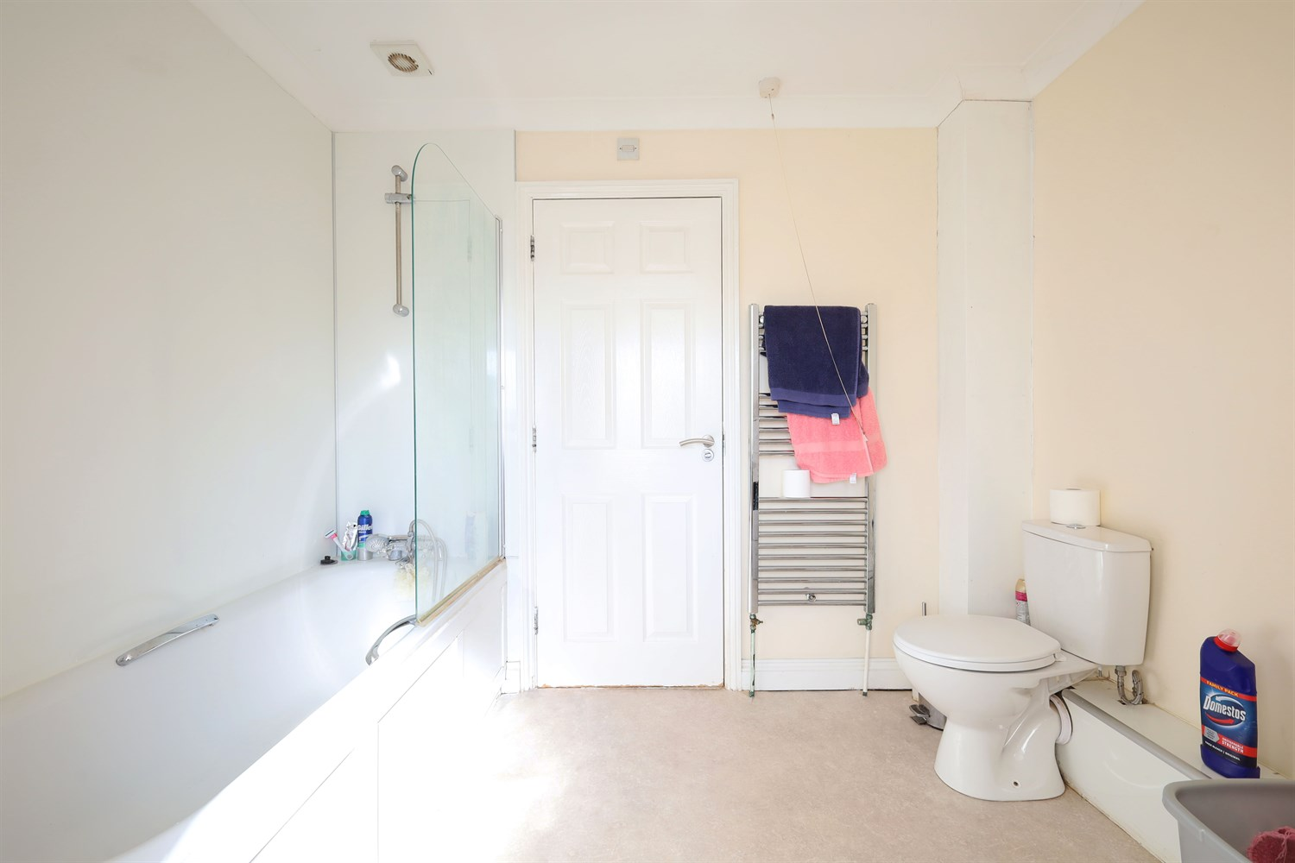
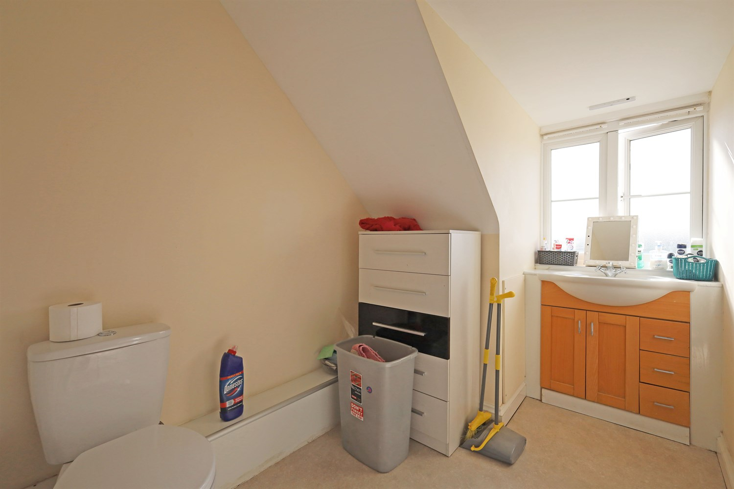
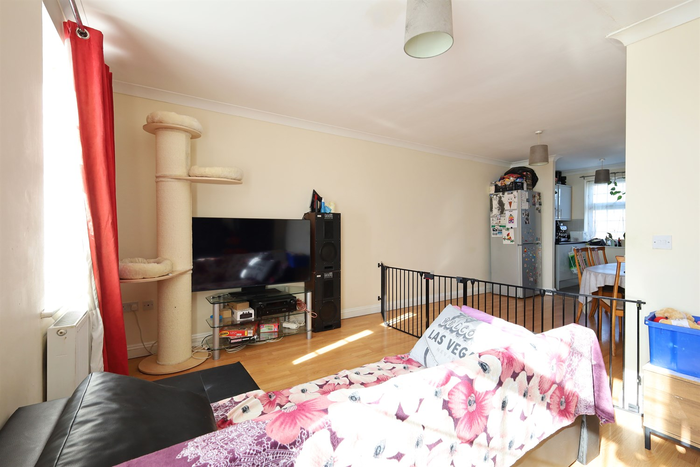
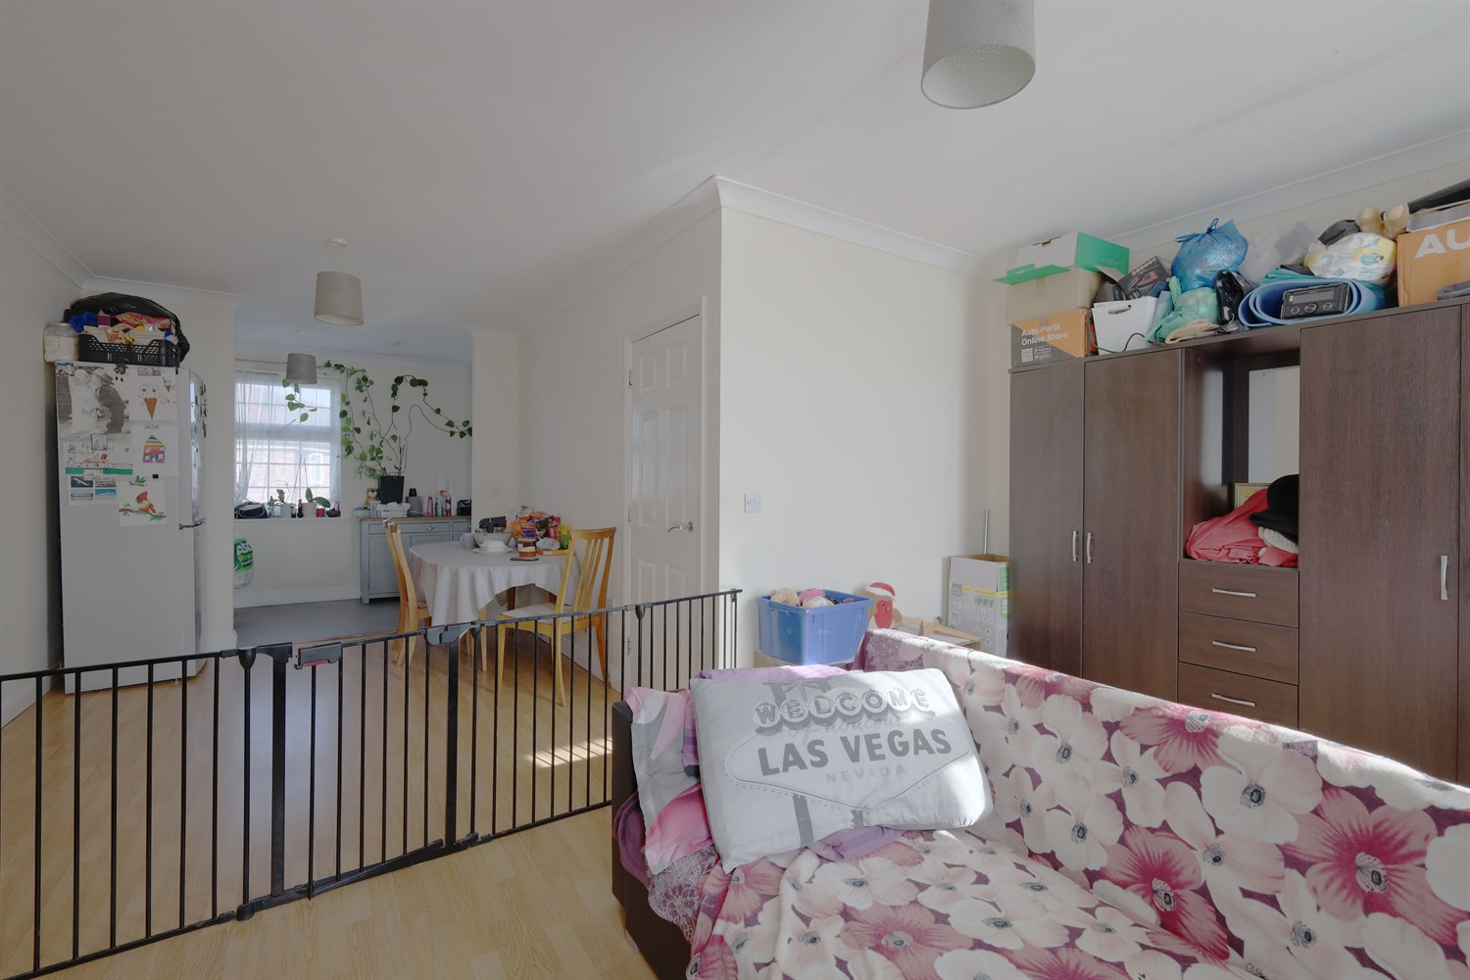
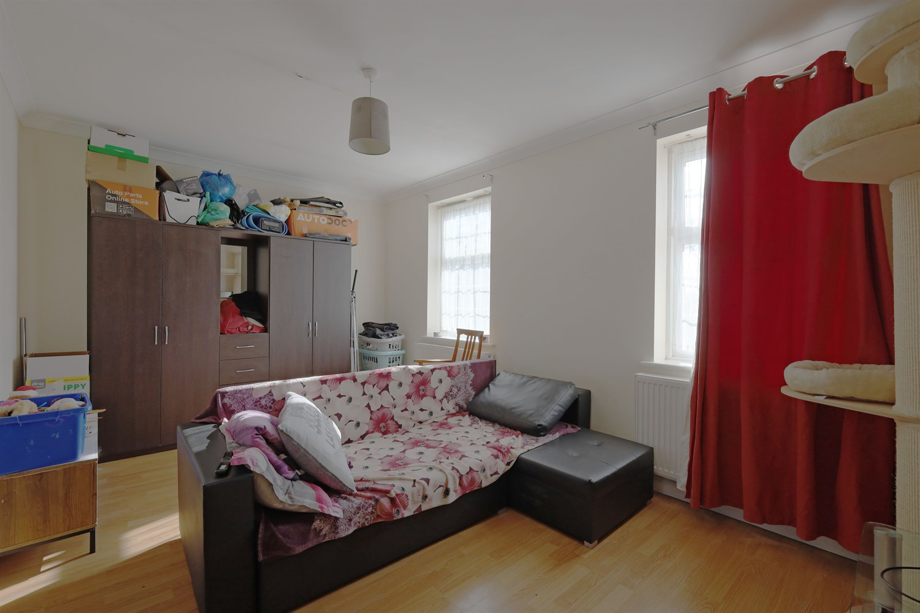
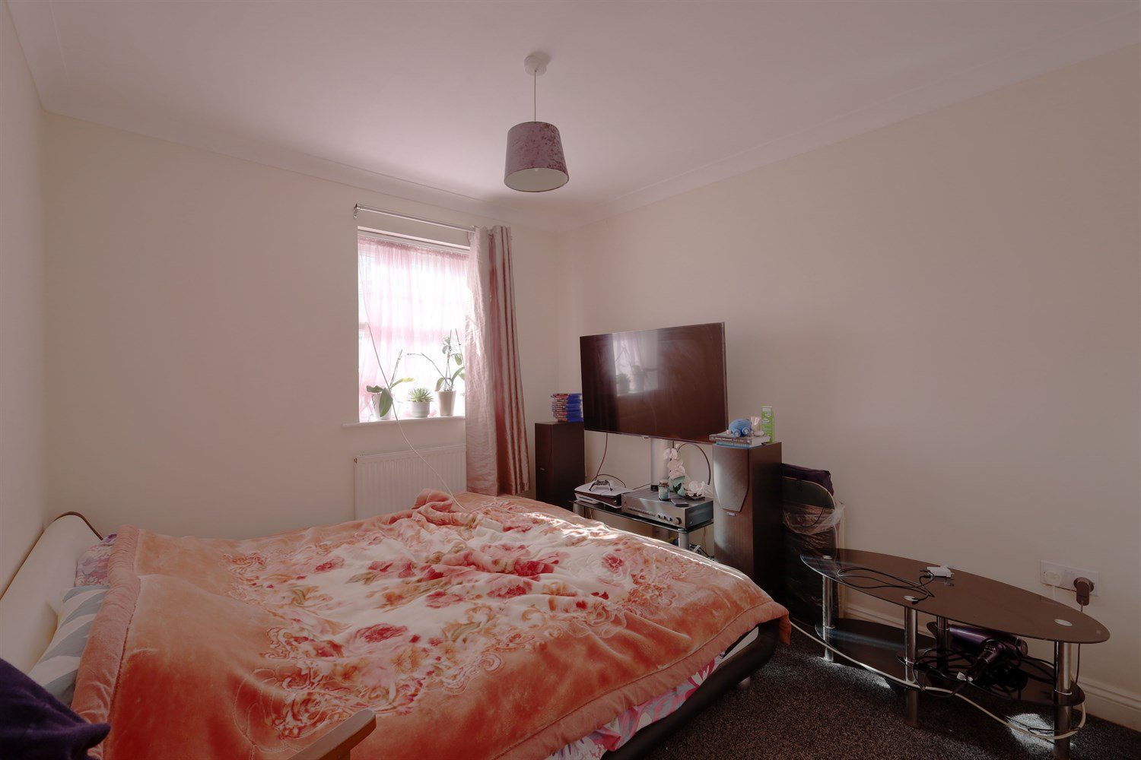
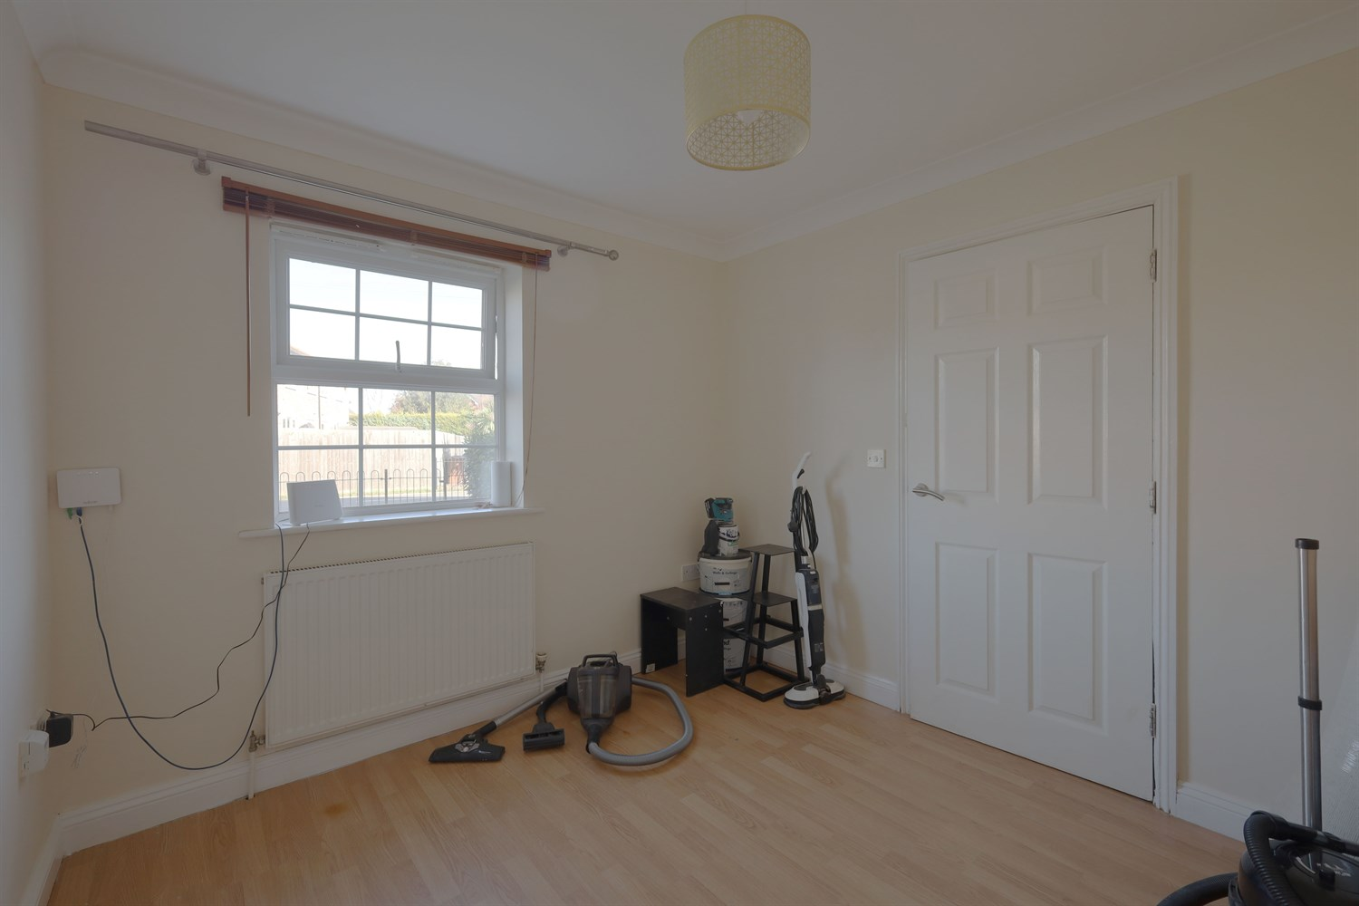

**NEW listing** This Spacious Three Storey Terraced House Situated in the Village of Kirton is Comprised of: Entrance Hallway, Open Plan Lounge, Kitchen/Diner, Four Double Bedrooms, Bathroom, En-Suite, Front and Rear Garden.

Bedroom 1- Third Floor
This spacious top floor master bedroom consists of a double panelled radiator and two windows to front elevation as well as an over the stairs small storage cupboard.

Bedroom 2- Third Floor
Top floor carpeted double bedroom with a window to rear elevation and double panelled radiator.

Bedroom 3- Ground Floor
Another double bedroom with a window to rear elevation, grey carpets and door leading into ensuite and a door leading to the ground floor hallway.

Bedroom 4- Ground Floor
This front ground floor double bedroom consists of Laminate floor, window to front elevation and a double panelled radiator which can be accessed via the ground floor hallway.

Reception 1
This large open plan lounge/ dining room consists of laminate flooring, 2 windows to rear elevation and 2 double panelled radiators.

Bathroom
Having a three piece suite bathroom including WC, sink, bath with over head shower as well as a hung heated towel rail and a window to the rear aspect.

Kitchen
This kitchen consists of cupboards to both base & eye level, lamona ceramic hob and electric oven with extractor fan overhead. There is space for a dishwasher located underneath the sink area and the kitchen is presented with a tiled splashback, stainless steal sink & drainer, ceiling spot lights and two windows to front elevation.

Garden
Enclosed rear garden with patio area, gate leading to allocated parking. A large enclosed garden with lawn to the front of this property with pathing leading to the composite front door.

Utility Room
This utility consists of cupboards to base level with space for washer/dryer, Ideal combi boiler, Stainless Sink Sink & drainer with mixer tap, tiled splash back, UPVC door leading into rear garden and tiled flooring.

Entrance Hall
Access via the Composite front door the hallway has all the ground floor internal doors leading off featuring two ground floor bedrooms, en-suite, utility room & stairs off to the 1st floor.

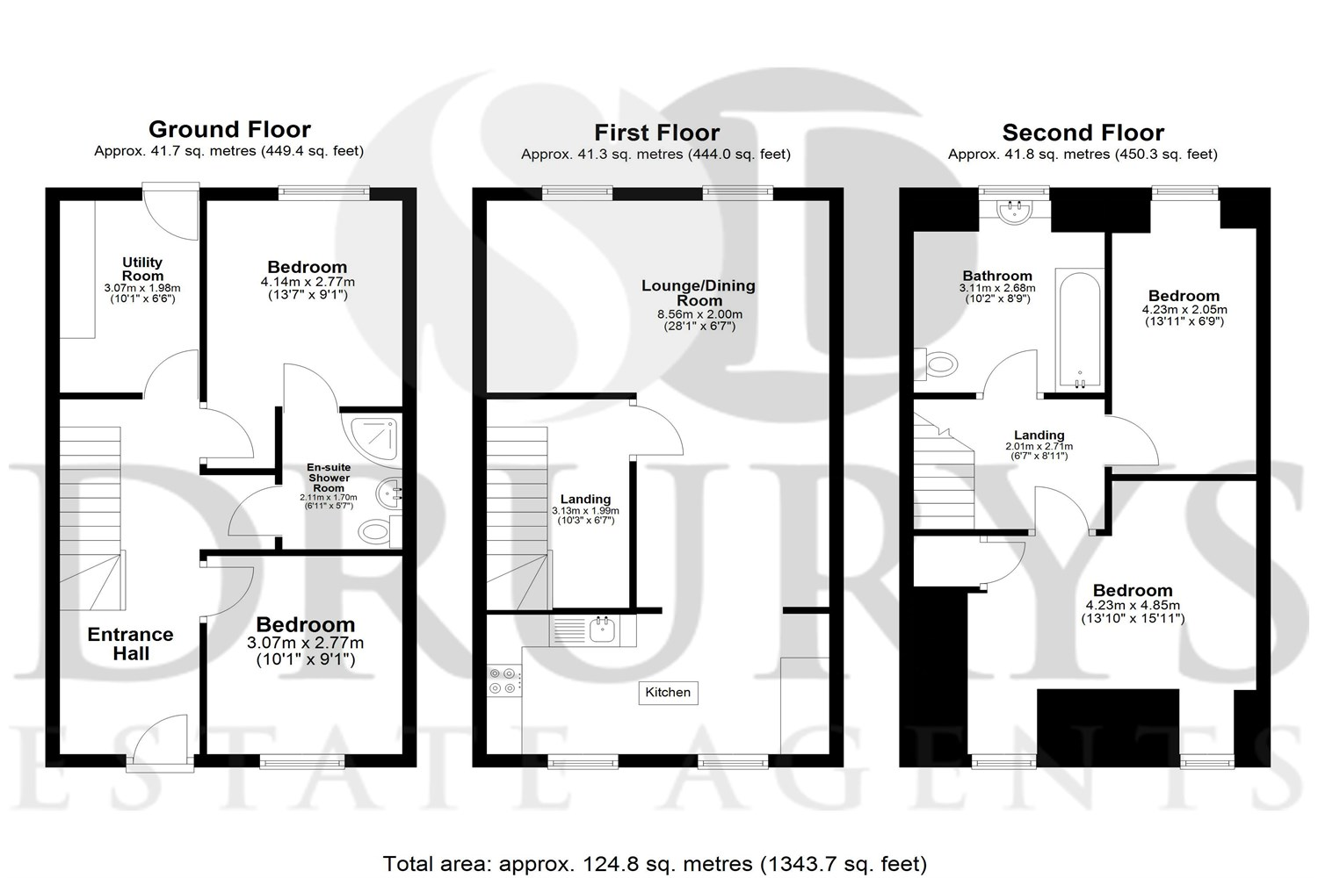

These particulars are intended to give a fair description of the property, but their accuracy cannot be guaranteed, and they do not constitute an offer of contract. Intending purchasers must rely on their own inspection of the property. None of the above appliances/services have been tested by ourselves. We recommend purchasers arrange for a qualified person to check all appliances/services before legal commitment.

Property Ref: 3390

www.drurysestateagents.co.uk
amber@drurysestateagents.co.uk
01205 350889

45 Willoughby Road
Boston
Lincolnshire
PE21 9HN
Agents Note: Whilst every care has been taken to prepare these sales particulars, they are for guidance purposes only. All measurements are approximate are for general guidance purposes only and whilst every care has been taken to ensure their accuracy, they should not be relied upon and potential buyers are advised to recheck the measurements

