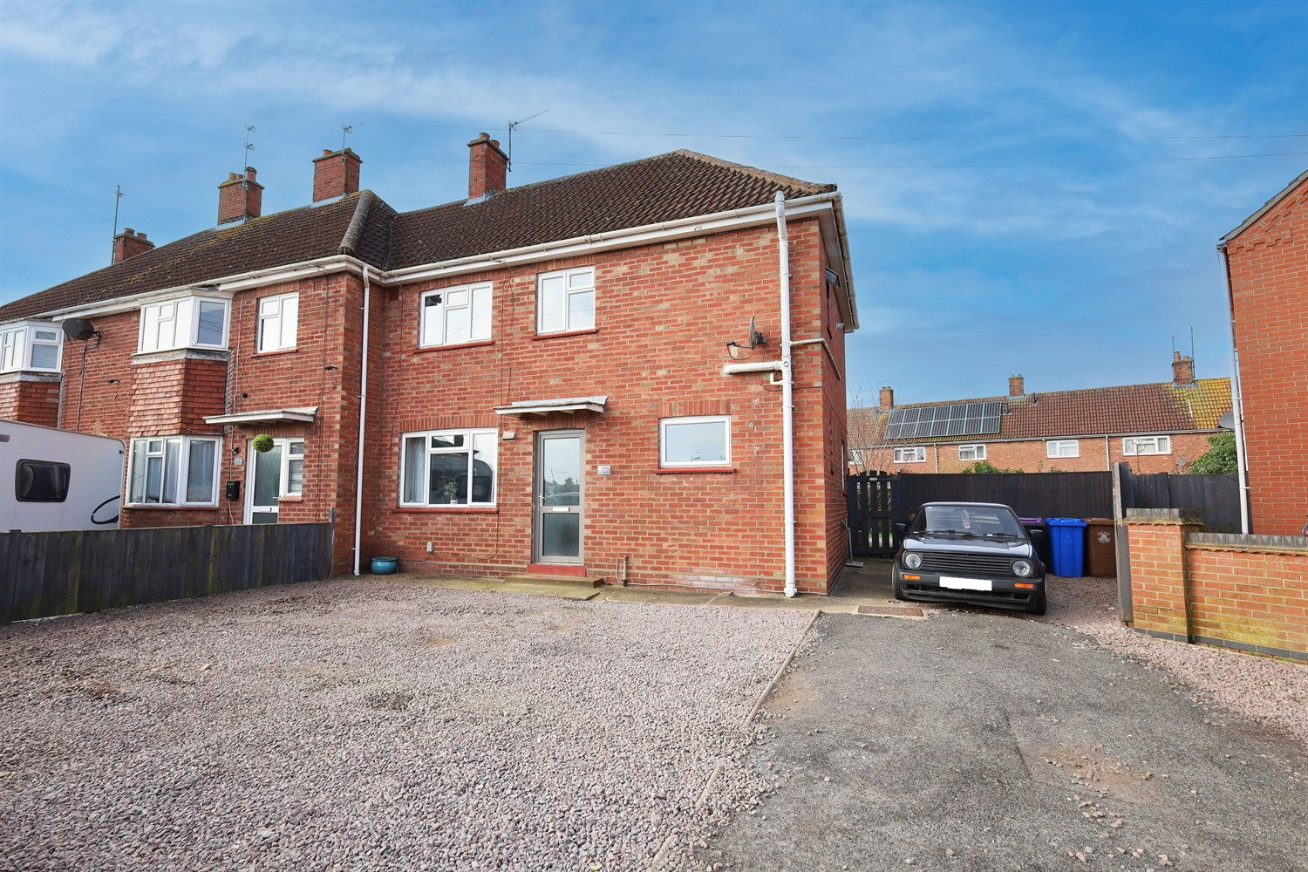




3 Bedroom(s)
3 Reception(s)
1 Bathroom(s)
£169,950.00
Church Road, PE21
EPC Rating ‘’

- Popular Residential Location
- Ideal for First-Time Buyers or Families
- Off Road Parking to the Front

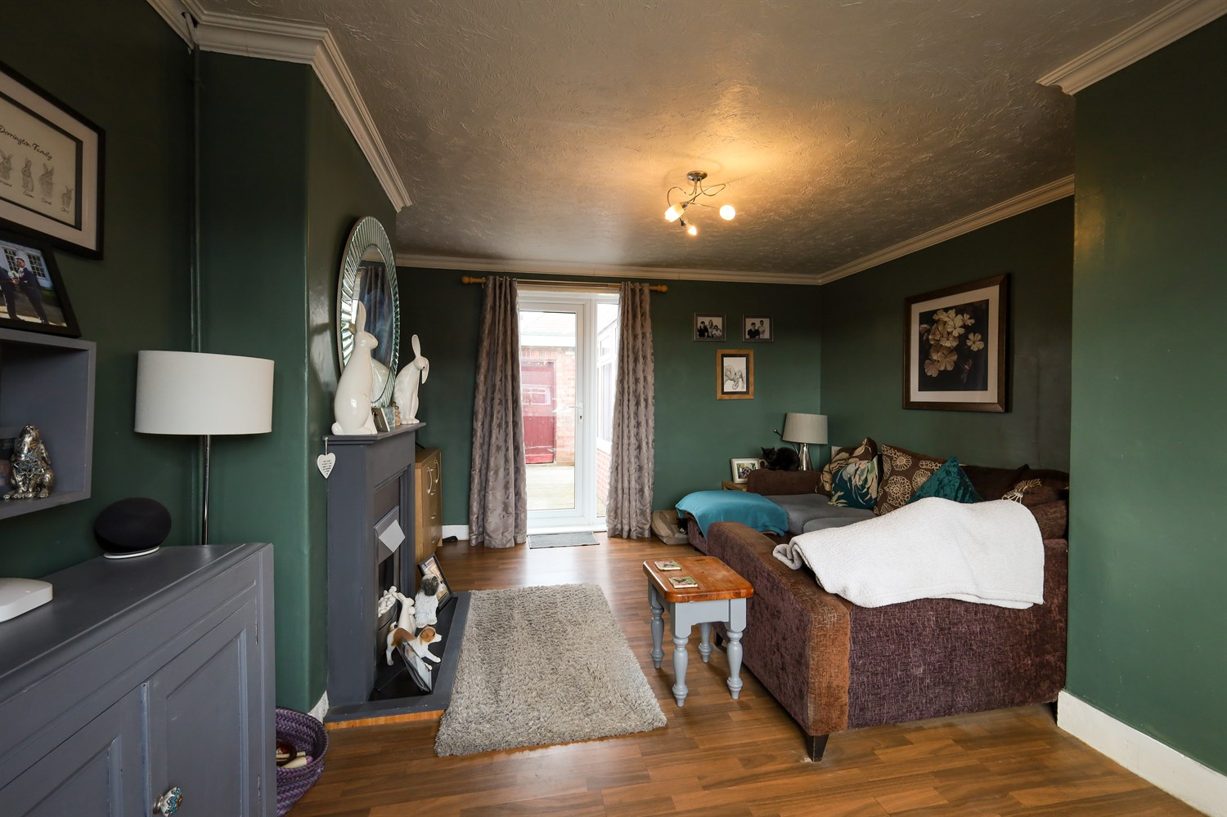
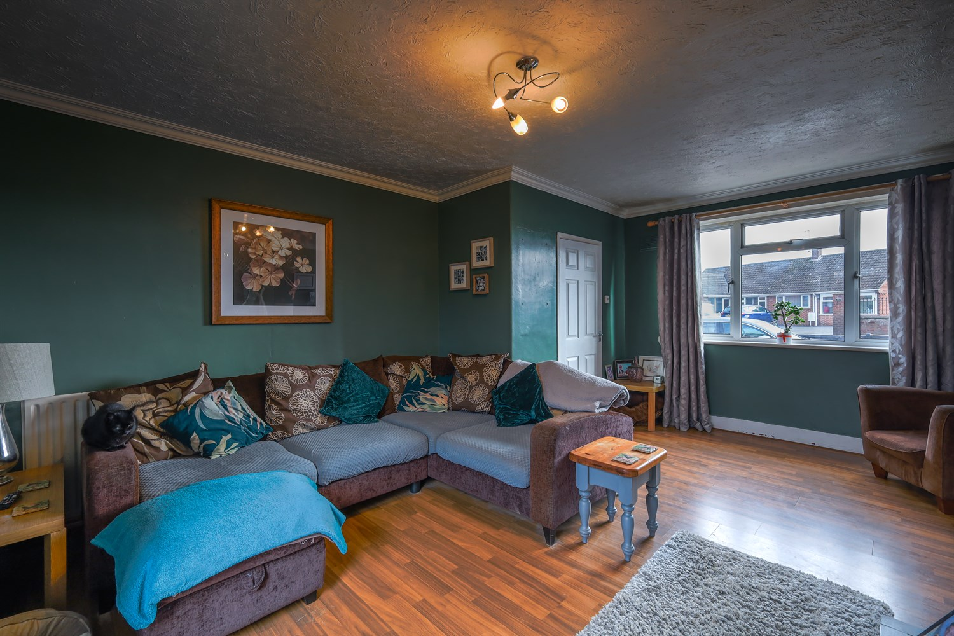
00
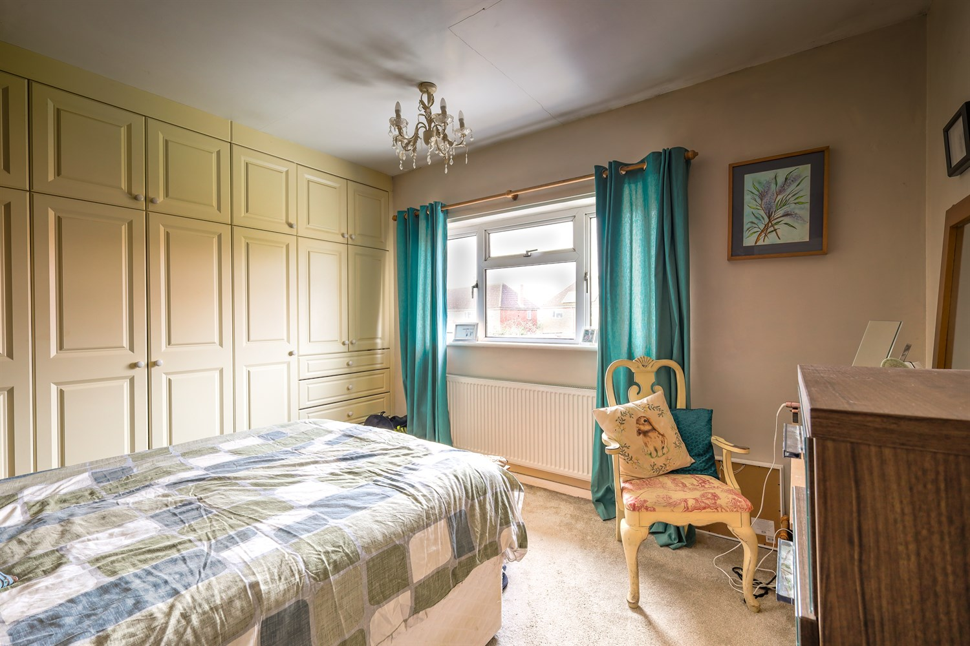
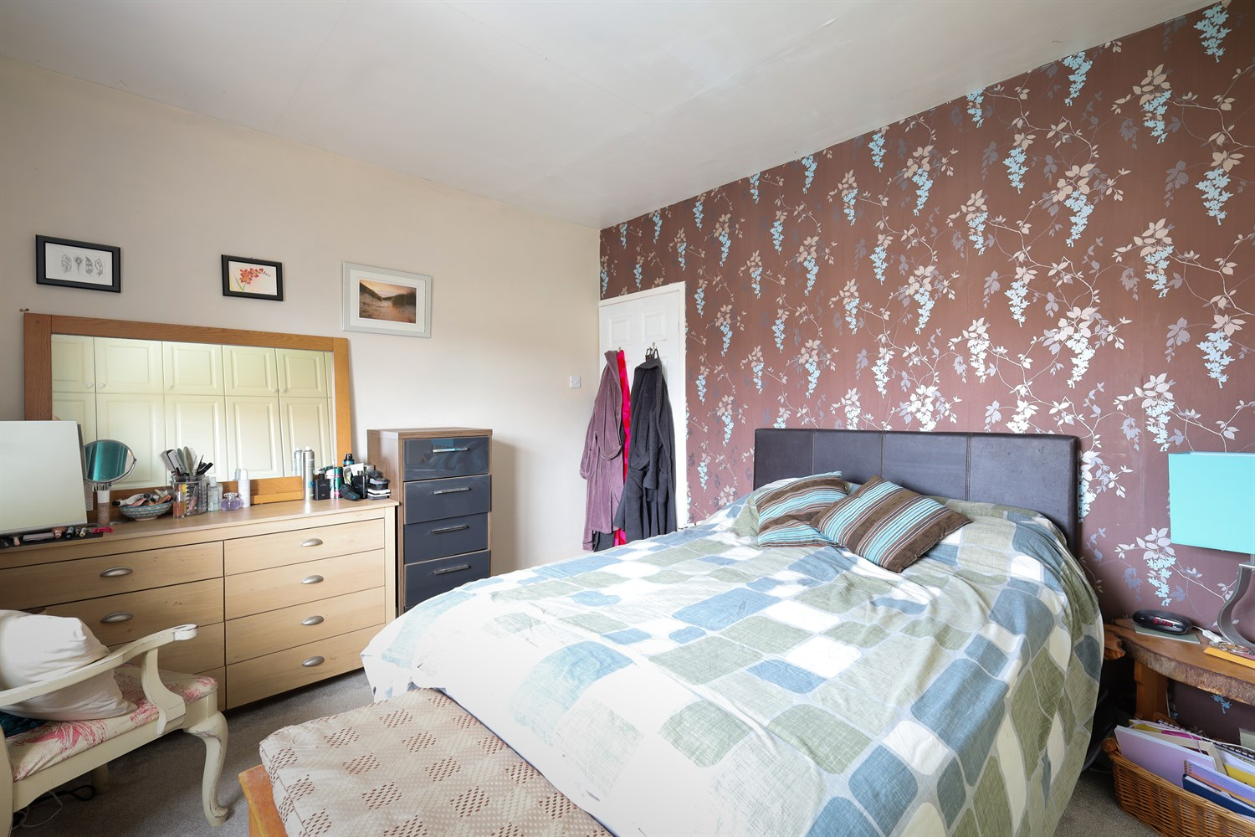
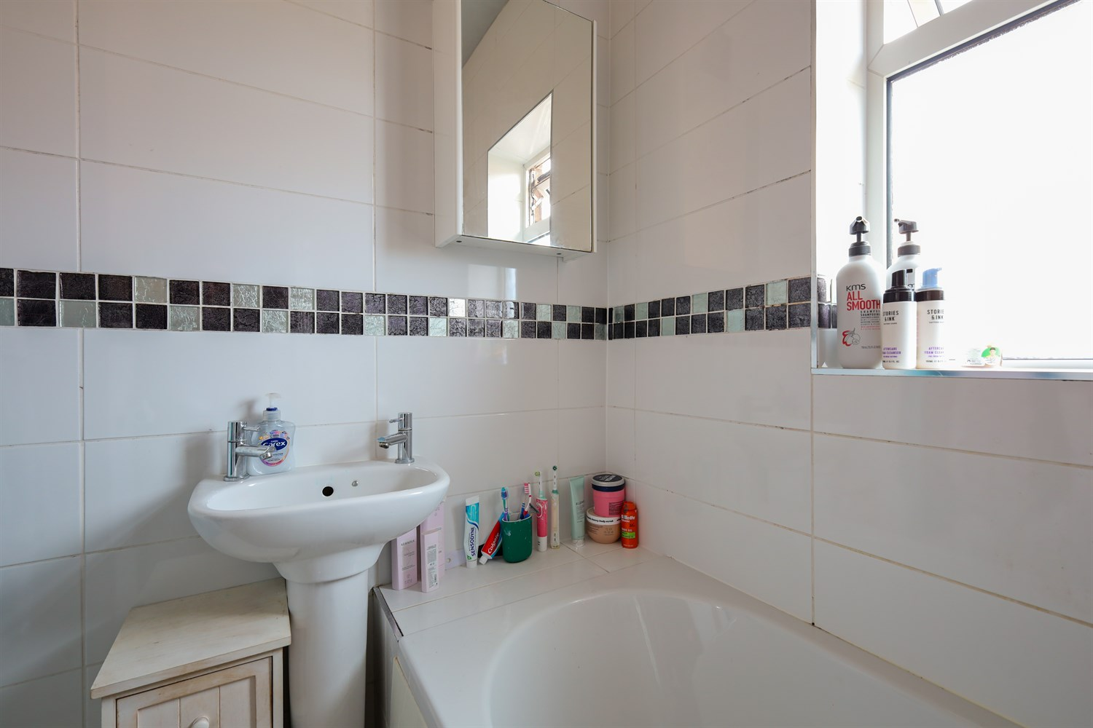
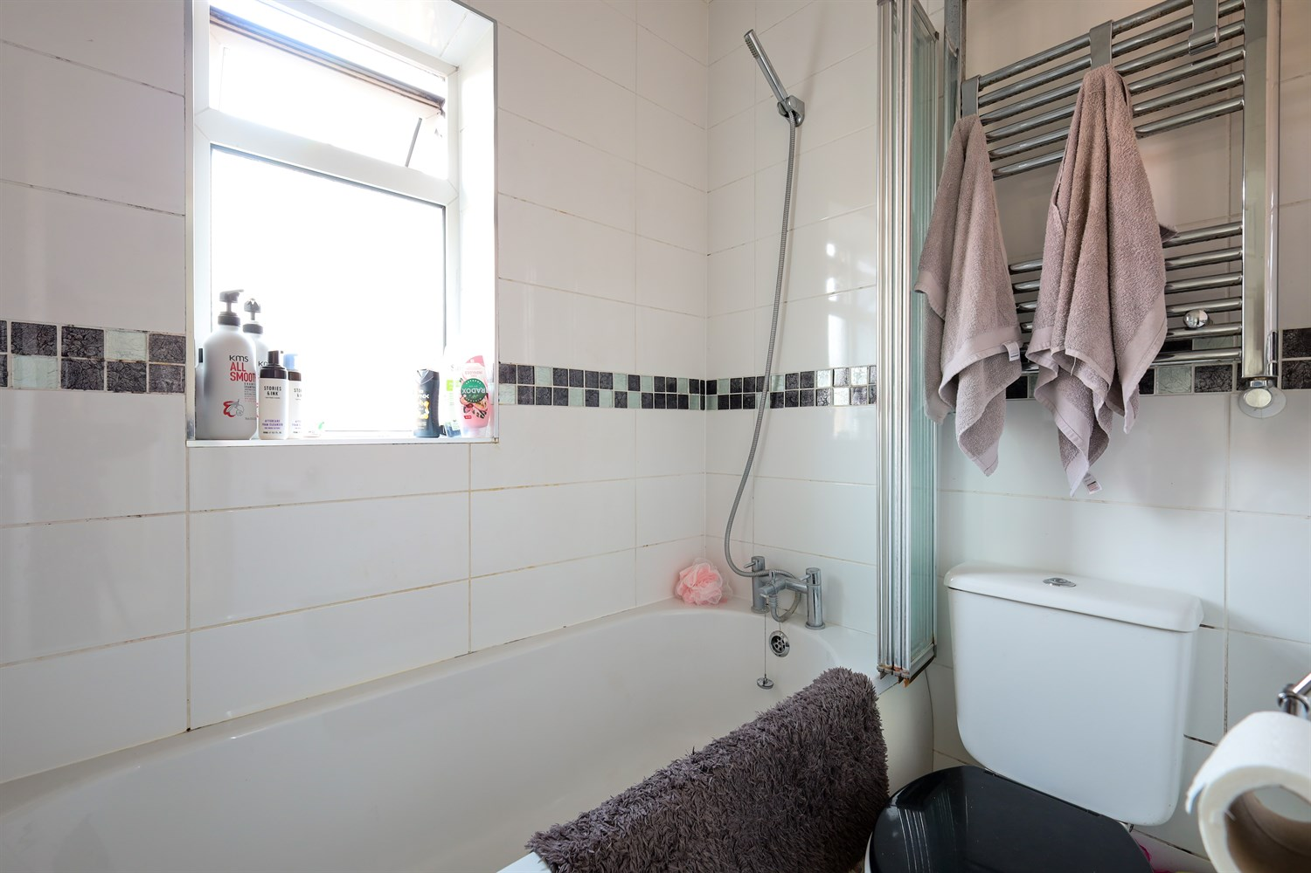
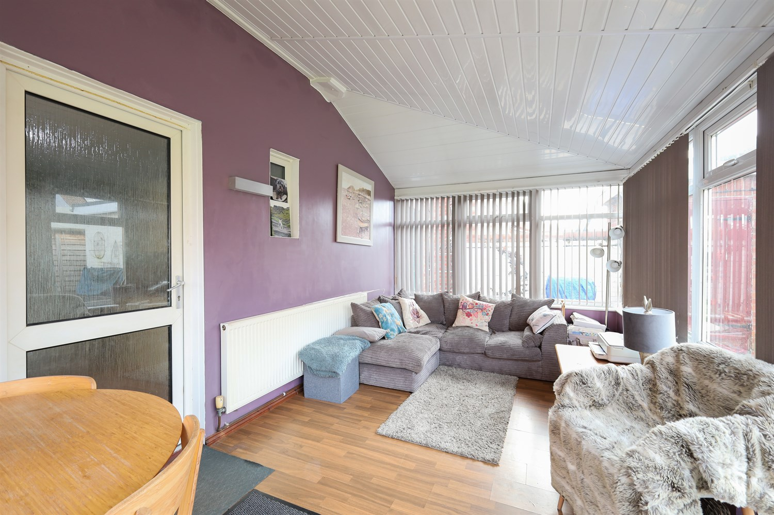
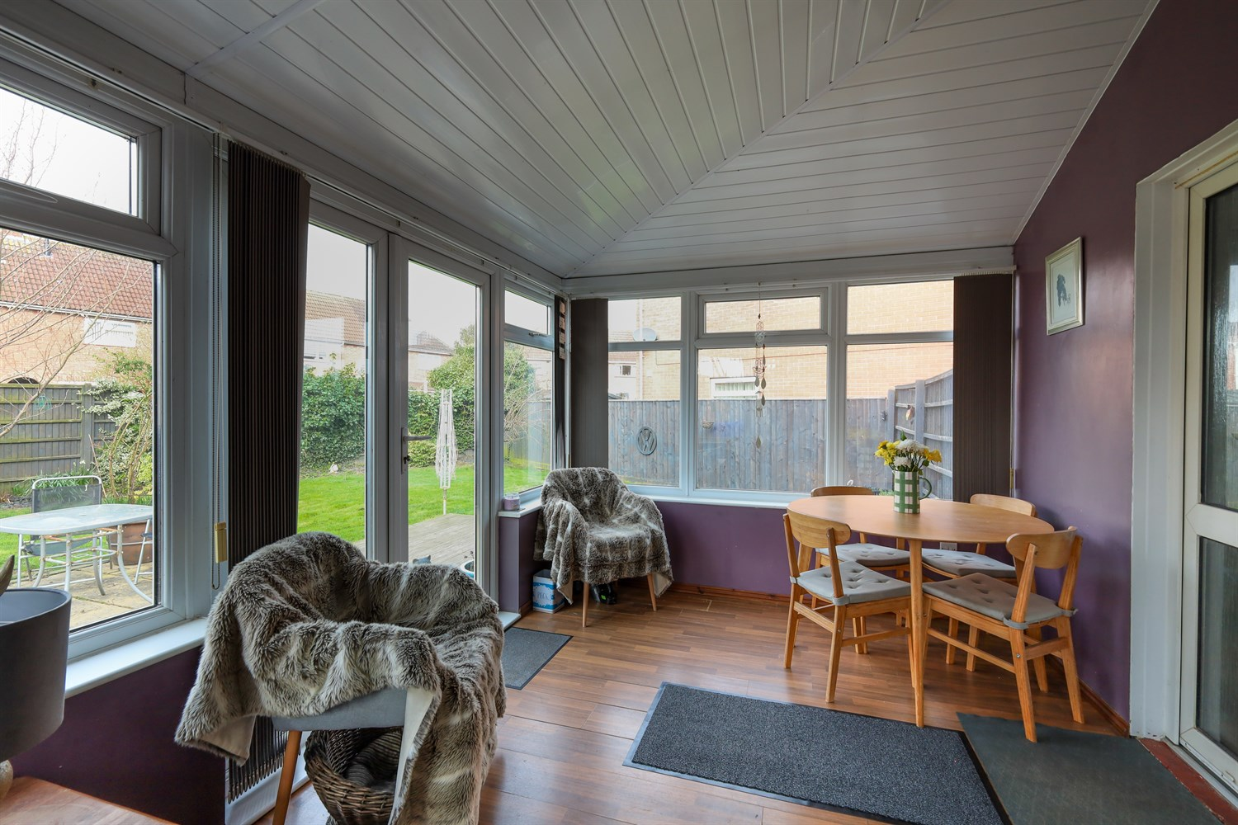
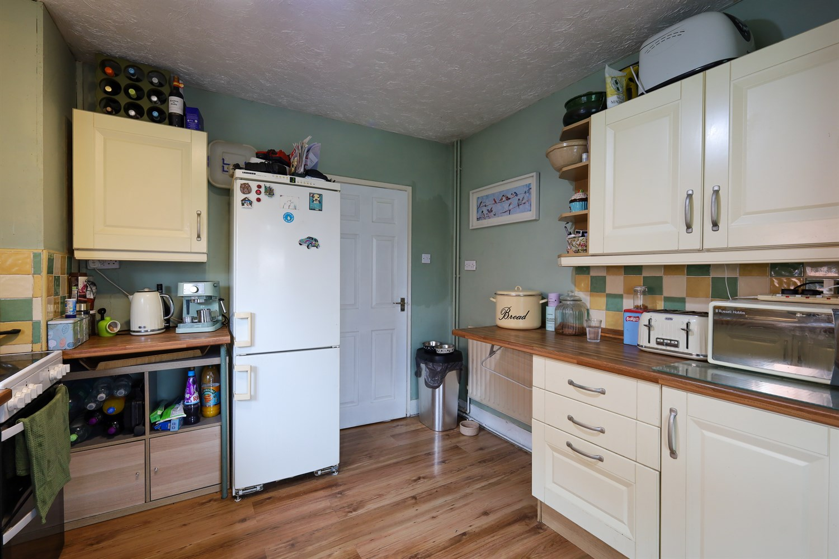
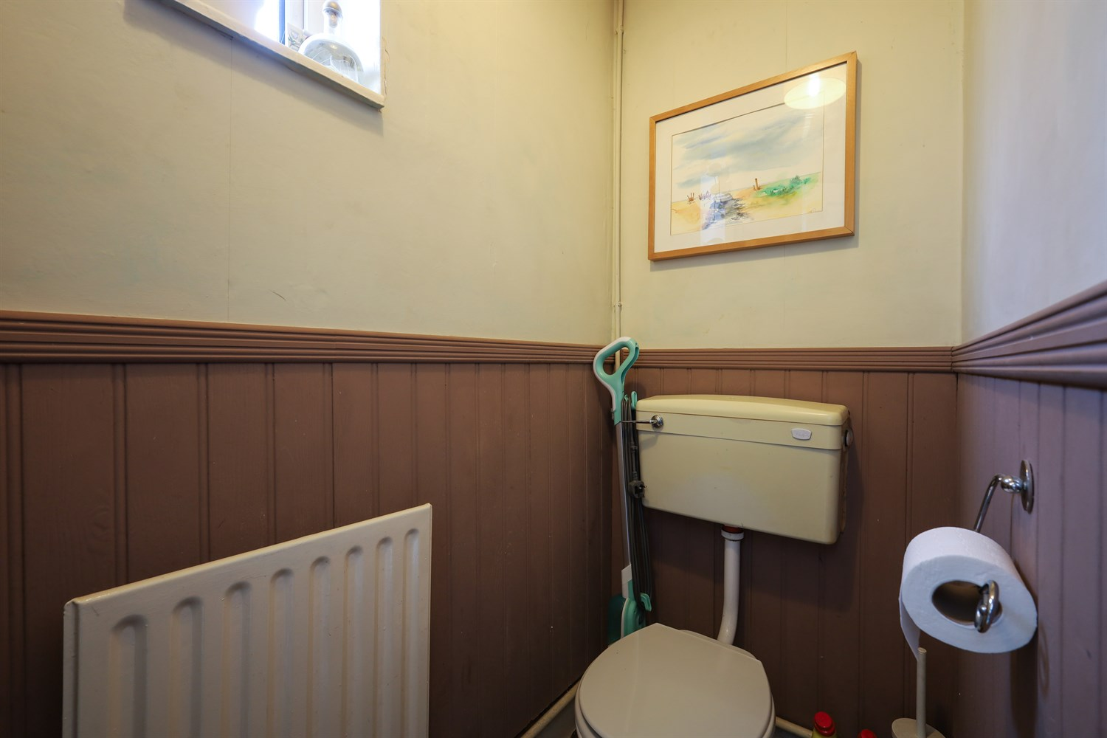

Property Description
Drury's Estate Agents are pleased to present this well maintained three bedroom semi detached home offering spacious and versatile accommodation throughout, situated within a popular residential location.
The property benefits from a welcoming entrance hallway providing access to the main ground floor accommodation and staircase rising to the first floor. The main living room offers a comfortable and well proportioned space for relaxing and entertaining.
To the rear of the property is a bright and spacious conservatory enjoying views over the garden. Surrounded by windows allowing for an abundance of natural light, the conservatory also features French doors opening directly onto the decking area and garden beyond, creating an excellent additional reception space which could be used as a sitting area, dining room or garden room.
The ground floor further benefits from a convenient downstairs WC.
Externally, the property enjoys a generous enclosed rear garden which is mainly laid to lawn and complemented by a decking area and paved patio providing excellent space for outdoor seating and entertaining. The garden also benefits from gated side access. Additionally, the property features useful brick-built outbuildings offering excellent additional storage or potential workshop space.
To the front of the property is a gravelled frontage providing off-road parking.
This property offers excellent potential for a range of buyers including first-time buyers, families or investors and early viewing is highly recommended.

Front Aspect
The property is positioned behind a gravelled frontage providing off road parking and enjoys a traditional brick built semi detached exterior. The property also benefits from UPVC double glazed windows and gated side access leading to the rear garden.

Entrance Hallway
A welcoming entrance hallway providing access to the ground floor accommodation with staircase rising to the first floor. The space benefits from laminate flooring, radiator and useful space for coats and everyday storage.

Living Room
A spacious and well presented living room featuring a uPVC double glazed window to the front aspect allowing plenty of natural light. The room benefits from laminate flooring and offers and offers ample space for lounge furniture, creating a comfortable family living area. To the rear, a uPVC door provides direct access to the garden.

Kitchen
A fitted kitchen comprising a range of wall and base units with work surfaces over incorporating a stainless steel sink and drainer with mixer tap. There is space and plumbing for a washing machine along with additional space for further appliances. The room benefits from tiled splashbacks, a uPVC double glazed window to the rear aspect and a uPVC door providing access to the garden.

Downstairs Toilet/Cloakroom
A convenient ground floor cloakroom fitted with a low level WC, with frosted window providing natural light and ventilation. The room also benefits from wall panelling and a radiator.

Conservatory
A spacious and light filled UPVC conservatory enjoying views over the rear garden. Surrounded by windows allowing for plenty of natural light and featuring French doors providing direct access onto the decking and garden. This versatile space offers excellent flexibility and could be used as an additional sitting room, dining area or relaxing garden room.

Bathroom
A family bathroom fitted with a three piece suite comprising panelled bath with shower over, pedestal wash hand basin and low level WC. The room features tiled walls, vinyl flooring and a uPVC double glazed frosted window to the rear aspect allowing natural light while maintaining privacy.

Landing
A central landing area with fitted carpet and doors leading to the bedrooms and bathroom. The space also provides access to the loft via a ceiling hatch and is finished with a pendant light fitting.

Bedroom 1
A well proportioned double bedroom featuring an extensive range of fitted wardrobes and drawers providing excellent built in storage. A uPVC double glazed widow to the rear aspect allows plenty of natural light into the room, complemented by a panel radiator beneath. The room offers ample space for a double bed and additional bedroom furniture, creating comfortable and practical sleeping space.

Bedroom 2
A well proportioned second bedroom featuring a uPVC double glazed window to the front aspect allowing plenty of natural light. The room offers space for a bed and additional bedroom furniture and benefits from a panel radiator beneath the window.

Bedroom 3
A well proportioned third bedroom with a uPVC double glazed window to the front aspect providing natural light. The room benefits from a panel radiator and offers versatility as a child's bedroom, nursery or home office.

Rear Garden
A generous enclosed rear garden featuring a well maintained lawn along with a raised decking area and paved patio providing ideal space for outdoor seating and entertaining. The garden is enclosed by fencing and benefits from gated side access. The property also includes useful brick built outbuildings offering excellent additional storage.

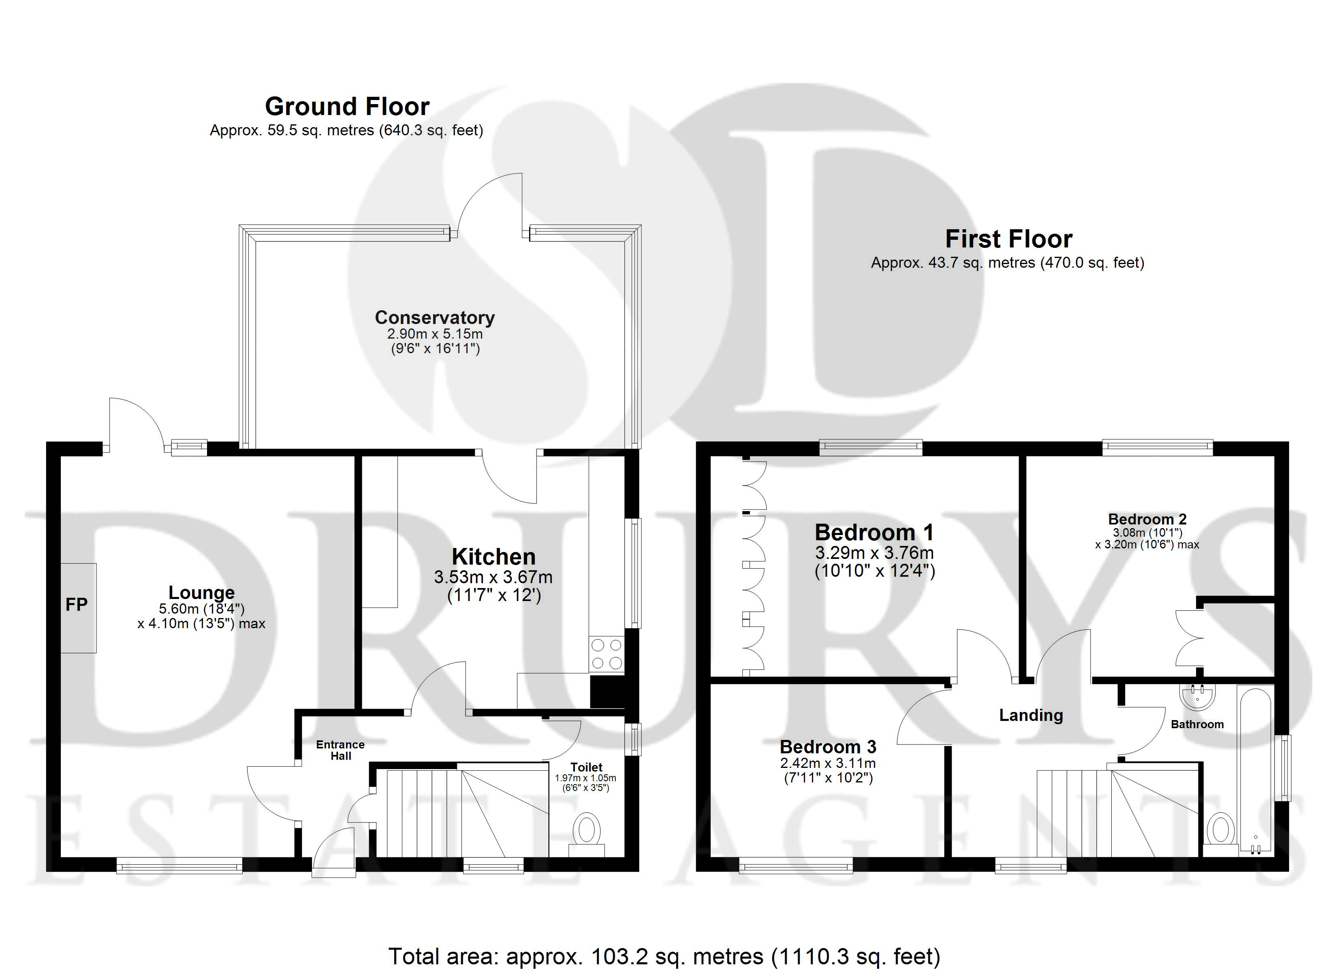

These particulars are intended to give a fair description of the property, but their accuracy cannot be guaranteed, and they do not constitute an offer of contract. Intending purchasers must rely on their own inspection of the property. None of the above appliances/services have been tested by ourselves. We recommend purchasers arrange for a qualified person to check all appliances/services before legal commitment.

Property Ref: 3217

www.drurysestateagents.co.uk
amber@drurysestateagents.co.uk
01205 350889

45 Willoughby Road
Boston
Lincolnshire
PE21 9HN
Agents Note: Whilst every care has been taken to prepare these sales particulars, they are for guidance purposes only. All measurements are approximate are for general guidance purposes only and whilst every care has been taken to ensure their accuracy, they should not be relied upon and potential buyers are advised to recheck the measurements

