



3 Bedroom(s)
2 Reception(s)
2 Bathroom(s)
£229,950.00
Blue Cedar Drive, PE21
EPC Rating ‘’

- Spacious open-plan kitchen/diner with garden access
- Close to Pilgrim Hospital
- 3 Bedrooms & 2 Bathrooms
- Gated Community

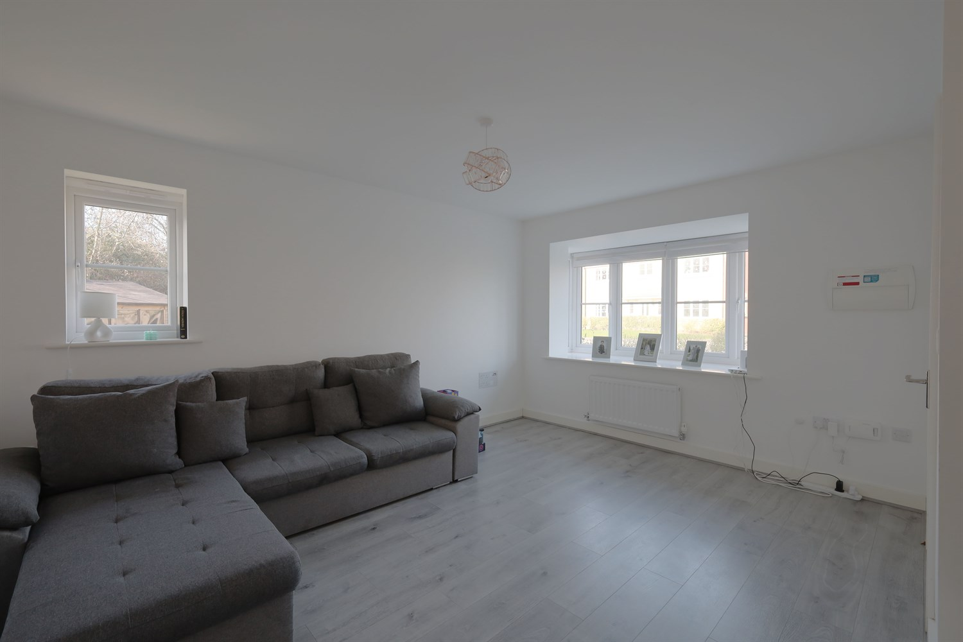
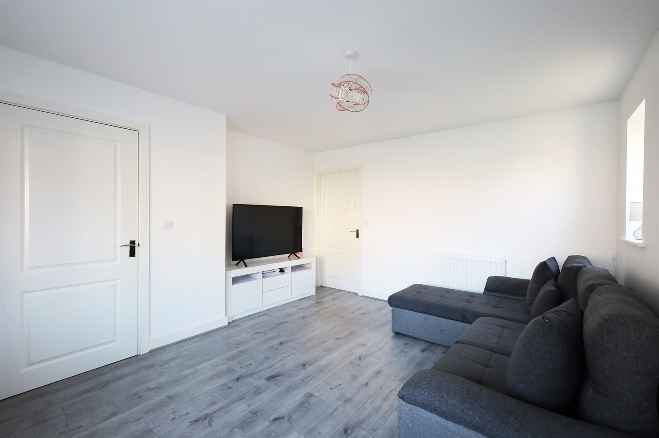
00
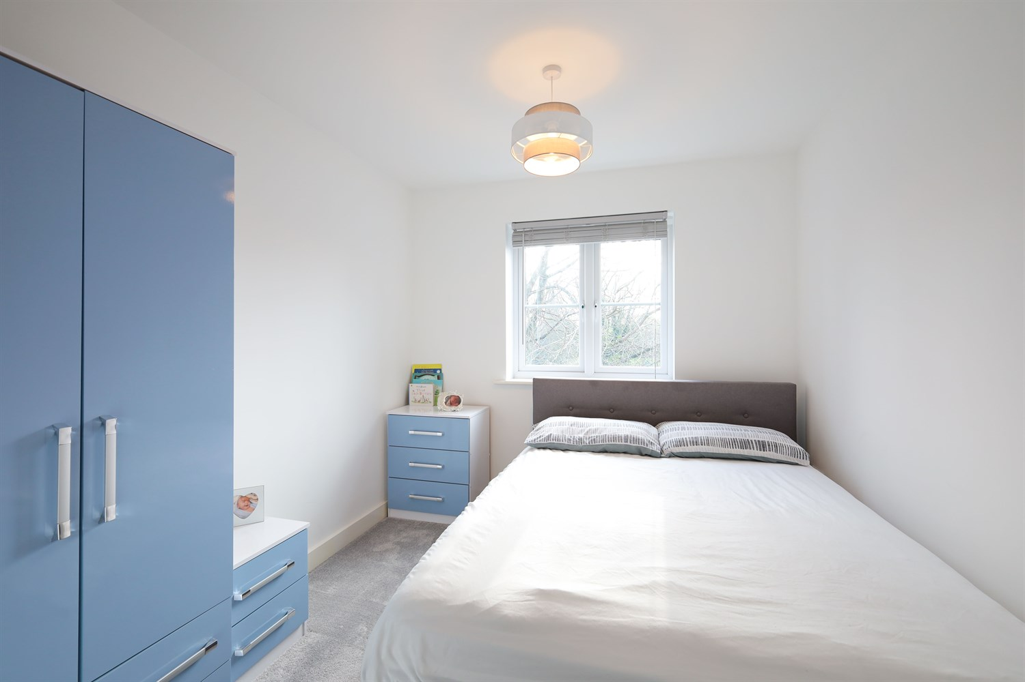
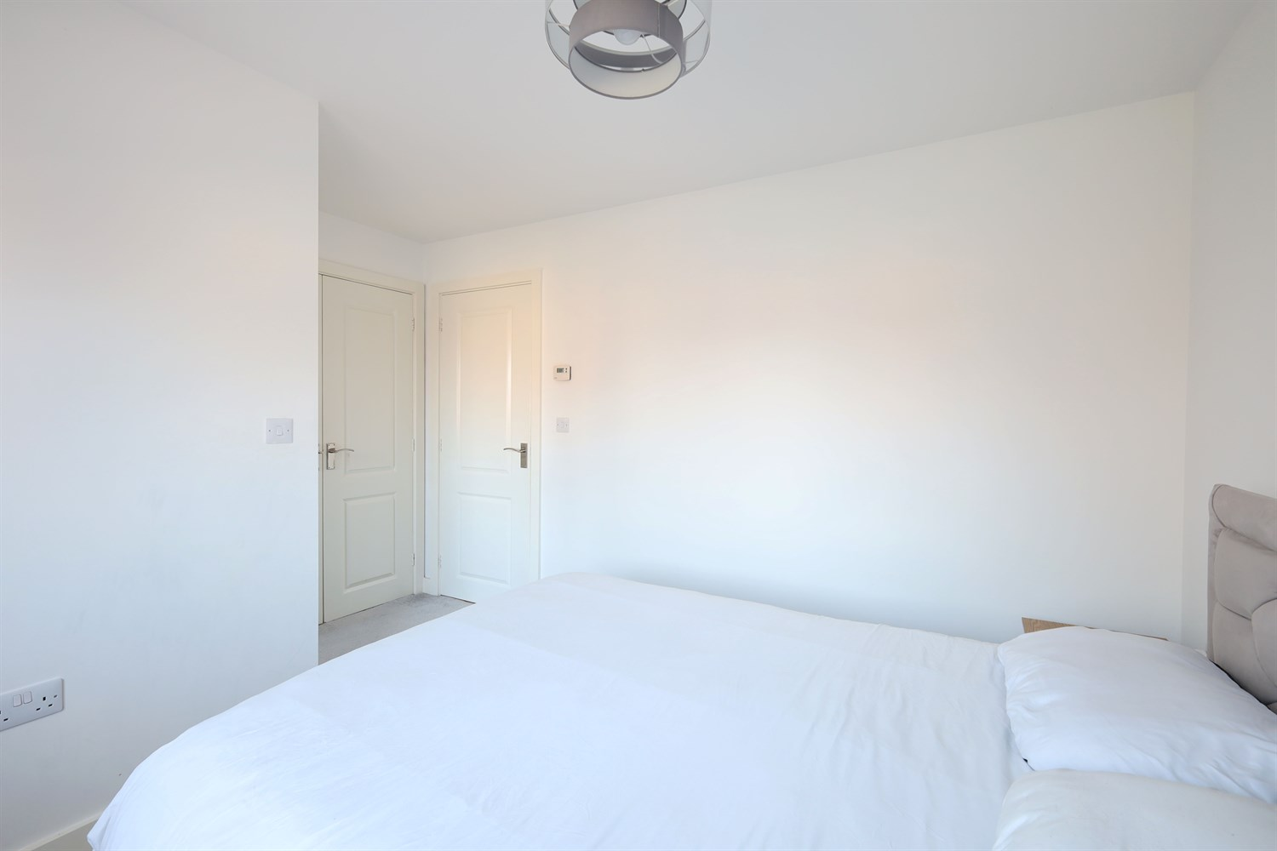
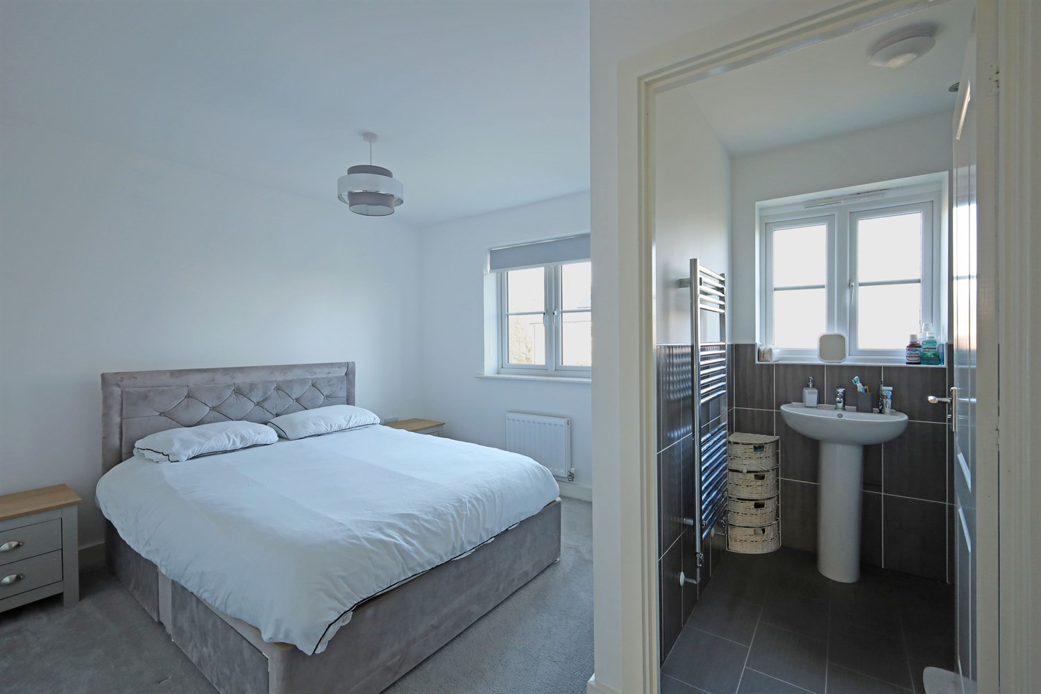
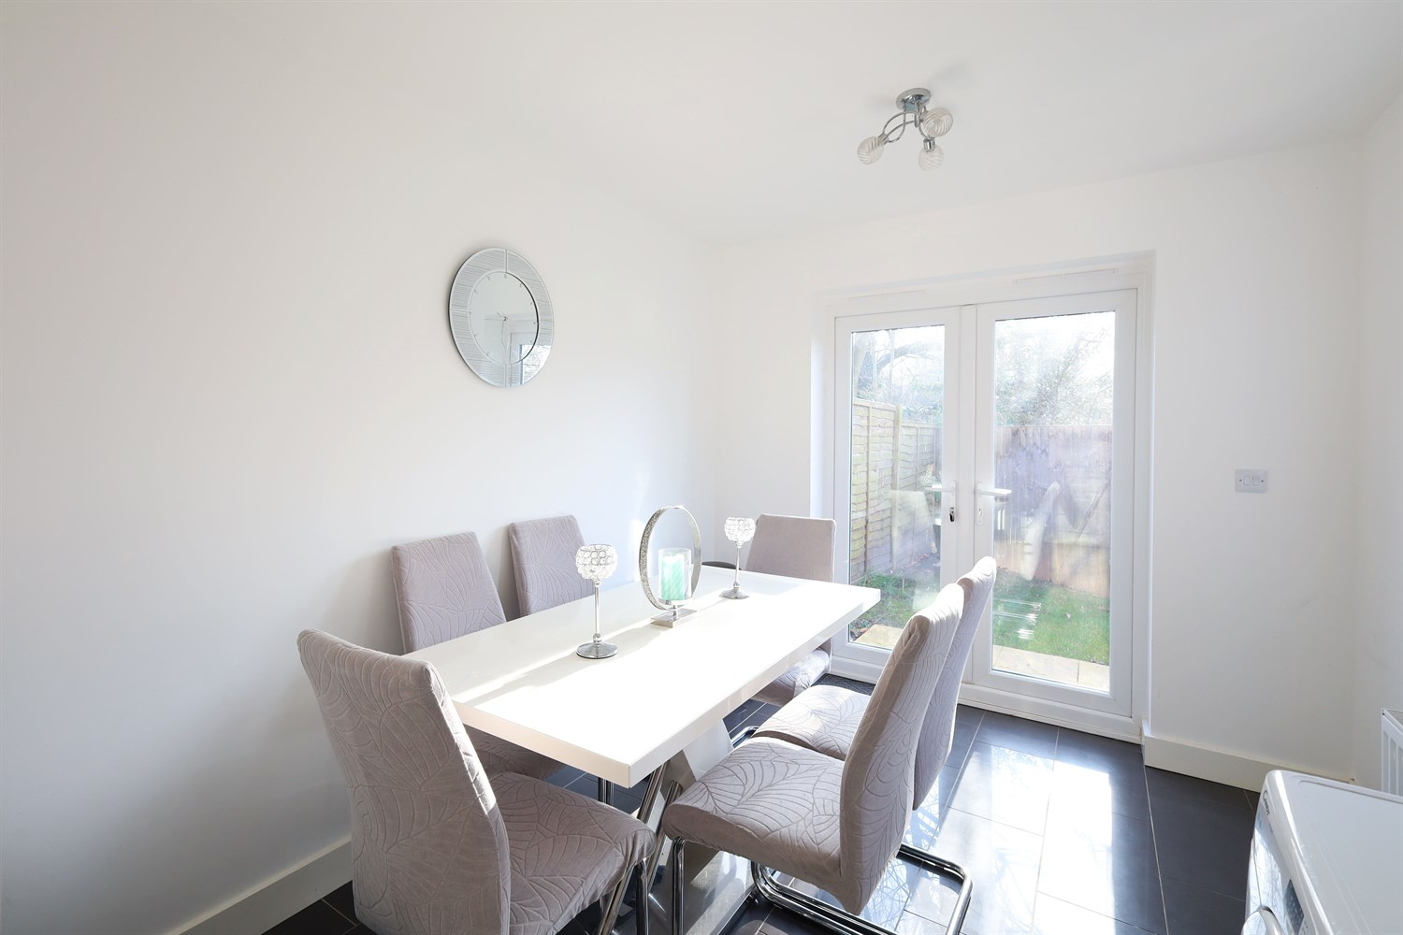
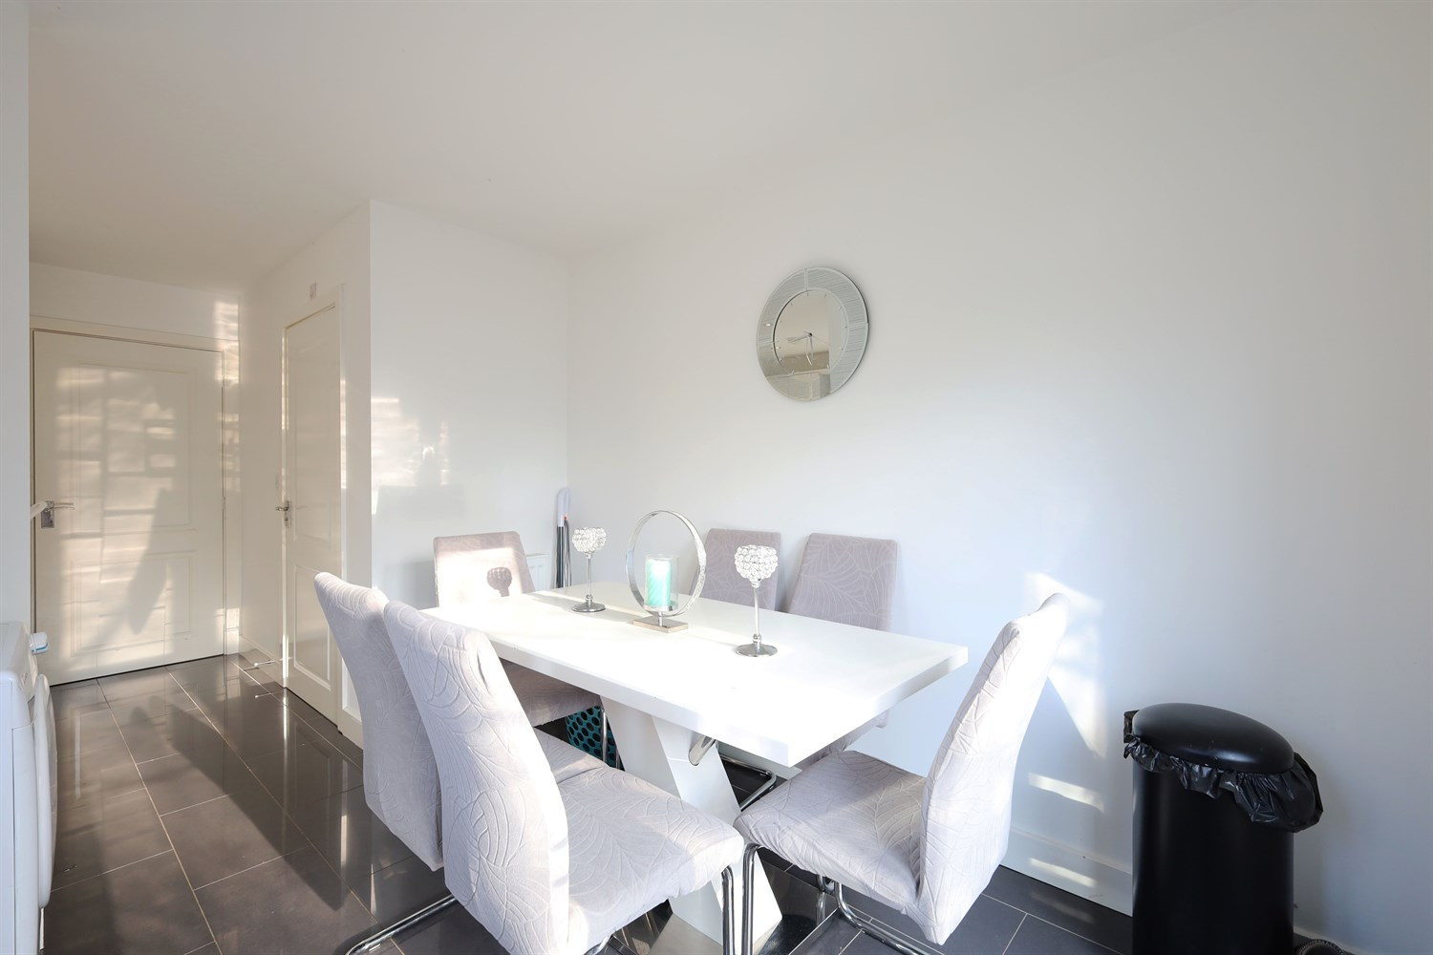
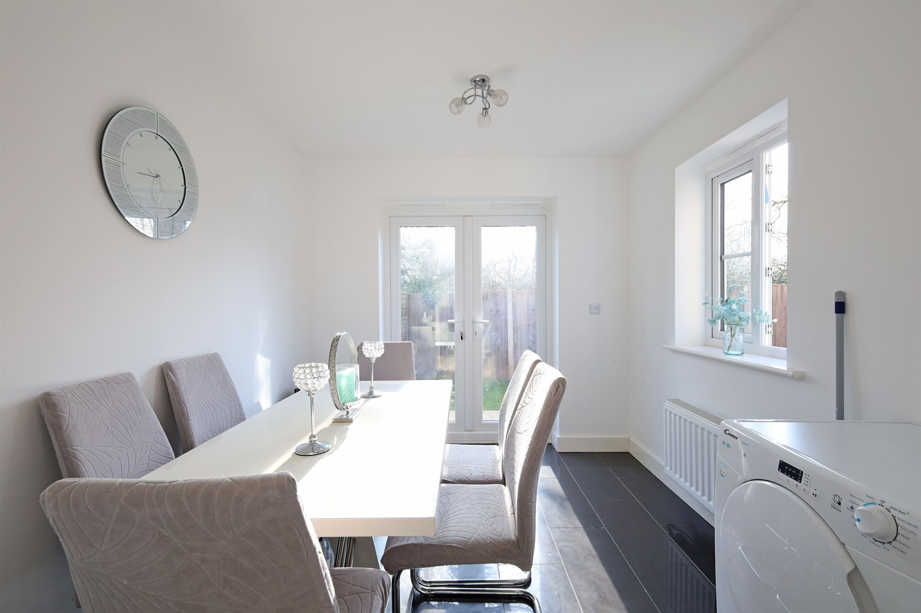
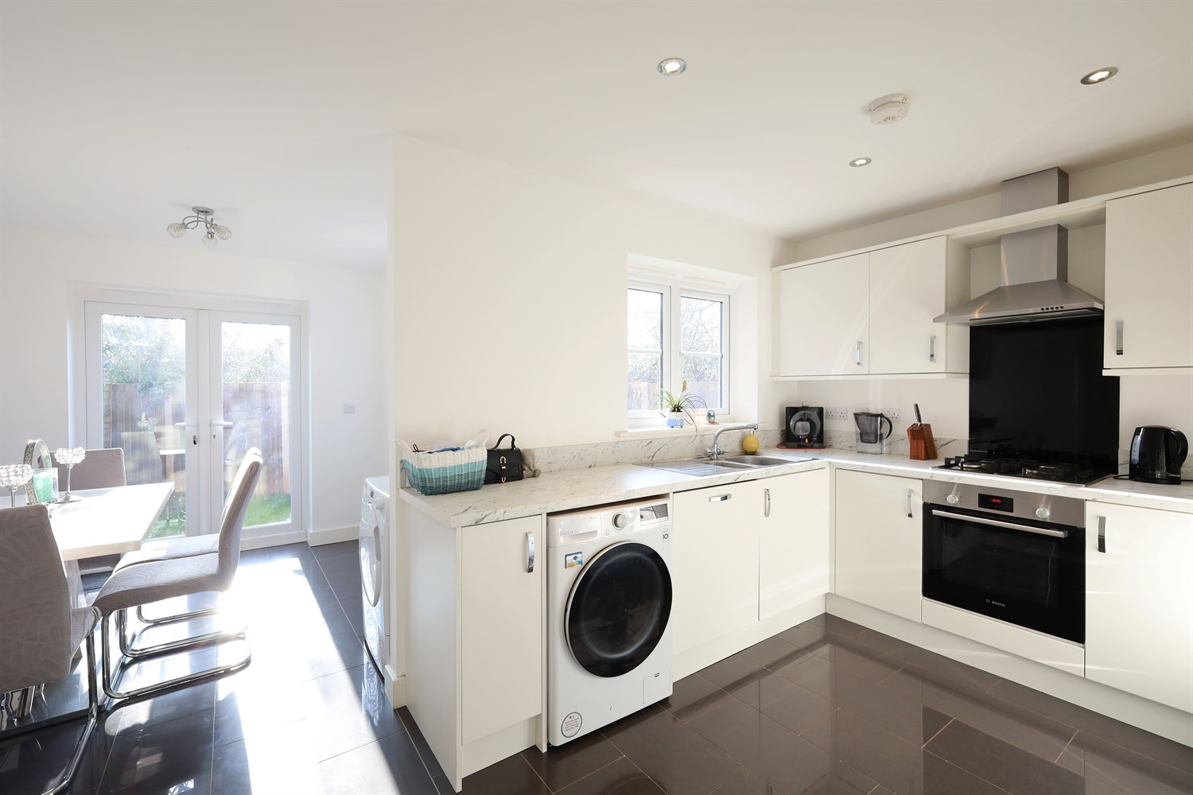
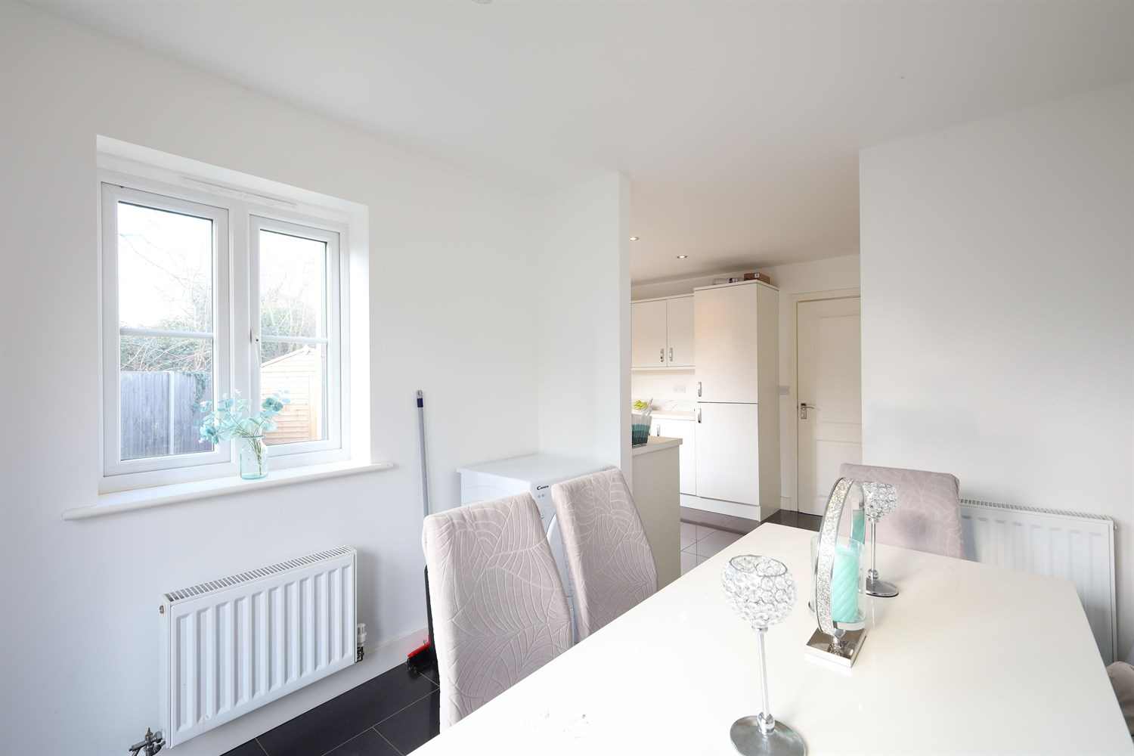

Property Description
A stylish and well-appointed three-bedroom semi-detached home situated within walking distance of Pilgrim Hospital. Offering spacious interiors, modern fittings, an enclosed garden, and excellent local amenities, this property is ideal for families or professionals seeking convenience and comfort in a popular gated community
The ground floor accommodation includes a welcoming entrance hallway, a bright and comfortable living room, and a spacious open-plan kitchen/diner that's ideal for both everyday living and entertaining. The kitchen offers ample storage and workspace, with direct access to the enclosed rear garden. A convenient downstairs WC completes the ground floor layout.
Upstairs, the property features two generous double bedrooms, with the master benefitting from an en-suite shower room and built-in storage. A third bedroom and a contemporary family bathroom are also located on the first floor, offering well-balanced space for families or guests.
Externally, the home enjoys a private, enclosed rear garden perfect for outdoor relaxation, along with a neatly maintained front garden and driveway providing off-street parking. The property also includes an electric vehicle charging point, gas central heating, and double glazing throughout for added comfort and efficiency.

Hallway
Entered through the Upvc door this room allows access to the lounge.

Lounge
Having a bay window to the front aspect and lvt style flooring, this light and bright room gives a blank canvas for anyone.

Kitchen
Having units to the eye level in a modern white gloss with marble prink worktops over and splash backs. Electric inset oven with gas hob and extractor over. Space for a washing machine, integral dishwasher and tall fridge freezer, a window to give plenty of light and access to the dining room.

Dining Room
A space off the kitchen with Double doors leading out into the garden area.

Downstairs WC
Having a WC and sink unit, an ideal space for modern living.

Landing
Approached from the staircase and giving access to all the first floor rooms.

Bedroom 1
The master bedroom is a great space with a window to the front aspect, double panelled radiator and access to the en-suite.

En-Suite
With a shower cubicle, WC, and sink this space is ideal for a couple or family.

Bedroom 2
Another double room with window to the rear aspect and double panelled radiator.

Bedroom 3
A great single bedroom or office space with window to the side aspect and double panelled radiator.

Bathroom
A three piece bathroom set with bath, pedestal sink and WC.

Medium sized Garden
A lovely garden "L-Shaped' with shed, patio and facing to all sides. There is a gated access to the side of the property and driveway.

Parking
A block paved driveway for several vehicles.

Central Heating
Gas central heating.

Double Glazing
Double glazed throughout.

These particulars are intended to give a fair description of the property, but their accuracy cannot be guaranteed, and they do not constitute an offer of contract. Intending purchasers must rely on their own inspection of the property. None of the above appliances/services have been tested by ourselves. We recommend purchasers arrange for a qualified person to check all appliances/services before legal commitment.

Property Ref: 3383

www.drurysestateagents.co.uk
amber@drurysestateagents.co.uk
01205 350889

45 Willoughby Road
Boston
Lincolnshire
PE21 9HN
Agents Note: Whilst every care has been taken to prepare these sales particulars, they are for guidance purposes only. All measurements are approximate are for general guidance purposes only and whilst every care has been taken to ensure their accuracy, they should not be relied upon and potential buyers are advised to recheck the measurements

