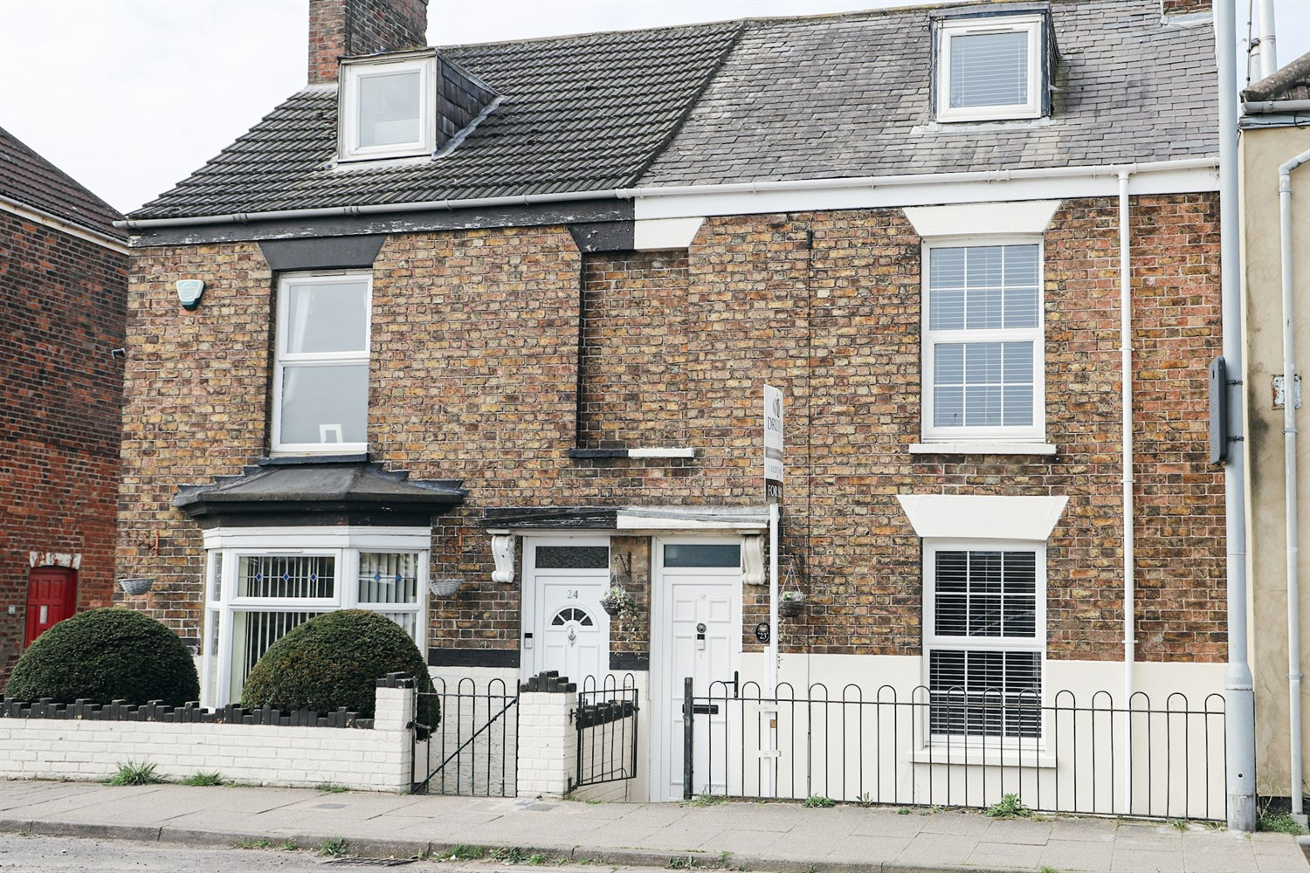




3 Bedroom(s)
3 Reception(s)
1 Bathroom(s)
£199,950.00
London Road, PE21
EPC Rating ‘’

- Three generously sized bedrooms
- Character features including fireplaces & wooden panelling
- Fully updated soffits, fascia's & guttering
- Walking distance to town & amenities

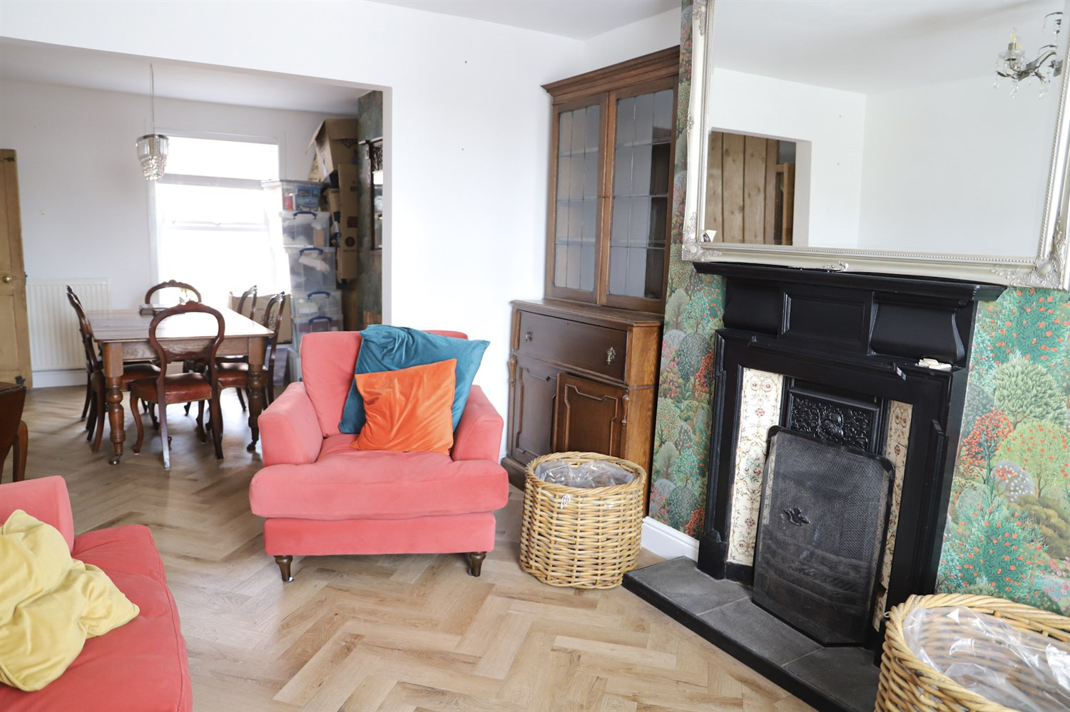
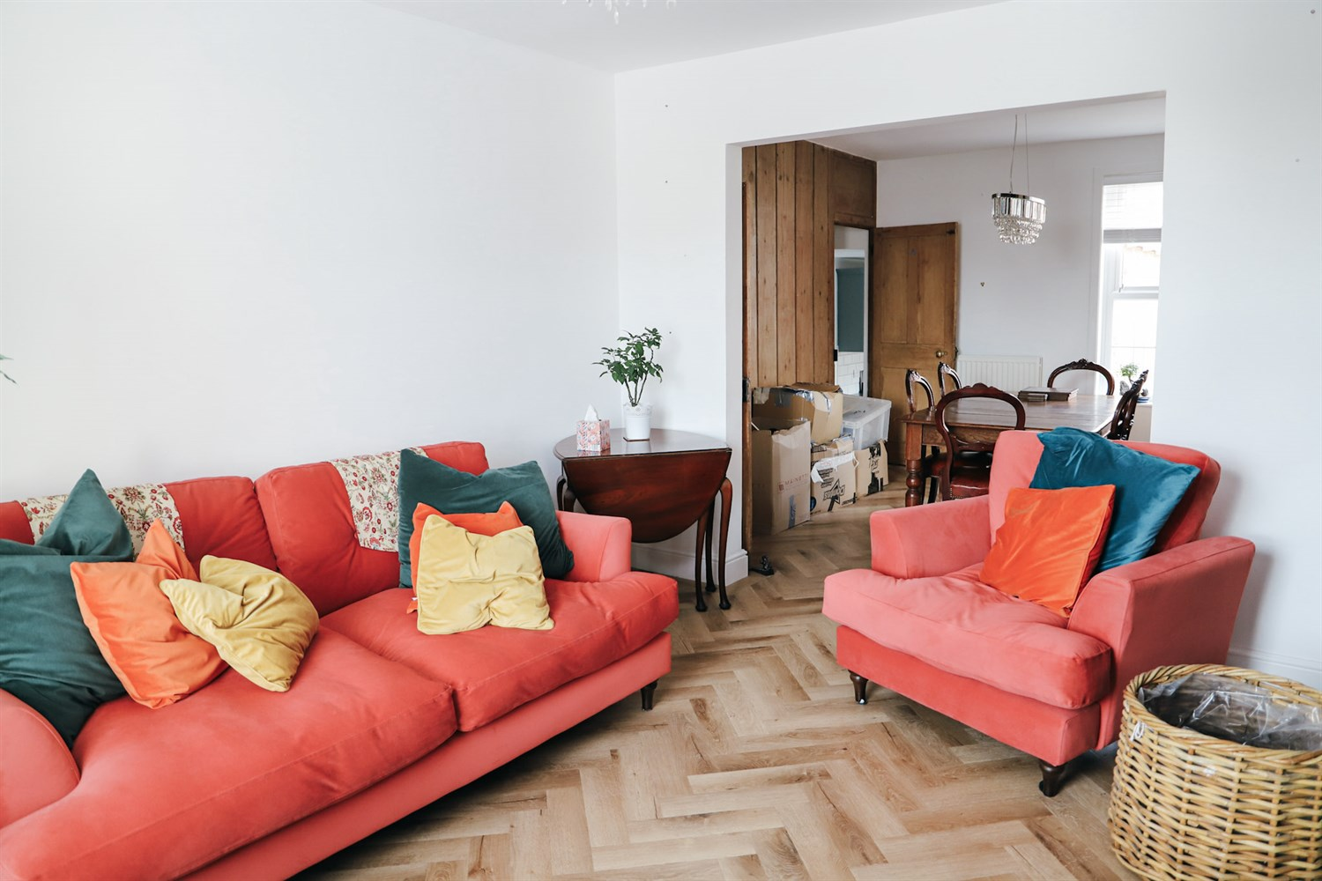
00
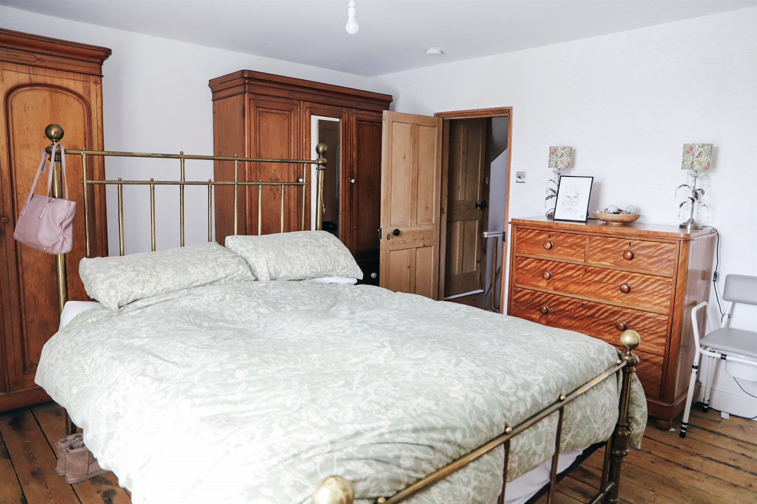
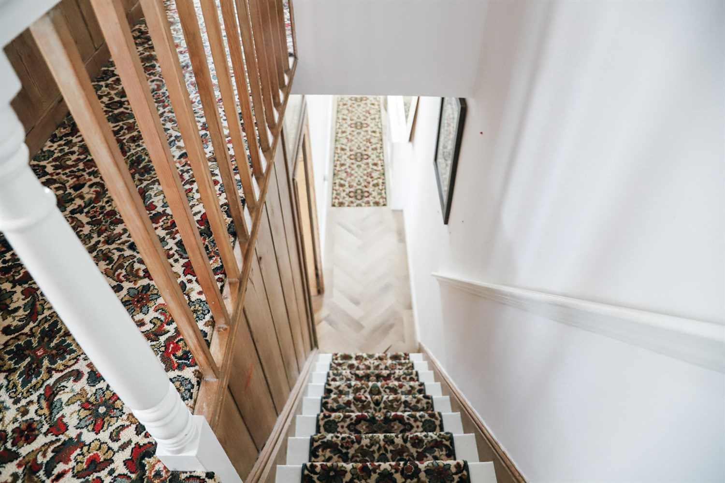
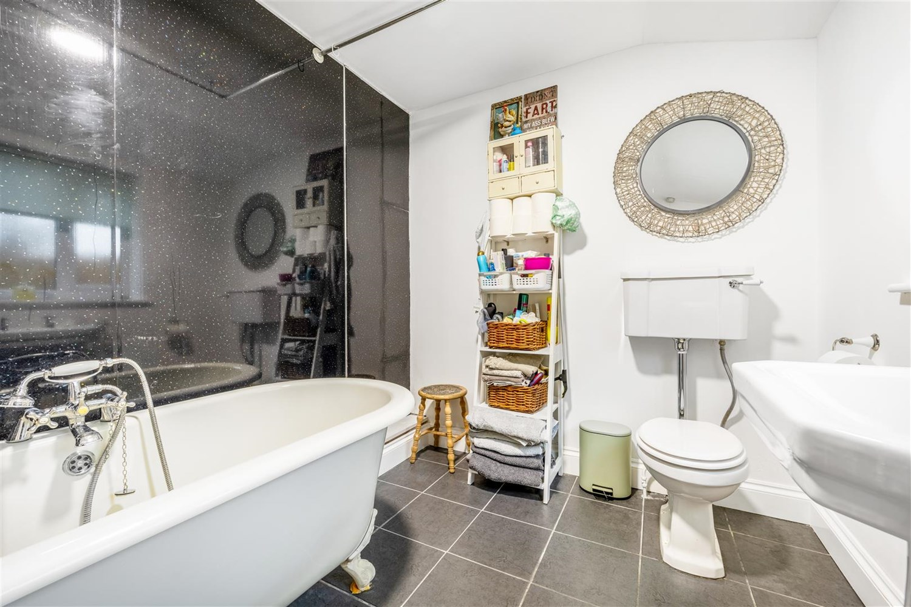
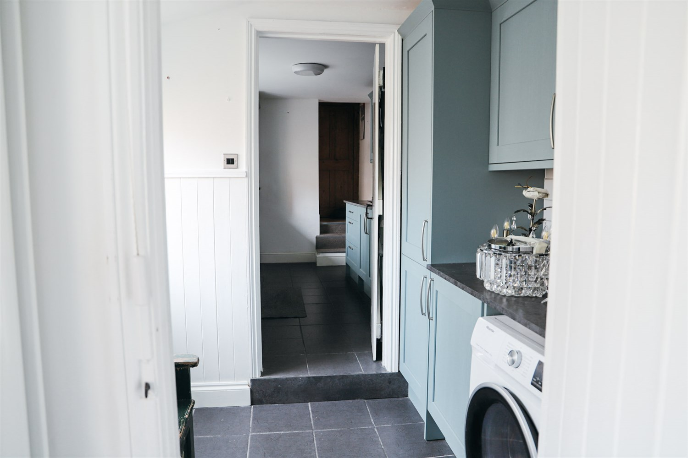
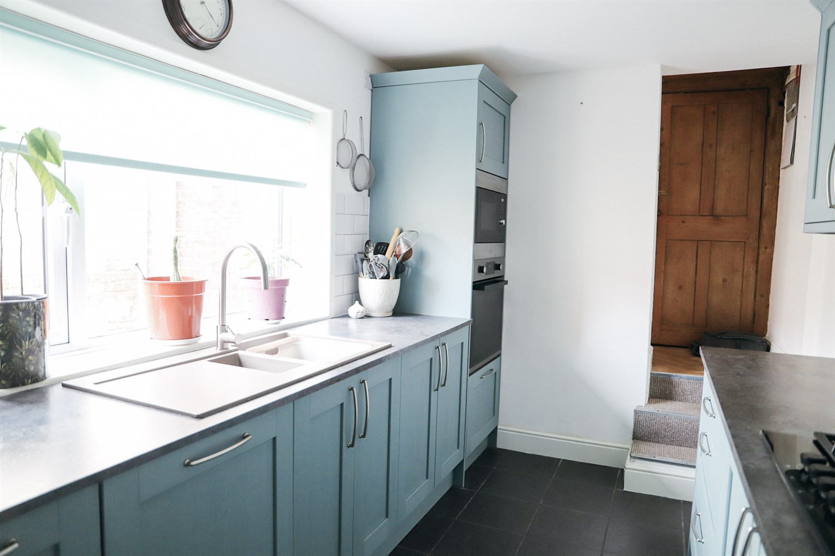
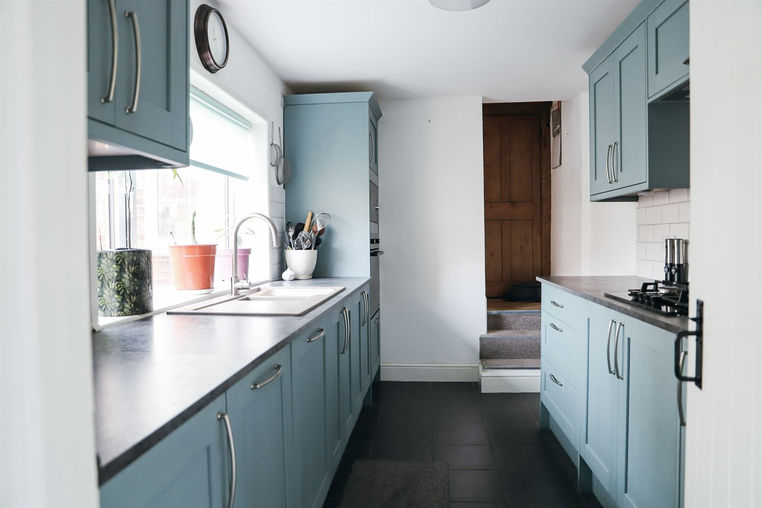
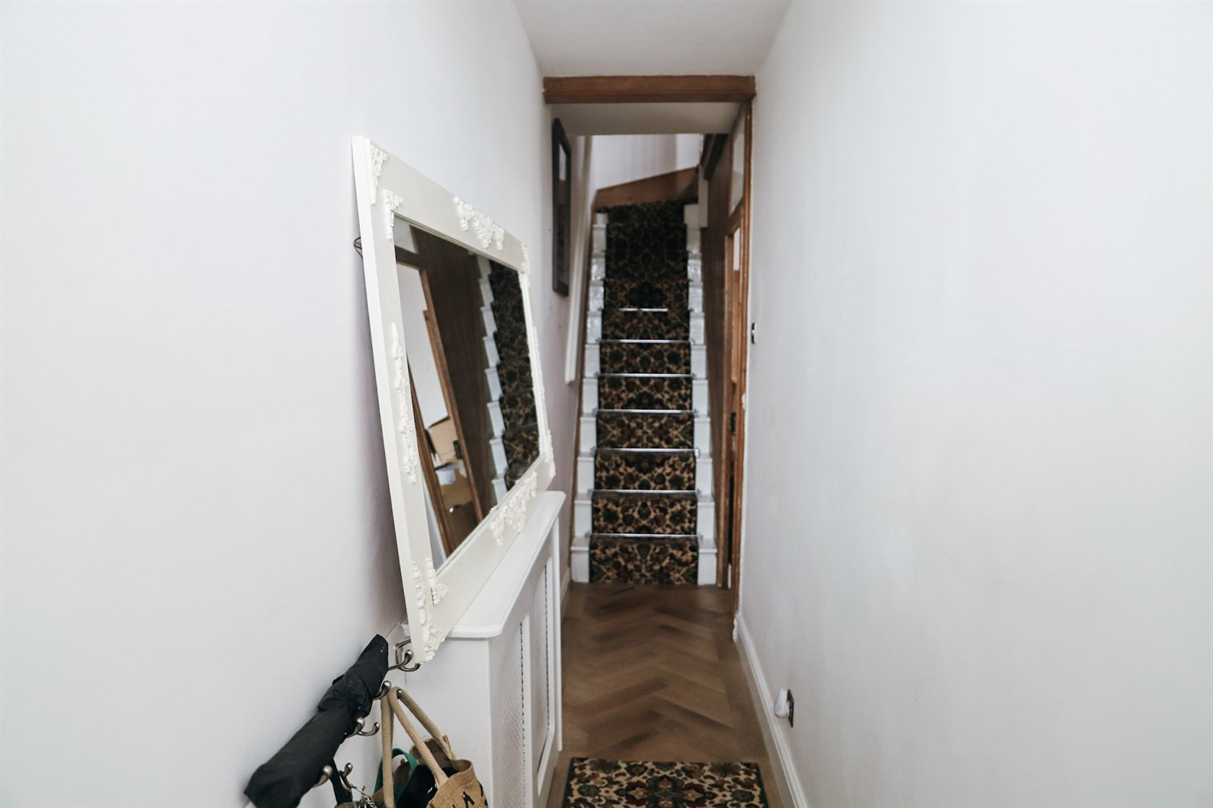
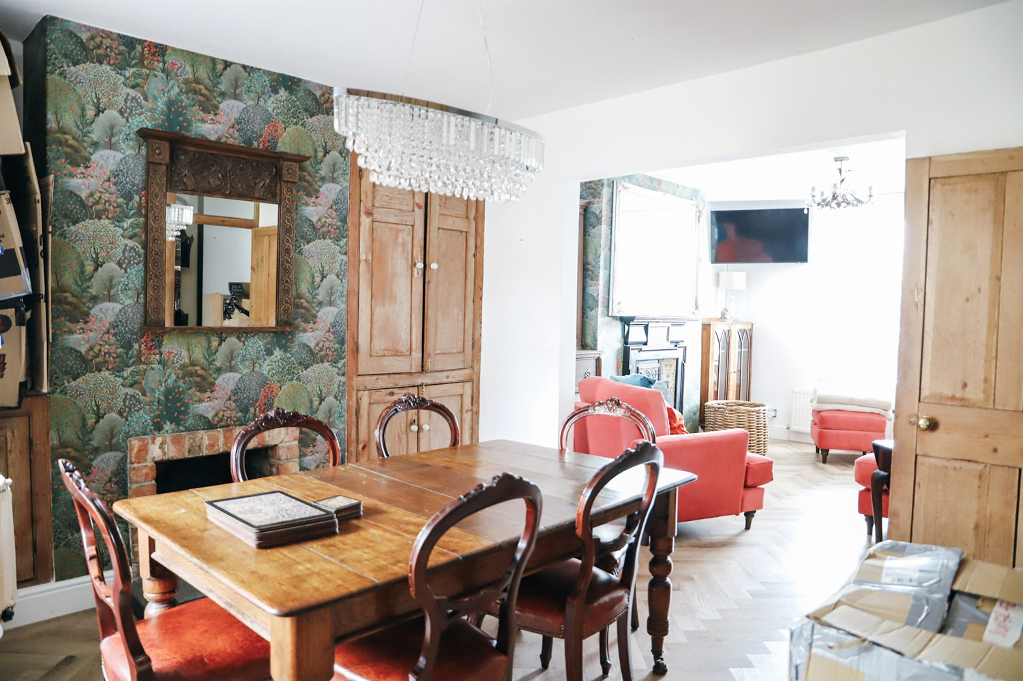

Property Description
Drury's Estate Agents is proud to present a three-bedroom townhouse, perfectly positioned within a sought-after waterside location in the heart of Boston, offering an excellent blend of character features and modern upgrades throughout.
This charming home has been tastefully improved by the current owners, benefitting from new flooring and carpets, along with updated soffits, fascia's and guttering, ensuring both the interior and exterior are well maintained and ready to move straight into.
The accommodation comprises a spacious dining room and a cosy reception room, both featuring attractive fireplaces and wooden panelling, creating a warm and inviting feel. The newly fitted kitchen has been finished to a high standard with modern units and integrated appliances, while a separate utility room provides additional practicality and includes an integrated freezer. The family bathroom is conveniently located on the ground floor.
To the upper floors, the property offers three well-proportioned bedrooms, two of which benefit from their own wash basins. The master bedroom presents excellent potential for the addition of an ensuite, subject to the necessary works.
Externally, the property benefits from on-street parking to the front, whilst to the rear there is a newly landscaped, low-maintenance garden, ideal for both relaxing and entertaining.
Situated within easy walking distance of Boston town centre, the property is ideally located for access to local amenities, schools and transport links.
A fantastic opportunity to acquire a characterful home in a prime central location.

Front Aspect
The property boasts an attractive and characterful frontage, with a charming exposed brick façade that immediately reflects the home's period appeal. Set behind a low-level brick wall with wrought iron railings, the property enjoys a defined yet welcoming boundary.
A private gated entrance leads to the front door, adding both security and a sense of individuality. The frontage is enhanced by well-maintained detailing, including contrasting brickwork and neatly presented windows, creating a smart and inviting first impression.
Positioned along a pleasant street, the property benefits from on-street parking directly to the front, providing convenient access for residents and visitors alike.

Entrance Hallway
A welcoming entrance hallway that immediately showcases the home's character and charm.
Upon entering, you are greeted by a bright and well-presented space, featuring stylish flooring laid in a classic pattern and a staircase with a distinctive runner, adding a touch of personality. The hallway retains a number of period features, including traditional woodwork and detailing, setting the tone for the rest of the property.
The space provides access to the main ground floor accommodation and offers a practical area for coats and storage, all while maintaining a clean and inviting first impression.

Living Room
A beautifully presented and generously proportioned lounge, full of character and charm, offering the perfect space for both relaxing and entertaining.
The room is centred around a stunning feature fireplace, complete with a traditional surround, creating a real focal point and enhancing the home's period appeal. High ceilings and large windows allow for plenty of natural light, giving the space a bright yet cosy feel.
Tastefully decorated throughout, the lounge benefits from modern flooring laid in a stylish herringbone pattern, perfectly complementing the properties character features.
The layout comfortably accommodates multiple seating areas and flows seamlessly through to the dining room, making it ideal for both everyday living and hosting guests.

Dining Room
A stunning and character-filled dining room, offering a perfect space for entertaining and family gatherings.
The room is rich in period charm, featuring a beautiful exposed brick fireplace, complemented by striking decorative wallpaper and traditional wooden finishes. A statement chandelier-style light fitting adds a touch of elegance, enhancing the overall atmosphere of the space.
Generously sized, the dining room comfortably accommodates a large table and chairs, making it ideal for hosting. The layout flows seamlessly through to the lounge, creating a sociable and versatile living arrangement.
Finished with stylish flooring and filled with natural light, this is a room that perfectly balances character, warmth, and functionality.

Kitchen
A beautifully presented and recently fitted kitchen, finished to a high standard and thoughtfully designed to maximise both style and functionality.
The space features a range of modern shaker-style units in a soft, contemporary tone, complemented by contrasting work surfaces and sleek chrome fittings. A large window allows for an abundance of natural light, creating a bright and welcoming environment ideal for everyday living.
The kitchen benefits from integrated appliances, including an oven and hob, along with ample worktop and storage space, making it perfectly suited for both cooking and entertaining.
Finished with tiled splashbacks and durable flooring, the space is both practical and stylish. The layout also provides easy access through to the rest of the home, enhancing the overall flow of the property.

Utility Room
A useful and well-appointed utility room, providing additional storage and practicality separate from the main kitchen.
Fitted with matching units and work surfaces, the space offers room for appliances, including plumbing for a washing machine, along with an integrated freezer. This helps to keep the main kitchen clutter-free while adding valuable functionality to the home.
Finished with durable flooring and conveniently positioned off the kitchen, the utility room enhances the overall flow and usability of the property.

Bathroom
A stylish and well-presented family bathroom, offering a blend of modern fittings and classic design.
The room features a freestanding roll-top bath, creating a real focal point and adding a touch of luxury, alongside a separate walk-in shower with contemporary tiling. A pedestal wash hand basin and WC complete the suite.
Finished with tiled flooring and neutral décor, the space feels bright, clean, and ready to move straight into.

Landing/Staircase
A characterful staircase and landing area that continues the home's period charm throughout the upper floors.
The staircase features a distinctive patterned runner, complemented by traditional wooden balustrades and detailing, creating a warm and inviting transition between levels. The landing itself is well-presented and provides access to the bedrooms.
Finished with neutral décor, the space feels bright and airy while maintaining the property¿s original character features.

Bedroom 1
A spacious and well-presented principal bedroom, offering a comfortable and relaxing retreat.
The room benefits from generous proportions, easily accommodating a large bed along with additional furniture, while still maintaining a sense of space. Large windows allow for plenty of natural light, creating a bright and airy feel.
Character features continue throughout, including exposed wooden flooring and a traditional fireplace, adding warmth and charm to the room.
The layout also provides excellent potential for the addition of an ensuite, subject to the necessary works, further enhancing the room's appeal.

Bedroom 2
A well-proportioned double bedroom, full of character and offering versatile living space.
The room features a traditional fireplace, adding to the property¿s period charm, along with exposed wooden flooring that enhances the overall warmth of the space. A built-in alcove provides useful storage or display options.
Further benefits include a wash hand basin within the room, adding a practical and convenient touch.
Bright and neutrally decorated, this is an ideal guest room, second bedroom, or even a stylish home office if required.

Staircase

Bedroom 3
A bright and spacious bedroom, located on the upper floor, offering a versatile and peaceful setting.
The room benefits from plenty of natural light, along with characterful features including sloped ceilings and exposed flooring, adding to its charm and individuality. Built-in storage areas provide practical use of space.
Generous in size, the room can comfortably accommodate a double bed and additional furniture, making it ideal as a guest room, bedroom, or home office.

Garden & Outdoor Space
A well-presented and thoughtfully arranged rear garden, designed with low maintenance in mind while still offering a pleasant outdoor space to enjoy.
The garden features a combination of patio and gravelled areas, providing ideal spots for seating and entertaining. A decorative archway adds a touch of charm, creating a defined space within the garden.
Fully enclosed by fencing, the garden offers a good degree of privacy and security. There is also the benefit of a timber outbuilding, providing useful storage.
Overall, a practical and inviting outdoor space, perfect for relaxing with minimal upkeep required.

Parking

Central Heating

These particulars are intended to give a fair description of the property, but their accuracy cannot be guaranteed, and they do not constitute an offer of contract. Intending purchasers must rely on their own inspection of the property. None of the above appliances/services have been tested by ourselves. We recommend purchasers arrange for a qualified person to check all appliances/services before legal commitment.

Property Ref: 3420

www.drurysestateagents.co.uk
amber@drurysestateagents.co.uk
01205 350889

45 Willoughby Road
Boston
Lincolnshire
PE21 9HN
Agents Note: Whilst every care has been taken to prepare these sales particulars, they are for guidance purposes only. All measurements are approximate are for general guidance purposes only and whilst every care has been taken to ensure their accuracy, they should not be relied upon and potential buyers are advised to recheck the measurements

