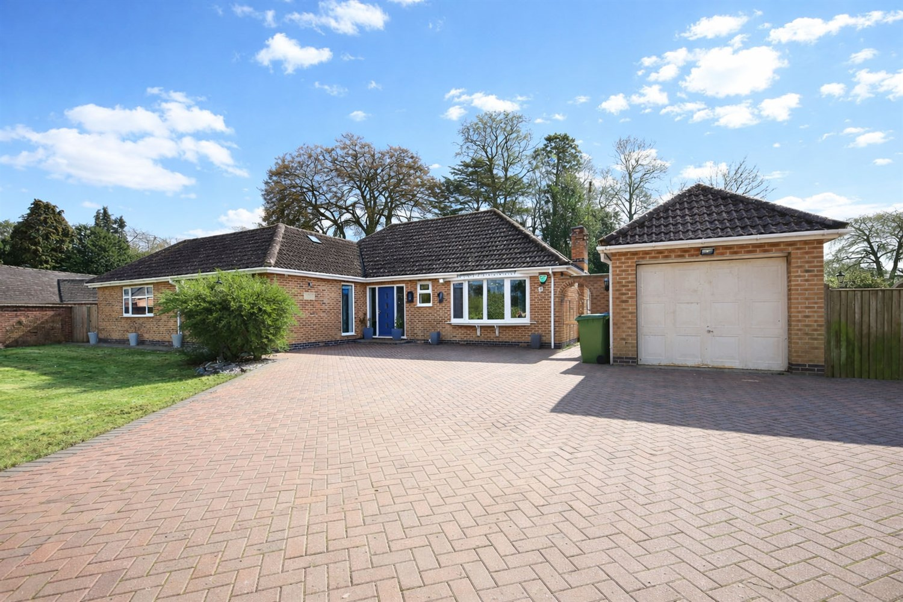




3 Bedroom(s)
3 Reception(s)
1 Bathroom(s)
£375,000.00
Garfits Lane, PE21
EPC Rating ‘’

- Spacious Three Bedroom Bungalow
- Ample off Road Parking & Garage
- Large Rear Garden With Patio & Pergola

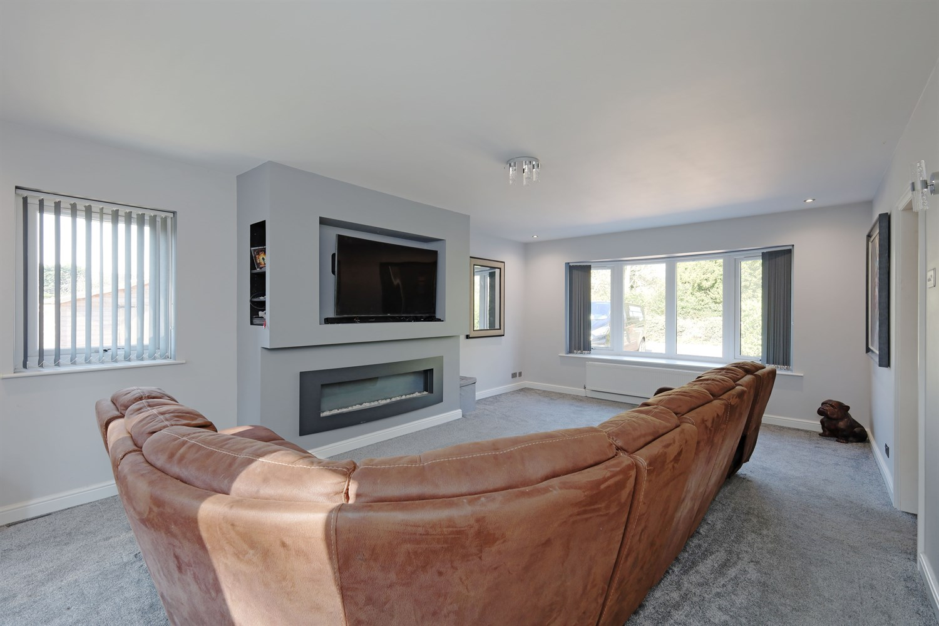
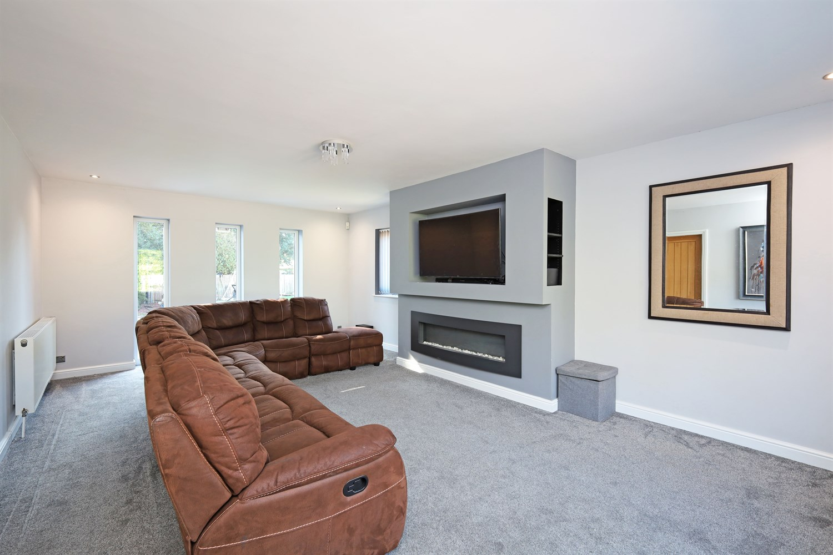
00
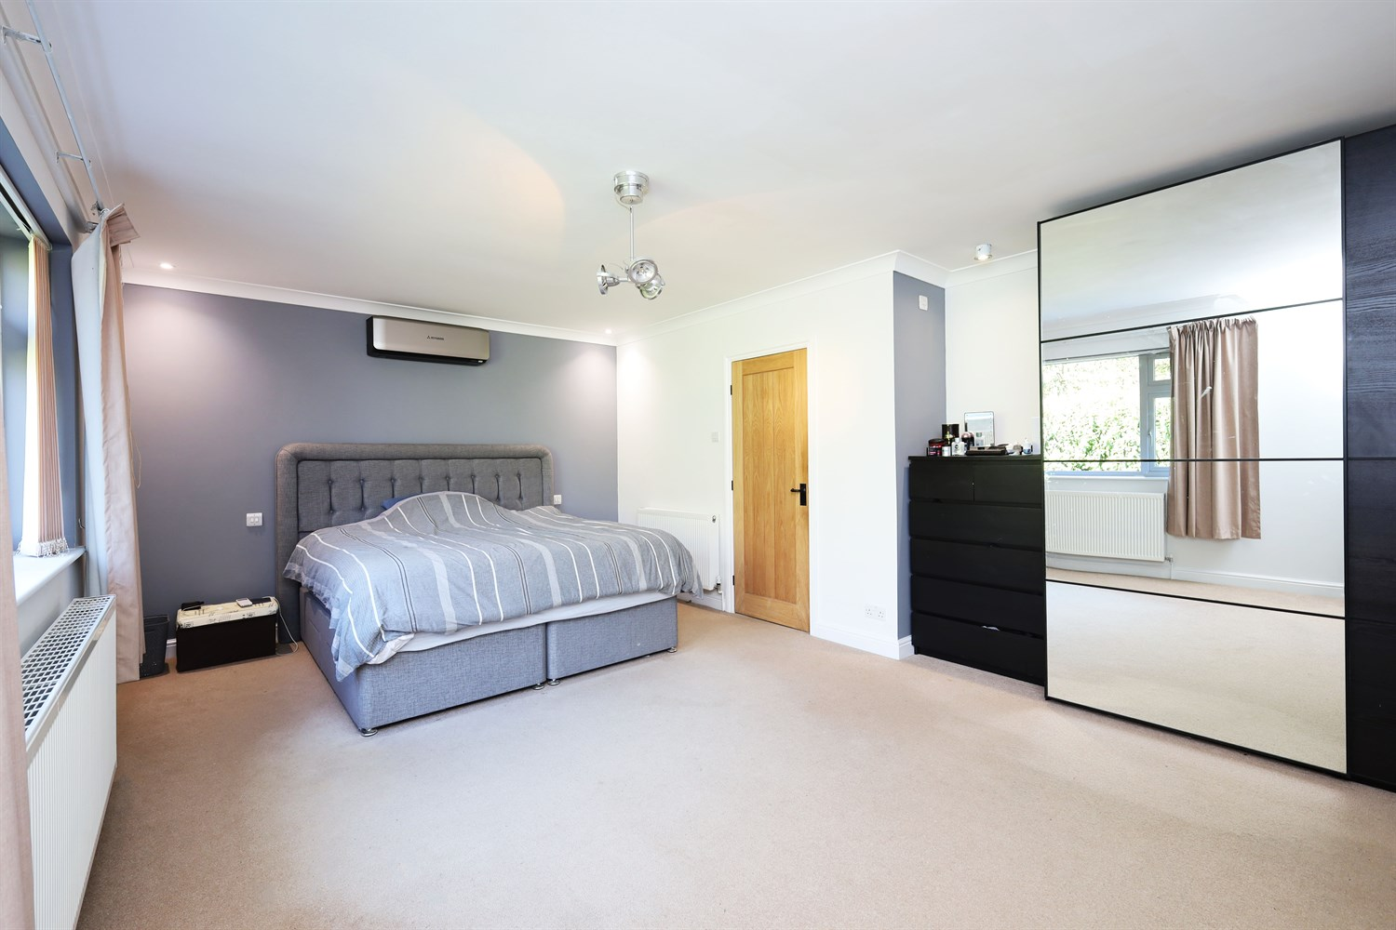
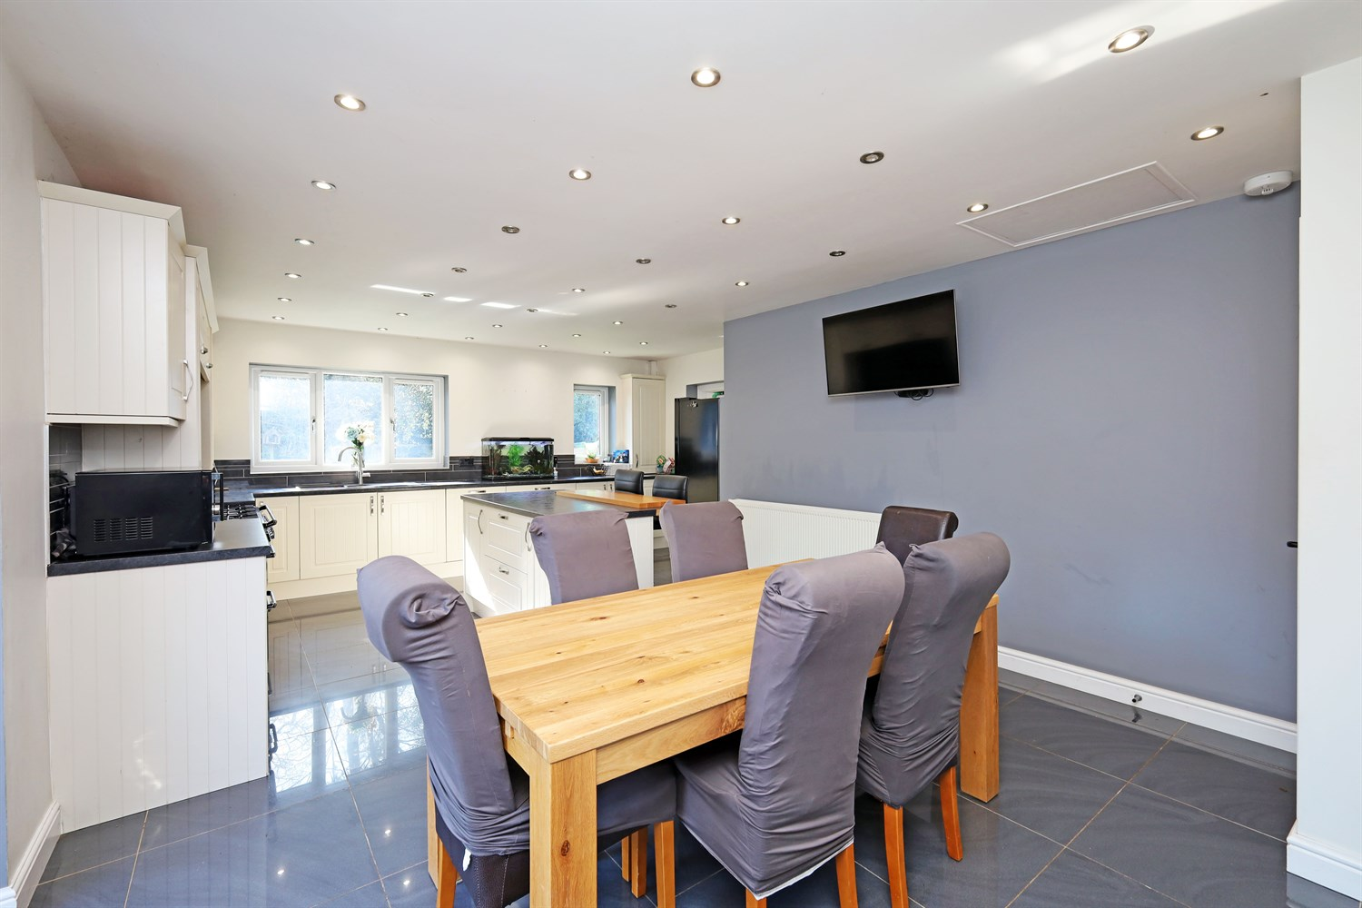
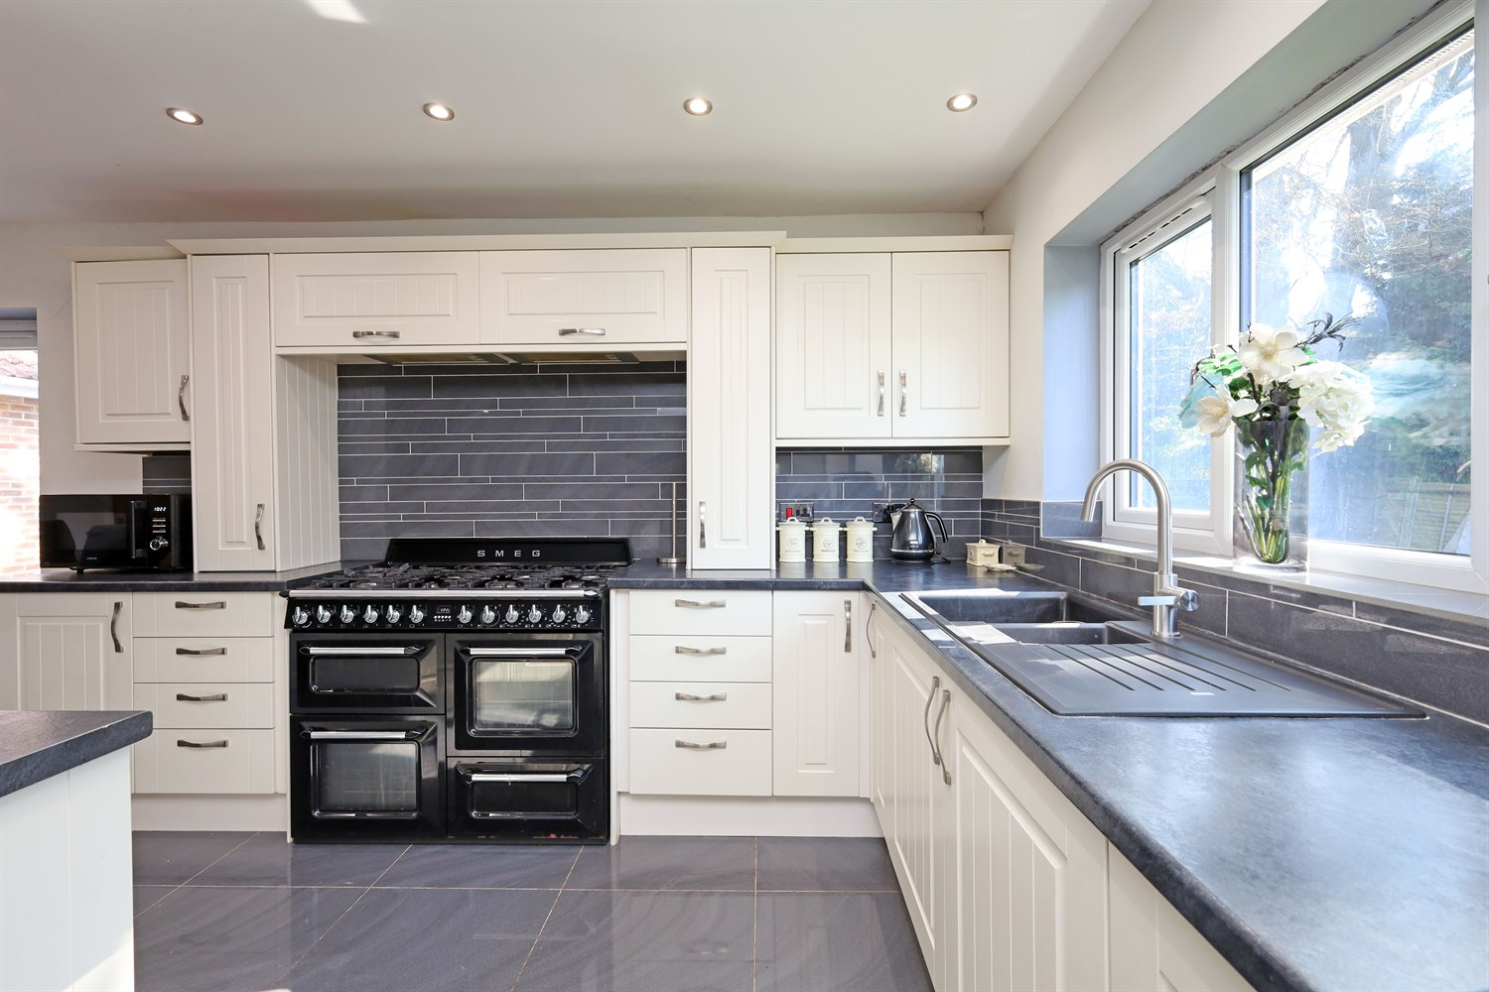
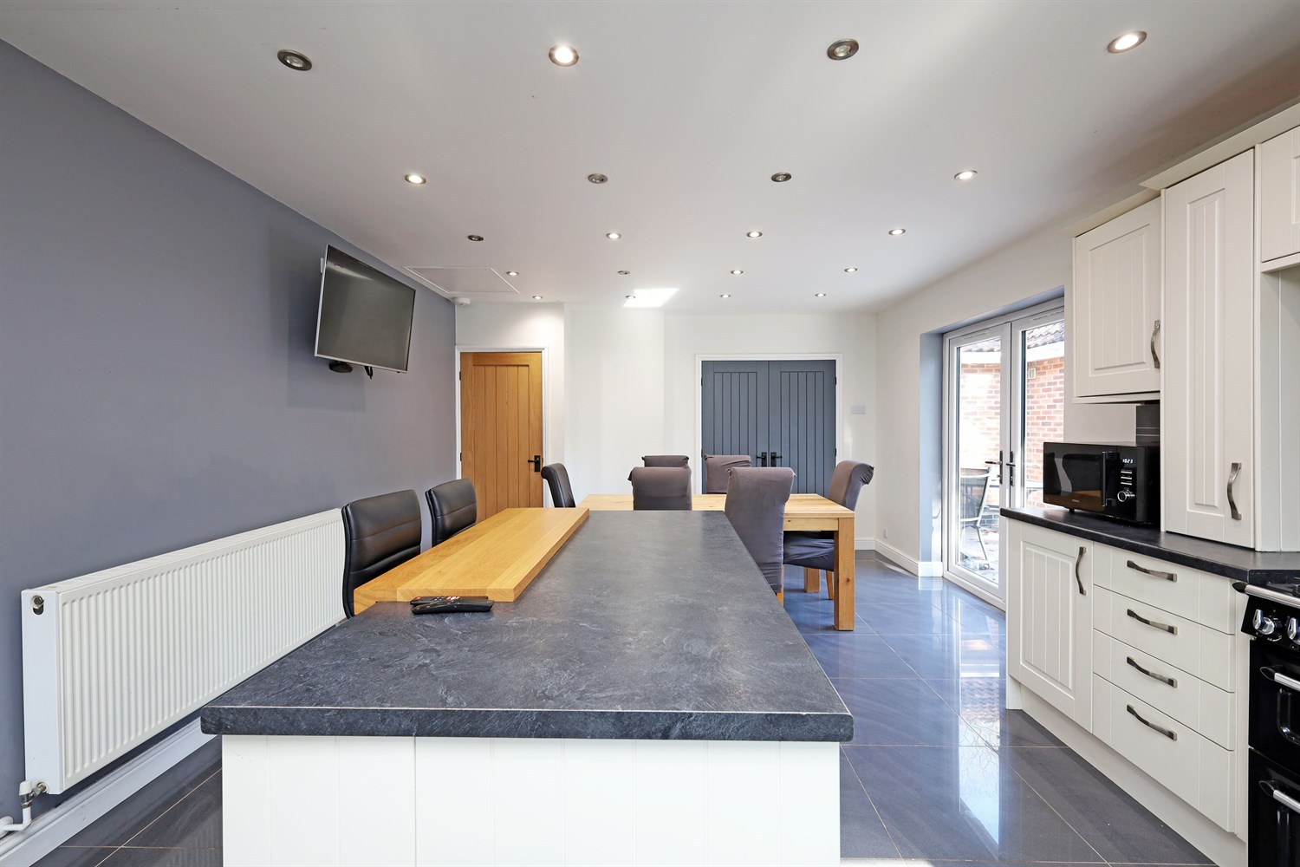
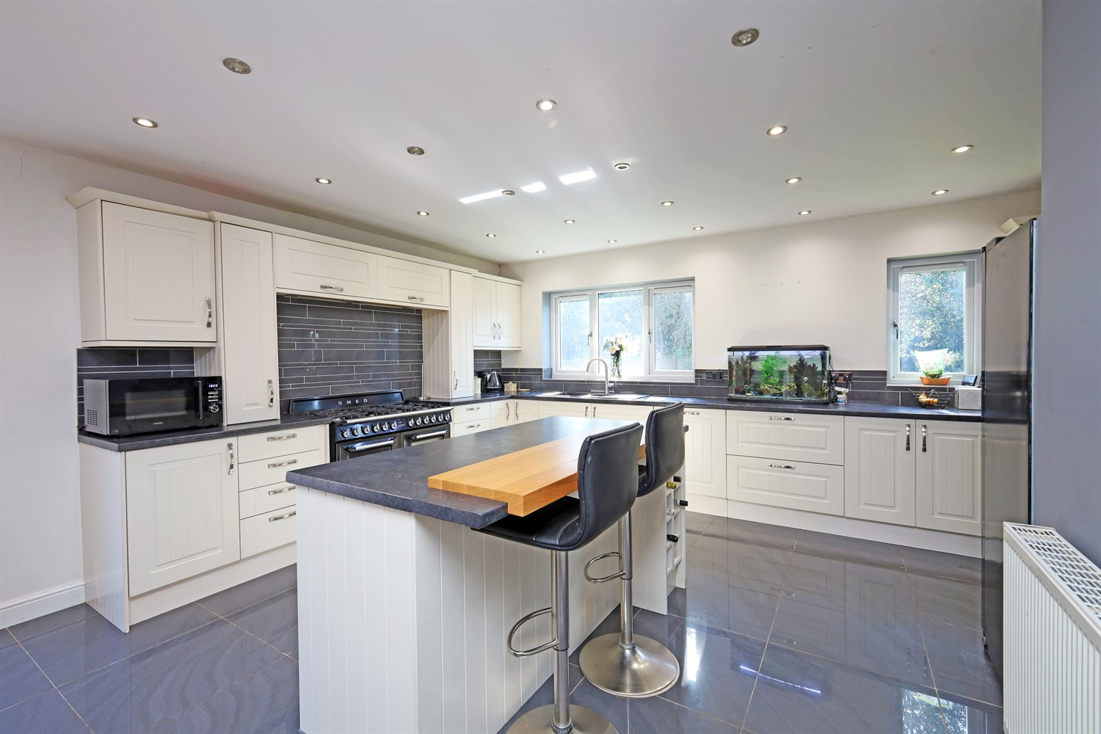
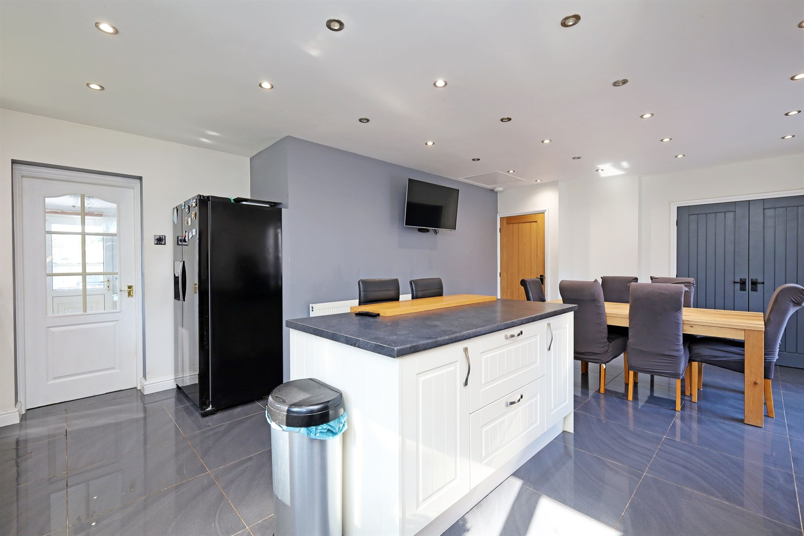
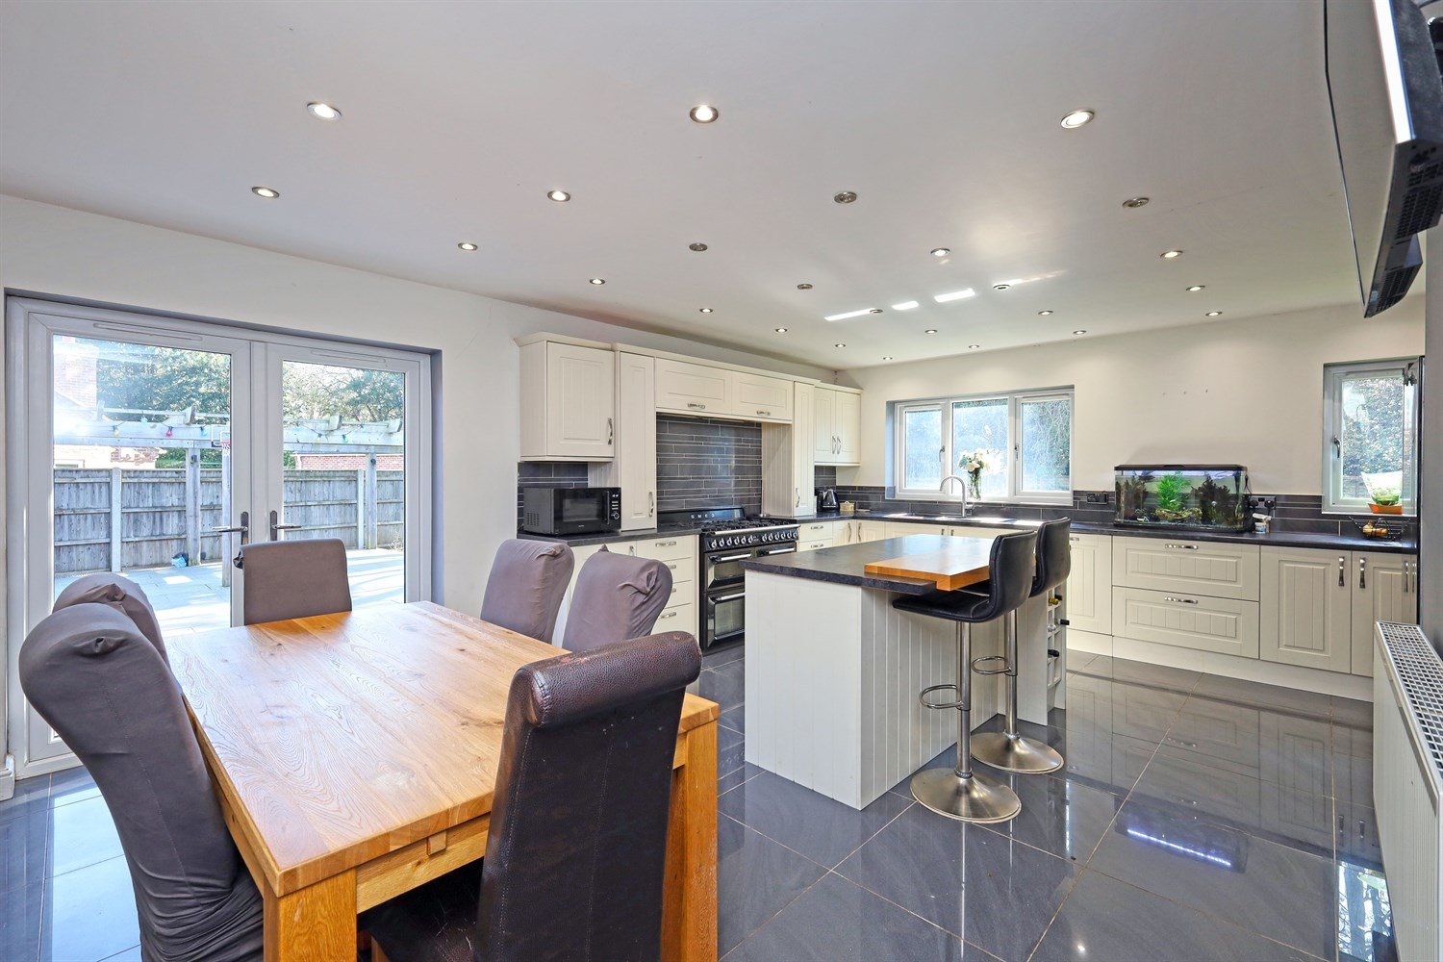
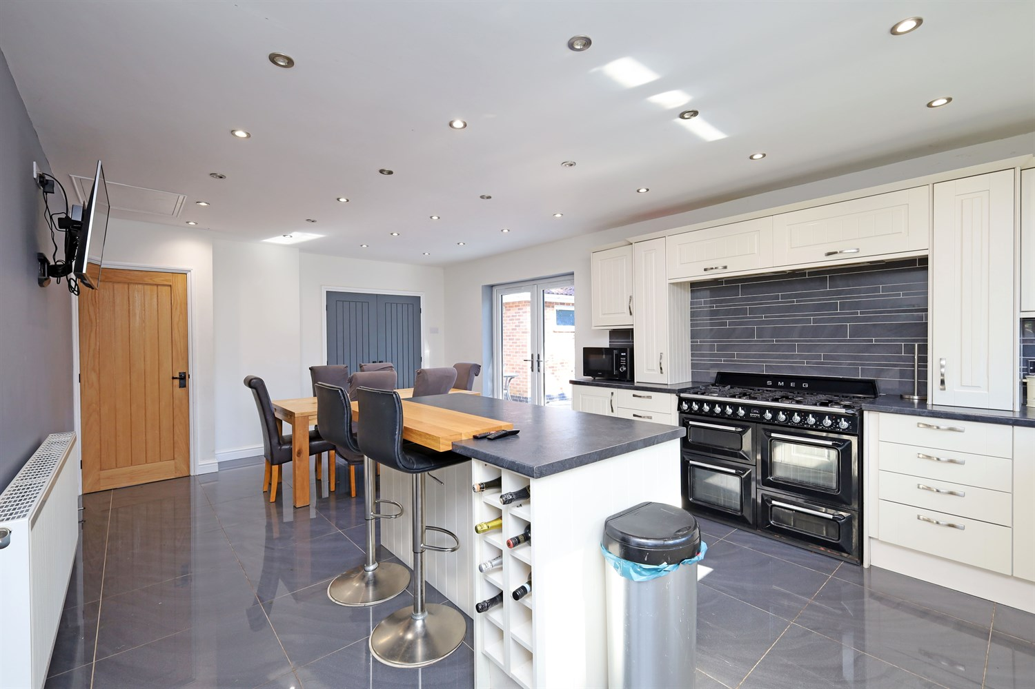

Property Description
Drury's Estate Agents would like to present this beautiful bungalow, situated in a desirable location, this well presented three bedroom bungalow offers spacious and versatile accommodation, ideal for a range of buyers.
The property welcomes you via a entrance hallway, leading to a beautifully presented and light filled living room, featuring a contemporary media wall with inset fireplace, creating a stylish focal point.
The heart of the home is the stunning kitchen/dining room, fitted with a range of modern units, contemplated by a central island and range style cooker. With ample space for dining and French doors opening directly onto the rear patio, this is a perfect space for both everyday living and entertaining.
The property offers three well-proportioned bedrooms, providing flexibility for family living, guest accommodation or home working. A useful utility room adds further practicality, with direct access to the rear garden.
The bathroom is currently undergoing renovation, presenting an excellent opportunity for buyers to complete the space to their own specification and add further value.
Externally, the property truly excels with a substantial rear garden, a rare feature for a bungalow. The garden offers a combination of patio, pergola seating area, artificial lawn and extensive further lawn space, ideal for families, pets and outdoor entertaining.
To the front, a large block paved driveaway provides ample off road parking for multiple vehicles and leads to a garage, completing this highly desirable home.

Front Aspect & Parking
The property is approached via a generous block paved driveway, providing ample off road parking for multiple vehicles. The frontage offers a neat and well maintained appearance, with areas of lawn and mature planting adding to the overall kerb appeal.
Further benefits include access to a garage, offering additional storage or parking, and a private setting set back from the road.

Entrance Hallway
A welcoming entrance hallway providing access to all principal rooms within the property. The space offers a practical layout, with a central corridor leading through to the bedrooms, enhancing the overall flow of the home. With natural light and a clean, neutral finish, this area creates a bright and inviting first impression upon entering the property.

Airing Cupboard / Hot Water System
A useful airing cupboard housing the hot water cylinder, providing practical storage space alongside the property's water system. Ideal for additional household storage.

Living Room
An impressive and generously sized living room, beautifully presented and filled with natural light from multiple windows, creating a bright and welcoming atmosphere. The space comfortably accommodates a large suite, making it ideal for both relaxing and entertaining. A standout feature of the room is the contemporary media wall with inset fireplace, adding a modern focal point to the space. Finished in neutral tones throughout, this stylish and spacious room is perfect for modern family living.

Kitchen/Dining Room
A beautifully presented and spacious kitchen/dining room, fitted with a comprehensive range of a modern wall and base units complemented by contrasting work surfaces. The kitchen features a central island providing additional workspace and storage, along with integrated wine storage, making it both practical and ideal for entertaining.
A standout feature is the range style cooker with feature splash back, creating focal point within the space. The room is finished with tiled flooring and benefits from ample natural light.
There is plenty of space for a family dining table, making this a superb social hub of the home, with French doors opening directly onto the rear patio and garden, seamlessly connecting indoor and outdoor living.

Bedroom 1
A generously proportioned principle bedroom offering a bright and dry airy feel throughout, with a large window allowing for an abundance of natural light. The room comfortably accommodates a king sized bed alongside additional furnishings, with ample floor space enhancing the sense of openness. Finished in neutral tones, this well presented room provides a calm and versatile space, ideal for relaxation.

En-Suite
Coming off from the 1st bedroom, a stylish and contemporary en suite. Fitted with a sleek walk in shower featuring a rainfall shower head and modern glass screen. Finished with high quality tiling throughout, the space also includes a low level WC, vanity wash hand basin with storage, and a heated towel rail. A frosted window provides natural light while maintaining privacy, completing this well appointed and modern space.

Bedroom 2
A well proportioned second bedroom, benefiting from a large window overlooking front garden, allowing for plenty of natural light. The room offers ample space for a bed and additional furnishings, making it ideal as a guest bedroom, home office or dressing room. Finished in neutral tones, this versatile space suits a variety of needs.

Bedroom 3
A well sized third bedroom, offering versatility to suit a range if uses including a guest bedroom, home office or additional living space. The room benefits from natural light via a window and provides space for a bed and freestanding furniture. Finished in neutral tones, this is a practical and adaptable room within the home.

Cloakroom/WC
Conveniently located within the property, this useful cloakroom is fitted with a low level WC and wash hand basin set within a vanity unit. A frosted window provides natural light while maintaining privacy, with the space offering practically for both residents and guests.

Bathroom (Currently under Renovation)
A spacious room currently undergoing renovation, offering an excellent opportunity for buyers to create a bespoke family bathroom to their own taste and specification. The space is well proportioned and already benefits from plumbing in place, providing strong potential for a modern suite including bath and separate shower if desired. A window allows natural light and ventilation, enhancing the overall appeal of the space once completed.

Utility Room
A practical and well proportioned utility room providing additional storage and workspace, fitted with base units and work surfaces. The room offers space for white goods and benefits from a door providing direct access to the rear garden, adding convenience for day to day living. An ideal area for laundry and household tasks, keeping the main living spaces clutter free.

Rear Garden
A truly impressive and exceptionally generous rear garden, offering a fantastic outdoor space rarely found with bungalows. The garden is predominantly laid to lawn, with substantial section of artificial grass as a 4g football pitch, providing a low maintenance and all weather area ideal for families, pets and year round use.
A spacious patio area sits directly to the rear of the property, perfect for outdoor dining and entertaining, complemented by a pergola creating dedicated seating space. The garden extends significantly beyond, offering a vast lawned area with excellent versatility for a range of uses.
Further benefits include a detached outbuilding/shed for storage, enclosed boundaries for privacy, and gates side access.

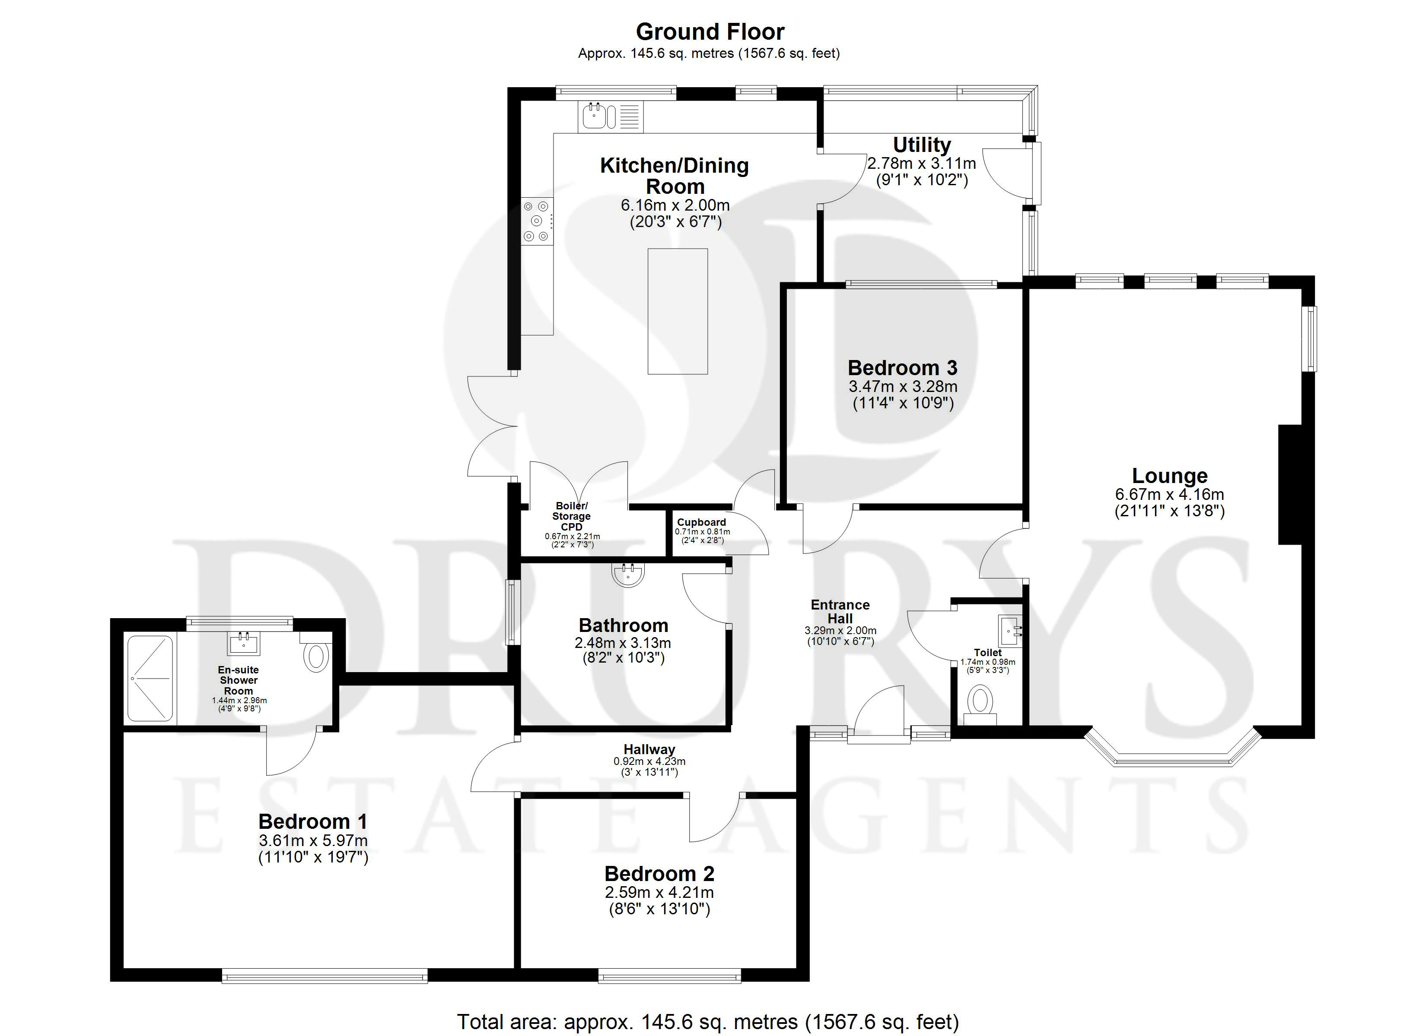

These particulars are intended to give a fair description of the property, but their accuracy cannot be guaranteed, and they do not constitute an offer of contract. Intending purchasers must rely on their own inspection of the property. None of the above appliances/services have been tested by ourselves. We recommend purchasers arrange for a qualified person to check all appliances/services before legal commitment.

Property Ref: 3418

www.drurysestateagents.co.uk
amber@drurysestateagents.co.uk
01205 350889

45 Willoughby Road
Boston
Lincolnshire
PE21 9HN
Agents Note: Whilst every care has been taken to prepare these sales particulars, they are for guidance purposes only. All measurements are approximate are for general guidance purposes only and whilst every care has been taken to ensure their accuracy, they should not be relied upon and potential buyers are advised to recheck the measurements

