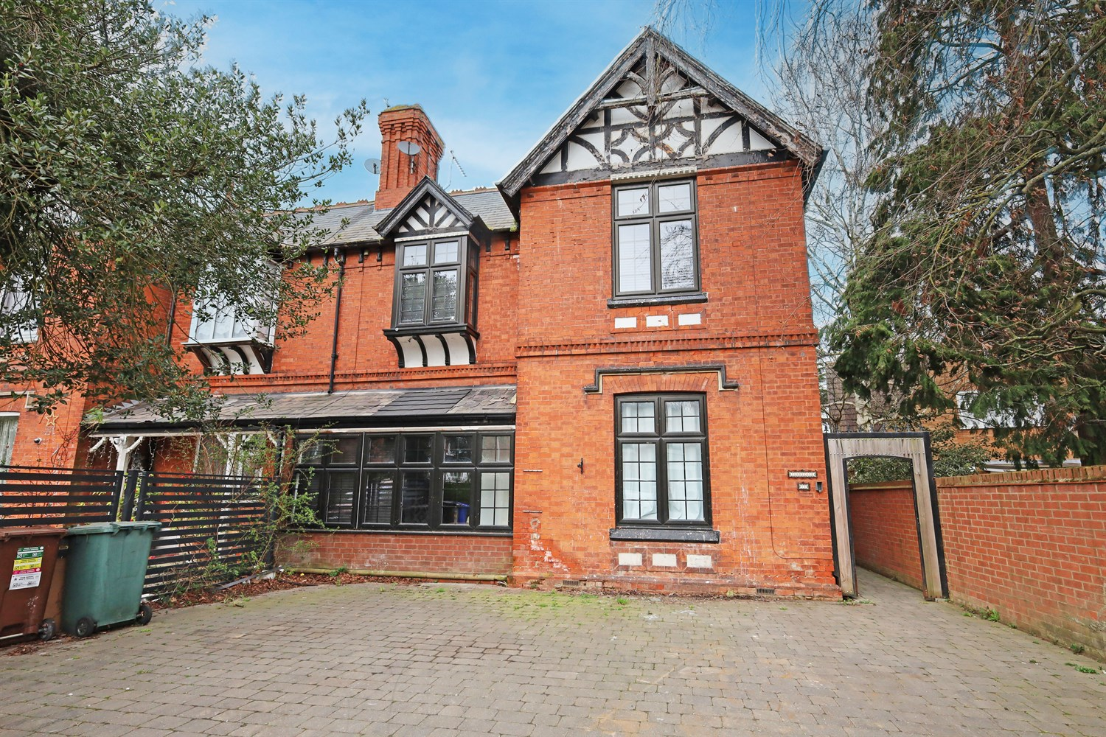




3 Bedroom(s)
2 Reception(s)
1 Bathroom(s)
£329,950.00
Sleaford Road, PE21
EPC Rating ‘’

- Open Plan Kitchen/Diner/Games Room
- 3 Reception Rooms
- Large Driveway & Garden
- Close to town

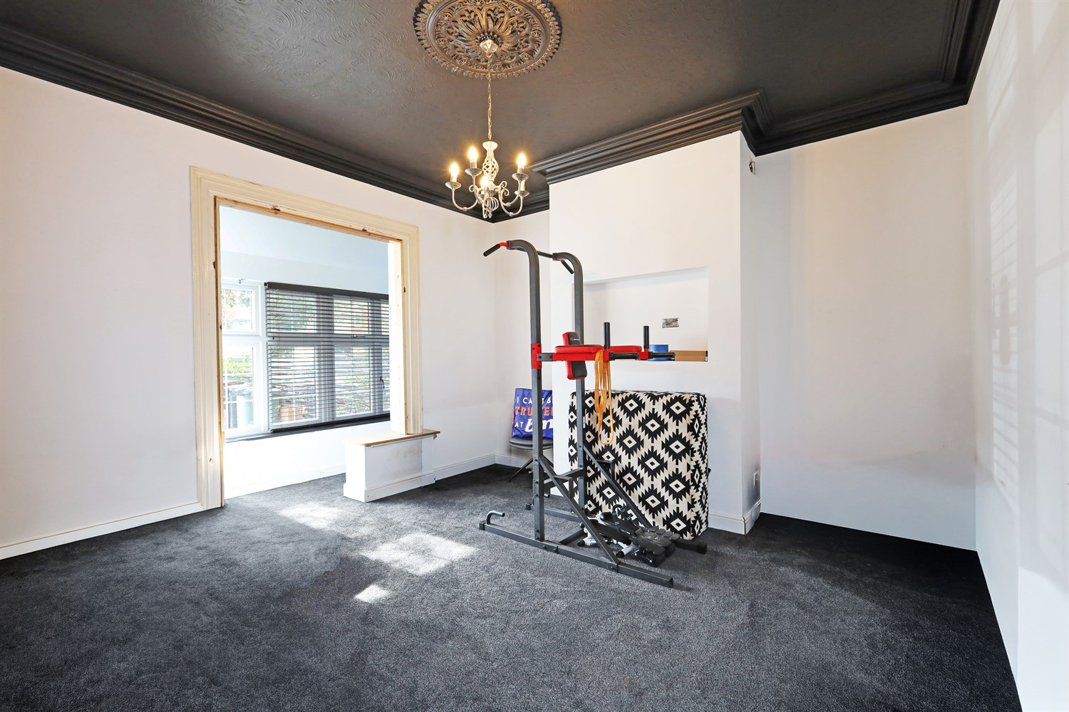
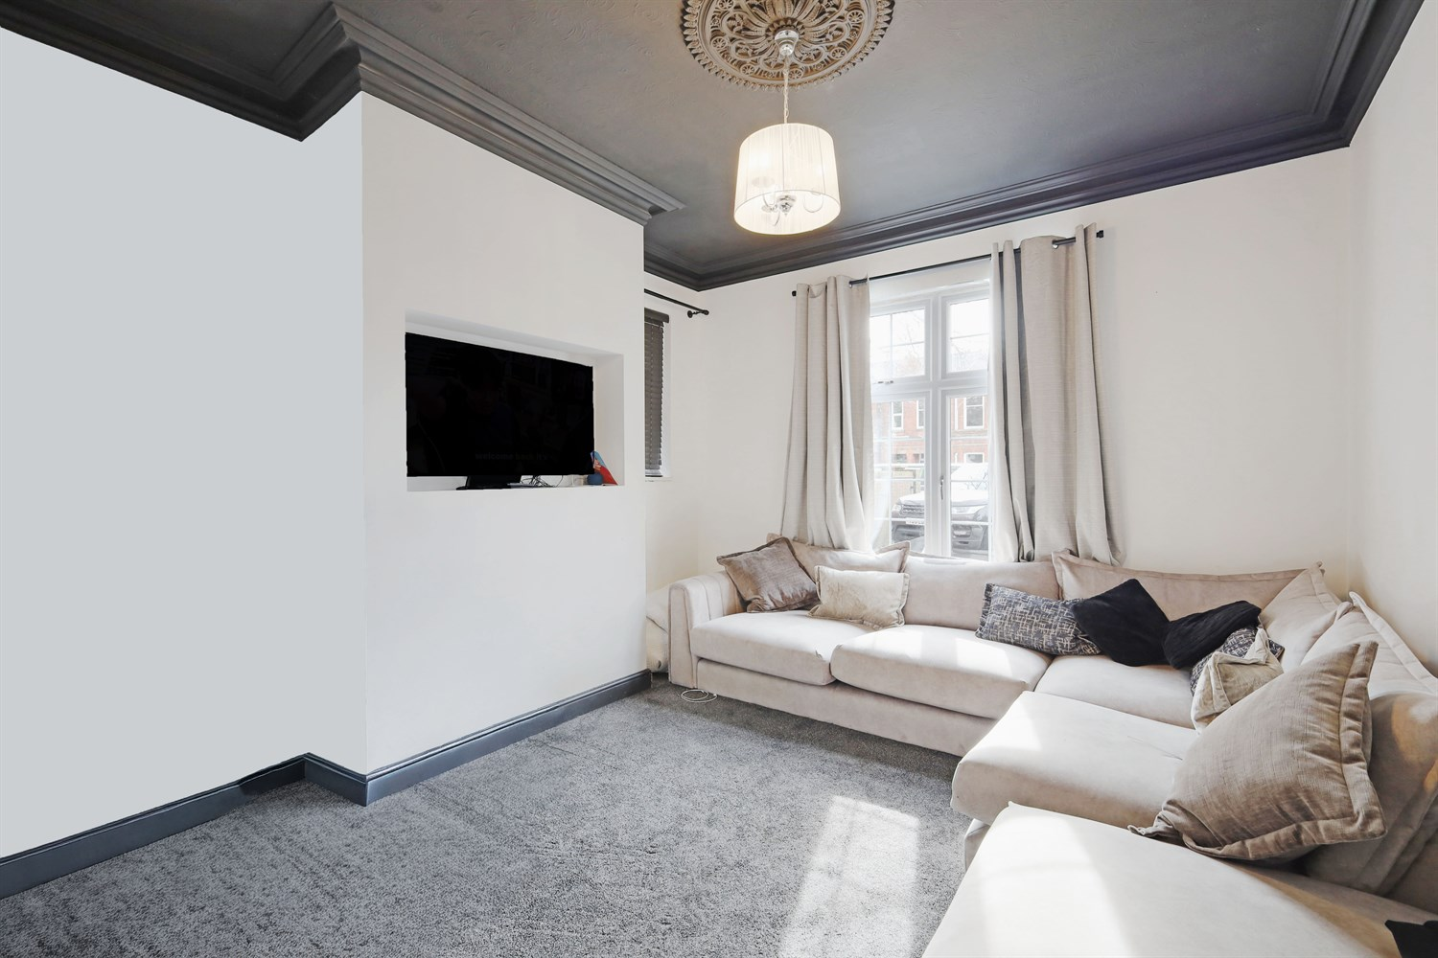
00
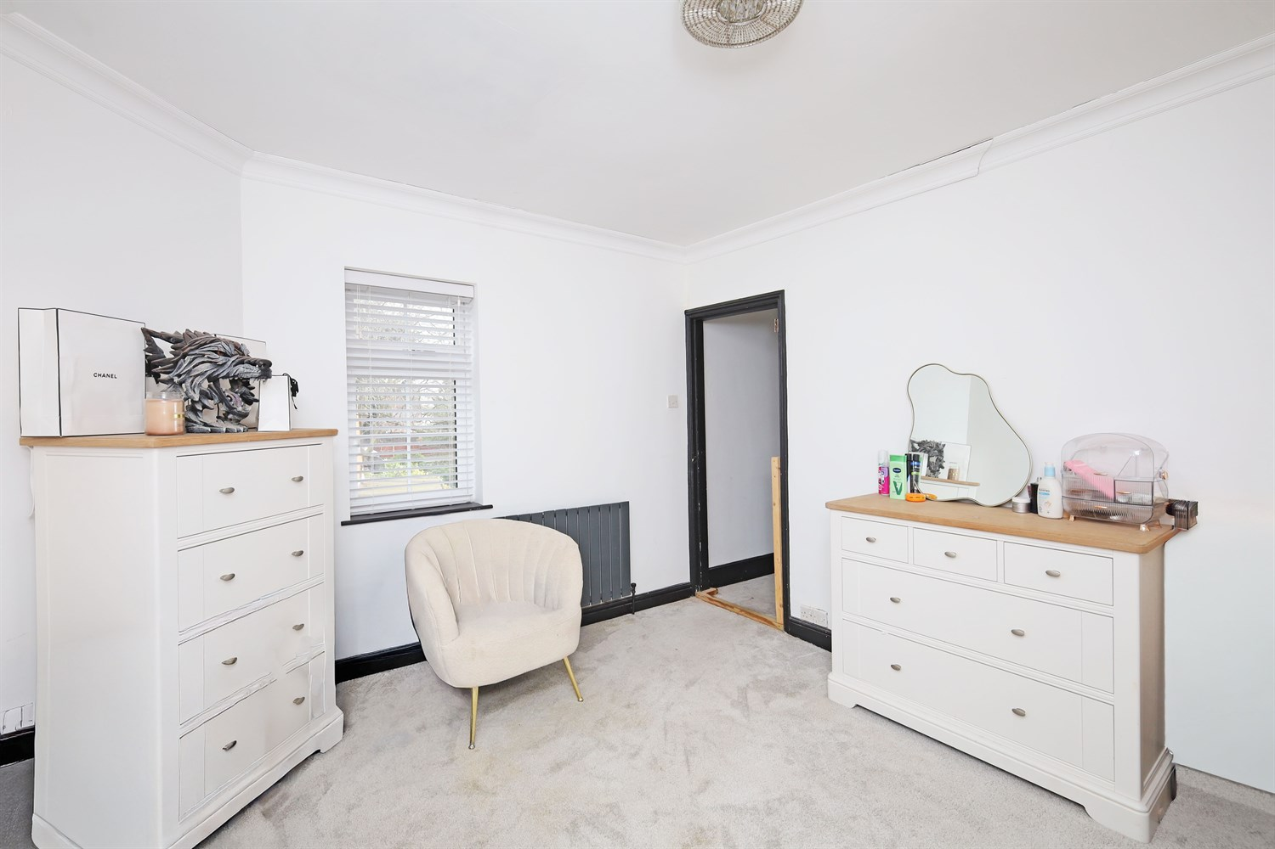
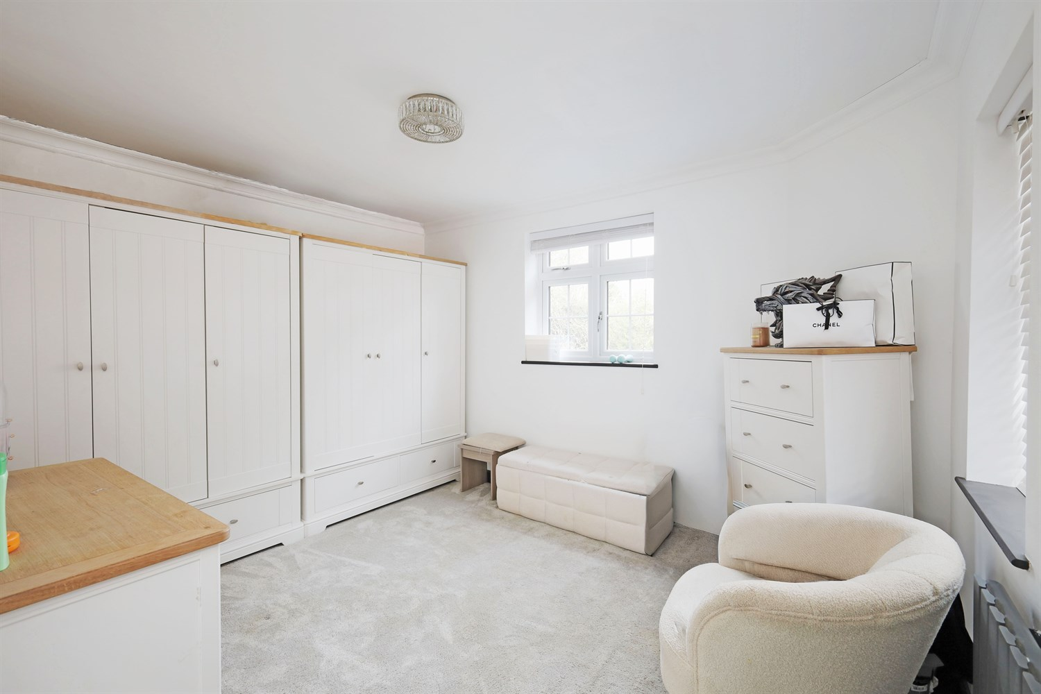
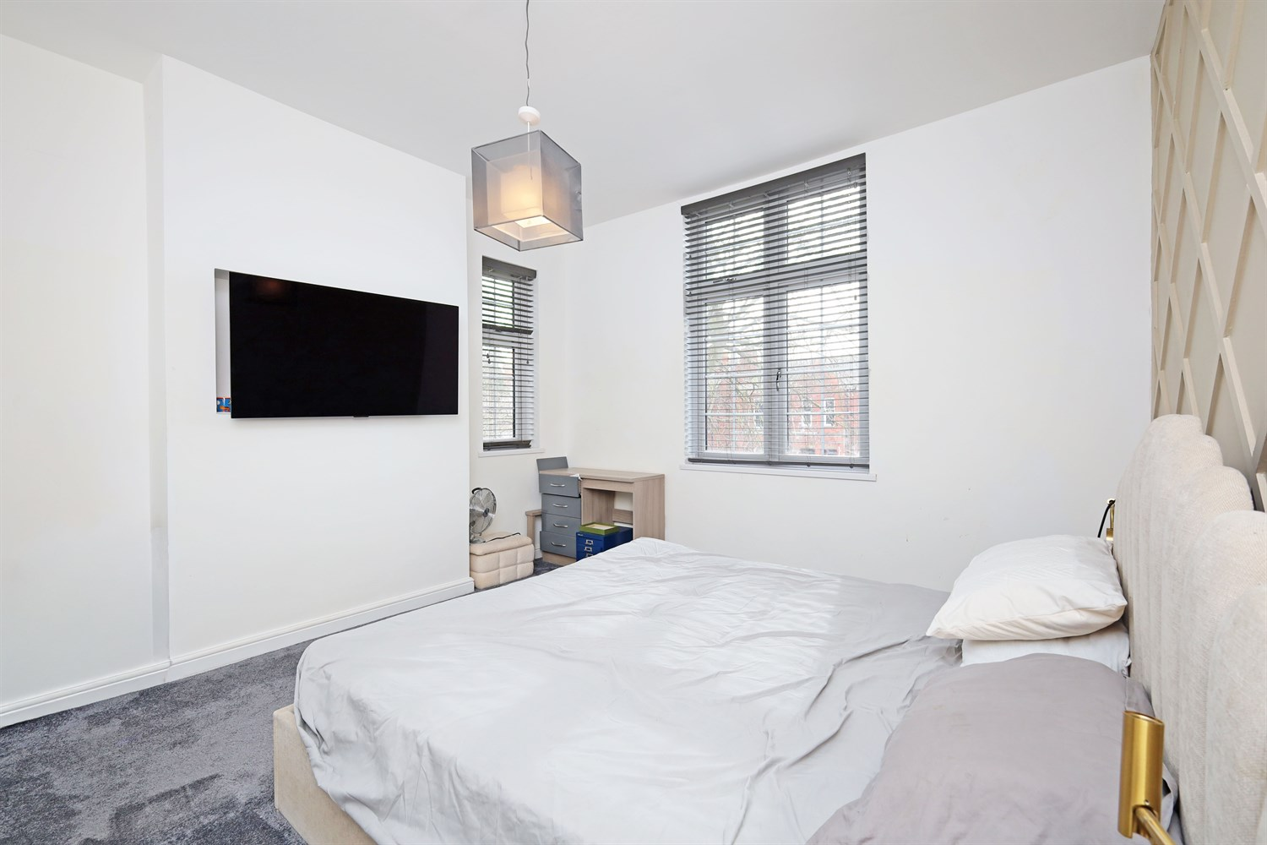
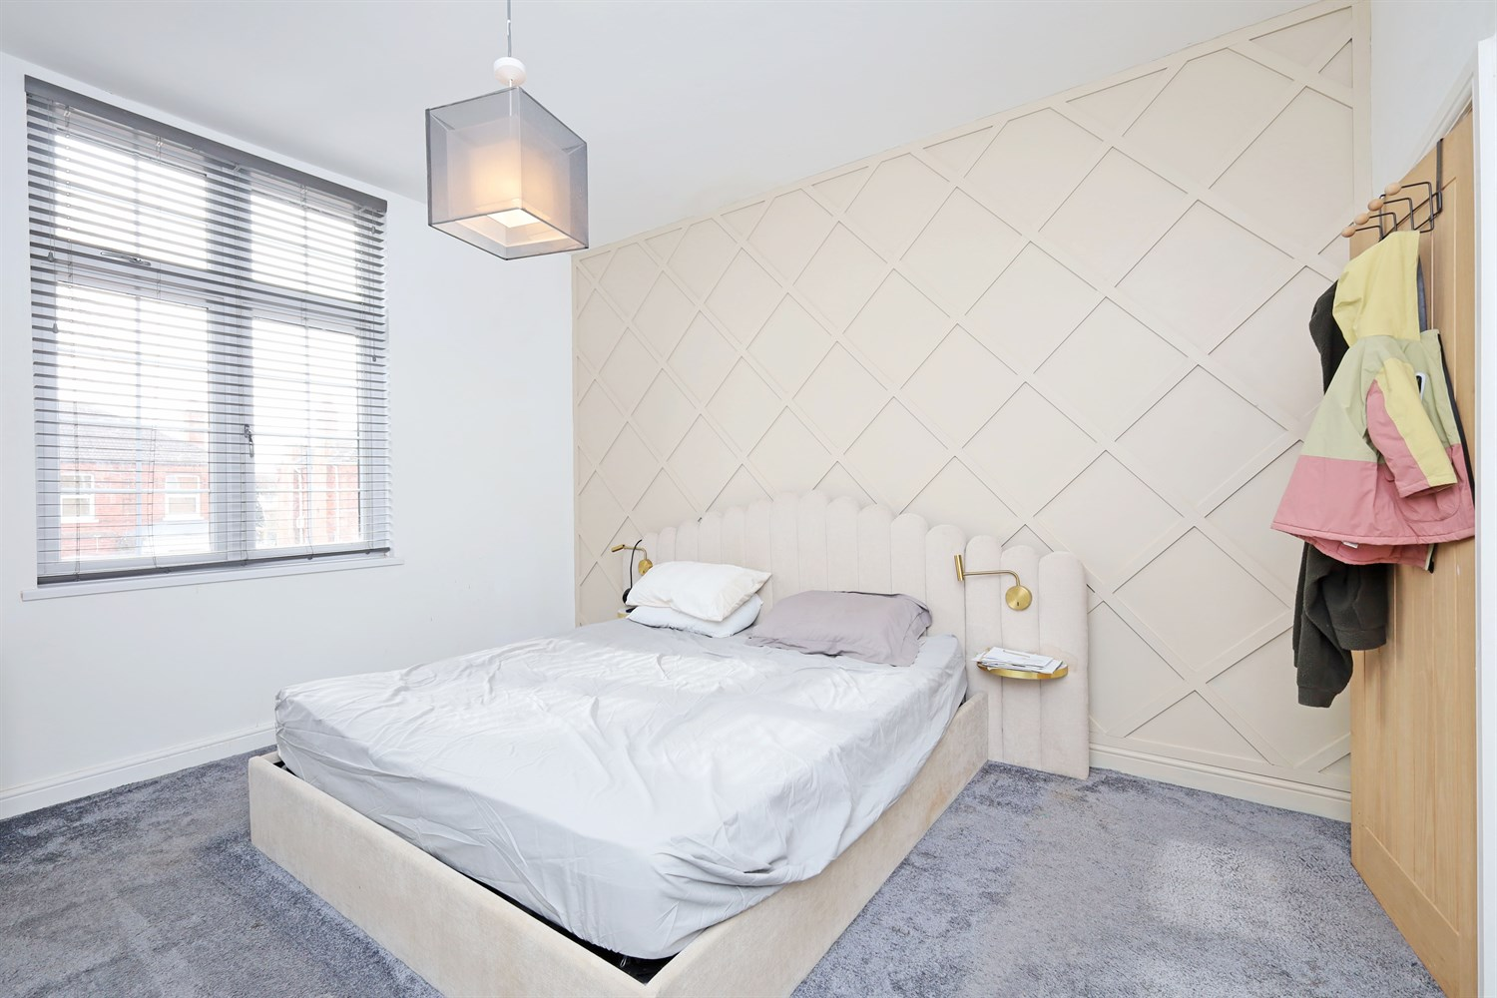
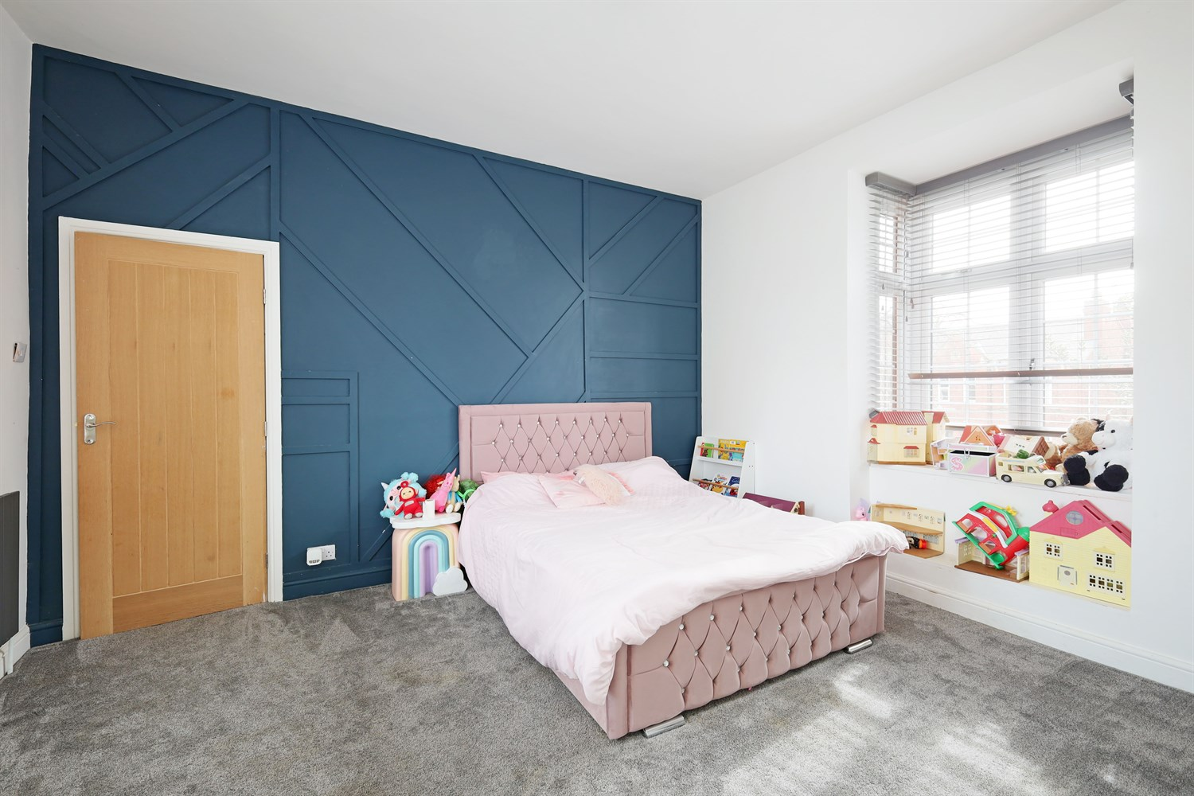
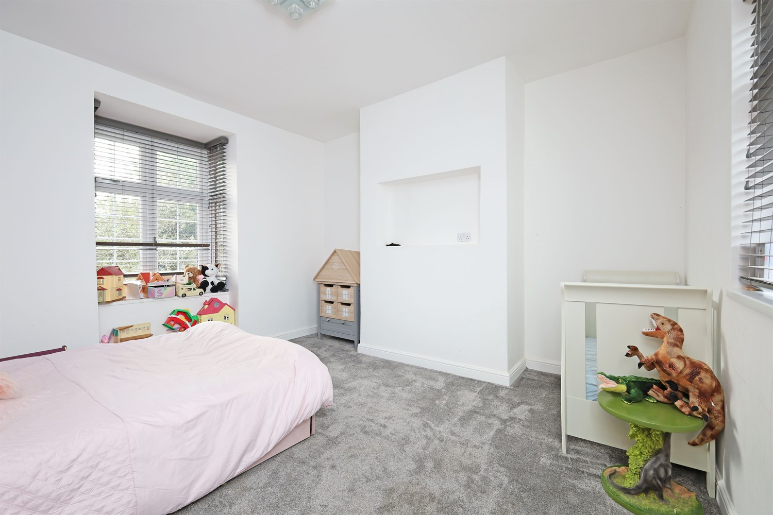
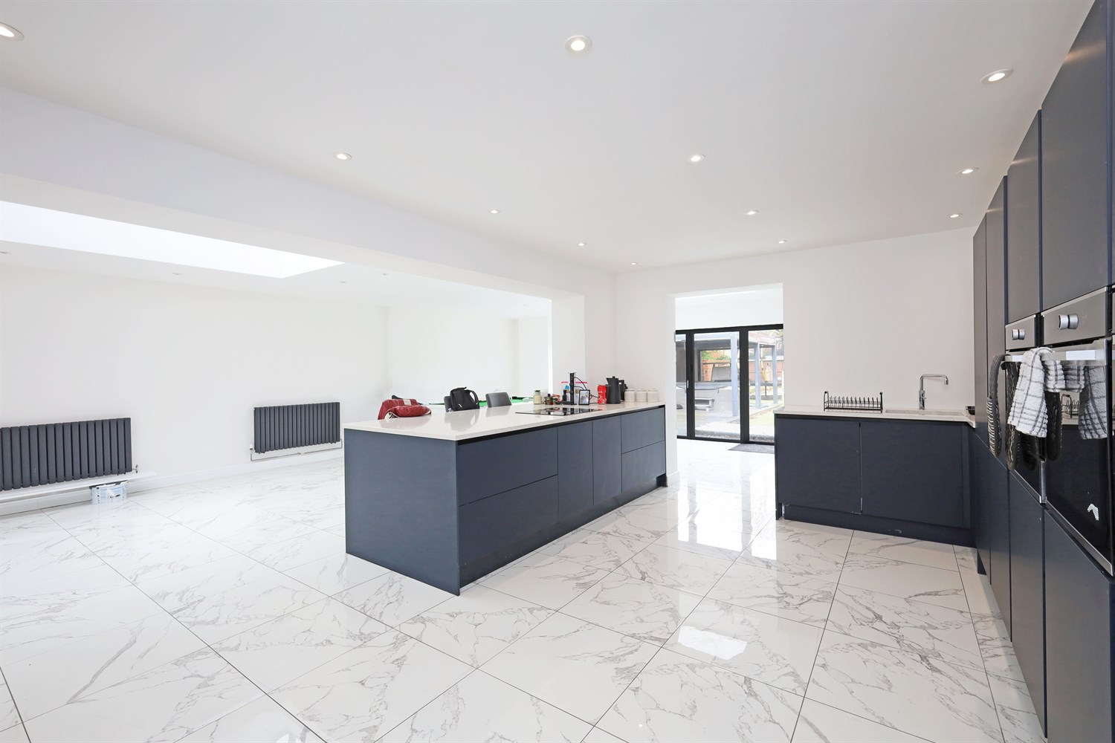
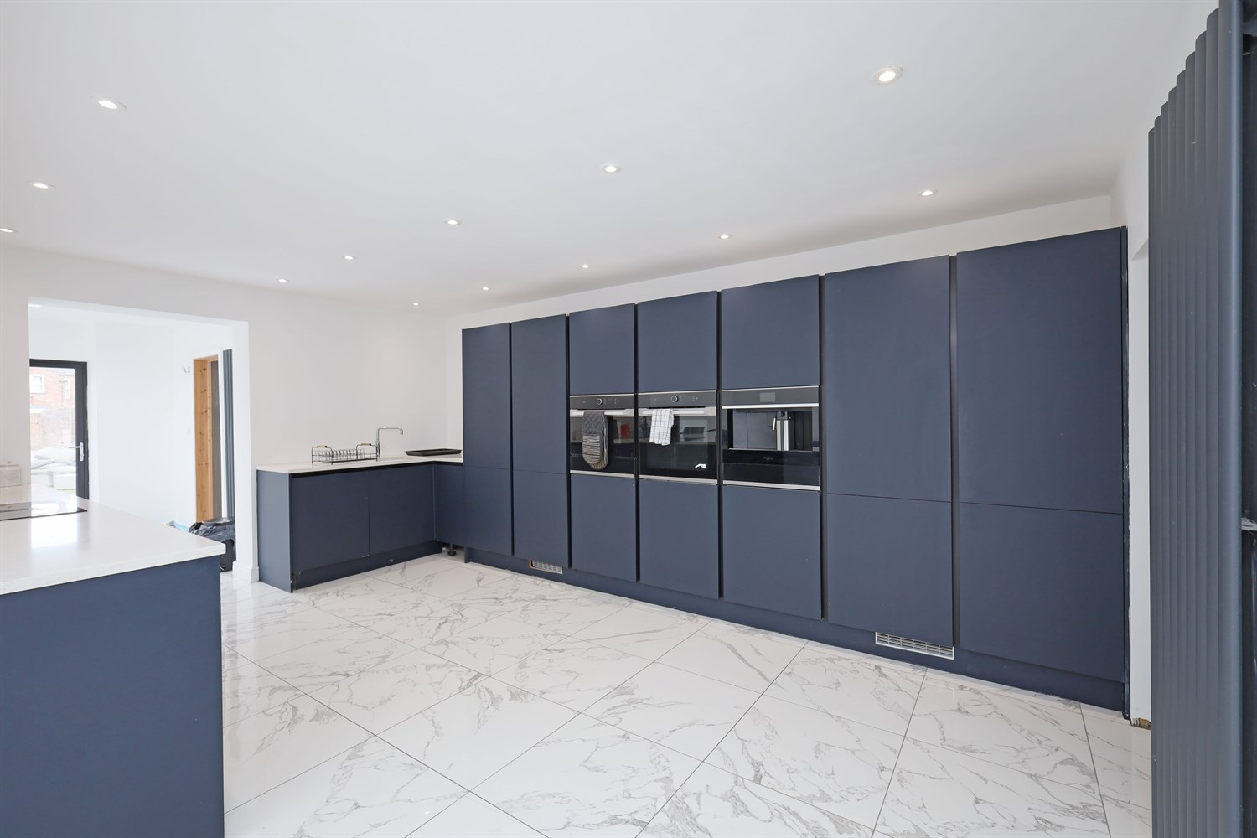

Property Description
Absolutely stunning unique 3 bedroom semi detached property in a sort after location. Offering a modern a hallway, lounge, sitting room, large open plan kitchen, dining room and games room, 3 double bedrooms and bathroom with garden to the rear, huge block paved driveway and all within close proximity to town and all the major routes through Boston.

Hallway
This very grand looking hallway is entered through a door at the side giving access to all ground floor rooms and the stairs up to the first floor.

Lounge
Having a window to the front aspect, modern wall hung radiator providing plenty of light and home comforts.

Reception 2/ Sun Room
Having a long window to the front providing lots of light, this additional sitting room is ideal for a relaxing space or home office.

Kitchen/Diner/Games Room
Wow an absolutely stunning space! The owner has created a wonderful open plan living space with ample room for cooking, dining and relaxing, with rear aspect views to the garden via the bi-fold doors and large window. The kitchen comprises an extensive range modern blue concealed units to floor and ceiling height, housing a tall fridge freezer, double oven and microwave, an abundance of cupboards and shelving creating an abundance of storage for many creative dishes. There's also an island unit to the base level with marble work surfaces, having an inset ceramic hob with and units to either side concealed in the worktop. In addition there is also an integral dishwasher, having an inset sink with mixer taps and breakfast bar. Inset ceiling lights, tiled marble flooring and vertical grey radiator. The kitchen extends into a seating area in front of the bi-folds doors and further more into the dining area large enough for a family dining table with additional radiator and the window looking out into the garden. This area also has a concealed laundry area with plumbing for a washing machine and electric for a tumble dryer. Once again this space has been created for a games room, entertaining area and dining area.

Bedroom 1
A great master bedroom with panelling, modern radiator and a large bay window to the front aspect and a window to the rear.

Bedroom 2
Another great sized double room with small window to the side, large window to the front aspect and insets for a TV.

Bedroom 3
A great sized double room with window to the side and rear aspect with radiator, inset for a tv, this really is a lovely light room from the natural light.

Bathroom
This amazing family bathroom had a double walk in shower, modern bath with mixer taps and shower hose.

Garden
This great outdoor space is low maintenance with paving, a hot tub, garden room, decking a great sized out door space.

Driveway
Driveway blocked paved with ample parking for multiple cars.

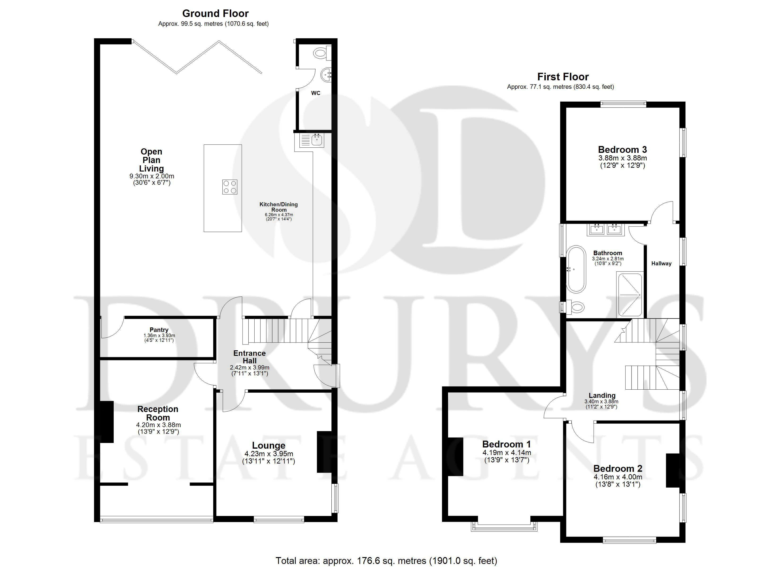

These particulars are intended to give a fair description of the property, but their accuracy cannot be guaranteed, and they do not constitute an offer of contract. Intending purchasers must rely on their own inspection of the property. None of the above appliances/services have been tested by ourselves. We recommend purchasers arrange for a qualified person to check all appliances/services before legal commitment.

Property Ref: 1340

www.drurysestateagents.co.uk
amber@drurysestateagents.co.uk
01205 350889

45 Willoughby Road
Boston
Lincolnshire
PE21 9HN
Agents Note: Whilst every care has been taken to prepare these sales particulars, they are for guidance purposes only. All measurements are approximate are for general guidance purposes only and whilst every care has been taken to ensure their accuracy, they should not be relied upon and potential buyers are advised to recheck the measurements

