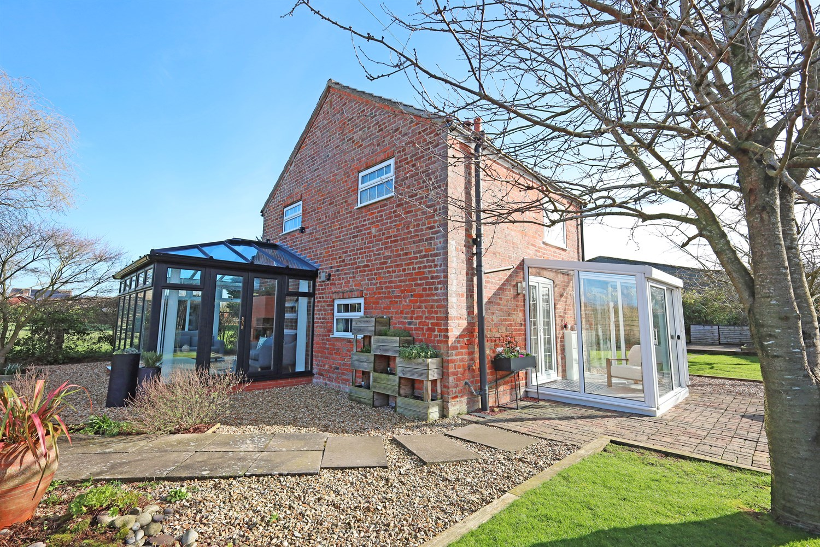




2 Bedroom(s)
2 Reception(s)
1 Bathroom(s)
£279,950.00
Keal Bank, PE22
EPC Rating ‘’

- Beautiful Landscaped Gardens
- Modernised 2 Bed Cottage
- Peaceful Location
- No Onward Chain

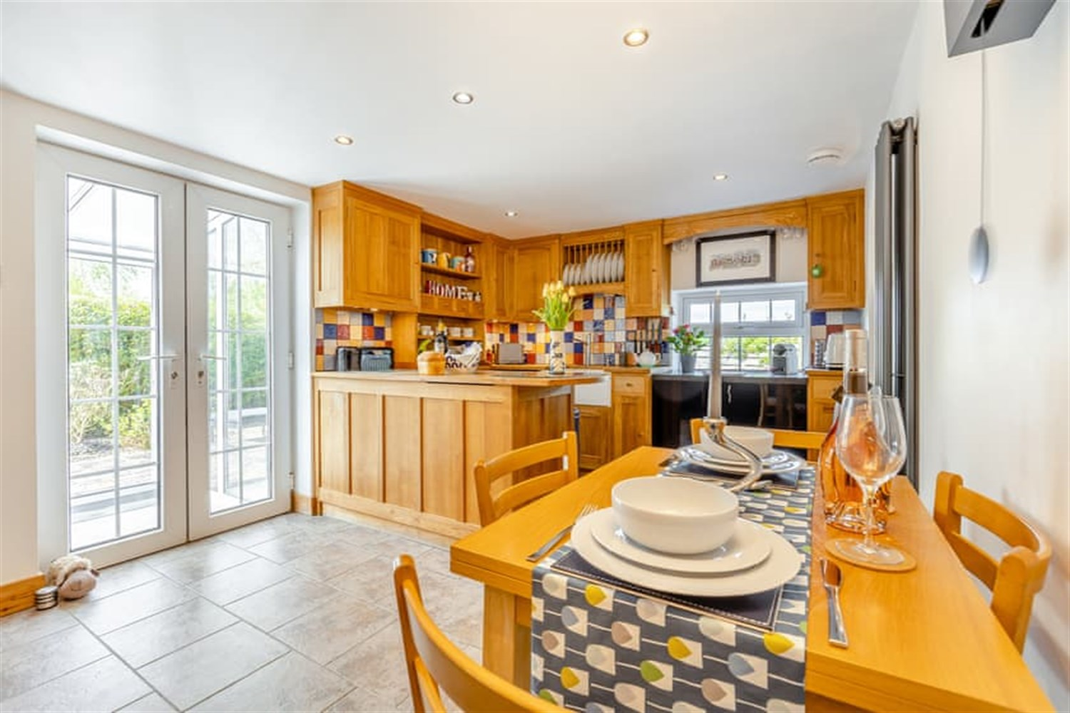
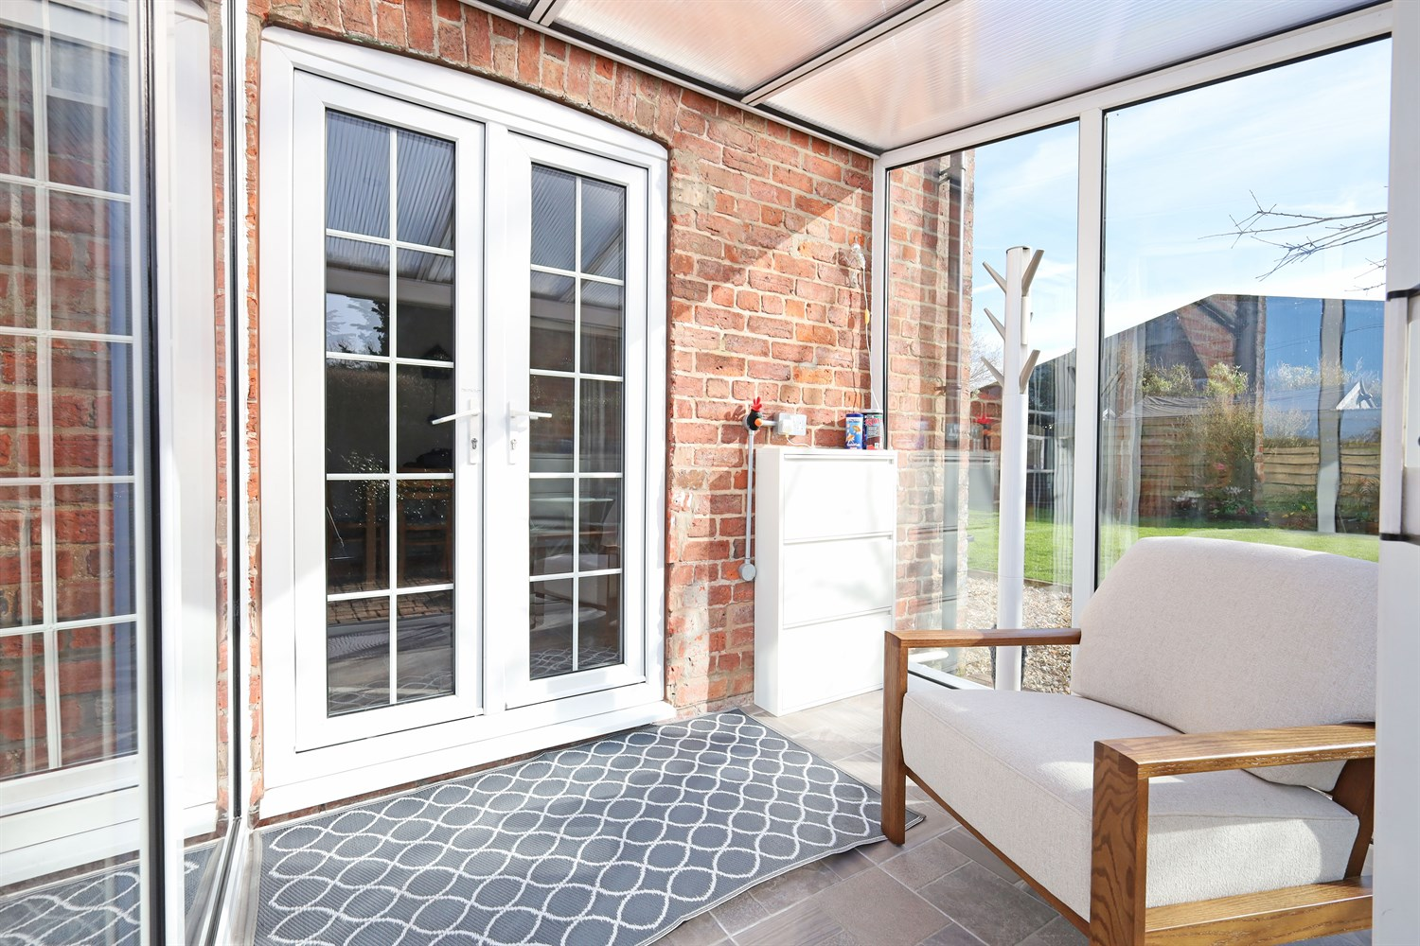
00
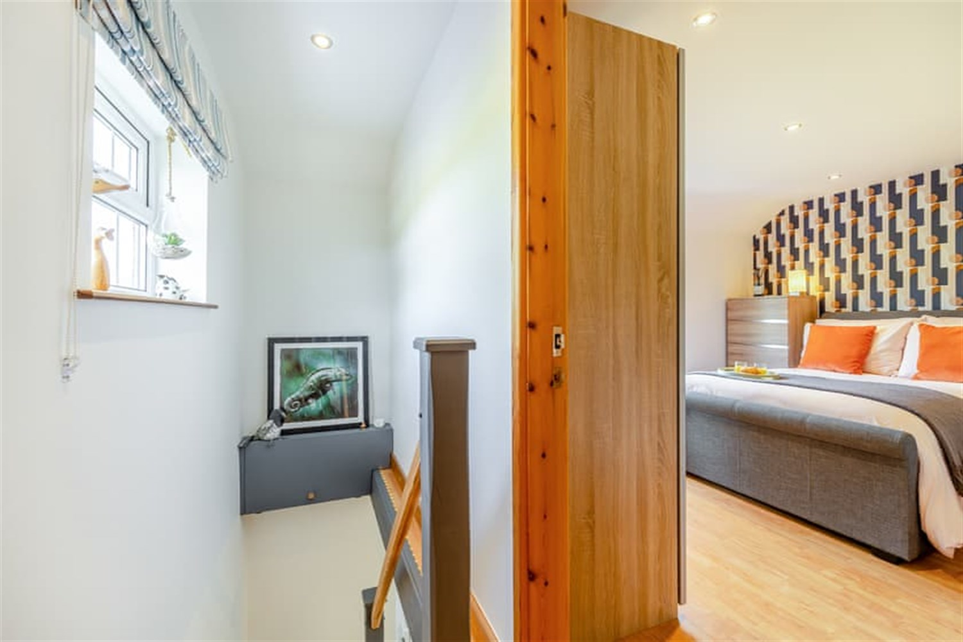
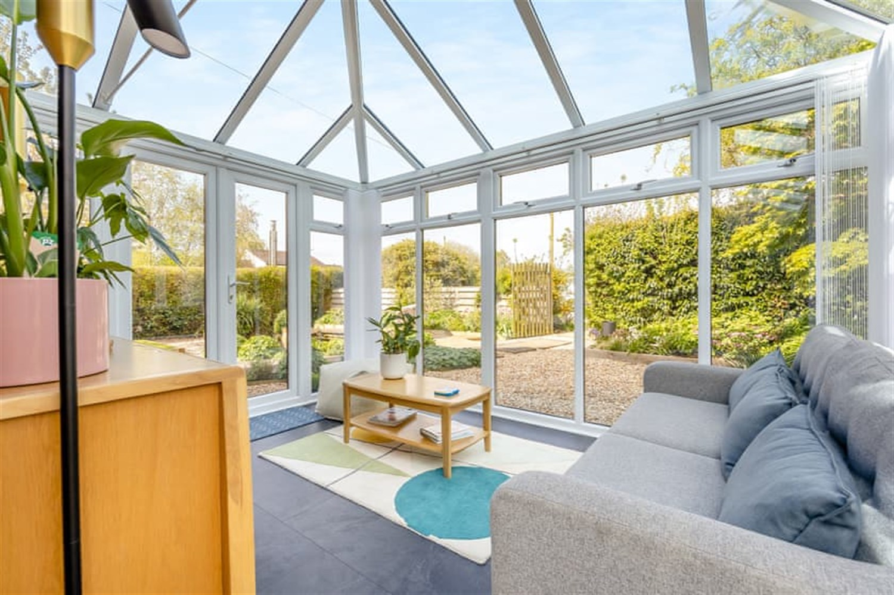
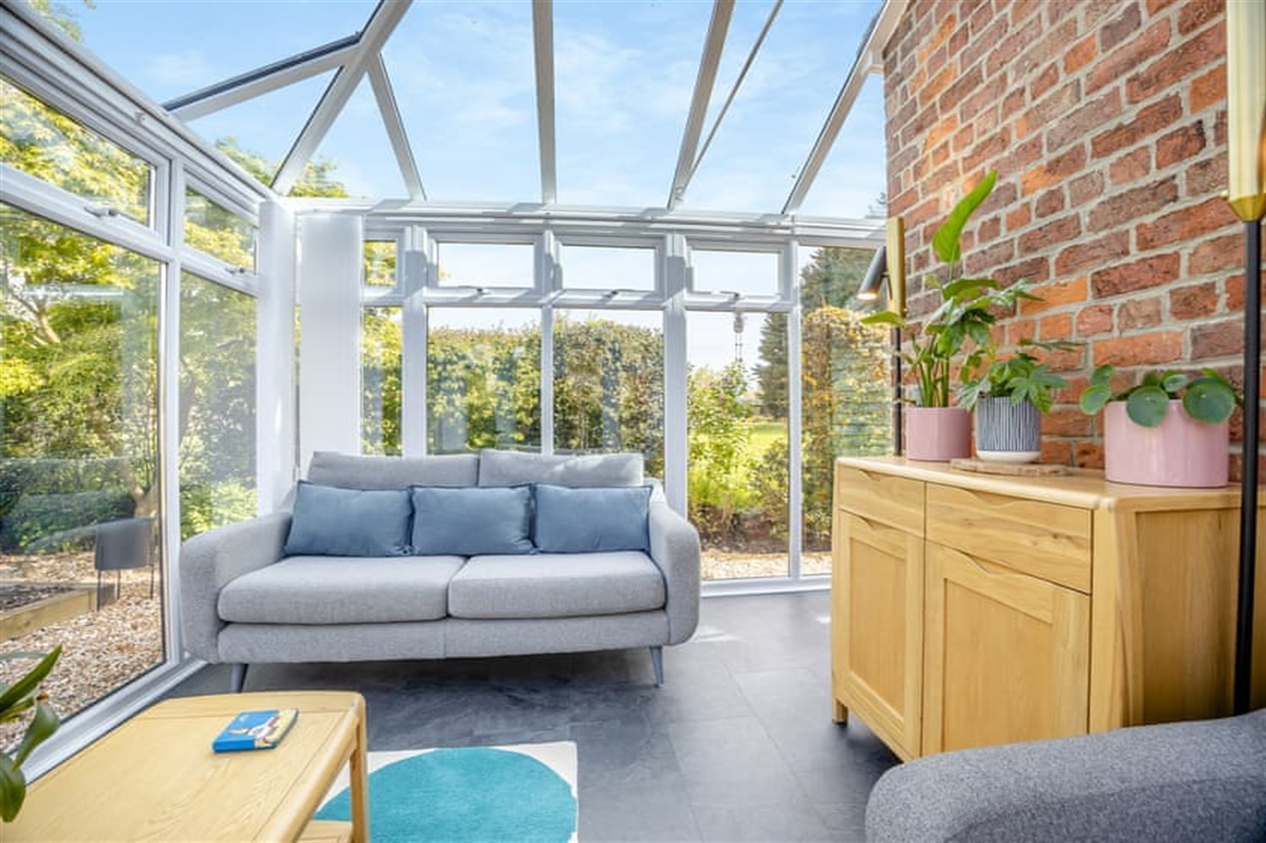
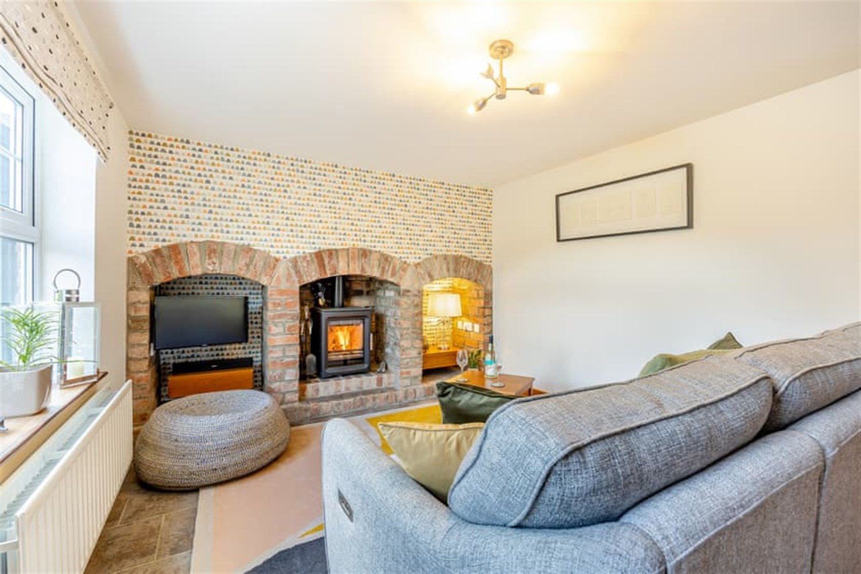
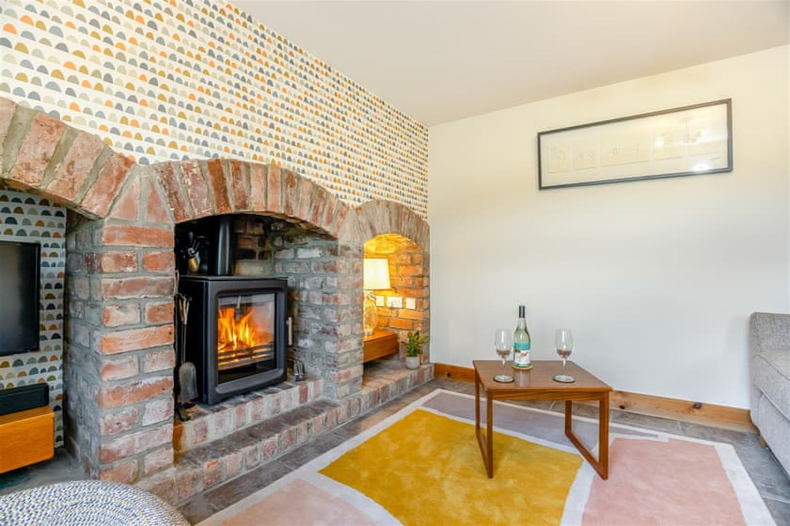
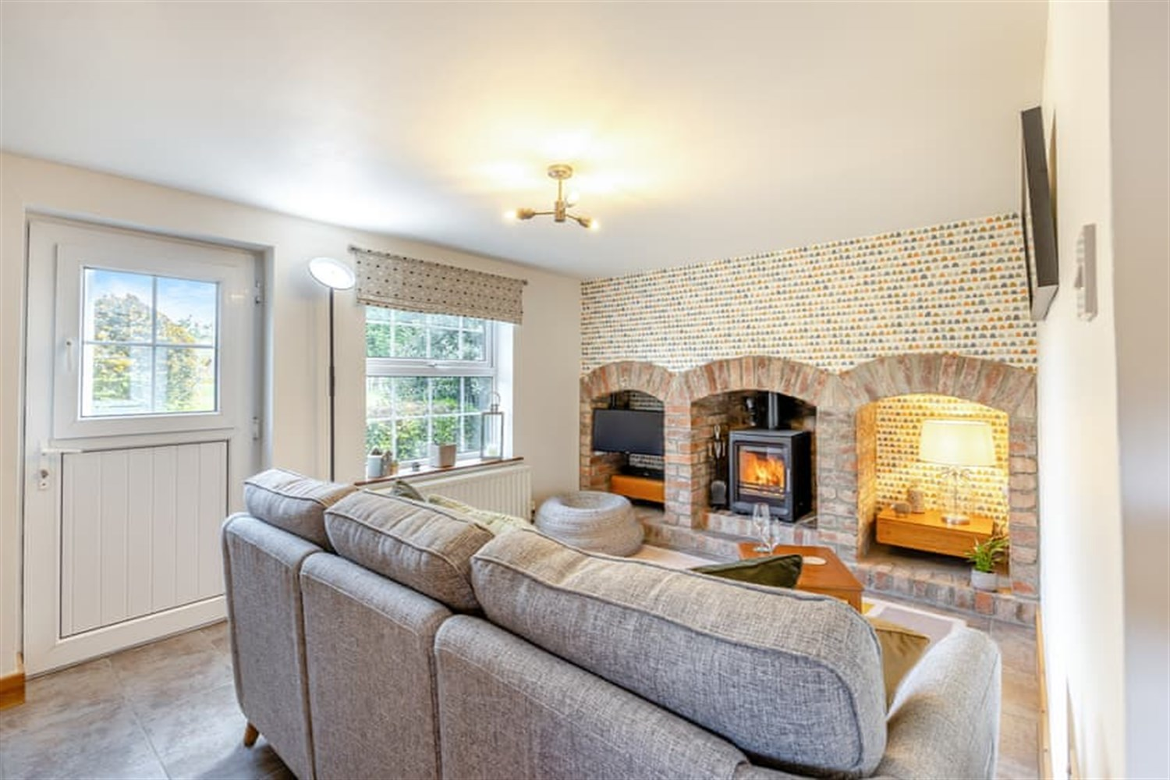
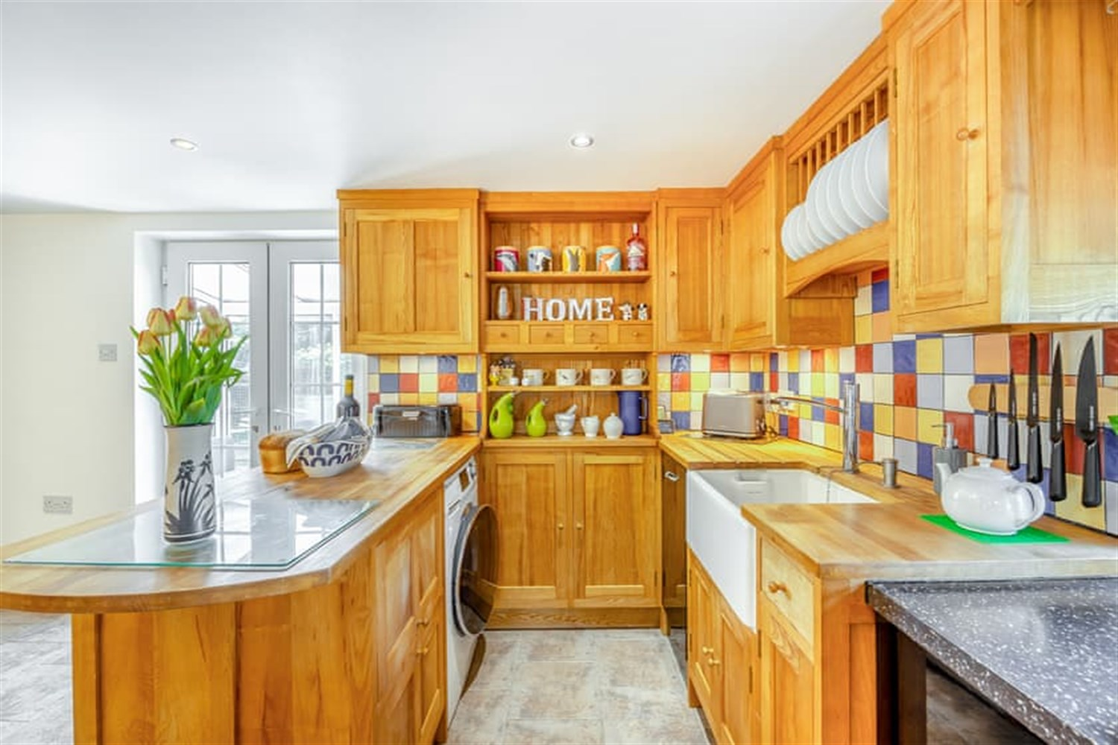
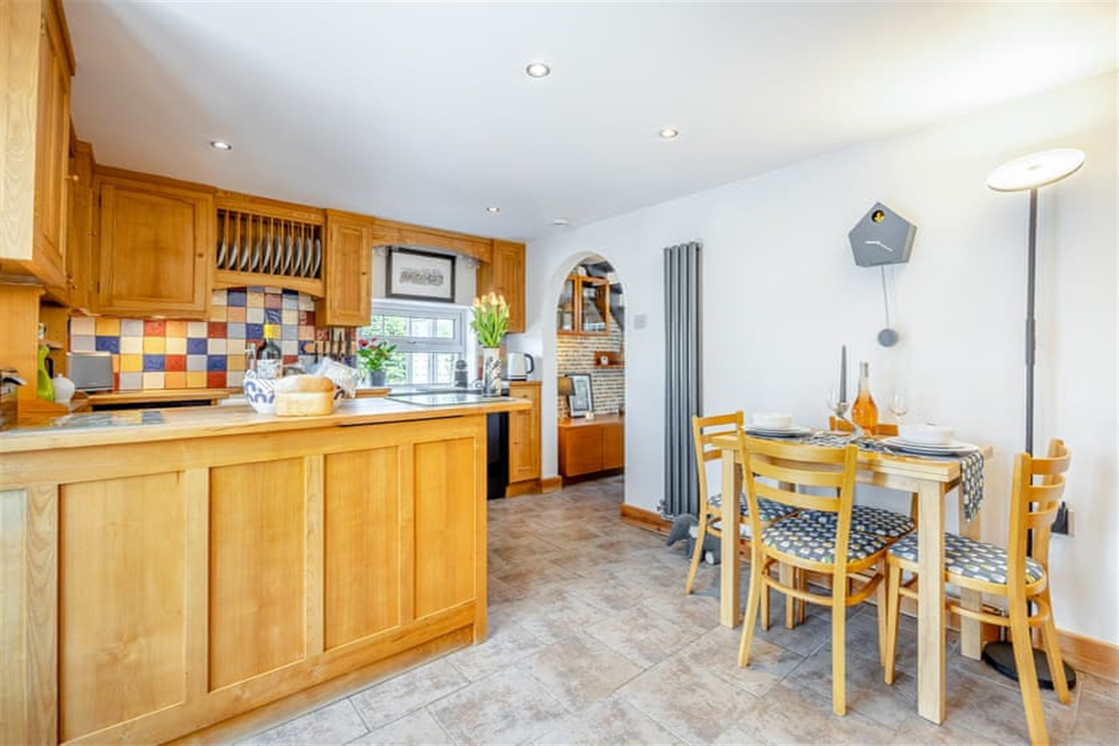

Property Description
A lovely, renovated country cottage over looking the riverbank. Featuring Porchway, Kitchen/Diner, Lounge with multi fuel burner, Conservatory, 2 Bedrooms and Bathroom. Large gravelled driveway, beautiful landscaped gardens with pond and Summer House.

Entrance Porch
This UPVC entrance porch is fully tiled and gives the perfect space for storing shoes and coats or to sit in and watch over the perfect gardens. Access into the Kitchen/Diner leads on from here.

Kitchen
This perfect space is modern with a cottage feel. There are wooden units to the eye and base level with built in plate rack, shelving and worktop over. Featured here is a breakfast Area, electric Range, microwave, fridge/freezer, dishwasher and Belfast sink unit with with mixer tap. There is a window to the front aspect and French doors into the entrance porch. There is plenty of space for a dining table, this really is a fabulous space with plenty of light from the windows and ceiling spots and the added warm of a wall mounted radiator. The door is befitting with the style of the property and is tiled which continues through the archway into the lounge area.

Reception 1
Entered through the archway from the Kitchen/Diner this room is very stylish with triple arch wall features one with a multi fuel burner inset and the others to house a TV and storage if required. There is a UPVC door leading out into the garden, window to the side aspect and the staircase leading to the first floor. An adding bonus to this property is lead on from this room and it is a conservatory looking out into the South West facing garden.

Reception/Conservatory
Using the original brick wall this lovely space gives this cottage a real tranquil feel. Looking out into the South West facing garden over looking the pond and having sliding door leading out to the patio area, this just feels homely with a sense of calm.

Landing
This little space allows access to all bedrooms, Shoer room and loft space. The is natural light in this room from a window to the front aspect.

Bedroom 1
A lovely Double room with a window to the side aspect over looking the gardens.

Bedroom 2
Another lovely room with a window to the side aspect.

Shower room
This room is perfect for the modern couple with a shower cubicle fitted with a double head shower, white gloss fully fitted vanity unit with sink with mixer tap over, worktop and built in storage. There is a low level WC, modern heated towel rail and frosted window to the side aspect.

Garden
These beautiful gardens are maintained to a very hight level, with mature trees, perennials, lawn, patio areas, a pond and pathway leading to the property and Summerhouse.
The wooden summer house has power and is a perfect spot for reading, morning coffee and evenings sat back and relaxing. There is access all around the property. Having a South West facing garden it really feels like a serene space to sit back and enjoy. There is a pond, greenhouse and so much more to occupy your time and energy.

Driveway
Fully fenced and entered from the road through a five bar gate. This area is gravelled and has parking for several vehicles. The current owners have a greenhouse on this part of the property to. The garden and property leads on from here.

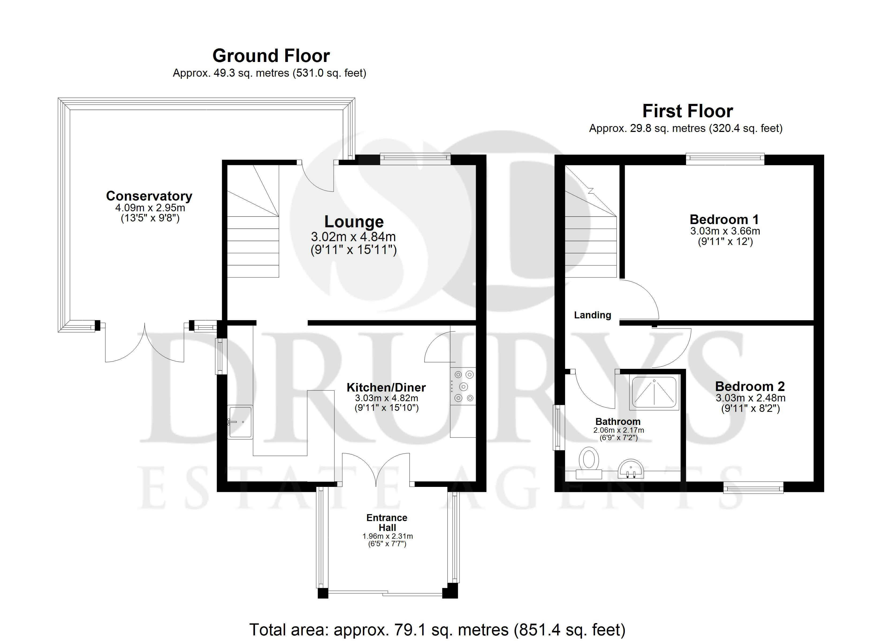

These particulars are intended to give a fair description of the property, but their accuracy cannot be guaranteed, and they do not constitute an offer of contract. Intending purchasers must rely on their own inspection of the property. None of the above appliances/services have been tested by ourselves. We recommend purchasers arrange for a qualified person to check all appliances/services before legal commitment.

Property Ref: 2751

www.drurysestateagents.co.uk
amber@drurysestateagents.co.uk
01205 350889

45 Willoughby Road
Boston
Lincolnshire
PE21 9HN
Agents Note: Whilst every care has been taken to prepare these sales particulars, they are for guidance purposes only. All measurements are approximate are for general guidance purposes only and whilst every care has been taken to ensure their accuracy, they should not be relied upon and potential buyers are advised to recheck the measurements

