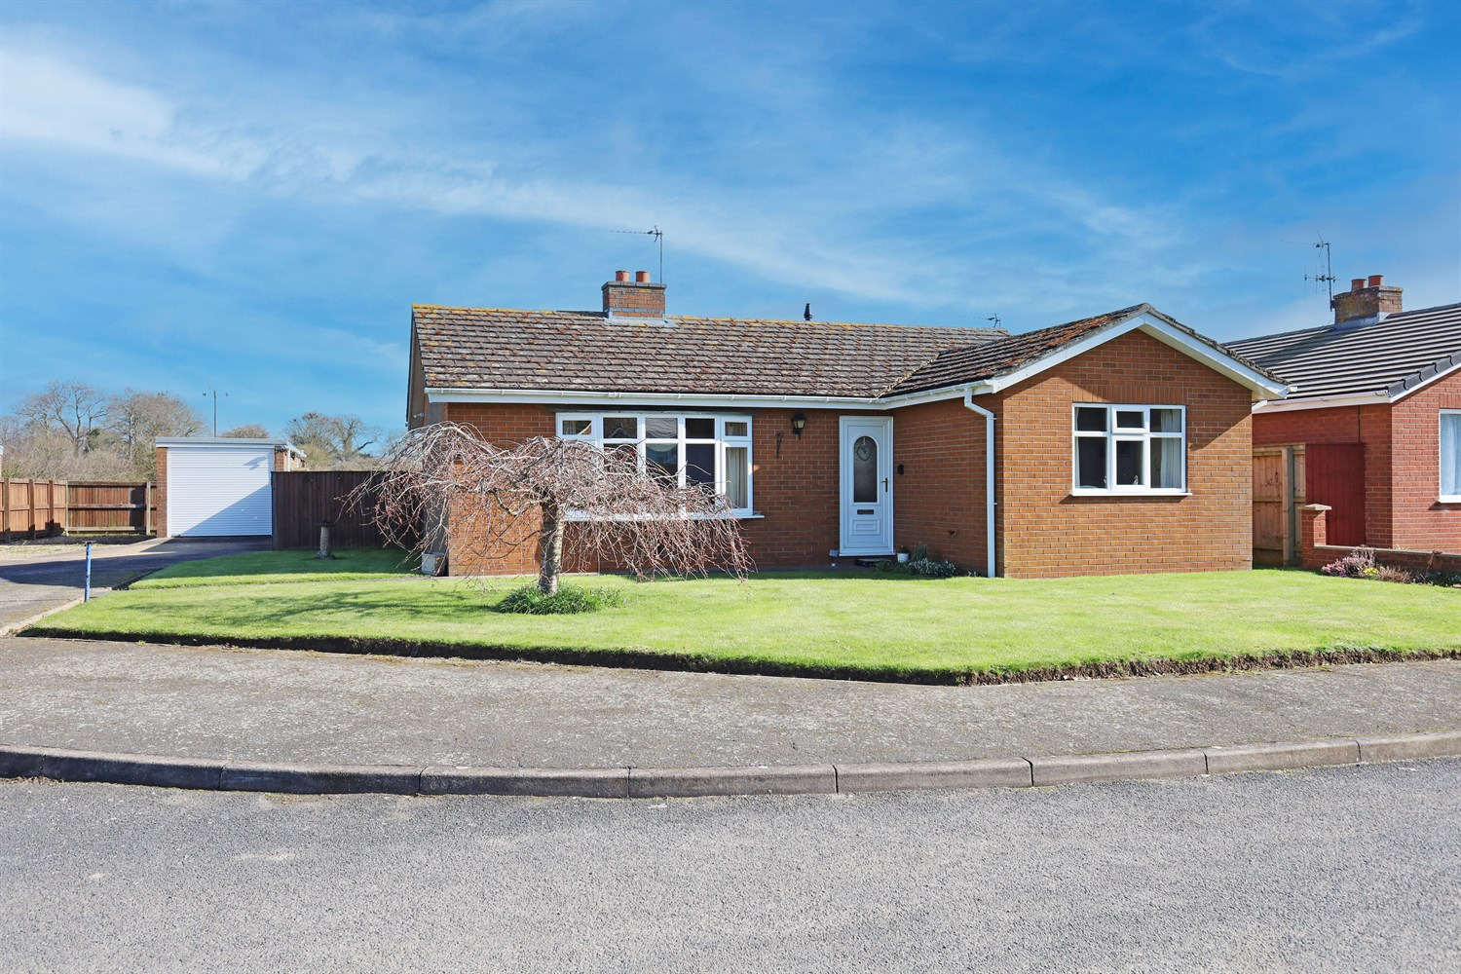




2 Bedroom(s)
3 Reception(s)
1 Bathroom(s)
£199,950.00
Laceys Drive, PE22
EPC Rating ‘’

- Driveway and Detached Garage
- Detached Bungalow
- Conservatory Overlooking the Garden

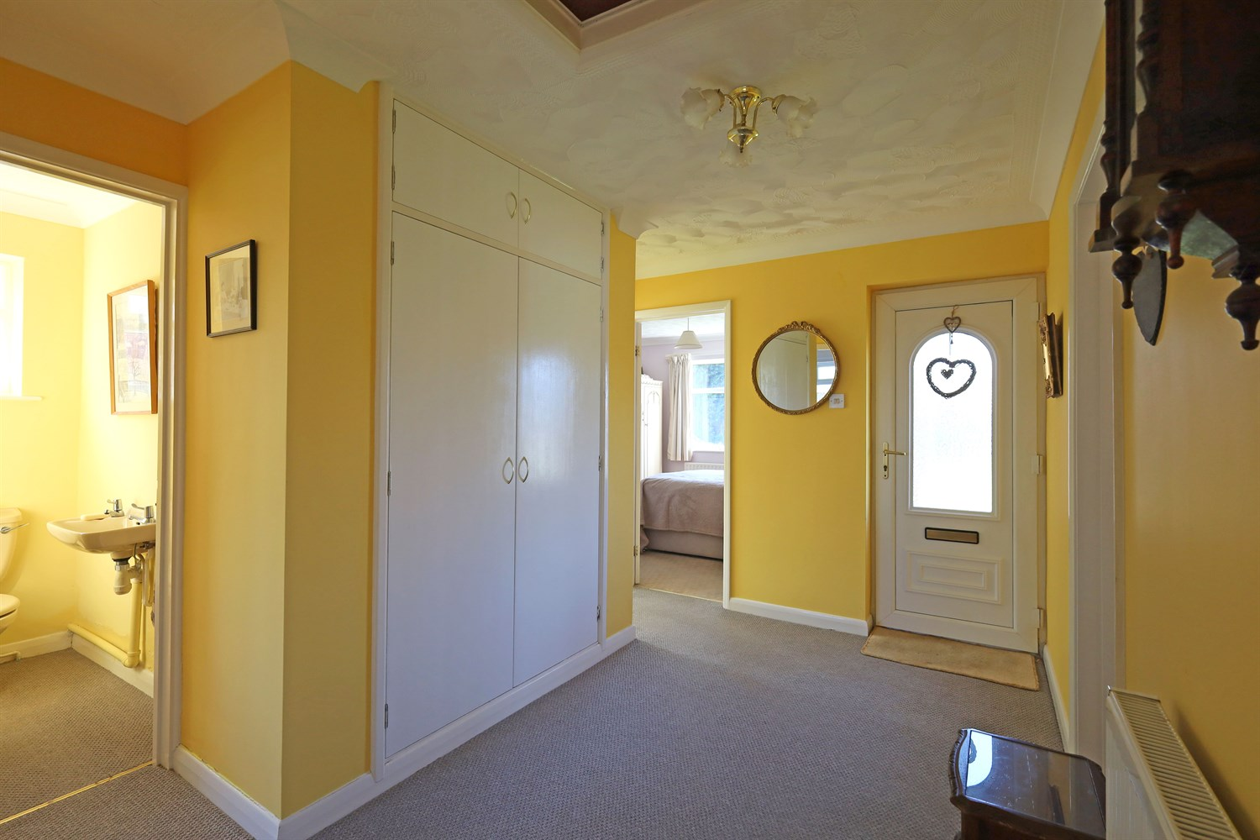
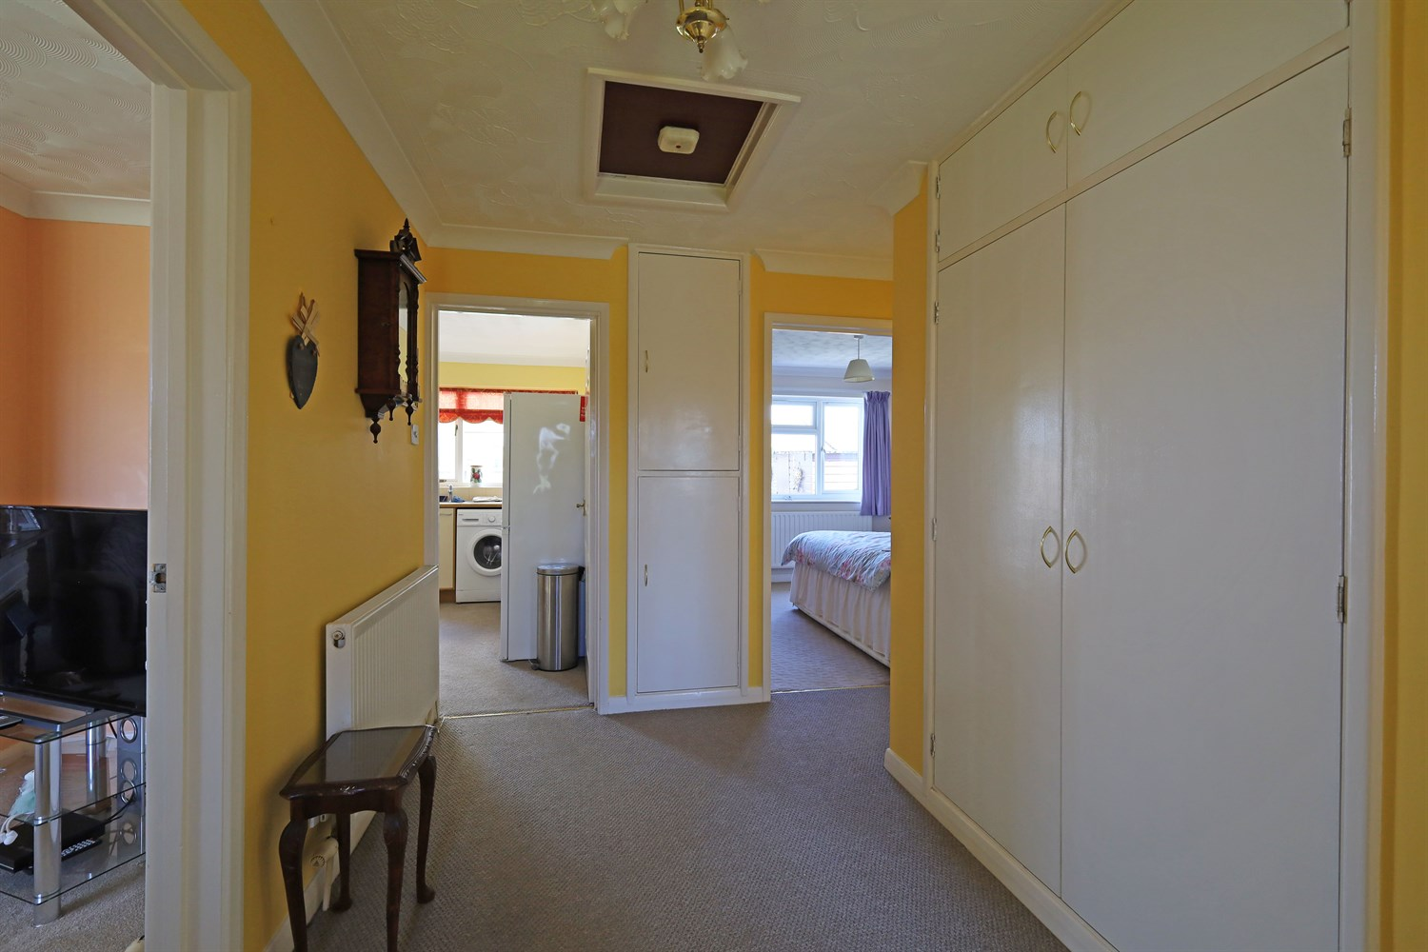
00
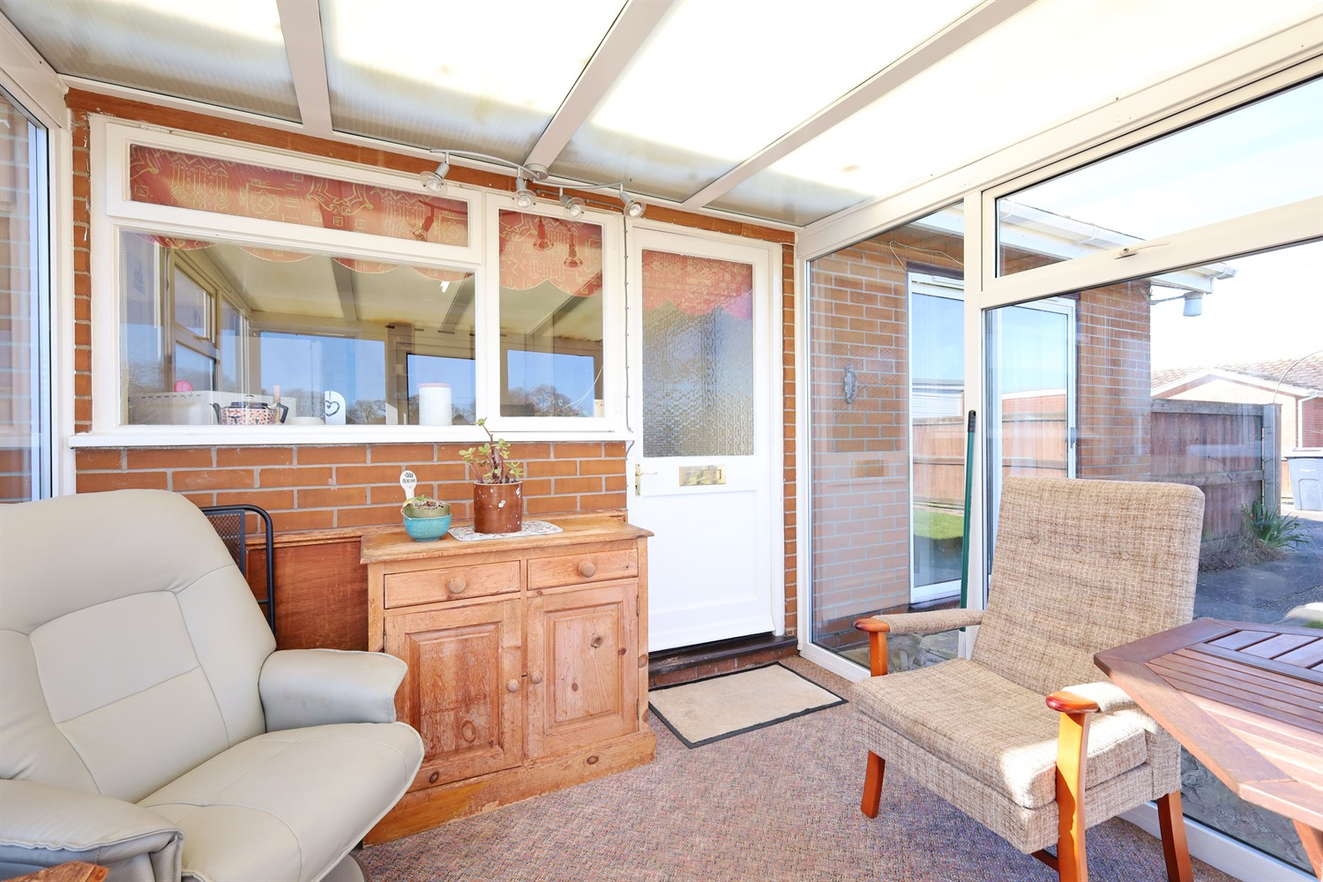
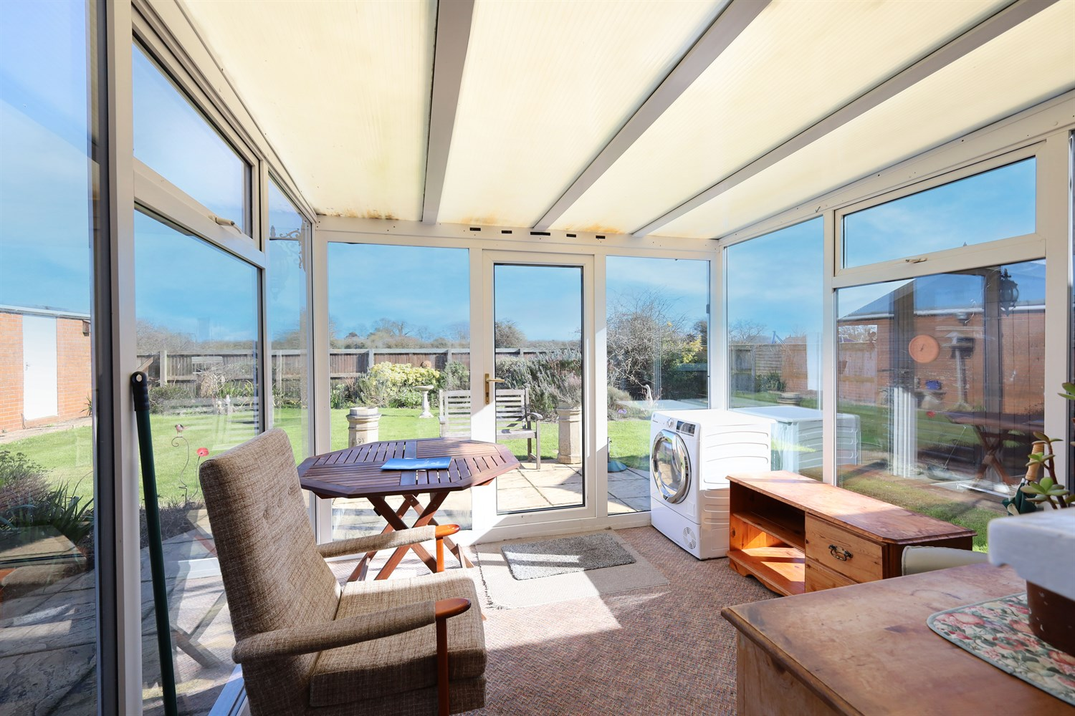
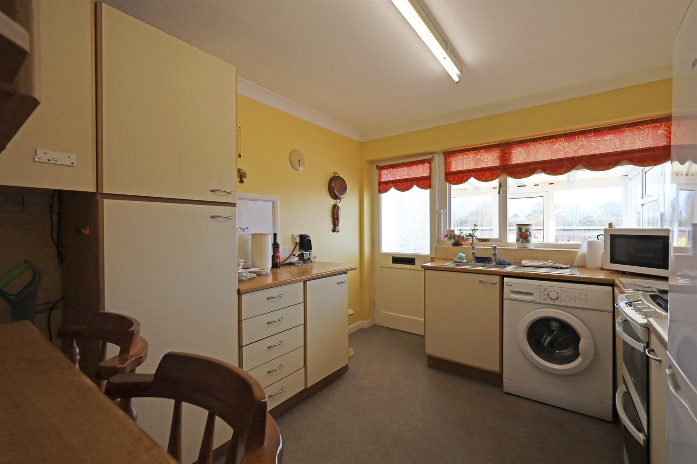
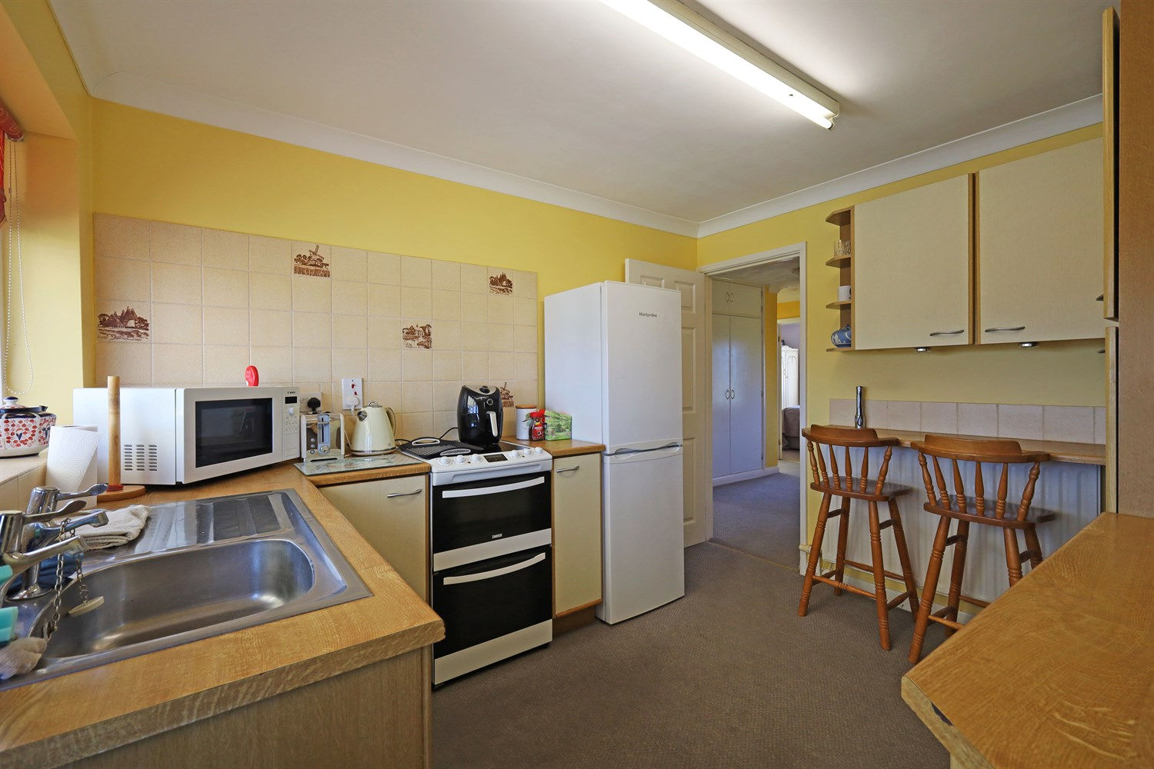
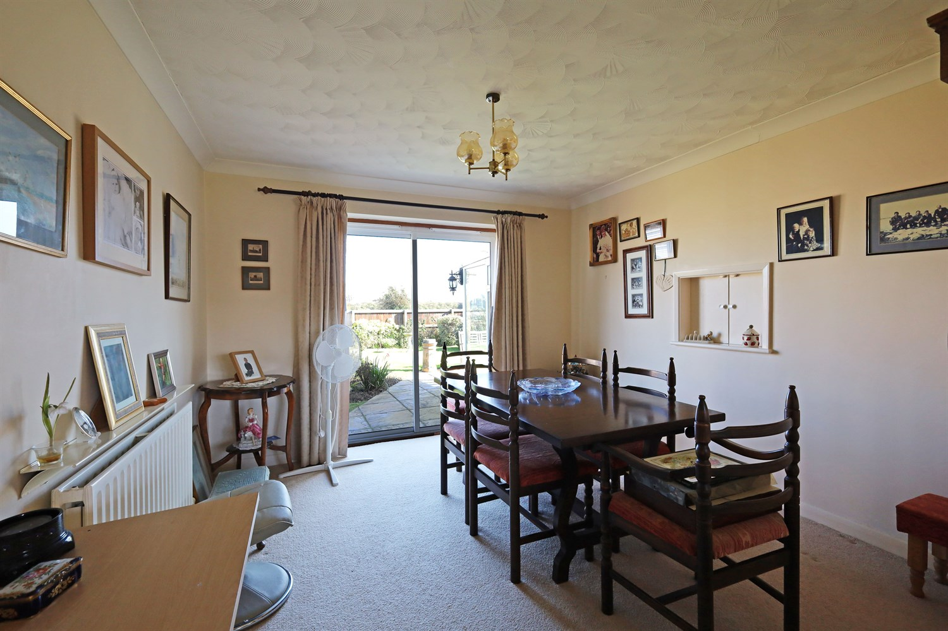
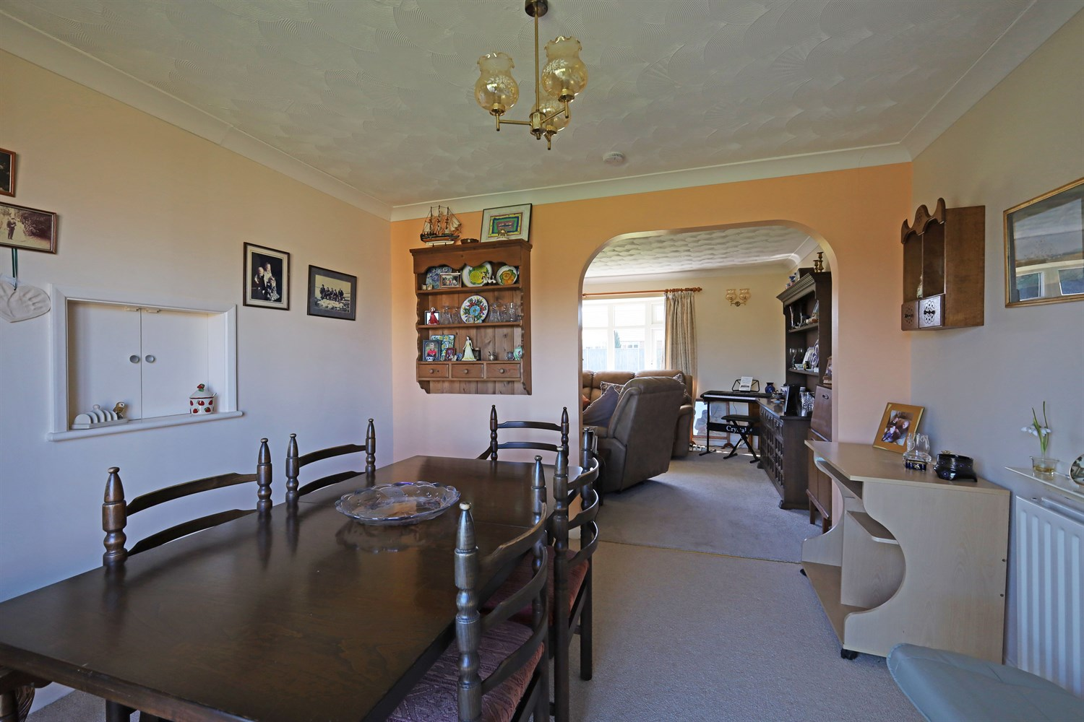
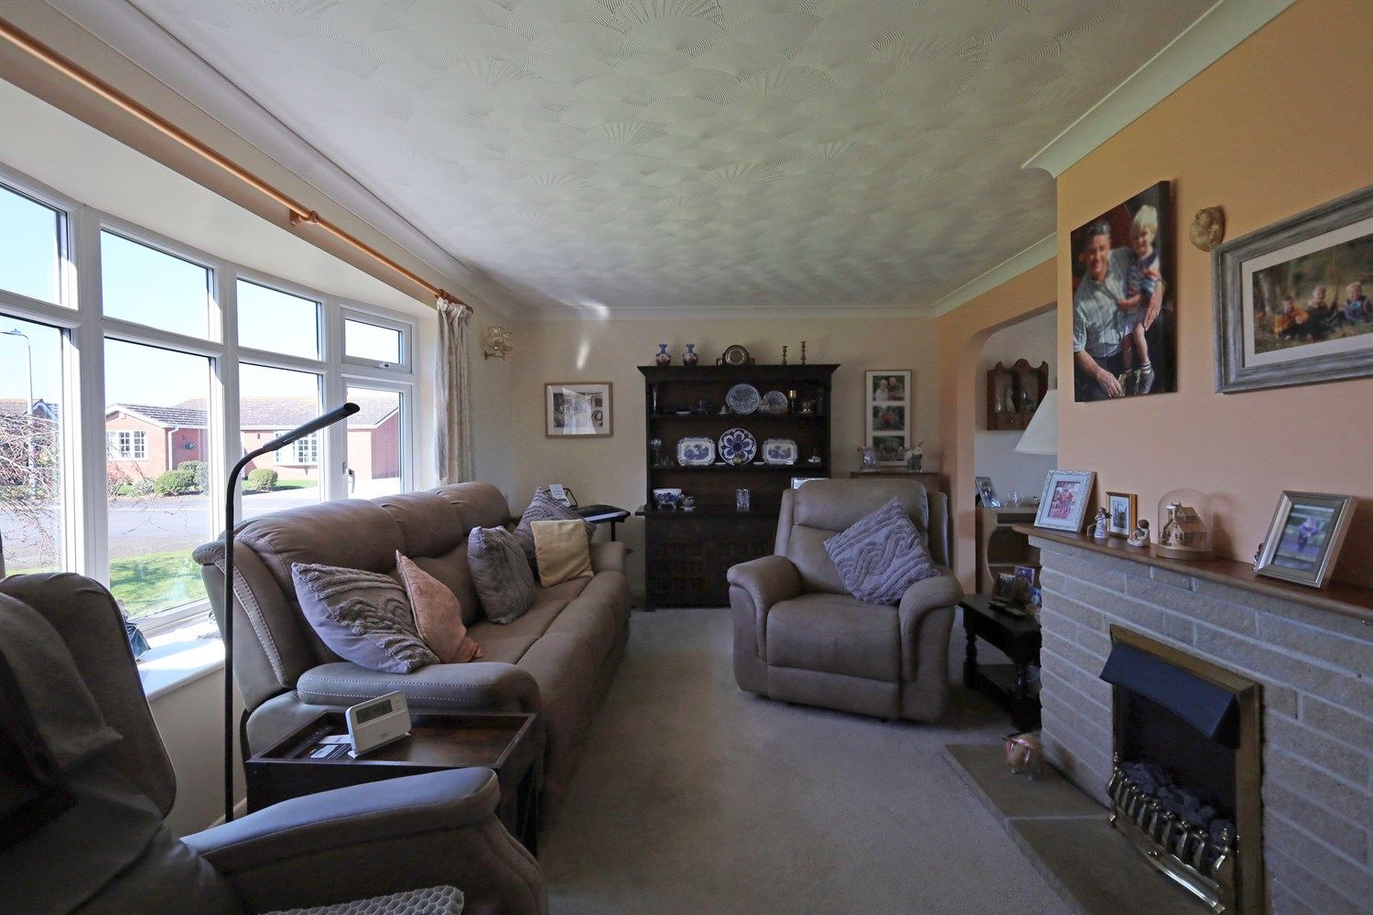
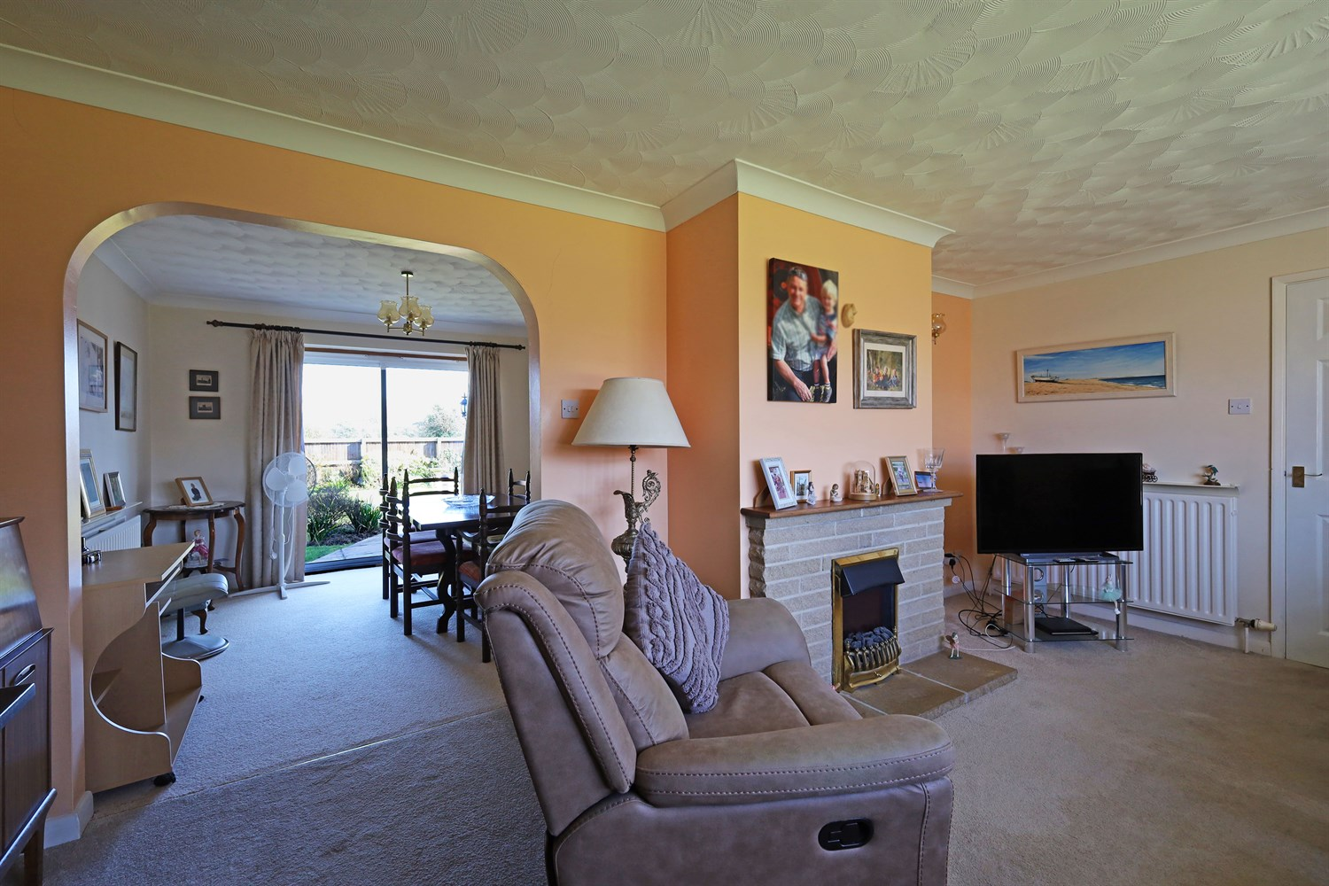

Property Description
Drury's Estate Agents is proud to present CHAIN FREE this well presented bungalow which offers spacious and versatile accommodation throughout. The property comprises a bright living room, a separate dining room with access to the rear garden, and a well proportioned kitchen providing ample storage and workspace which leads through to a light filled conservatory overlooking the garden.
The accommodation further includes two bedrooms, a shower room and a convenient additional cloakroom. The conservatory provides an attractive additional reception space with direct access to the patio and garden, creating a lovely indoor-outdoor connection.
Externally, the property benefits from a generous rear garden mainly laid to lawn with established borders and a paved patio seating area ideal for relaxing or entertaining. To the front, there is a well maintained garden along with a driveaway providing off road parking and access to detached garage.

Front Aspect
The property enjoys an attractive position with a well maintained front garden mainly laid to lawn, creating a pleasant approach to the home. A driveway to the side provides off road parking and leads to a detached garage, offering additional parking or useful storage.

Entrance Hallway
A welcoming entrance hallway providing access to the principle rooms within the property. The space offers a bright and practical introduction to the home, featuring neutral décor and fitted carpet. There is also space for occasional furniture and useful wall space for storage or decorative features.

Living Room
A spacious and inviting living room positioned to the front of the property, featuring a large window that allows an abundance of natural light to fill the space while providing pleasant views of the surrounding area. The room offers generous proportions, comfortably accommodating multiple sofas and additional furnishings. A feature fireplace with decorative surround creates an attractive focal point, adding warmth and character to the room. Neutral décor and fitted carpeting enhance the bright and comfortable feel, making this an ideal space for relaxing or entertaining. An archway leads conveniently through to the adjoining dining room.

Dining Room
A bright and well proportioned dining room enjoying pleasant views over the rear garden through large sliding patio doors, which also provide direct access onto the patio area. The room offers ample space for a family dining table and chairs, creating an ideal setting for everyday meals or entertaining guests. Neutral décor and fitted carpet provide a warm and inviting feel, while a radiator ensure comfort throughout the seasons. The generous natural light combined with the garden outlook makes this a particularly attractive space within the home.

Kitchen
A well proportioned kitchen fitted with a range of wall and base units providing ample storage along with generous worktop space for food preparation. The room benefits from a large rear facing window overlooking the garden, allowing plenty of natural light to fill the space. There is space for a range of freestanding appliances including cooker, fridge freezer and washing machine, with stainless steel sink and drainer positioned under the window. A useful breakfast bar area provides additional seating or workspace. A door leads directly through to the conservatory, creating a practical flow between the kitchen and the garden facing living space.

Conservatory
A bright and versatile conservatory enjoying attractive views over the rear garden, with large surrounding windows allowing an abundance of natural light to fill the space. This pleasant room offers additional living accommodation and could be used as a sitting area, garden room or dining space. Double doors provide direct access onto the patio and garden, creating seamless connection between the indoor and outdoor areas, ideal for relaxing or entertaining.

Bedroom 1
A well proportioned double bedroom positioned to the front of the property, featuring a large window that allows plenty of natural light while offering pleasant views of the surrounding area. The room provides ample space for a double bed along with freestanding bedroom furniture including wardrobes and drawers. Neutral décor and fitted carpet create a bright and comfortable atmosphere, making this an ideal main bedroom.

Bedroom 2
A comfortable bedroom positioned to the rear of the property, enjoying pleasant views over the rear garden. The room offers space for a bed along with additional furniture and benefits from fitted wardrobes providing useful storage. A large window allows plenty of natural light while neutral décor and fitted carpet create a bright and welcoming feel. This room would make an ideal guest bedroom, child's room.

Shower Room
A well presented shower room fitted with a walk in shower enclosure, pedestal wash hand basin and low level WC. The room benefits from a frosted window allowing natural light while maintaining privacy. Neutral flooring and easy maintenance wall finishes create a clean and practical space suitable for everyday use.

Cloakroom/Downstairs Toilet
A convenient ground floor cloakroom fitted with a low level WC and wash hand basin. The room benefits from a frosted window allowing natural light while maintaining privacy, creating a practical additional facility for guests and everyday use.

Rear Garden
A generously sized and well maintained rear garden, mainly laid to lawn with established borders featuring a variety of shrubs and plants. A paved patio area adjacent to the property provides an ideal space for outdoor seating and entertaining while enjoying views across the garden. The garden offers a pleasant outlook and benefits from a useful garden shed providing additional outdoor storage.

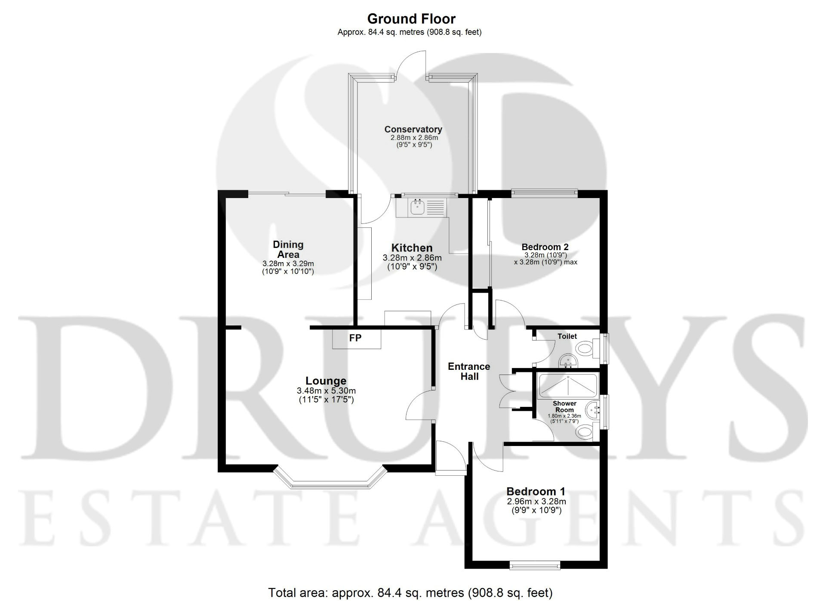

These particulars are intended to give a fair description of the property, but their accuracy cannot be guaranteed, and they do not constitute an offer of contract. Intending purchasers must rely on their own inspection of the property. None of the above appliances/services have been tested by ourselves. We recommend purchasers arrange for a qualified person to check all appliances/services before legal commitment.

Property Ref: 3375

www.drurysestateagents.co.uk
amber@drurysestateagents.co.uk
01205 350889

45 Willoughby Road
Boston
Lincolnshire
PE21 9HN
Agents Note: Whilst every care has been taken to prepare these sales particulars, they are for guidance purposes only. All measurements are approximate are for general guidance purposes only and whilst every care has been taken to ensure their accuracy, they should not be relied upon and potential buyers are advised to recheck the measurements

