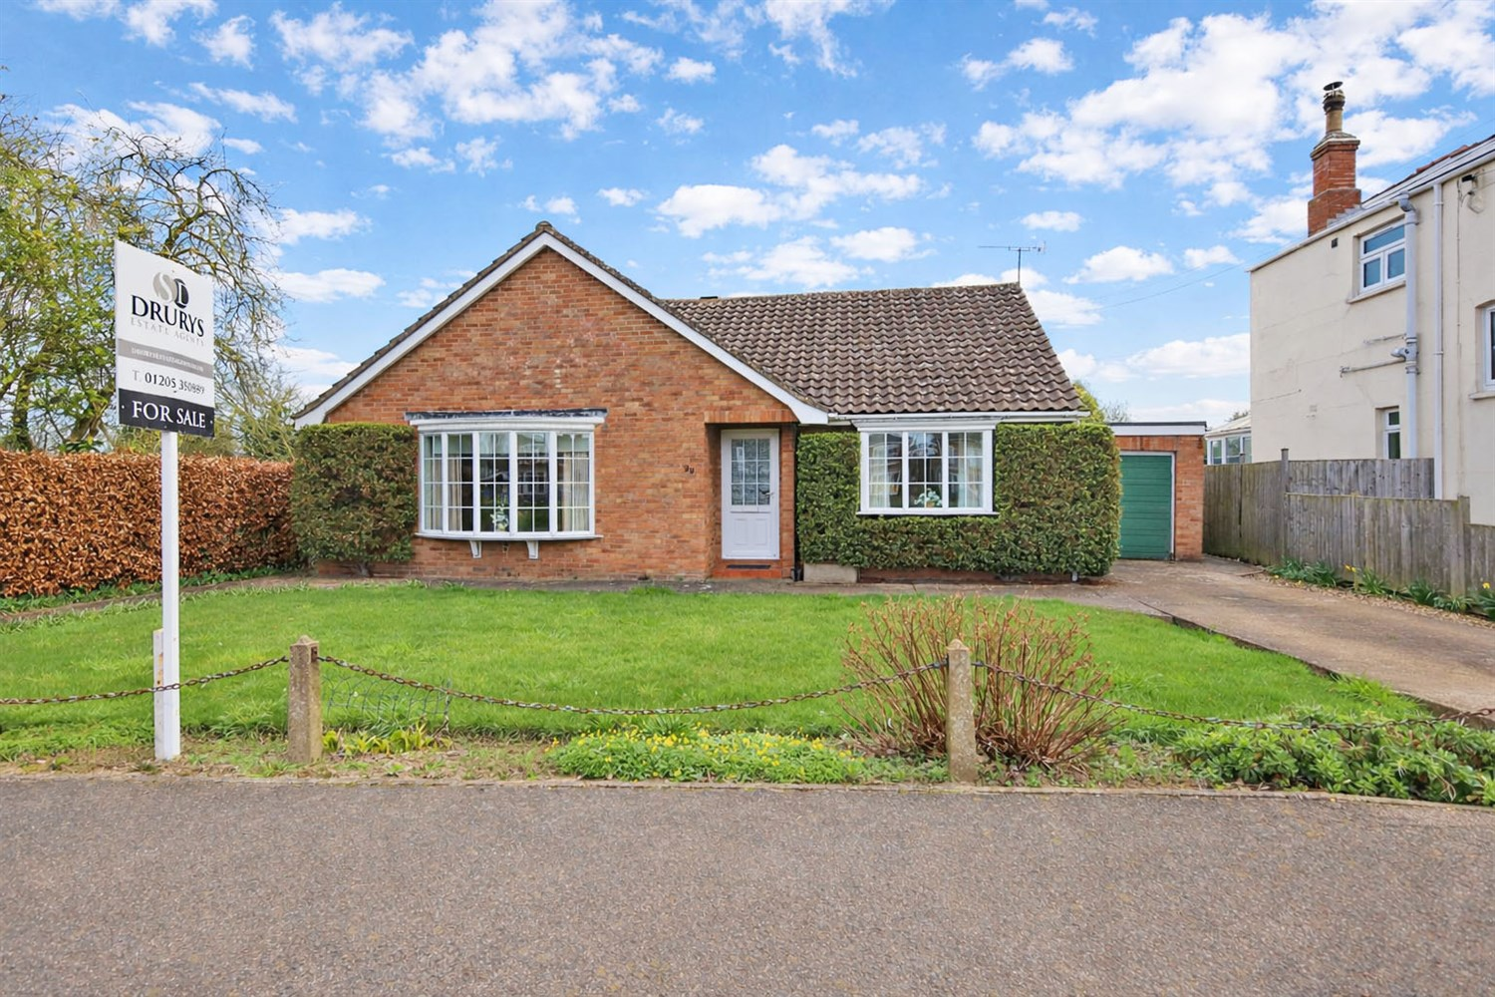




2 Bedroom(s)
1 Reception(s)
1 Bathroom(s)
£224,950.00
Willoughby Road, PE21
EPC Rating ‘’

- Chain Free
- 2 Bedrooms, Lounge, Kitchen
- Garden, Garage & Great views
- Sought After Location

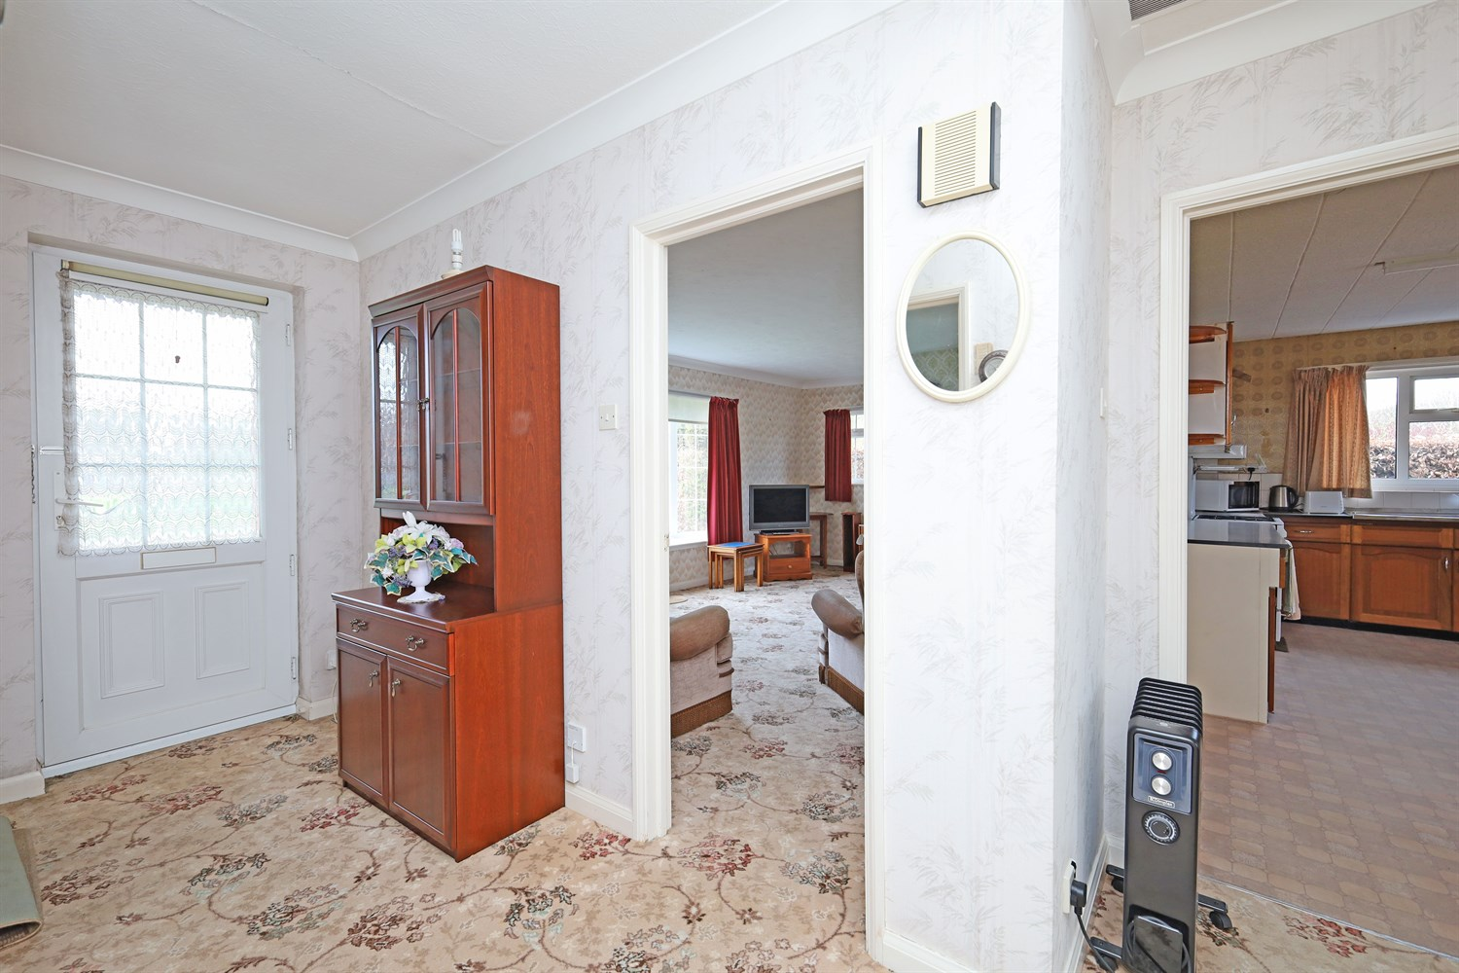
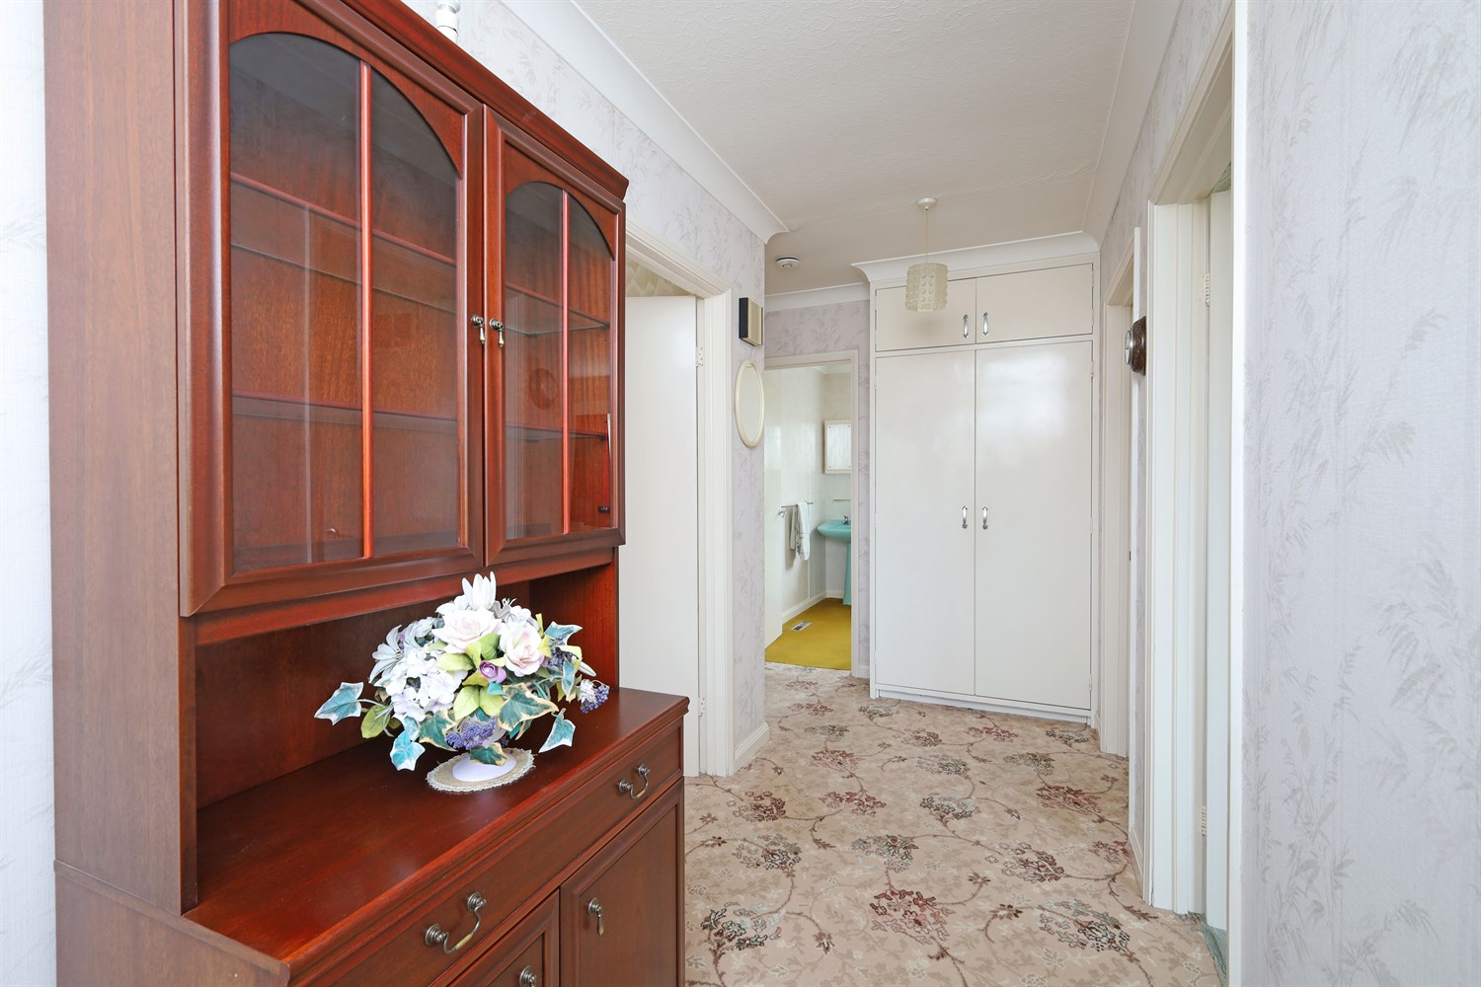
00
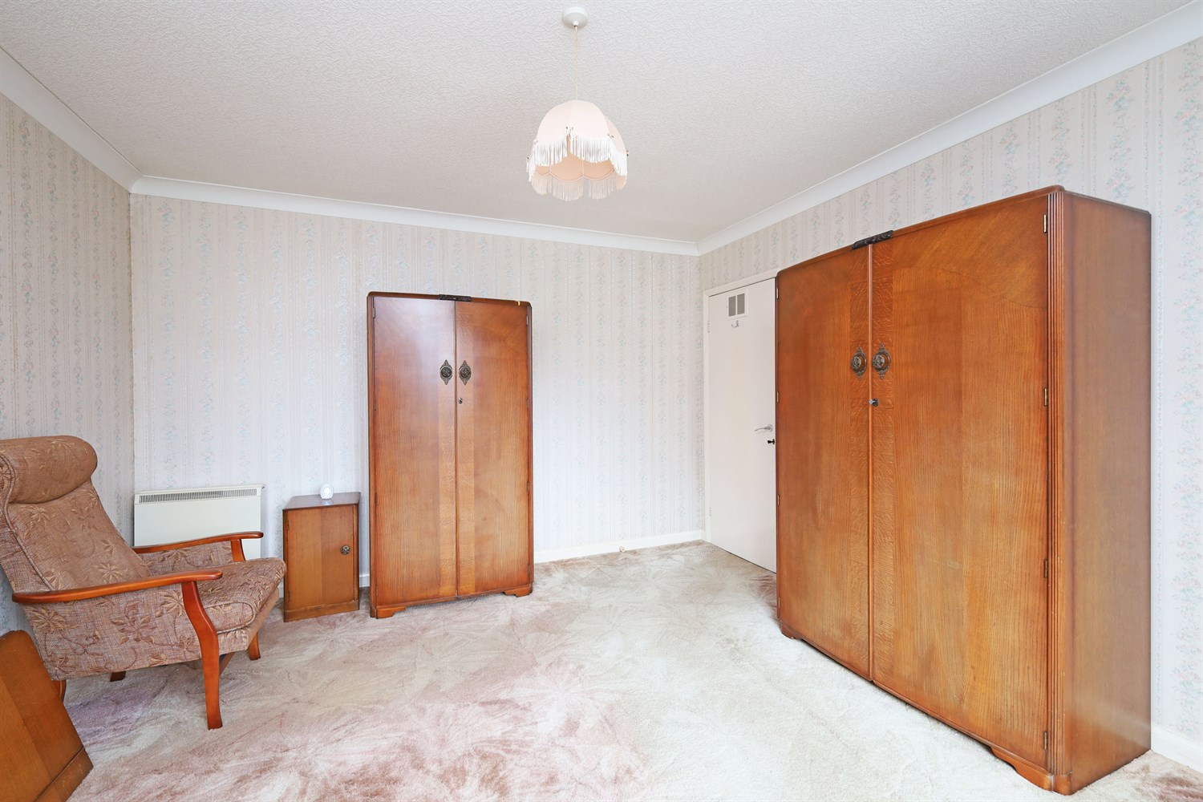
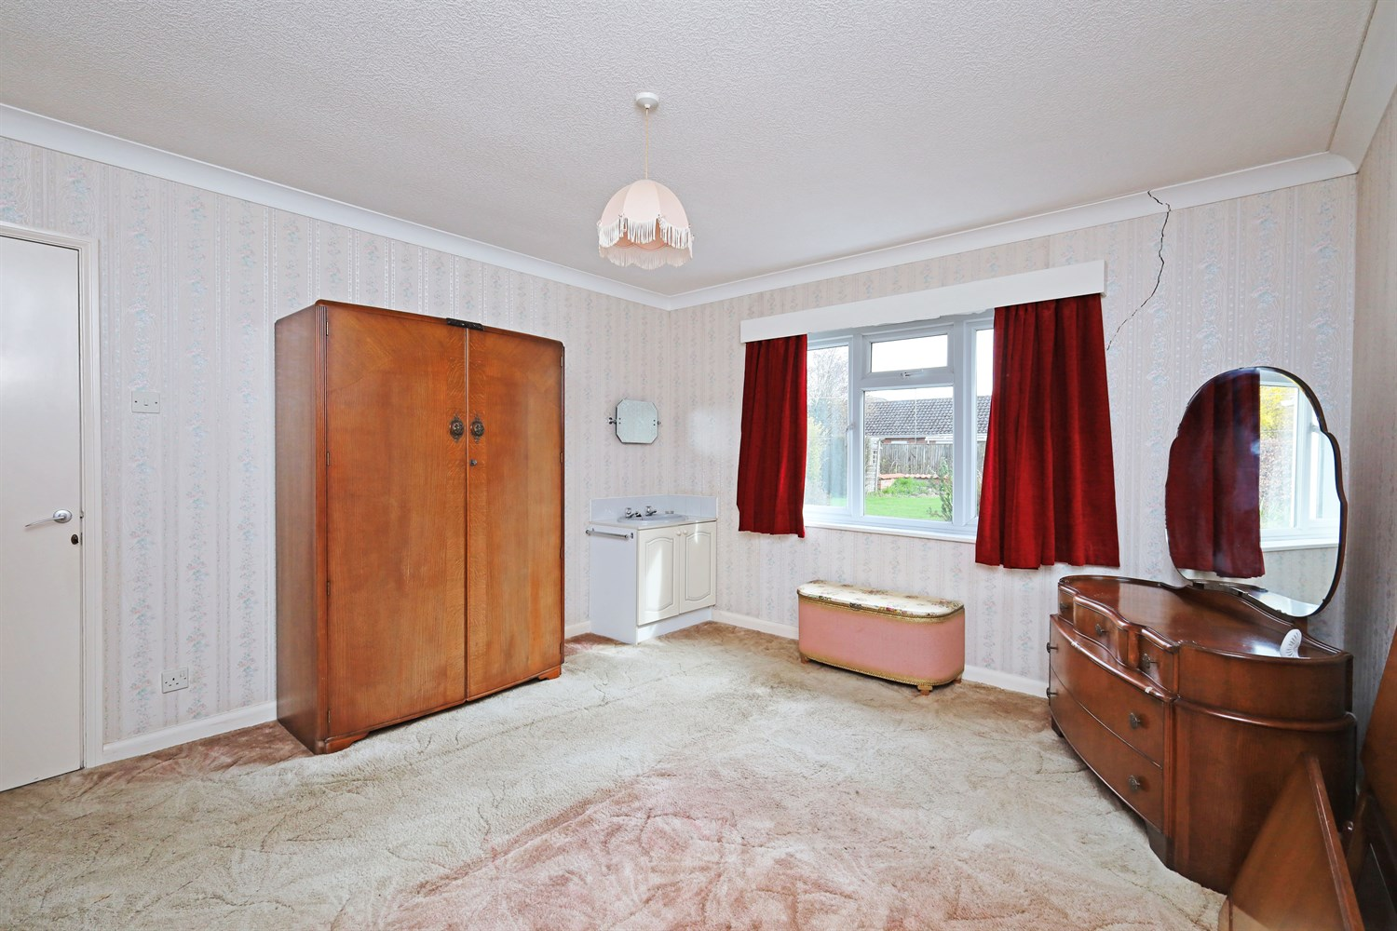
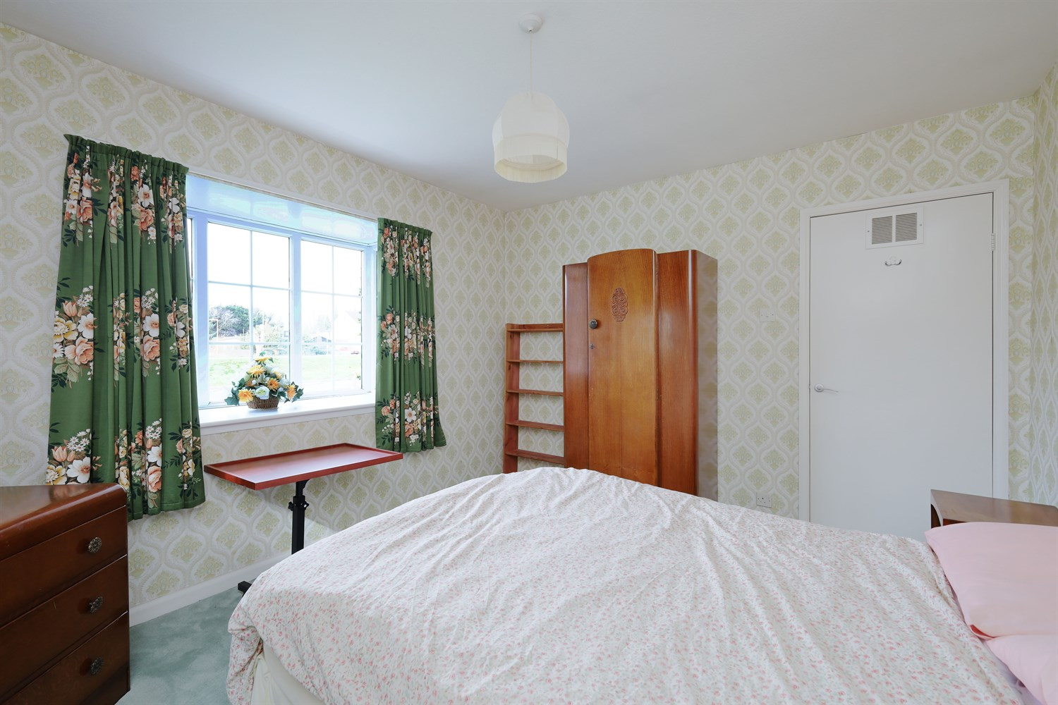
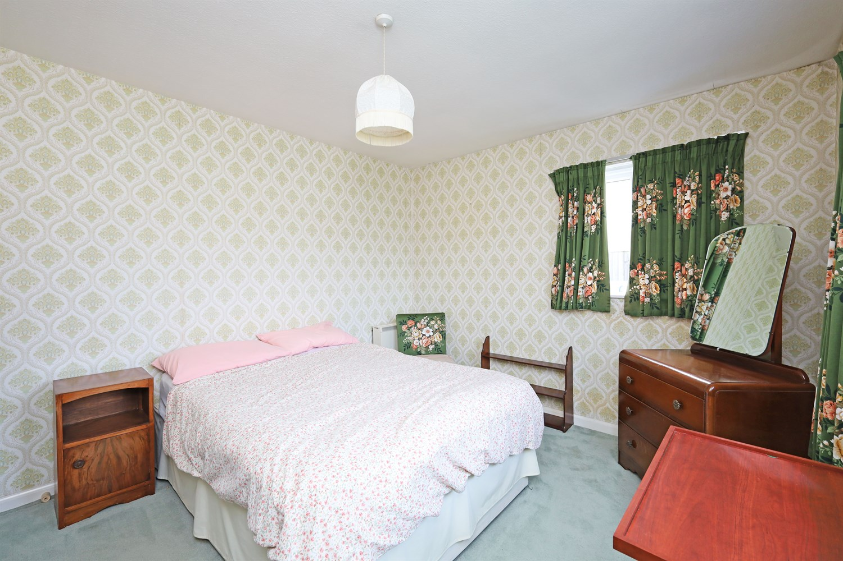
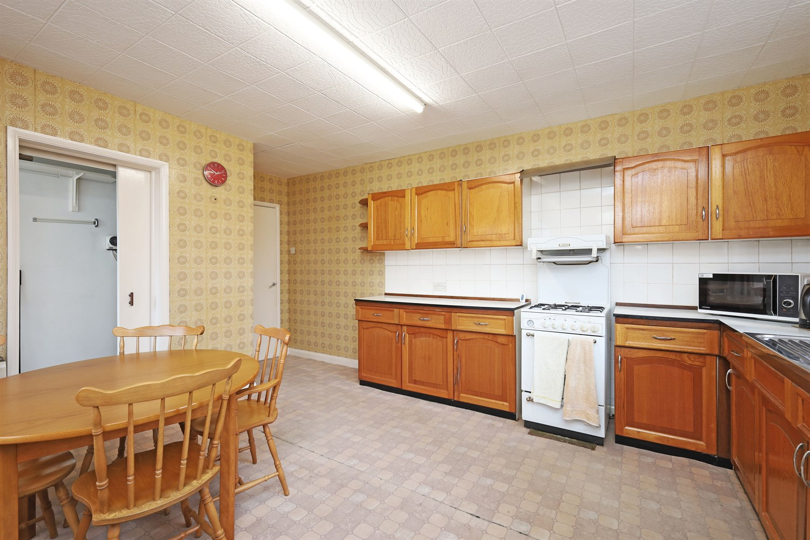
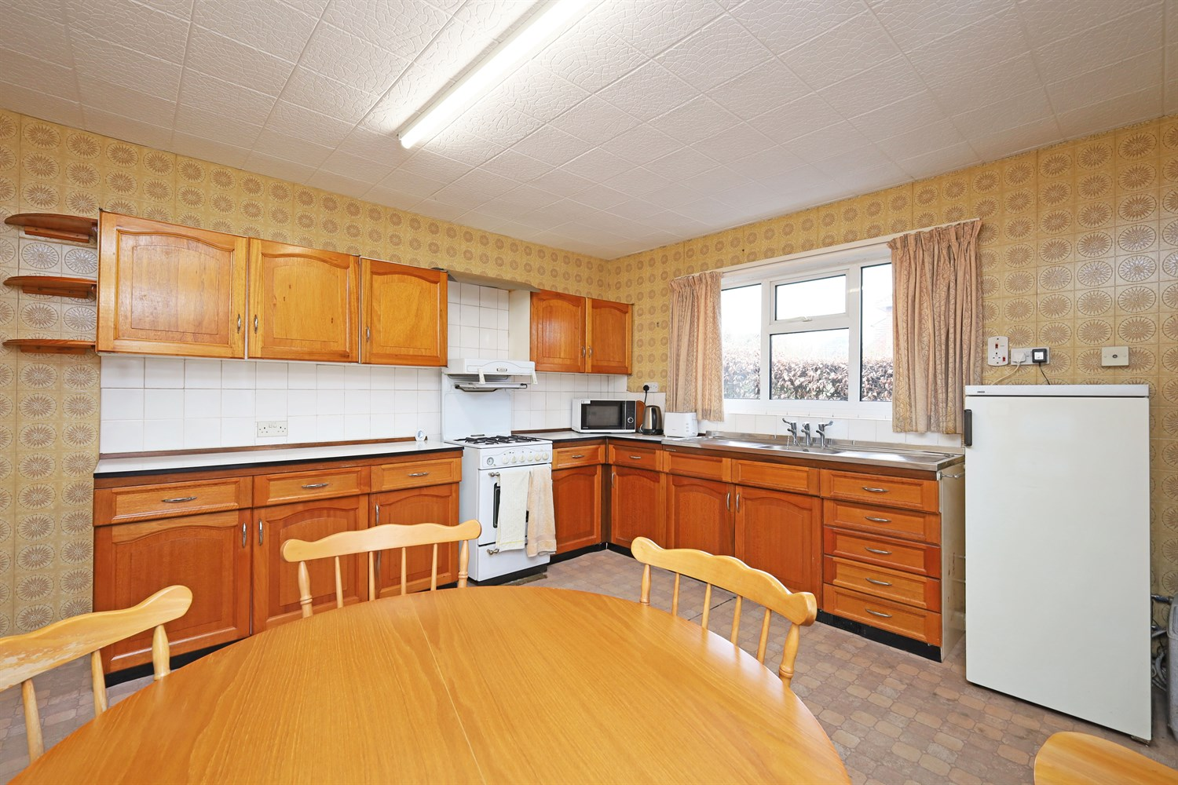
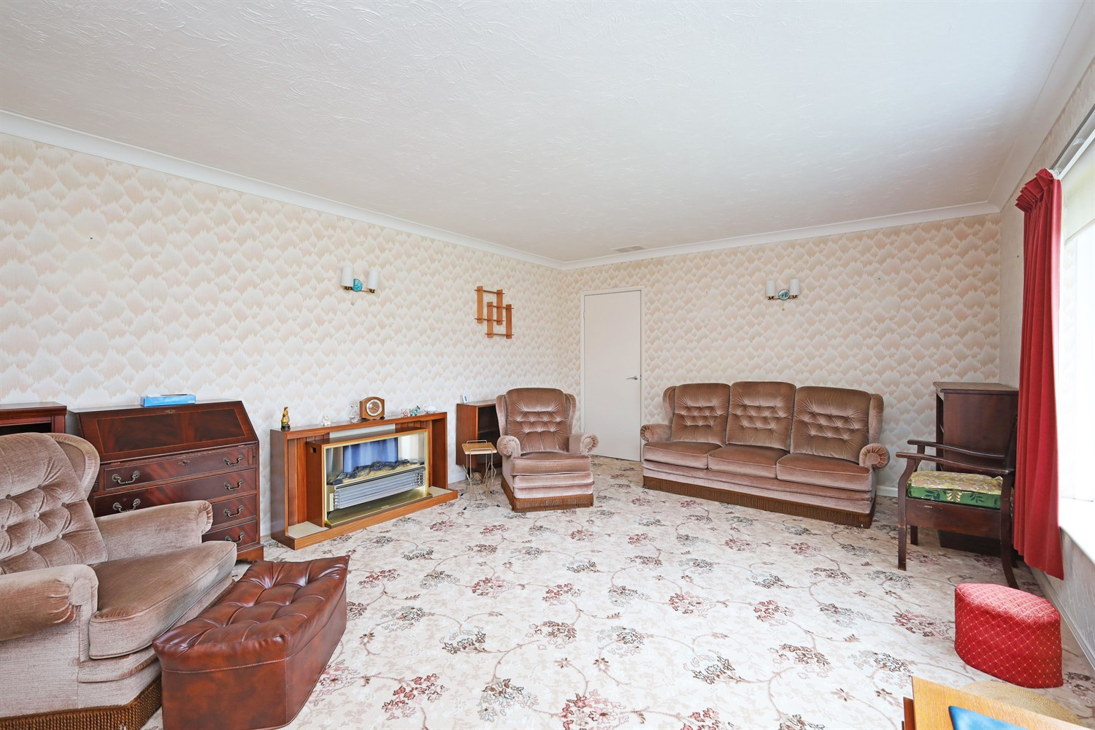
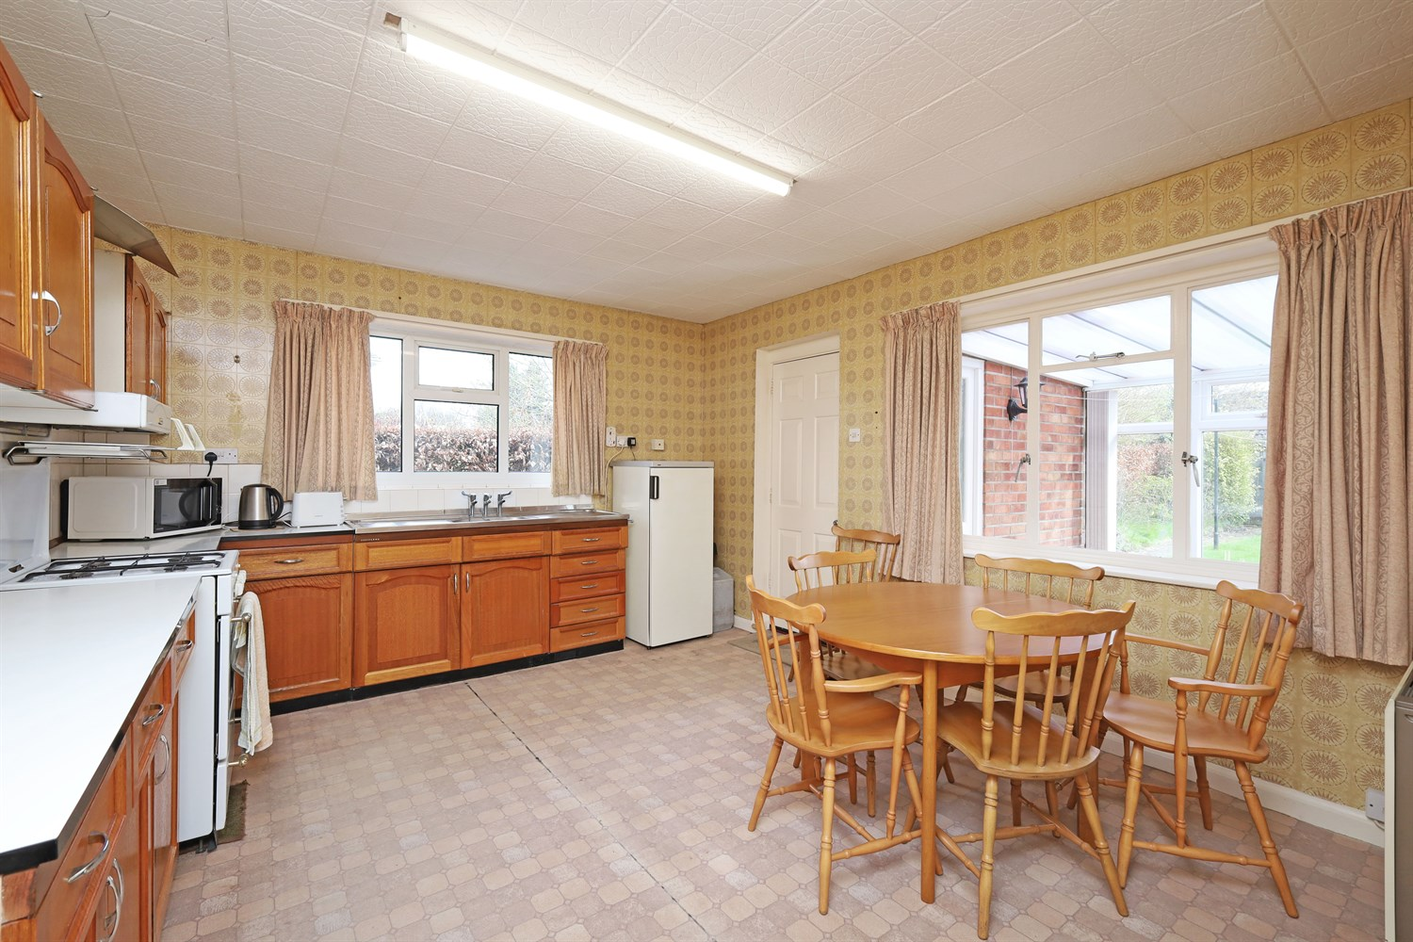

Property Description
This charming two double bedroom detached bungalow is located in a desirable location over looking the Maud Foster, with driveway and garage.
The spacious lounge is a fantastic space to relax with great views, kitchen/diner that opens up into a utility and conservatory which is sun-filled room door that step out to the patio and rear garden. There are two well proportioned double bedrooms, bathroom, and a great sized garden with access to both sides.

Hallway
Entered through the Upvc door and giving access to all the rooms, there is a thermostat and floor to ceiling storage cupboard.

Reception Lounge
This room is so relaxing with views across the Maud Foster through the low bay window to the front aspect. Featuring an electric fireplace this room is a great size and has great protection.

Kitchen
Having units to the eye and base level with worktop over, having a stainless steel sink and double drainer with three taps. There is ample space for a dining table, tall fridge freezer and an additional bonus of a pantry (housing the old gas boiler.) This room is lovely and light with windows to the rear and side aspects.

Bedroom 1
The master bedroom has a bay window to the front aspect over looking the Maud Foster, there is also a window to the side aspect and electric storage heater.

Bedroom 2
Another great sized double room with a window to the rear aspect over looking the fabulous garden and an electric storage heater.

Bathroom
Having a three piece suite with panel bath featuring a hot and cold tap with shower over, pedestal sink, push button WC and frosted window to the rear aspect.

Utility Room
Having plumbing for a washing machine and electric for a tumble dryer or freezer, this room leads on from the kitchen and into the Conservatory.

Conservatory
A lovely sun filled room to sit and relax in. Having great views of the lovely established gardens with window to two sides, a door leading into the garden and polycarbonate roof.

Medium sized Garden
This lovely garden laid with lawn, perennials, shrubs, hedging to one side and fencing to the others. This really is a sun trap and is a great place to relax or entertain.
Having access to both sides of the property a patio area and shed.

Garage
A brick built garage attached to the property with a up and over door.

Parking
Having a driveway with access to the garage.

Double Glazing

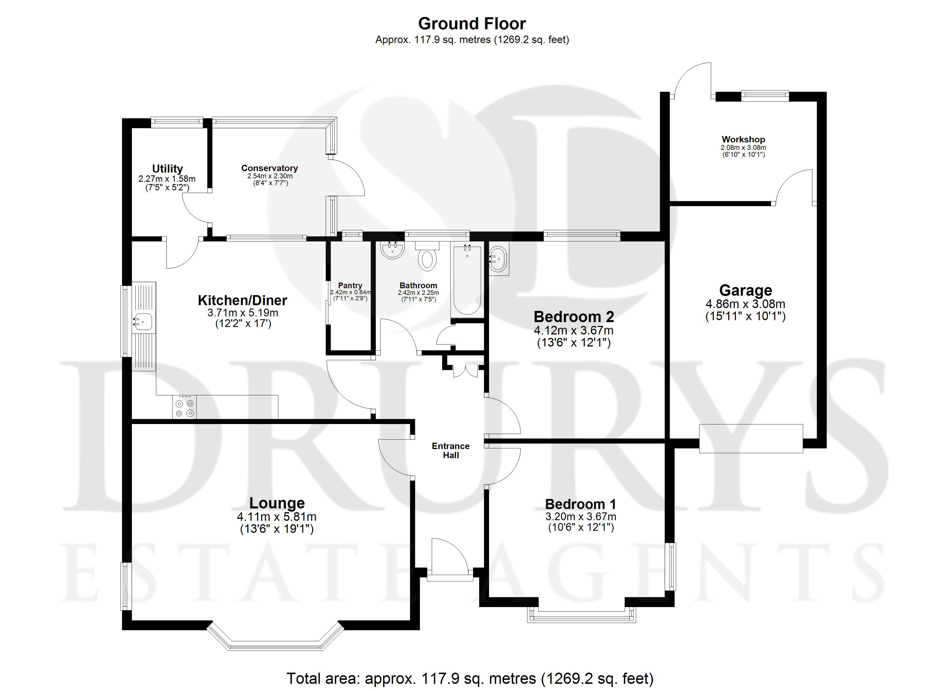

These particulars are intended to give a fair description of the property, but their accuracy cannot be guaranteed, and they do not constitute an offer of contract. Intending purchasers must rely on their own inspection of the property. None of the above appliances/services have been tested by ourselves. We recommend purchasers arrange for a qualified person to check all appliances/services before legal commitment.

Property Ref: 3213

www.drurysestateagents.co.uk
amber@drurysestateagents.co.uk
01205 350889

45 Willoughby Road
Boston
Lincolnshire
PE21 9HN
Agents Note: Whilst every care has been taken to prepare these sales particulars, they are for guidance purposes only. All measurements are approximate are for general guidance purposes only and whilst every care has been taken to ensure their accuracy, they should not be relied upon and potential buyers are advised to recheck the measurements

