
£625.00 MONTH
EPC Rating ‘’
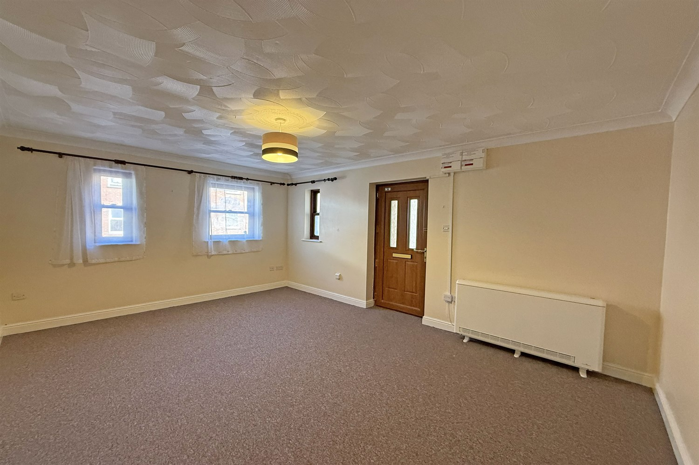

AVAILABLE NOW

- RECENTLY REFURBISHED ONE BED GROUND FLOOR FLAT

- SITUATED WITHIN WALKING DISTANCE OF TOWN CENTRE

- Deposit £625
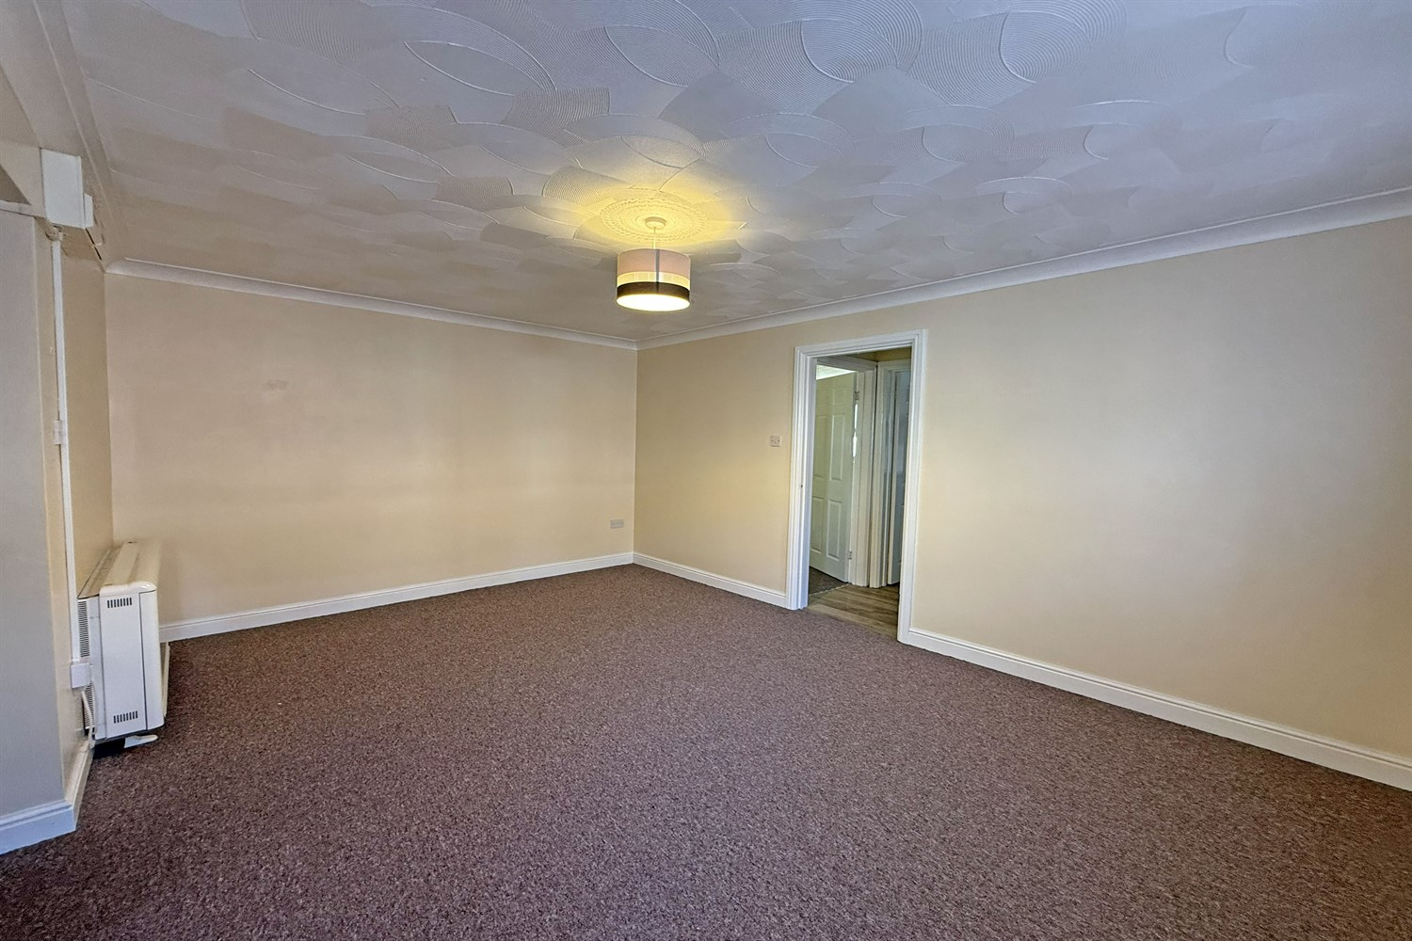
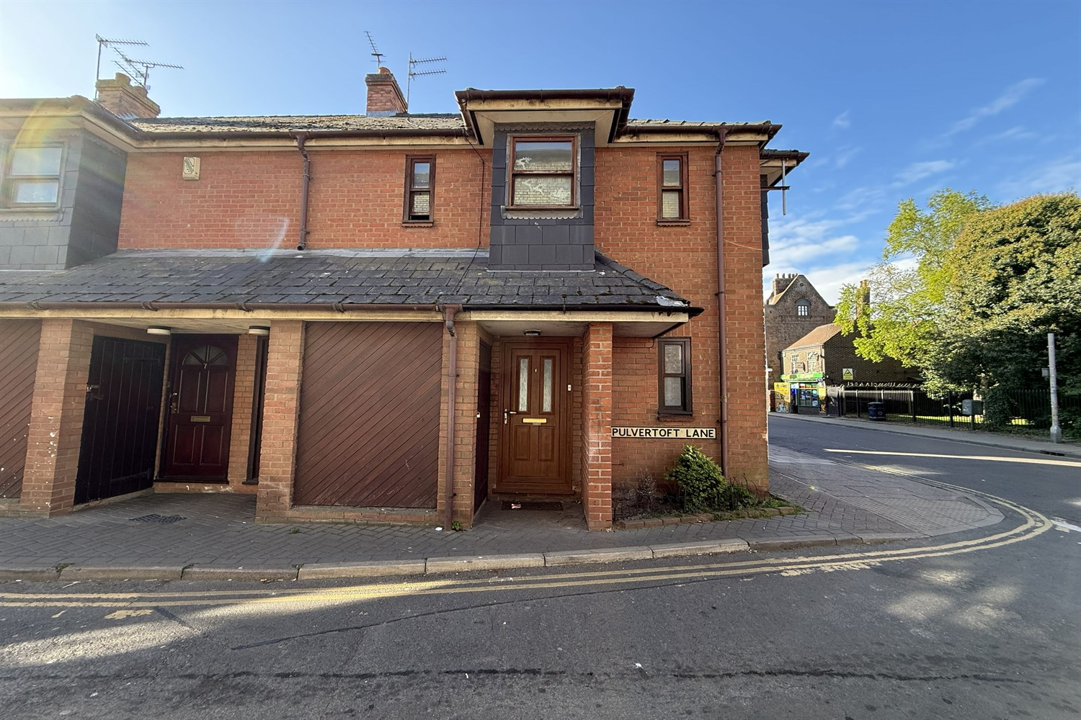

1 Pulvertoft Lane
Boston, PE21 8TB

1 Pulvertoft Lane, Boston, Lincolnshire, PE21 8TB
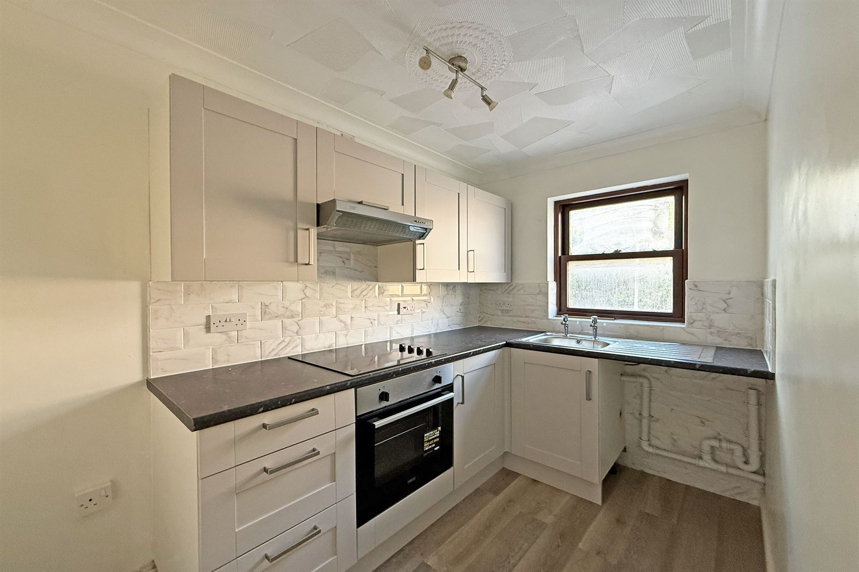
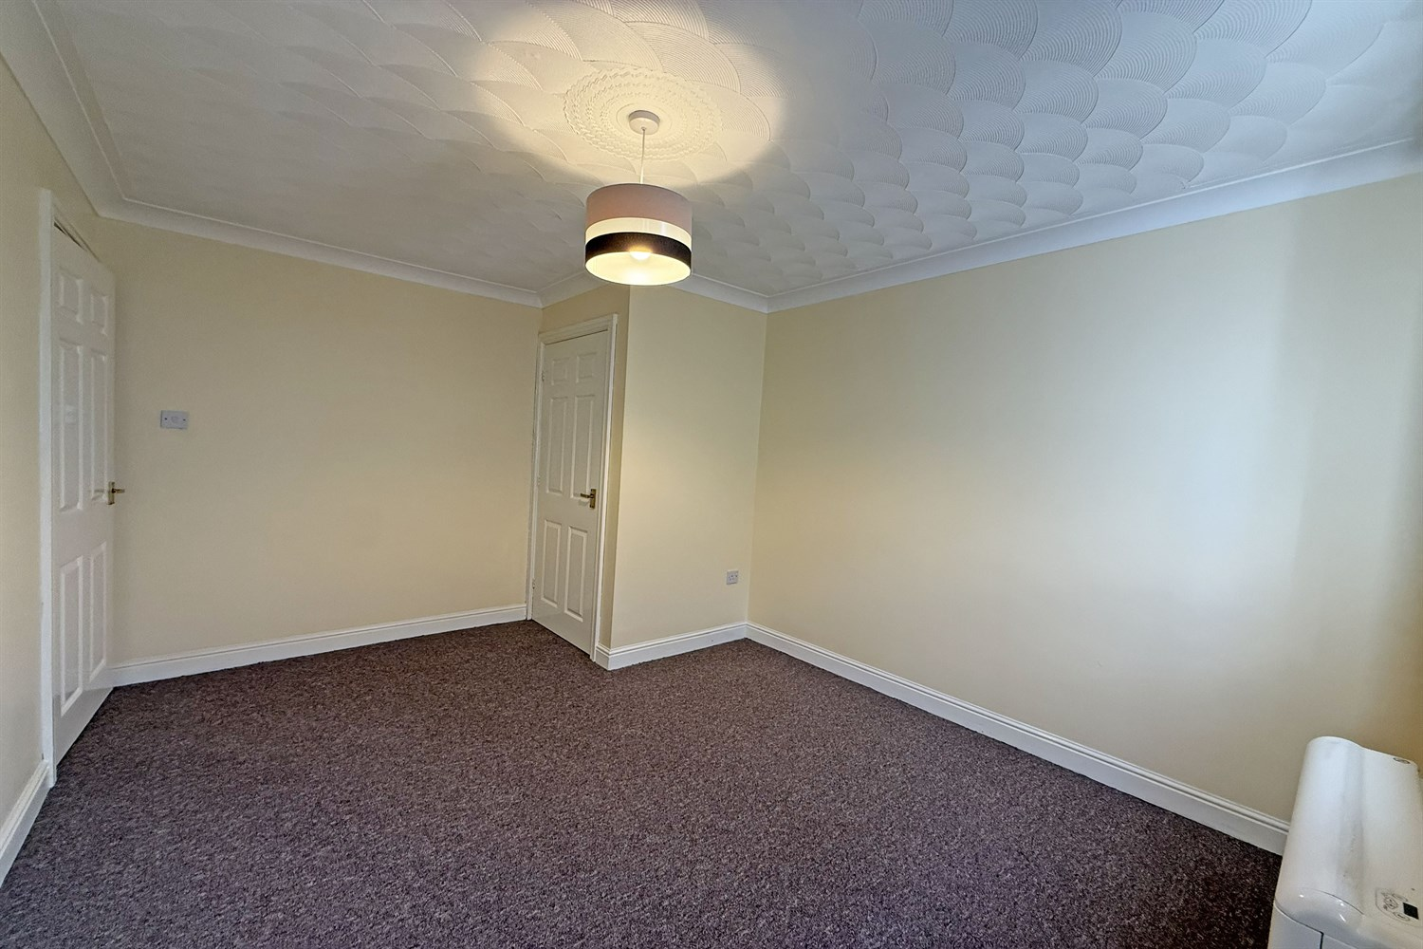
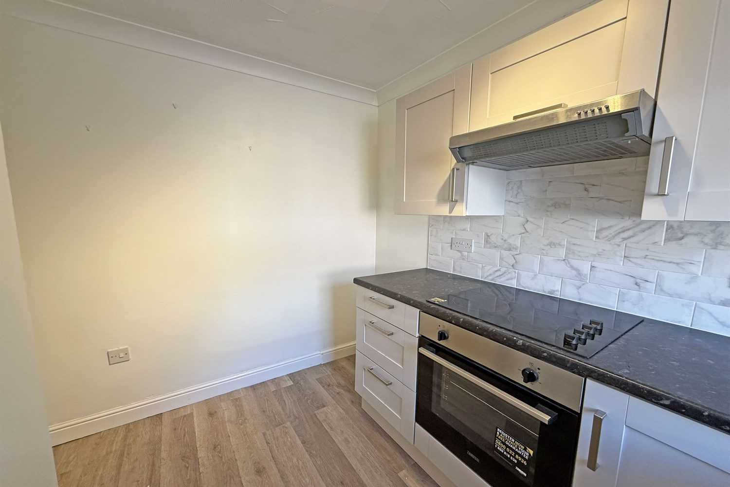

Lounge
Entrance leading to lounge area with windows to front elevation with TV and telephone points, carpet to floor.
Kitchen
A new kitchen compromising a range of wall and base units, stainless steel sink and tiled splash back. Integrated electric hob and oven with extractor fan over. Space and plumbing for a washing machine and space for a Fridge Freezer. Vinyl to the floor.
Bedroom
Double Room to the rear with an airing cupboard. Access to a door leading to rear courtyard, carpet to the floor.
Bathroom
Compromises a three-piece suite, bath with mixer shower over and tiled splashback. Hand basin and WC, vinyl to the floor.
Courtyard
Enclosed courtyard to the rear.
Parking
Allocated Residents Parking Space off Road
Additional Information
EPC Rating: C
Council Tax Band: A
Electric storage heaters and double glazing throughout.

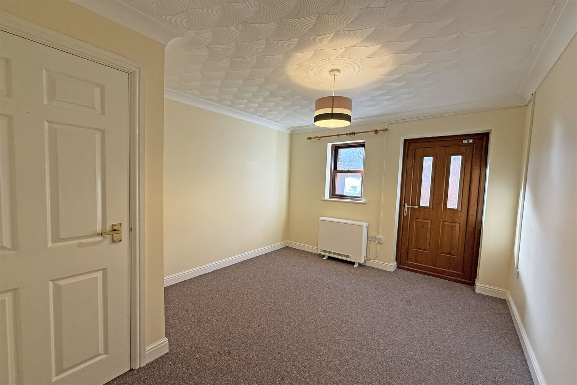

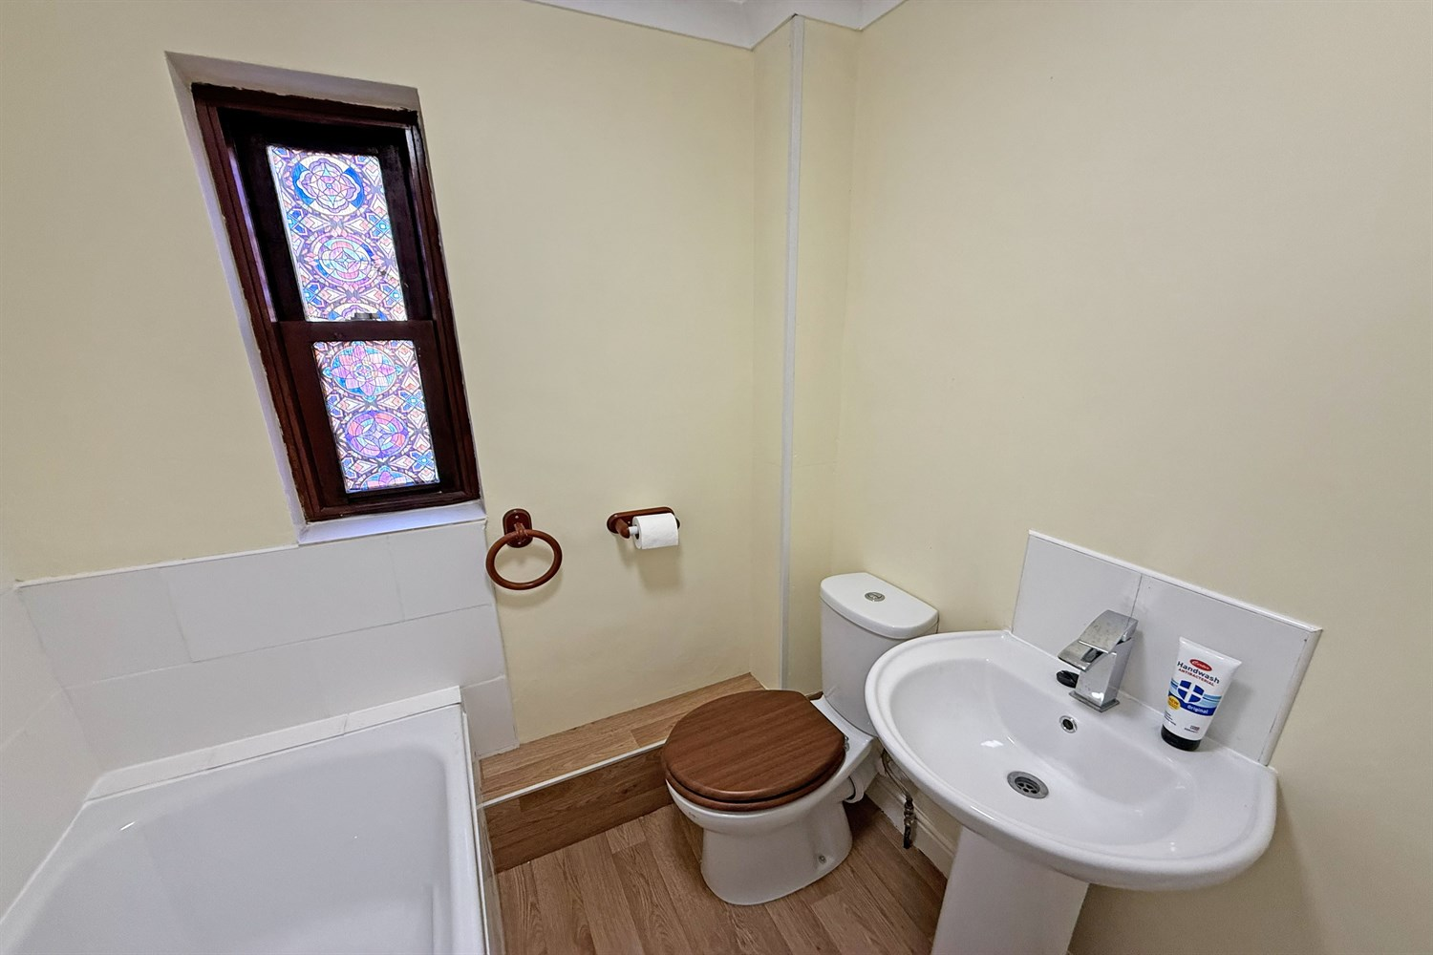

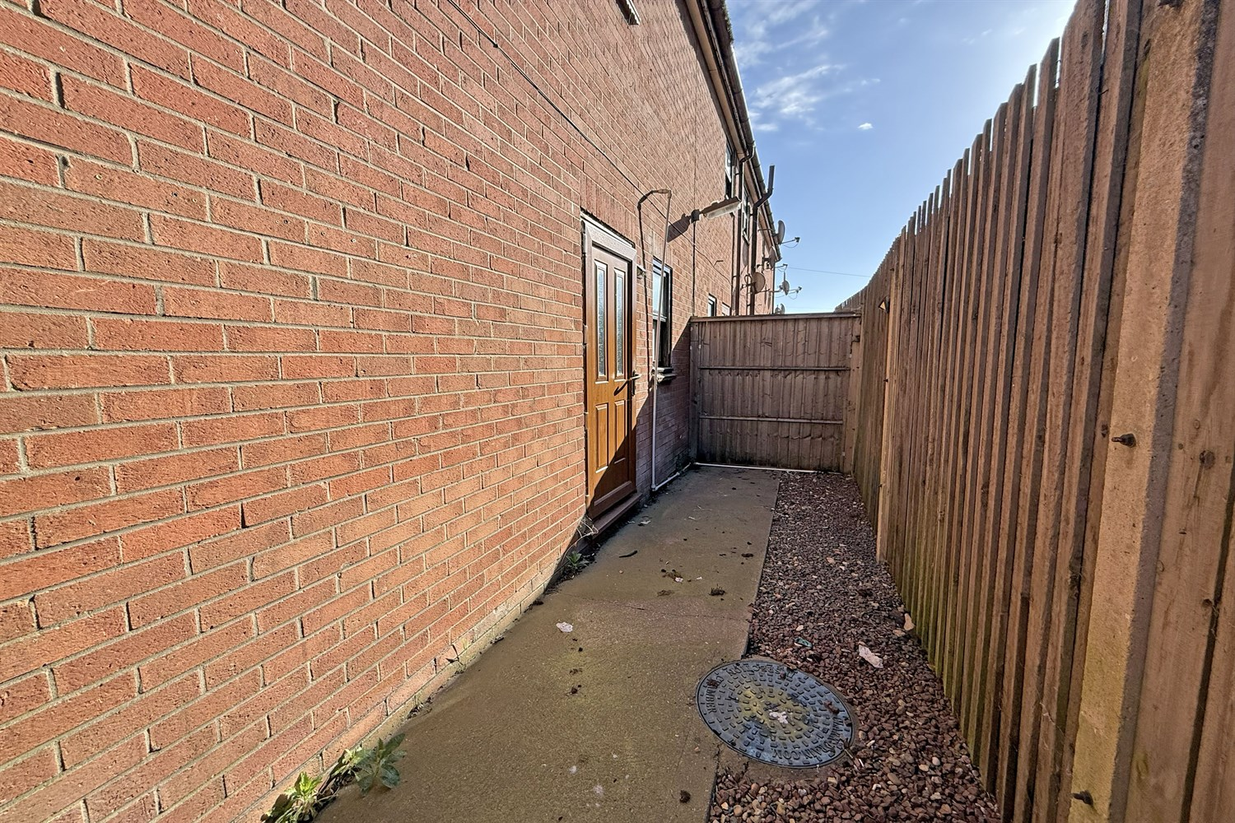
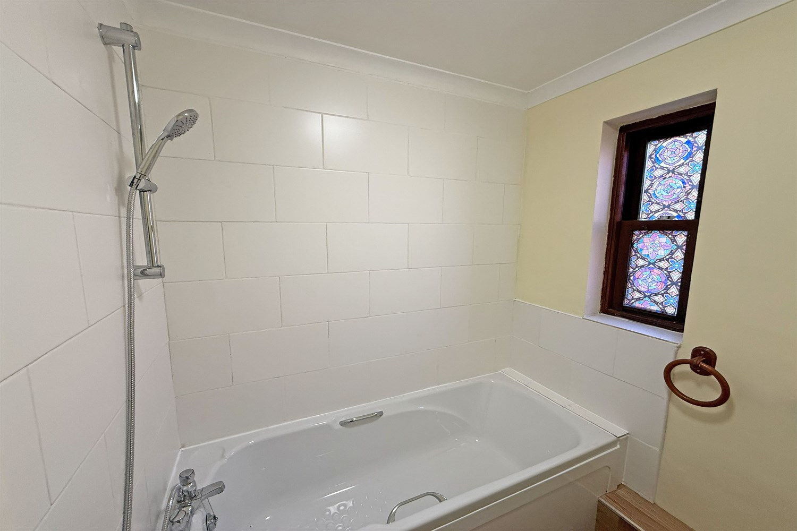

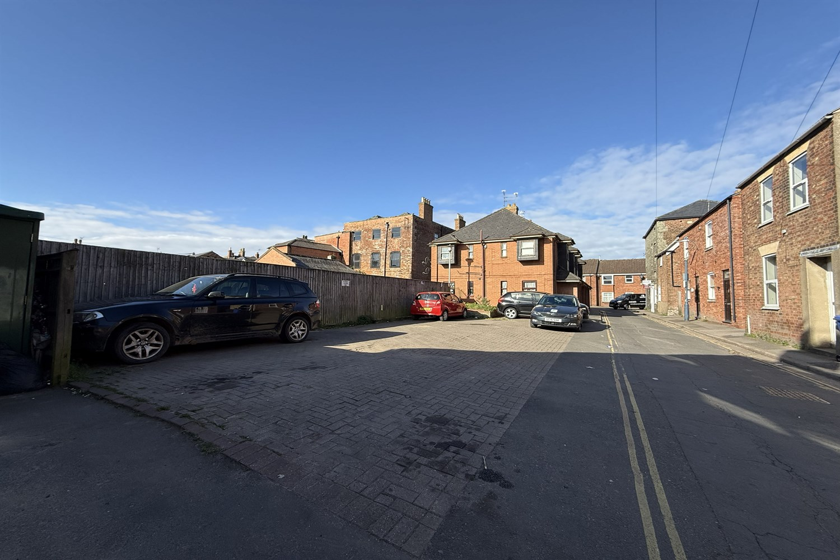

{IMAGE_FP_1-550w}
Agents Note: Whilst every care has been taken to prepare these sales particulars, they are for guidance purposes only. All measurements are approximate are for general guidance purposes only and whilst every care has been taken to ensure their accuracy, they should not be relied upon and potential buyers are advised to recheck the measurements
www.drurysestateagents.co.uk
amber@drurysestateagents.co.uk
01205 350889

45 Willoughby Road
Boston
Lincolnshire
PE21 9HN

