
£850.00 MONTH
EPC Rating ‘’
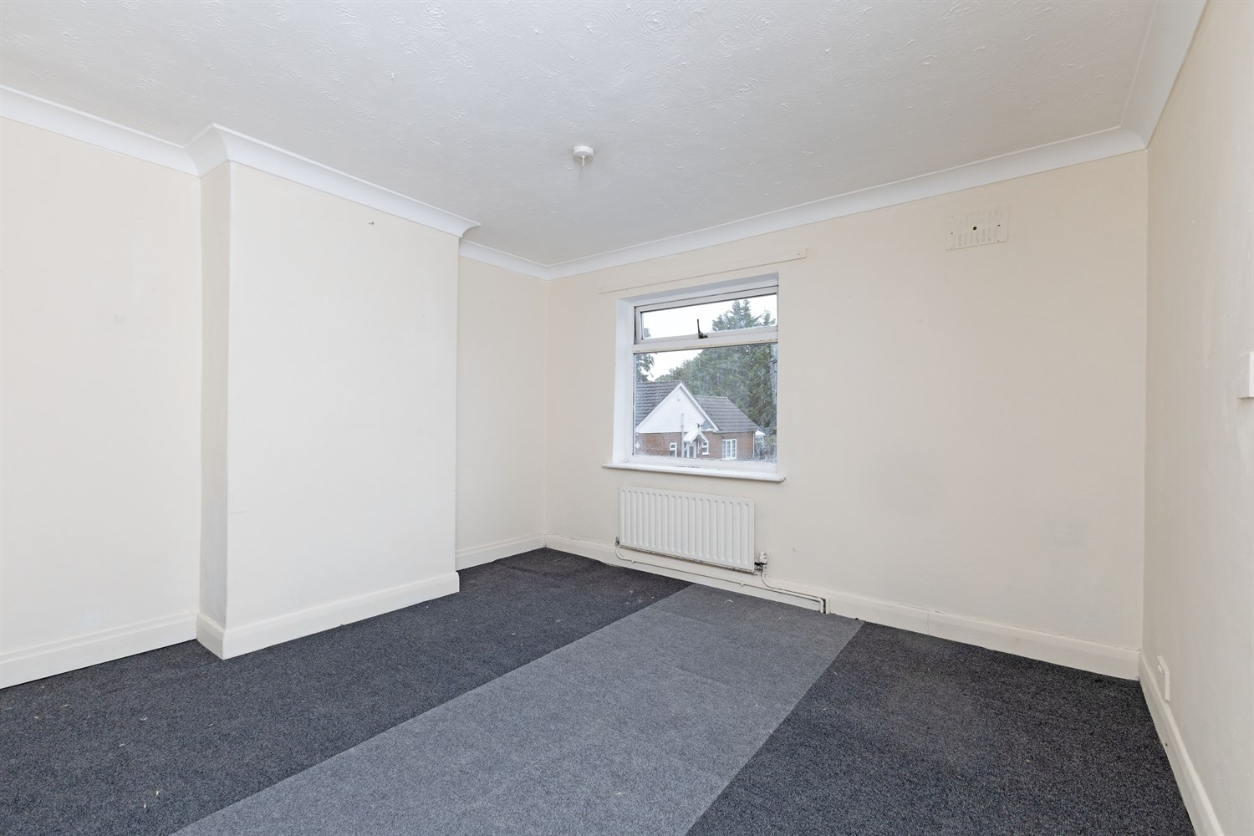
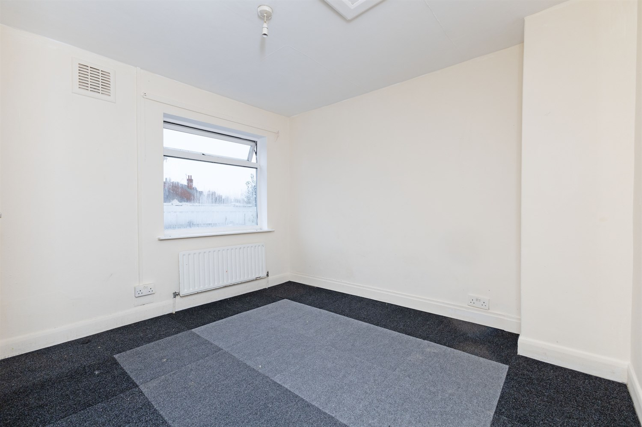
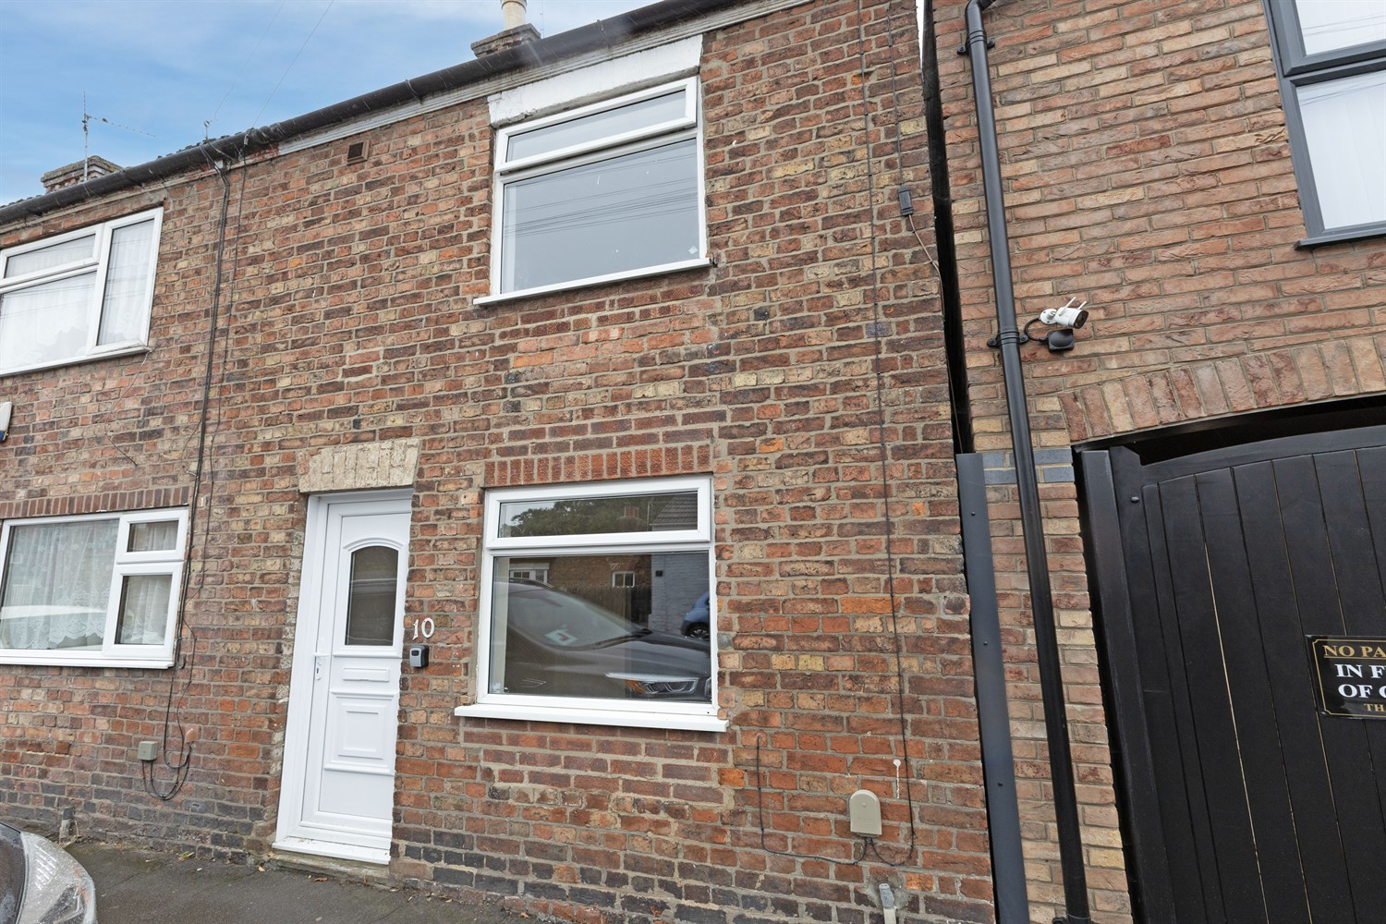

10 Castle Street
Boston, PE21 8PN

10 Castle Street, Boston, Lincolnshire, PE21 8PN
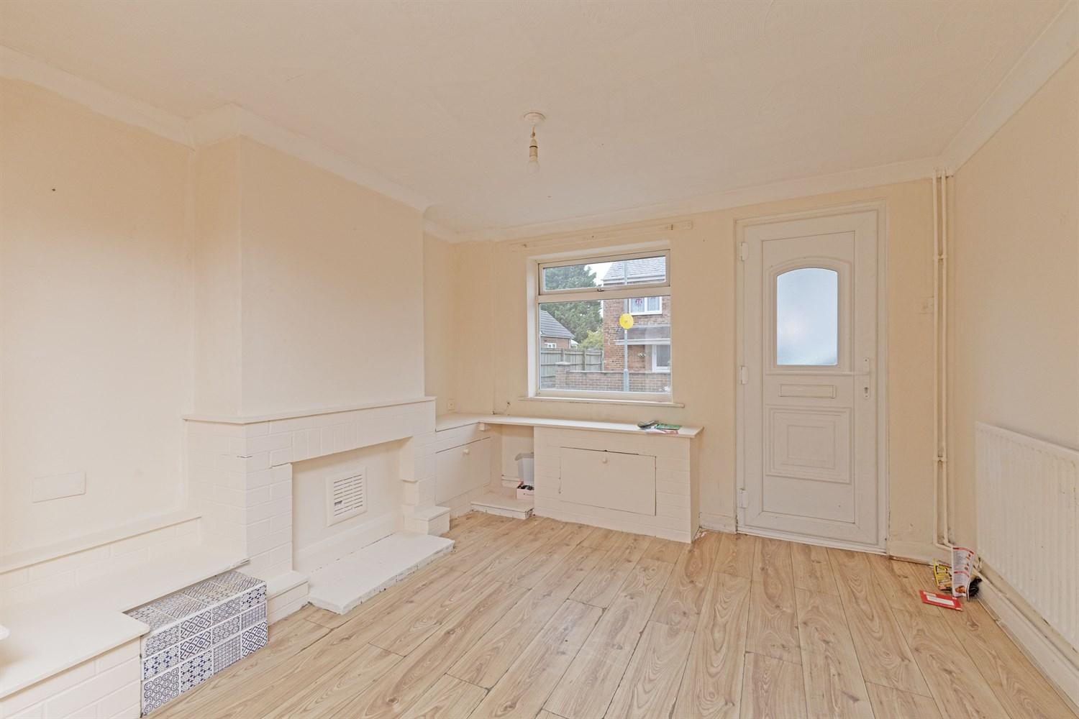
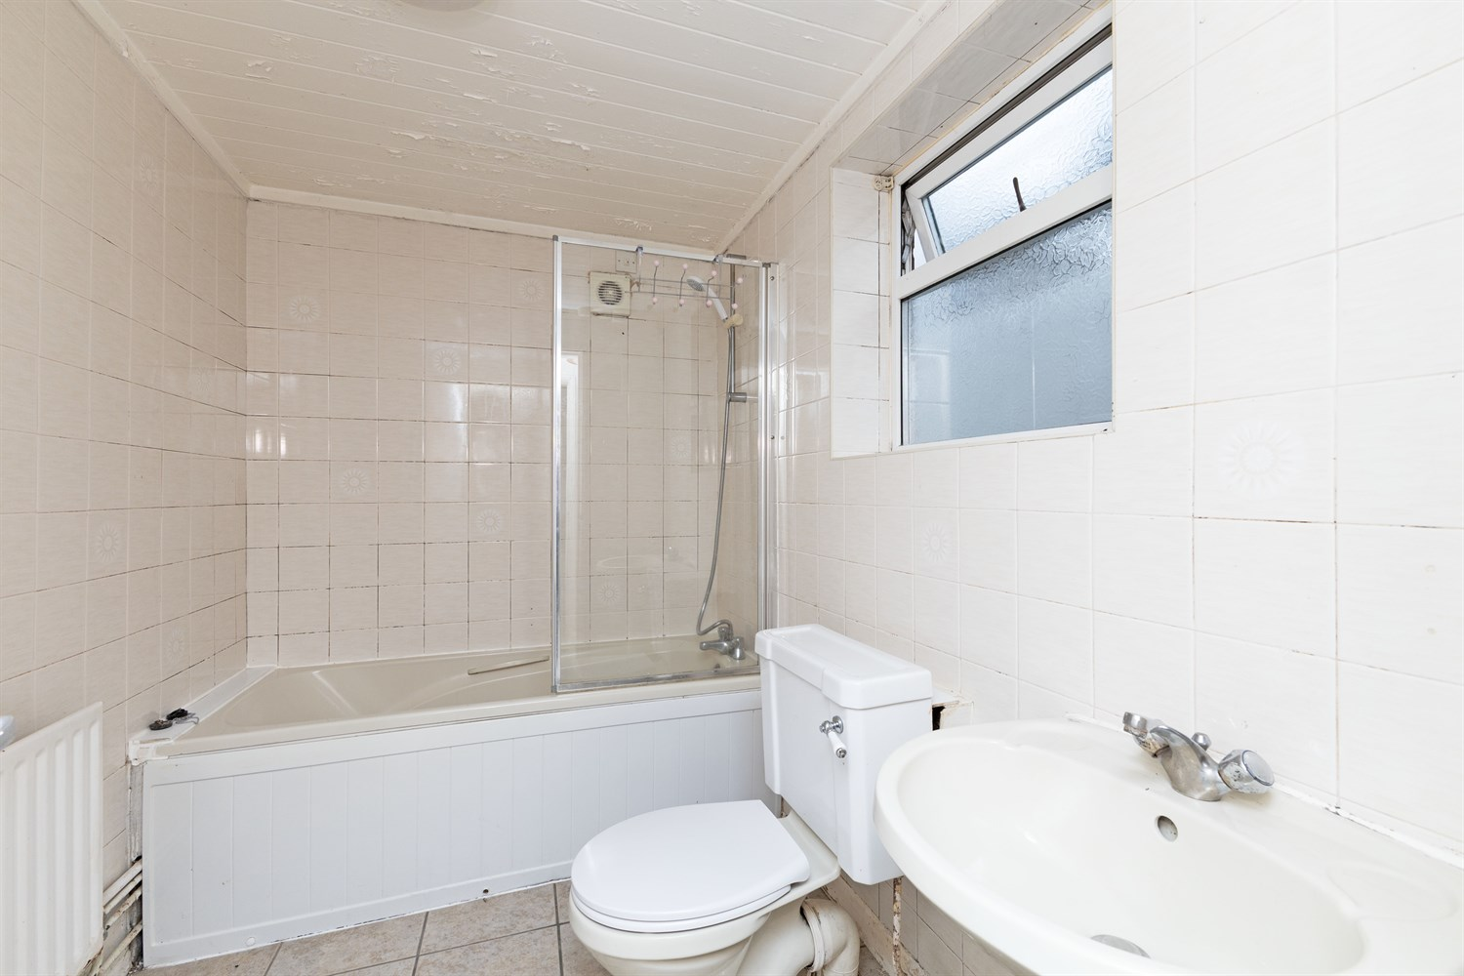
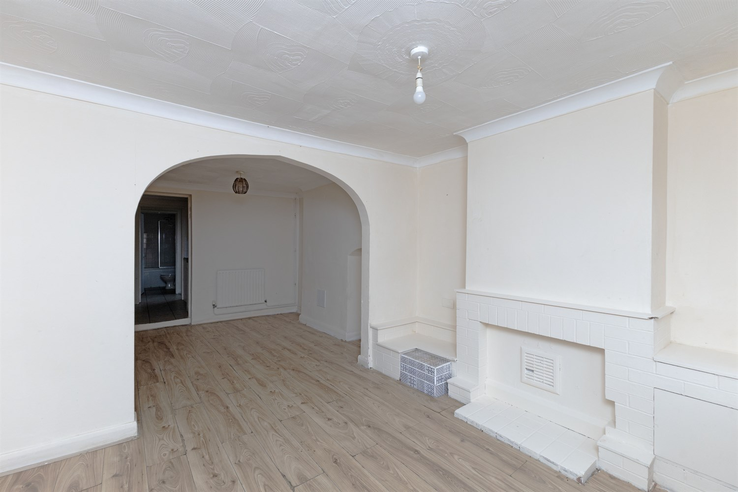

Bedroom 1
Double bedroom
Bedroom 2
Double Bedroom
Reception 1
Open reception/ dining area with fire place
Bathroom
3 piece suite including bath, shower and sink basin.
Kitchen

Garden
Tenants to maintain

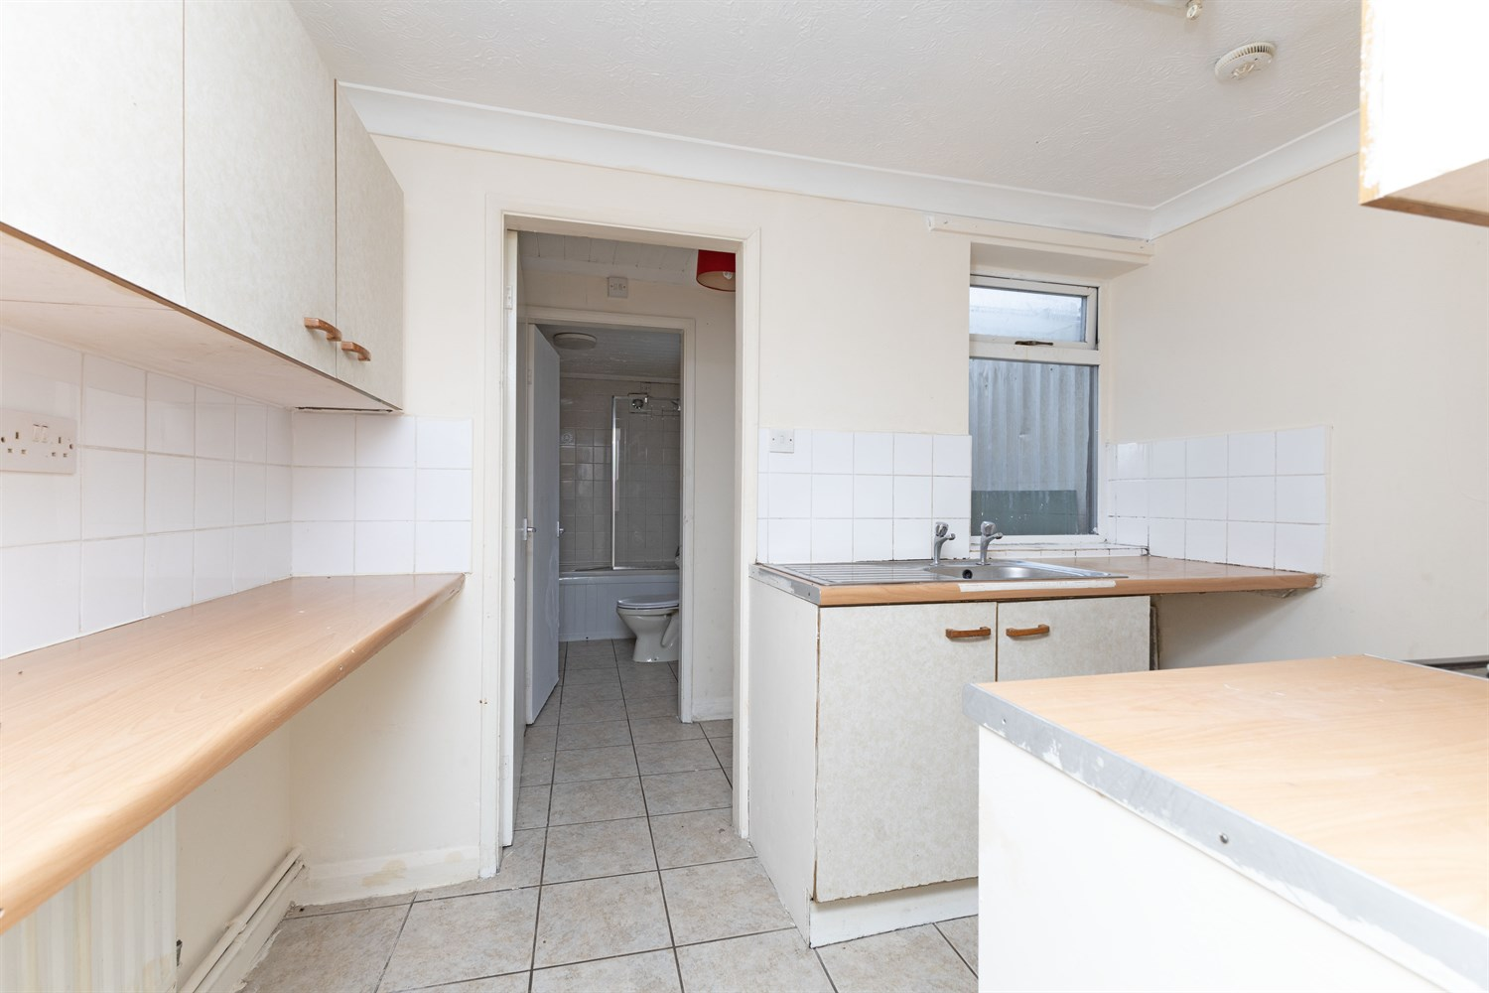

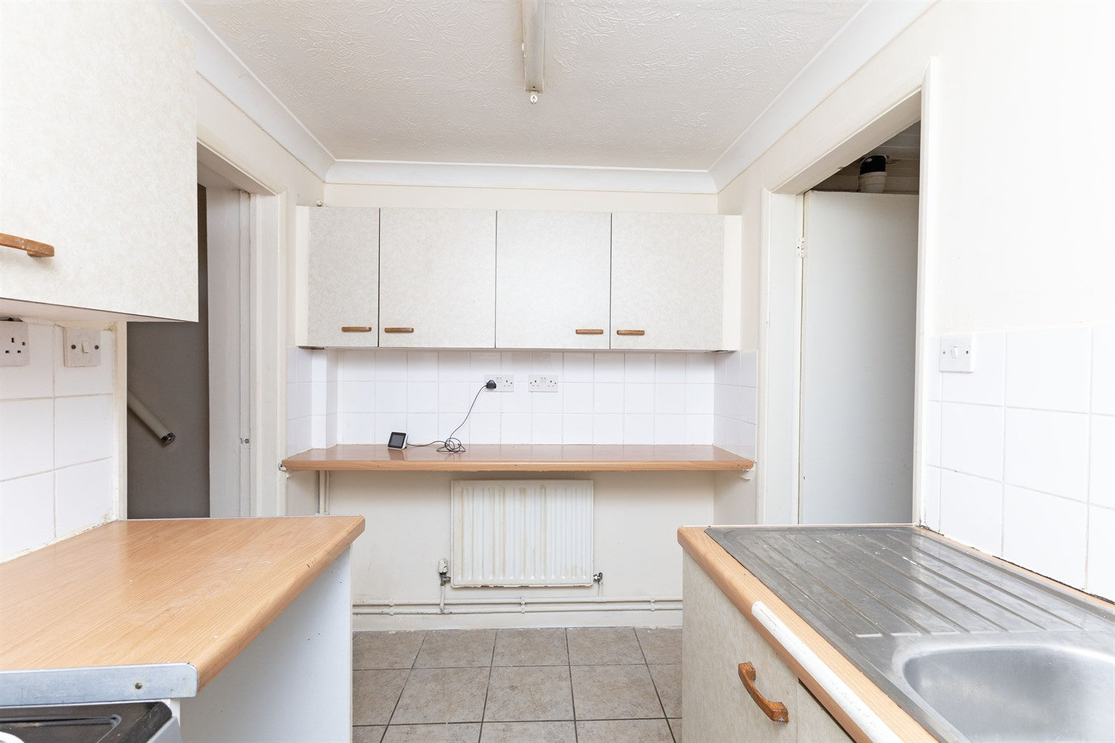

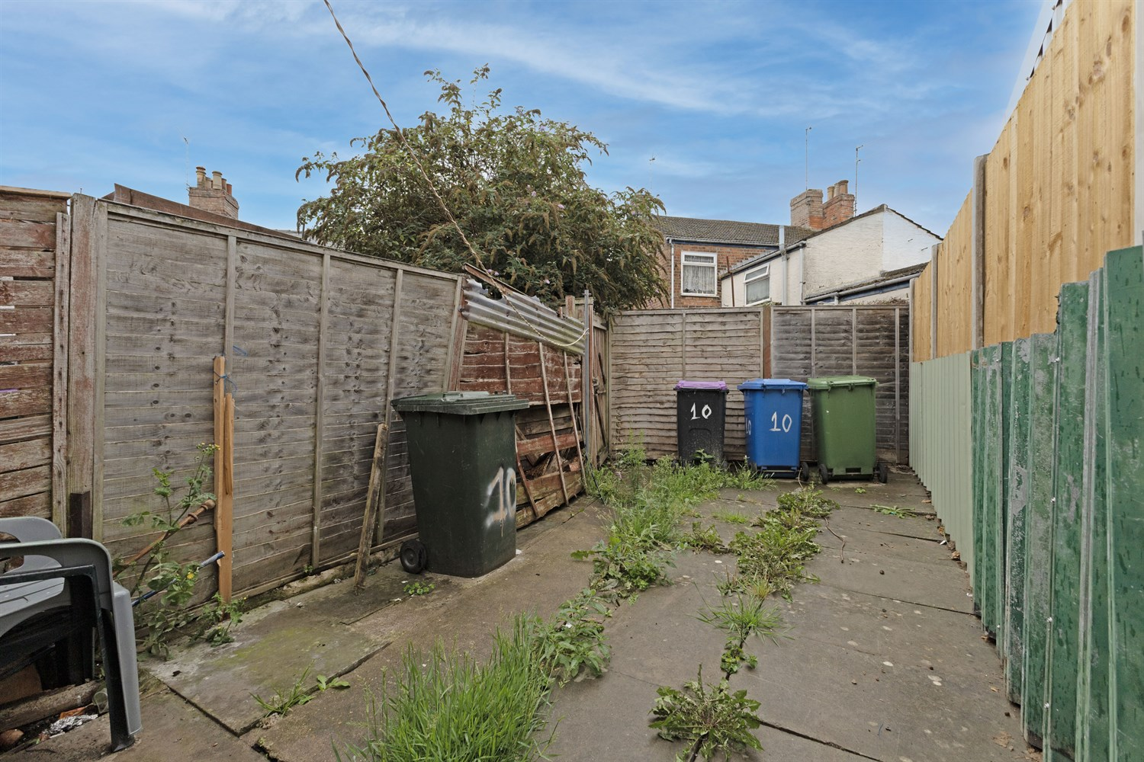
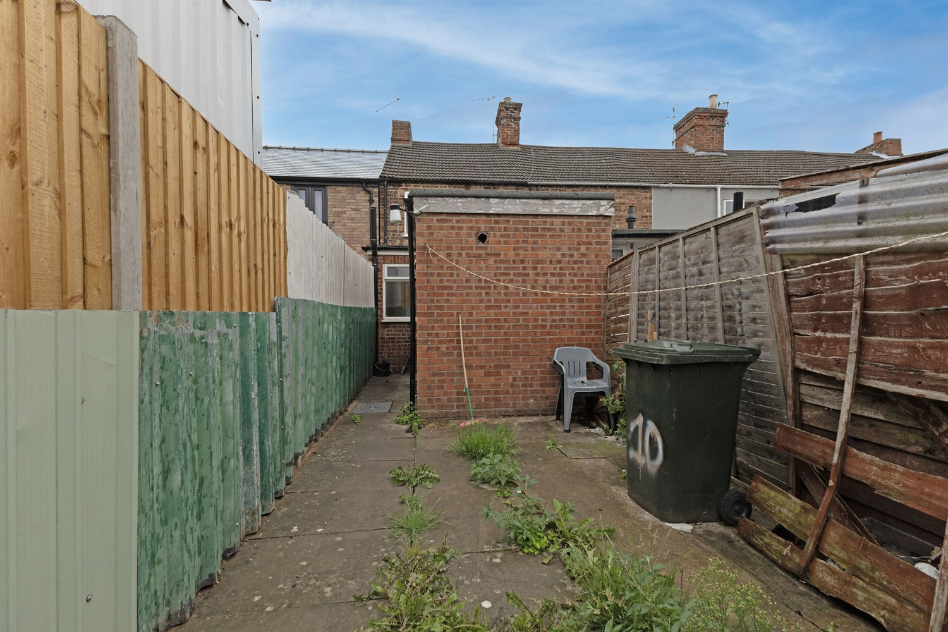

{IMAGE_FP_1-550w}
Agents Note: Whilst every care has been taken to prepare these sales particulars, they are for guidance purposes only. All measurements are approximate are for general guidance purposes only and whilst every care has been taken to ensure their accuracy, they should not be relied upon and potential buyers are advised to recheck the measurements
www.drurysestateagents.co.uk
amber@drurysestateagents.co.uk
01205 350889

45 Willoughby Road
Boston
Lincolnshire
PE21 9HN

