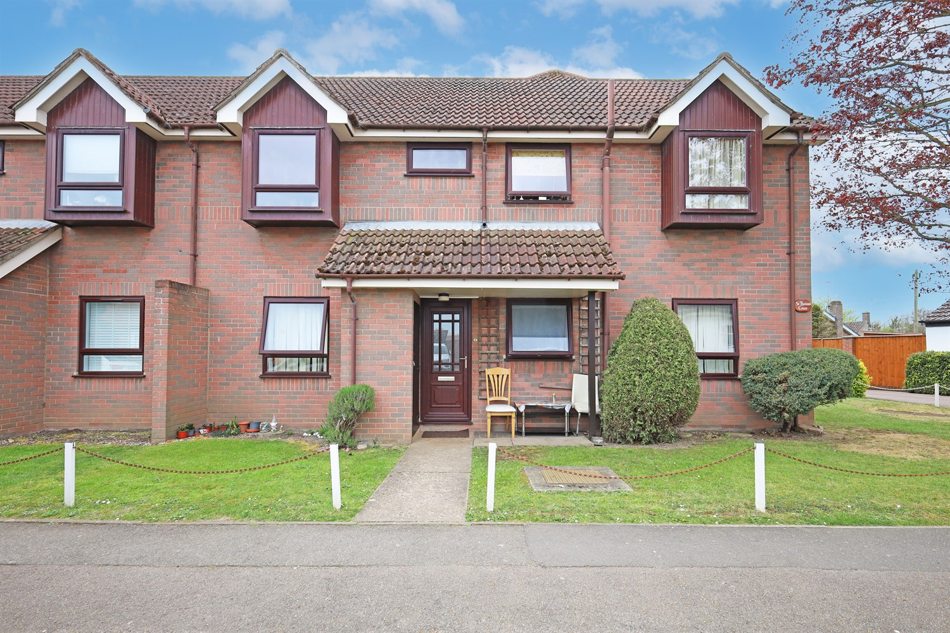




2 Bedroom(s)
1 Reception(s)
1 Bathroom(s)
£89,950.00
St Thomas Court, PE21
EPC Rating ‘’

- Ground Floor Flat
- No Onward Chain Ideal FTB or Investment
- Off Road Parking, Garden
- Close to Town Centre

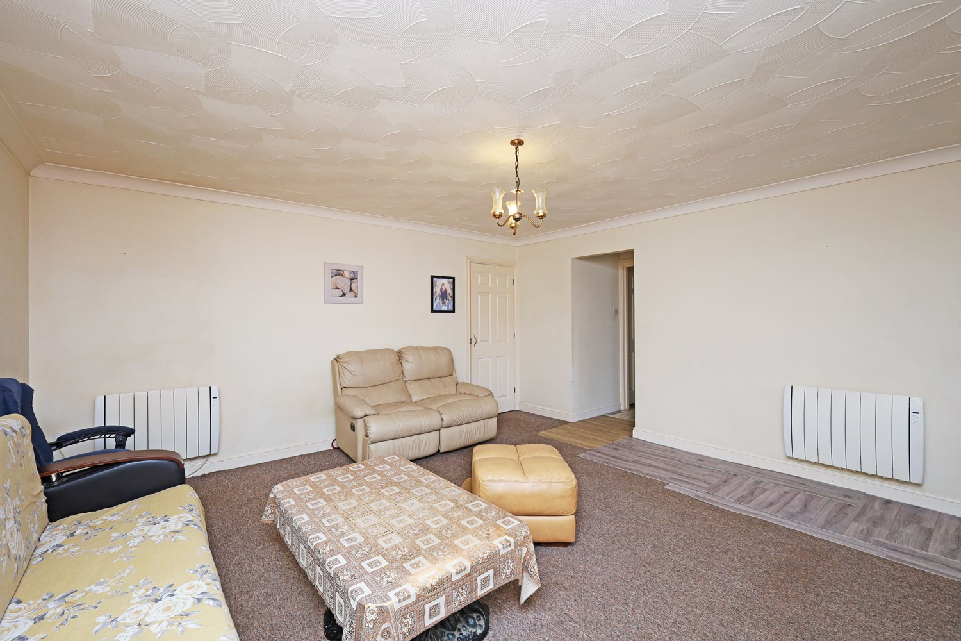
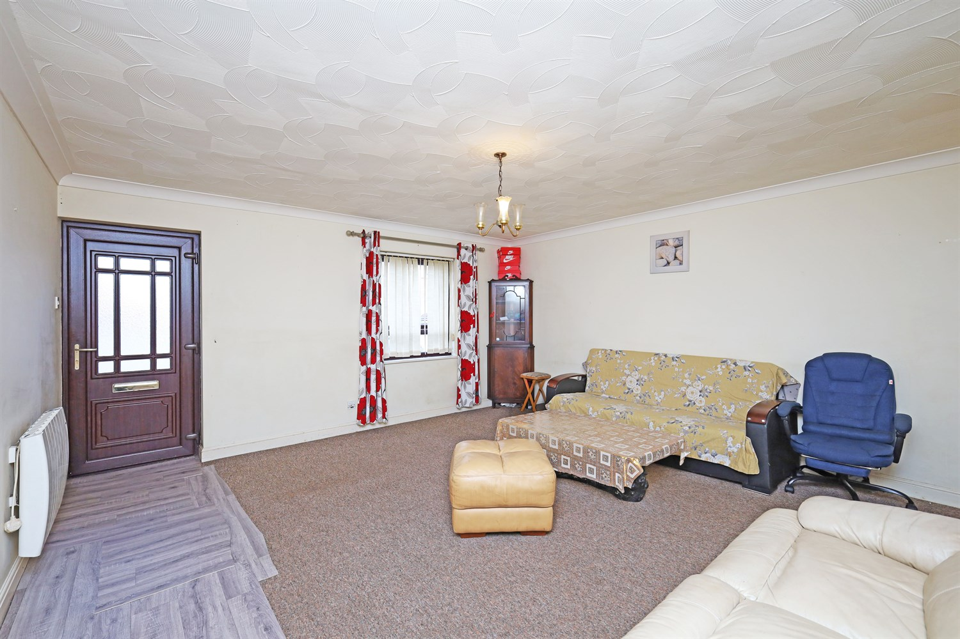
00

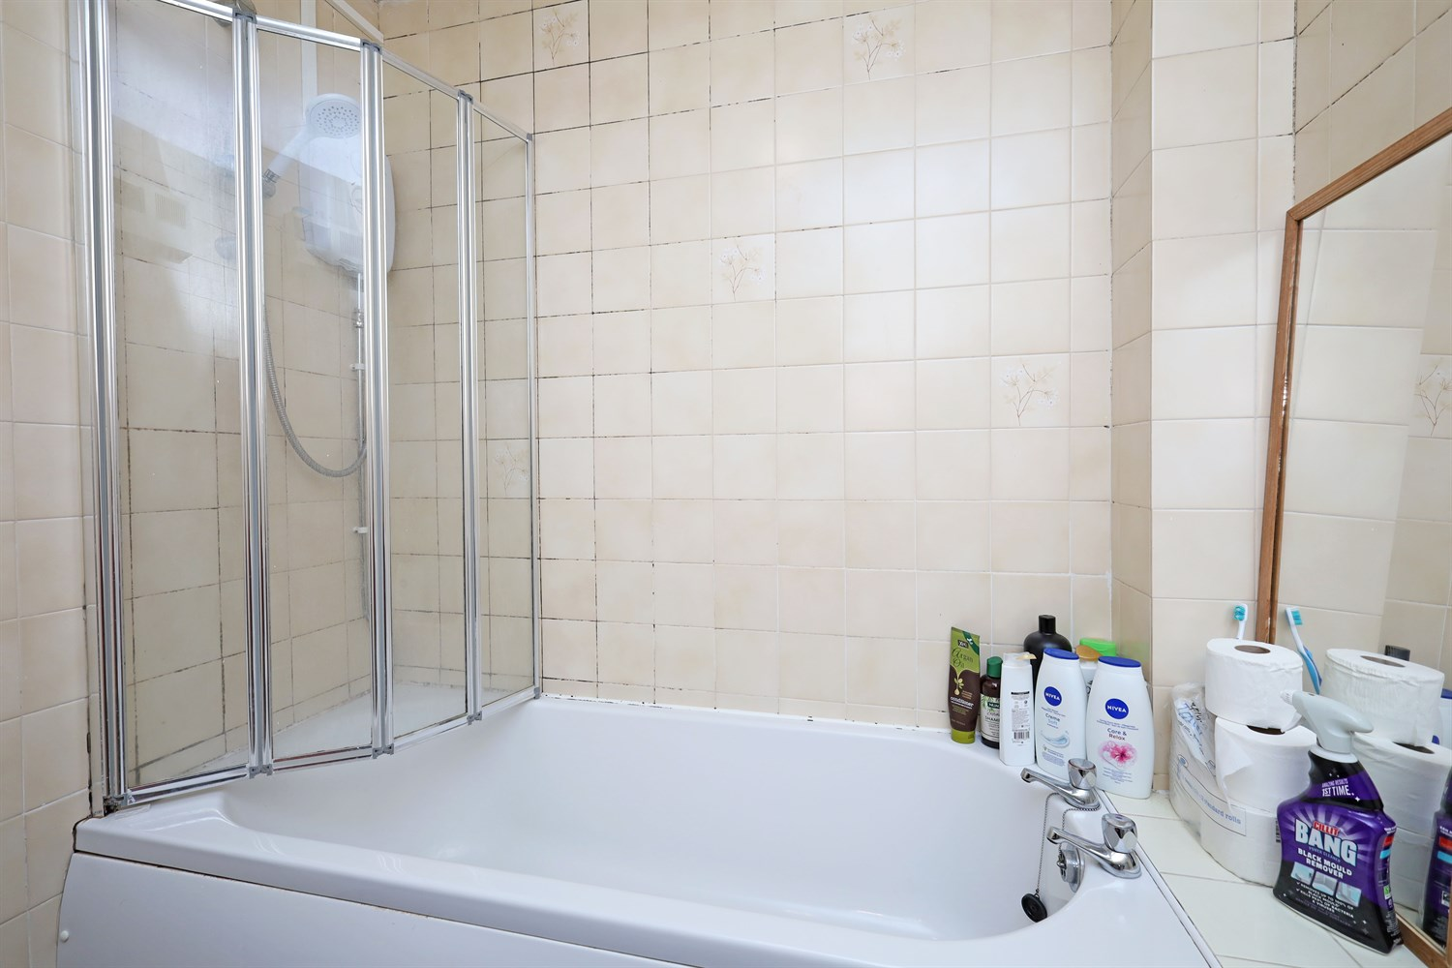
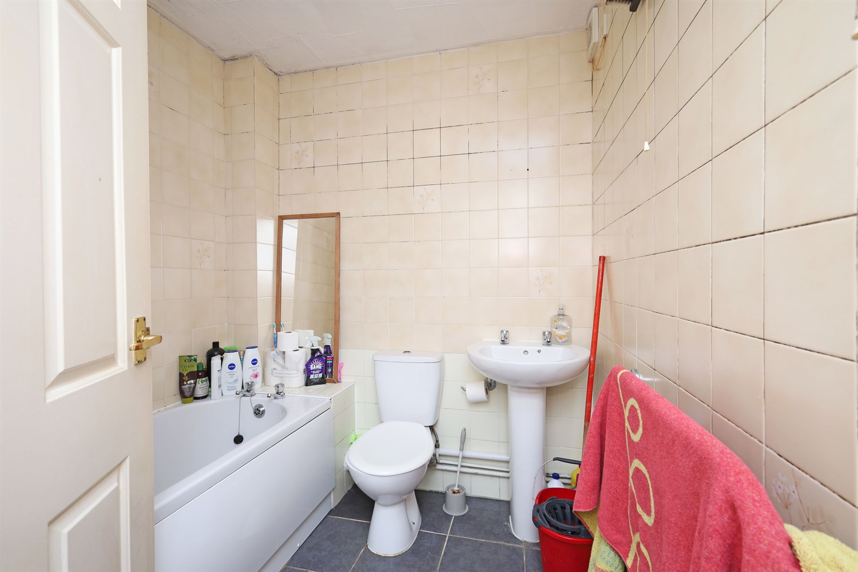
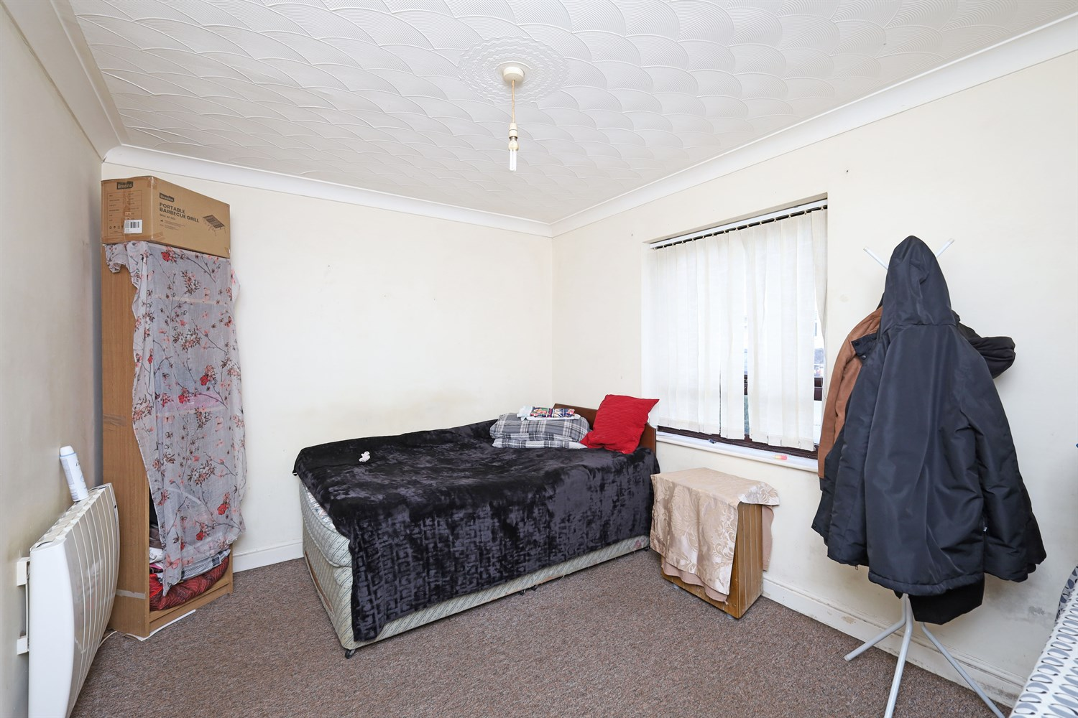
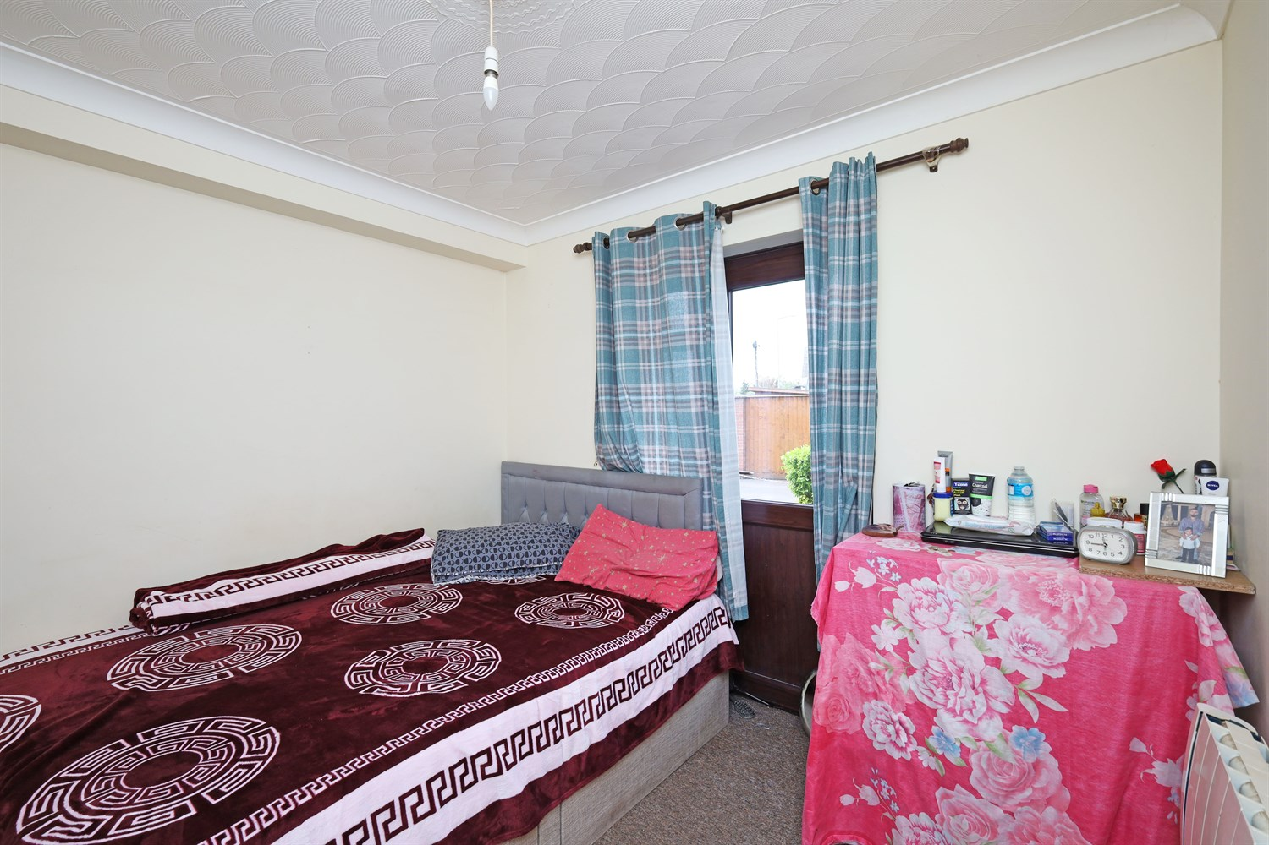

Property Description
NEW LISTING!! A Great 2 bedroom ground floor flat in St Thomas Court in Boston. In a great location, close to town and with plenty of local amenities nearby. The flat consists of a lounge, kitchen area, two double bedrooms one and family bathroom. There is an allocated parking space for the flat.

Brief Description
Entering through the front door, you are welcomed into a comfortable living room featuring a front-facing window, two electric radiators, a useful storage cupboard, and a fitted carpet. The room is completed with a central ceiling light point and offers a bright, inviting space to relax.
The living room leads through to a hallway, providing access to the kitchen. The kitchen is fitted with a sink, hob, and offers space for a fridge and a washing machine beneath the counter. A front-facing window allows for natural light, and the space is finished with practical lino flooring and a ceiling light point.
The property offers two double bedrooms:

Lounge
Featuring a front-facing window, two electric radiators, a useful storage cupboard, and a fitted carpet. The room is completed with a central ceiling light point. This room leads onto the inner hallway, allowing access to the 2 bedrooms and Kitchen.

Kitchen
The kitchen is fitted with a sink, hob, and offers space for a fridge and a washing machine beneath the counter, units to the floor and base level with work top over. A front-facing window allows for natural light, and the space is finished with practical lino flooring and a ceiling light point.

Bedroom 1
A double bedroom includes a front-facing window, an electric radiator, fitted carpet, and a ceiling light point.

Bedroom 2
This is also a double room, featuring carpet flooring, an electric radiator, a side door with a glazed panel for additional light, and built-in storage/wardrobe cupboard access.

Bathroom
The bathroom is fitted with tiled flooring, a heated towel rail, and a three-piece suite including a bath with an overhead shower.

Parking
Allocated parking to the rear of the property.

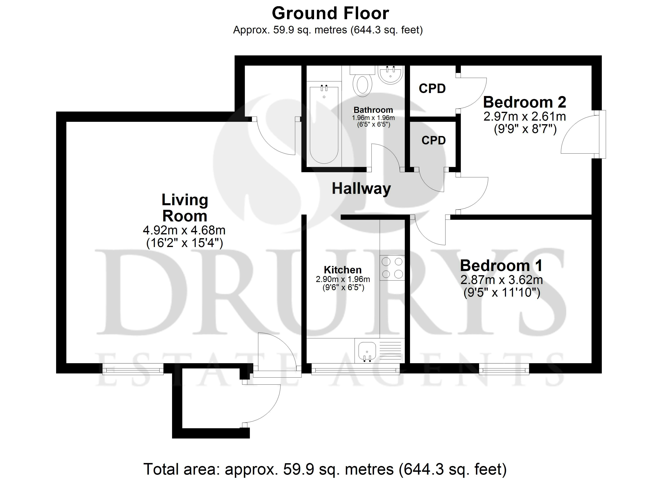

These particulars are intended to give a fair description of the property, but their accuracy cannot be guaranteed, and they do not constitute an offer of contract. Intending purchasers must rely on their own inspection of the property. None of the above appliances/services have been tested by ourselves. We recommend purchasers arrange for a qualified person to check all appliances/services before legal commitment.

Property Ref: 3504

www.drurysestateagents.co.uk
amber@drurysestateagents.co.uk
01205 350889

45 Willoughby Road
Boston
Lincolnshire
PE21 9HN
Agents Note: Whilst every care has been taken to prepare these sales particulars, they are for guidance purposes only. All measurements are approximate are for general guidance purposes only and whilst every care has been taken to ensure their accuracy, they should not be relied upon and potential buyers are advised to recheck the measurements

