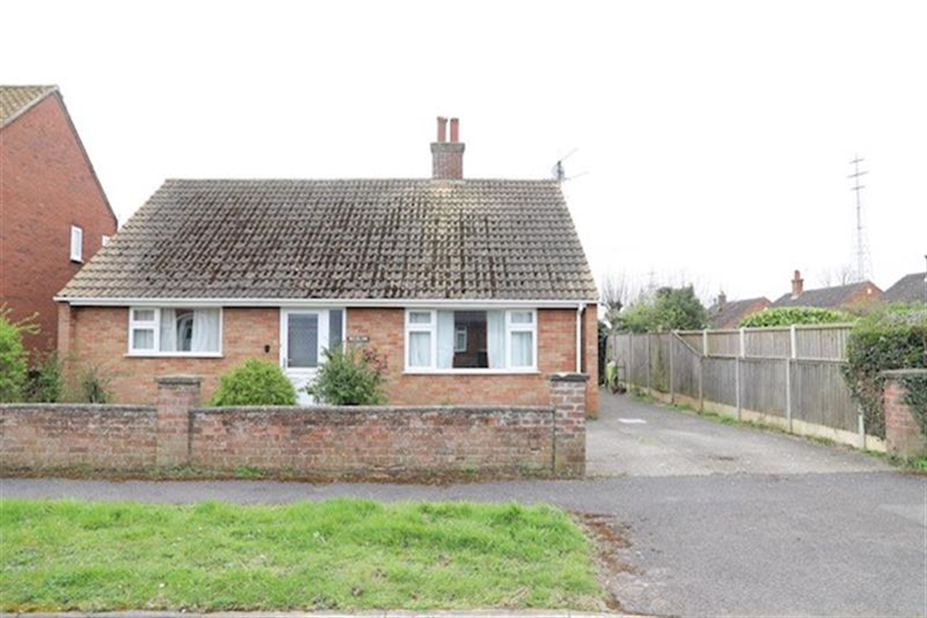




3 Bedroom(s)
1 Reception(s)
1 Bathroom(s)
£199,950.00
Kings Crescent, PE21
EPC Rating ‘’

- Sought After Location
- Mature Garden
- Flexible accommodation
- Chain Free

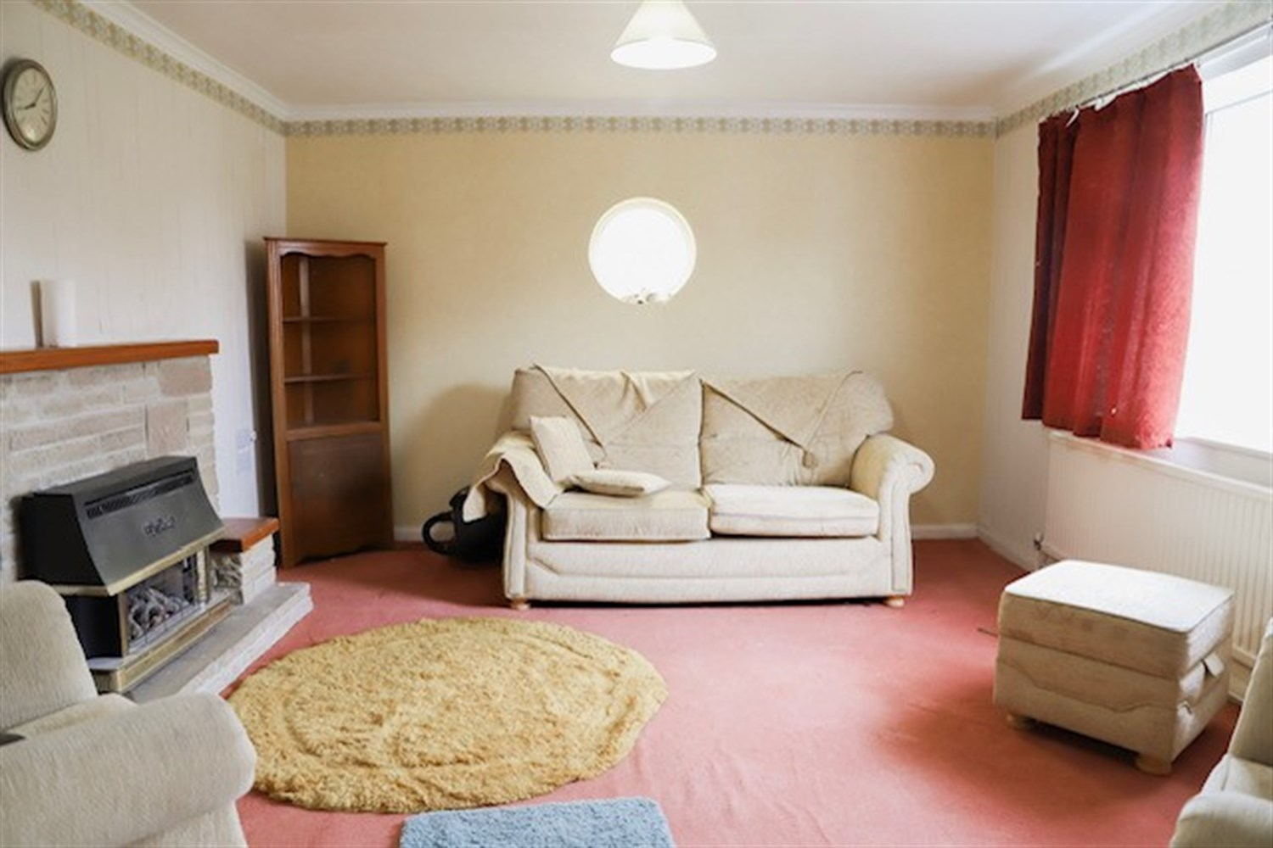
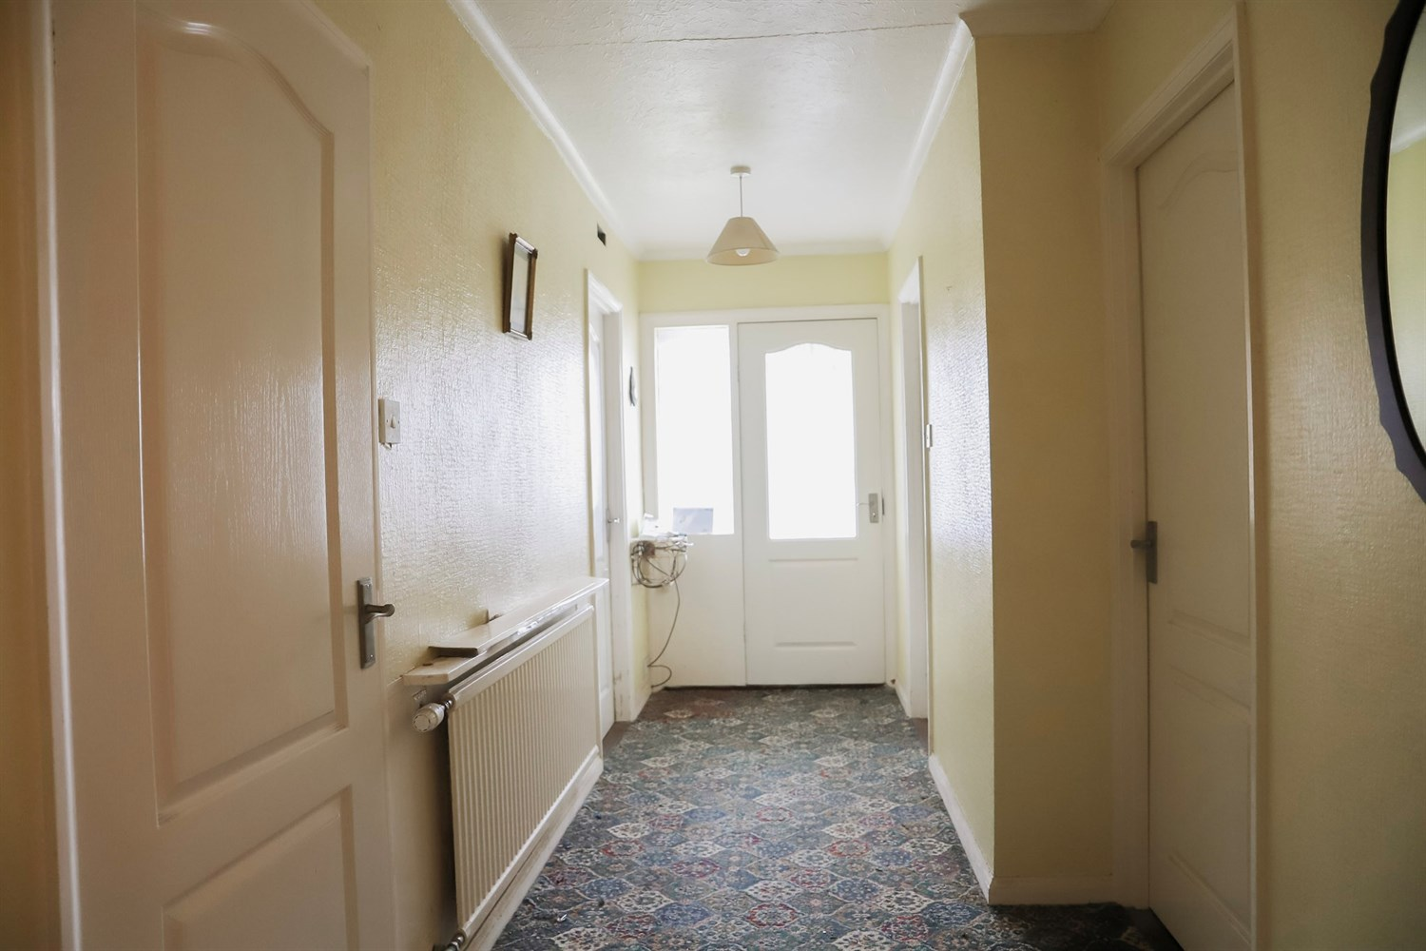
00

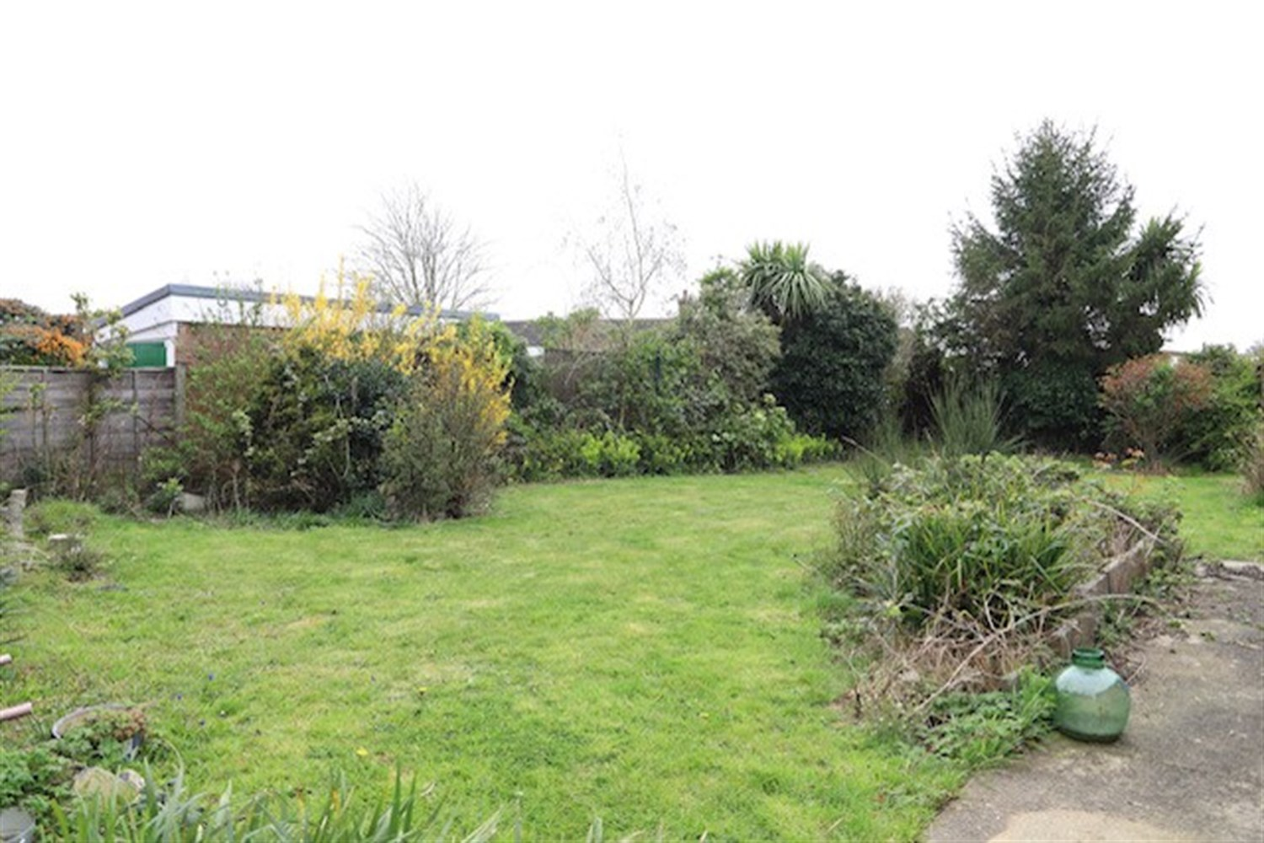
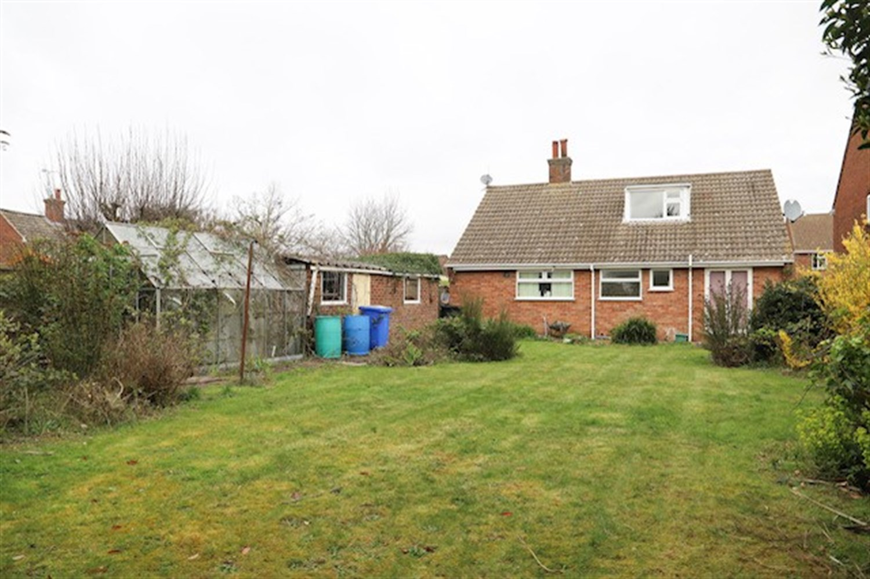
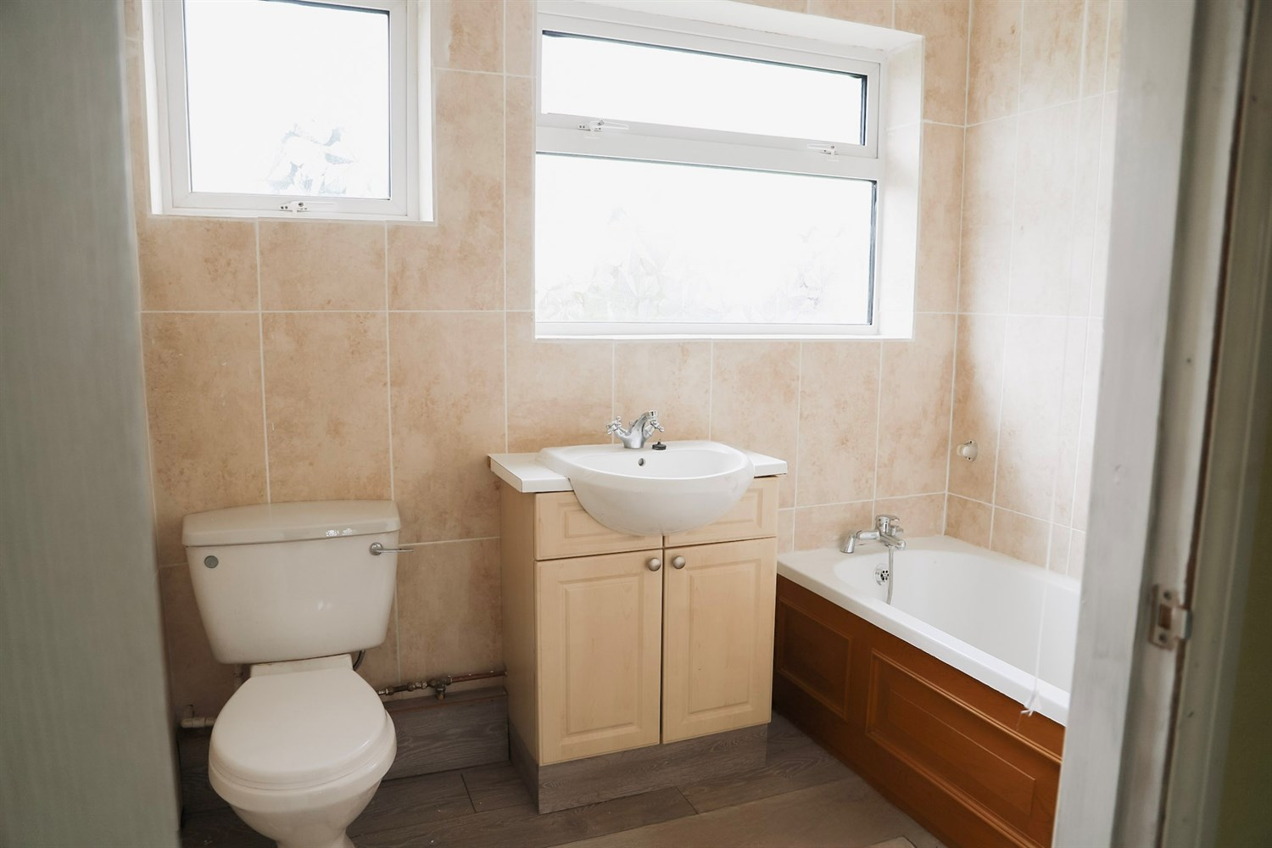
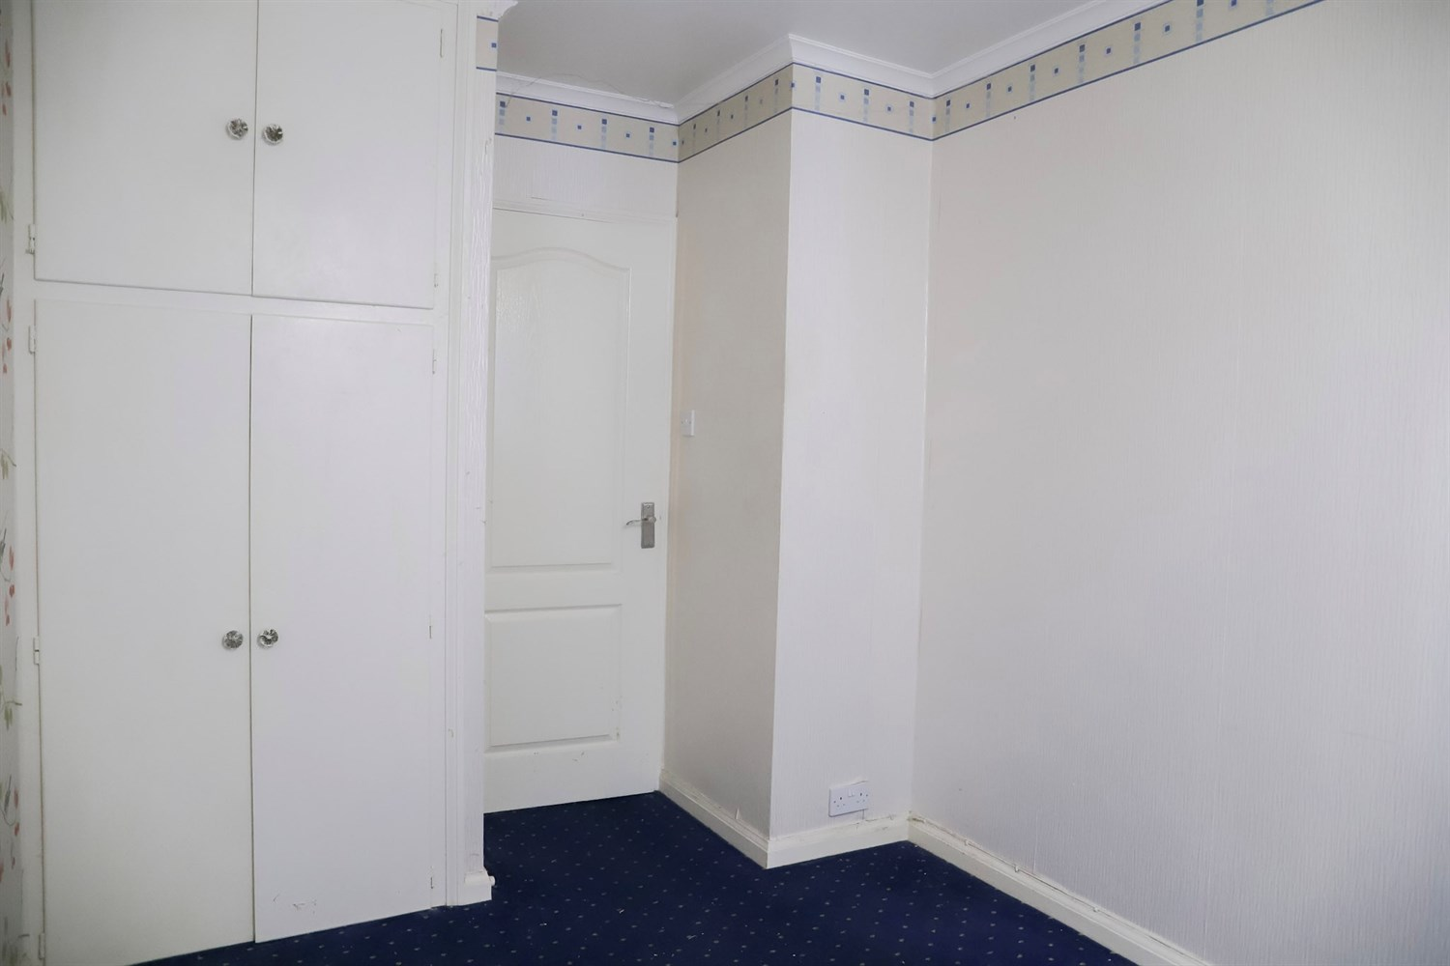
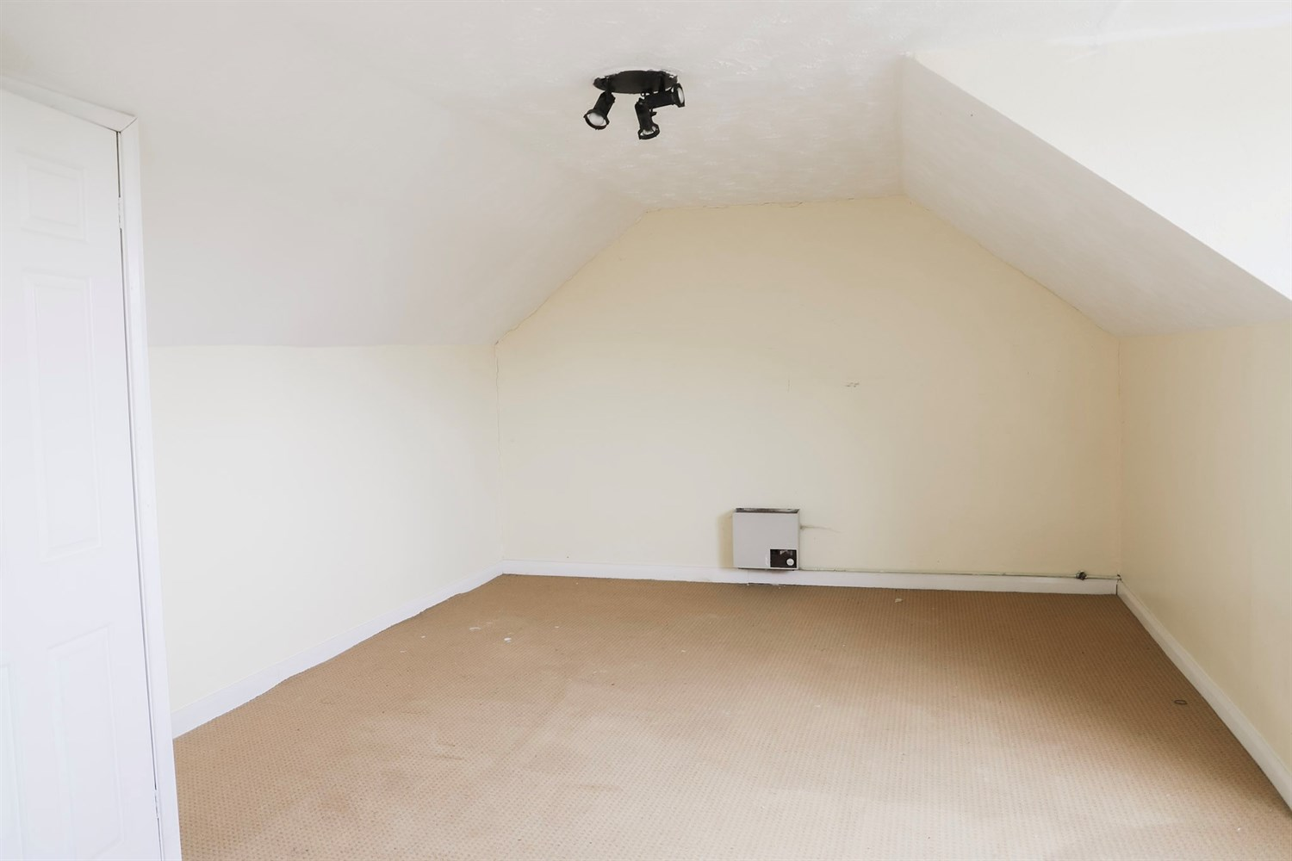
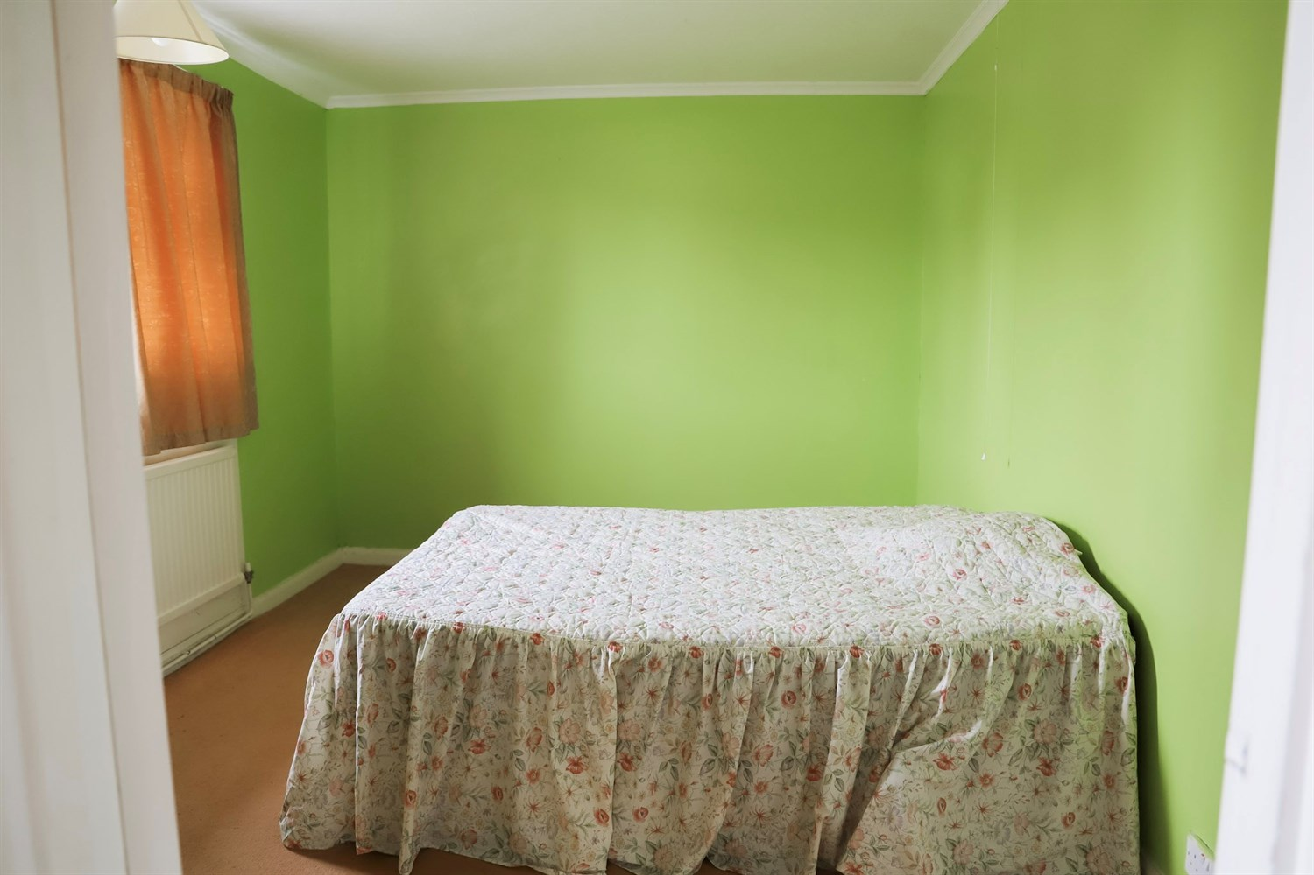
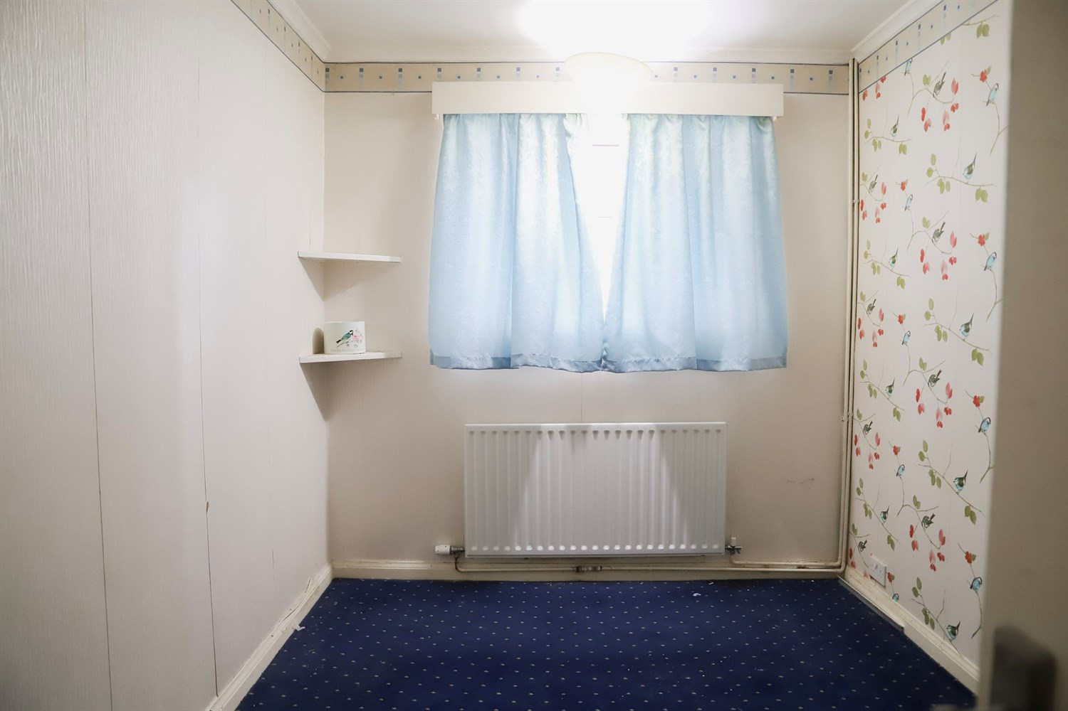

A detached bungalow requiring some modernisation, being sold with the advantage of NO ONWARD CHAIN. The property is situated in a popular residential location close to the town centre. Accommodation comprises a lounge, kitchen/diner with pantry, 3 bedrooms, a family bathroom and converted attic. Further benefits include a driveway, gardens to the front and rear and gas central heating.

Inner Hallway
Entered through the porch door the hallway features a single panelled radiator, ceiling light points, access to lounge, kitchen, bathroom and three bedrooms.

Lounge
This large room compromises a window to front elevation, a single panelled radiator, ceiling light point and electric fire in a brick fireplace feature.

Kitchen
A fitted kitchen comprising a range of wall and base units with work surfaces, incorporating a stainless steel sink and drainer with mixer tap and a gas hob. The kitchen also offers a built in electric oven and grill. There is space and plumbing for a washing machine and the room benefits from tiled splashback, a uPVC double glazed window to the rear aspect and space for a dining area with a single panelled radiator.

Bedroom 1
Spacious double bedroom having a window to front elevation, a single panelled radiator, ceiling light point, built-in storage cupboard.

Bedroom 2
Having window to side elevation, a single panelled radiator, ceiling light point and built-in wardrobe/storage.

Bedroom 3
Bedroom to rear with french glass double doors leading into the garden, a double panelled radiator and ceiling light point.

Attic Conversion
Spacious upstairs Attic Conversion with window to the side elevation

Bathroom
Having a three piece suite with panel bath featuring a hot and mixer tap, pedestal sink, WC and two seperate frosted windows to the rear aspect.

Mature sized Garden
This lovely enclosed garden laid with lawn, perennials, shrubs, with fencing all around has a shed located at the bottom of the garden and the garage to the right hand side. Access from the third bedroom from the patio doors or from the right hand side of the property via the driveway. This really is a sun trap and is a great place to relax or entertain.

Garage
A good size brick built garage separate from the property with a up and over door with two windows to the side aspect and a side door.

Driveway
Having a driveway with access to the garage.

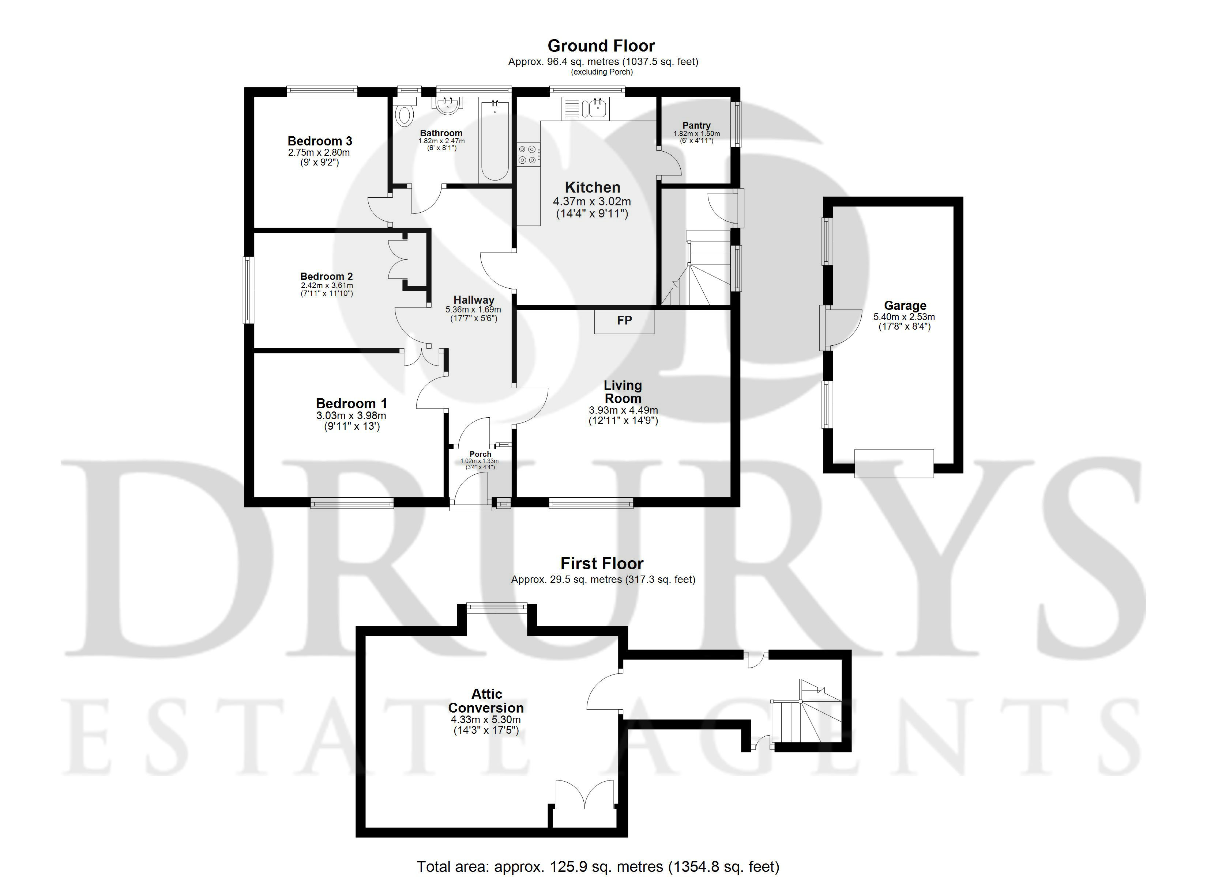

These particulars are intended to give a fair description of the property, but their accuracy cannot be guaranteed, and they do not constitute an offer of contract. Intending purchasers must rely on their own inspection of the property. None of the above appliances/services have been tested by ourselves. We recommend purchasers arrange for a qualified person to check all appliances/services before legal commitment.

Property Ref: 3428

www.drurysestateagents.co.uk
amber@drurysestateagents.co.uk
01205 350889

45 Willoughby Road
Boston
Lincolnshire
PE21 9HN
Agents Note: Whilst every care has been taken to prepare these sales particulars, they are for guidance purposes only. All measurements are approximate are for general guidance purposes only and whilst every care has been taken to ensure their accuracy, they should not be relied upon and potential buyers are advised to recheck the measurements

