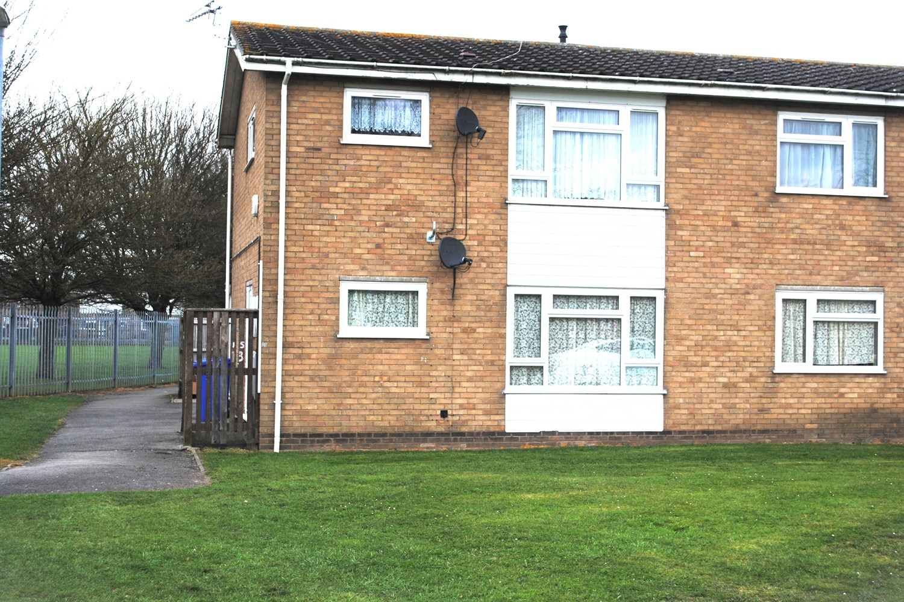




2 Bedroom(s)
1 Reception(s)
1 Bathroom(s)
£89,950.00
Broadfield Lane, PE21
EPC Rating ‘’

- Investment Purchase Only
- Ground Floor Apartment
- Two Bedrooms, Living Room & Modern Kitchen
- Located Close to Boston Town Centre

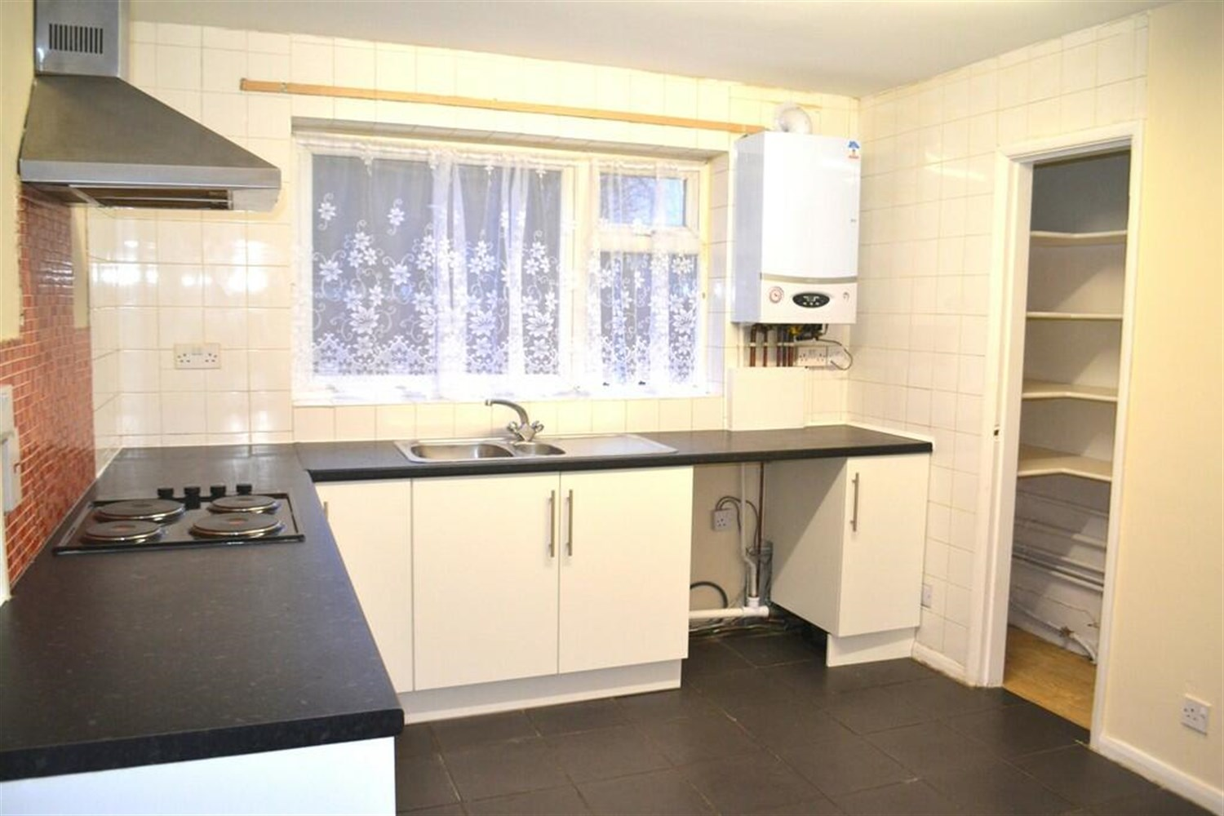
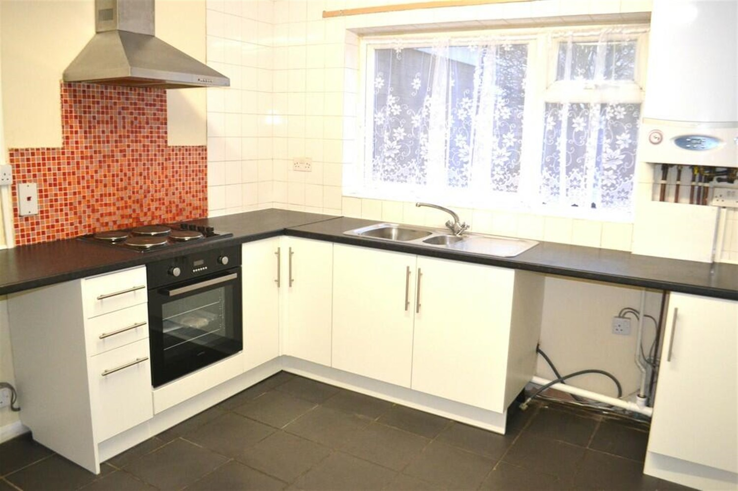
00

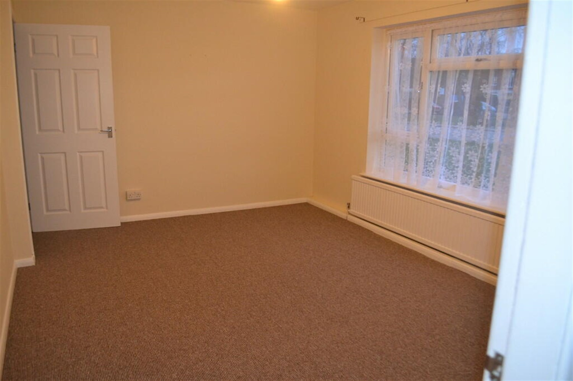

This two bedroom ground floor apartment is available to buy for investment purposes to be sold with sitting tenants and includes two bedrooms, living room, large storage cupboards, rear garden and is located close to Boston Town Centre and amenities including schools. Viewing is Essential.

Entrance Hallway
Entered from a UPVC door with the Kitchen/Diner, Lounge and a Store Room leading on from here.

Kitchen/Diner
Having units to the base level with sink drainer and mixer tap over, electric cooker and hob, space for a washing machine, pantry and window to rear elevation.

Lounge
With a window to the front elevation, radiator and door into a small hallway with access to both Bedrooms and Bathroom.

Bedroom 1
Having a window to the front aspect and radiator.

Bedroom 2
Having a window to the rear aspect and radiator.

Bathroom
Having a WC, bath, hand wash basin, radiator and cupboard housing the hot water tank.

Garden
Enclosed garden with a lawn.

Heating
GCH

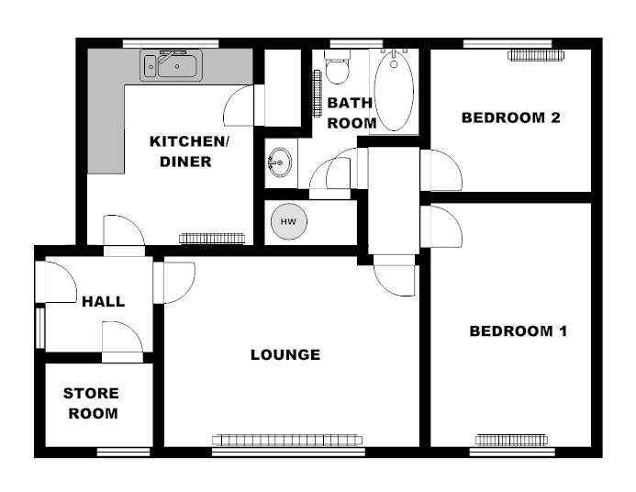

These particulars are intended to give a fair description of the property, but their accuracy cannot be guaranteed, and they do not constitute an offer of contract. Intending purchasers must rely on their own inspection of the property. None of the above appliances/services have been tested by ourselves. We recommend purchasers arrange for a qualified person to check all appliances/services before legal commitment.

Property Ref: 3373

www.drurysestateagents.co.uk
amber@drurysestateagents.co.uk
01205 350889

45 Willoughby Road
Boston
Lincolnshire
PE21 9HN
Agents Note: Whilst every care has been taken to prepare these sales particulars, they are for guidance purposes only. All measurements are approximate are for general guidance purposes only and whilst every care has been taken to ensure their accuracy, they should not be relied upon and potential buyers are advised to recheck the measurements

