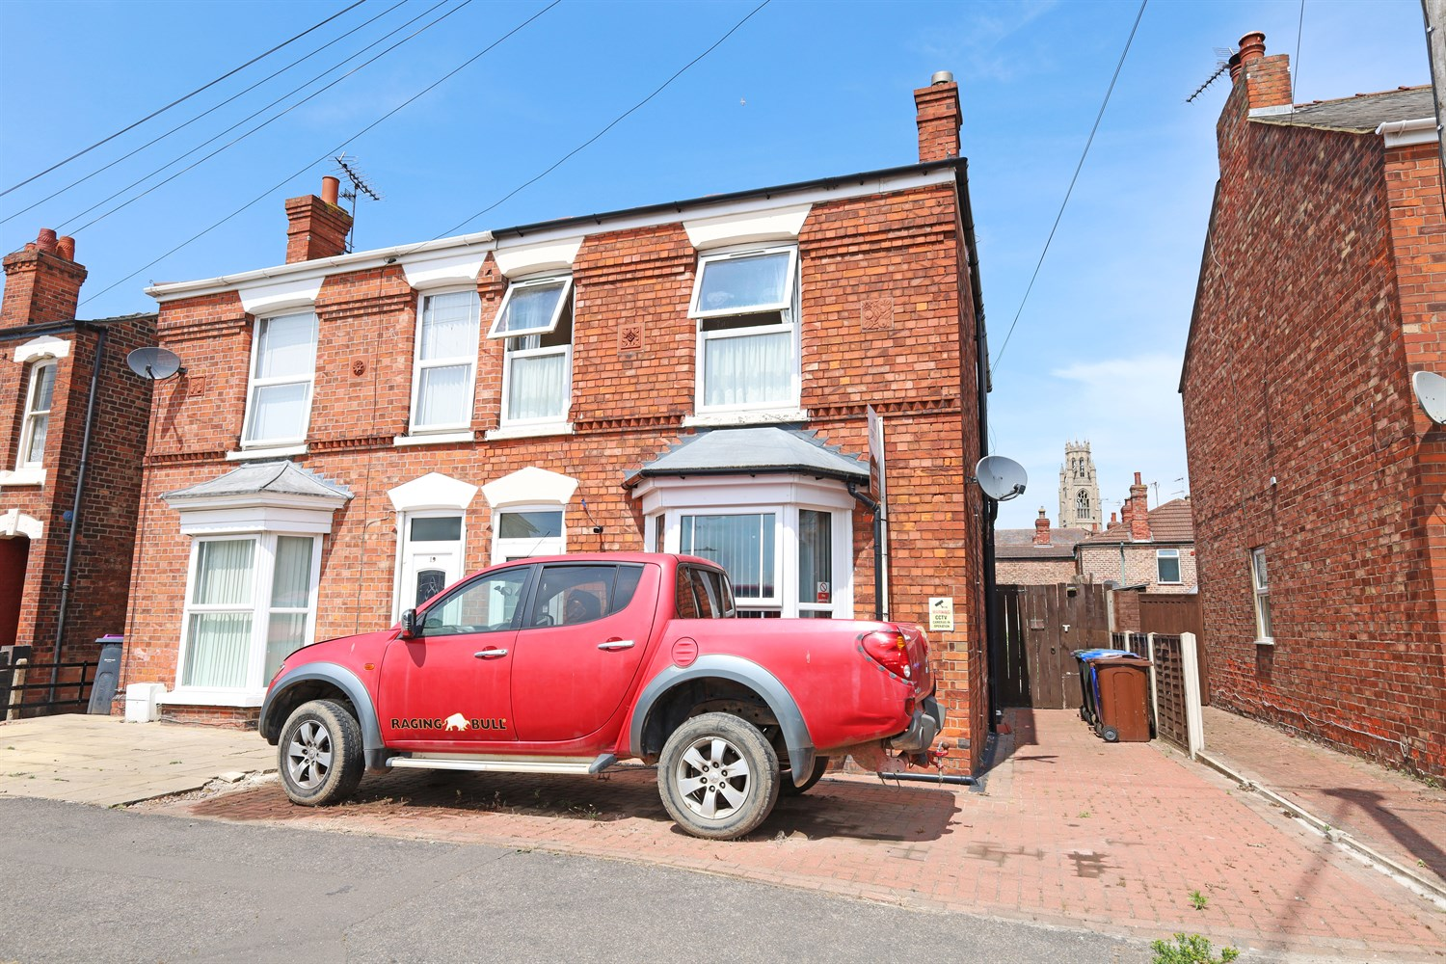




3 Bedroom(s)
2 Reception(s)
2 Bathroom(s)
£225,000.00
Fydell Crescent, PE21
EPC Rating ‘’

- Semi detached house
- 2 reception rooms
- Rear garden
- 3 bedrooms
- Off road parking

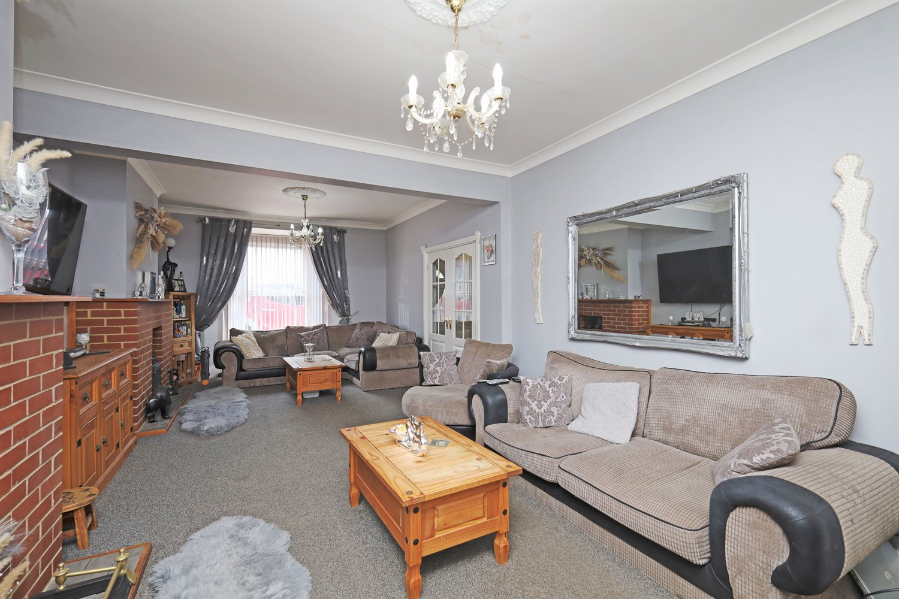
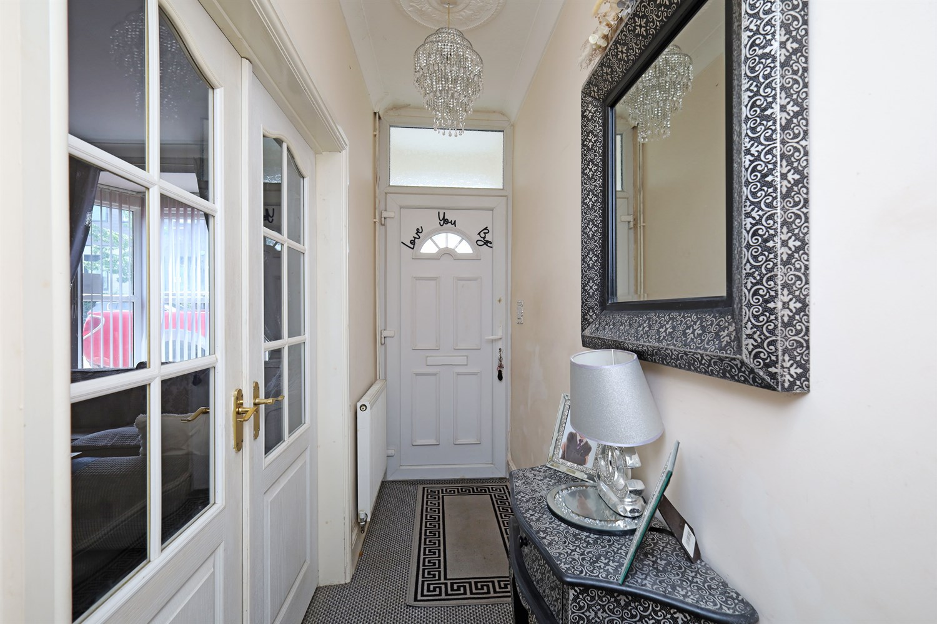
00
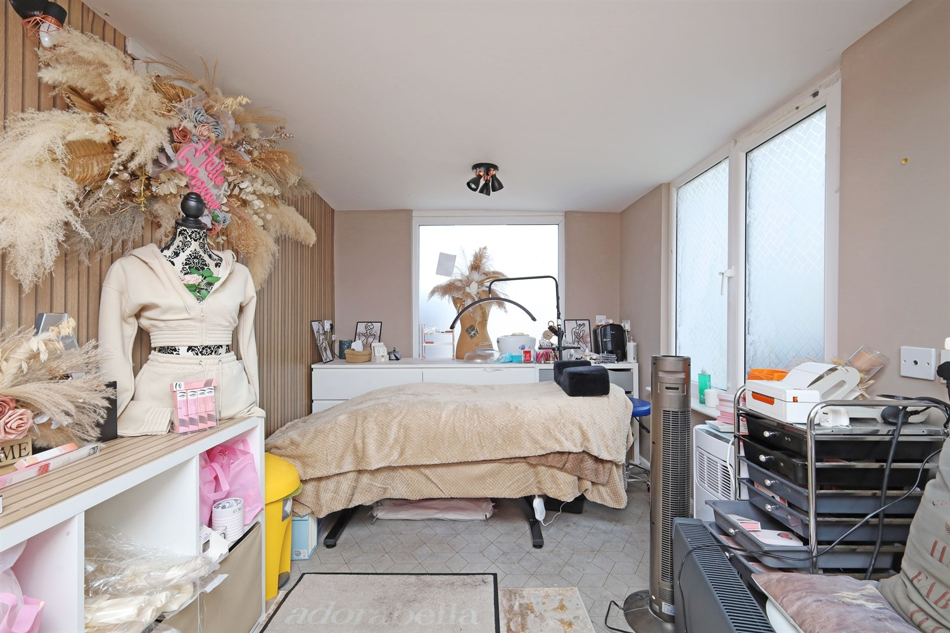
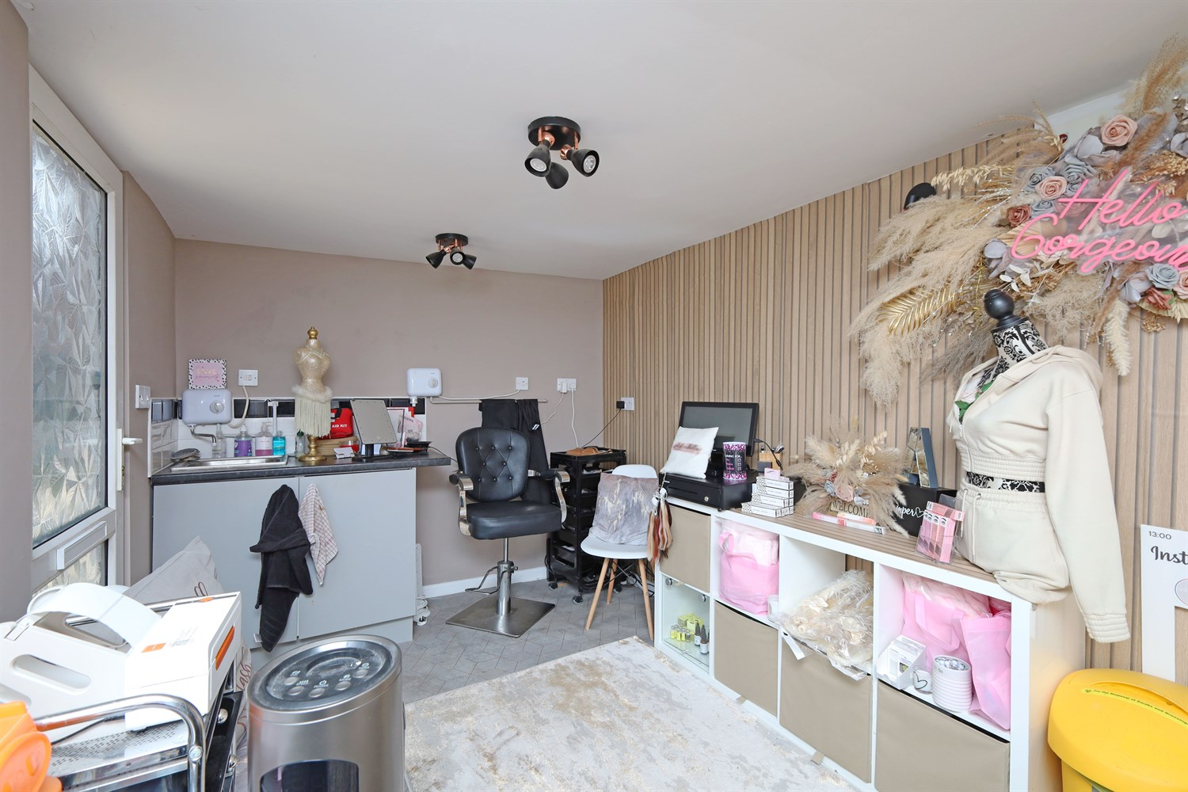
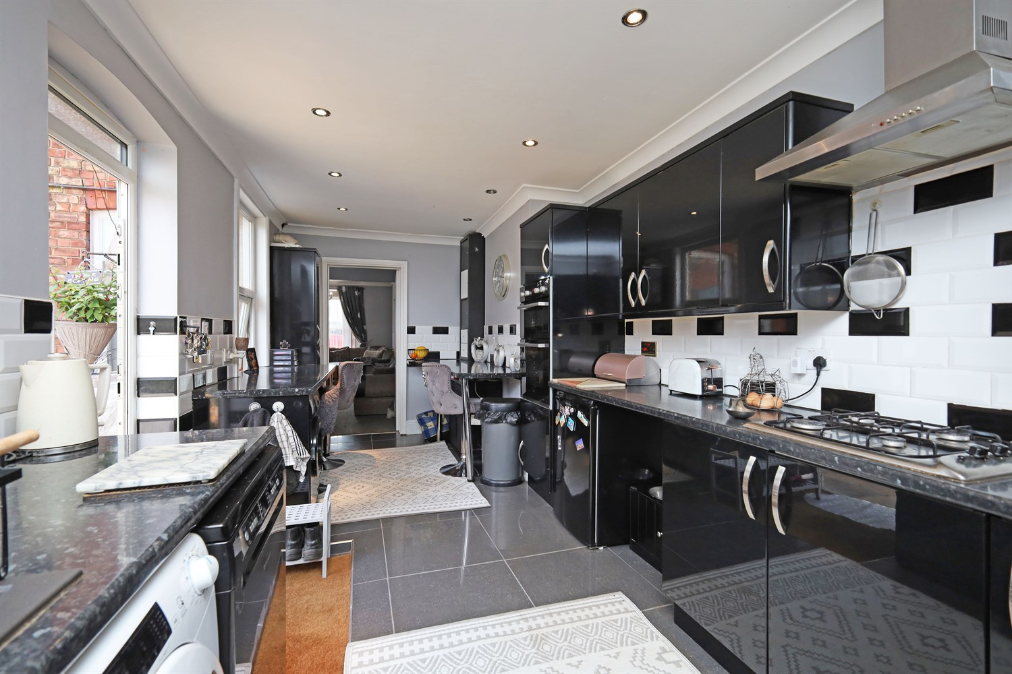
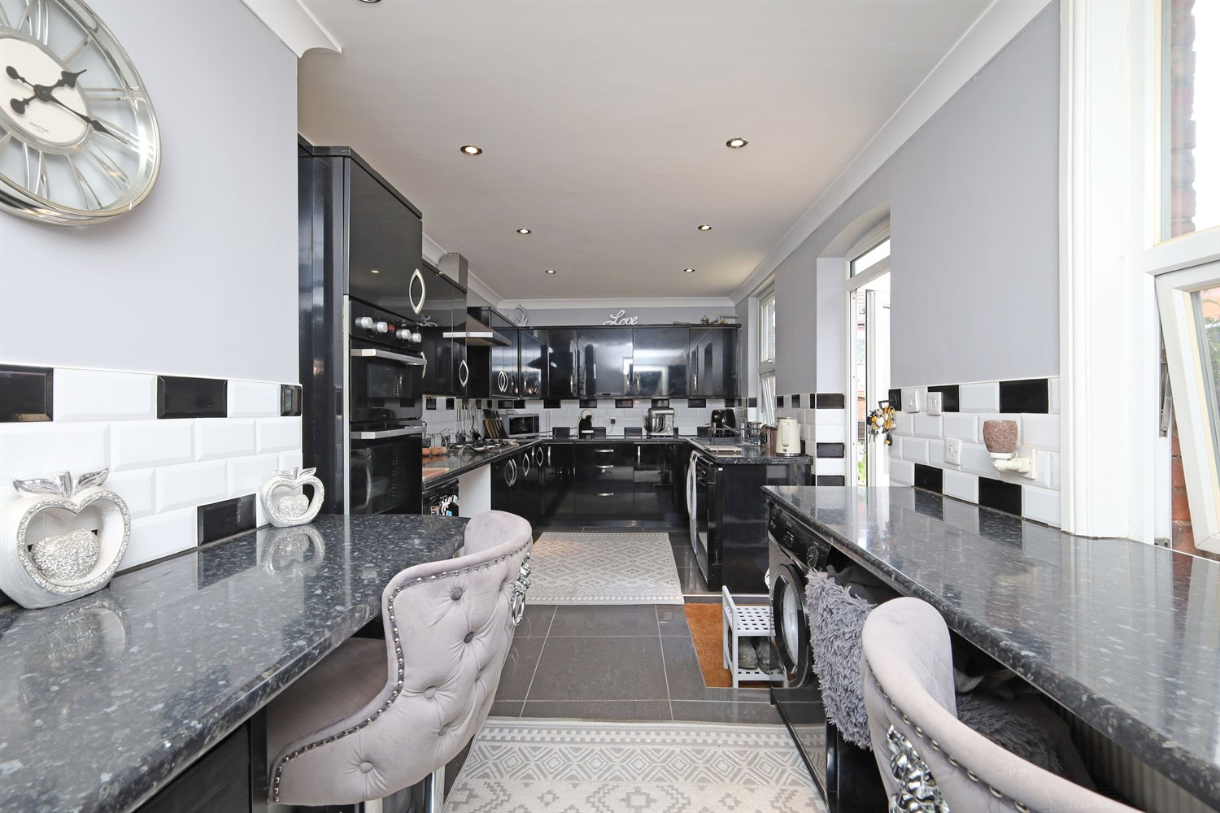
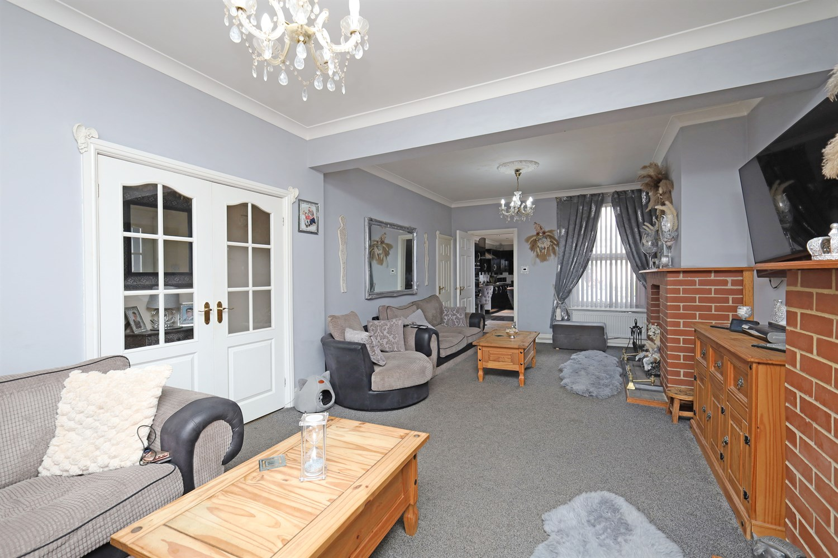
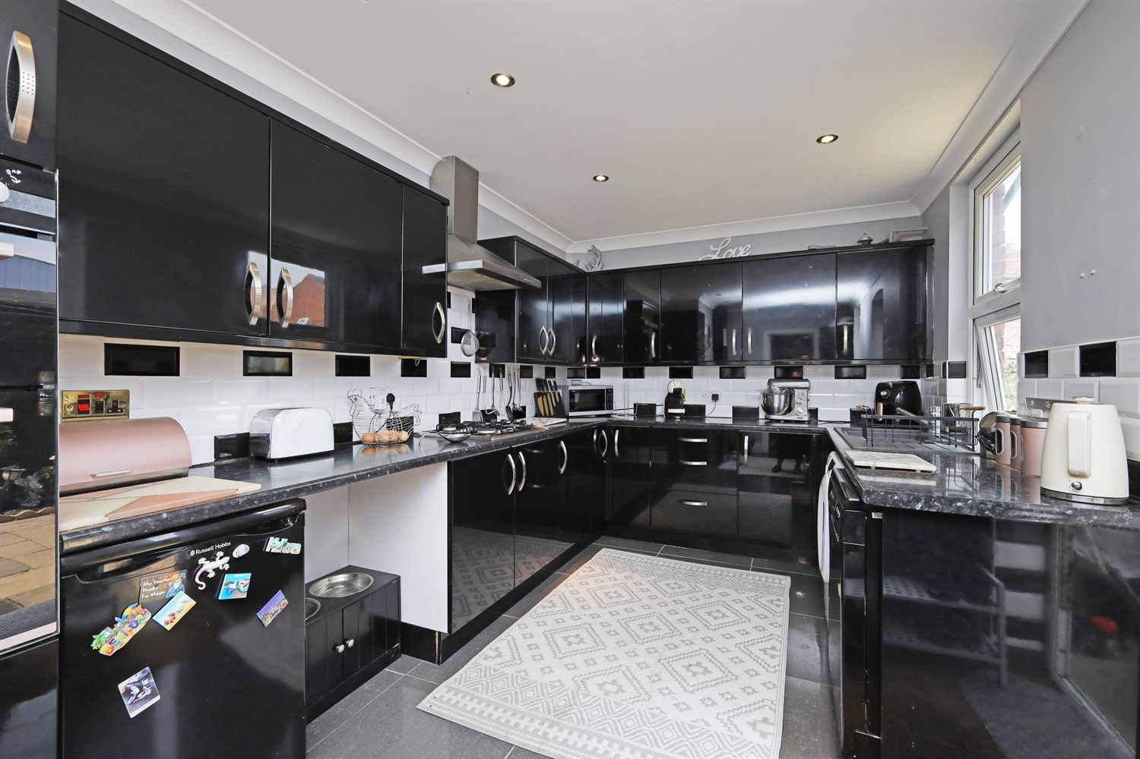
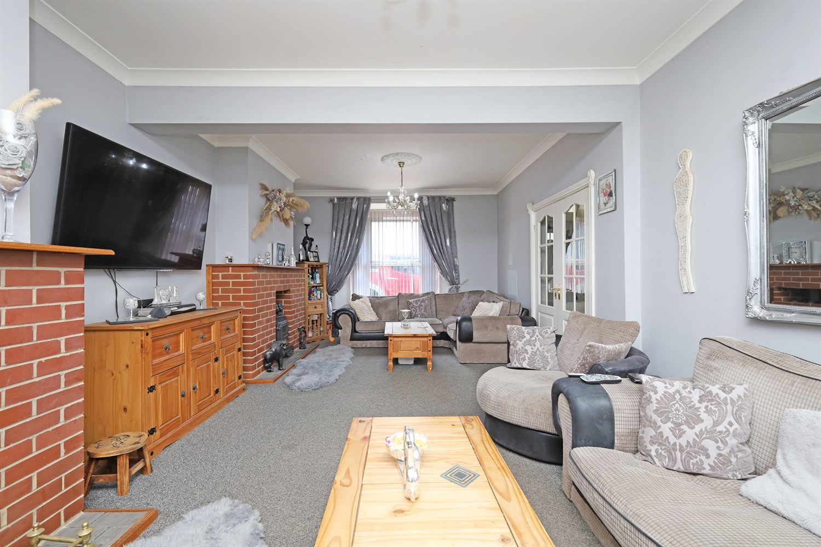
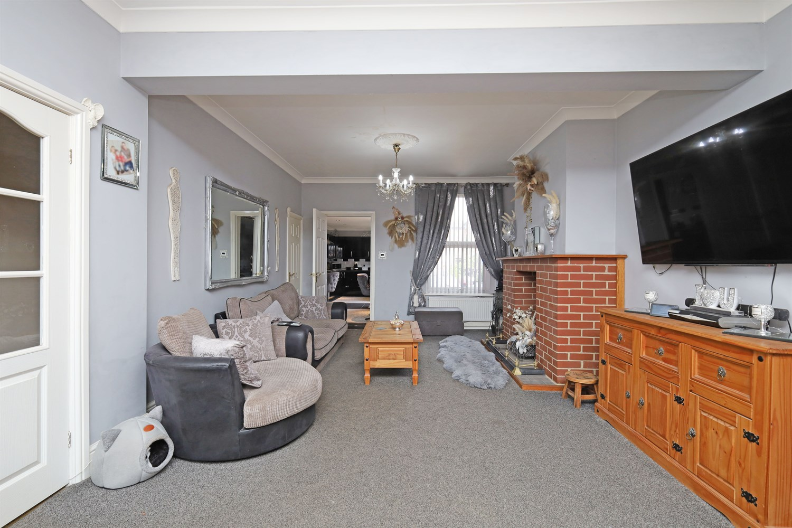

property description
Drury's are very happy to offer For Sale this lovely Semi Detached home situated in a sought after location. Within walking distance to the town centre and being close to local amenities and Schools. The accommodation comprises Entrance Hallway, Lounge, Kitchen, Three Bedrooms, 2 ensuites, family bathroom and a garden featuring a shed Ample off road parking to the front, Studio workshop and and enclosed rear garden featuring a shed

Hallway
In this hallway there is a single panel radiator, beautiful archway and double door which leads to the Lounge .

Reception/Lounge
This is a beautiful big living area with a large window to the front elevation. Amazing double French doors which follow through to the hallway there are two fireplaces and an additional window to the rear of the front elevation, there is also an extra door to a cupboard which can be used as storage. This space also includes a double panel radiator.

Kitchen
This lovely kitchen includes glossy black storage cupboards and units, with black and white tiling, space provided for a fridge freezer and also room left for a washing machine, tumble dryer, dishwasher and fridge. There is also a hob which has an extractor fan above. It also has a very nice area for seating / bar stool area / breakfast bar. Includes a built in oven, spot light lighting and 2 windows to the side making the space filled with light.

Studio/Extension
This area includes a sink and unit area , window to the rear of the room and the side bringing in lots of light to the area there is also an electricity point and units for lots of storage,

Landing
This landing space include doors to the bedrooms , storage cupboards , single panel radiator and double sockets.

Bedroom 1
Beautiful spacious double room with two windows to the front elevation, bringing in lots of light. Also featuring a single panelled radiator and a door leading into the ensuite.

Ensuite
This lovely spacious ensuite features a jacuzzi bath, heated towel rack, WC, sink with small storage unit and a single panelled radiator. Along with a window to the side aspect.

Bedroom 2
Large double room with a window to the side aspect, double panelled radiators and a door leading into the ensuite.

En-Suite
This ensuite includes a single panel radiator , a lovely spacious bath, sink with lots of storage space, window to the rear elevation , WC and also a heated towel rack

Box room
This room features a double panel radiator, window to the rear elevation of the room and electricity of double sockets

Garden
This lovely garden features a huge patio area with lawn space, planters, amazing sun spot, gate, hose and also a great seating area with steps

Workshop/Shed
This shed includes windows to the front , clear glass doors bringing in lots of light to the space, outdoor electricity, storage space, plug sockets inside for electricity.

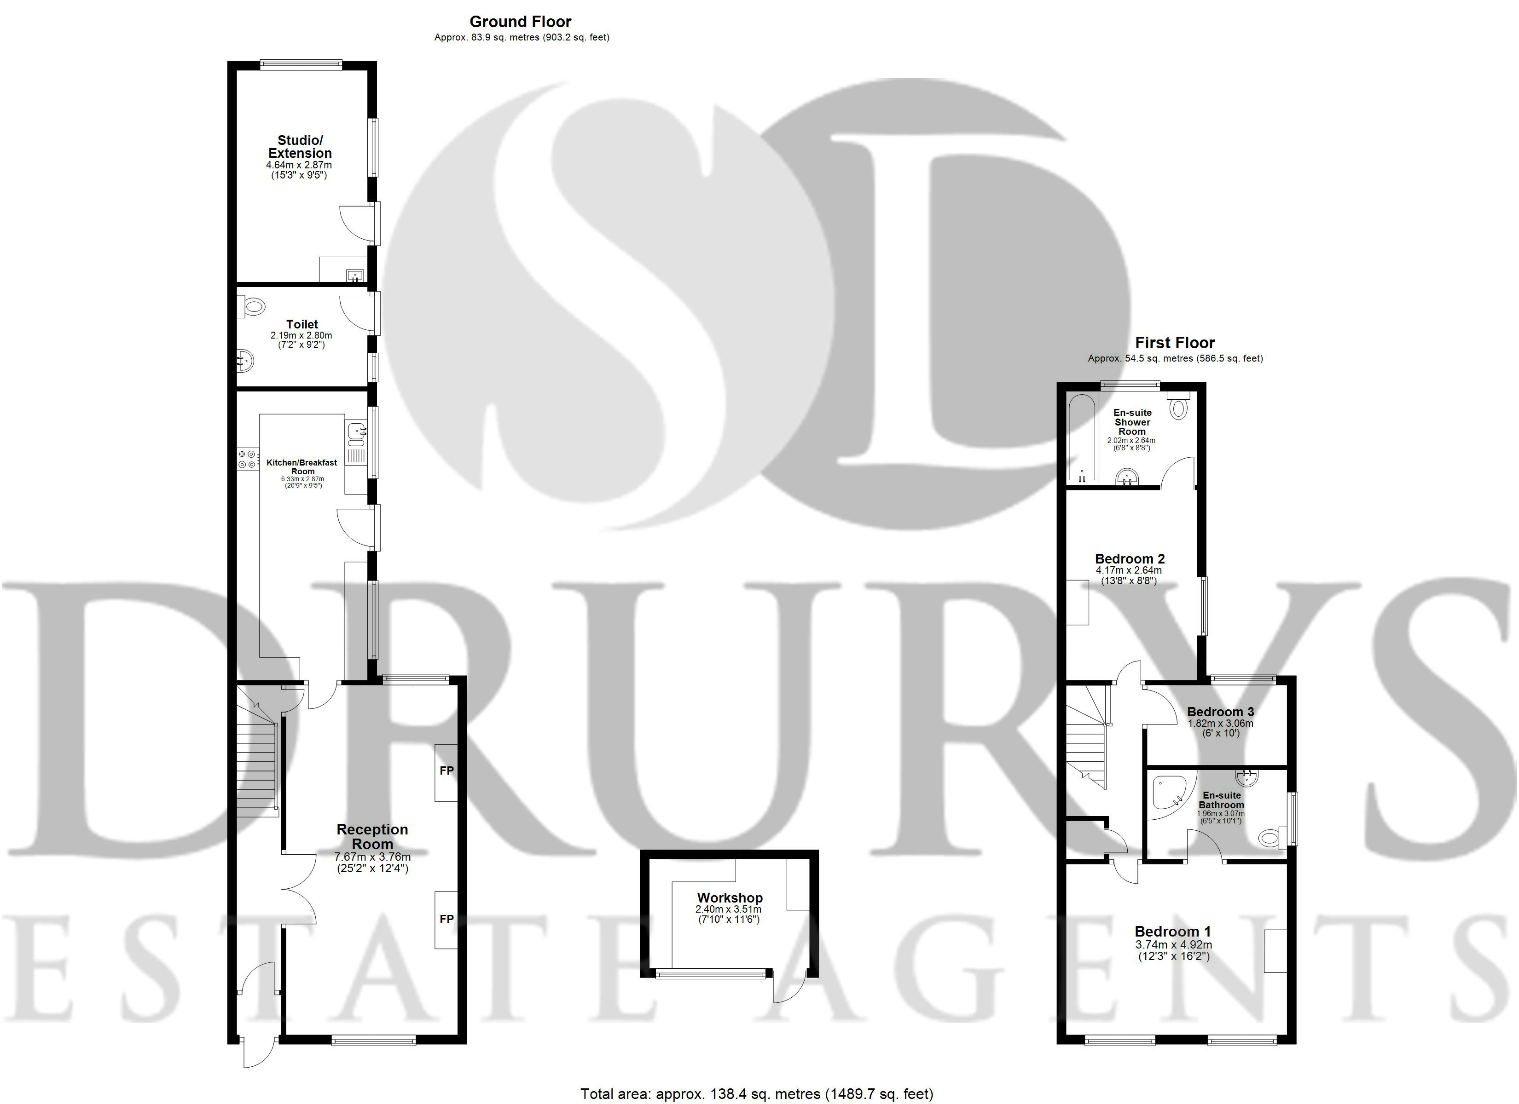

These particulars are intended to give a fair description of the property, but their accuracy cannot be guaranteed, and they do not constitute an offer of contract. Intending purchasers must rely on their own inspection of the property. None of the above appliances/services have been tested by ourselves. We recommend purchasers arrange for a qualified person to check all appliances/services before legal commitment.

Property Ref: 2806

www.drurysestateagents.co.uk
amber@drurysestateagents.co.uk
01205 350889

45 Willoughby Road
Boston
Lincolnshire
PE21 9HN
Agents Note: Whilst every care has been taken to prepare these sales particulars, they are for guidance purposes only. All measurements are approximate are for general guidance purposes only and whilst every care has been taken to ensure their accuracy, they should not be relied upon and potential buyers are advised to recheck the measurements

