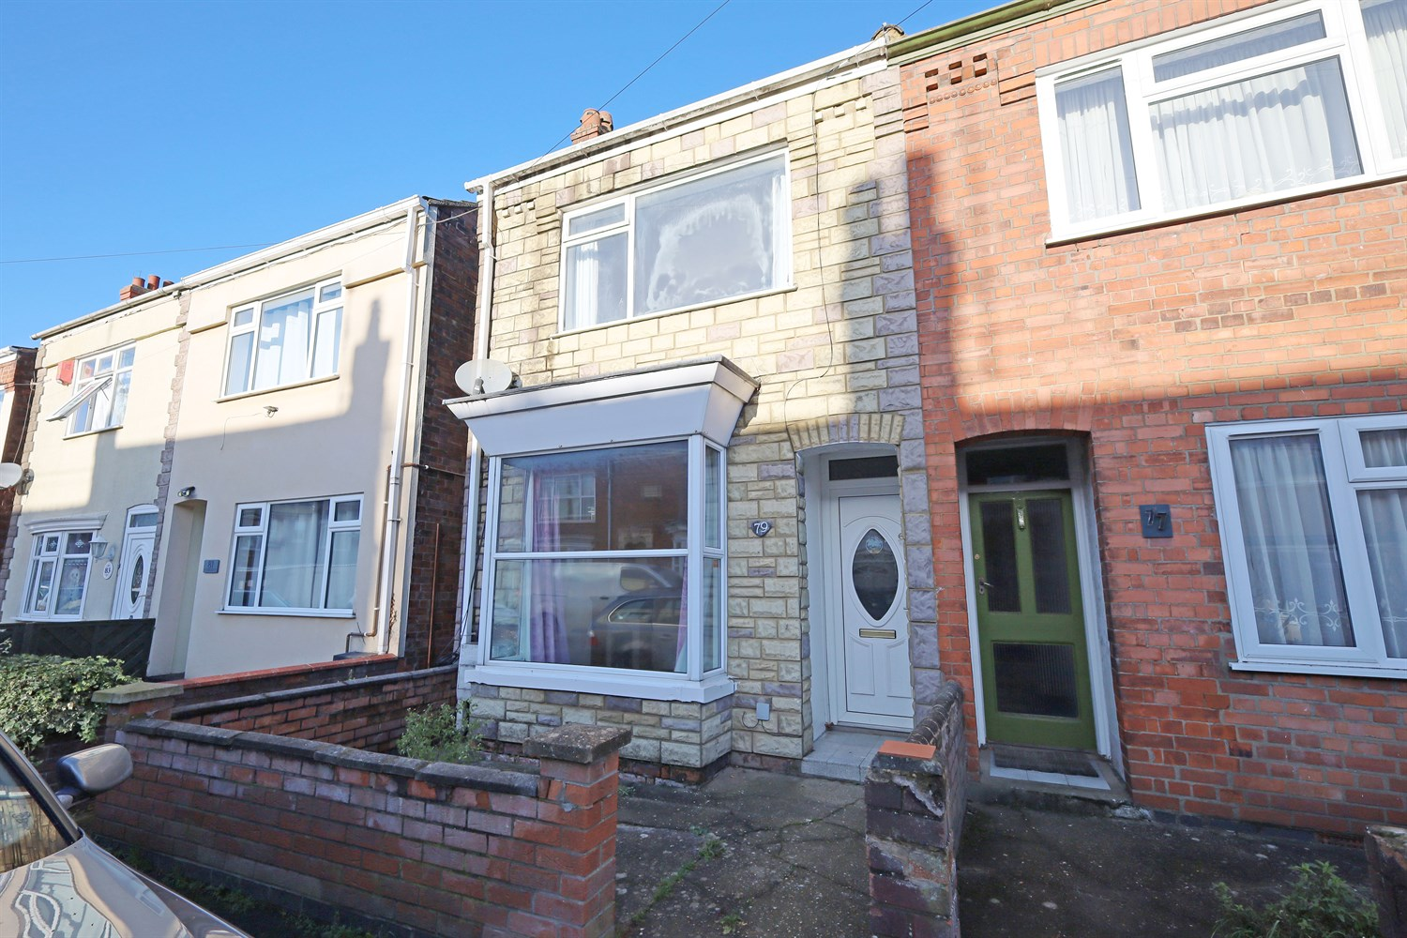




3 Bedroom(s)
2 Reception(s)
1 Bathroom(s)
£134,950.00
Granville Street, PE21
EPC Rating ‘’

- Chain Free
- 3 Bed semi, 2 Reception Rooms
- Town Centre Location

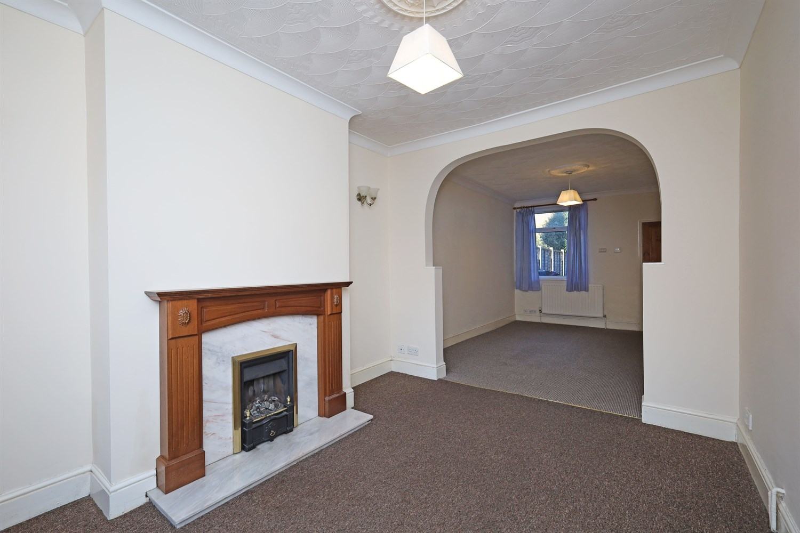
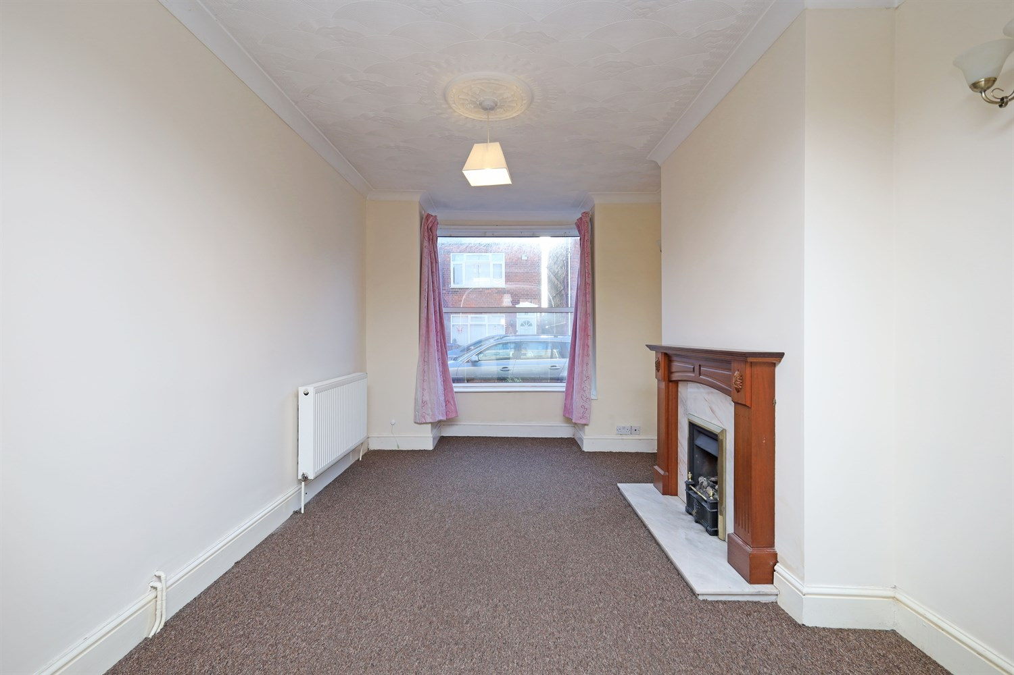
00
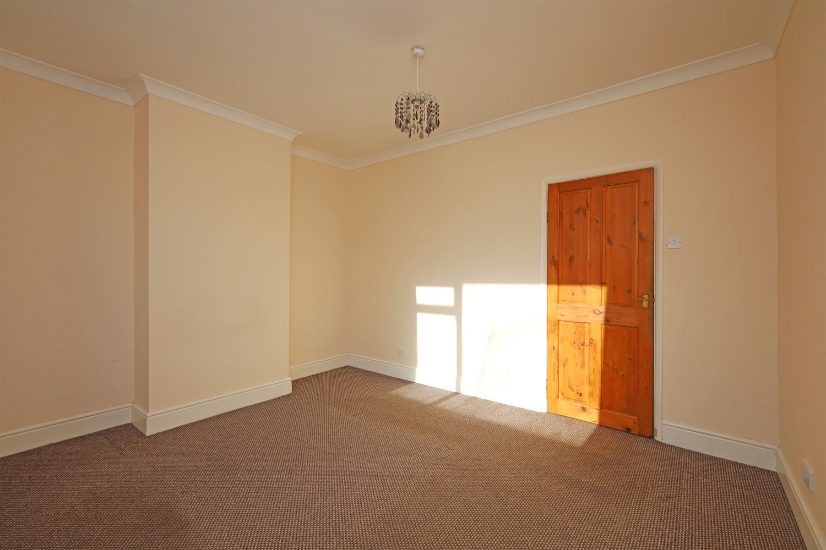
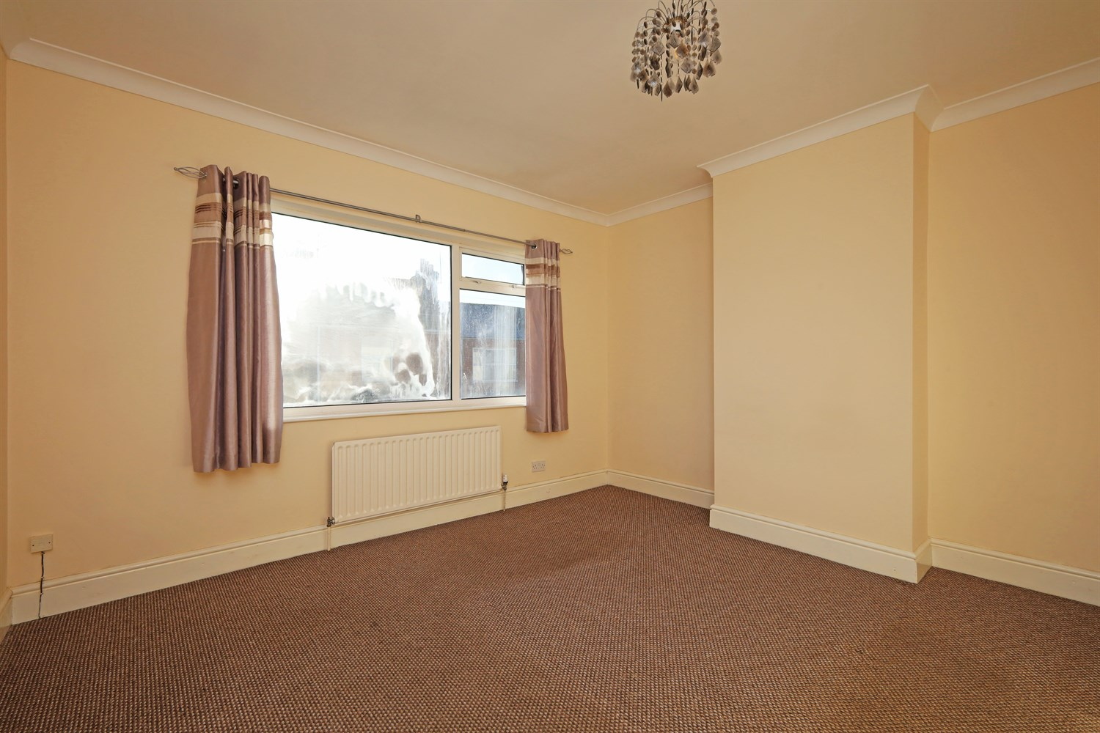
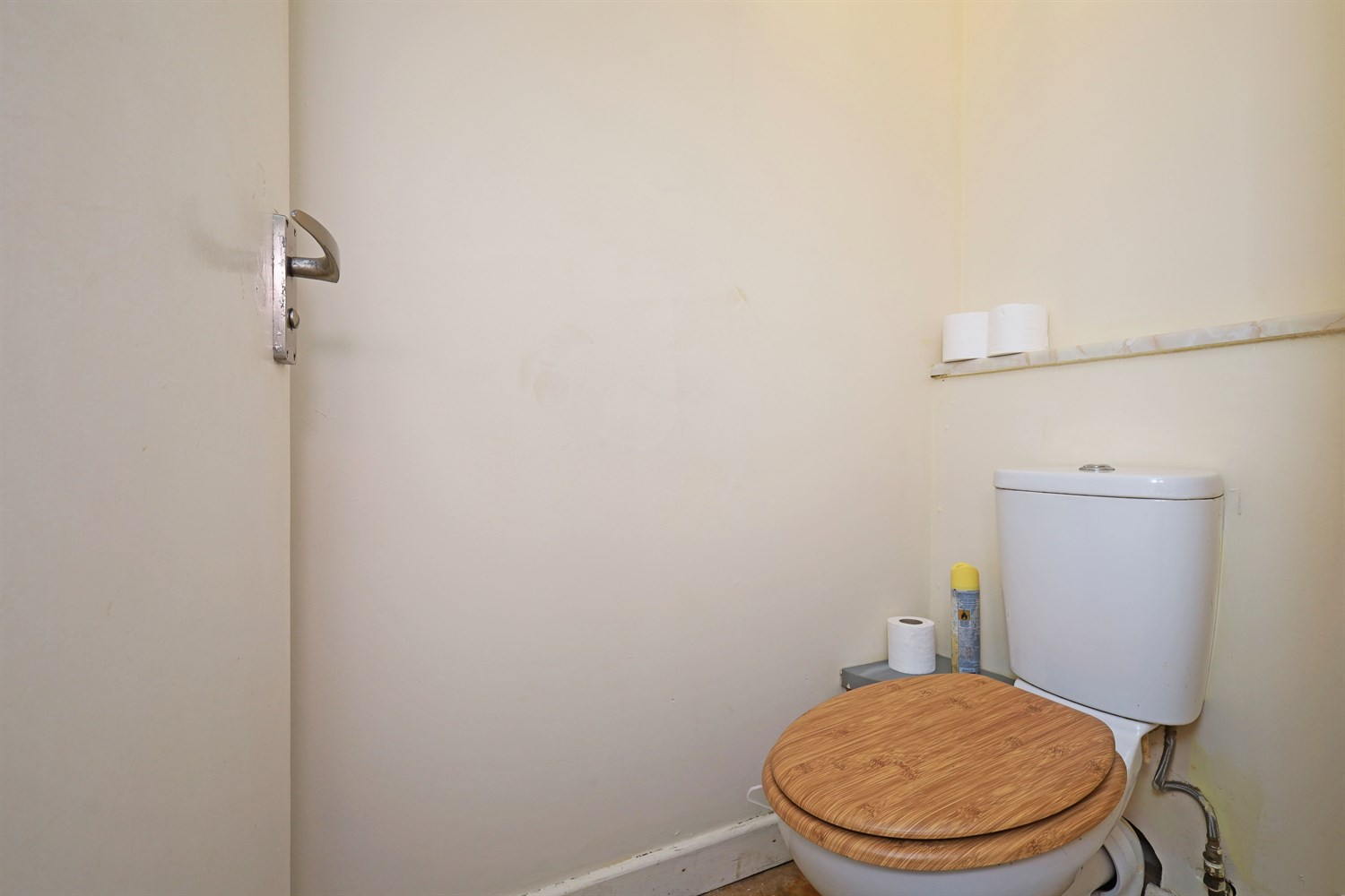
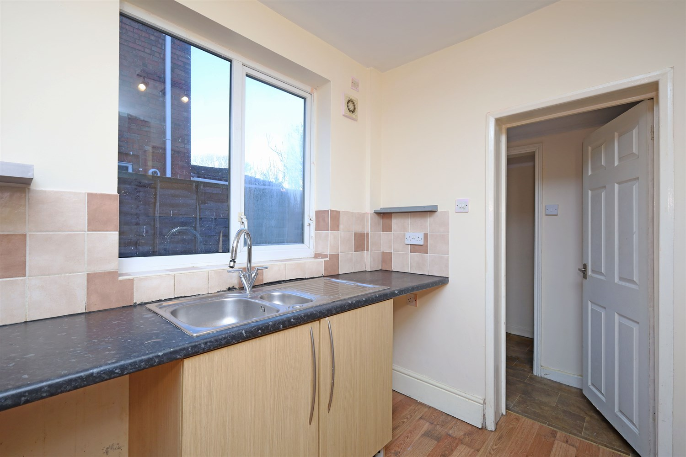
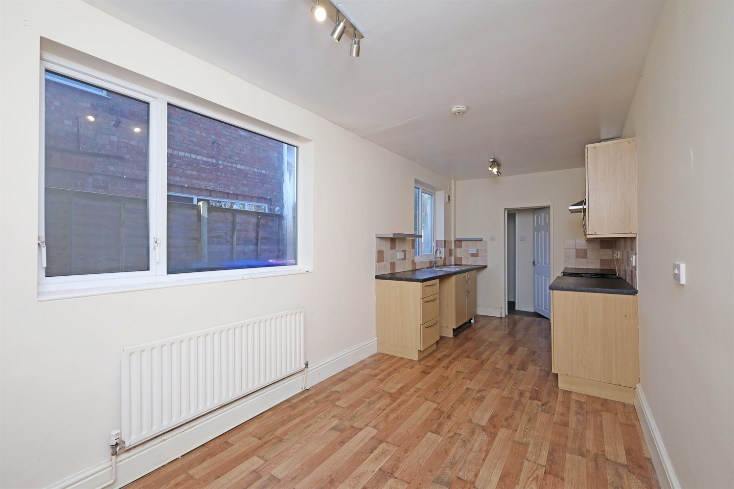
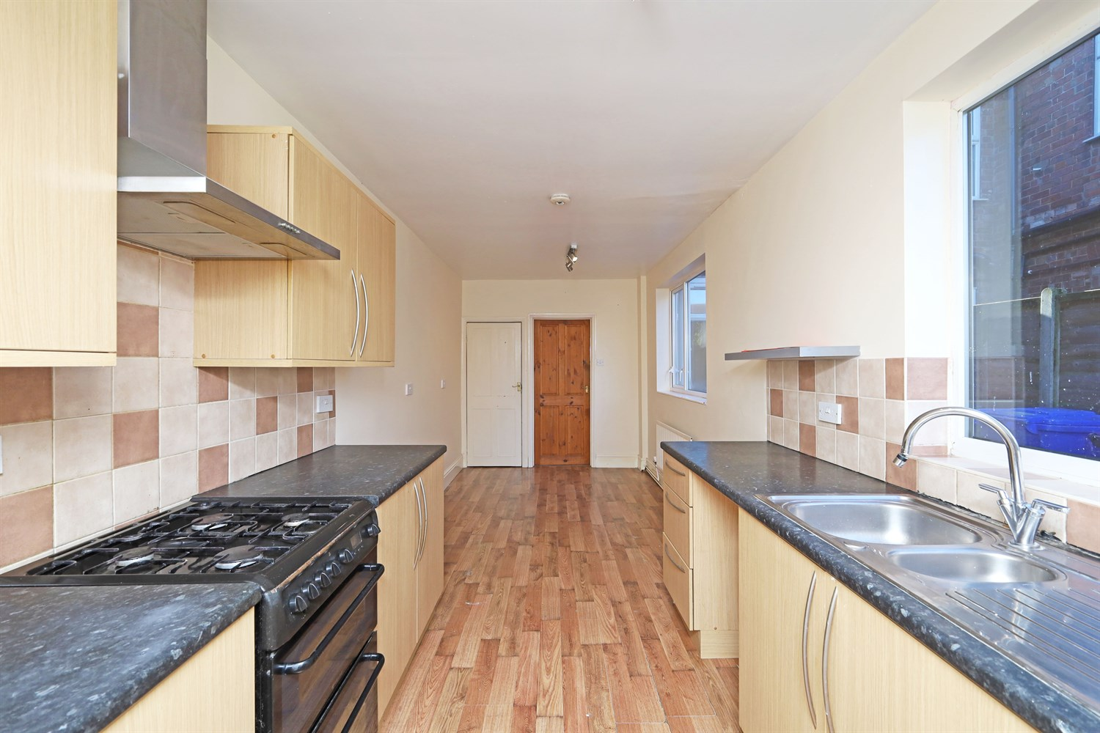
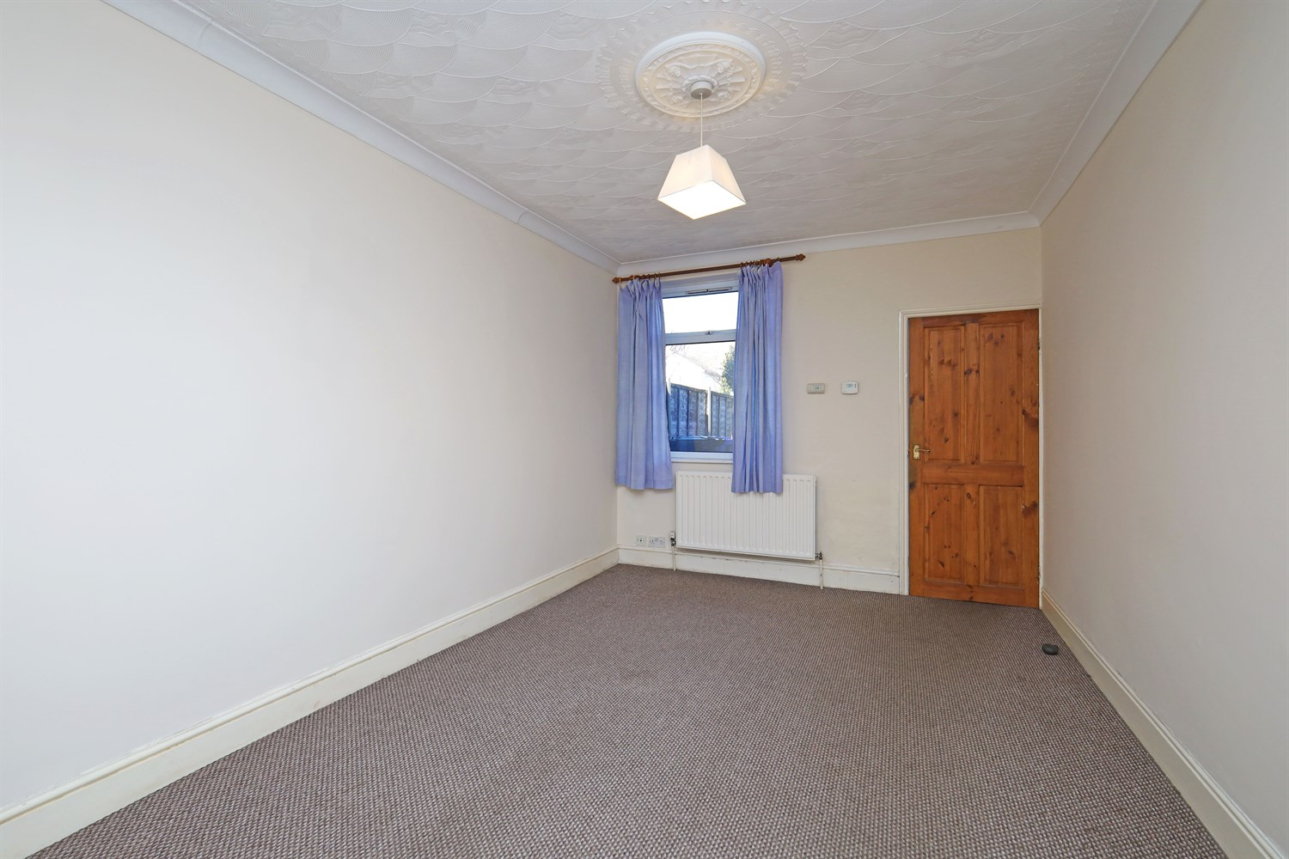
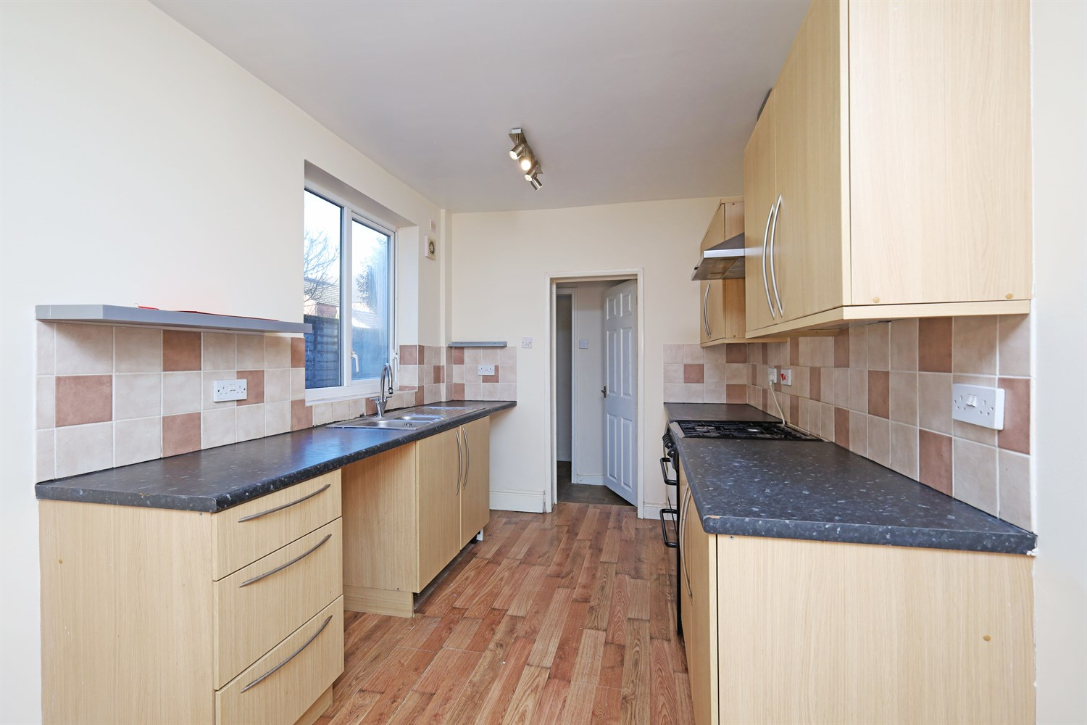

Property Description
This 3 bedroom semi-detached house is being offered CHAIN FREE. The property consist of Lounge, Dining Room, Kitchen/Diner, 3 Bedrooms, Bathroom, and rear garden. Within walking distance to town this is an ideal first home or investment property. This property needs to be viewed to appreciate everything it has to offer.

This 3 bedroom semi-detached house is being offered Chain Free. The property consist of Lounge, Dining Room, Kitchen/Diner, 3 Bedrooms, Bathroom, and rear garden. Within walking distance to town this is an ideal first home or investment property.
Conveniently located close to local amenities, including schools, shops, a gp surgery, and public transport links, this home is perfectly placed for everyday living.
The ground floor features a welcoming entrance hall, a lounge, and a separate dining room that flows into a spacious kitchen/Diner, ideal for family life or entertaining.
Upstairs, you¿ll find three well-sized bedrooms and a family bathroom, providing comfortable accommodation for a family or shared tenants.
Outside, the property benefits from a low-maintenance rear garden, and on-street parking at the front.

Hallway
Accessed from the front uPVC door this room gives access to the lounge and access to the first floor stairs.

Reception 1
Lovely reception room with window to the front aspect accessed from the hallway, fireplace and double panelled radiator. Archway leading to the dining room.

Reception 2/Dining Room
Access through an arch way from the lounge, there is a window to the rear aspect, double panelled radiator and access to the Kitchen/Diner.

Kitchen
Having units to the eye and base level with worktop over. Stainless steel sink and drainer, window to the rear aspect and free standing gas cooker. An additional window to the dining end with space for a table. Leading to the rear entrance hall and WC.

Rear Entrance Hall
Having access to the rear door, garden and downstairs WC.

Toilet
Having a WC.

Landing
Having access for the stairs and giving access to all the rooms.

Bedroom 1
The master bedroom has a window to the front aspect and radiator.

Bedroom 2
Another good sized room with a window to the rear aspect and radiator.

Bedroom 3
A single room with a window to the rear aspect and radiator.

Bathroom
Having a three piece suite with WC, pedestal sink, bath with shower over and frosted window to the side aspect.

Garden
Having a patio area, lawn and shed to the rear garden. This is accessed from the alley way at the side and through a tall wooden gate.

Heating
GCH

Double Glazing

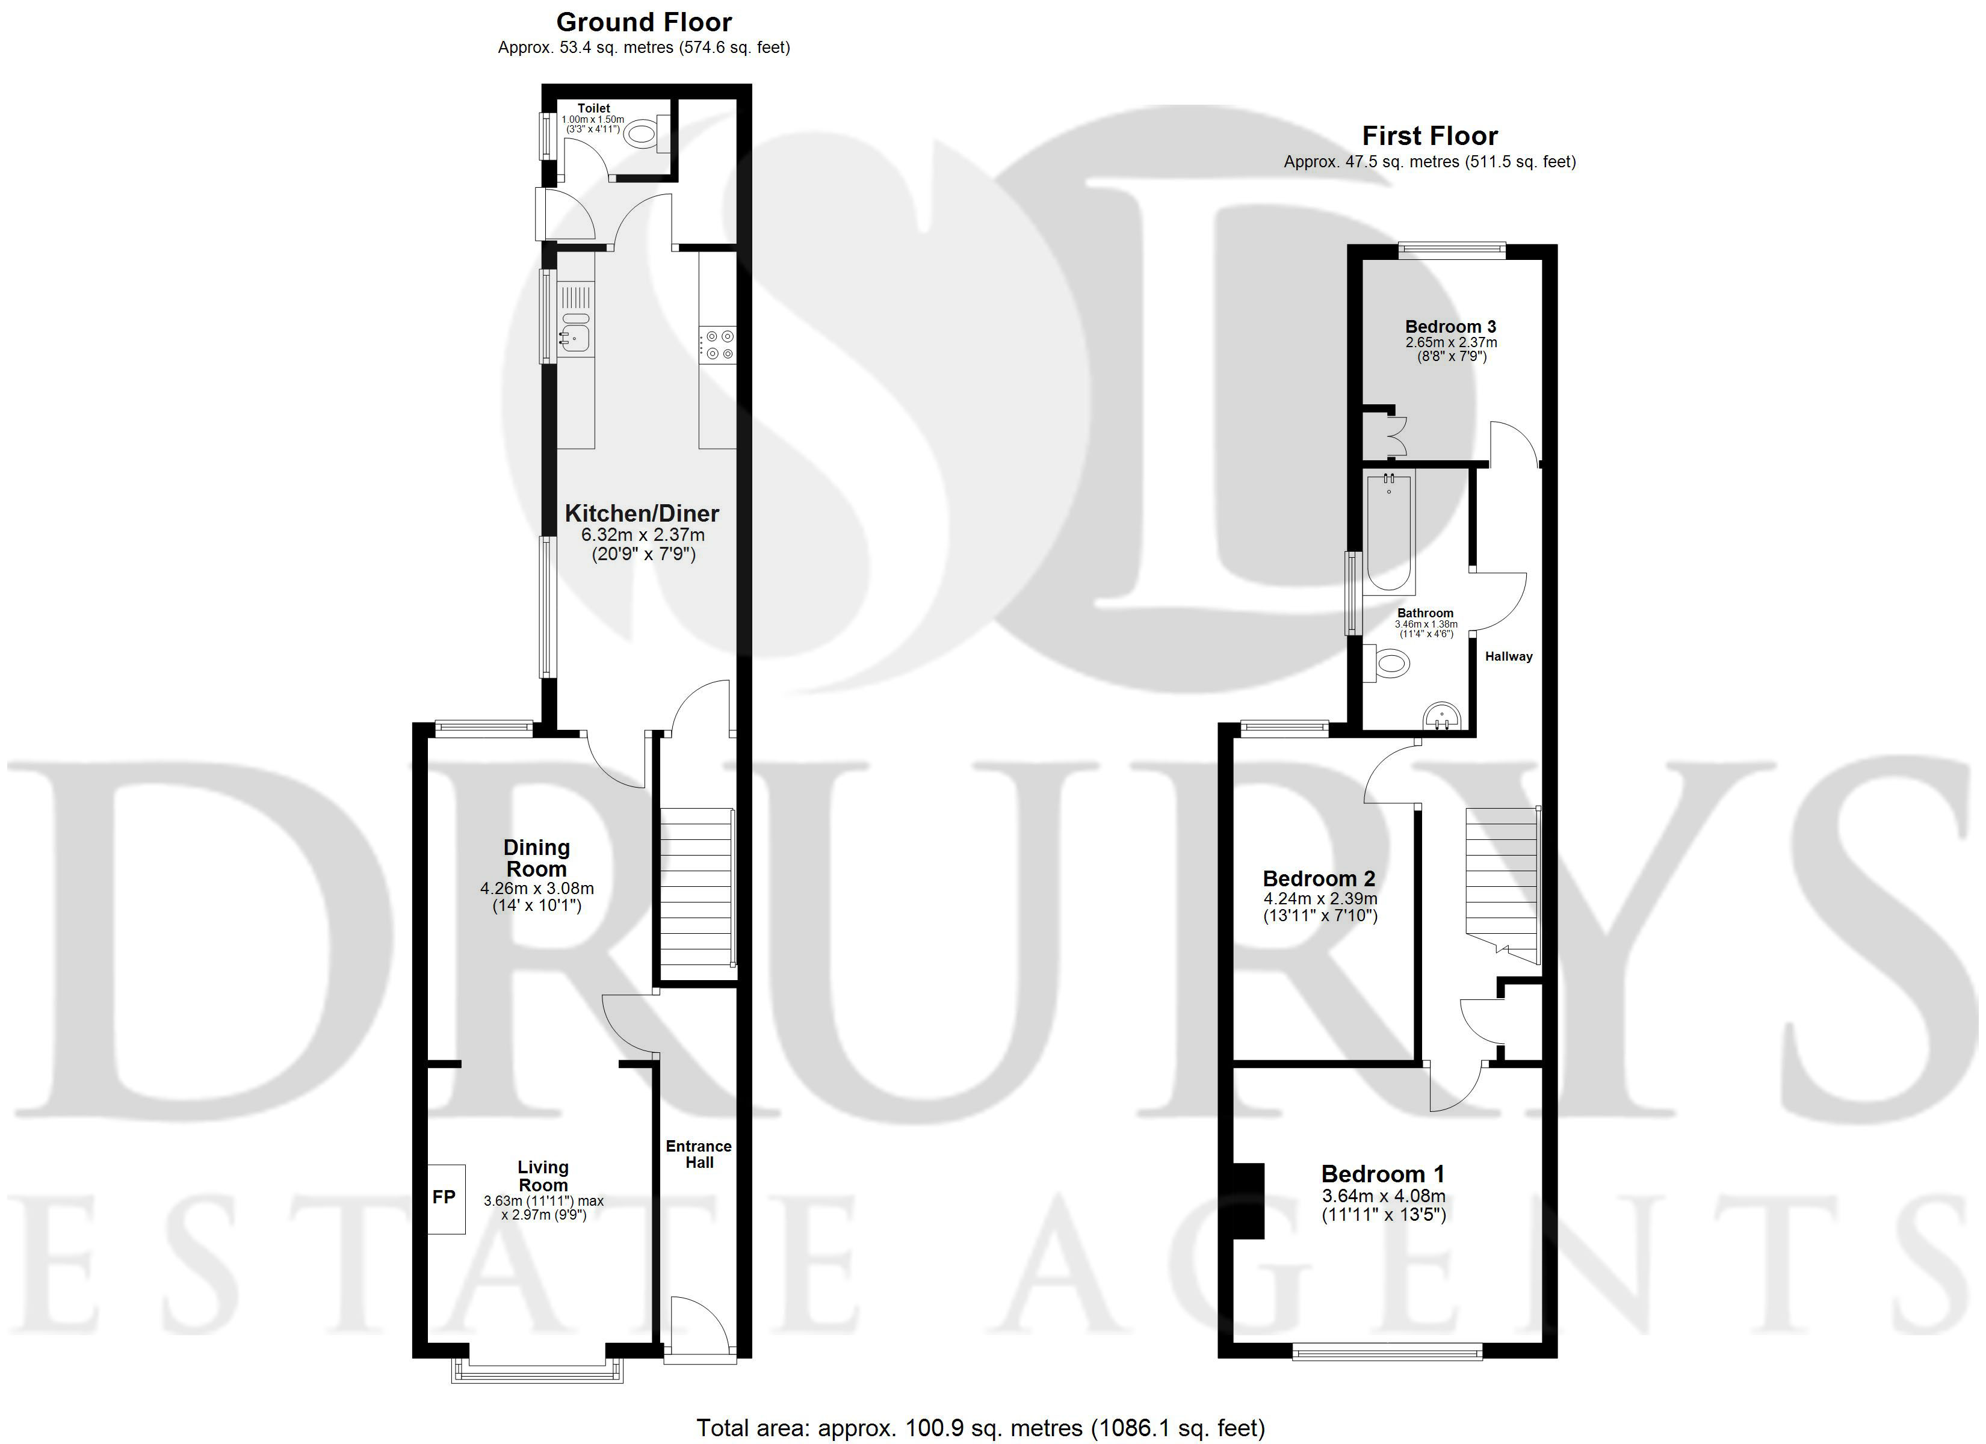

These particulars are intended to give a fair description of the property, but their accuracy cannot be guaranteed, and they do not constitute an offer of contract. Intending purchasers must rely on their own inspection of the property. None of the above appliances/services have been tested by ourselves. We recommend purchasers arrange for a qualified person to check all appliances/services before legal commitment.

Property Ref: 3159

www.drurysestateagents.co.uk
amber@drurysestateagents.co.uk
01205 350889

45 Willoughby Road
Boston
Lincolnshire
PE21 9HN
Agents Note: Whilst every care has been taken to prepare these sales particulars, they are for guidance purposes only. All measurements are approximate are for general guidance purposes only and whilst every care has been taken to ensure their accuracy, they should not be relied upon and potential buyers are advised to recheck the measurements

