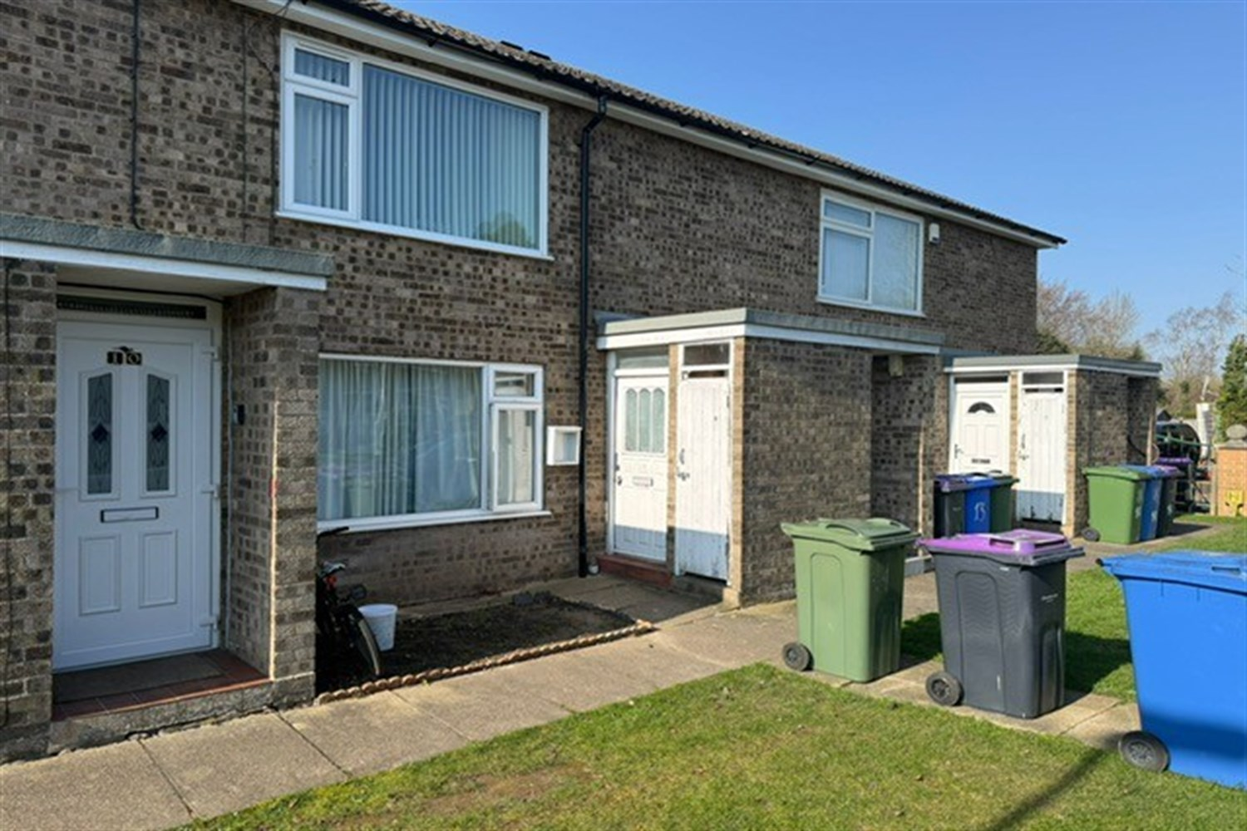




1 Bedroom(s)
1 Reception(s)
1 Bathroom(s)
£109,950.00
Standish Grove, PE21
EPC Rating ‘’

- One Bedroom First Floor Leasehold Flat
- Popular Cul-de-Sac Location
- First Floor Flat
- Investment Opportunity

00

Property Description
Great Investment Opportunity for a 1 bedroom ground floor flat, reception room, kitchen and hallway, close to Pilgrim Hospital. Currently rented.

Reception 1
A great room to relax with window to front.

Kitchen
Having units to the eye and base level with work top over with window to rear aspect.

Bedroom 1
A great size room.

Bathroom
With a three piece suite featuring a panel bath, sink and WC.

Central Heating

These particulars are intended to give a fair description of the property, but their accuracy cannot be guaranteed, and they do not constitute an offer of contract. Intending purchasers must rely on their own inspection of the property. None of the above appliances/services have been tested by ourselves. We recommend purchasers arrange for a qualified person to check all appliances/services before legal commitment.

Property Ref: 3398

www.drurysestateagents.co.uk
amber@drurysestateagents.co.uk
01205 350889

45 Willoughby Road
Boston
Lincolnshire
PE21 9HN
Agents Note: Whilst every care has been taken to prepare these sales particulars, they are for guidance purposes only. All measurements are approximate are for general guidance purposes only and whilst every care has been taken to ensure their accuracy, they should not be relied upon and potential buyers are advised to recheck the measurements

