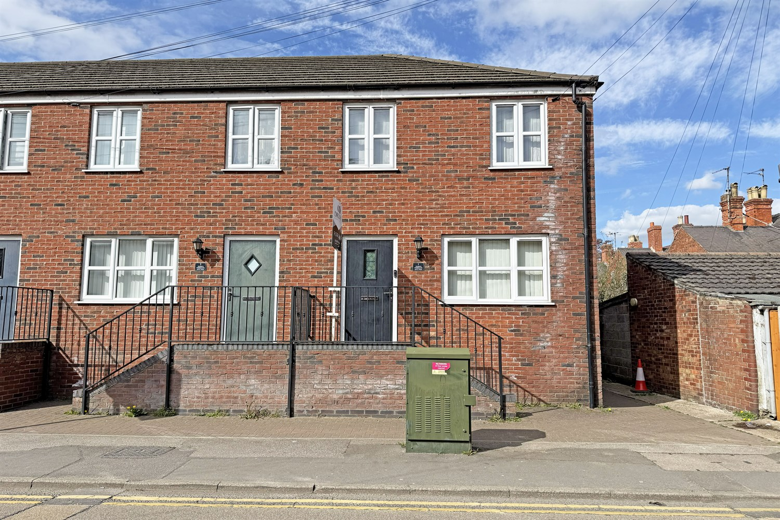




3 Bedroom(s)
1 Reception(s)
1 Bathroom(s)
£154,950.00
Tinks Terrace, PE21
EPC Rating ‘’

- INVESTMENT OPPORTUNITY
- TENANTS IN SITU
- TOWN CENTRE LOCATION

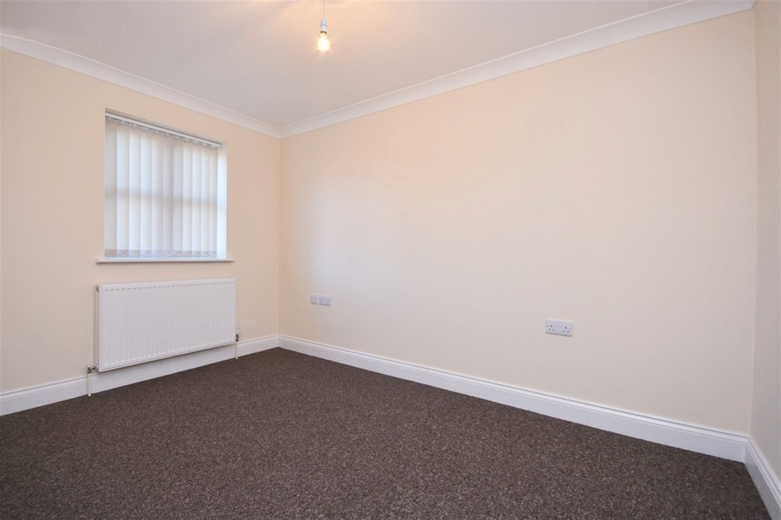
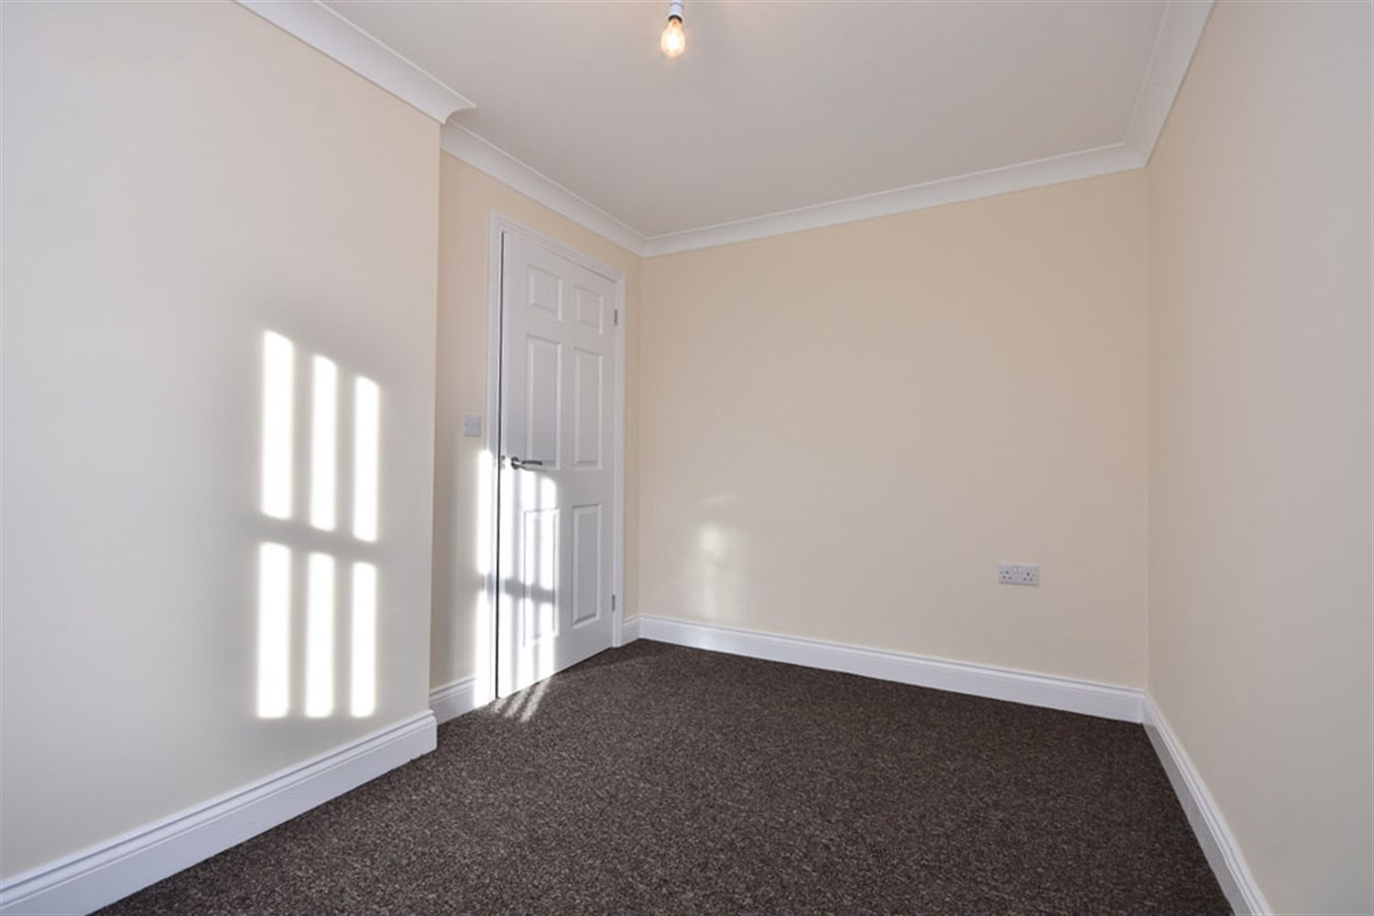
00
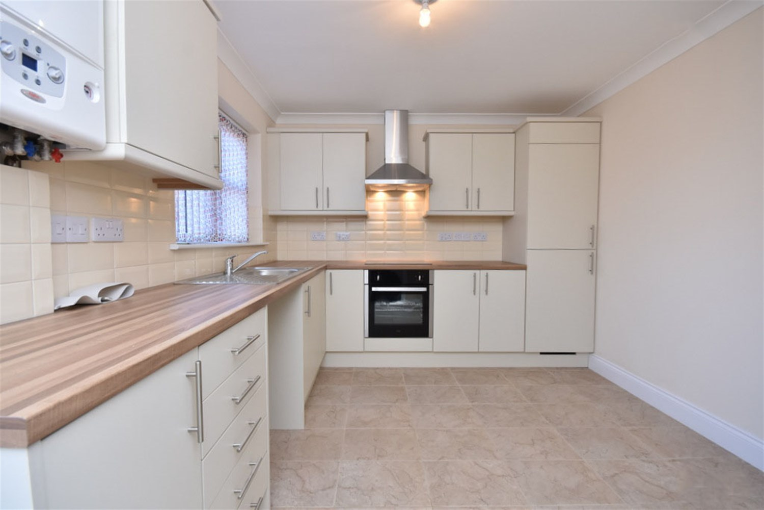
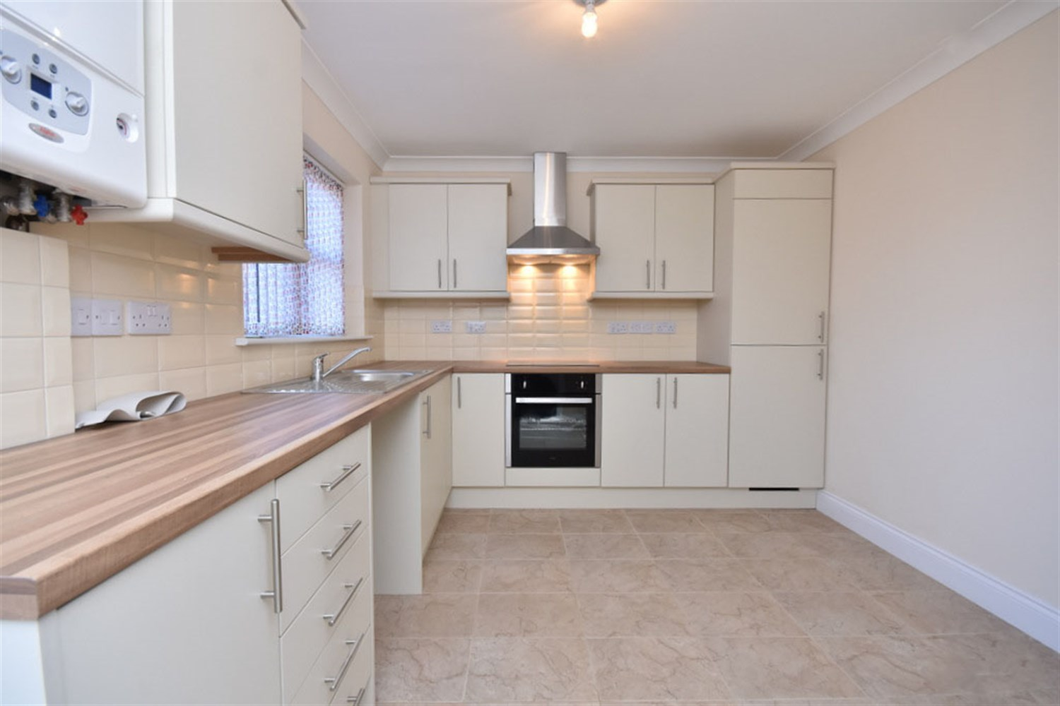
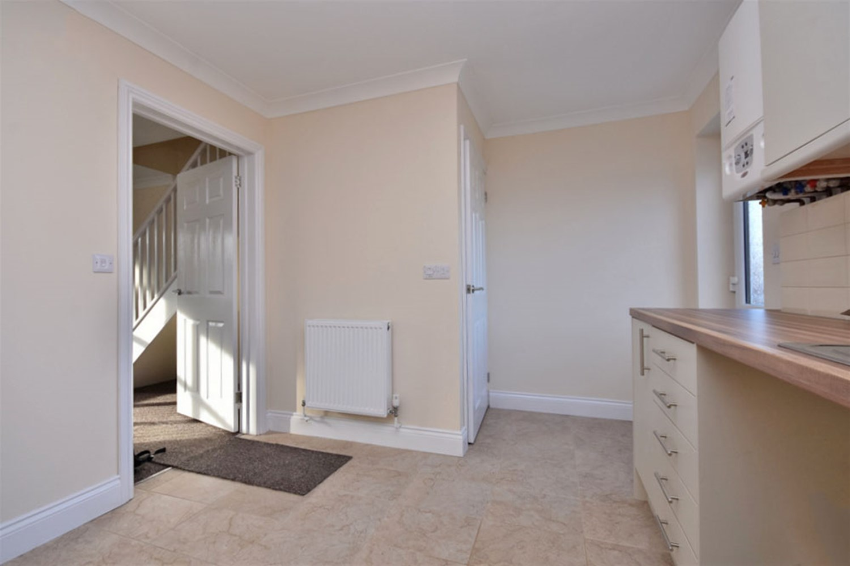
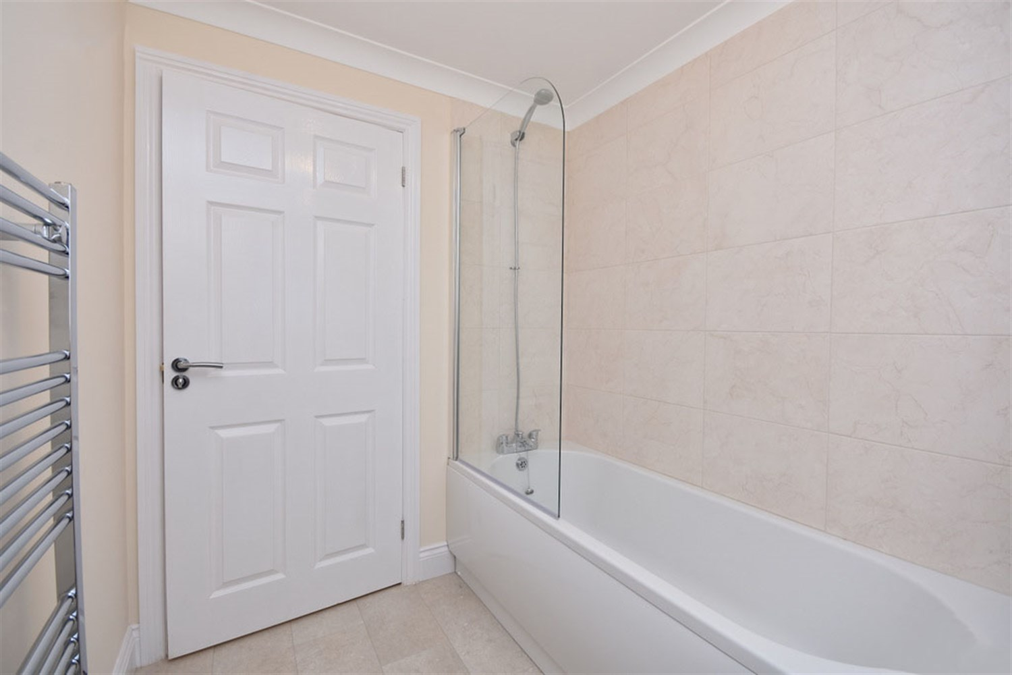
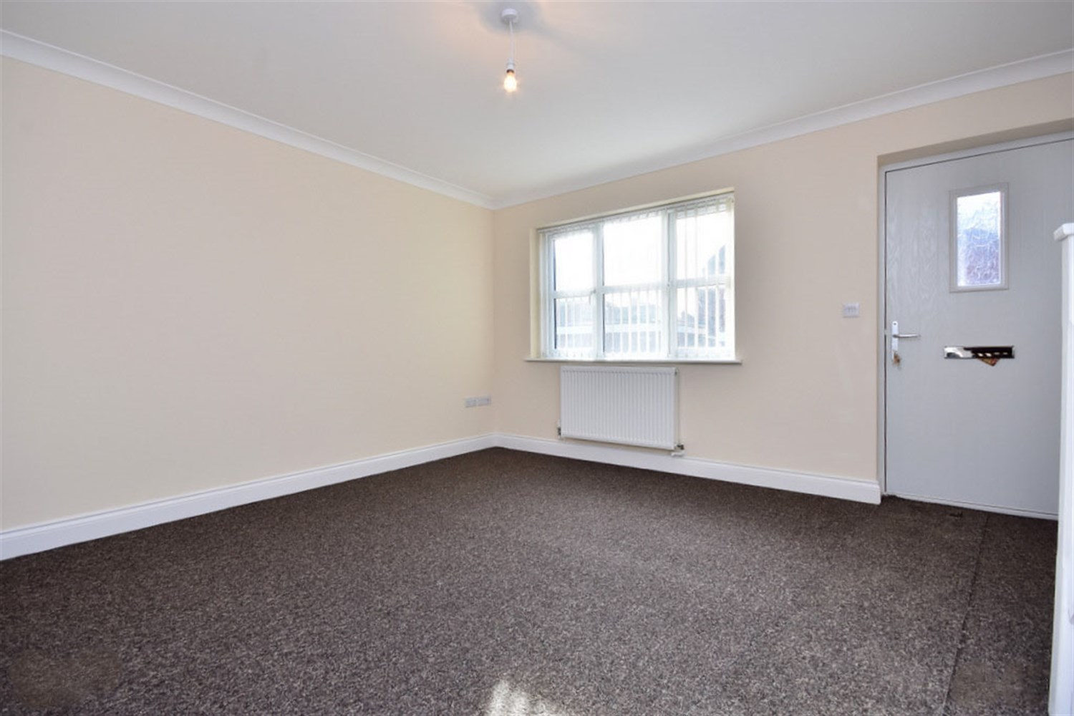
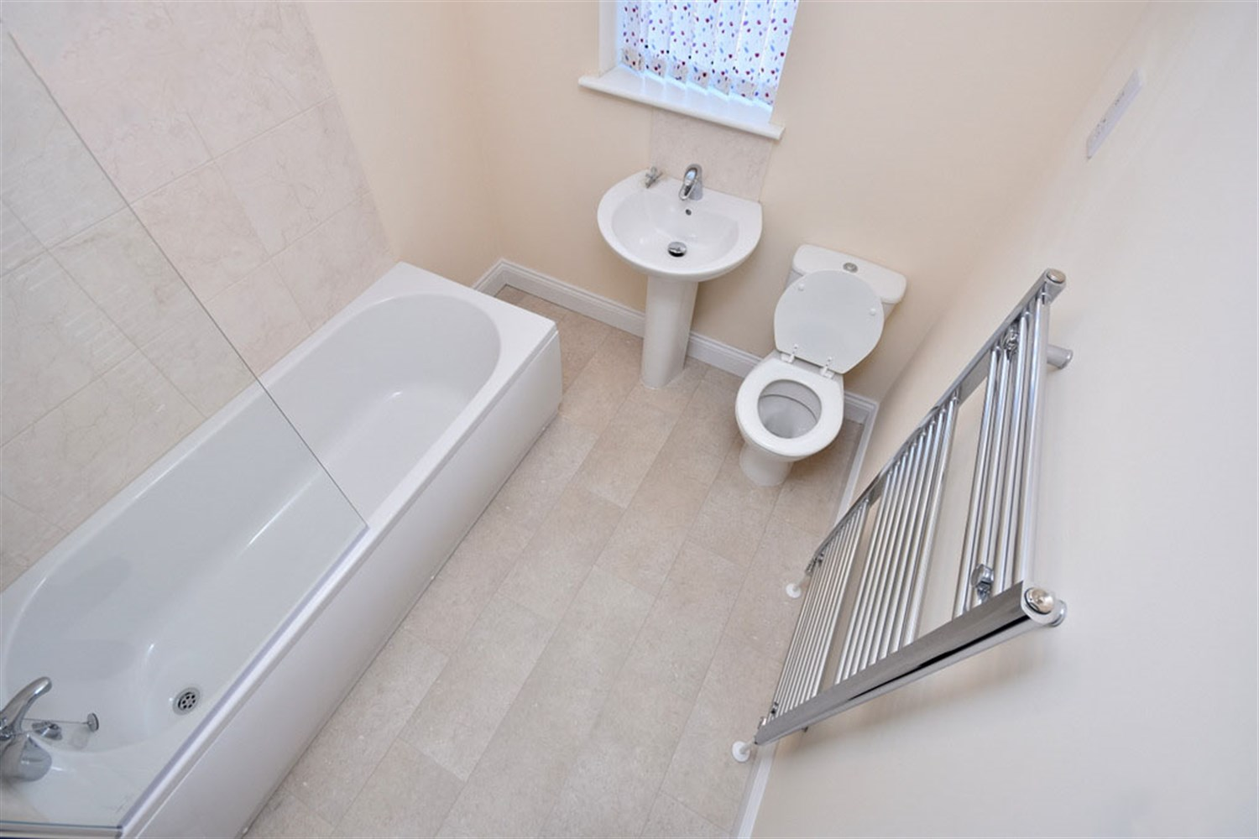
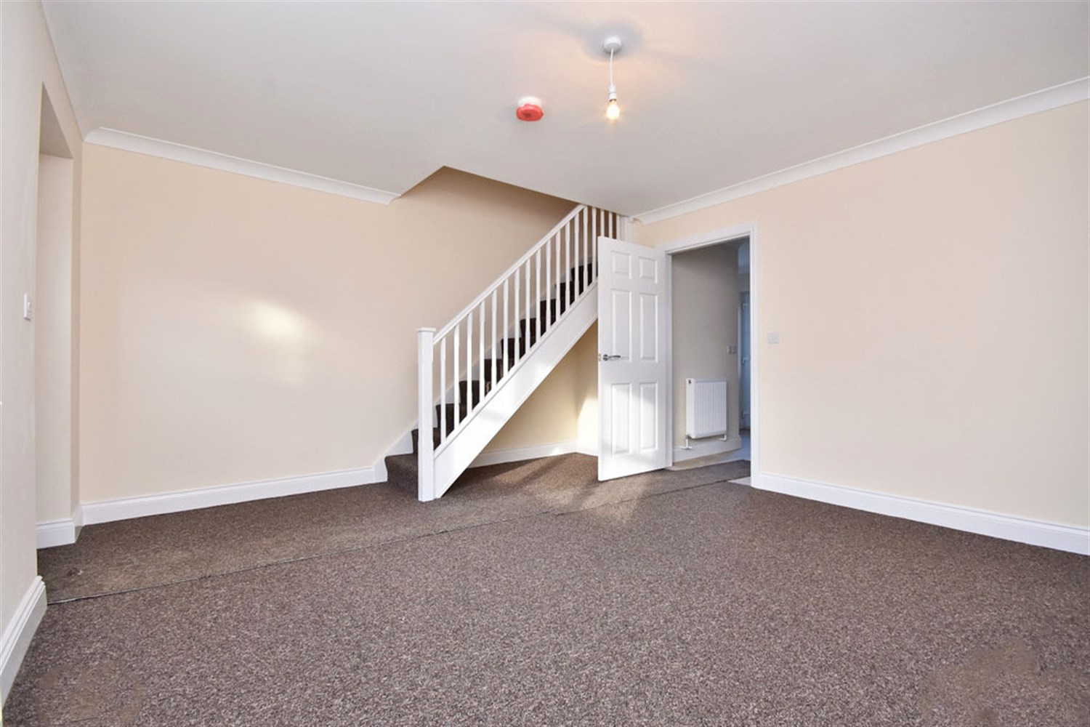
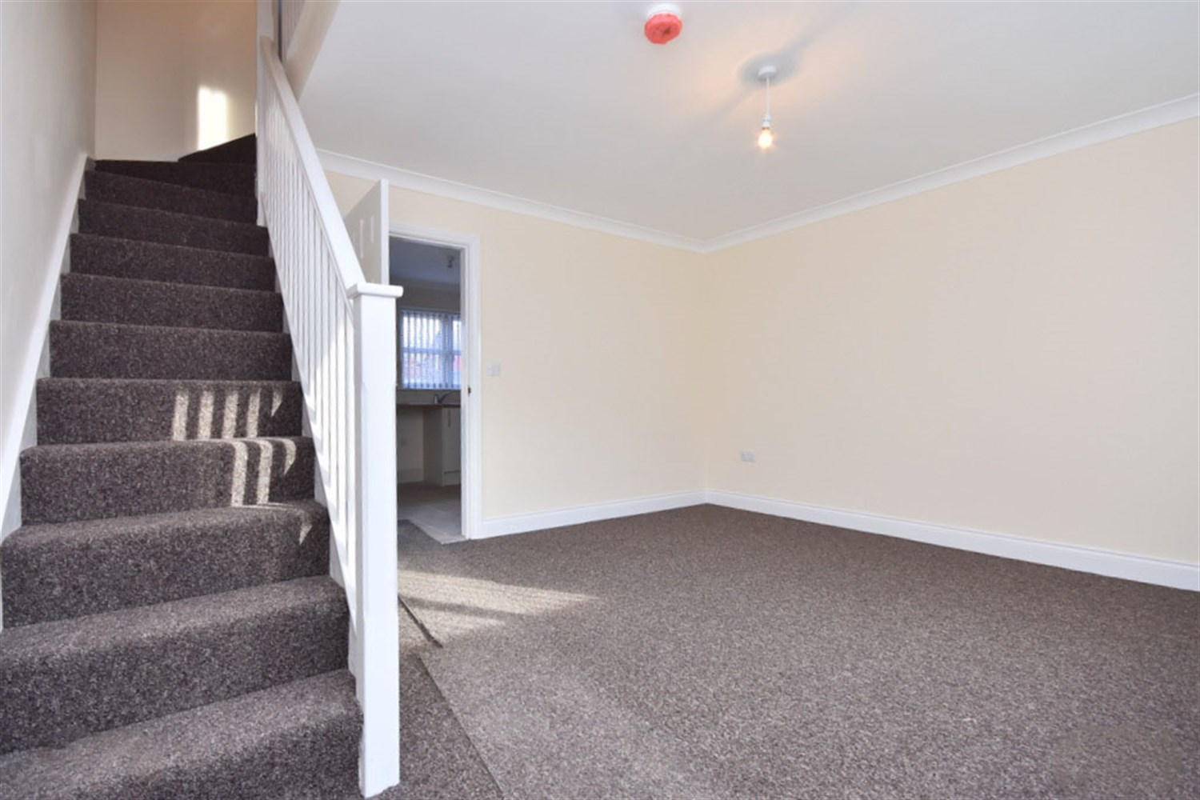

Property Description
A well-presented and attractive red brick end-terrace property, occupying a prominent position within a convenient town location. The home benefits from a smart and low-maintenance frontage, approached via a raised entrance with steps leading to a modern black composite front door, complete with external lighting and wrought iron railings adding both character and security.
The property features a clean and uniform façade with uPVC double glazed windows throughout, allowing for plenty of natural light. To the front is a paved area directly off the pavement, providing easy access and a practical, low upkeep outdoor space.
Being an end-terrace, the property also benefits from side access leading to the rear, a desirable feature not always available with mid-terrace homes. Situated within a traditional residential setting, the property further benefits from on-street parking nearby.
Investment Opportunity- Tenants in Situ!

Bedroom 1
A well-presented and neutrally decorated bedroom, offering a bright and comfortable space. The room benefits from a large window allowing for plenty of natural light, complemented by light-toned walls and crisp white skirting boards which enhance the sense of space.
Finished with fitted carpet underfoot, the room provides a warm and practical setting. There is ample space for a bed and freestanding furniture, making it a versatile and functional room.

Bedroom 2
A well-proportioned and neutrally decorated second bedroom, offering a bright and versatile space. The room benefits from a window to the rear aspect fitted with vertical blinds, allowing for good levels of natural light while maintaining privacy.
Finished with fitted carpet and complemented by a radiator beneath the window, the room provides a comfortable and practical setting. There is ample space for a bed and additional furnishings, making it ideal as a guest bedroom, home office, or nursery depending on individual needs.

Bedroom 3
A well-presented and neutrally decorated third bedroom, offering a cosy yet functional space. The room benefits from a window to the rear aspect fitted with vertical blinds, allowing for natural light while maintaining privacy.
Finished with fitted carpet and a radiator beneath the window, the room provides a comfortable setting. Ideal for use as a single bedroom, home office, or dressing room, it offers flexibility to suit a range of needs.

Living Room
A spacious and well-presented living room, offering a bright and versatile main reception space. The room benefits from a large front-facing window allowing for plenty of natural light, enhancing the neutral décor and creating a warm and inviting atmosphere.
A standout feature of the room is the open staircase leading to the first floor, adding character and a sense of openness to the layout. Finished with fitted carpet and complemented by a radiator beneath the window, the space is both comfortable and practical.
There is ample room for a range of lounge furnishings as well as space for a dining area if required, making it ideal for both relaxing and entertaining. The room also provides access through to the kitchen, offering a convenient and functional flow throughout the ground floor.

Bathroom
A modern and well-presented family bathroom, fitted with a three-piece suite comprising a panelled bath with shower over and glass screen, pedestal wash hand basin, and low-level WC.
The room is finished with contemporary wall tiling around the bath area and complemented by neutral décor throughout, creating a clean and bright space. Additional features include a chrome heated towel rail and a window to the rear aspect allowing for natural light and ventilation.

Kitchen
A spacious and well-appointed kitchen, fitted with a modern range of matching wall and base units complemented by work surfaces over. The kitchen incorporates a stainless steel sink and drainer, integrated oven with hob and extractor hood above, along with space for additional appliances.
The room benefits from a window to the rear aspect allowing for natural light, while the layout provides ample worktop and storage space, making it both practical and functional for everyday use.
Finished with tiled flooring and neutral décor throughout, the kitchen offers a clean and contemporary feel. There is also sufficient space to accommodate a small dining area if required, along with access leading through to the main living space.

Garden
An enclosed rear garden, offering a low-maintenance outdoor space ideal for relaxing or entertaining. The garden is mainly laid to lawn with a paved pathway leading to the property, providing practical access.
The space is fully enclosed with fencing to the boundaries, offering a good degree of privacy and making it suitable for families or those with pets. There is also a raised entrance area with steps leading to the rear door, adding a defined and functional layout to the space.
Tenants to maintain

Landing
A well-presented first floor landing, providing access to all bedrooms and the family bathroom. The space benefits from neutral décor and fitted carpet, creating a clean and cohesive feel throughout.
The landing also features a loft access hatch, offering additional storage potential, and is complemented by a white balustrade overlooking the staircase, adding a sense of openness to the area.

Downstairs WC

Heating
Gas Central Heating

These particulars are intended to give a fair description of the property, but their accuracy cannot be guaranteed, and they do not constitute an offer of contract. Intending purchasers must rely on their own inspection of the property. None of the above appliances/services have been tested by ourselves. We recommend purchasers arrange for a qualified person to check all appliances/services before legal commitment.

Property Ref: 3469

www.drurysestateagents.co.uk
amber@drurysestateagents.co.uk
01205 350889

45 Willoughby Road
Boston
Lincolnshire
PE21 9HN
Agents Note: Whilst every care has been taken to prepare these sales particulars, they are for guidance purposes only. All measurements are approximate are for general guidance purposes only and whilst every care has been taken to ensure their accuracy, they should not be relied upon and potential buyers are advised to recheck the measurements

