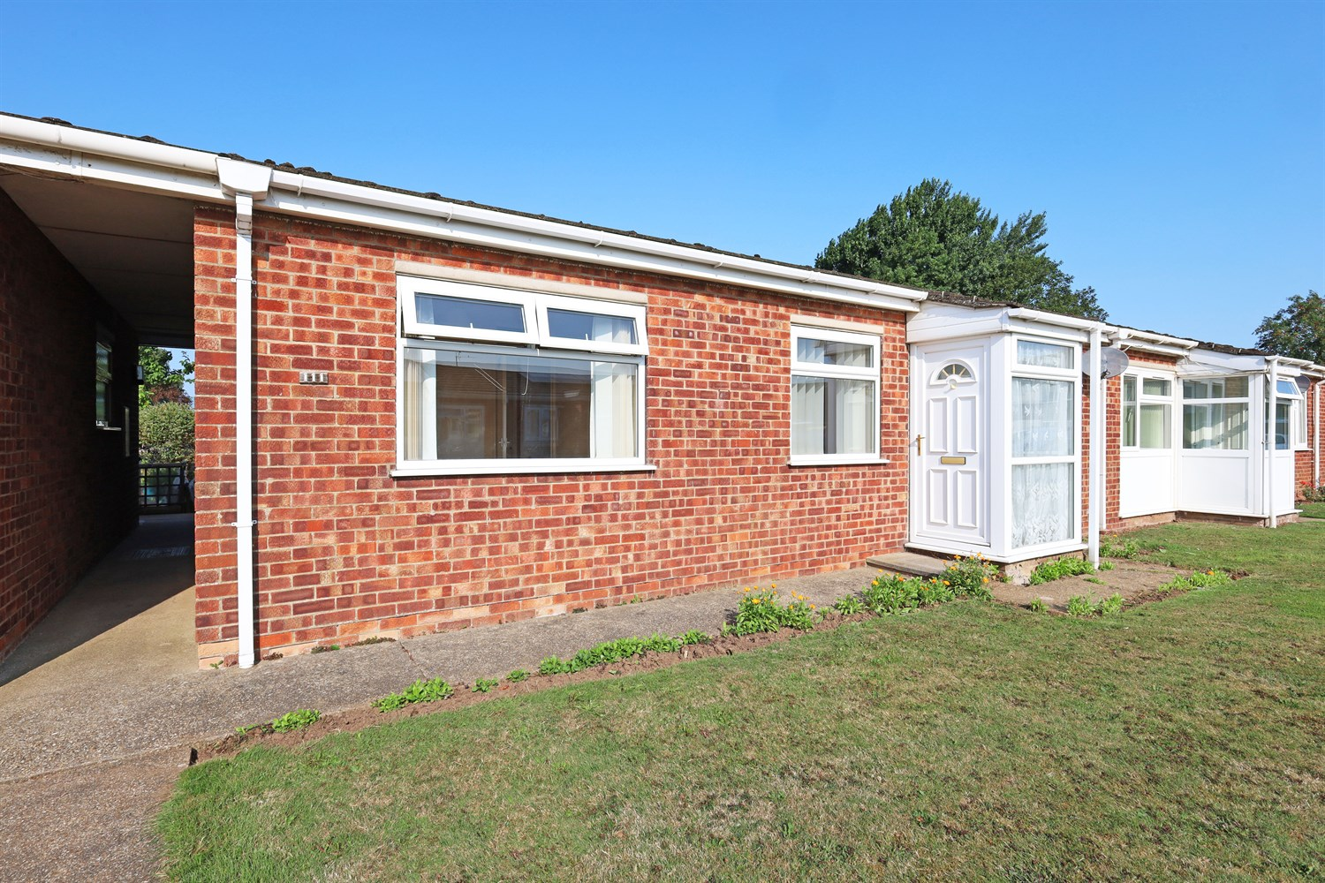




2 Bedroom(s)
1 Reception(s)
1 Bathroom(s)
£139,950.00
Ward Crescent, PE21
EPC Rating ‘’

- 2 Bedroomed Terraced Bungalow
- Lounge diner, breakfast kitchen, white 3 piece bathroom suite.
- No Onward Chain

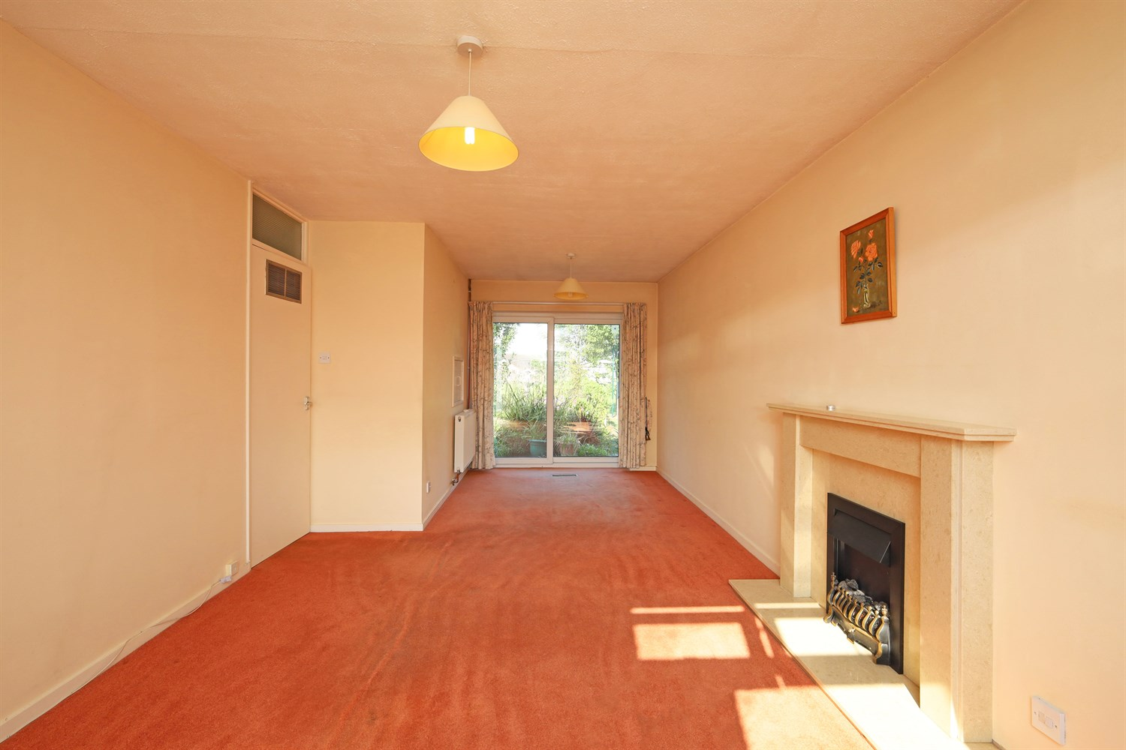
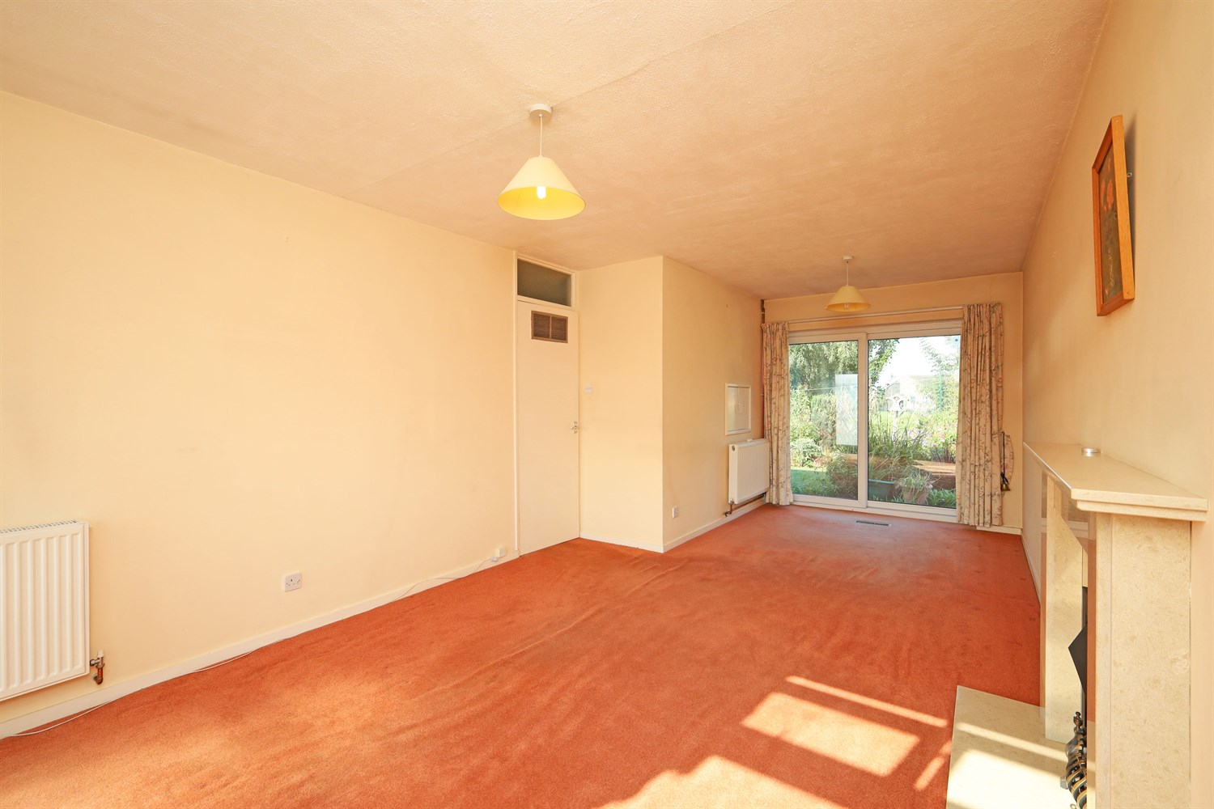
00
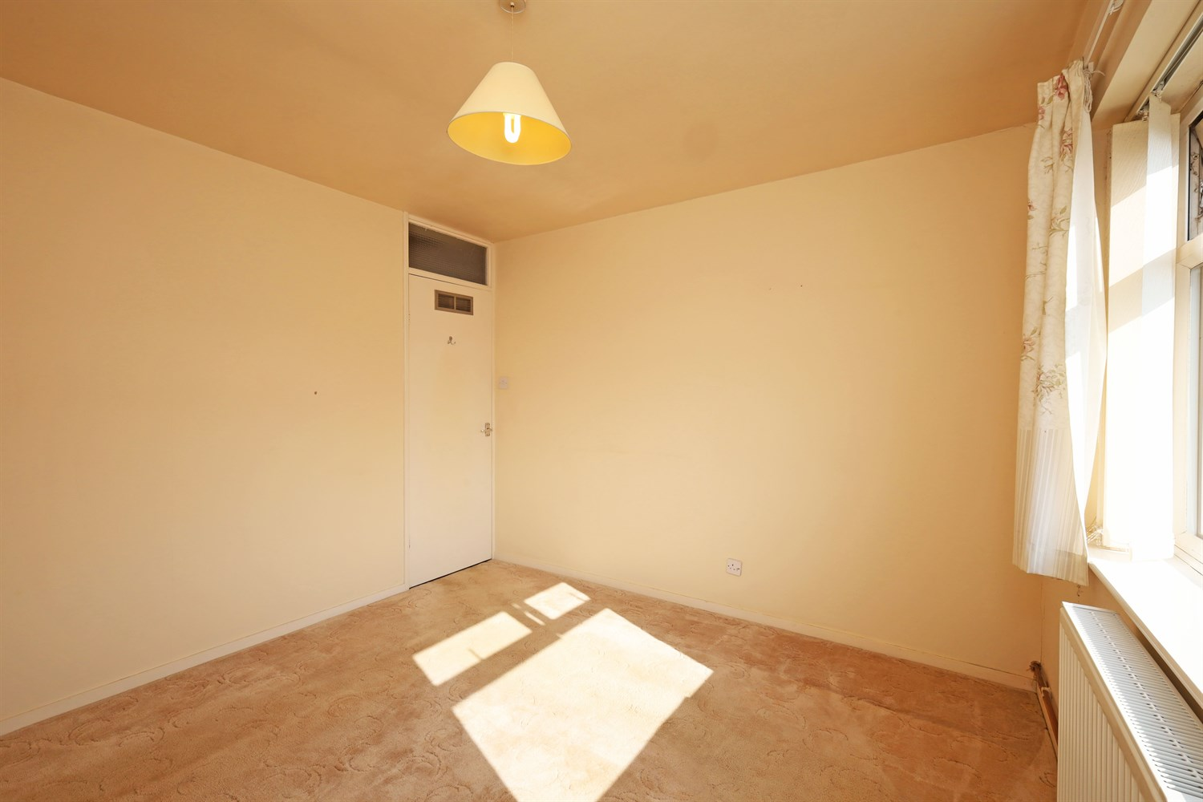
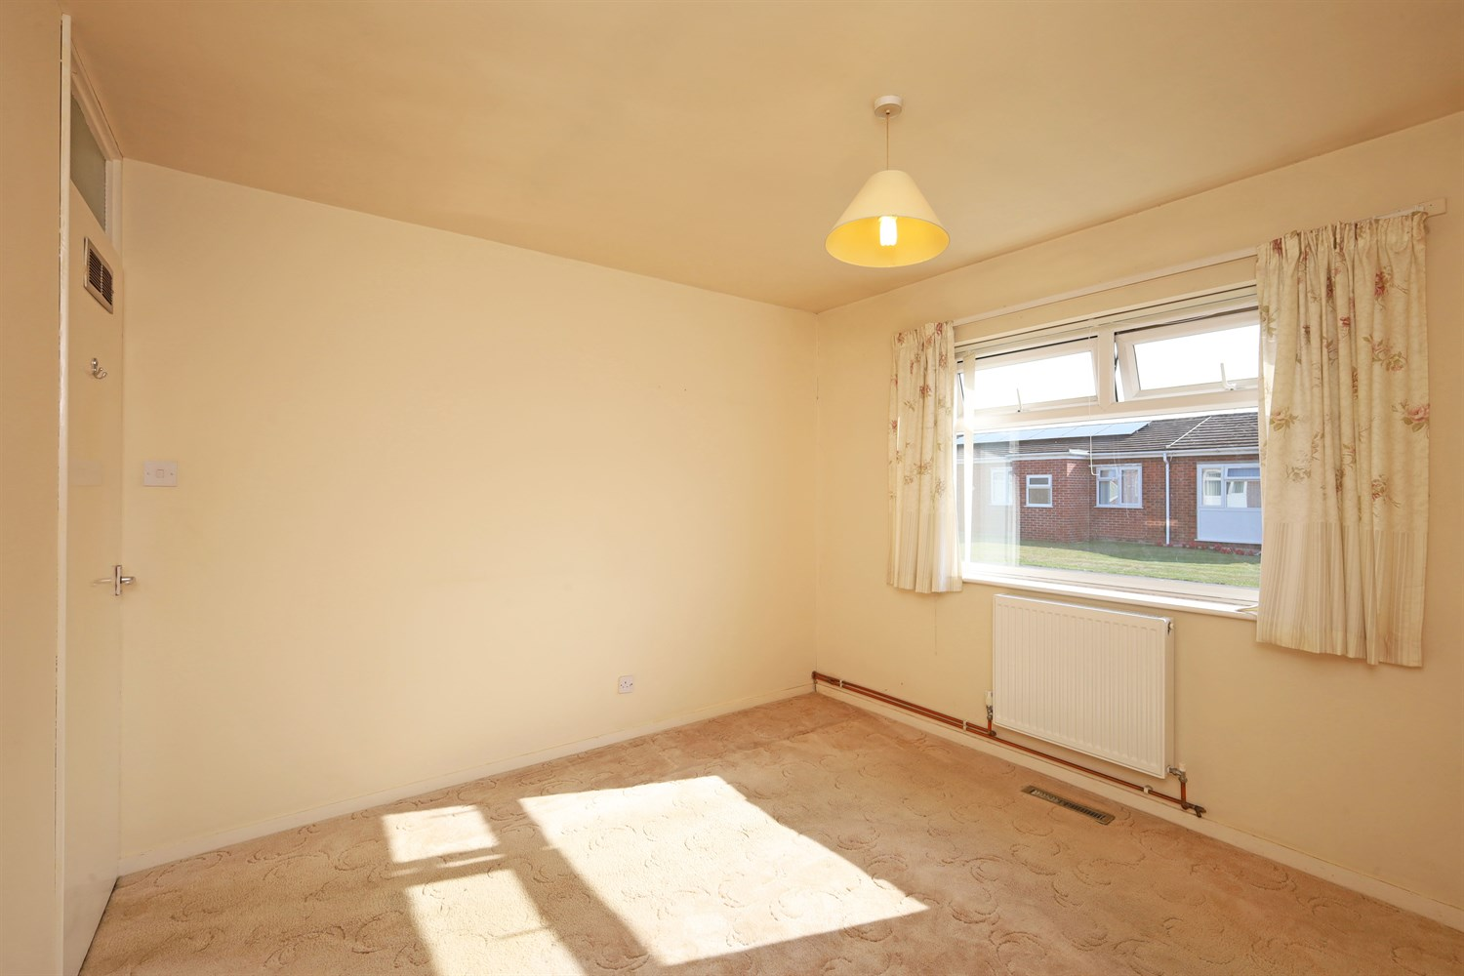
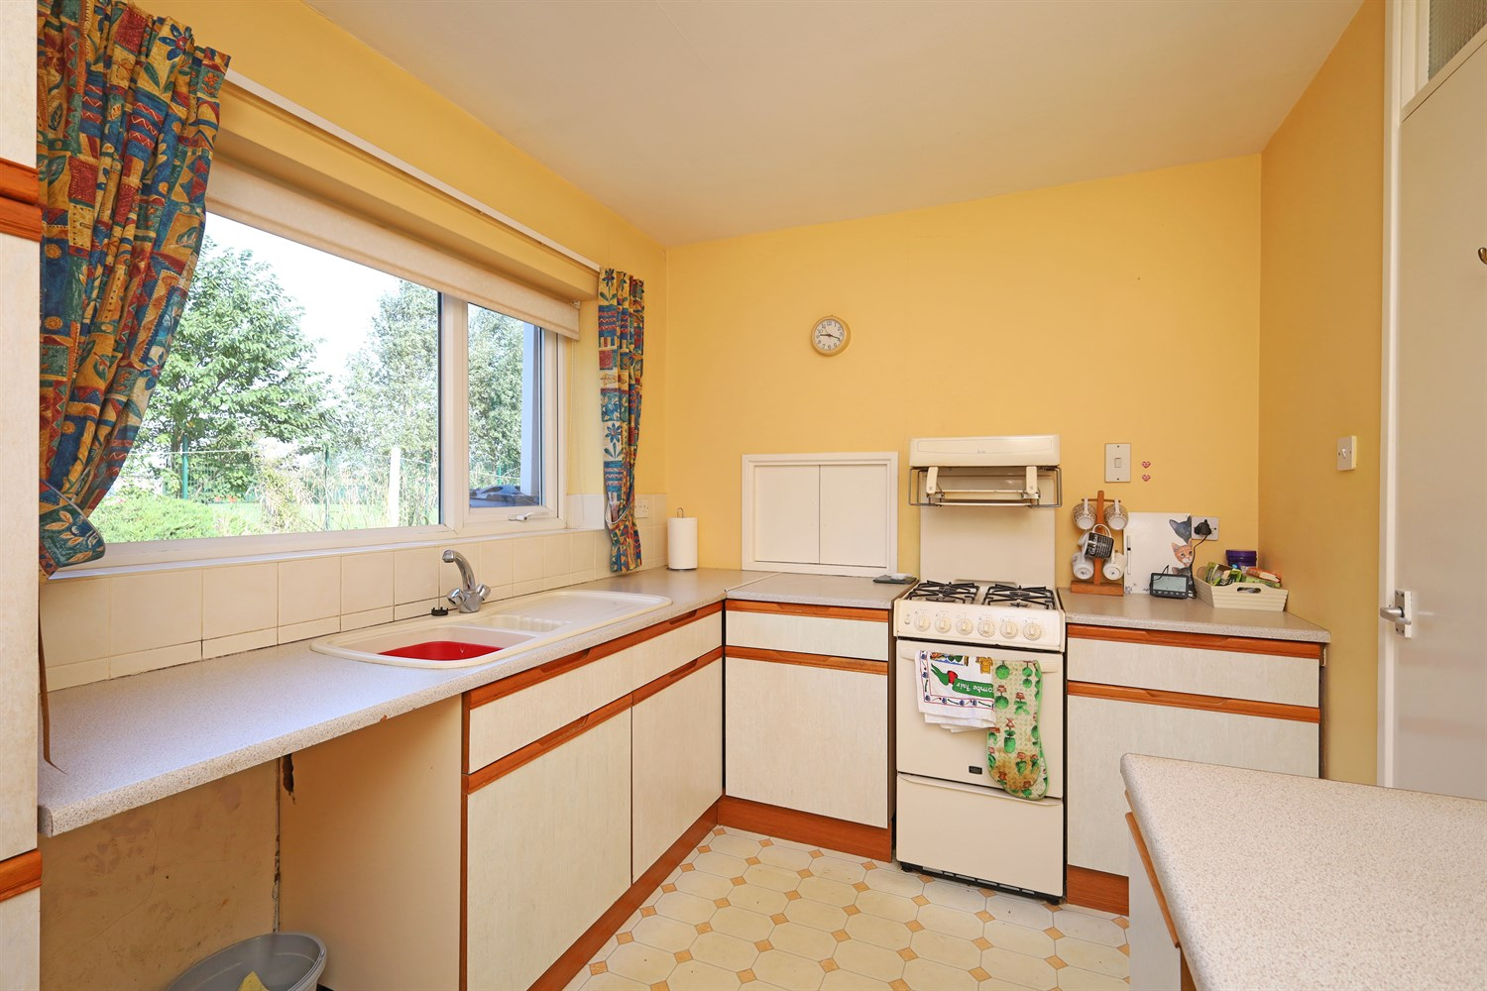
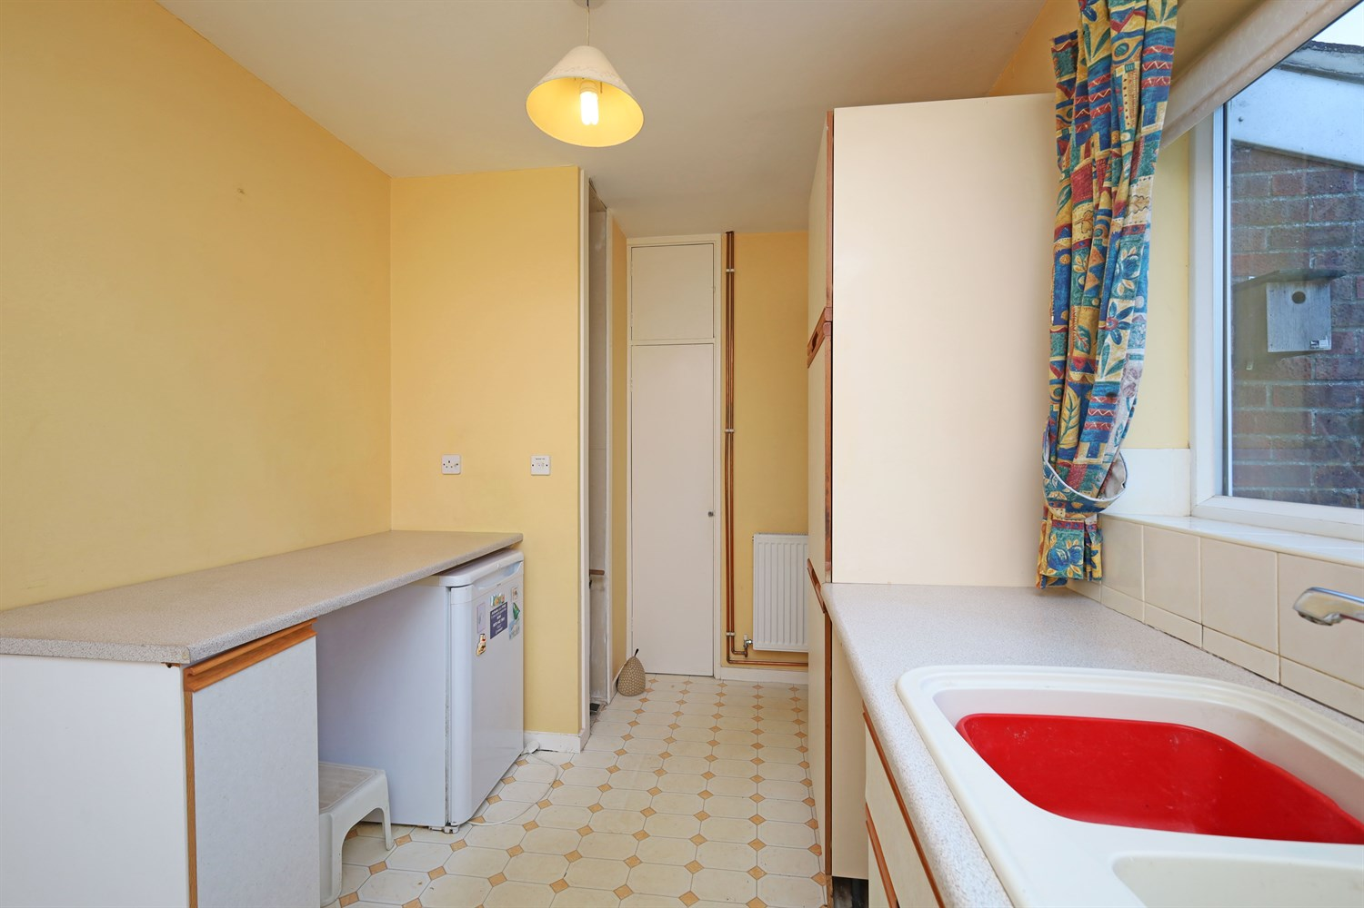
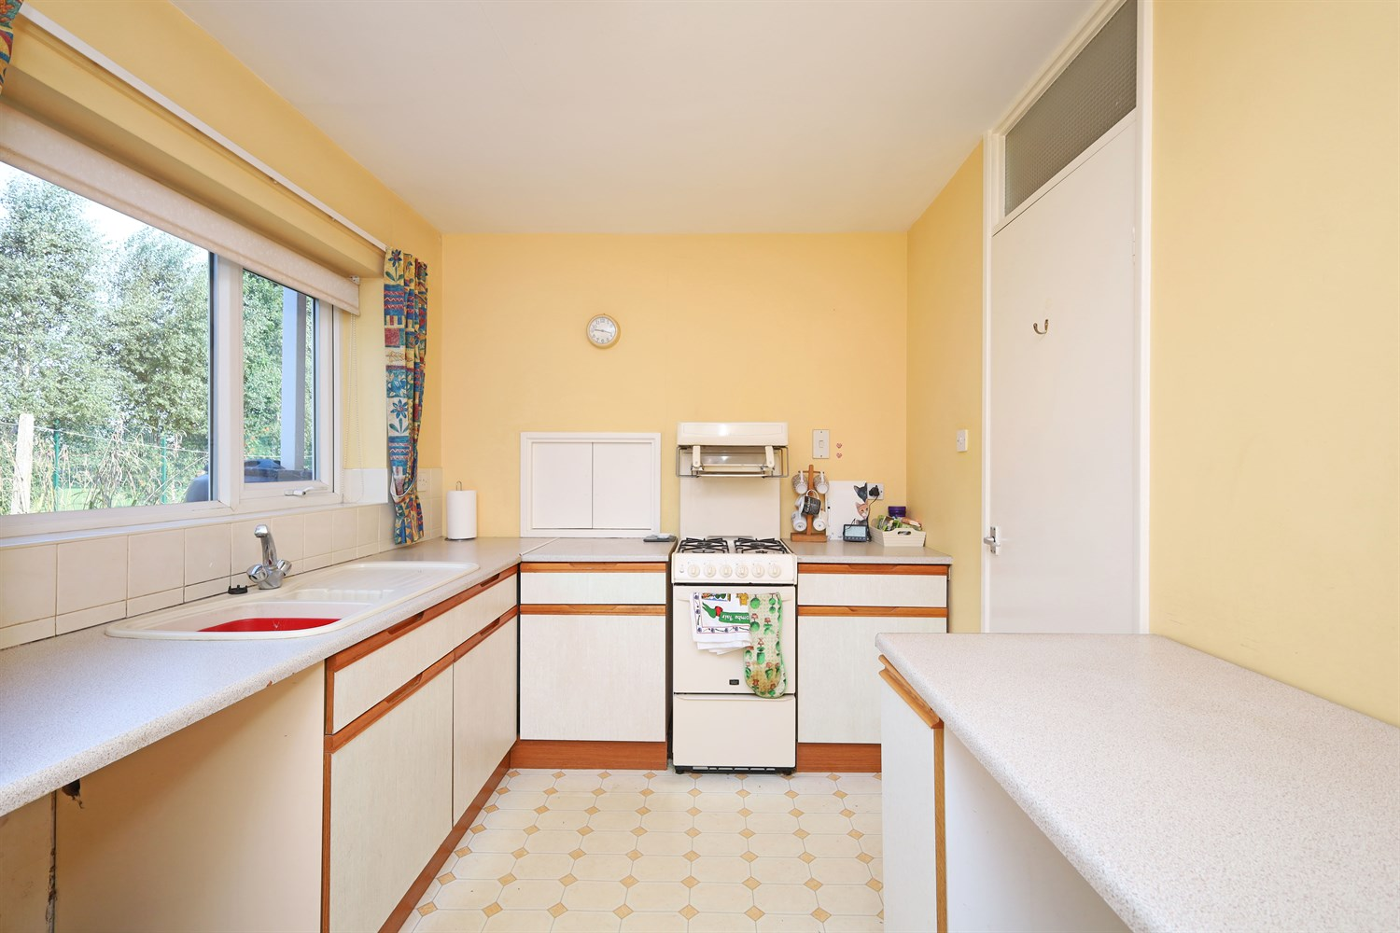
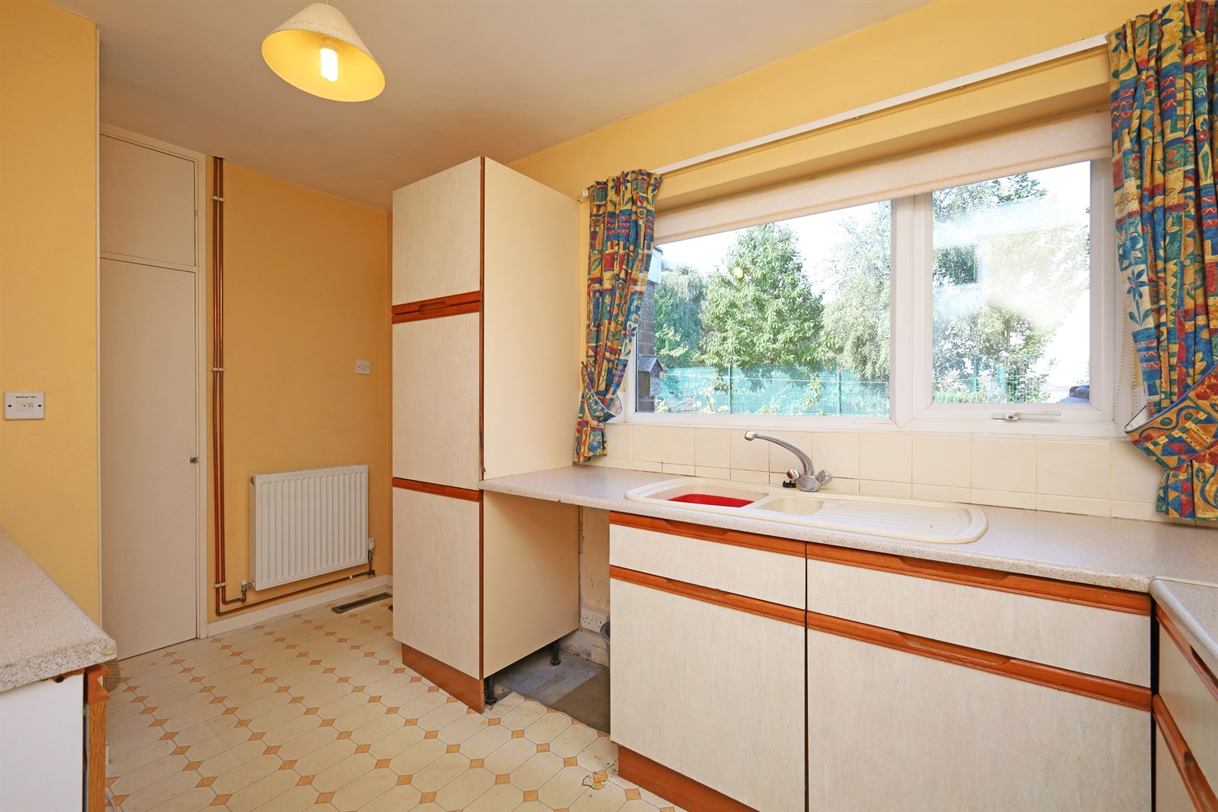
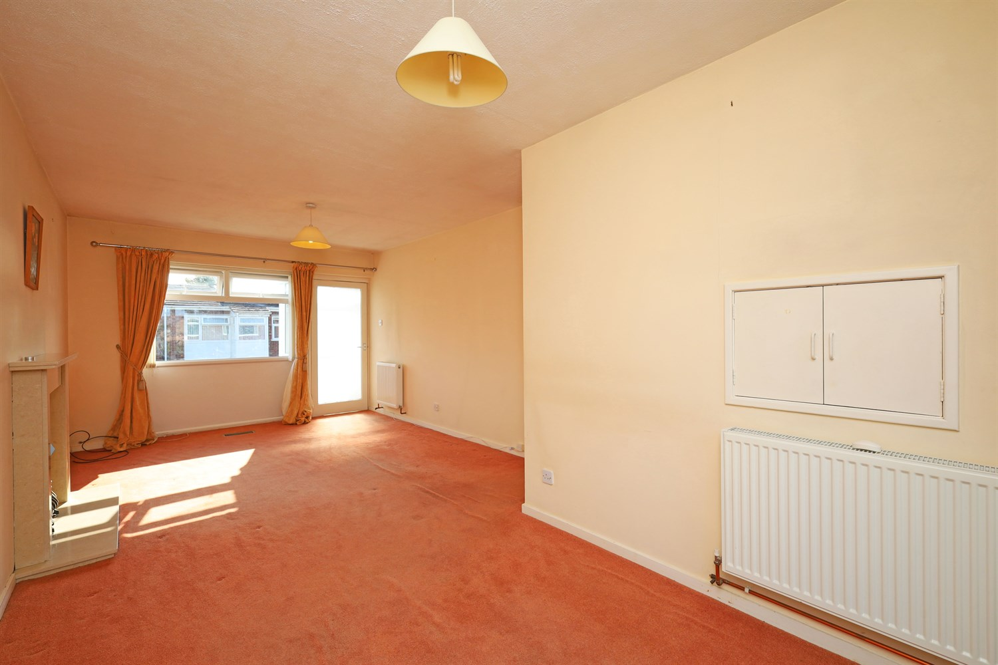
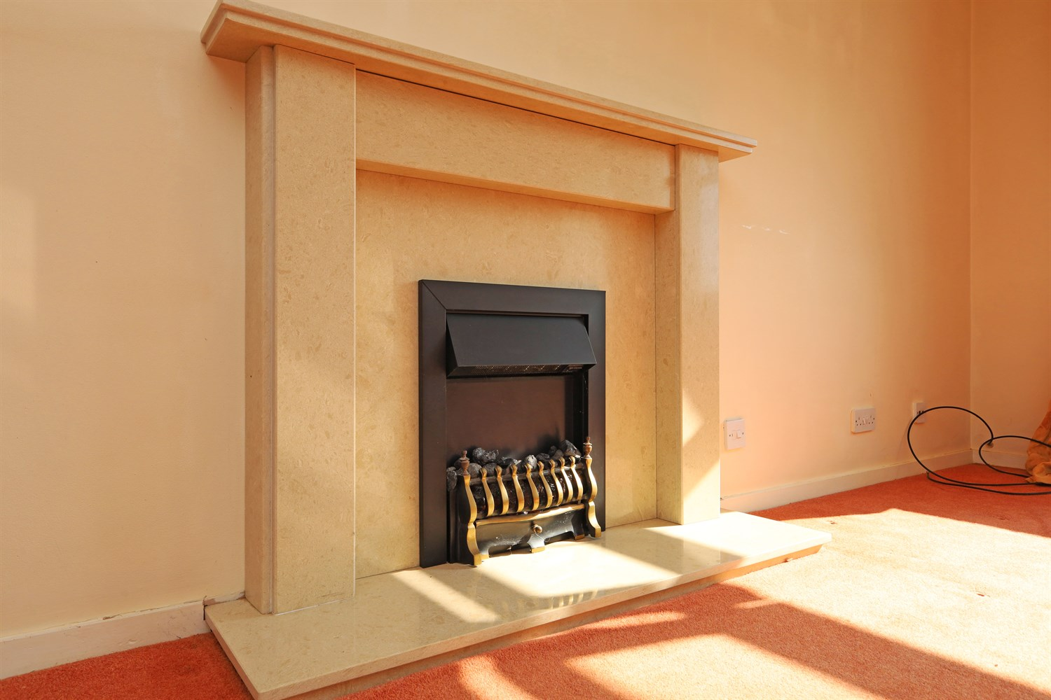

Property Description
**NEW PRICE** CHAIN FREE.... Terraced bungalow in a sort after location is being offered to the market. Accommodation comprises OF entrance porch, lounge/diner, kitchen, potential utility/workshop, two double bedrooms and a three piece family bathroom. Further benefits include parking, enclosed garden to the rear.

Reception Lounge/Diner
Entered through the front door, this lovely sized room has a window to the front aspect and French doors out into the garden. A radiator and Fireplace housing an electric fire.

Kitchen
With wooden units mainly to the base level with a worktop over and plumbing and space for a washing machine and fridge. A window to the rear aspect and access to the potential utility/workshop.

Bedroom 1
A good sized double room with window to the front aspect and radiator.

Bedroom 2
A good sized double room with window to the front aspect, with radiator.

Inner Hallway
Accessed from the lounge. This gives access to the bedrooms, and bathroom.

Bathroom
A three piece bathroom with a shower, WC and pedestal sink. Featuring a frosted window and radiator.

Potential Utility/Workshop
With the potential to use this room for multi uses.

An enclosed rear garden with lawn and pathway.

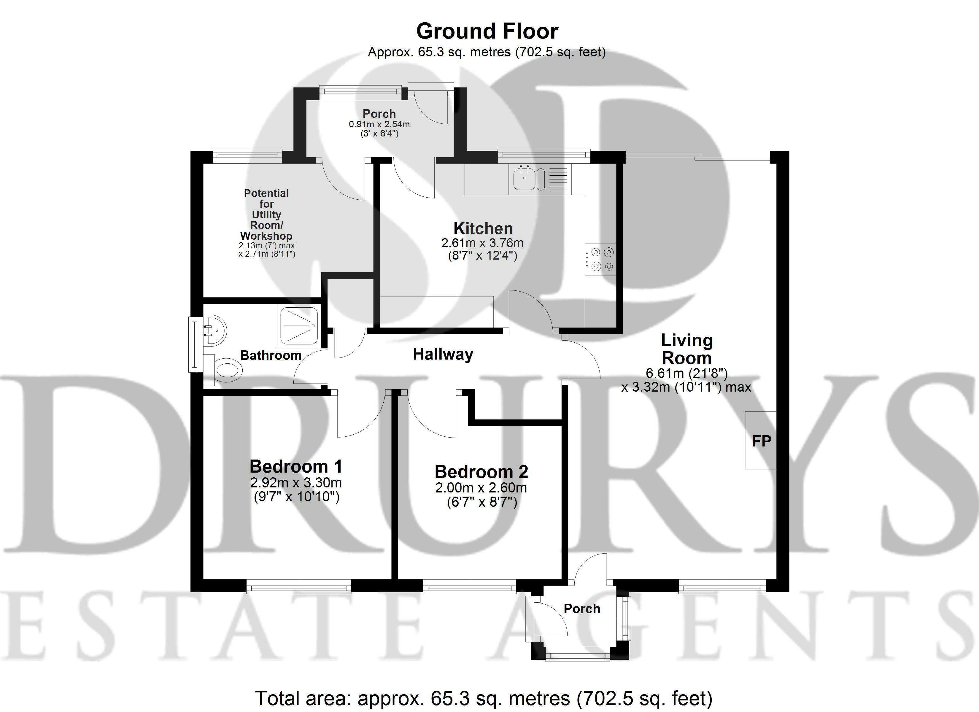

These particulars are intended to give a fair description of the property, but their accuracy cannot be guaranteed, and they do not constitute an offer of contract. Intending purchasers must rely on their own inspection of the property. None of the above appliances/services have been tested by ourselves. We recommend purchasers arrange for a qualified person to check all appliances/services before legal commitment.

Property Ref: 1868

www.drurysestateagents.co.uk
amber@drurysestateagents.co.uk
01205 350889

45 Willoughby Road
Boston
Lincolnshire
PE21 9HN
Agents Note: Whilst every care has been taken to prepare these sales particulars, they are for guidance purposes only. All measurements are approximate are for general guidance purposes only and whilst every care has been taken to ensure their accuracy, they should not be relied upon and potential buyers are advised to recheck the measurements

